Guide Title
Your screenshots are placed in step-by-step order. You can add an introduction here and edit any of the step descriptions. Thank you for sharing your knowledge.
1 | Click the highlighted area.  See the orange cursor for details.
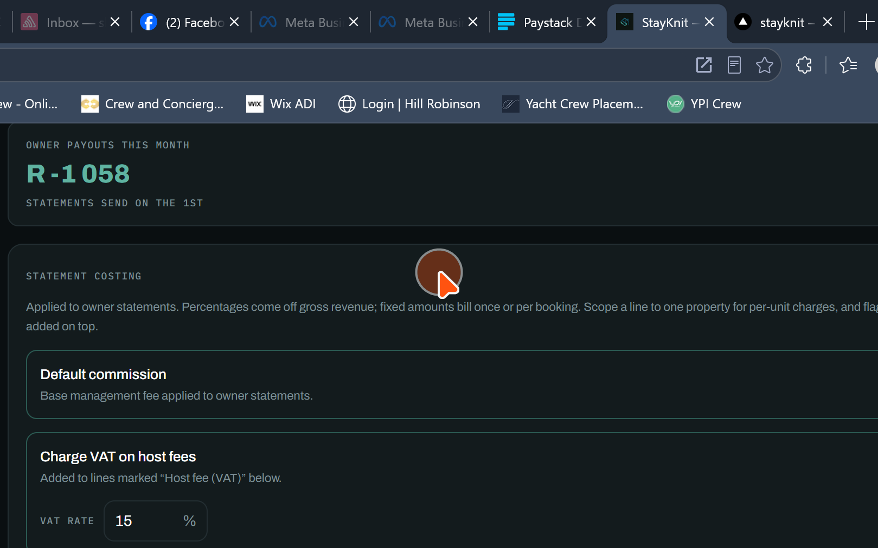
2 | Click the highlighted area.  See the orange cursor for details.
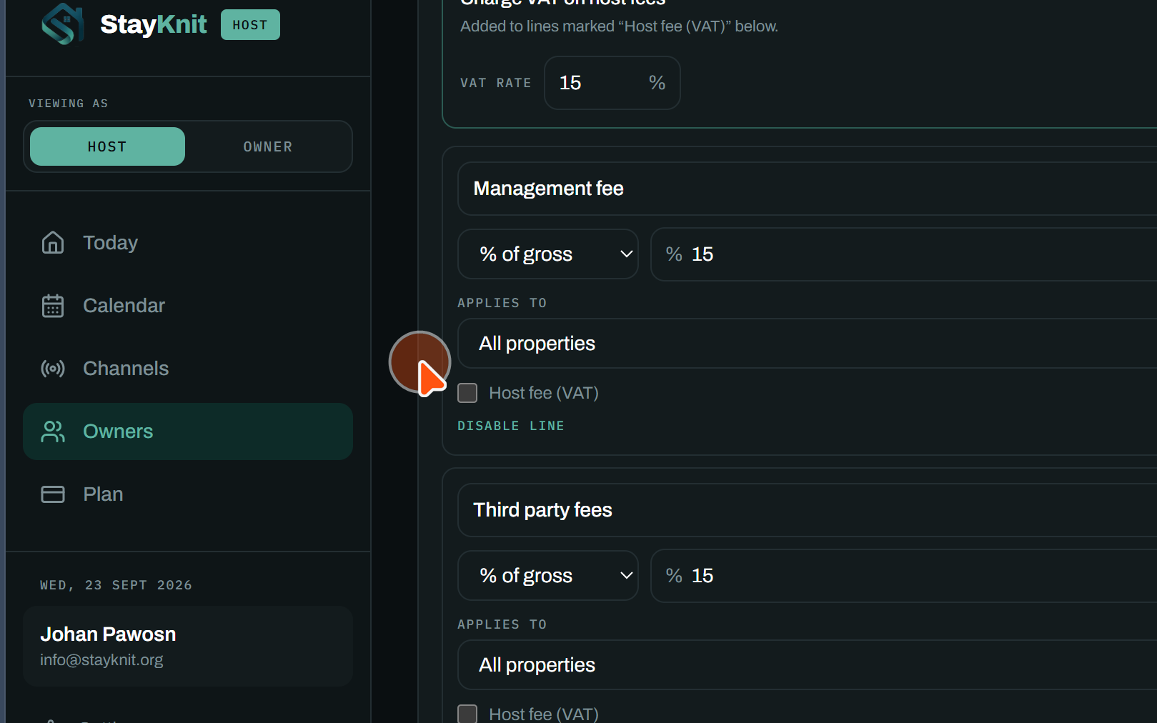
3 | Click the highlighted area.  See the orange cursor for details.
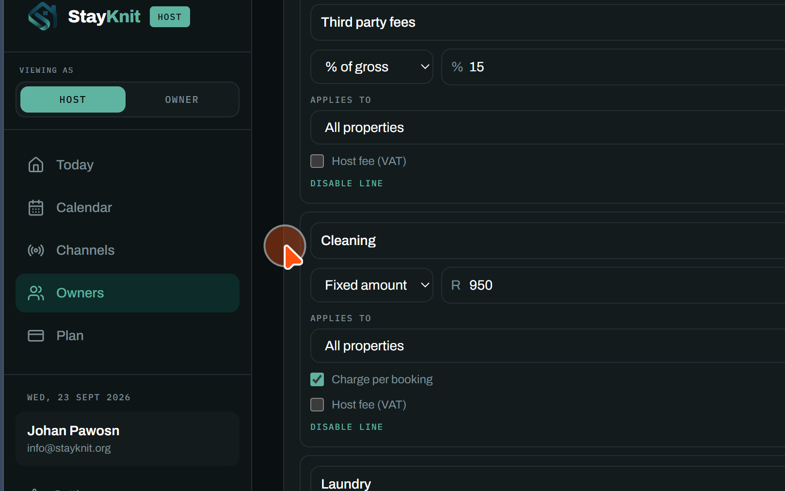
4 | Click the highlighted area.  See the orange cursor for details.
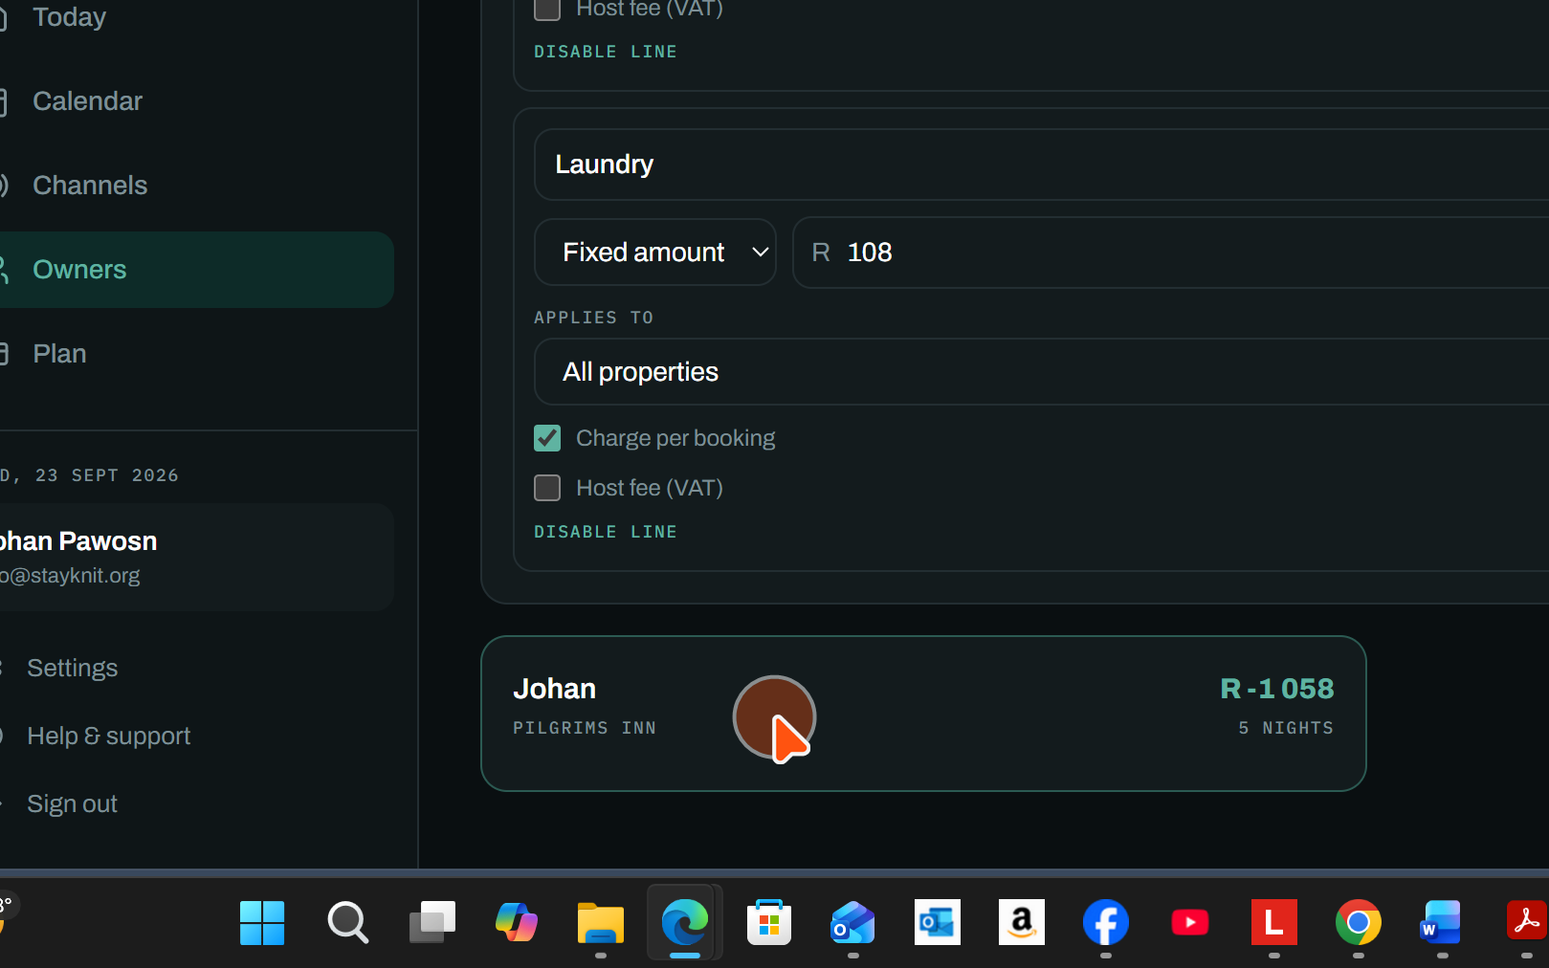
5 | Click the highlighted area.  See the orange cursor for details.
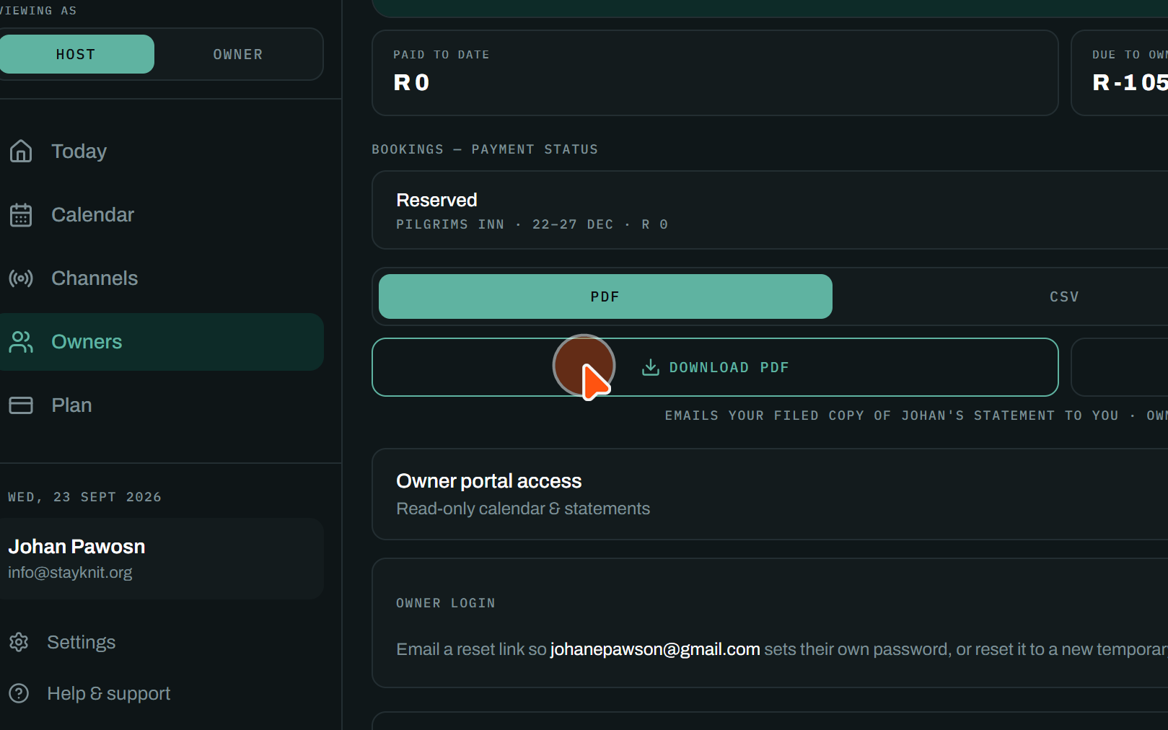
6 | Click the highlighted area.  See the orange cursor for details.
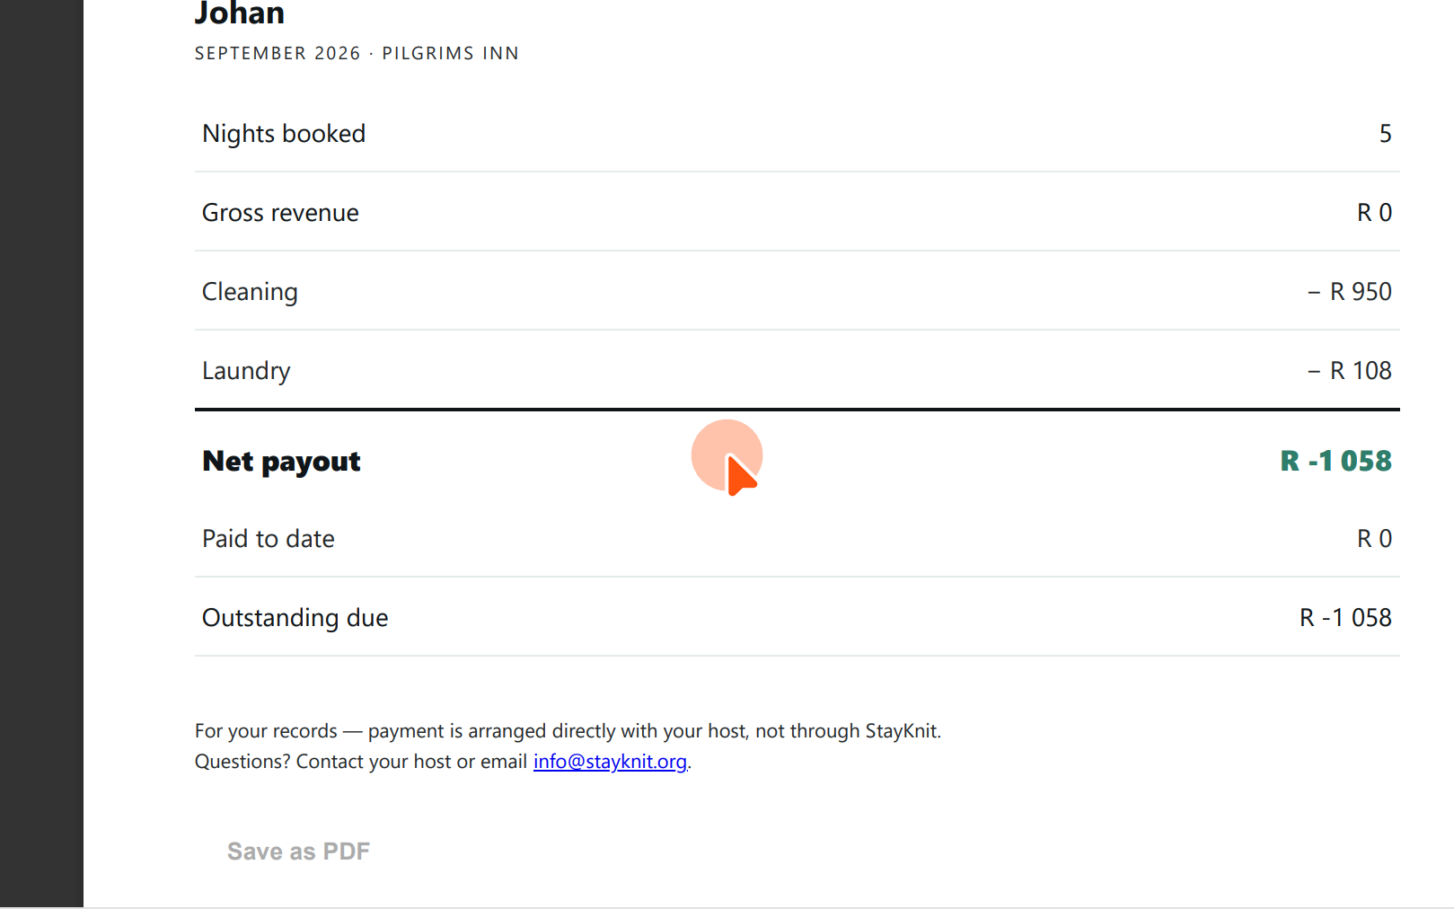
7 | Click the highlighted area.  See the orange cursor for details.
