Guide Title
Your screenshots are placed in step-by-step order. You can add an introduction here and edit any of the step descriptions. Thank you for sharing your knowledge.
1 | Click the highlighted area.  See the orange cursor for details.
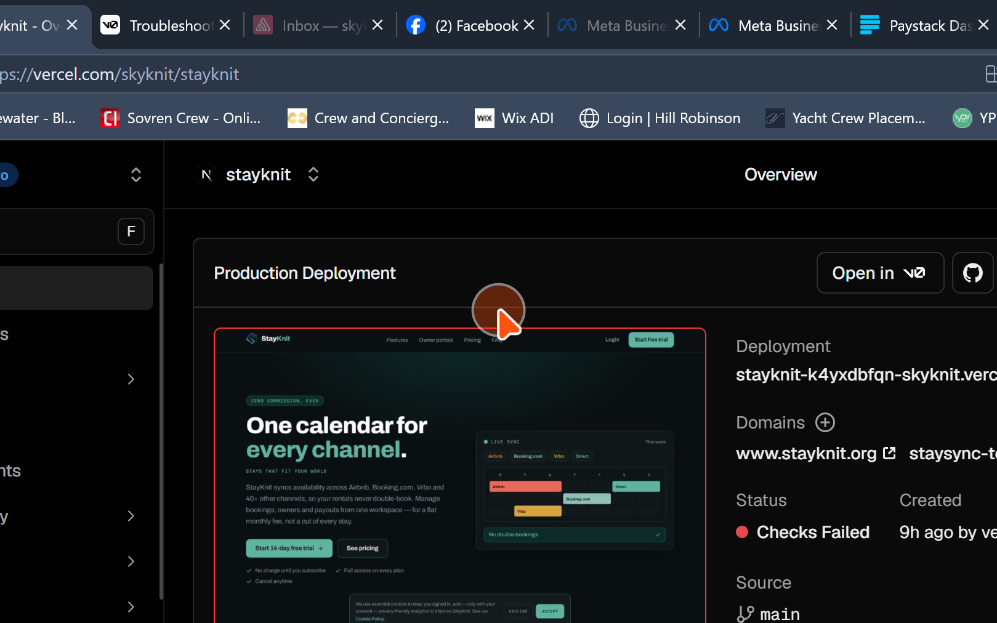
2 | Click the highlighted area.  See the orange cursor for details.
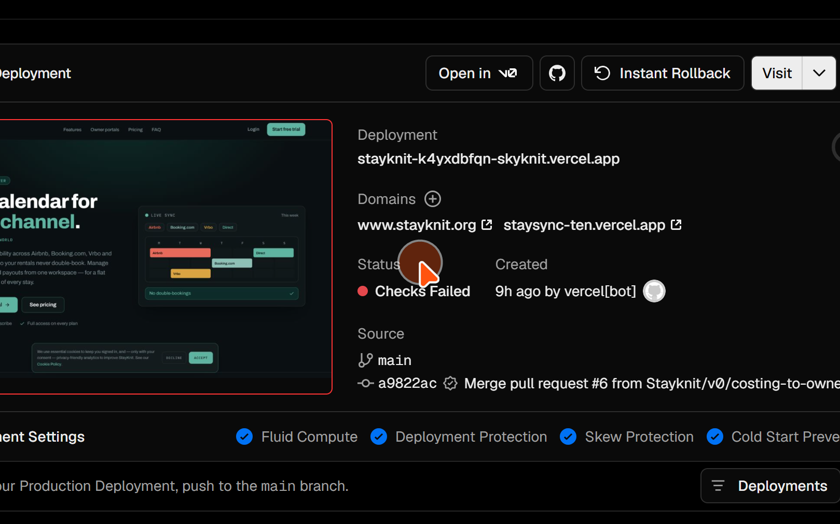
3 | Click the highlighted area.  See the orange cursor for details.
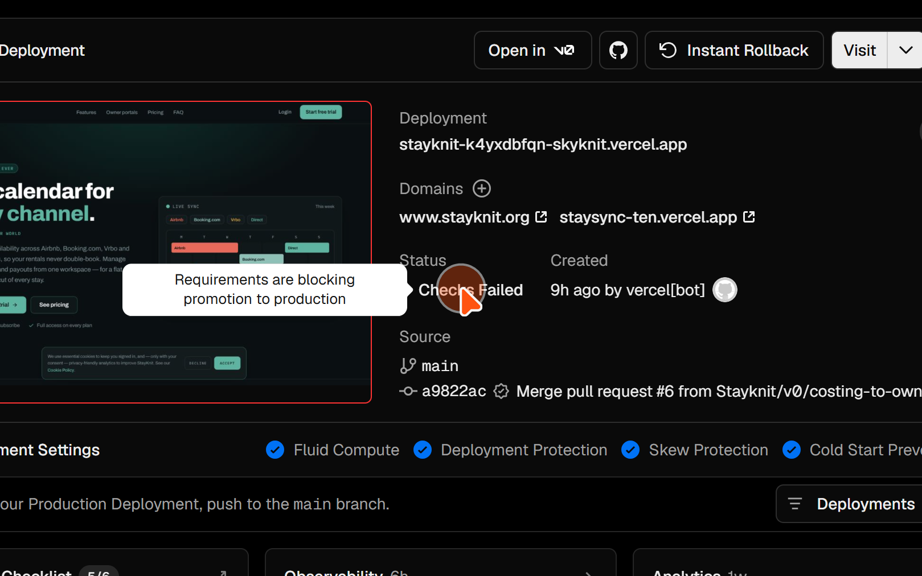
4 | Click the highlighted area.  See the orange cursor for details.
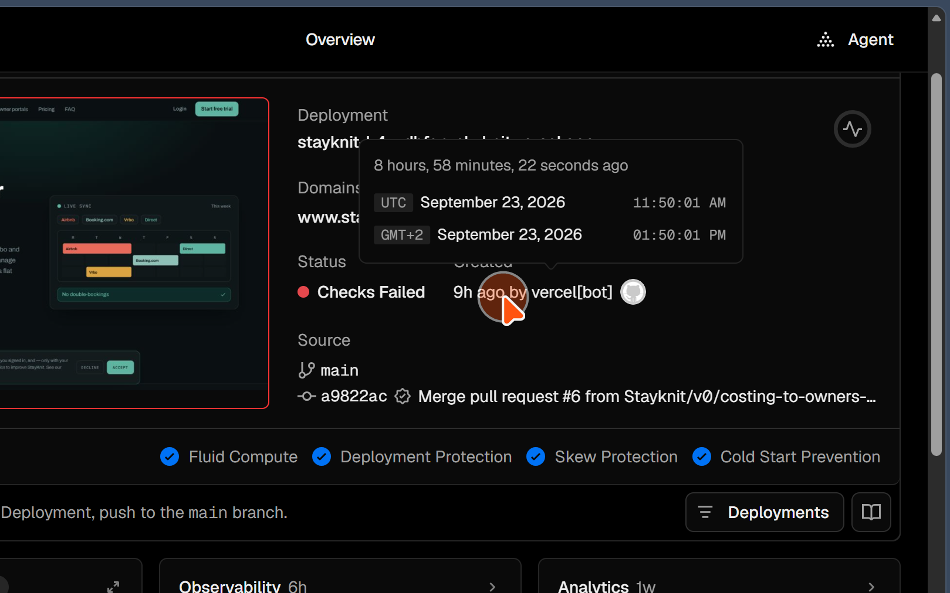
5 | Click the highlighted area.  See the orange cursor for details.
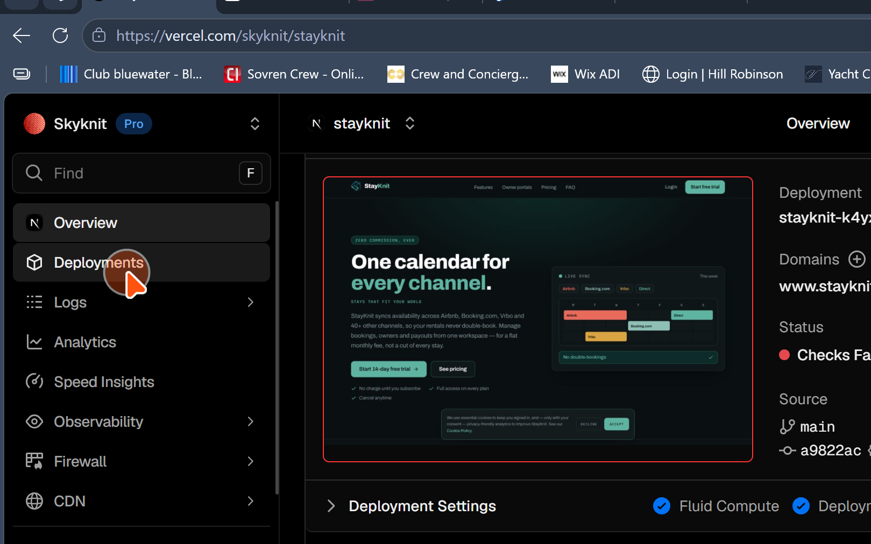
6 | Click the highlighted area.  See the orange cursor for details.
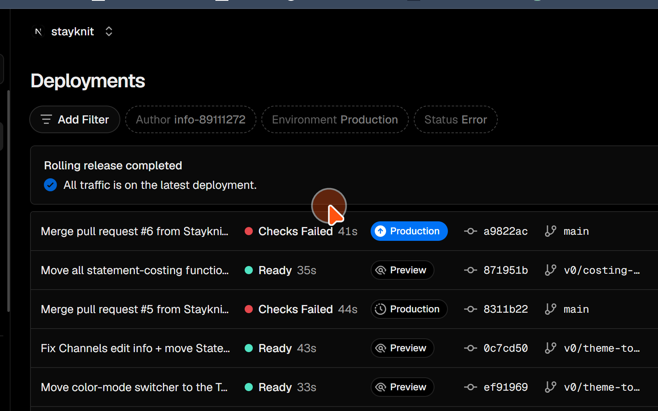
7 | Click the highlighted area.  See the orange cursor for details.
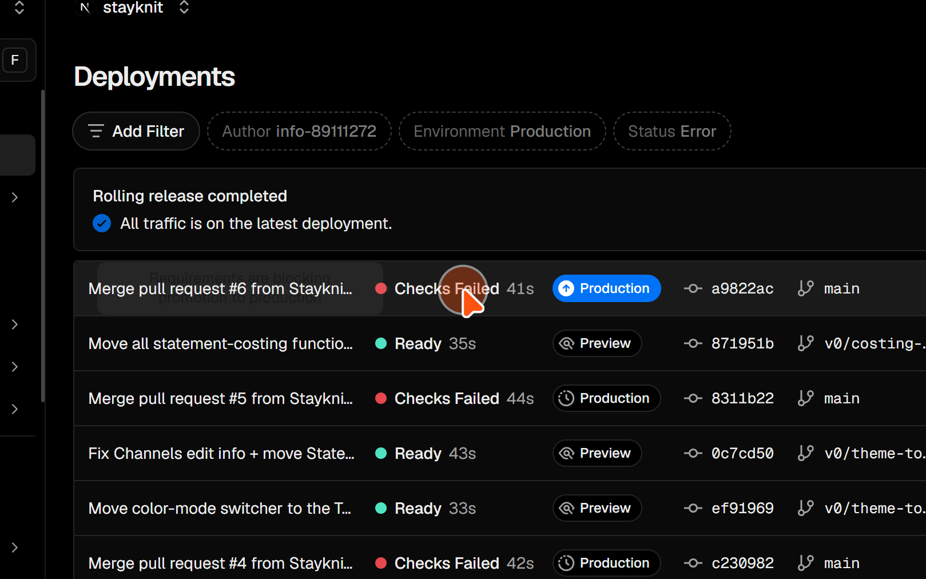
8 | Click the highlighted area.  See the orange cursor for details.
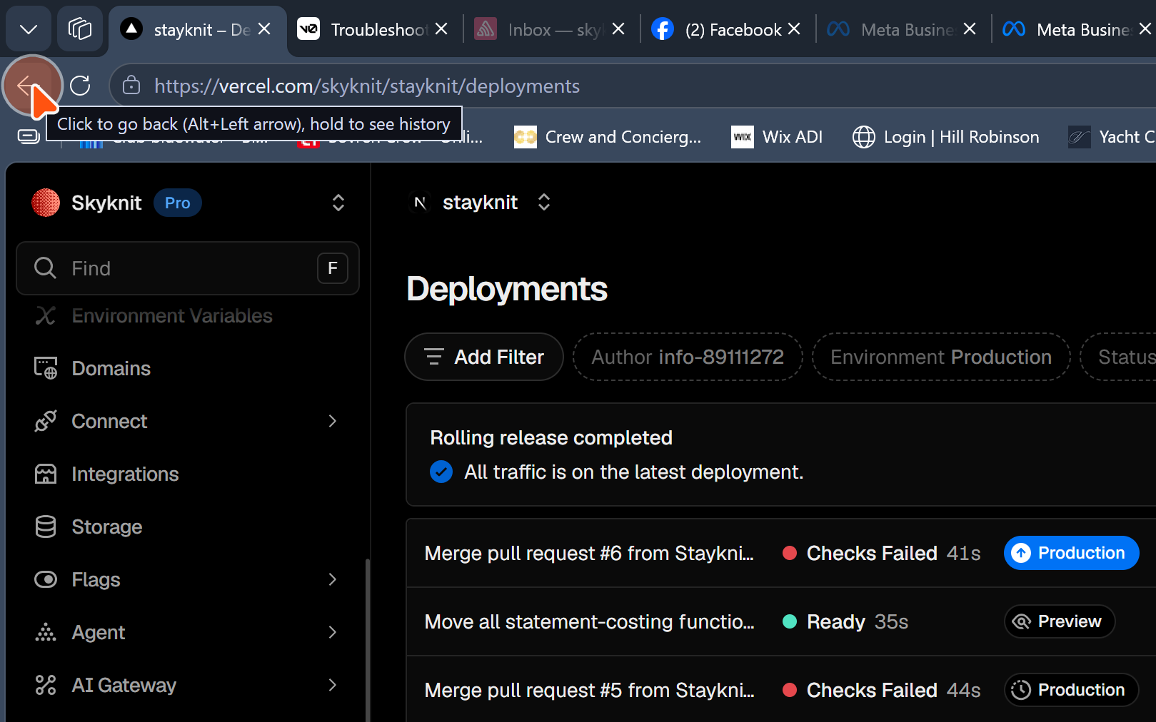
9 | Click the highlighted area.  See the orange cursor for details.
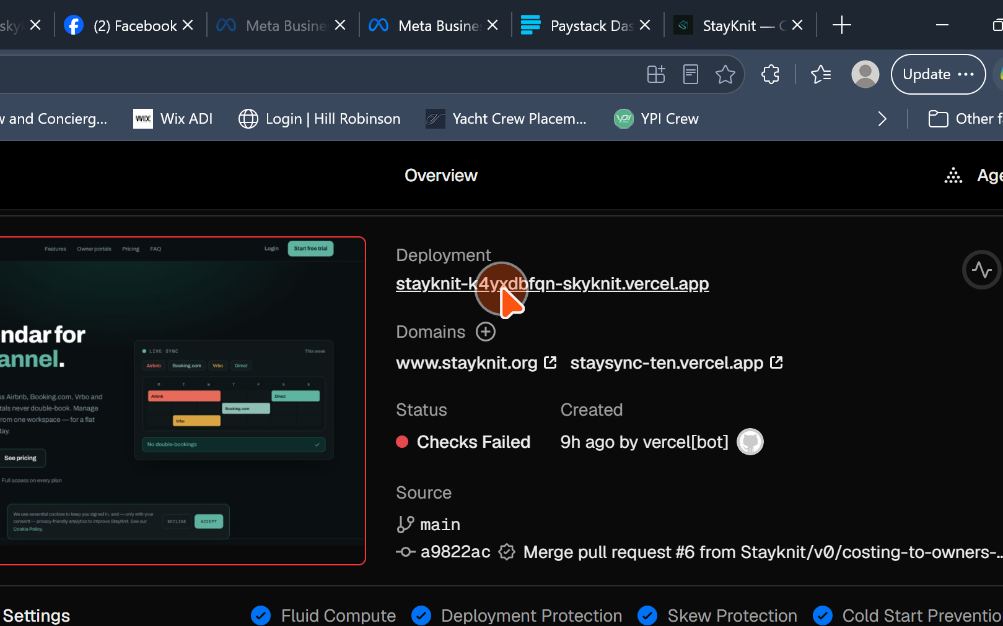
10 | Click the highlighted area.  See the orange cursor for details.
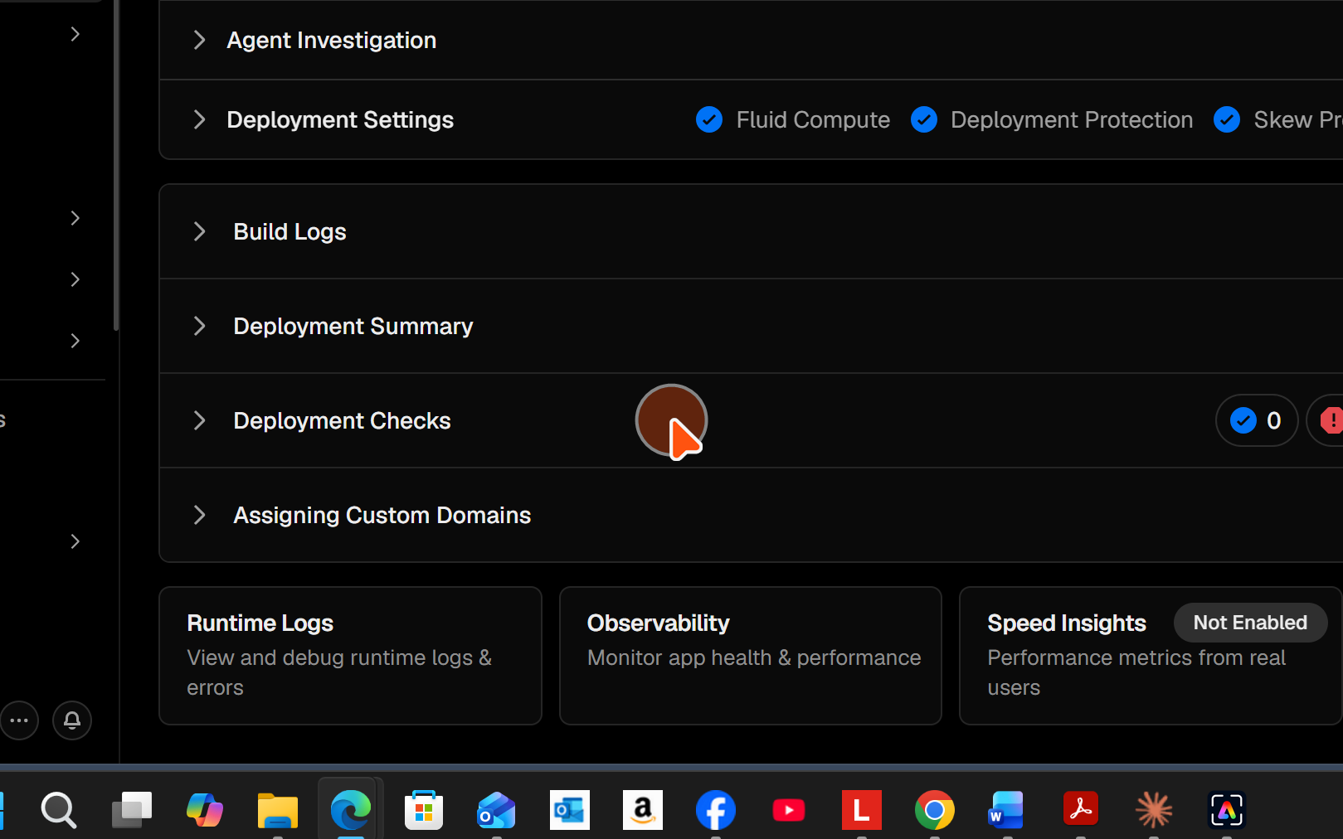
11 | Click the highlighted area.  See the orange cursor for details.
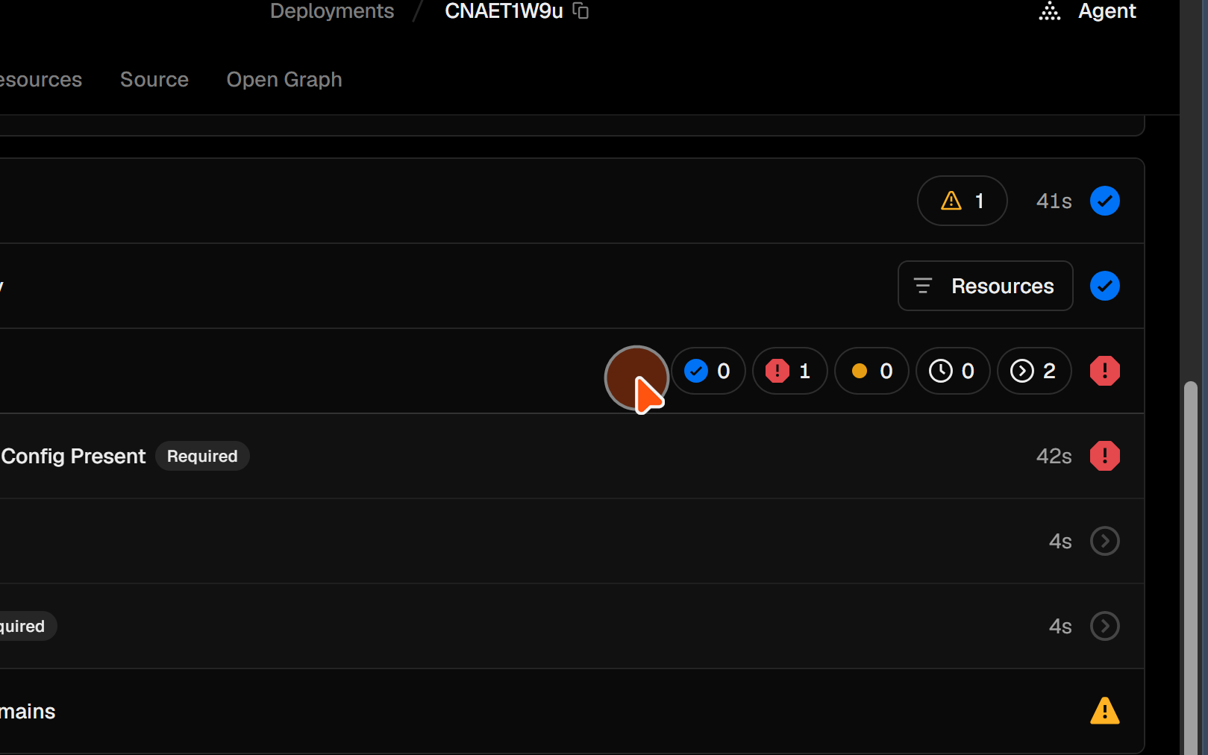
12 | Click the highlighted area.  See the orange cursor for details.
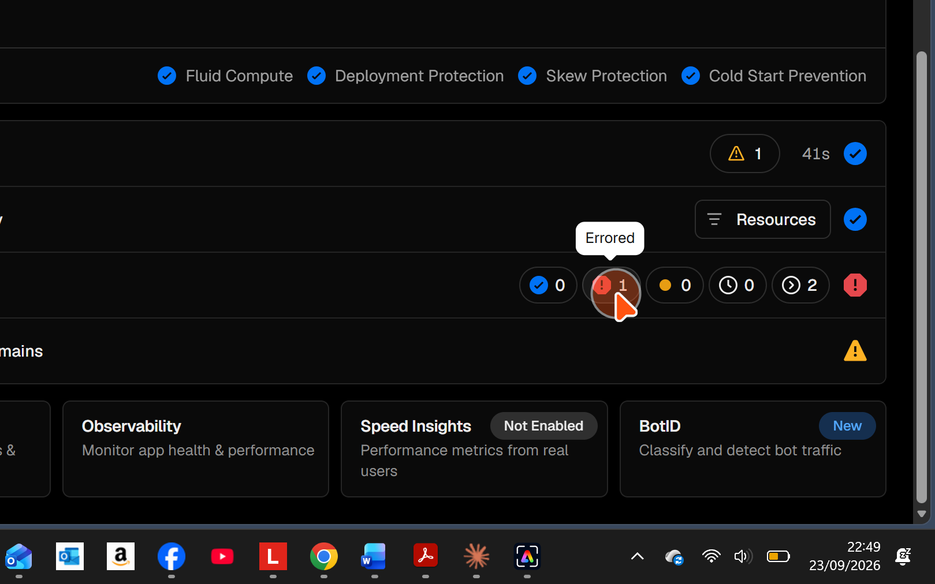
13 | Click the highlighted area.  See the orange cursor for details.
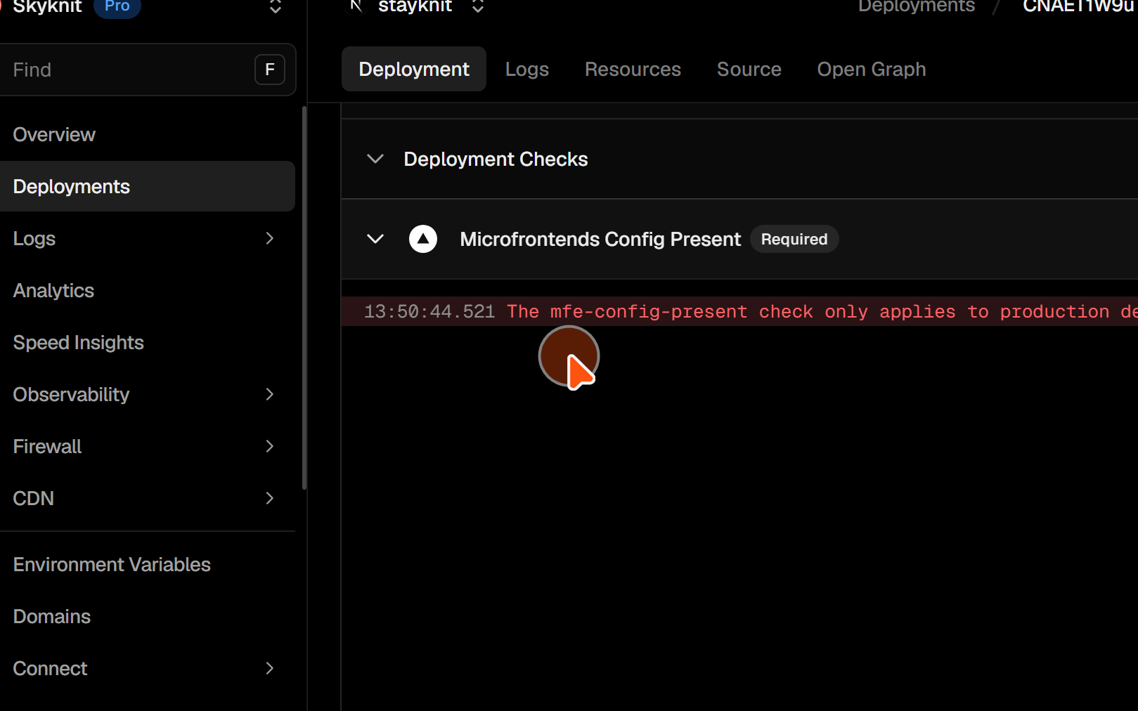
14 | Click the highlighted area.  See the orange cursor for details.
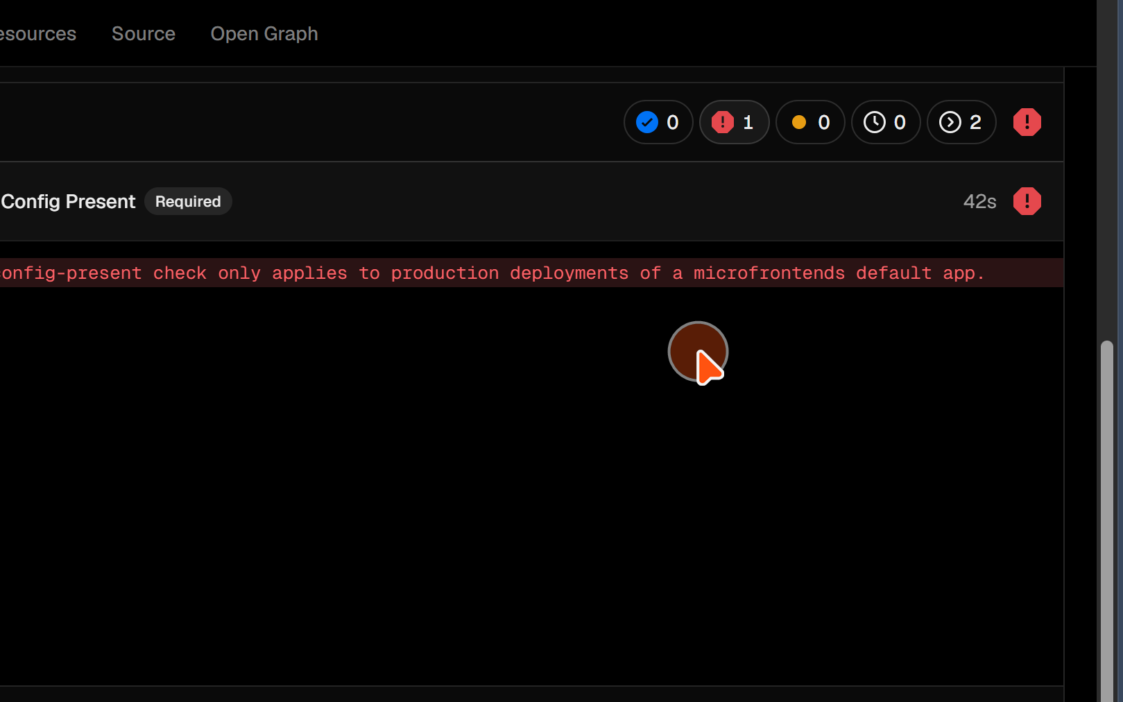
15 | Click the highlighted area.  See the orange cursor for details.
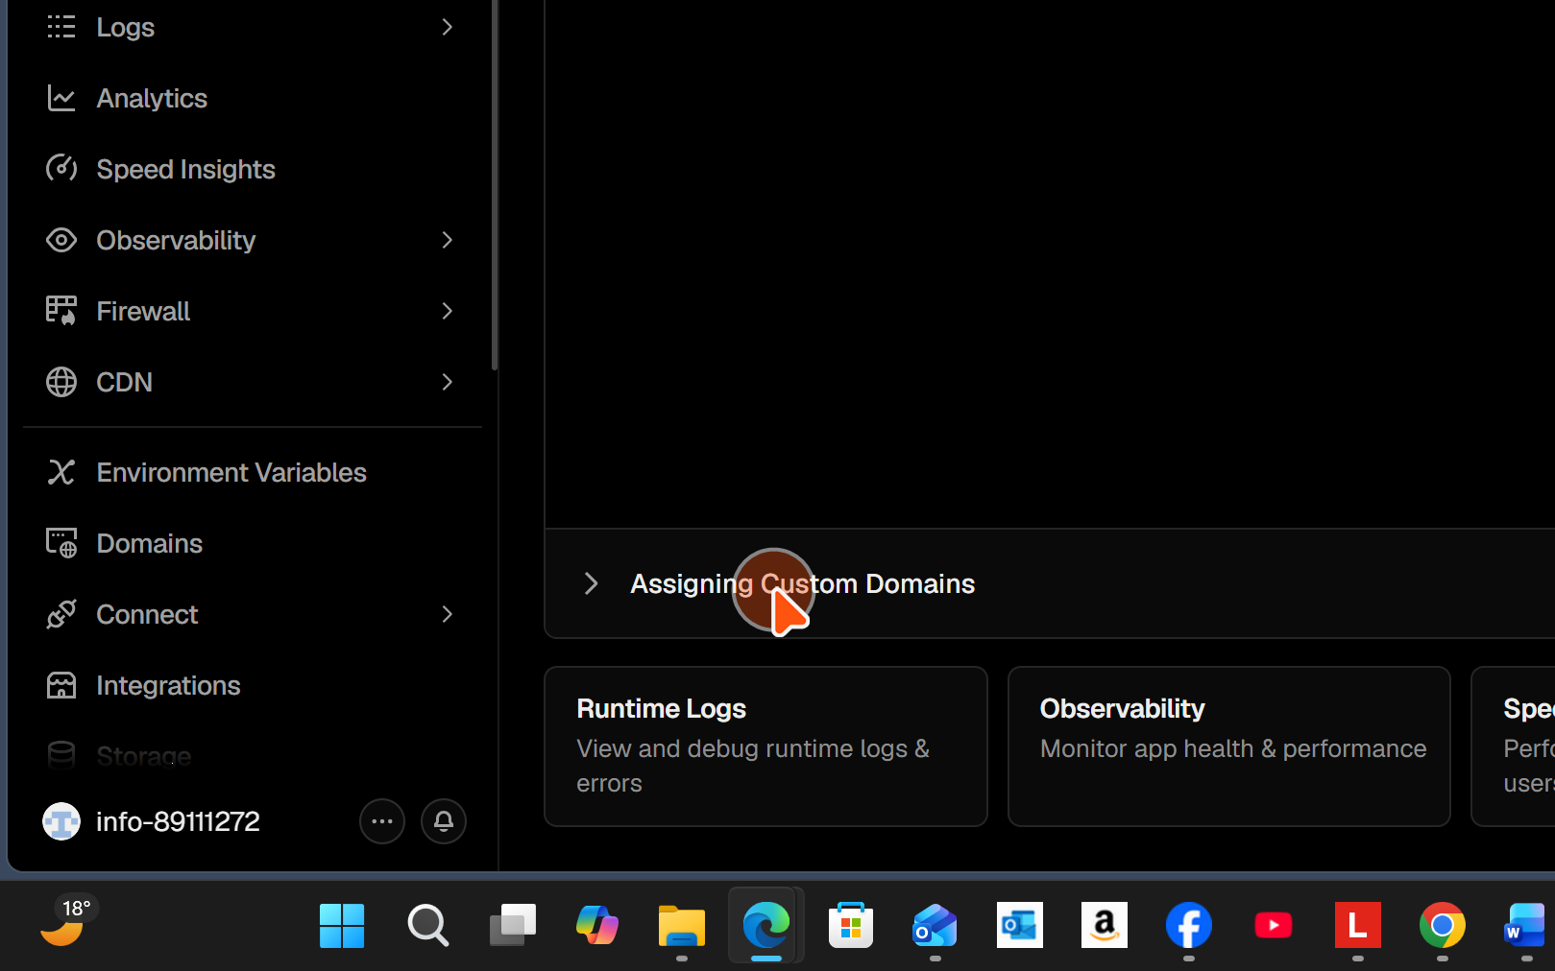
16 | Click the highlighted area.  See the orange cursor for details.
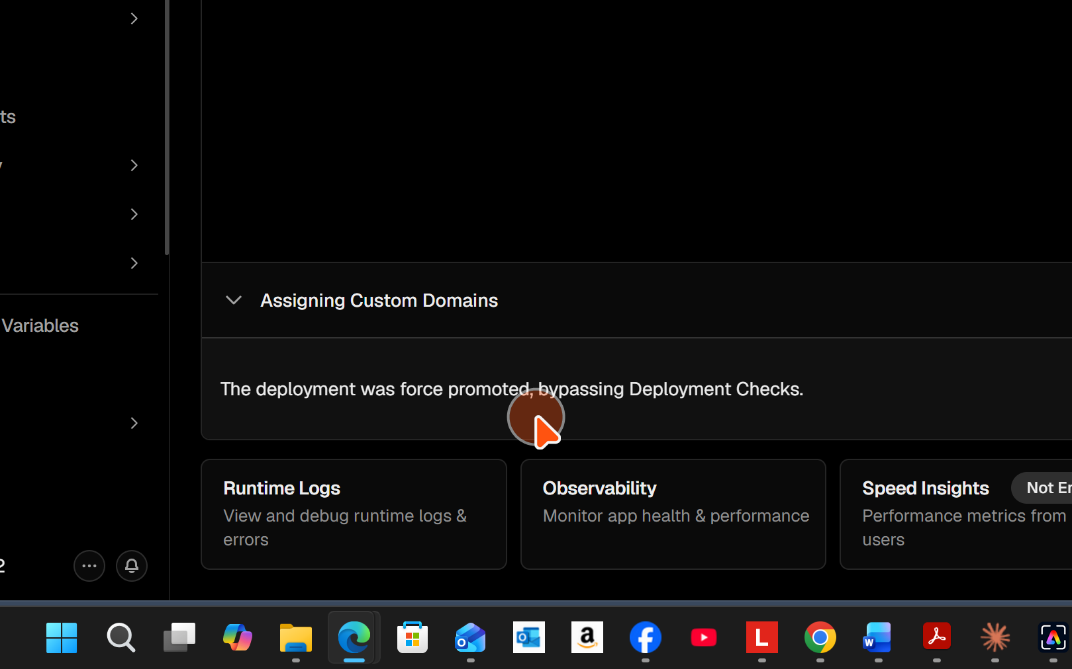
17 | Click the highlighted area.  See the orange cursor for details.
