Mirey Kellian - Tas Atilla

**Rapport Stats**

1-

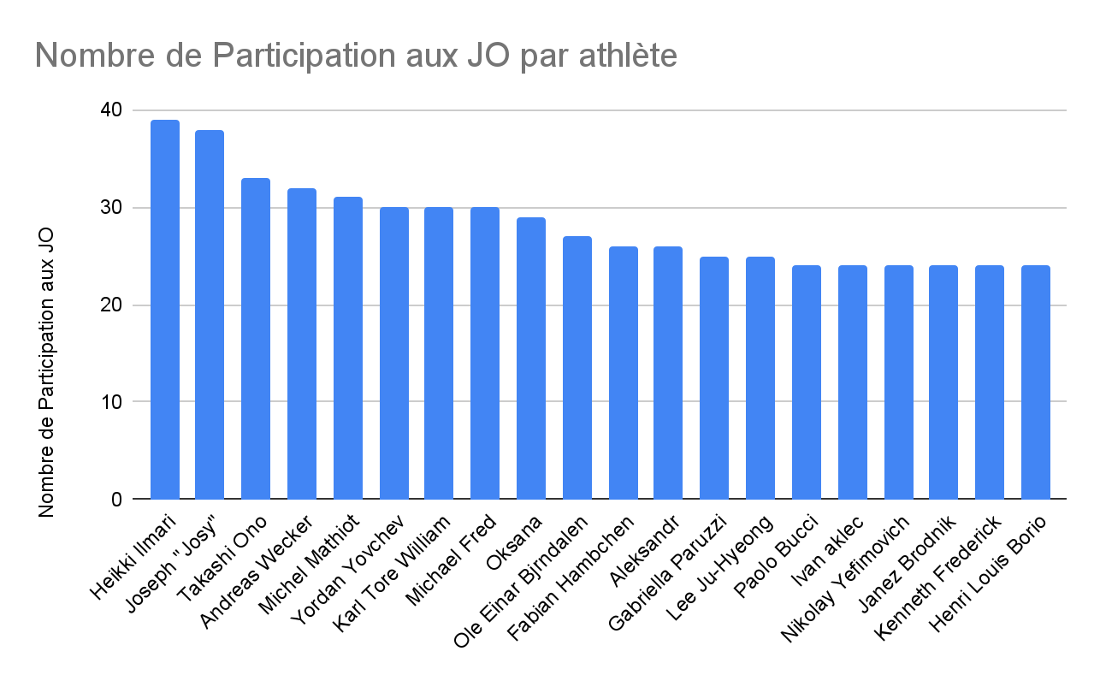

**requête** **SQL**:

###

Select a.ano, name, Count(*) as NbParticipation From athlete as a, resultat as r

Where a.ano = r.ano

Group By a.ano, name

Order By Count(*) Desc

Limit 20;

###

2-

**Édition des Jeux Olympique:**

Dans notre cas, nous avons choisi l’édition des Jeux d’été de 1968 au Mexique.

2.a-

| Pays | Moyenne d’âge | Nb sportifs | Min âge | Max âge |
| --- | --- | --- | --- | --- |
| Mexique | 24 | 5386 | 11 | 68 |

Comme indiqué dans le tableau ci-dessus, la moyenne d’âge des athlètes est de 24 ans, 5386 athlètes ont participé à cette édition, l’athlète le plus jeune avait 11 et l’athlète le plus âgé en avait 68.

2.b-

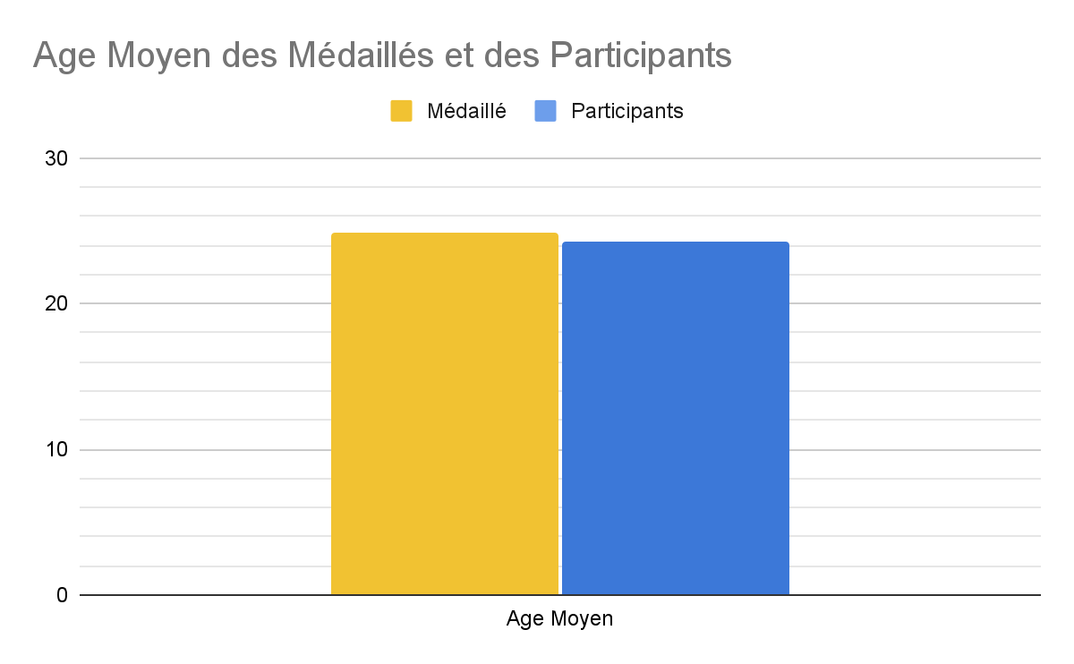

**requêtes SQL**:

###

* Select Avg(age) as AgeMoyMedaille From resultat as r, edition as e Where r.edno = e.edno And medal is not null And year = 1968 And season = 'Summer';

**retour:**

AgeMoyMedaille = 24,85

* Select Avg(age) as AgeMoyParticipant From resultat as r, edition as e Where r.edno = e.edno And year = 1968 And season = 'Summer';

**retour:**

AgeMoyParticipant = 24,23

###

Comme on peut le constater, l’âge moyen de l’ensemble des médaillés est extrêmement proche de celui des participants avec un âge moyen de 24,85 ans pour les médaillés et un âge moyen de 24,23 ans.

Avec ces moyennes, on peut en déduire qu’il y a une proportion légèrement supérieure d’athlètes ayant plus de 24 ans que dans l’ensemble de tous les participants.

2.c-

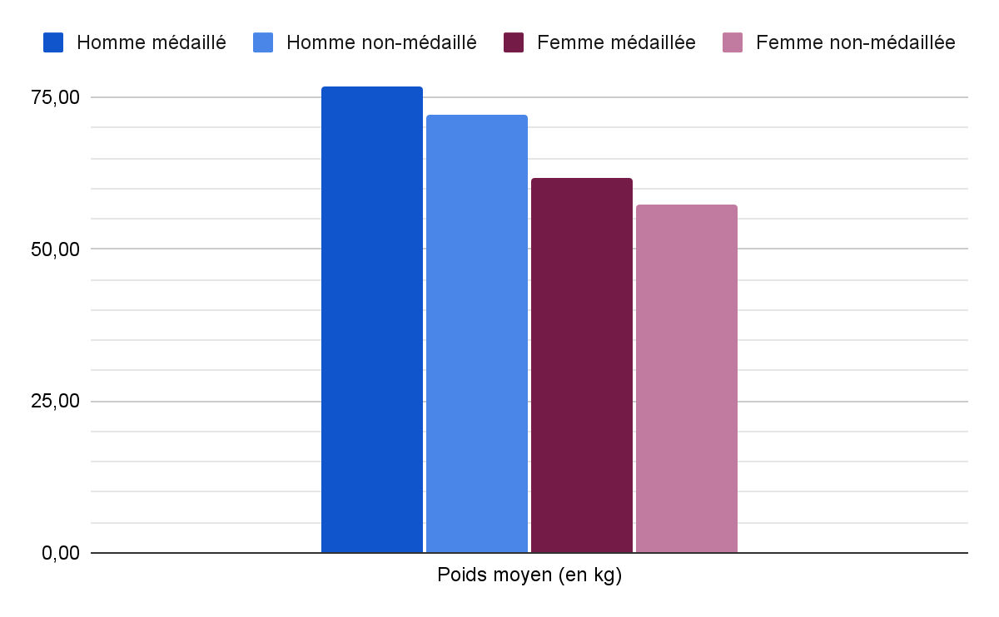

| Poids moyen médaillé Homme | Poids moyen médaillé Femme |
| --- | --- |
| 76.81 | 61.65 |
| Poids moyen participant Homme | Poids moyen participant Femme |
| 72.70 | 57.43 |

**requêtes** **SQL**:

**- Poids moyen médaillé Homme**

Select Round(avg(weight), 2) From resultat as r, athlete as a, edition as e

Where r.ano = a.ano

And r.edno = e.edno

And sex = 'M'

And medal is not null

And year = 1968

And season = 'Summer';

**-Poids moyen médaillé Femme**

Select Round(avg(weight), 2) From resultat as r, athlete as a, edition as e

Where r.ano = a.ano

And r.edno = e.edno

And sex = 'F'

And medal is not null

And year = 1968

And season = 'Summer';

**-Poids moyen participant Homme**

Select Round(avg(weight), 2) From resultat as r, athlete as a, edition as e

Where r.ano = a.ano

And r.edno = e.edno

And sex = 'M'

And year = 1968

And season = 'Summer';

**-Poids moyen participant Femme**

Select Round(avg(weight), 2) From resultat as r, athlete as a, edition as e

Where r.ano = a.ano

And r.edno = e.edno

And sex = 'F'

And year = 1968

And season = 'Summer';

On constate avec le graphique ci-dessus que le poids moyen des hommes est supérieur à celui des femmes et que dans les deux cas que le poids moyen des médaillés est supérieur à celui des participants. Cela nous mène à penser qu’il y a une corrélation entre le poids et la probabilité de remporter une médaille or cela n’est pas le cas et l’impact du poids dépend de la discipline et de la catégorie et dans notre cas, elle n’est pas prise en compte.

3- La place des femmes dans les JO

3.a-

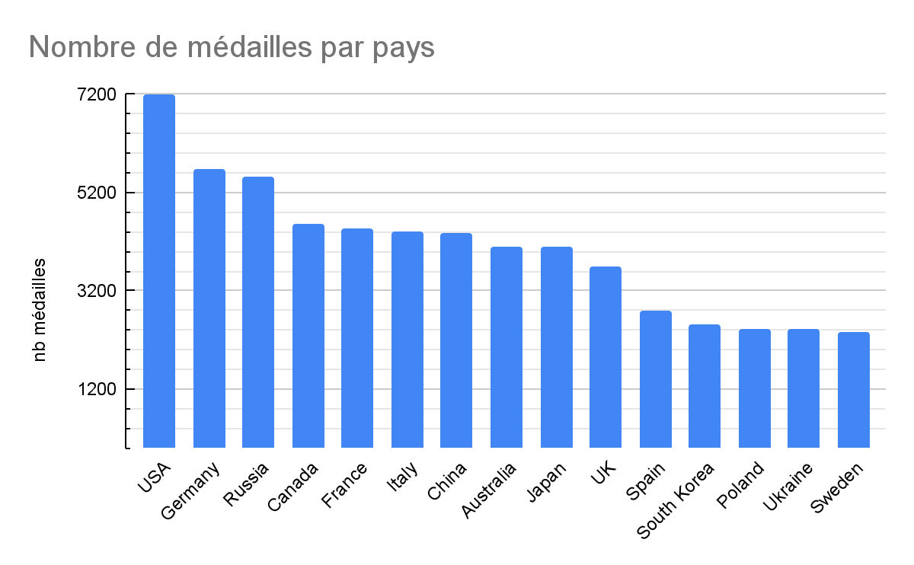

**requête SQL**:

Select region, Count(*) From resultat as r, edition as e, noc as n

Where r.edno = e.edno

And r.noc = n.noc

And year >= 1992

And year <= 2016

Group By region

Order By Count(*) Desc

Limit 15;

3.b-

**Pays choisis parmis les 15 ci-dessus:**

**France, Italy, Canada, Sweden, South Korea;**

**France**

1. Évolution du nombre de participants

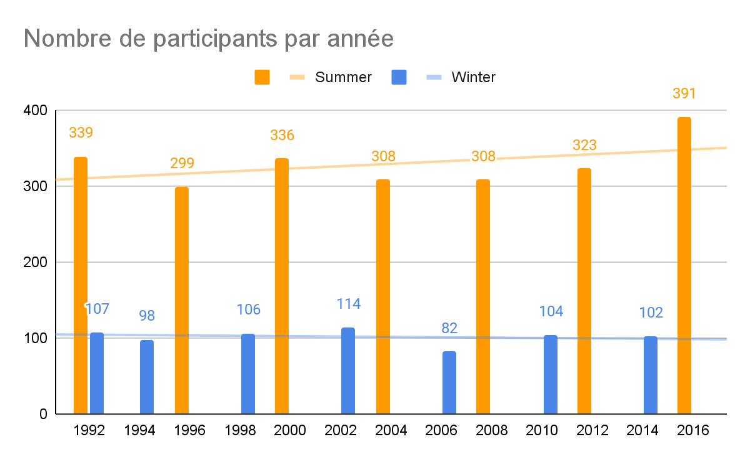

**requête SQL:**

###

Select season, year, Count(Distinct ano) as nb_participants From resultat as r, noc as n, edition as e Where r.noc = n.noc And r.edno = e.edno And region = 'France' Group by season, year;

###

**Observation:**

Sur la période étudiée, on voit que le nombre de participants augmente à chaque Jeux d’été malgré une baisse en 1996 et 2004. Tandis qu’il reste constant chaque année pour les Jeux d’hiver.

1. Évolution du nombre de médaillés

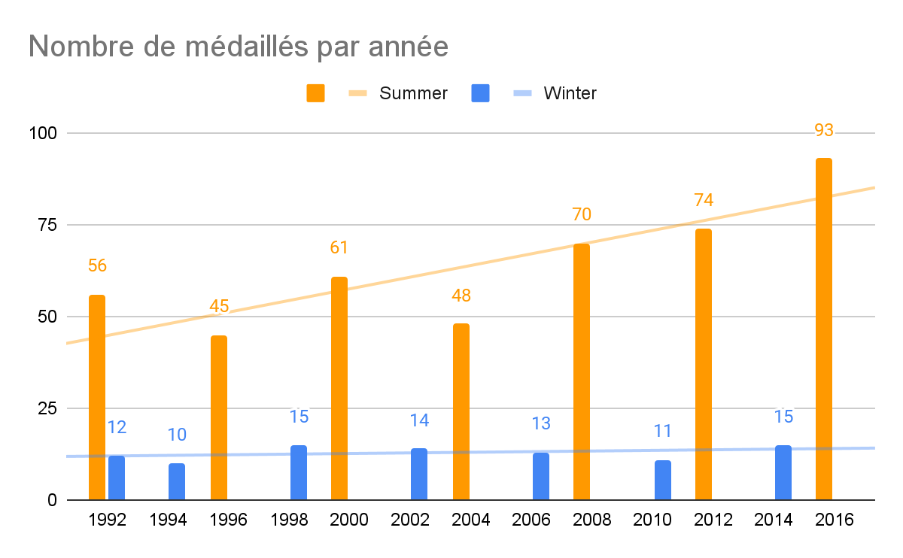

**requête SQL:**

###

Select season, year, Count(Distinct ano) as nb_medailles From resultat as r, noc as n, edition as e Where r.noc = n.noc And r.edno = e.edno And region = 'France' And medal is not null Group by season, year;

###

**Observation:**

Sur la période étudiée, on voit que le nombre de médaillés augmente à chaque Jeux d’été malgré une baisse en 1996 et 2004. Tandis qu’il reste constant chaque année pour les Jeux d’hiver. Si on compare ce graphique au précédent on pourrait penser que des athlètes ayant de grande chance de gagner des médailles n’est pas participé durant les Jeux d’été de 1996 et 2004.

1. Évolution du nombre de femmes participantes

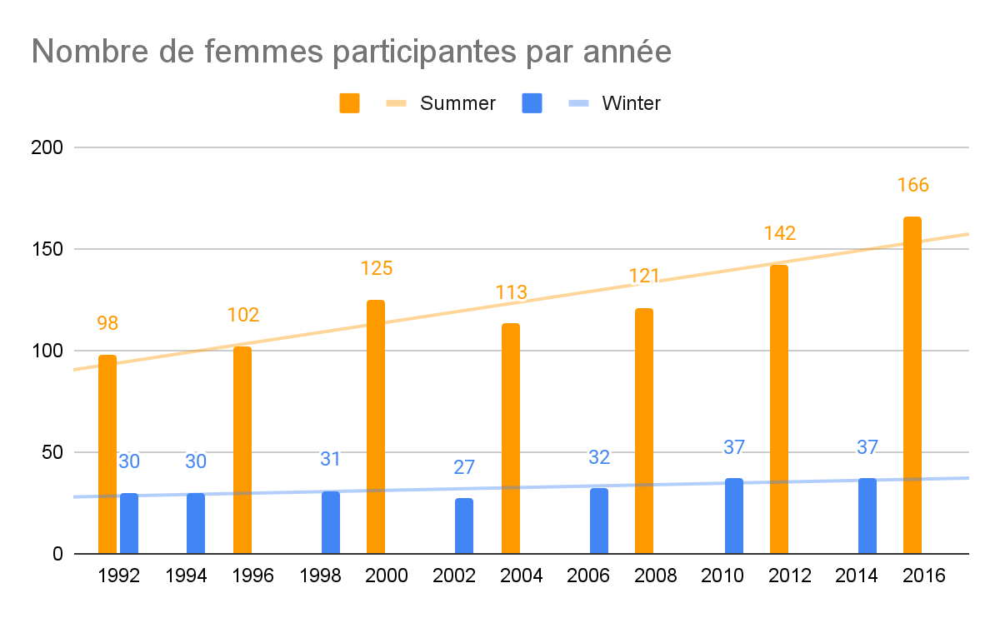

**requête SQL:**

###

Select season, year, Count(Distinct r.ano) as nb_femmes From resultat as r, noc as n, edition as e, athlete as a Where r.ano = a.ano And r.noc = n.noc And r.edno = e.edno And region = 'France' And sex = 'F' Group by season, year;

###

**Observation:**

Depuis 1992, le nombre de femmes augmente fortement à chaque édition des Jeux d’été et légèrement à chaque édition des Jeux d’hiver.

1. Évolution de la proportion de femmes participantes

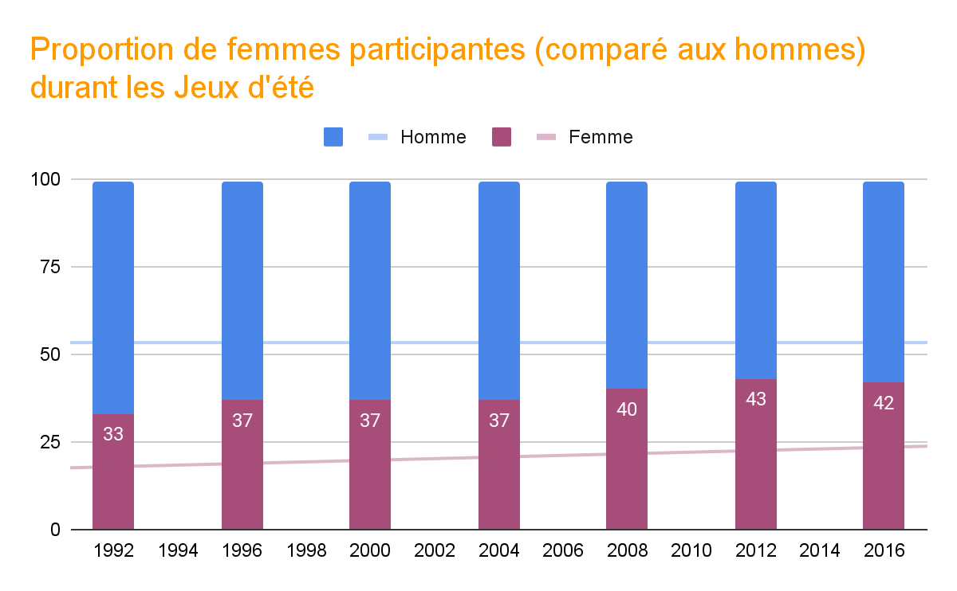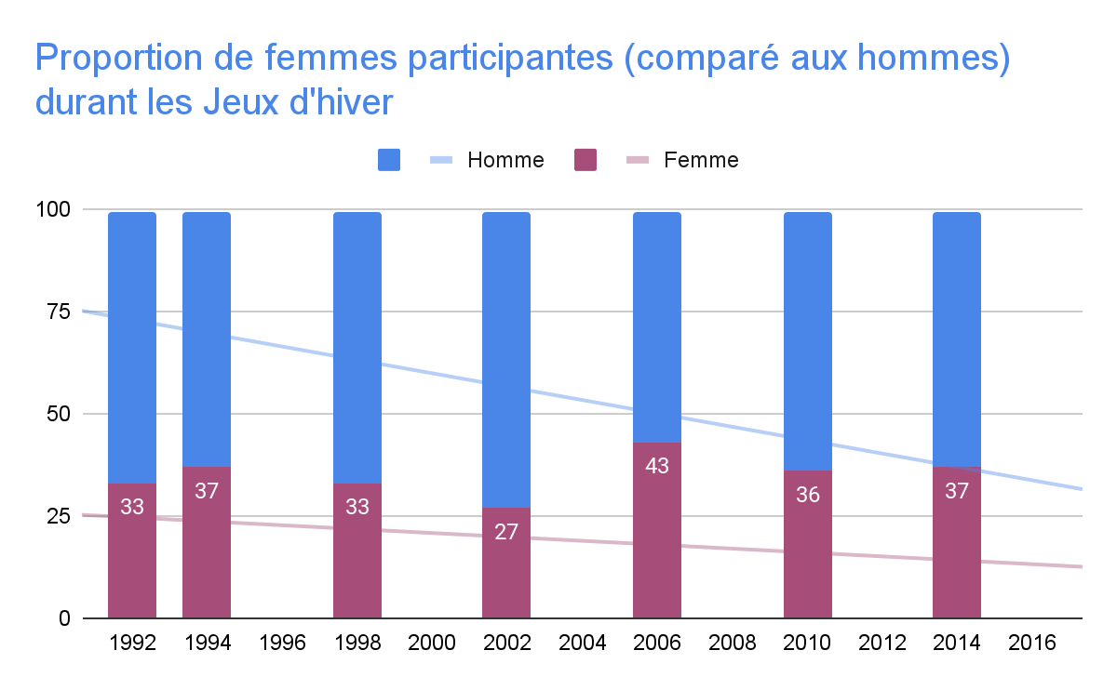

**requête SQL:**

###

Select * From

(Select season, year, (Count(*)*100)/(Select Count(*) From resultat as r2, noc as n2, edition as e2, athlete as a2 Where r2.ano = a2.ano And r2.noc = n2.noc And r2.edno = e2.edno And region = 'France' And e1.year = e2.year And e1.season = e2.season Group by season, year) as percent_femme From resultat as r1, noc as n1, edition as e1, athlete as a1 Where r1.ano = a1.ano And r1.noc = n1.noc And r1.edno = e1.edno And region = 'France' And sex = 'F' Group by season, year)as t1 Left Join (Select season, year, (Count(*)*100)/(Select Count(*) From resultat as r2, noc as n2, edition as e2, athlete as a2 Where r2.ano = a2.ano And r2.noc = n2.noc And r2.edno = e2.edno And region = 'France' And e1.year = e2.year And e1.season = e2.season Group by season, year) as percent_homme From resultat as r1, noc as n1, edition as e1, athlete as a1 Where r1.ano = a1.ano And r1.noc = n1.noc And r1.edno = e1.edno And region = 'France' And sex = 'M'

Group by season, year)as t2 Using(season,year);

###

**Observation:**

Sur cette période, la proportion de femmes participantes augmente chaque édition des Jeux d’été avec une augmentation de 10% entre 1992 et 2016.

Tandis que pour les Jeux d’hiver l’évolution n’est pas régulière avec une augmentation pour certaine édition mais avec une diminution l’édition suivante.

1. Évolution de la proportion de médaillées parmis les femmes

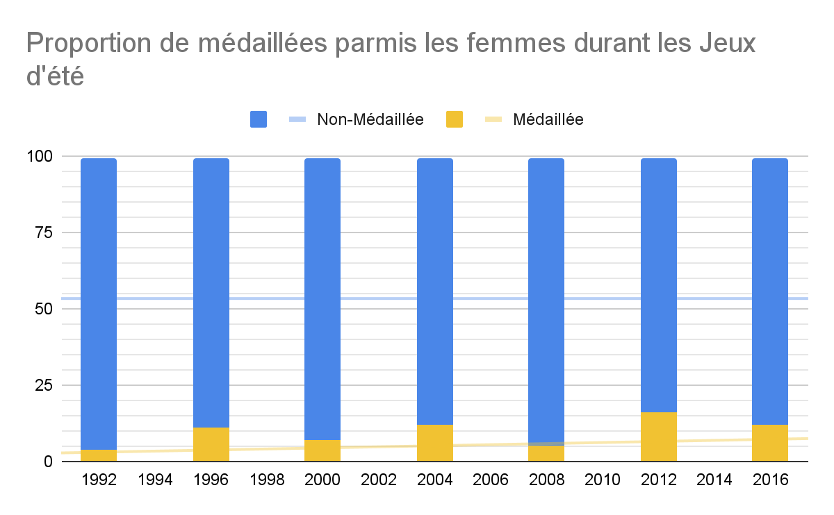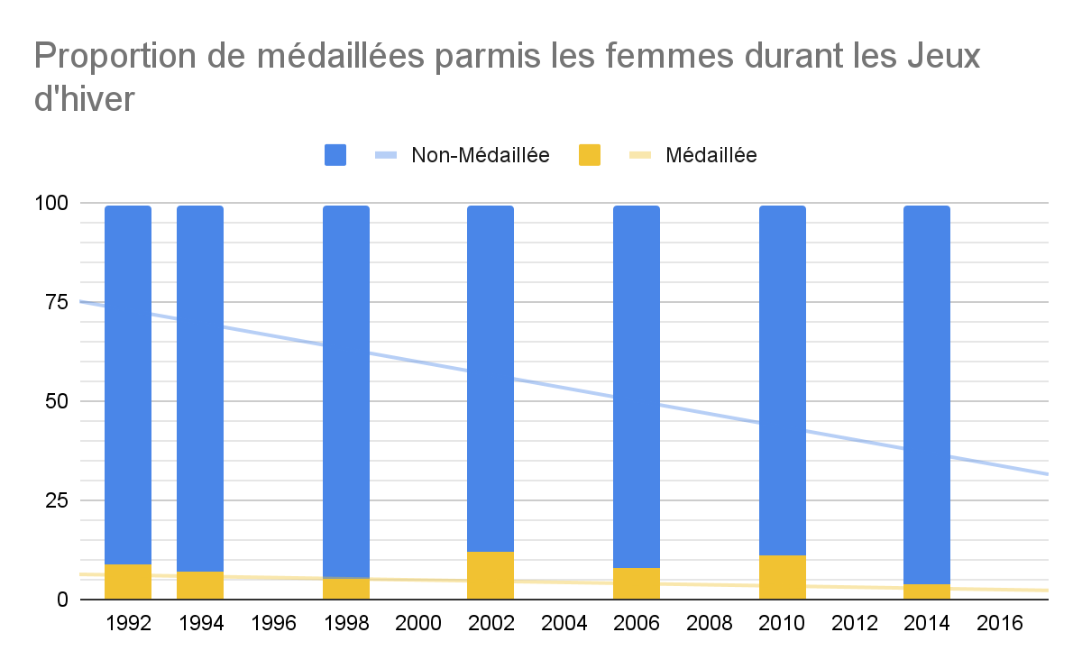

**requête SQL:**

###

Select * From

(Select season, year, (Count(*)*100)/(Select Count(*) From resultat as r2, noc as n2, edition as e2, athlete as a2 Where r2.ano = a2.ano And r2.noc = n2.noc And r2.edno = e2.edno And region = 'France' And e1.year = e2.year And e1.season = e2.season And sex = 'F' Group by season, year) as percent_femme_medaillee From resultat as r1, noc as n1, edition as e1, athlete as a1 Where r1.ano = a1.ano And r1.noc = n1.noc And r1.edno = e1.edno And region = 'France' And sex = 'F' And medal is not null Group by season, year)

as t1c Left Join(Select season, year, (Count(*)*100)/(Select Count(*) From resultat as r2, noc as n2, edition as e2, athlete as a2 Where r2.ano = a2.ano And r2.noc = n2.noc And r2.edno = e2.edno And region = 'France' And e1.year = e2.year And e1.season = e2.season And sex = 'F' Group by season, year) as percent_femme_non_medaillee

From resultat as r1, noc as n1, edition as e1, athlete as a1 Where r1.ano = a1.ano And r1.noc = n1.noc And r1.edno = e1.edno And region = 'France' And sex = 'F' And medal is null Group by season, year) as t2 Using(season,year);

###

**Observation:**

Durant cette période, le nombre de médaillées parmi les femmes a globalement légèrement augmenté durant les Jeux d’été. Tandis que durant les Jeux d’hiver, une augmentation a eu lieu de 2002 à 2010 suivie d’une baisse en 2014.

1. Évolution de la proportion de femmes parmis les médaillés

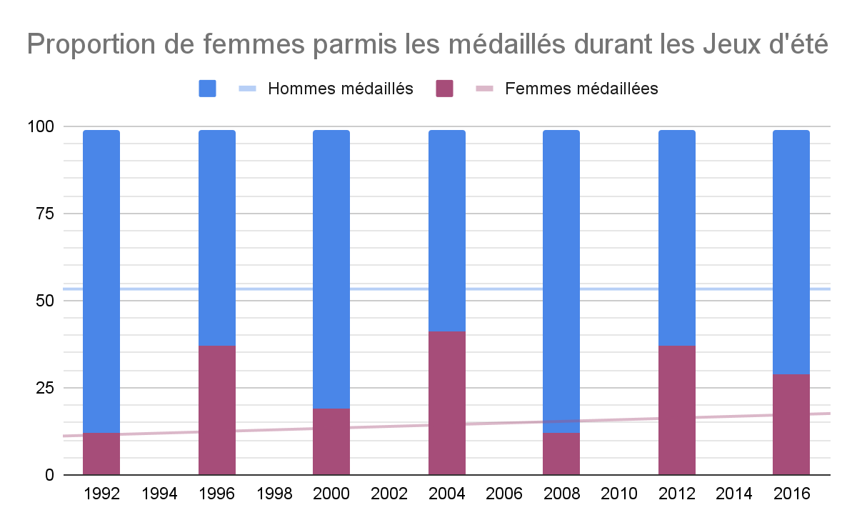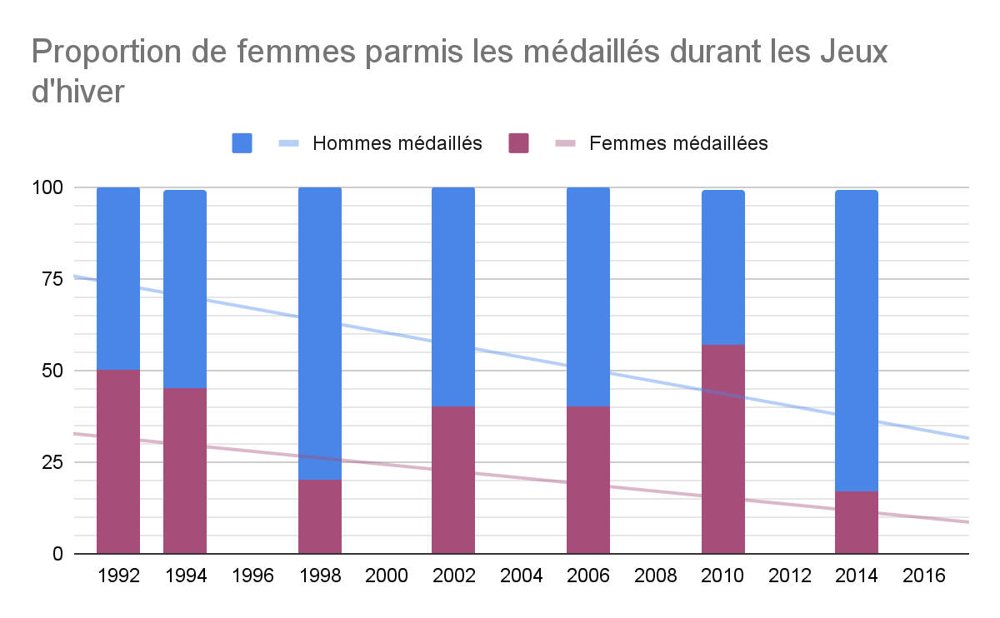

**requête SQL:**

###

Select * From

(Select season, year, (Count(*)*100)/(Select Count(*) From resultat as r2, noc as n2, edition as e2, athlete as a2 Where r2.ano = a2.ano And r2.noc = n2.noc And r2.edno = e2.edno And region = 'France' And e1.year = e2.year And e1.season = e2.season And medal is not null Group by season, year) as percent_femme_medaillee From resultat as r1, noc as n1, edition as e1, athlete as a1 Where r1.ano = a1.ano And r1.noc = n1.noc

And r1.edno = e1.edno And region = 'France' And sex = 'F'And medal is not null Group by season, year) as t1 Left Join (Select season, year, (Count(*)*100)/(Select Count(*) From resultat as r2, noc as n2, edition as e2, athlete as a2 Where r2.ano = a2.ano And r2.noc = n2.noc And r2.edno = e2.edno And region = 'France' And e1.year = e2.year And e1.season = e2.season And medal is not null Group by season, year) as percent_homme_medaillee From resultat as r1, noc as n1, edition as e1, athlete as a1

Where r1.ano = a1.ano And r1.noc = n1.noc And r1.edno = e1.edno And region = 'France'

And sex = 'M' And medal is not null Group by season, year) as t2 Using(season,year);

###

**Observation:**

On remarque que l’évolution de la proportion des femmes parmi les médaillés suit celle de la proportion de médaillées parmi les femmes.

**Canada**

1. Évolution du nombre de participants

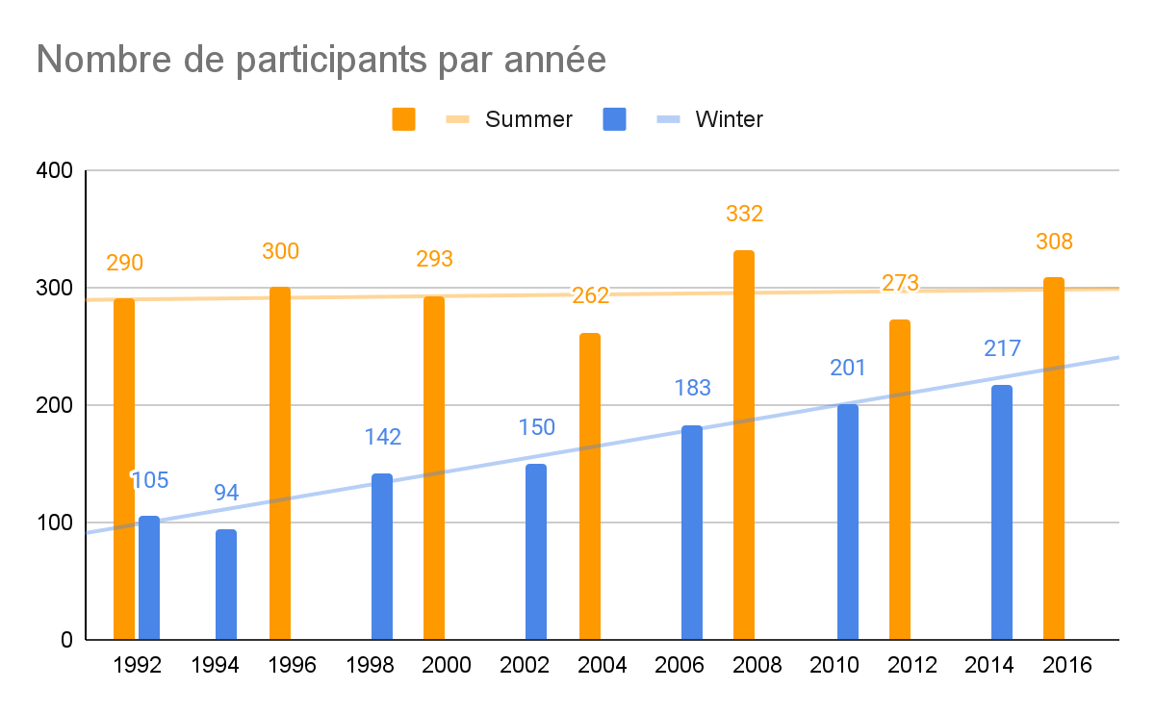

**requête SQL:**

###

Select season, year, Count(Distinct ano) as nb_participants From resultat as r, noc as n, edition as e Where r.noc = n.noc And r.edno = e.edno And region = 'Canada' Group by season, year;

###

**Observation:**

Sur cette période, le nombre de participants durant les Jeux d’été reste plutôt constant. Tandis que durant les Jeux d’hiver, le nombre de participants est en constante augmentation depuis 1994.

1. Évolution du nombre de médaillés

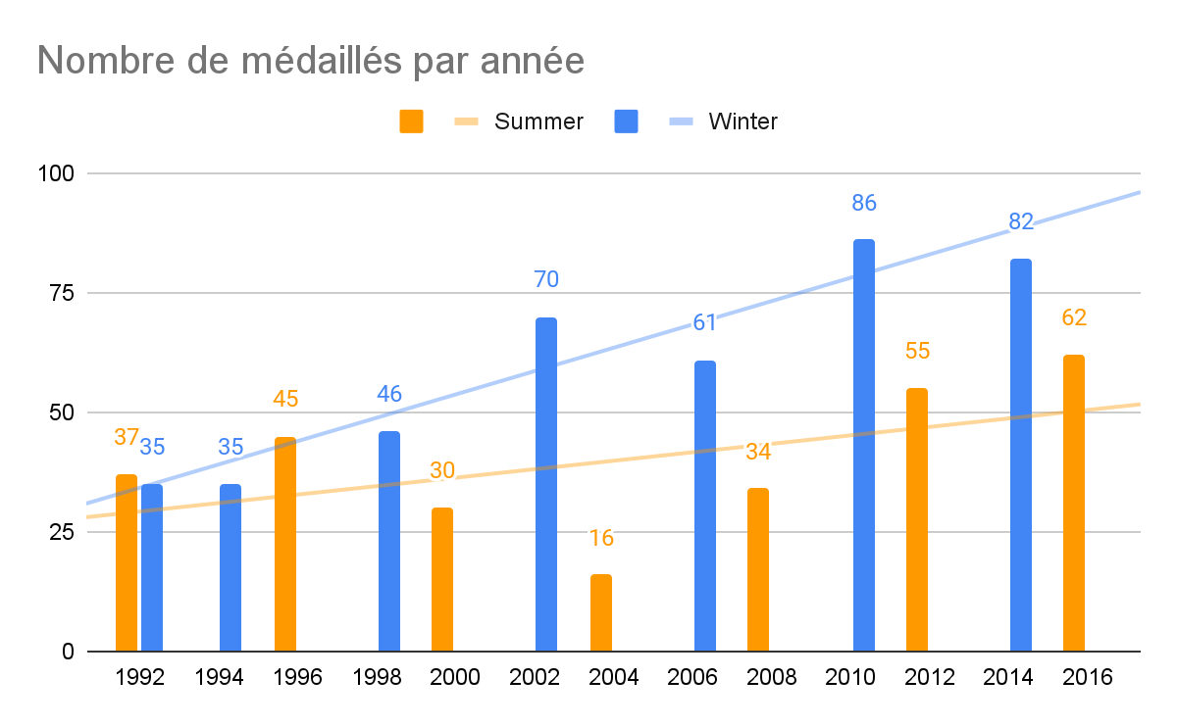

**requête SQL:**

###

Select season, year, Count(Distinct ano) as nb_medailles From resultat as r, noc as n, edition as e Where r.noc = n.noc And r.edno = e.edno And region = 'Canada' And medal is not null Group by season, year;

###

**Observation:**

Pour les Jeux d’été, le nombre de médailles a augmenté jusqu’à 1996 puis a subi une baisse en 2000 et 2004 en atteignant les 16 médailles pour finalement augmenter jusqu’en 2016 à hauteur de 62 médailles.

Pour les Jeux d’hiver cependant on pourrait penser que le nombre de médailles évolue avec le nombre de participants car il augmente depuis 1992.

1. Évolution du nombre de femmes participantes

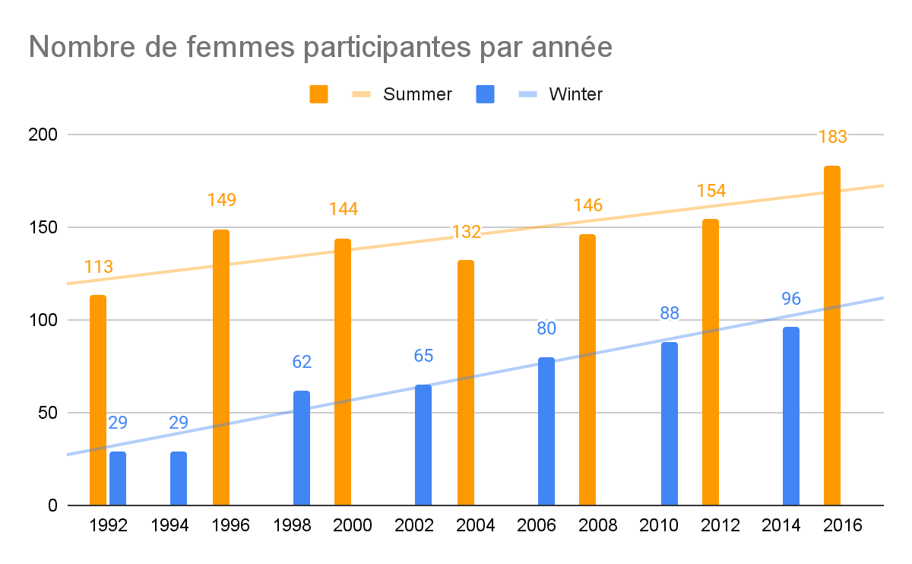

**requête SQL:**

###

Select season, year, Count(Distinct r.ano) as nb_femmes From resultat as r, noc as n, edition as e, athlete as a Where r.ano = a.ano And r.noc = n.noc And r.edno = e.edno And region = 'Canada' And sex = 'F' Group by season, year;

###

**Observation:**

Le nombre de femmes participantes augmente fortement depuis 1992 pour les Jeux d’été et d’hiver.

1. Évolution de la proportion de femmes participantes

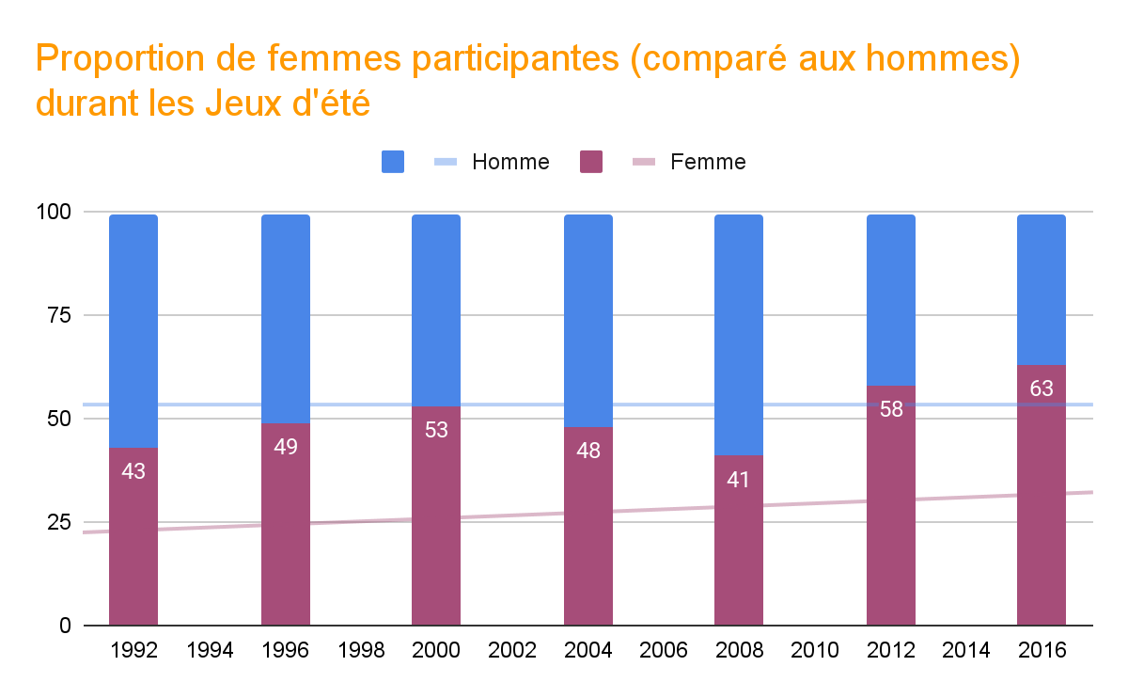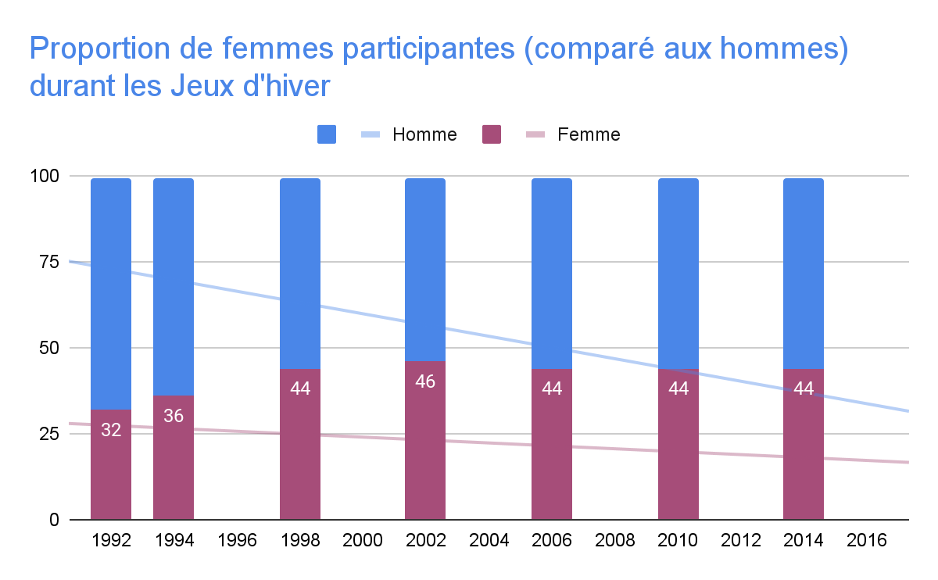

**requête SQL:**

###

Select * From

(Select season, year, (Count(*)*100)/(Select Count(*) From resultat as r2, noc as n2, edition as e2, athlete as a2 Where r2.ano = a2.ano And r2.noc = n2.noc And r2.edno = e2.edno And region = 'Canada' And e1.year = e2.year And e1.season = e2.season Group by season, year) as percent_femme From resultat as r1, noc as n1, edition as e1, athlete as a1 Where r1.ano = a1.ano And r1.noc = n1.noc And r1.edno = e1.edno And region = 'Canada' And sex = 'F' Group by season, year)as t1 Left Join (Select season, year, (Count(*)*100)/(Select Count(*) From resultat as r2, noc as n2, edition as e2, athlete as a2 Where r2.ano = a2.ano And r2.noc = n2.noc And r2.edno = e2.edno And region = 'Canada' And e1.year = e2.year And e1.season = e2.season Group by season, year) as percent_homme From resultat as r1, noc as n1, edition as e1, athlete as a1 Where r1.ano = a1.ano And r1.noc = n1.noc And r1.edno = e1.edno And region = 'Canada' And sex = 'M'

Group by season, year)as t2 Using(season,year);

###

**Observation:**

Sur cette période, la proportion de femmes participantes augmente chaque édition des Jeux d’été malgré une baisse de 2004 à 2008.

Tandis que pour les Jeux d’hiver, la proportion de femmes à augmenté jusqu’en 2002 puis est restée constante. Ce qui signifie que le nombre d’hommes participants suit la même évolution que celui de femmes participantes.

1. Évolution de la proportion de médaillées parmis les femmes

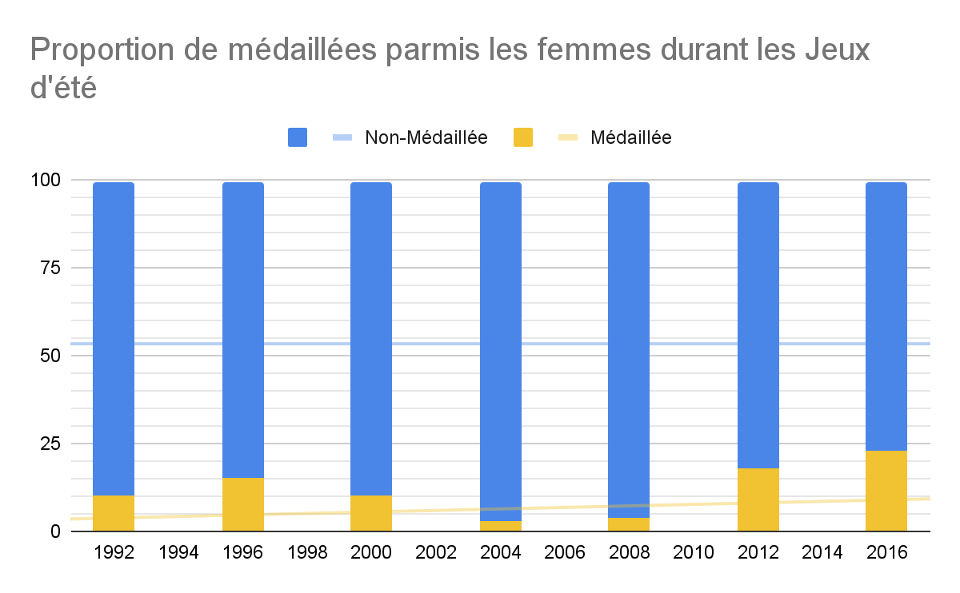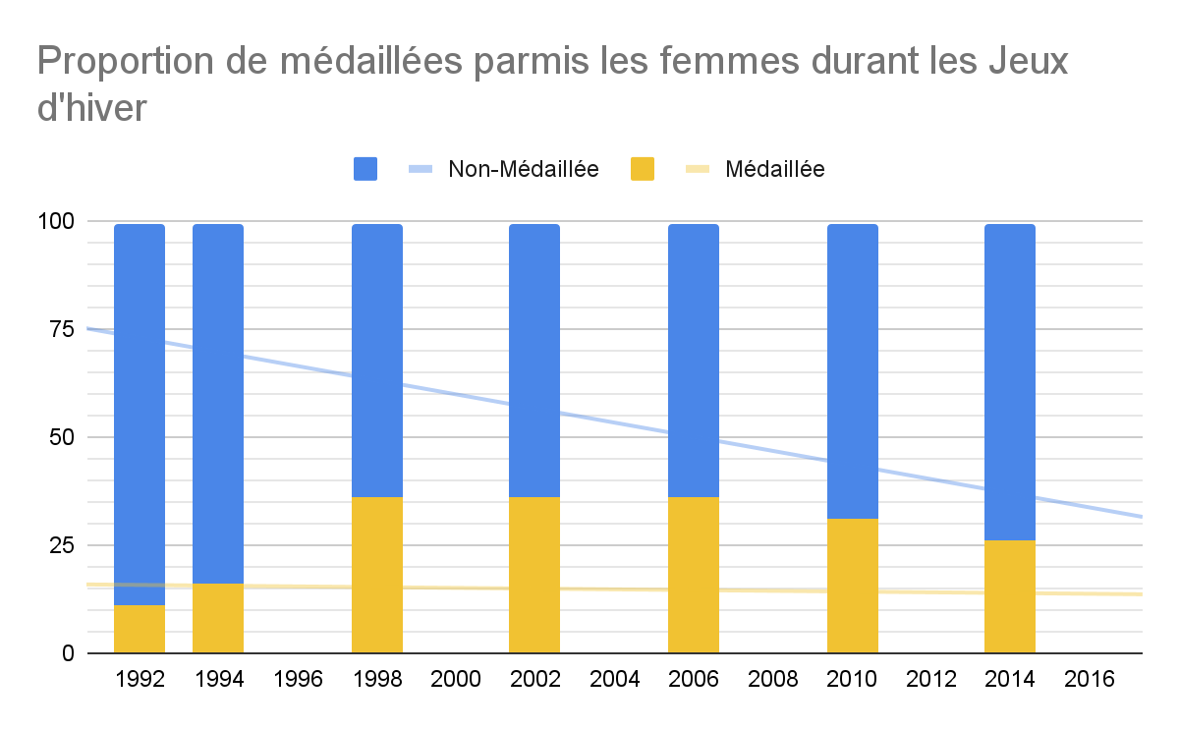

**requête SQL:**

###

Select * From

(Select season, year, (Count(*)*100)/(Select Count(*) From resultat as r2, noc as n2, edition as e2, athlete as a2 Where r2.ano = a2.ano And r2.noc = n2.noc And r2.edno = e2.edno And region = 'Canada' And e1.year = e2.year And e1.season = e2.season And sex = 'F' Group by season, year) as percent_femme_medaillee From resultat as r1, noc as n1, edition as e1, athlete as a1 Where r1.ano = a1.ano And r1.noc = n1.noc And r1.edno = e1.edno And region = 'Canada' And sex = 'F' And medal is not null Group by season, year)

as t1c Left Join(Select season, year, (Count(*)*100)/(Select Count(*) From resultat as r2, noc as n2, edition as e2, athlete as a2 Where r2.ano = a2.ano And r2.noc = n2.noc And r2.edno = e2.edno And region = 'Canada' And e1.year = e2.year And e1.season = e2.season And sex = 'F' Group by season, year) as percent_femme_non_medaillee

From resultat as r1, noc as n1, edition as e1, athlete as a1 Where r1.ano = a1.ano And r1.noc = n1.noc And r1.edno = e1.edno And region = 'Canada' And sex = 'F' And medal is null Group by season, year) as t2 Using(season,year);

###

**Observation:**

La proportion de médaillées parmis les femmes augmente durant les Jeux d’été

malgré une forte baisse de 2000 à 2008.

Tandis que durant les Jeux d’hiver, la proportion de médaillées parmis les femmes

a fortement augmenté en 1998 puis est resté constante jusqu’à 2006 pour légèrement baissé jusqu’en 2014.

1. Évolution de la proportion de femmes parmis les médaillés

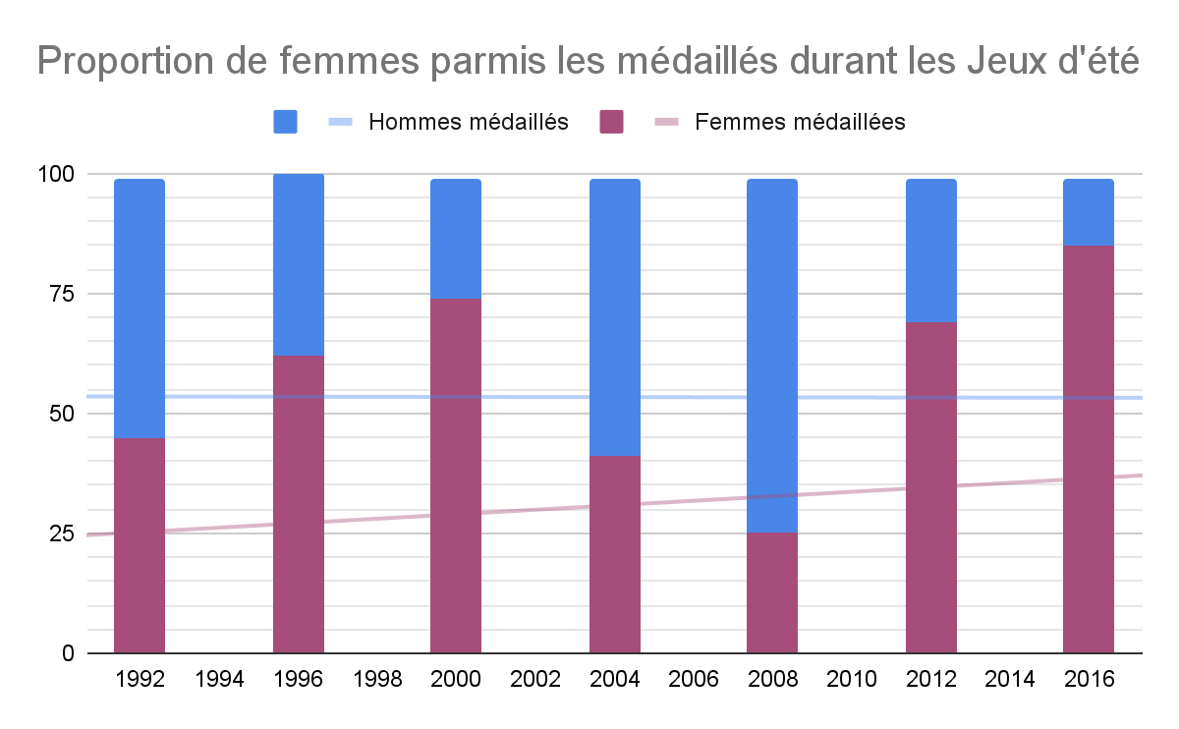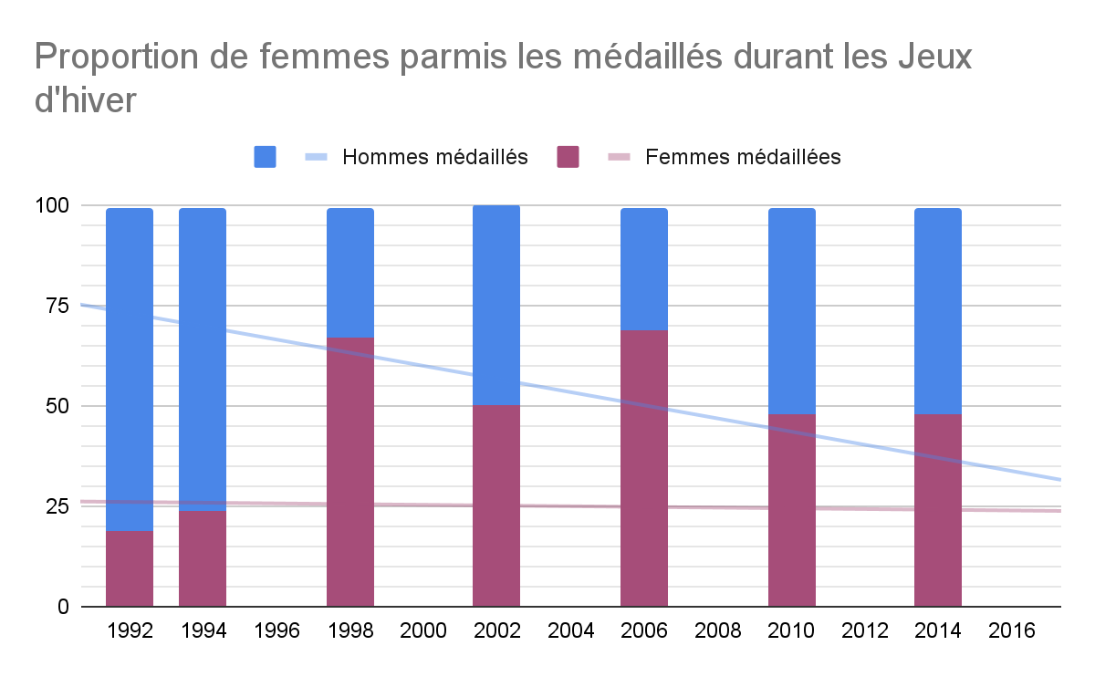

**requête SQL:**

###

Select * From

(Select season, year, (Count(*)*100)/(Select Count(*) From resultat as r2, noc as n2, edition as e2, athlete as a2 Where r2.ano = a2.ano And r2.noc = n2.noc And r2.edno = e2.edno And region = 'Canada' And e1.year = e2.year And e1.season = e2.season And medal is not null Group by season, year) as percent_femme_medaillee From resultat as r1, noc as n1, edition as e1, athlete as a1 Where r1.ano = a1.ano And r1.noc = n1.noc

And r1.edno = e1.edno And region = 'Canada' And sex = 'F'And medal is not null Group by season, year) as t1 Left Join (Select season, year, (Count(*)*100)/(Select Count(*) From resultat as r2, noc as n2, edition as e2, athlete as a2 Where r2.ano = a2.ano And r2.noc = n2.noc And r2.edno = e2.edno And region = 'Canada' And e1.year = e2.year And e1.season = e2.season And medal is not null Group by season, year) as percent_homme_medaillee From resultat as r1, noc as n1, edition as e1, athlete as a1

Where r1.ano = a1.ano And r1.noc = n1.noc And r1.edno = e1.edno And region = 'Canada'

And sex = 'M' And medal is not null Group by season, year) as t2 Using(season,year);

###

**Observation:**

On remarque que l’évolution de la proportion des femmes parmi les médaillés suit celle de la proportion de médaillées parmi les femmes.

**Italy**

I. Évolution du nombre de participants

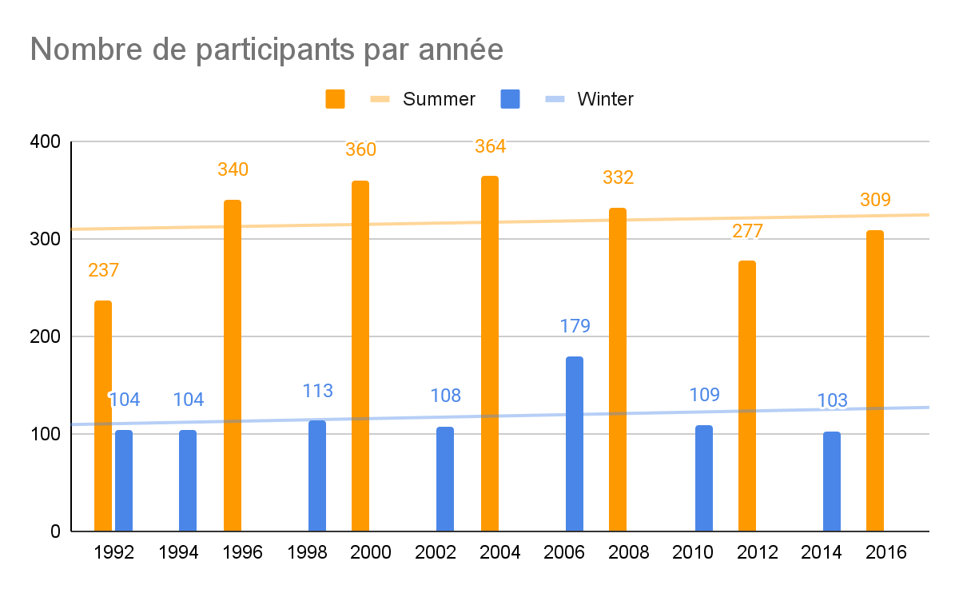

**requête SQL:**

###

Select season, year, Count(Distinct ano) as nb_participants From resultat as r, noc as n, edition as e Where r.noc = n.noc And r.edno = e.edno And region = 'Italy' Group by season, year;

###

**Observation:**

Pour les Jeux d’été, le nombre de participants augmente depuis 1992 malgré une baisse en 2012.

Pour les Jeux d’hiver, le nombre de participants reste plutôt constant avec tout de même une forte augmentation en 2006.

II. Évolution du nombre de médaillés

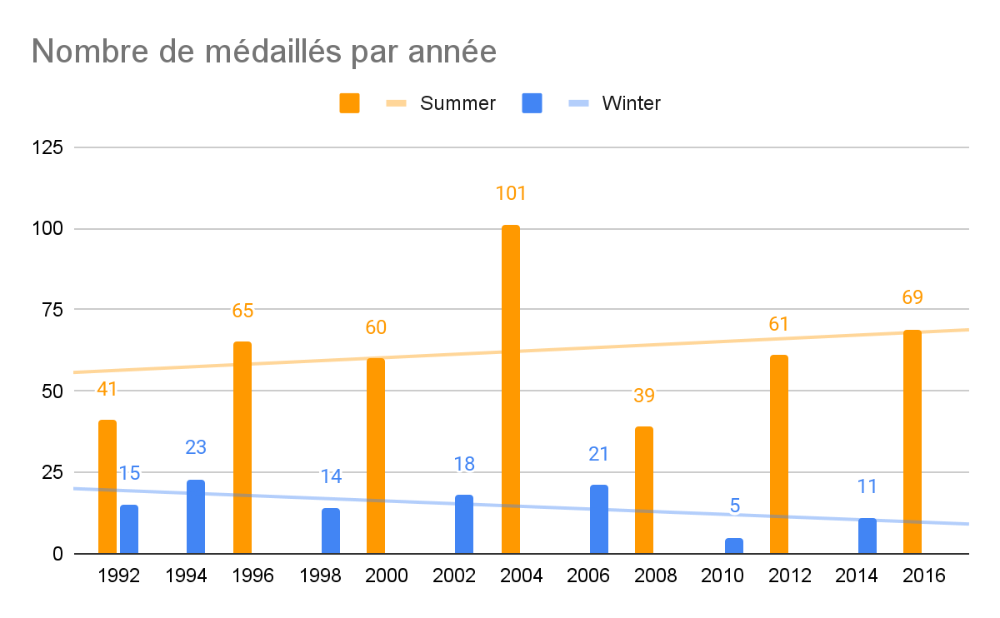

**requête SQL:**

###

Select season, year, Count(Distinct ano) as nb_medailles From resultat as r, noc as n, edition as e Where r.noc = n.noc And r.edno = e.edno And region = 'Italy' And medal is not null Group by season, year;

###

**Observation:**

Pour les Jeux d’été, on constate une augmentation globale perturbé par un pic de 101 médaillés en 2004 et une très forte baisse l’édition suivante.

Tandis que pour les Jeux d’hiver, le nombre de médaillés évolue par palier avec deux baisses, en 1998 et 2010, suivies chacune par une augmentation du nombre de médaillés

III. Évolution du nombre de femmes participantes

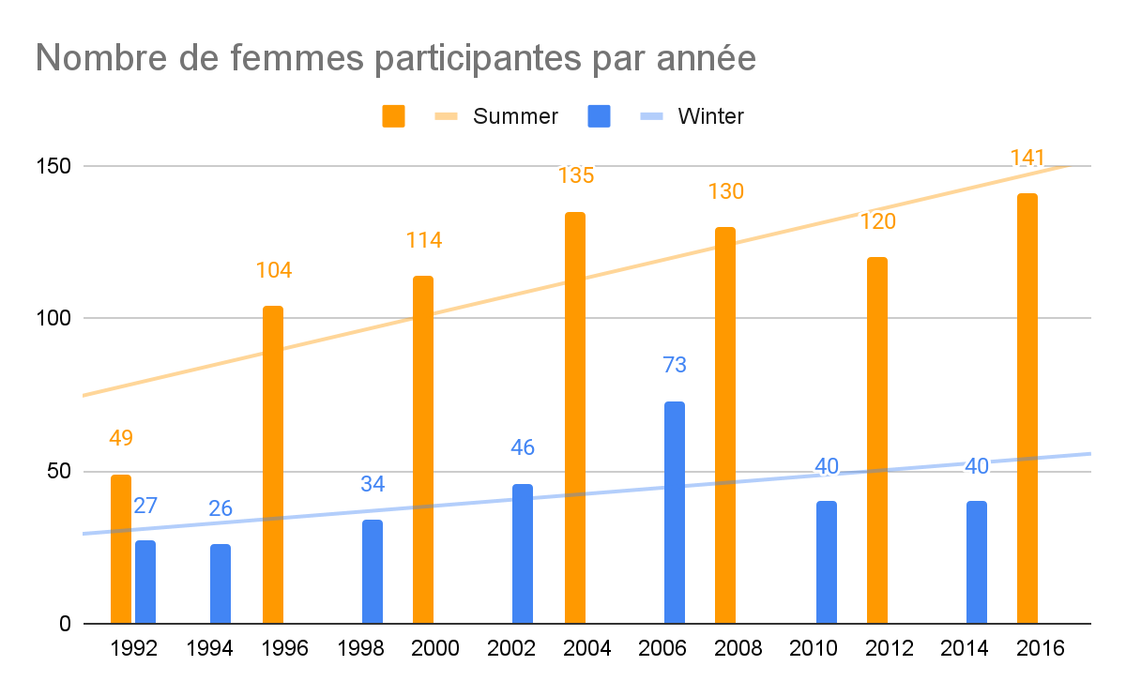

**requête SQL:**

###

Select season, year, Count(Distinct r.ano) as nb_femmes From resultat as r, noc as n, edition as e, athlete as a Where r.ano = a.ano And r.noc = n.noc And r.edno = e.edno And region = 'Italy' And sex = 'F' Group by season, year;

###

**Observation:**

Pour les Jeux d’été, le nombre de femmes participantes augmente depuis 1992.

Ce nombre à suivi la même évolution, pour les Jeux d’hiver jusqu’en 2006, puis à

subi une baisse en 2010.

IV. Évolution de la proportion de femmes participantes

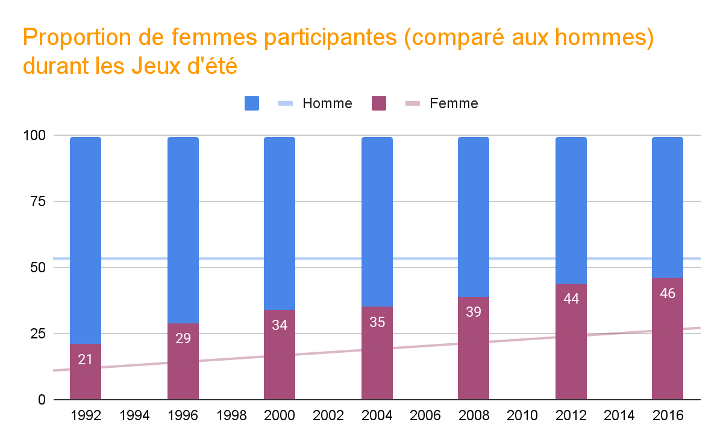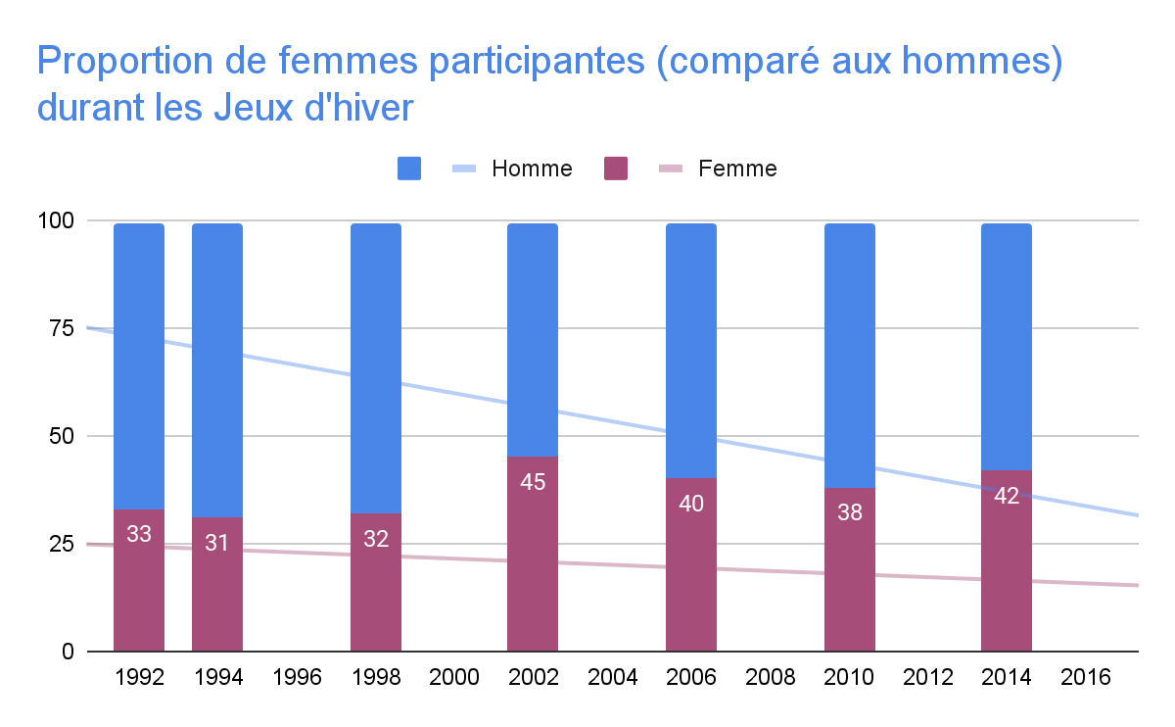

**requête SQL:**

###

Select * From

(Select season, year, (Count(*)*100)/(Select Count(*) From resultat as r2, noc as n2, edition as e2, athlete as a2 Where r2.ano = a2.ano And r2.noc = n2.noc And r2.edno = e2.edno And region = 'Italy' And e1.year = e2.year And e1.season = e2.season Group by season, year) as percent_femme From resultat as r1, noc as n1, edition as e1, athlete as a1 Where r1.ano = a1.ano And r1.noc = n1.noc And r1.edno = e1.edno And region = 'Italy' And sex = 'F' Group by season, year)as t1 Left Join (Select season, year, (Count(*)*100)/(Select Count(*) From resultat as r2, noc as n2, edition as e2, athlete as a2 Where r2.ano = a2.ano And r2.noc = n2.noc And r2.edno = e2.edno And region = 'Italy' And e1.year = e2.year And e1.season = e2.season Group by season, year) as percent_homme From resultat as r1, noc as n1, edition as e1, athlete as a1 Where r1.ano = a1.ano And r1.noc = n1.noc And r1.edno = e1.edno And region = 'Italy' And sex = 'M'

Group by season, year)as t2 Using(season,year);

###

**Observation:**

La proportion de femmes augmentent à chaque édition pour les Jeux d’été et d’hiver.

V. Évolution de la proportion de médaillées parmis les femmes

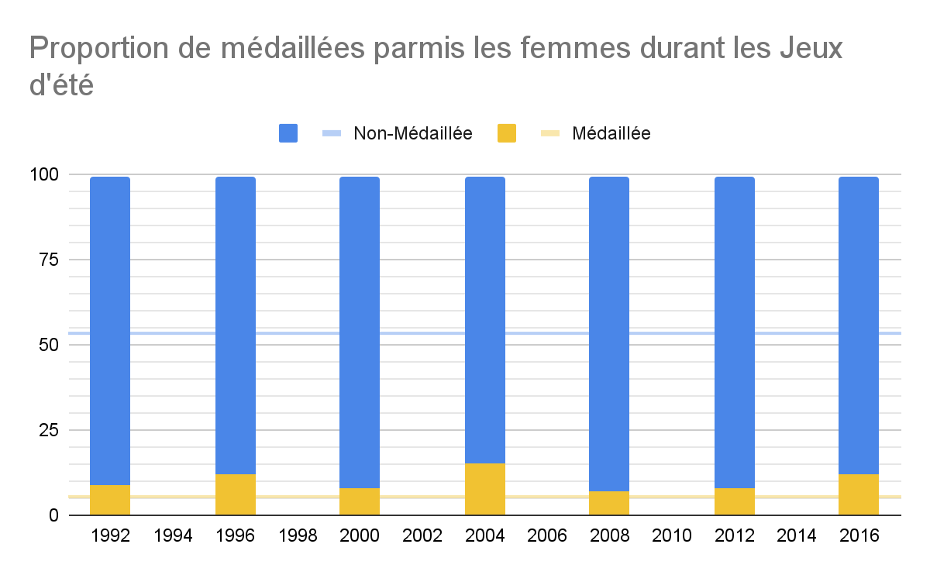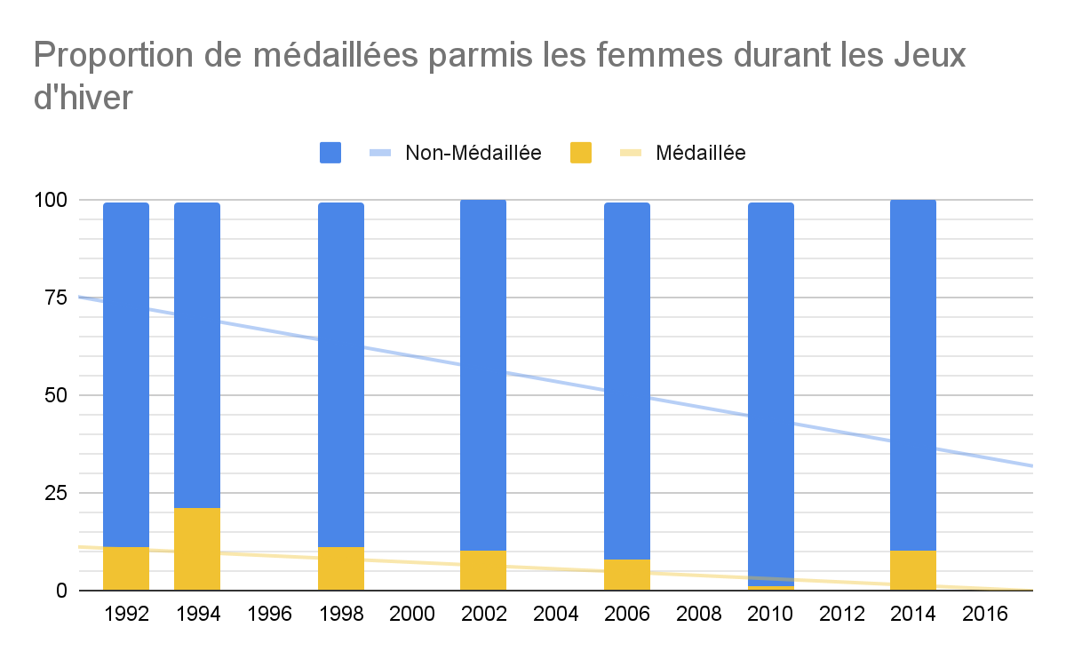

**requête SQL:**

###

Select * From

(Select season, year, (Count(*)*100)/(Select Count(*) From resultat as r2, noc as n2, edition as e2, athlete as a2 Where r2.ano = a2.ano And r2.noc = n2.noc And r2.edno = e2.edno And region = 'Italy' And e1.year = e2.year And e1.season = e2.season And sex = 'F' Group by season, year) as percent_femme_medaillee From resultat as r1, noc as n1, edition as e1, athlete as a1 Where r1.ano = a1.ano And r1.noc = n1.noc And r1.edno = e1.edno And region = 'Italy' And sex = 'F' And medal is not null Group by season, year)

as t1c Left Join(Select season, year, (Count(*)*100)/(Select Count(*) From resultat as r2, noc as n2, edition as e2, athlete as a2 Where r2.ano = a2.ano And r2.noc = n2.noc And r2.edno = e2.edno And region = 'Italy' And e1.year = e2.year And e1.season = e2.season And sex = 'F' Group by season, year) as percent_femme_non_medaillee

From resultat as r1, noc as n1, edition as e1, athlete as a1 Where r1.ano = a1.ano And r1.noc = n1.noc And r1.edno = e1.edno And region = 'Italy' And sex = 'F' And medal is null Group by season, year) as t2 Using(season,year);

###

**Observation:**

Pour les Jeux d’été, la proportion de médaillées parmi les femmes reste constante

chaque édition.

De même pour les Jeux d’hiver avec cependant un pic en 1994 et une baisse en

2010.

VI. Évolution de la proportion de femmes parmis les médaillés

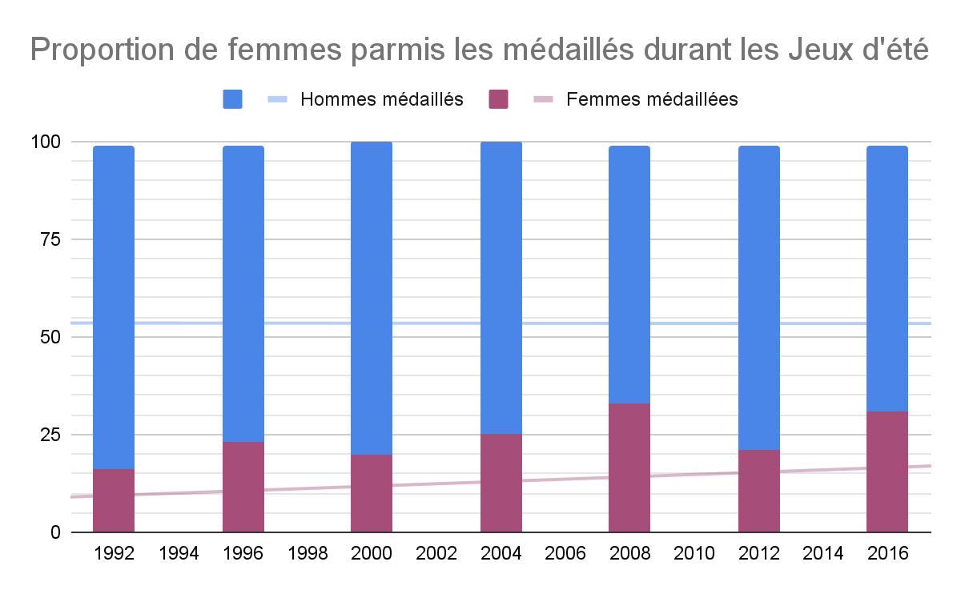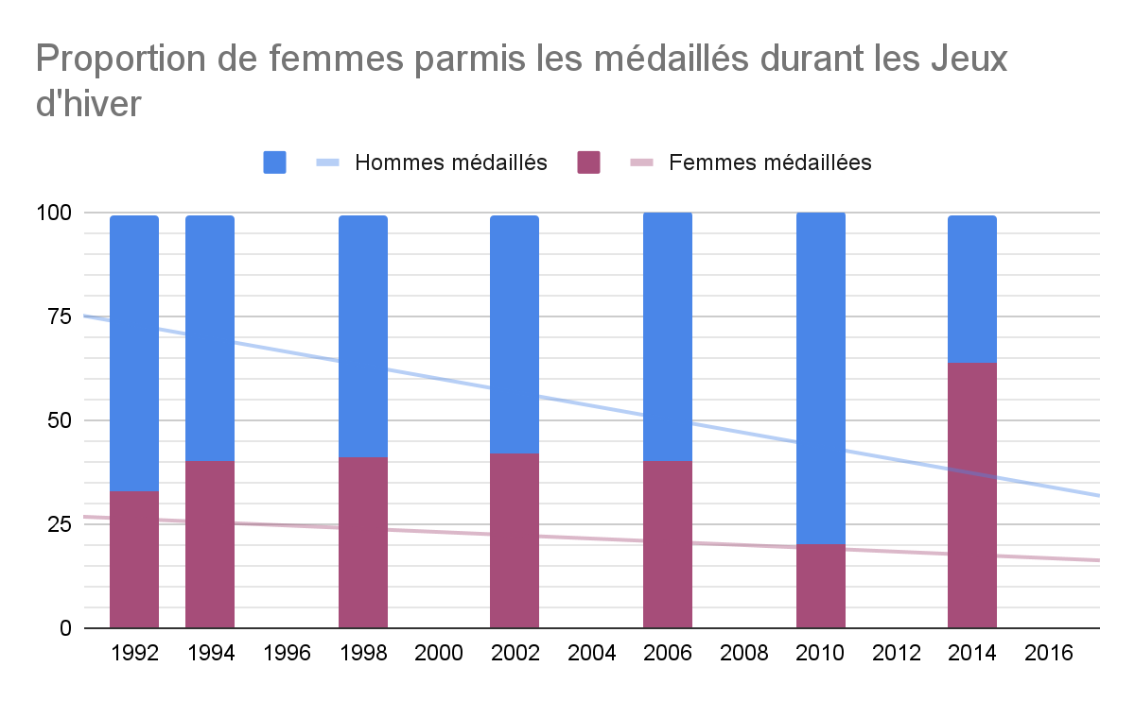

**requête SQL:**

###

Select * From

(Select season, year, (Count(*)*100)/(Select Count(*) From resultat as r2, noc as n2, edition as e2, athlete as a2 Where r2.ano = a2.ano And r2.noc = n2.noc And r2.edno = e2.edno And region = 'Italy' And e1.year = e2.year And e1.season = e2.season And medal is not null Group by season, year) as percent_femme_medaillee From resultat as r1, noc as n1, edition as e1, athlete as a1 Where r1.ano = a1.ano And r1.noc = n1.noc

And r1.edno = e1.edno And region = 'Italy' And sex = 'F'And medal is not null Group by season, year) as t1 Left Join (Select season, year, (Count(*)*100)/(Select Count(*) From resultat as r2, noc as n2, edition as e2, athlete as a2 Where r2.ano = a2.ano And r2.noc = n2.noc And r2.edno = e2.edno And region = 'Italy' And e1.year = e2.year And e1.season = e2.season And medal is not null Group by season, year) as percent_homme_medaillee From resultat as r1, noc as n1, edition as e1, athlete as a1

Where r1.ano = a1.ano And r1.noc = n1.noc And r1.edno = e1.edno And region = 'Italy'

And sex = 'M' And medal is not null Group by season, year) as t2 Using(season,year);

###

**Observation:**

La proportion de femmes parmi les médaillés augmente globalement durant les

Jeux d’été et d’hiver malgré une baisse durant les Jeux d’été de 2012 et les Jeux

d’hiver de 2010.

**Sweden**

I. Évolution du nombre de participants

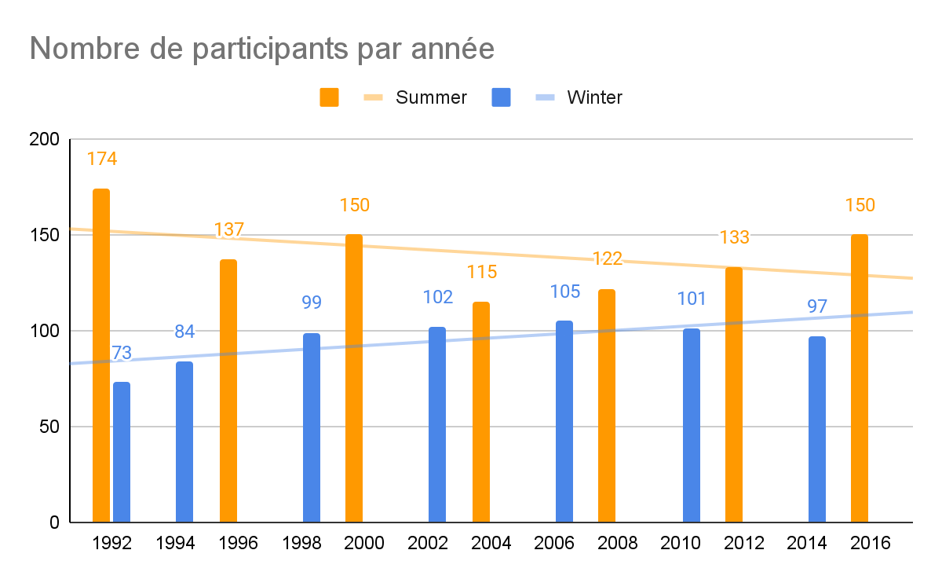

**requête SQL:**

###

Select season, year, Count(Distinct ano) as nb_participants From resultat as r, noc as n, edition as e Where r.noc = n.noc And r.edno = e.edno And region = 'Sweden' Group by season, year;

###

**Observation:**

Pour les Jeux d’été, le nombre de participants subit deux baisses, l’une en 1996 et l’autre en 2004, mais elles sont suivies par des augmentations jusqu'en 2016.

Tandis que pour les Jeux d’hiver, le nombre de participants augmente jusqu’en 2006 puis baisse légèrement en 2010 et 2014.

II. Évolution du nombre de médaillés

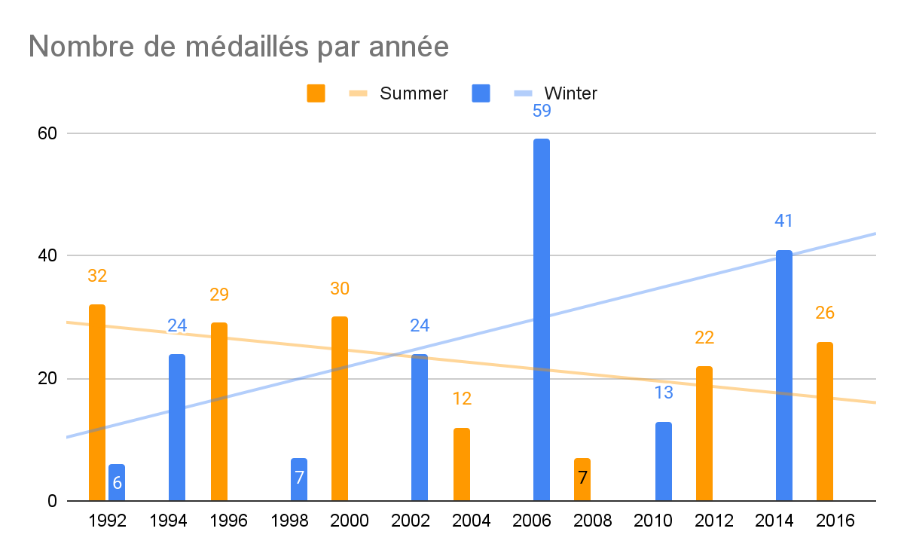

**requête SQL:**

###

Select season, year, Count(Distinct ano) as nb_medailles From resultat as r, noc as n, edition as e Where r.noc = n.noc And r.edno = e.edno And region = 'Sweden' And medal is not null Group by season, year;

###

**Observation:**

Pour les Jeux d’été, le nombre de médaillés reste constant malgré une forte baisse de 2004 à 2008.

Tandis que pour les Jeux d’hiver, le nombre de médaillés enchaîne les augmentations très fortes suivies de baisses tout aussi fortes.

III. Évolution du nombre de femmes participantes

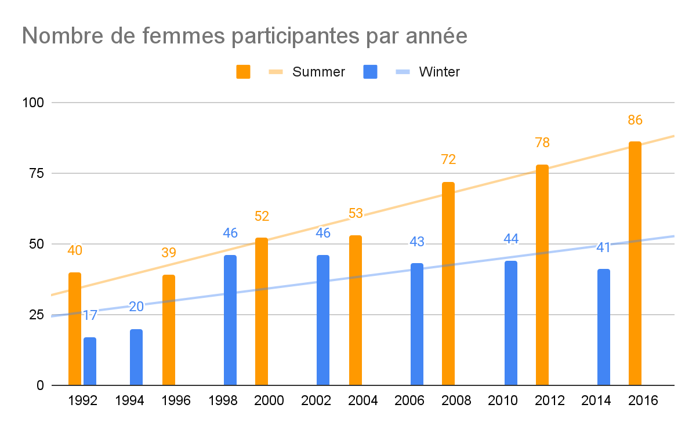

**requête SQL:**

###

Select season, year, Count(Distinct r.ano) as nb_femmes From resultat as r, noc as n, edition as e, athlete as a Where r.ano = a.ano And r.noc = n.noc And r.edno = e.edno And region = 'Sweden' And sex = 'F' Group by season, year;

###

**Observation:**

Pour les Jeux d’été, le nombre de femmes a fortement augmenté depuis 1992 en

passant de 40 à 86.

Pour les Jeux d’hiver, le nombre de femmes a augmenté jusqu’en 1998 puis a très

légèrement baissé à partir de 2006.

IV. Évolution de la proportion de femmes participantes

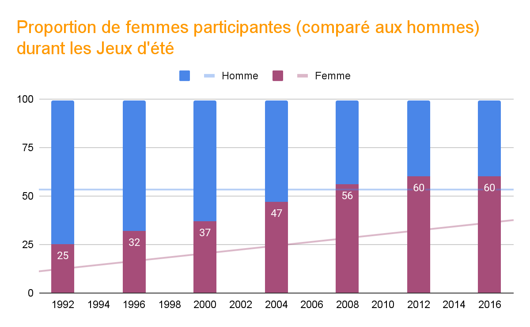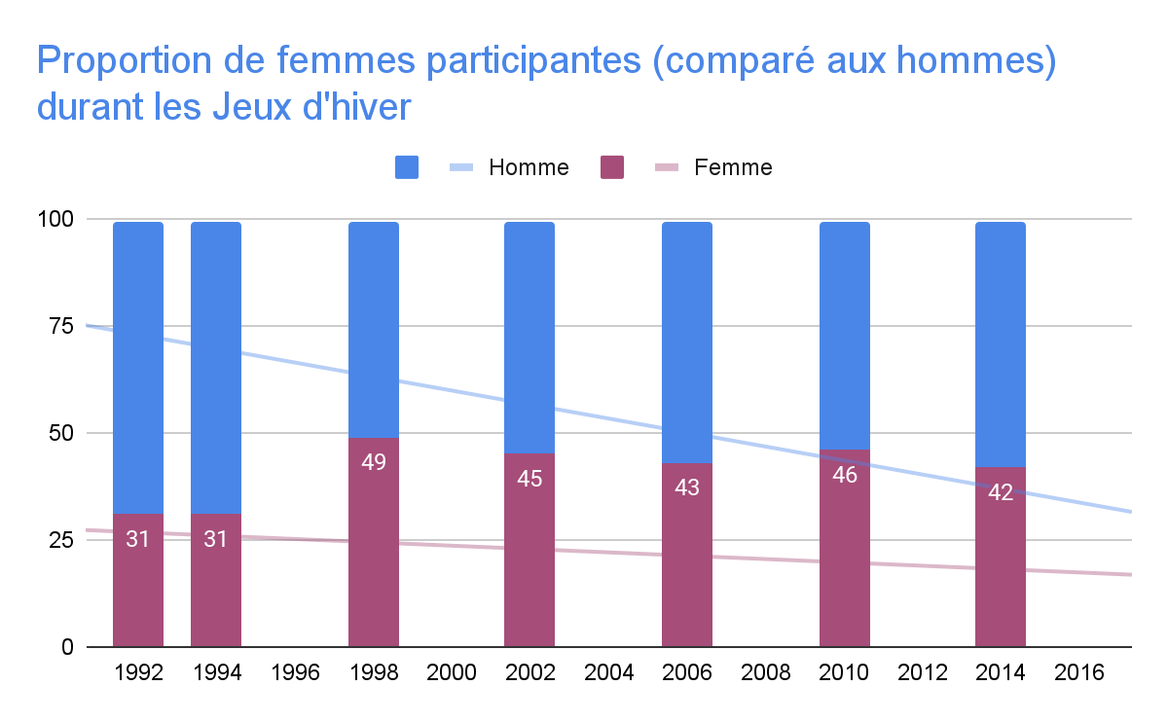

**requête SQL:**

###

Select * From

(Select season, year, (Count(*)*100)/(Select Count(*) From resultat as r2, noc as n2, edition as e2, athlete as a2 Where r2.ano = a2.ano And r2.noc = n2.noc And r2.edno = e2.edno And region = 'Sweden' And e1.year = e2.year And e1.season = e2.season Group by season, year) as percent_femme From resultat as r1, noc as n1, edition as e1, athlete as a1 Where r1.ano = a1.ano And r1.noc = n1.noc And r1.edno = e1.edno And region = 'Sweden' And sex = 'F' Group by season, year)as t1 Left Join (Select season, year, (Count(*)*100)/(Select Count(*) From resultat as r2, noc as n2, edition as e2, athlete as a2 Where r2.ano = a2.ano And r2.noc = n2.noc And r2.edno = e2.edno And region = 'Sweden' And e1.year = e2.year And e1.season = e2.season Group by season, year) as percent_homme From resultat as r1, noc as n1, edition as e1, athlete as a1 Where r1.ano = a1.ano And r1.noc = n1.noc And r1.edno = e1.edno And region = 'Sweden' And sex = 'M'

Group by season, year)as t2 Using(season,year);

###

**Observation:**

Durant cette période, la proportion de femmes a augmenté à chaque édition des Jeux d’été.

Pour les Jeux d’hiver, cette proportion a augmenté en 1998 puis est restée constante jusqu’en 2016.

V. Évolution de la proportion de médaillées parmis les femmes

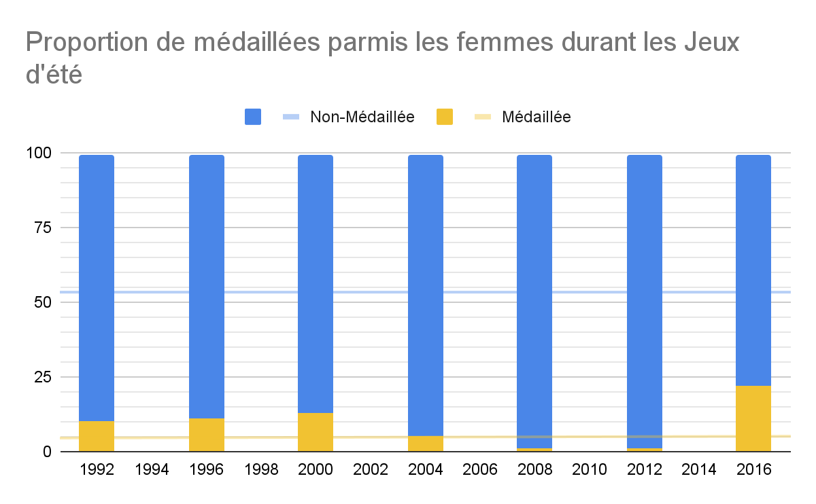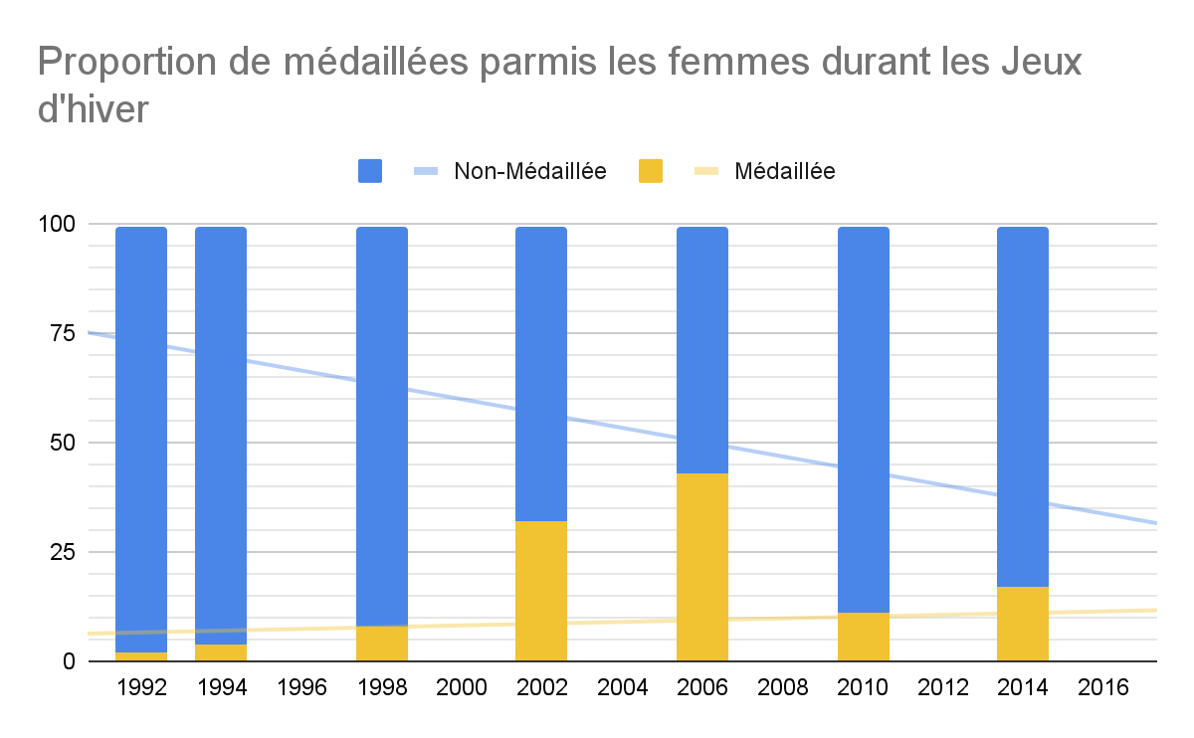

**requête SQL:**

###

Select * From

(Select season, year, (Count(*)*100)/(Select Count(*) From resultat as r2, noc as n2, edition as e2, athlete as a2 Where r2.ano = a2.ano And r2.noc = n2.noc And r2.edno = e2.edno And region = 'Sweden' And e1.year = e2.year And e1.season = e2.season And sex = 'F' Group by season, year) as percent_femme_medaillee From resultat as r1, noc as n1, edition as e1, athlete as a1 Where r1.ano = a1.ano And r1.noc = n1.noc And r1.edno = e1.edno And region = 'Sweden' And sex = 'F' And medal is not null Group by season, year)

as t1c Left Join(Select season, year, (Count(*)*100)/(Select Count(*) From resultat as r2, noc as n2, edition as e2, athlete as a2 Where r2.ano = a2.ano And r2.noc = n2.noc And r2.edno = e2.edno And region = 'Sweden' And e1.year = e2.year And e1.season = e2.season And sex = 'F' Group by season, year) as percent_femme_non_medaillee

From resultat as r1, noc as n1, edition as e1, athlete as a1 Where r1.ano = a1.ano And r1.noc = n1.noc And r1.edno = e1.edno And region = 'Sweden' And sex = 'F' And medal is null Group by season, year) as t2 Using(season,year);

###

**Observation:**

Pour les Jeux d’été, la proportion de médaillées parmi les femmes est resté

constante de 1992 à 2000 puis a subi une baisse jusqu’en 2012 pour au final

atteindre un pic d’environ 20% en 2016.

Pour les Jeux d’hiver, cette proportion a fortement augmenté de 1992 à 2006 puis a subi une forte baisse en 2010.

VI. Évolution de la proportion de femmes parmis les médaillés

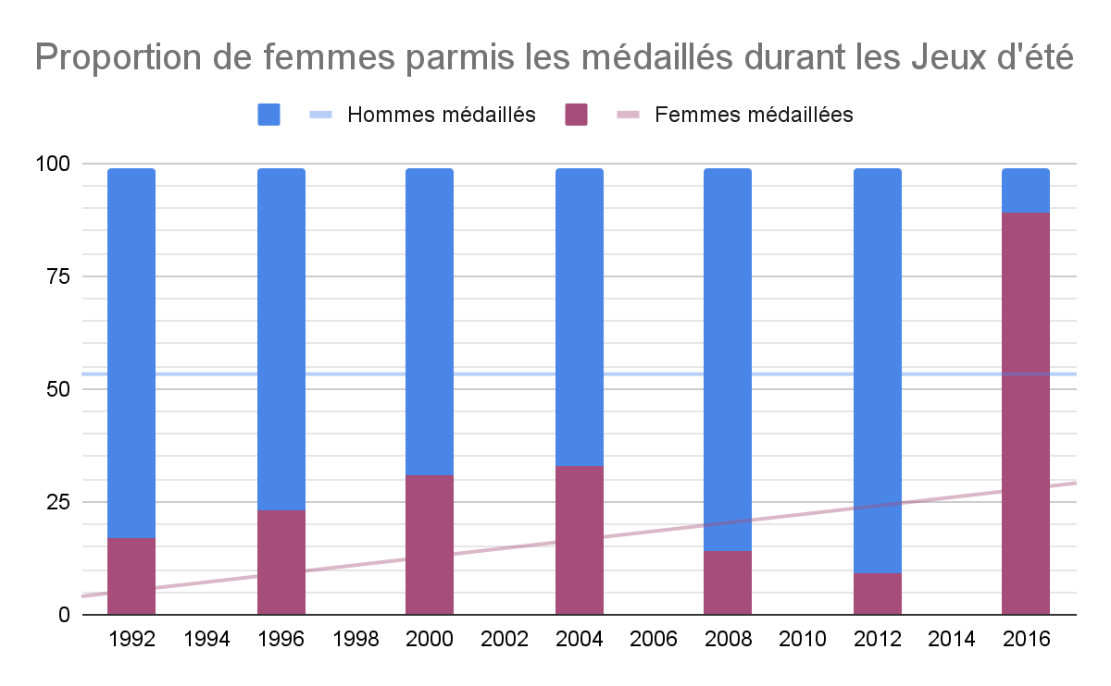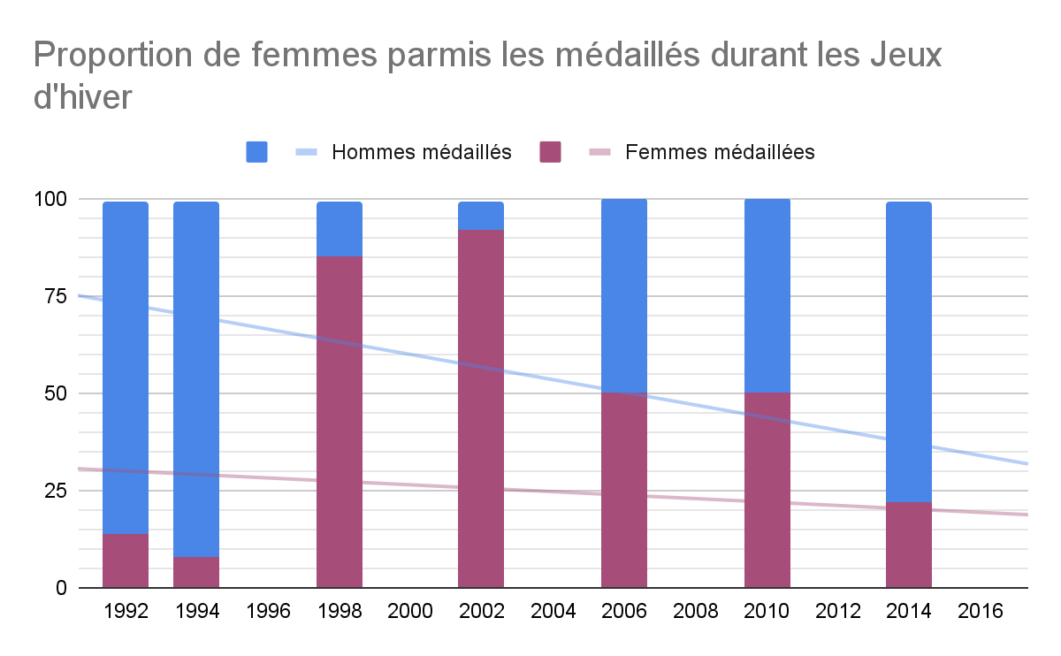

**requête SQL:**

###

Select * From

(Select season, year, (Count(*)*100)/(Select Count(*) From resultat as r2, noc as n2, edition as e2, athlete as a2 Where r2.ano = a2.ano And r2.noc = n2.noc And r2.edno = e2.edno And region = 'Sweden' And e1.year = e2.year And e1.season = e2.season And medal is not null Group by season, year) as percent_femme_medaillee From resultat as r1, noc as n1, edition as e1, athlete as a1 Where r1.ano = a1.ano And r1.noc = n1.noc

And r1.edno = e1.edno And region = 'Sweden' And sex = 'F'And medal is not null Group by season, year) as t1 Left Join (Select season, year, (Count(*)*100)/(Select Count(*) From resultat as r2, noc as n2, edition as e2, athlete as a2 Where r2.ano = a2.ano And r2.noc = n2.noc And r2.edno = e2.edno And region = 'Sweden' And e1.year = e2.year And e1.season = e2.season And medal is not null Group by season, year) as percent_homme_medaillee From resultat as r1, noc as n1, edition as e1, athlete as a1

Where r1.ano = a1.ano And r1.noc = n1.noc And r1.edno = e1.edno And region = 'Sweden'

And sex = 'M' And medal is not null Group by season, year) as t2 Using(season,year);

###

**Observation:**

Pour les Jeux d’été, on remarque que la proportion de femmes parmi les médaillés

a suivi la même évolution que la proportion de médaillées parmi les femmes.

Pour les Jeux d’hiver cependant en plus de suivre globalement le même évolution,

la proportion de femmes parmi les médaillés a subi une très forte augmentation en atteignant plus de 90%.

**South Korea**

I. Évolution du nombre de participants

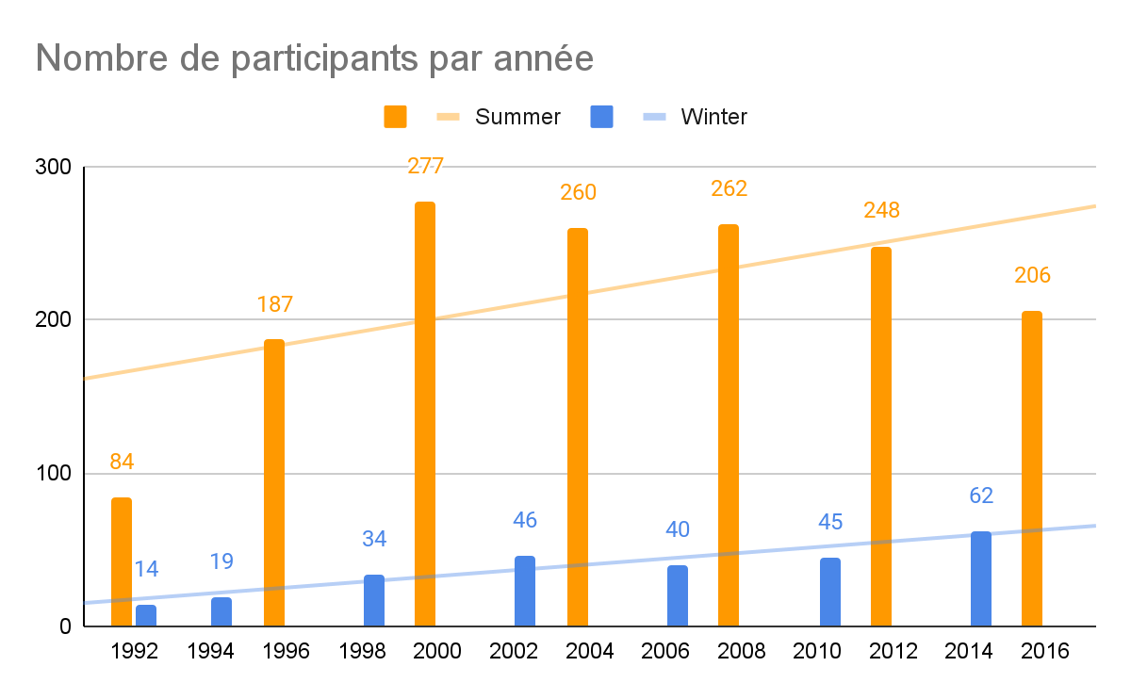

**requête SQL:**

###

Select season, year, Count(Distinct ano) as nb_participants From resultat as r, noc as n, edition as e Where r.noc = n.noc And r.edno = e.edno And region = 'South Korea' Group by season, year;

###

**Observation:**

Pour les Jeux d’été, le nombre de participants à fortement augmenté de 1992 à 2000 et depuis subi une baisse.

Pour les Jeux d’hiver cependant le nombre de participants ne fait globalement que d’augmenter.

II. Évolution du nombre de médaillés

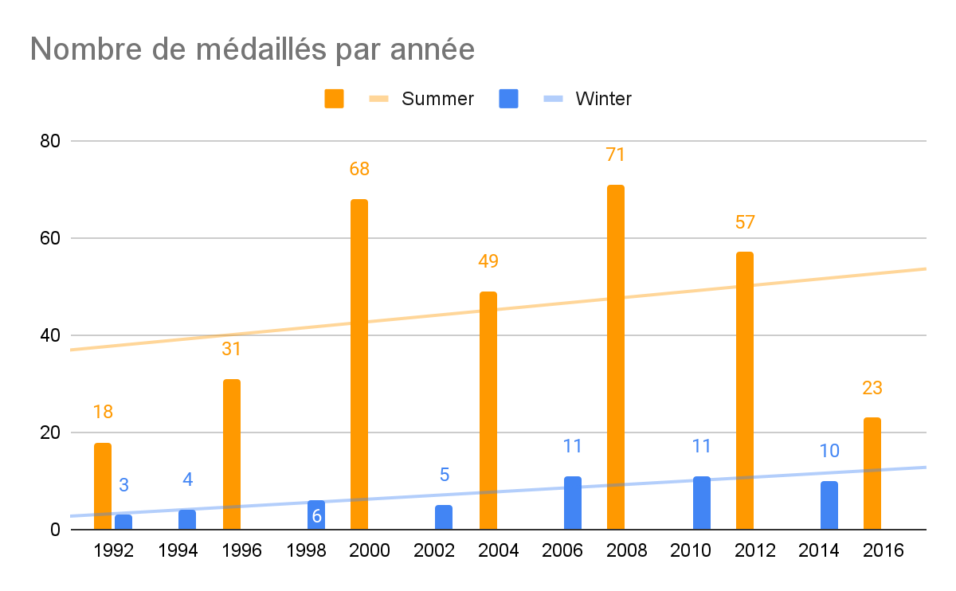

**requête SQL:**

###

Select season, year, Count(Distinct ano) as nb_medailles From resultat as r, noc as n, edition as e Where r.noc = n.noc And r.edno = e.edno And region = 'South Korea' And medal is not null Group by season, year;

###

**Observation:**

Pour les Jeux d’été, le nombre de médaillés a fortement augmenté en 2000 et 2008 mais subi de forte baisse en 2004 et 2016.

Pour les Jeux d’hiver, le nombre de médaillés ne fait globalement que d’augmenter.

III. Évolution du nombre de femmes participantes

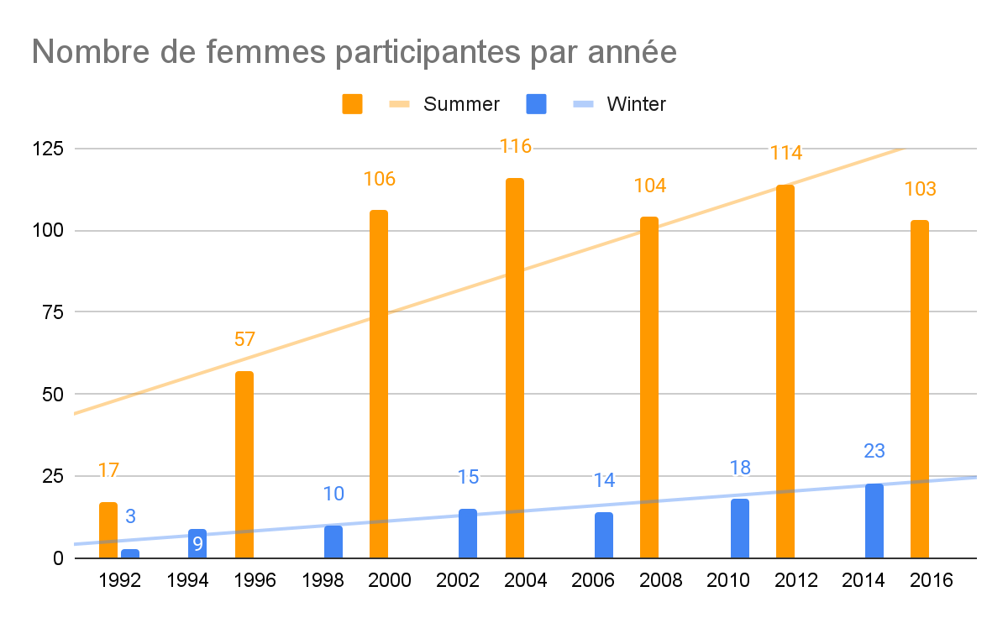

**requête SQL:**

###

Select season, year, Count(Distinct r.ano) as nb_femmes From resultat as r, noc as n, edition as e, athlete as a Where r.ano = a.ano And r.noc = n.noc And r.edno = e.edno And region = 'South Korea' And sex = 'F' Group by season, year;

###

**Observation:**

De 1992 à 2000, le nombre de femmes participantes a très fortement augmenté et

reste constant à hauteur de plus de 100 femmes participantes depuis.

Pour les Jeux d’hiver, le nombre de médaillés ne fait globalement que d’augmenter.

IV. Évolution de la proportion de femmes participantes

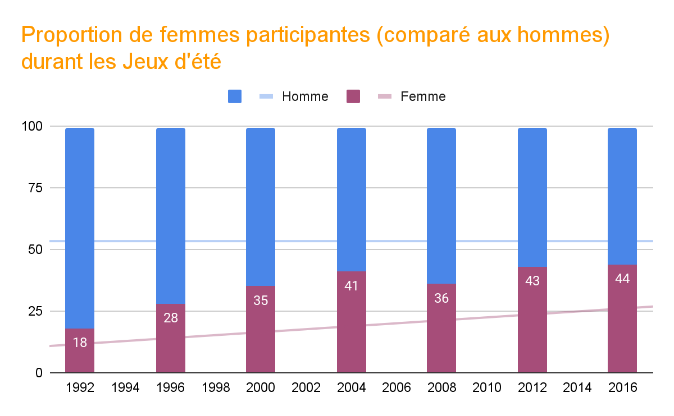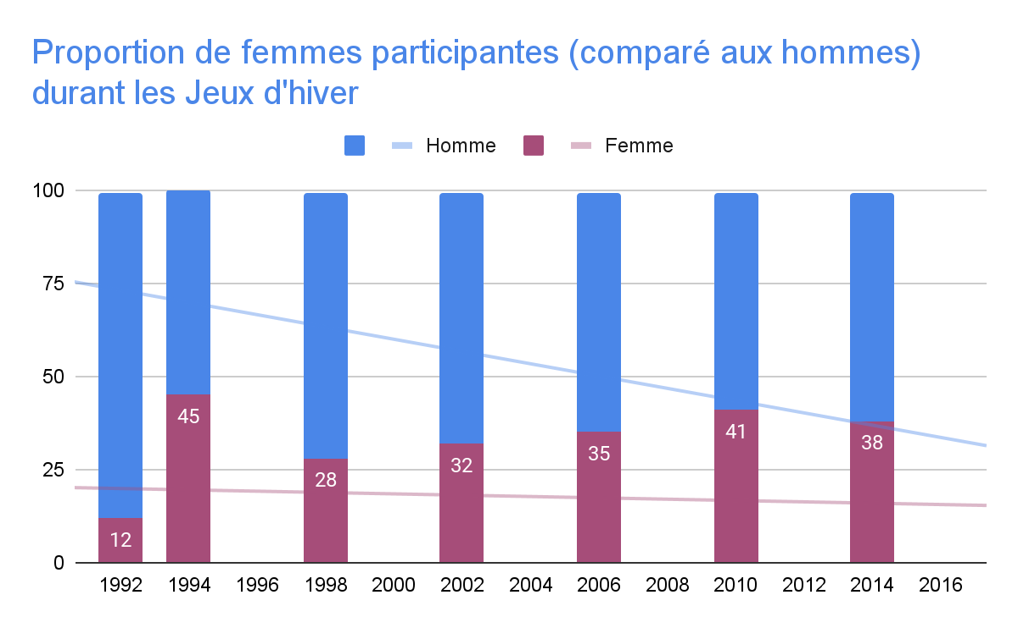

**requête SQL:**

###

Select * From

(Select season, year, (Count(*)*100)/(Select Count(*) From resultat as r2, noc as n2, edition as e2, athlete as a2 Where r2.ano = a2.ano And r2.noc = n2.noc And r2.edno = e2.edno And region = 'South Korea' And e1.year = e2.year And e1.season = e2.season Group by season, year) as percent_femme From resultat as r1, noc as n1, edition as e1, athlete as a1 Where r1.ano = a1.ano And r1.noc = n1.noc And r1.edno = e1.edno And region = 'South Korea' And sex = 'F' Group by season, year)as t1 Left Join (Select season, year, (Count(*)*100)/(Select Count(*) From resultat as r2, noc as n2, edition as e2, athlete as a2 Where r2.ano = a2.ano And r2.noc = n2.noc And r2.edno = e2.edno And region = 'South Korea' And e1.year = e2.year And e1.season = e2.season Group by season, year) as percent_homme From resultat as r1, noc as n1, edition as e1, athlete as a1 Where r1.ano = a1.ano And r1.noc = n1.noc And r1.edno = e1.edno And region = 'South Korea' And sex = 'M'

Group by season, year)as t2 Using(season,year);

###

**Observation:**

Durant cette période, la proportion de femmes a augmenté à chaque édition des

Jeux d’été sauf en 2008.

Pour les Jeux d’hiver, cette proportion a augmenté à chaque édition avec un pic en 1994 et a très légèrement baissé en 2014.

V. Évolution de la proportion de médaillées parmis les femmes

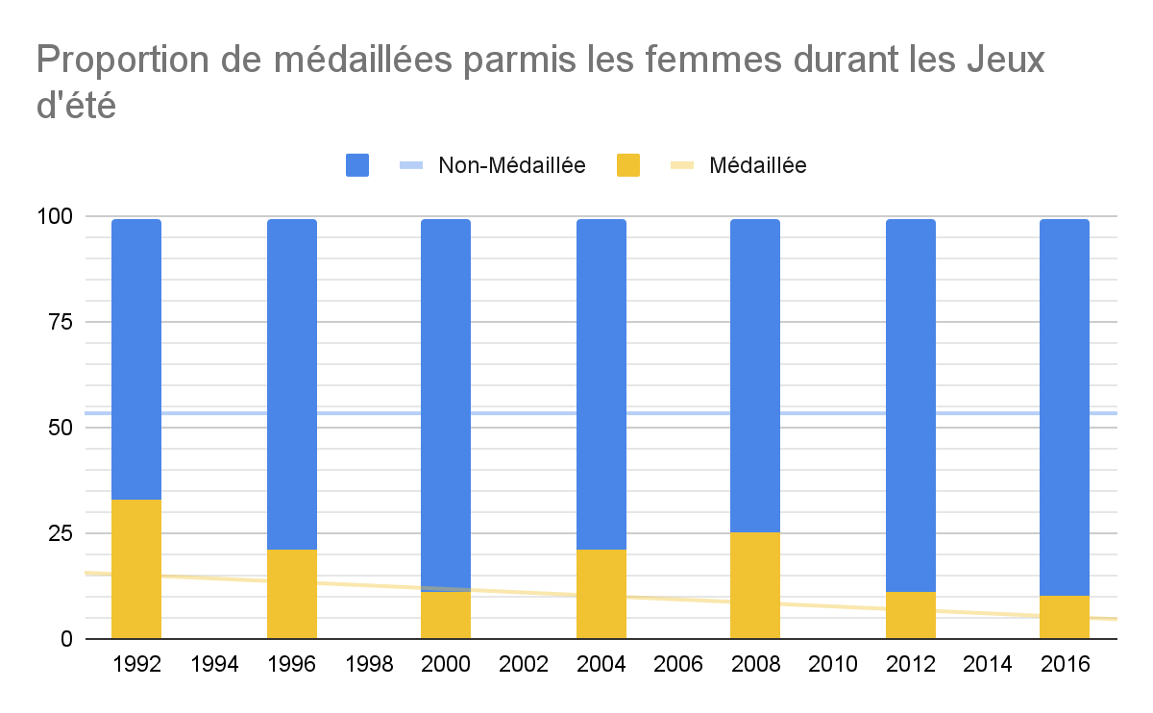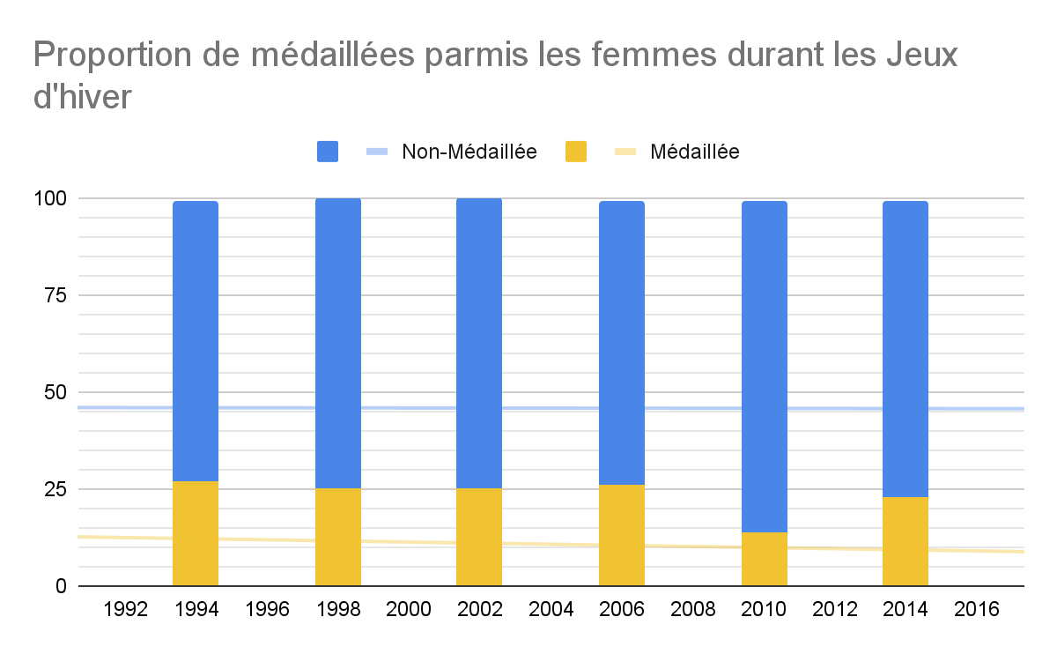

**requête SQL:**

###

Select * From

(Select season, year, (Count(*)*100)/(Select Count(*) From resultat as r2, noc as n2, edition as e2, athlete as a2 Where r2.ano = a2.ano And r2.noc = n2.noc And r2.edno = e2.edno And region = 'South Korea' And e1.year = e2.year And e1.season = e2.season And sex = 'F' Group by season, year) as percent_femme_medaillee From resultat as r1, noc as n1, edition as e1, athlete as a1 Where r1.ano = a1.ano And r1.noc = n1.noc And r1.edno = e1.edno And region = 'South Korea' And sex = 'F' And medal is not null Group by season, year)

as t1c Left Join(Select season, year, (Count(*)*100)/(Select Count(*) From resultat as r2, noc as n2, edition as e2, athlete as a2 Where r2.ano = a2.ano And r2.noc = n2.noc And r2.edno = e2.edno And region = 'South Korea' And e1.year = e2.year And e1.season = e2.season And sex = 'F' Group by season, year) as percent_femme_non_medaillee

From resultat as r1, noc as n1, edition as e1, athlete as a1 Where r1.ano = a1.ano And r1.noc = n1.noc And r1.edno = e1.edno And region = 'South Korea' And sex = 'F' And medal is null Group by season, year) as t2 Using(season,year);

###

**Observation:**

Pour les Jeux d’été, la proportion de médaillées parmi les femmes est resté

constante de 1992 à 2008 et a baissé à partir de l’édition suivante.

Pour les Jeux d’hiver, la proportion de médaillées parmi les femmes est resté

constante à environ 25% avec une baisse en 2012.

VI. Évolution de la proportion de femmes parmis les médaillés

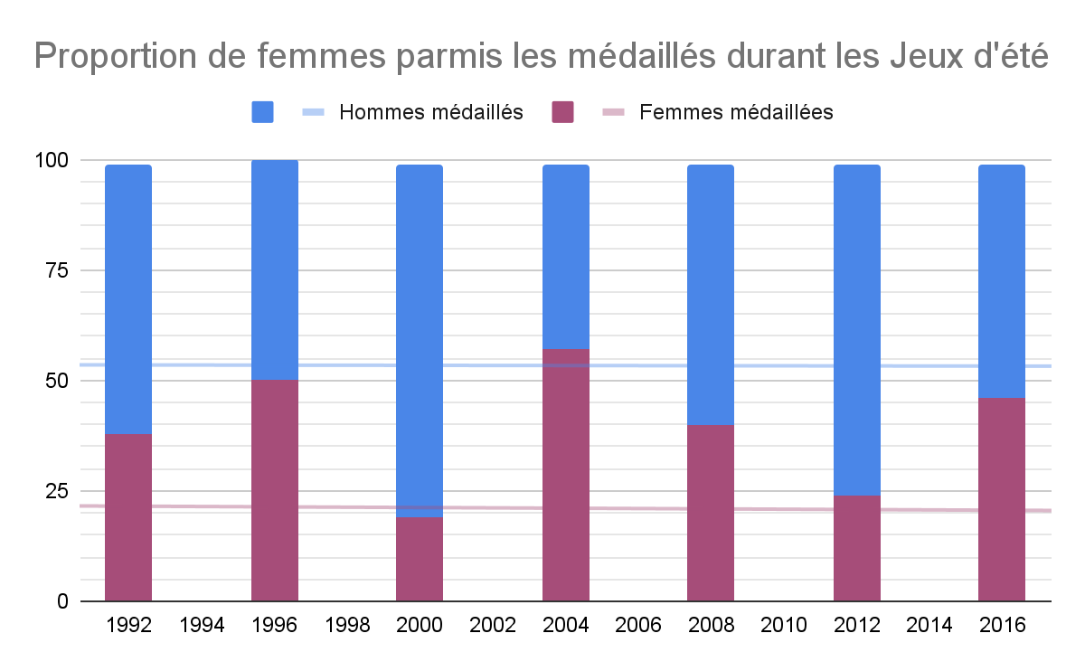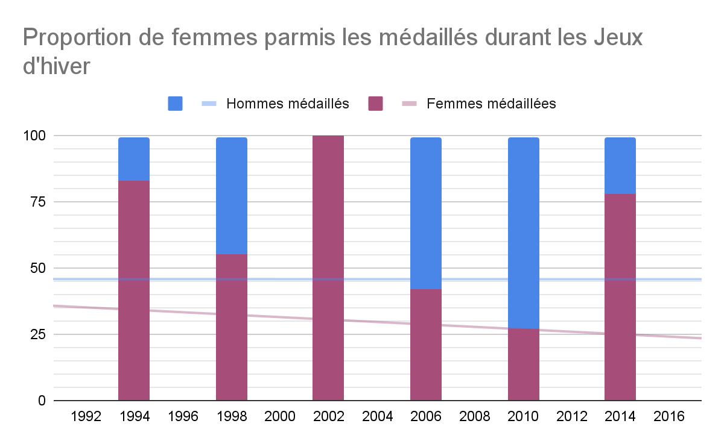

**requête SQL:**

###

Select * From

(Select season, year, (Count(*)*100)/(Select Count(*) From resultat as r2, noc as n2, edition as e2, athlete as a2 Where r2.ano = a2.ano And r2.noc = n2.noc And r2.edno = e2.edno And region = 'South Korea' And e1.year = e2.year And e1.season = e2.season And medal is not null Group by season, year) as percent_femme_medaillee From resultat as r1, noc as n1, edition as e1, athlete as a1 Where r1.ano = a1.ano And r1.noc = n1.noc

And r1.edno = e1.edno And region = 'South Korea' And sex = 'F'And medal is not null Group by season, year) as t1 Left Join (Select season, year, (Count(*)*100)/(Select Count(*) From resultat as r2, noc as n2, edition as e2, athlete as a2 Where r2.ano = a2.ano And r2.noc = n2.noc And r2.edno = e2.edno And region = 'South Korea' And e1.year = e2.year And e1.season = e2.season And medal is not null Group by season, year) as percent_homme_medaillee From resultat as r1, noc as n1, edition as e1, athlete as a1

Where r1.ano = a1.ano And r1.noc = n1.noc And r1.edno = e1.edno And region = 'South Korea'

And sex = 'M' And medal is not null Group by season, year) as t2 Using(season,year);

###

**Observation:**

Pour les Jeux d’été, la proportion de femmes parmi les médaillés a subi de forte

baisse en 2000 et 2012 mais malgré cela continue d’augmenter.

Pour les Jeux d’hiver, cette proportion a baissé de 1994 à 1998 et a subi un

immense pic avec 100% de femmes parmi les médaillés puis baissé jusqu’en 2010

pour finalement augmenter une fois de plus en 2014 en atteignant plus de 75%.