**Assignment 9**

**Implement a chatbot application based on real world scenario**

**Theory -**

This program implements a simple AI-powered health chatbot based on the concept of forward chaining, a fundamental reasoning mechanism in expert systems.  
Expert systems are AI programs designed to make decisions or solve problems in a specific domain (like health or finance) by applying a set of predefined rules to known facts.

In forward chaining, reasoning starts with the known facts and applies inference rules to derive new facts or conclusions.  
This process continues until no more new information can be inferred.  
It’s a data-driven approach — starting from available data and moving forward to derive conclusions.

For example:

* Known facts: fever, cough
* Rules:
  + If fever and cough → then flu
  + If flu → then rest
* Inference:
  + From fever + cough, deduce flu.
  + From flu, deduce rest.

**Code -**

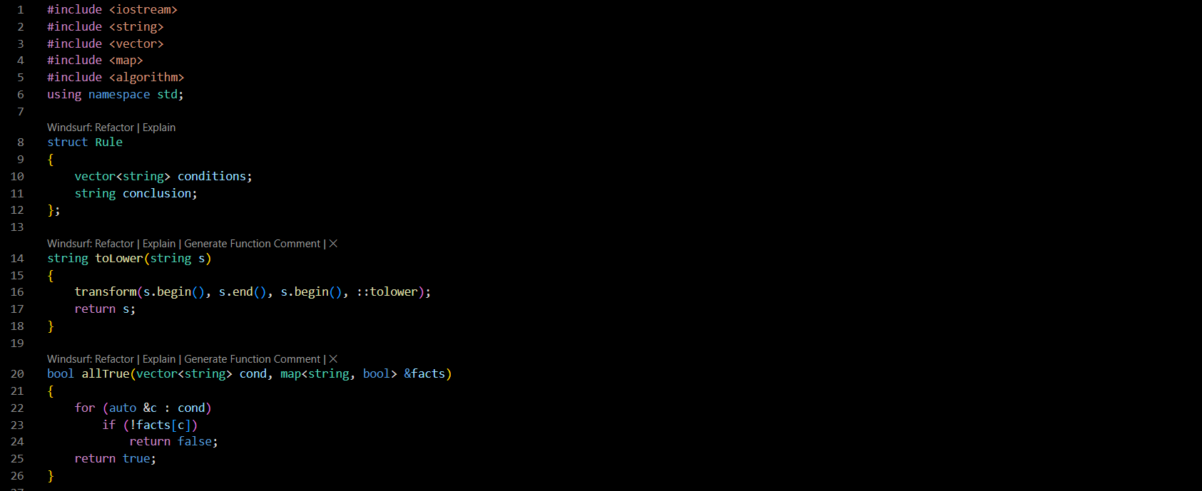

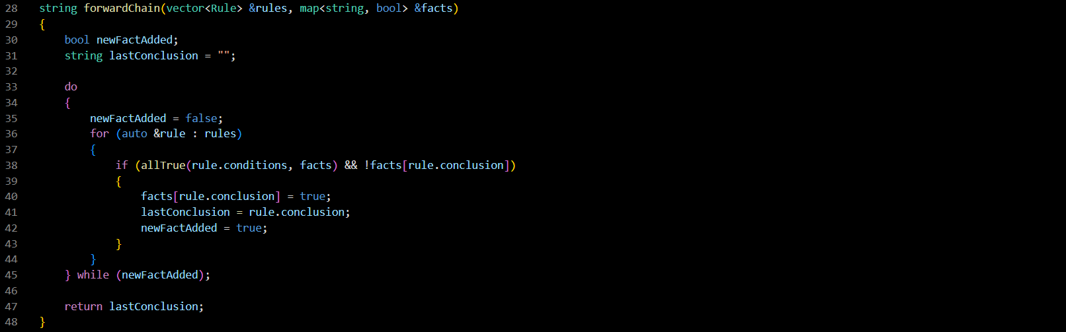

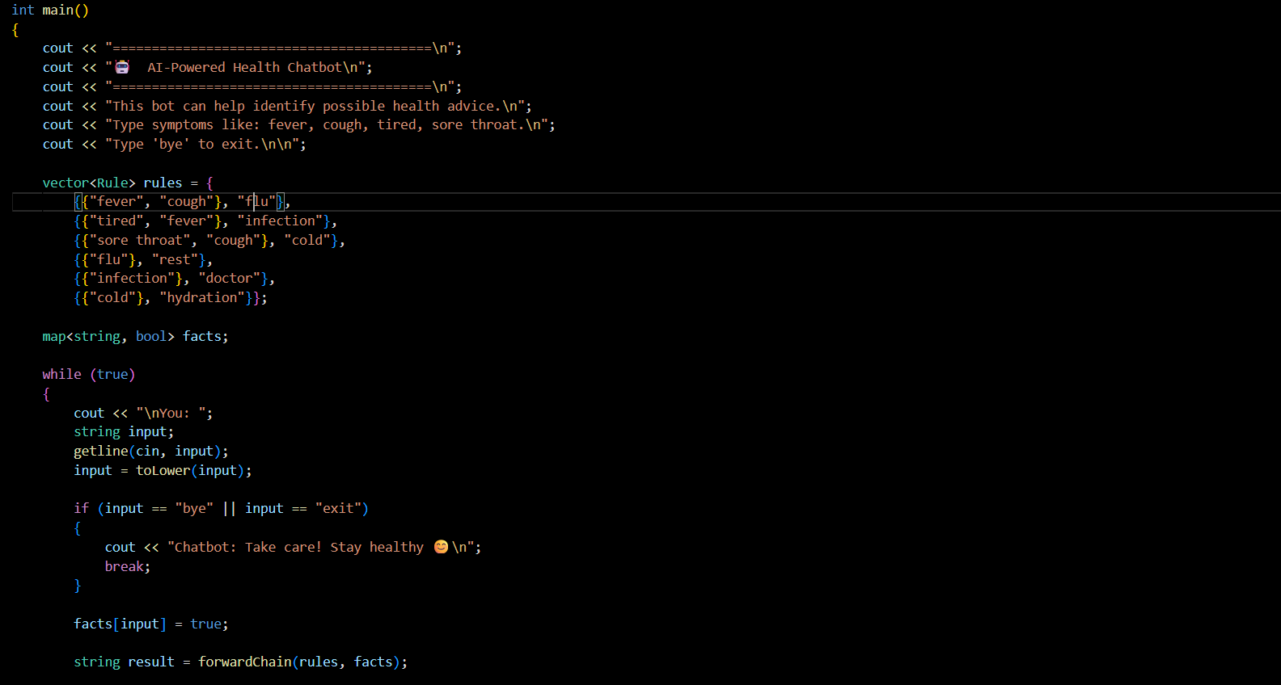

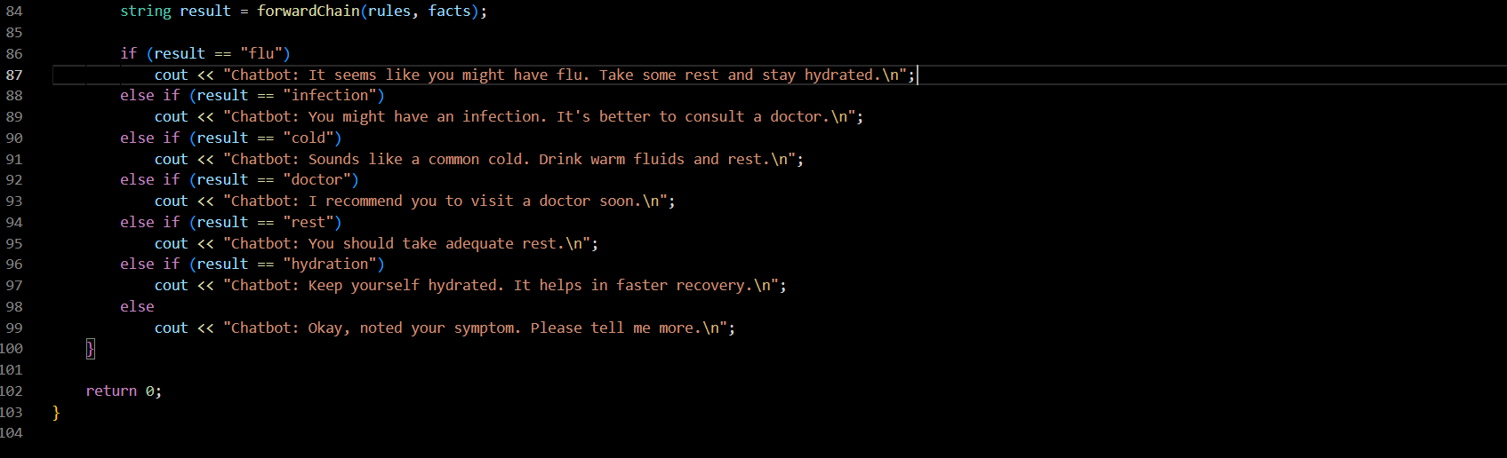

**Output -**

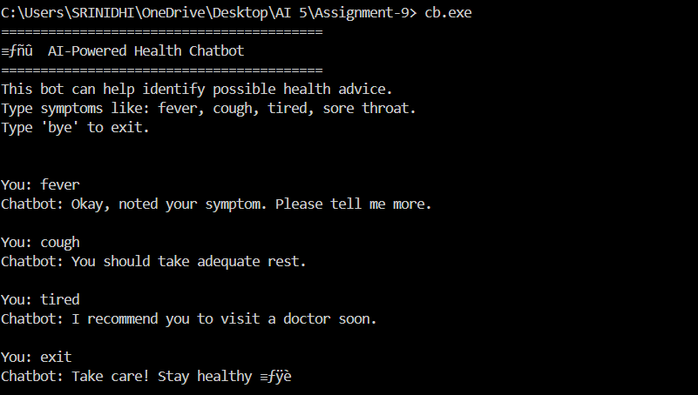

**Explanation –**

The program begins by defining a structure to represent a rule, which includes a list of conditions and a conclusion. Each rule acts as a logical statement — for example, if the user mentions having both a fever and a cough, the chatbot can infer that the person might have the flu. These rules form the system’s knowledge base, which stores expert-level information in a structured format.

When the program runs, it first greets the user and explains its purpose — to help identify possible health advice based on symptoms. It then waits for the user to input symptoms such as “fever,” “cough,” “tired,” or “sore throat.” The chatbot converts each user input to lowercase to maintain uniformity during comparisons, ensuring that inputs like “Fever” and “fever” are treated the same.

Each symptom entered by the user is stored as a fact in the system. The forward chaining function then checks all rules to determine whether the conditions of any rule are completely satisfied by the known facts. If a rule’s conditions are satisfied and its conclusion is not yet part of the facts, the chatbot adds that conclusion to the fact base. This process repeats automatically until no new facts can be derived.

For example, if the user enters “fever” and “cough,” the system identifies that both conditions satisfy a rule whose conclusion is “flu.” Once “flu” becomes a known fact, another rule may apply, such as one that suggests “rest” for flu. Through this mechanism, the chatbot simulates step-by-step logical reasoning similar to how an expert would deduce further advice based on earlier findings.

After inference, the chatbot interprets the final derived fact and responds with appropriate health advice. If it concludes that the user might have the flu, it suggests rest and hydration. If it detects an infection, it advises consulting a doctor. When the user types “bye” or “exit,” the chatbot politely ends the conversation.

**Conclusion –**

In conclusion, the chatbot demonstrates the working principles of a rule-based expert system using forward chaining for automated reasoning. It accepts user inputs in the form of symptoms, applies inference rules to deduce possible health conditions, and then provides suitable advice. The design makes it easy to extend by adding more rules, symptoms, or advice statements, showing the flexibility of knowledge-based AI models.