Bug Report|# TC_002
Bug ID | TC_002
Tester | Toribio, Carlo Miguel
Date submitted | 2025/04/13
Title | Login Form - Invalid username login
Bug Description
URL | https://www.saucedemo.com/
Summary | Error: "Epic sadface: Username and password do not match any user in this service" Appears
Screenshot | 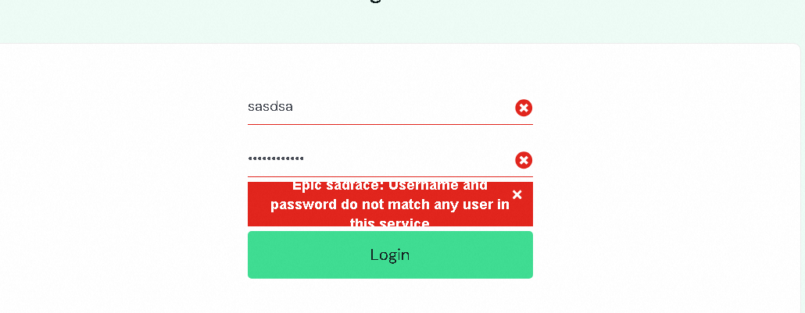
Platform | Windows 11
Browser | Chrome
Administrative
Assigned at | Delacruz, Juan
Priority | Low
Severity | Low

Additional Notes:
Step by Step Description
- Go to Login page
- Input Incorrect Username
- Input Correct password
- Click on Login Button
Result Should: "Epic sadface: Username do not match any user in this service"
Result is: “Epic sadface: Username and password do not match any user in this service"
Bug Report|# TC_003
Bug ID | TC_003
Tester | Toribio, Carlo Miguel
Date submitted | 2025/04/13
Title | Login Form - Invalid password login
Bug Description
URL | https://www.saucedemo.com/
Summary | Error: "Epic sadface: Username and password do not match any user in this service" Appears
Screenshot | 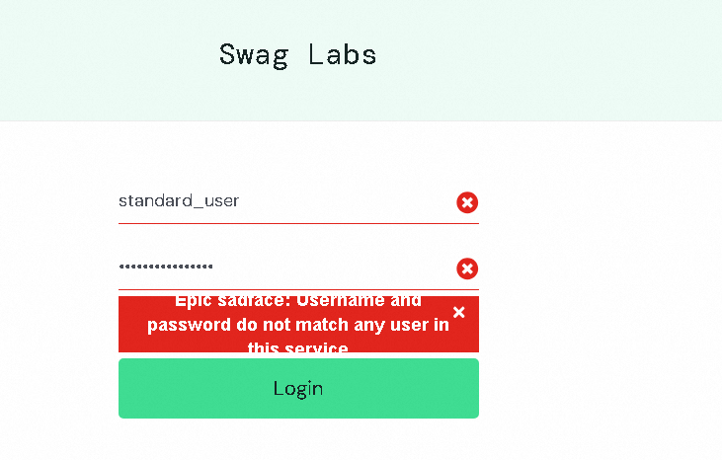
Platform | Windows 11
Browser | Chrome
Administrative
Assigned at | Delacruz, Juan
Priority | Low
Severity | Low

Additional Notes:
Step by Step Description
- Go to Login page
- Input Correct Username
- Input Incorrect password
- Click on Login Button
Result Should: "Epic sadface: Password do not match any username in this service"
Result is: “Epic sadface: Username and password do not match any user in this service"
Bug Report|# TC_006
Bug ID | TC_006
Tester | Toribio, Carlo Miguel
Date submitted | 2025/04/13
Title | Login Form - Empty Username and password login
Bug Description
URL | https://www.saucedemo.com/
Summary | Error: "Epic sadface: Username is required" Appears
Screenshot | 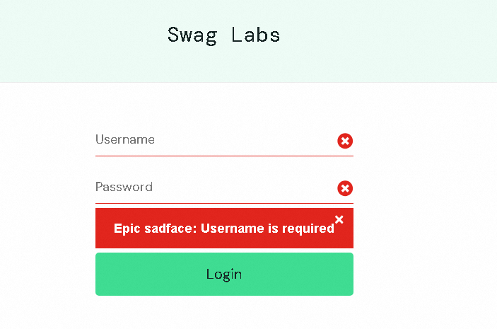
Platform | Windows 11
Browser | Chrome
Administrative
Assigned at | Delacruz, Juan
Priority | Low
Severity | Low

Additional Notes:
Step by Step Description
- Go to Login page
- leave Username as blank
- leave Incorrect as blank
- Click on Login Button
Result Should: "Epic sadface: Username and password is required"
Result is: "Epic sadface: Username is required"

Bug Report|# TC_010
Bug ID | TC_010
Tester | Toribio, Carlo Miguel
Date submitted | 2025/04/13
Title | Checkout Form – Empty Firstname, lastname and zipcodepassword login
Bug Description
URL | https://www.saucedemo.com/checkout-step-one.html
Summary | Error: "Epic sadface: Username is required" Appears
Screenshot | 
Platform | Windows 11
Browser | Chrome
Administrative
Assigned at | Delacruz, Juan
Priority | Low
Severity | Low

Additional Notes:
Step by Step Description
- Go to Login page
- leave Username as blank
- leave Incorrect as blank
- Click on Login Button
Result Should: "Epic sadface: Username and password is required"
Result is: "Epic sadface: Username is required"

Bug Report|# TC_023
Bug ID | TC_023
Tester | Toribio, Carlo Miguel
Date submitted | 2025/04/13
Title | Your order Form – Click Checkout button while no items in cart
Bug Description
URL | https://www.saucedemo.com/checkout-step-one.html
Summary | User goes to Checkout info page
Screenshot | 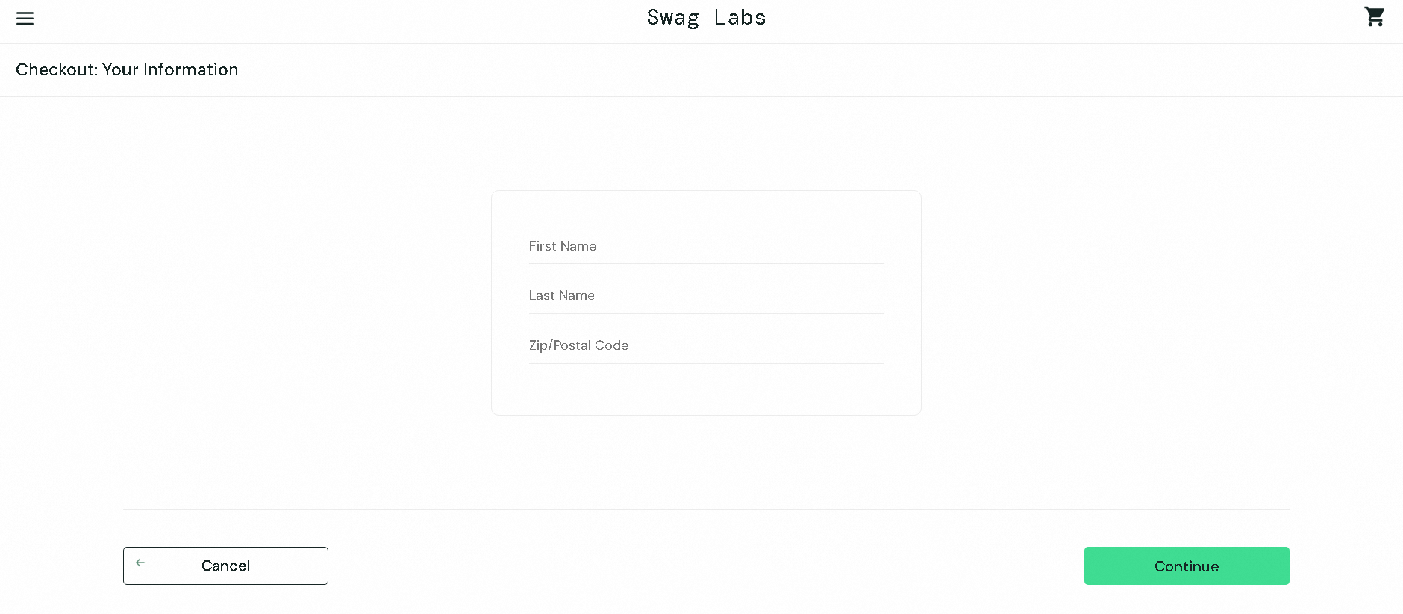
Platform | Windows 11
Browser | Chrome
Administrative
Assigned at | Delacruz, Juan
Priority | Low
Severity | Low

Additional Notes:
Step by Step Description
- Go to Login page
- Input username and password
- Click on Login Button
- Click Cart icon
- Click Checkout button
Result Should: "Error no item in carts " Appears"
Result is: “User goes to Checkout info page”

