Section 1: Title Page
Automated End-to-End Ad-Click Data Pipeline and Monitoring System
Course Name: Data Engineering
Name: Soumyajit Tarafdar
Roll Number: 23052926
Batch/Program: B.Tech Computer Science

Section 2: Problem Statement and Tech Stack
1. Problem Statement The digital advertising industry generates massive volumes of clickstream data that must be processed in real-time to prevent fraud and monitor advertising spend. The challenge is to ingest 1,000,000+ records, perform complex transformations, and ensure data quality without manual intervention. This project addresses these needs by building an automated, resilient, and scalable data pipeline that provides consistent monitoring and reporting.
2. Tech Stack Language: Python 3.10 Big Data Engine: Apache Spark Message Broker: Apache Kafka Orchestration: Apache Airflow Database: SQLite Lakehouse Architecture: Delta Lake Simulation Storage Formats: Parquet and CSV

Section 3: Solution Architecture and Features
3. Solution Architecture The architecture follows a modern Data Engineering lifecycle. First, the Ingestion Layer uses Kafka to act as the entry point for raw event data. Second, the Processing Layer utilizes Spark to handle batch transformations and cleaning for high-volume datasets. Third, the Orchestration Layer employs Airflow to manage task dependencies via a Directed Acyclic Graph. Finally, the Reporting Layer generates an automated HTML dashboard for end-user visibility.
4. Visual Proof of Execution

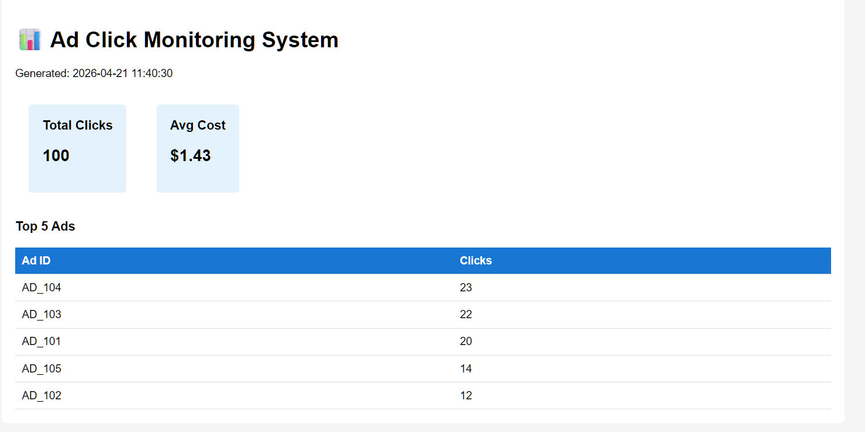

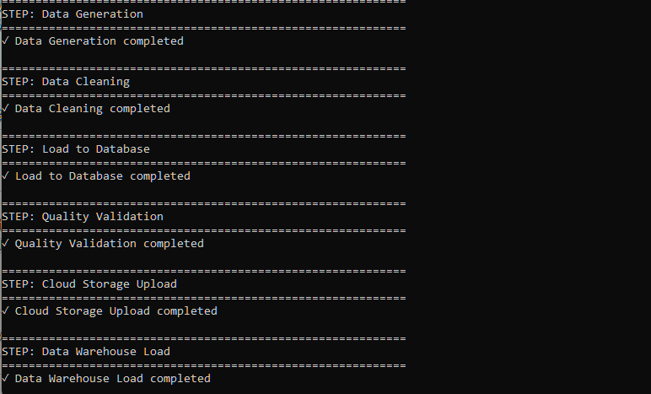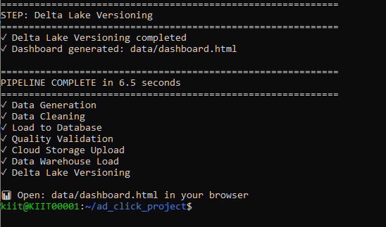
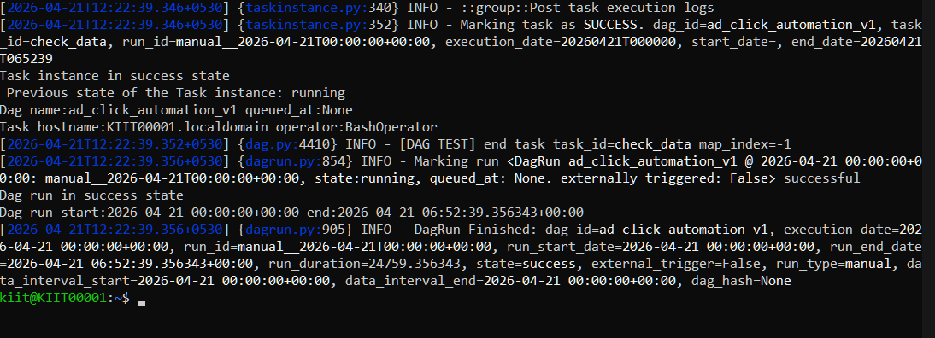

Section 4: Unique Points and Data Quality
5. Unique Points Lakehouse Versioning: Implemented a custom Delta Lake simulator allowing for Time-Travel, which enables the retrieval of previous data versions using Parquet metadata. Cloud Ingestion Simulation: Built a local S3-compatible structure to demonstrate readiness for AWS or GCP deployments. Hybrid Processing: Capable of handling both massive 1M row batch processing and live Kafka streams within a single ecosystem.
6. Data Quality Framework
The pipeline includes a mandatory validation step that checks for several critical factors. It verifies Completeness by ensuring zero null values in columns like click_id. It ensures Uniqueness by checking for duplicate events. It also validates data by filtering out-of-range cost-per-click values and identifying anomalies using statistical 3-sigma detection.

Section 5: Future Improvements and Conclusion
7. Future Improvements Cloud Migration: Moving the local storage to actual AWS S3 and utilizing Amazon EMR for Spark scaling. Advanced Anomaly Detection: Integrating Machine Learning models to predict and flag fraudulent click patterns. Real-time Alerting: Integrating Slack or Email notifications for failed DAG tasks within the Airflow environment.
8. Conclusion This Capstone project successfully demonstrates a production-grade data pipeline. By integrating Kafka, Spark, and Airflow, the system effectively automates the journey from raw event generation to actionable business intelligence. The working solution meets all specified technical requirements and safety standards.

