This procedure is intended to modify the config (Config_ESP32.yaml) of the CN105-2HA module.

Prerequisite :

ESPHome Device Builder add-on is installed on your Home Assistant :

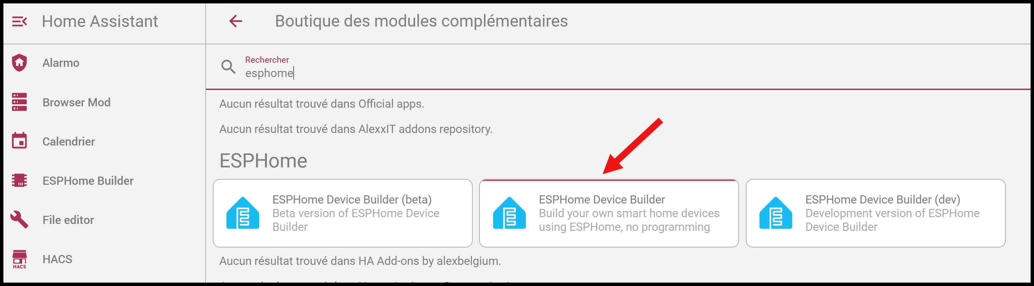

Operating Mode :

Connect the module you need to modify to a PC's USB port or a phone charger.

In Home Assistant / ESPHome Builder integration :

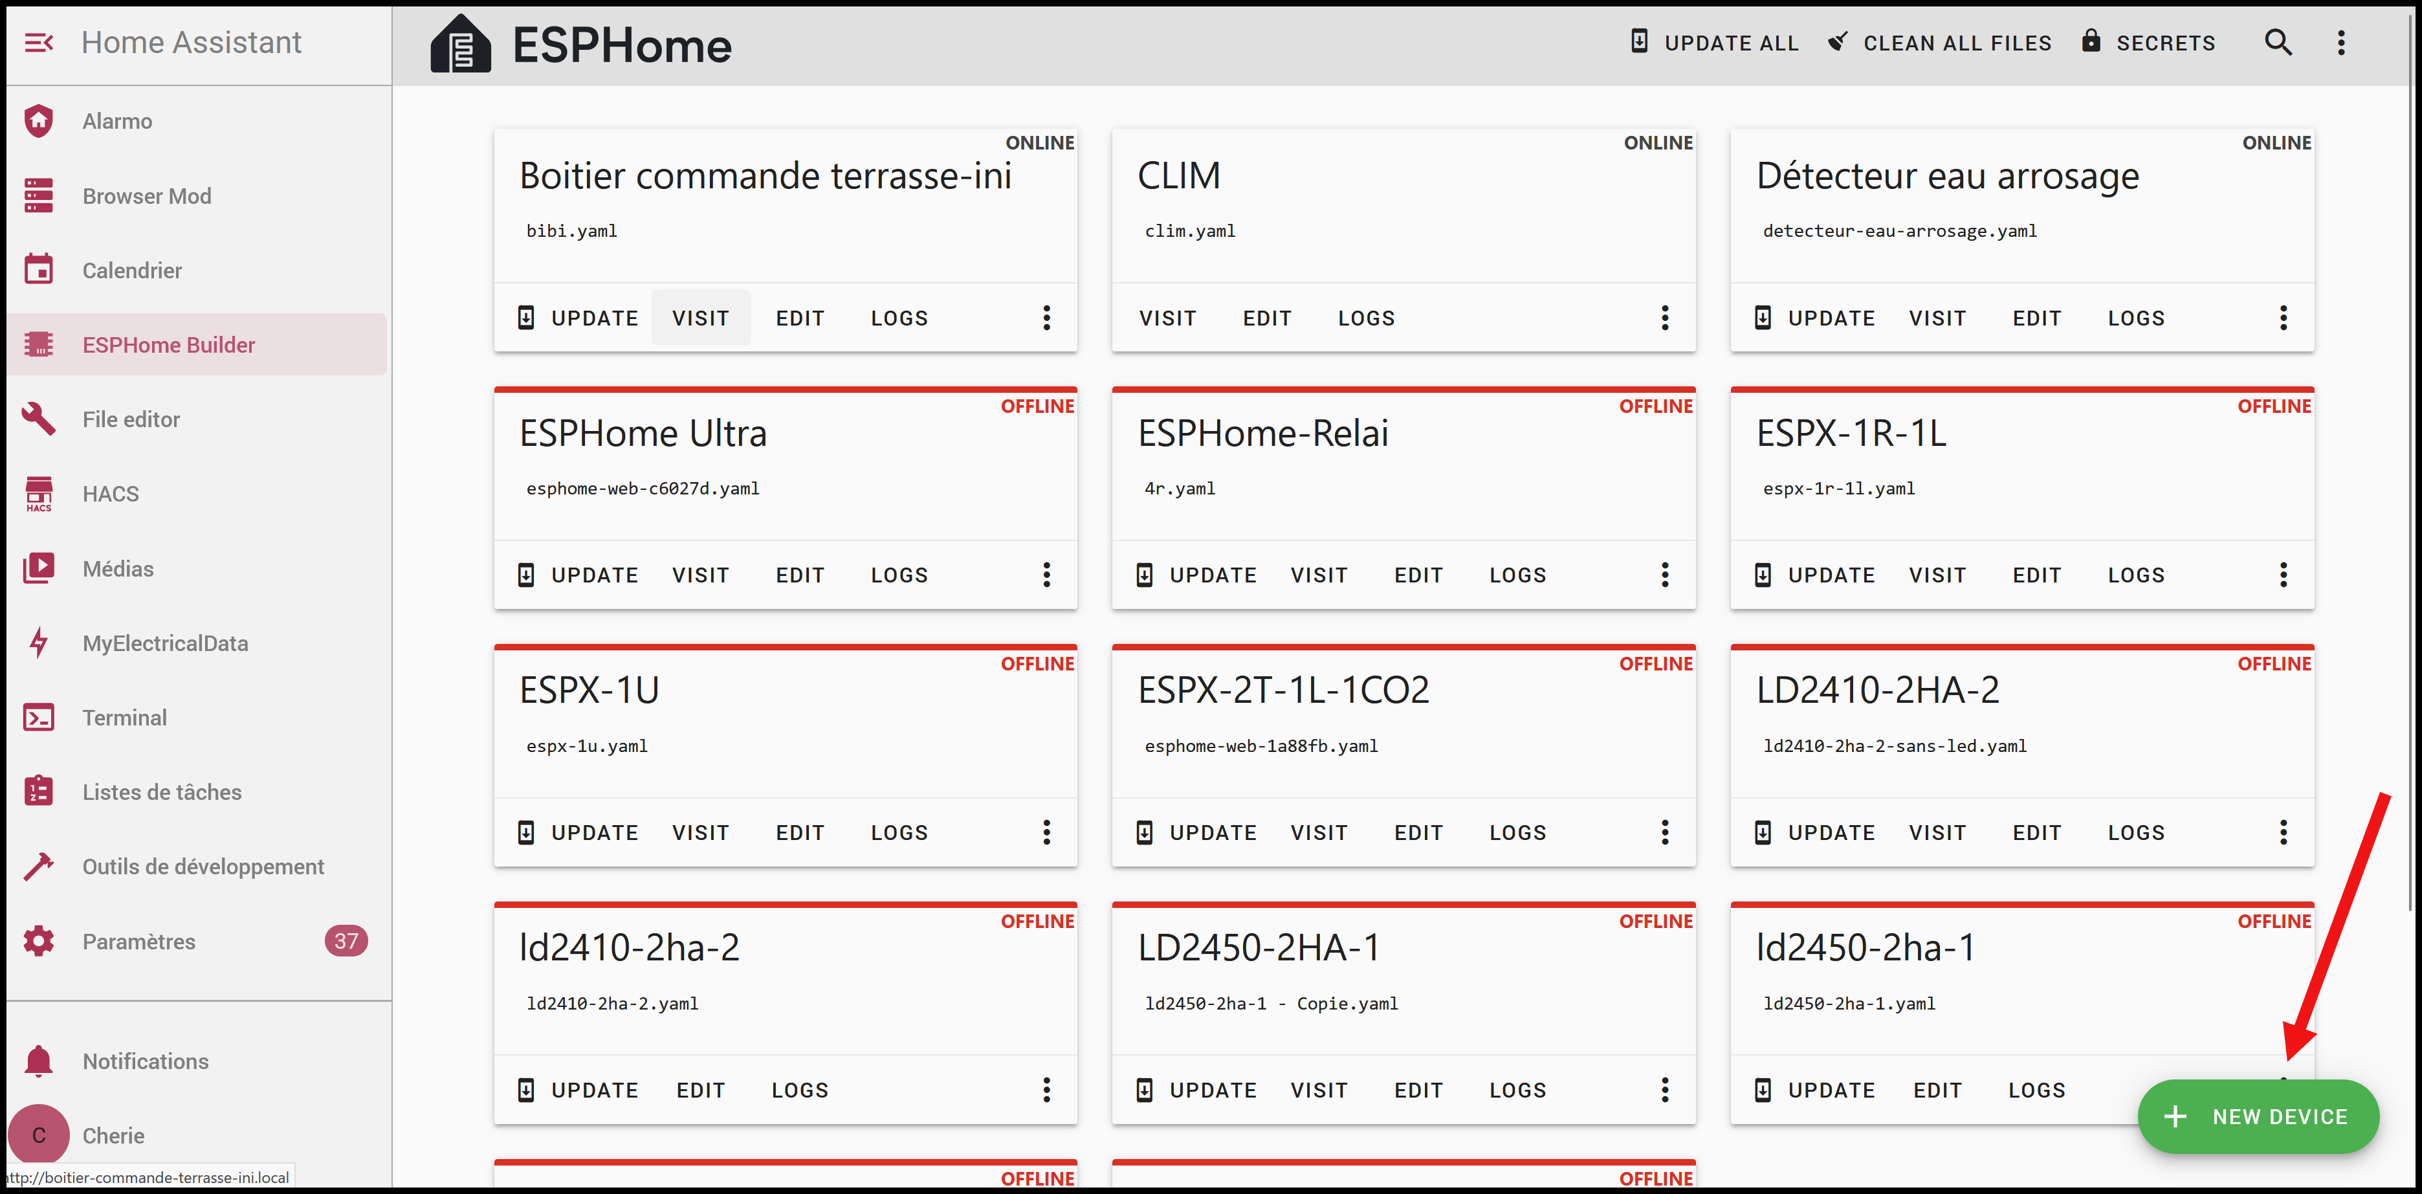

Click on NEW DEVICE :

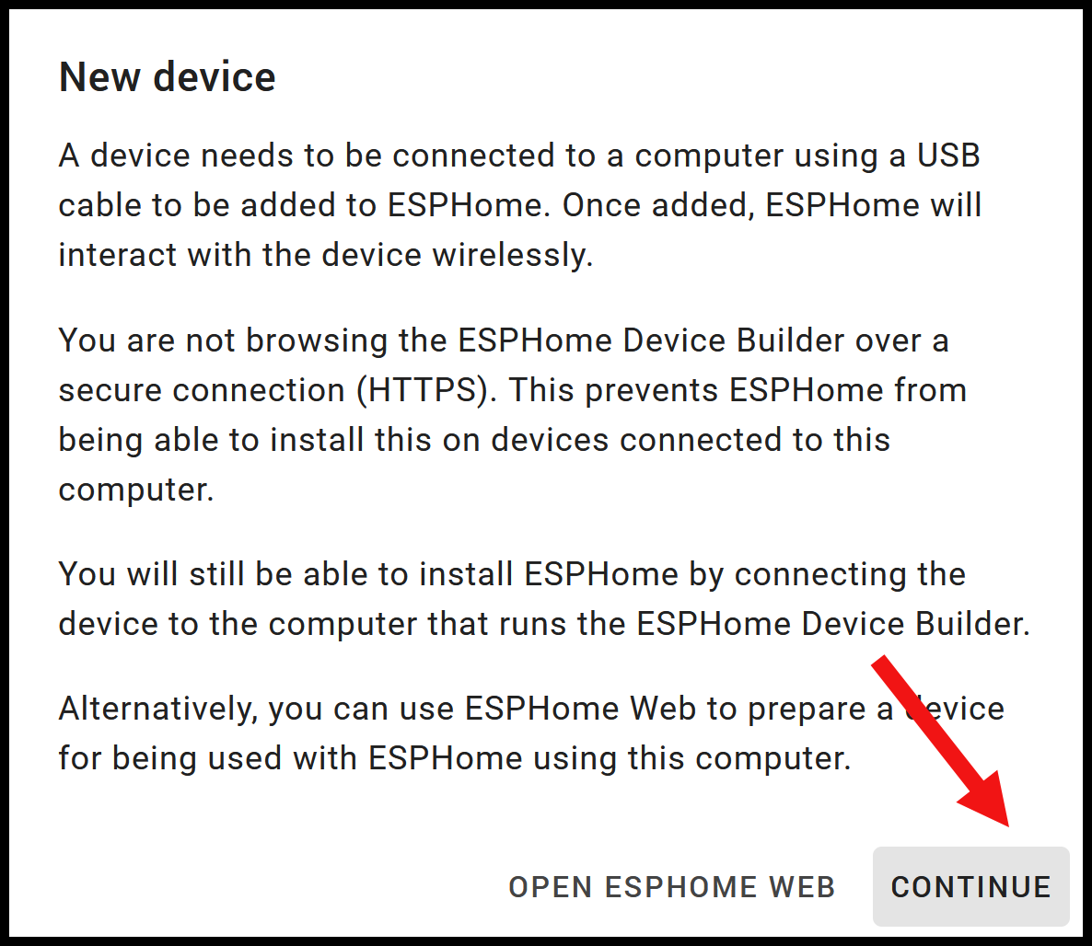

Click on CONTINUE :

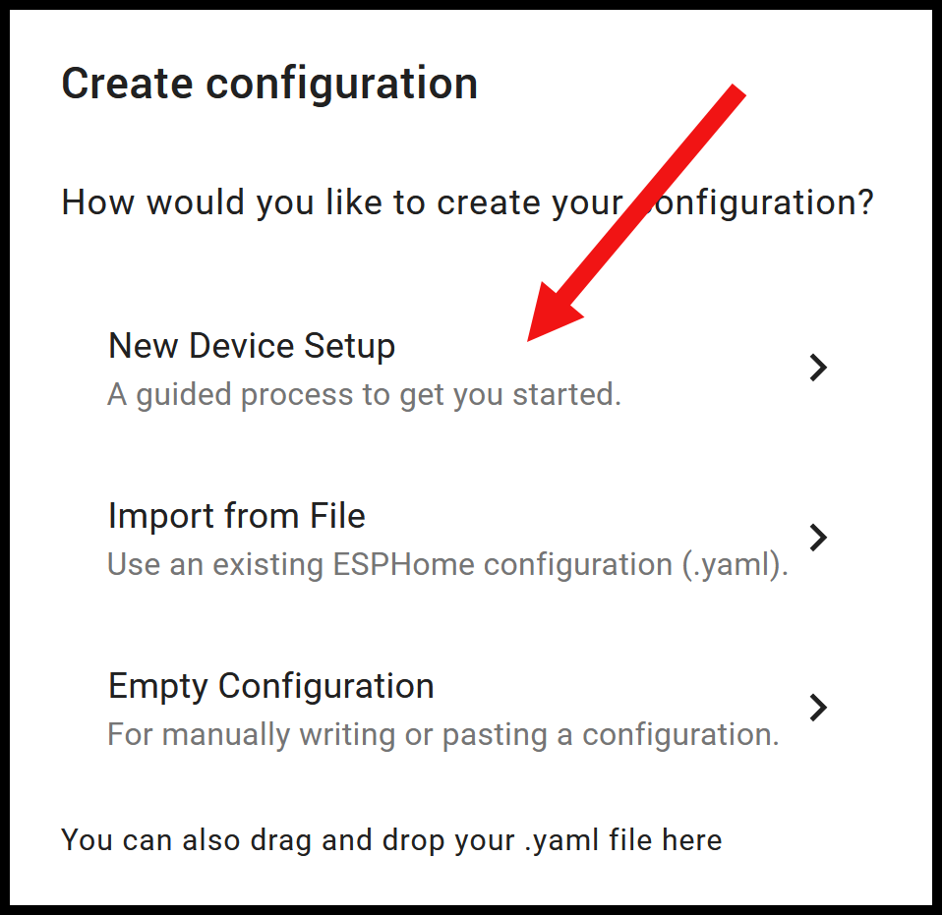

Click on New Device Setup :

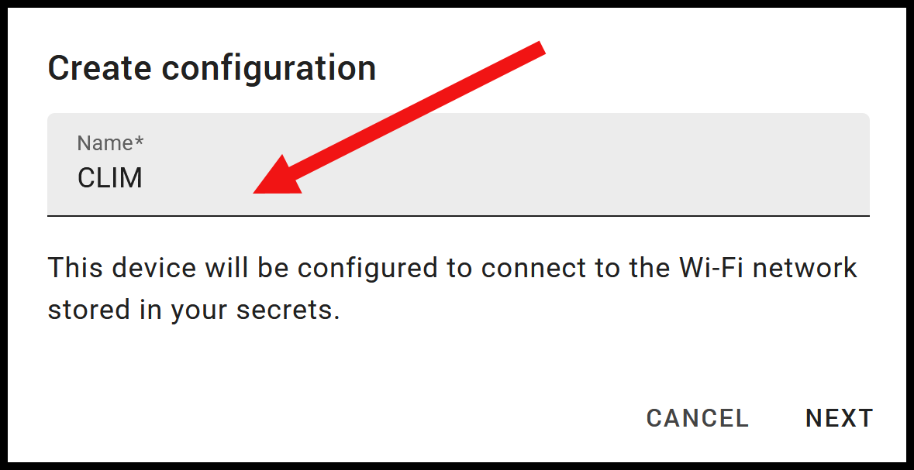

In the Name field, enter the exact name of the module you want to update: CLIM if you purchased a single module, or CLIM_1, CLIM_2, CLIM_3, etc., if you purchased multiple modules.

Click on NEXT :

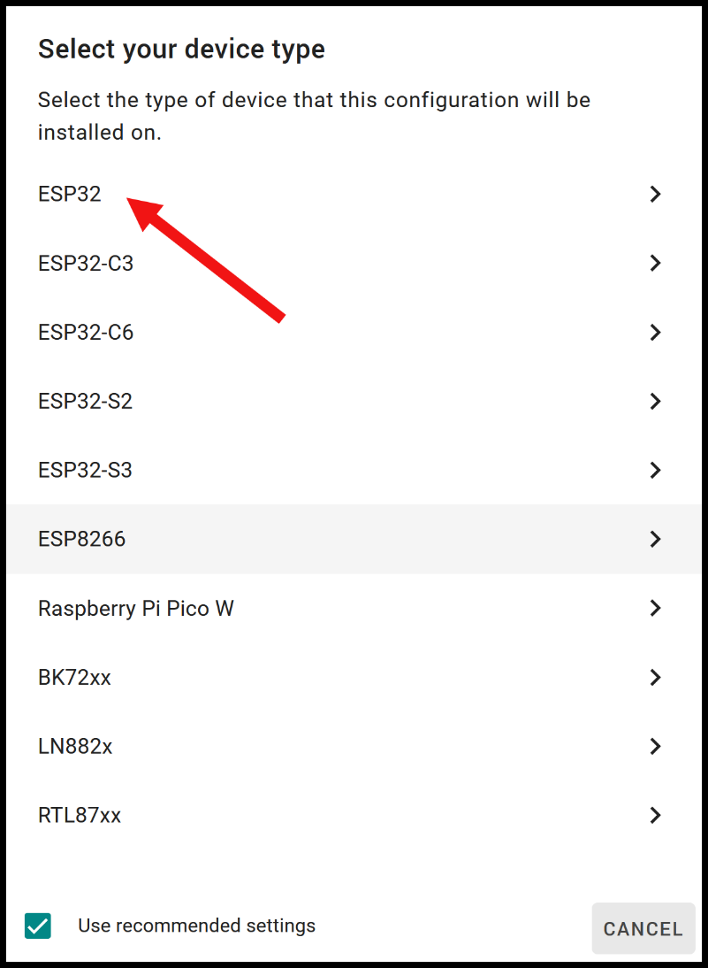

Click on ESP32 :

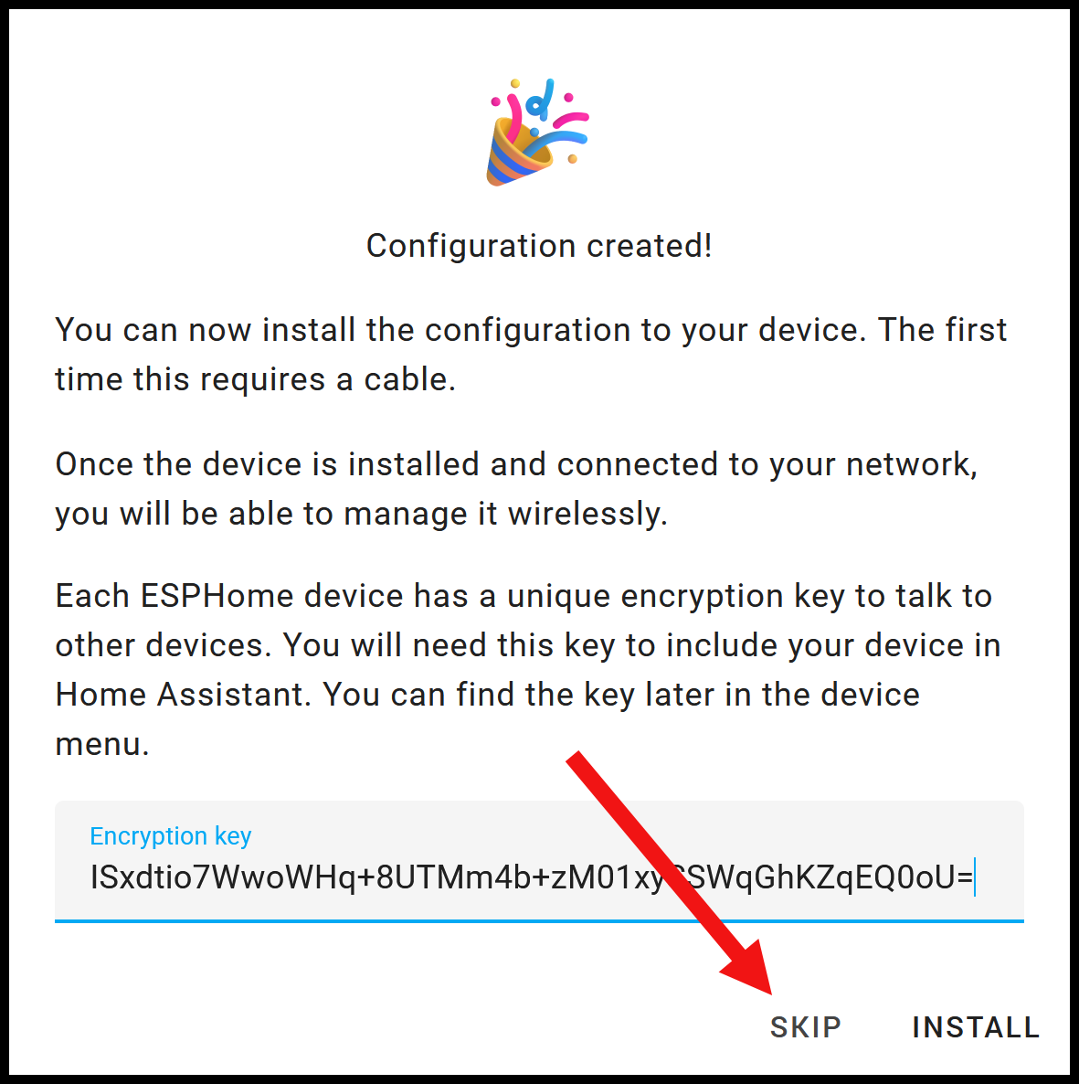

Click on SKIP :

Your device is now created in ESPHome Builder and named CLIM (or CLIM_1, CLIM_2, etc.) :

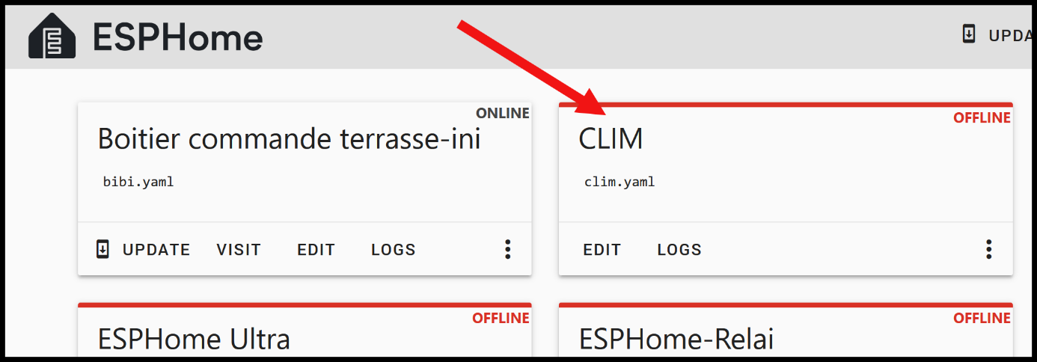

Click on EDIT on the card corresponding to your module :

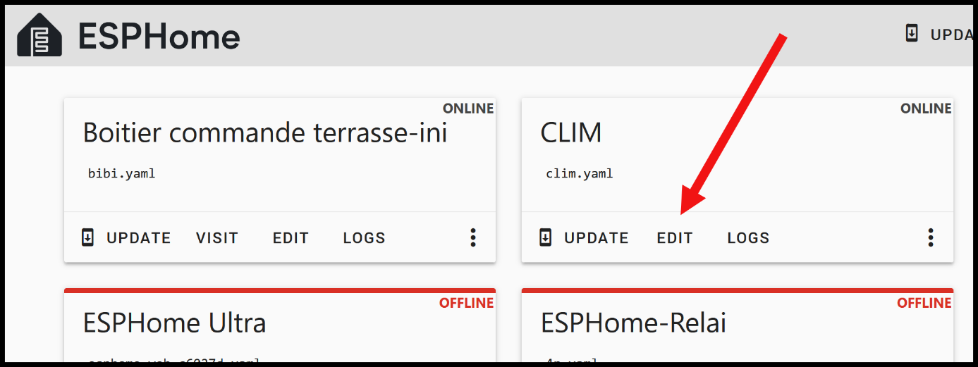

A window will open, delete all the lines in this window and replace them with the content of the following file:

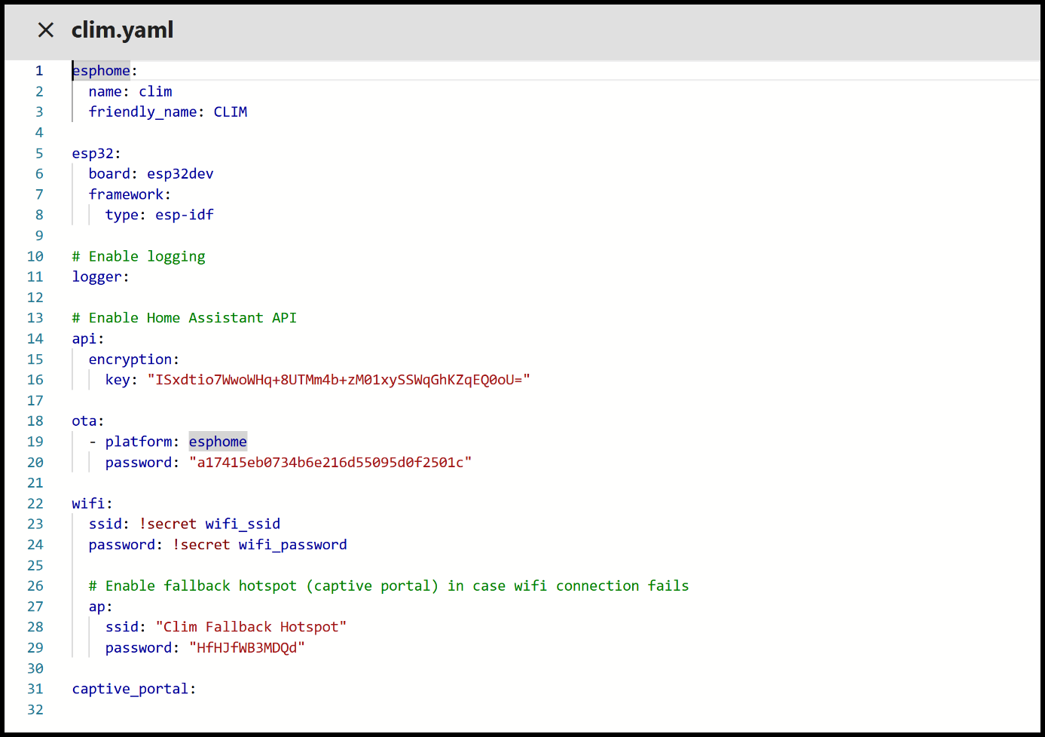

by Config_ESP32.yaml.

If you purchased a single module, its name is CLIM and you have no change to do in the script.

If you purchased multiple modules CLIM_1, CLIM_2, CLIM_3, etc., the following modifications must be done in the script :
Line 2 : change “” to “_1”, to “_2”, to “_3”, … depending of the name of your module.

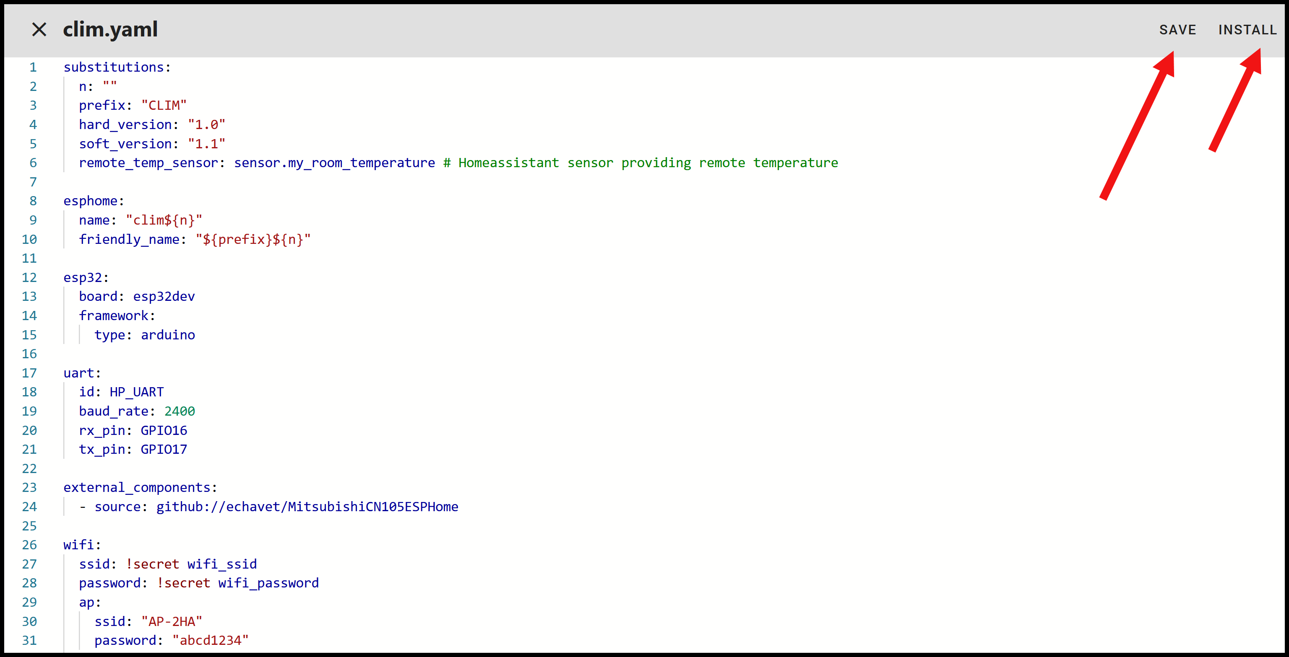

Click on SAVE, then click on INSTALL :

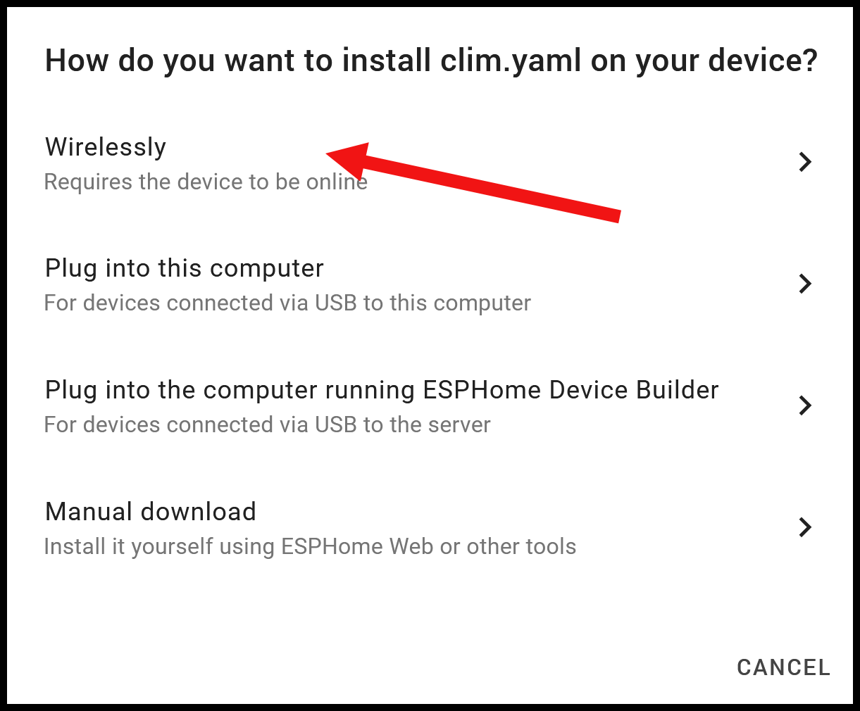

Click on Wirelessly :

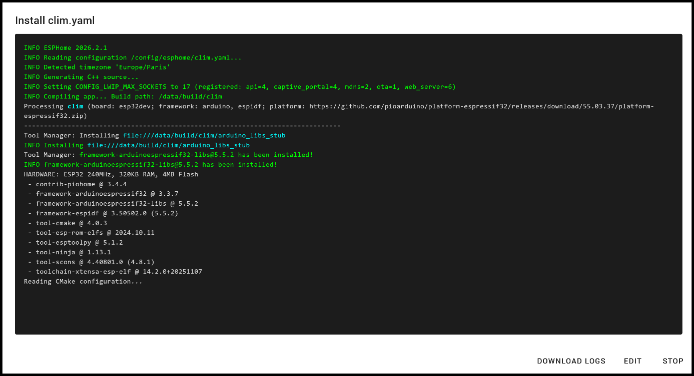

The new software version is installing, wait a few minutes, when the installation is finished, click on STOP :

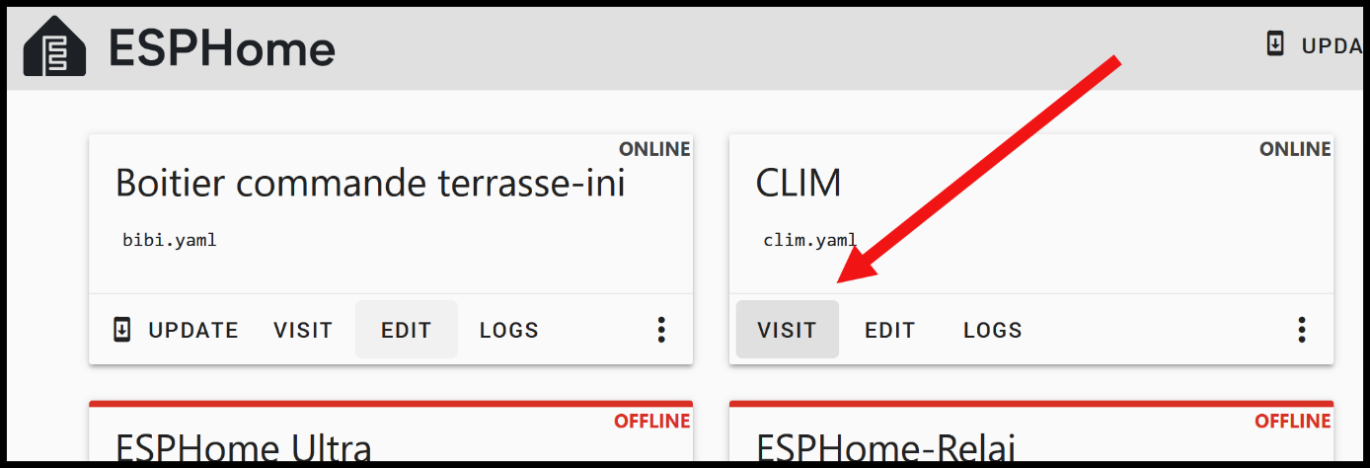

Click on VISIT :

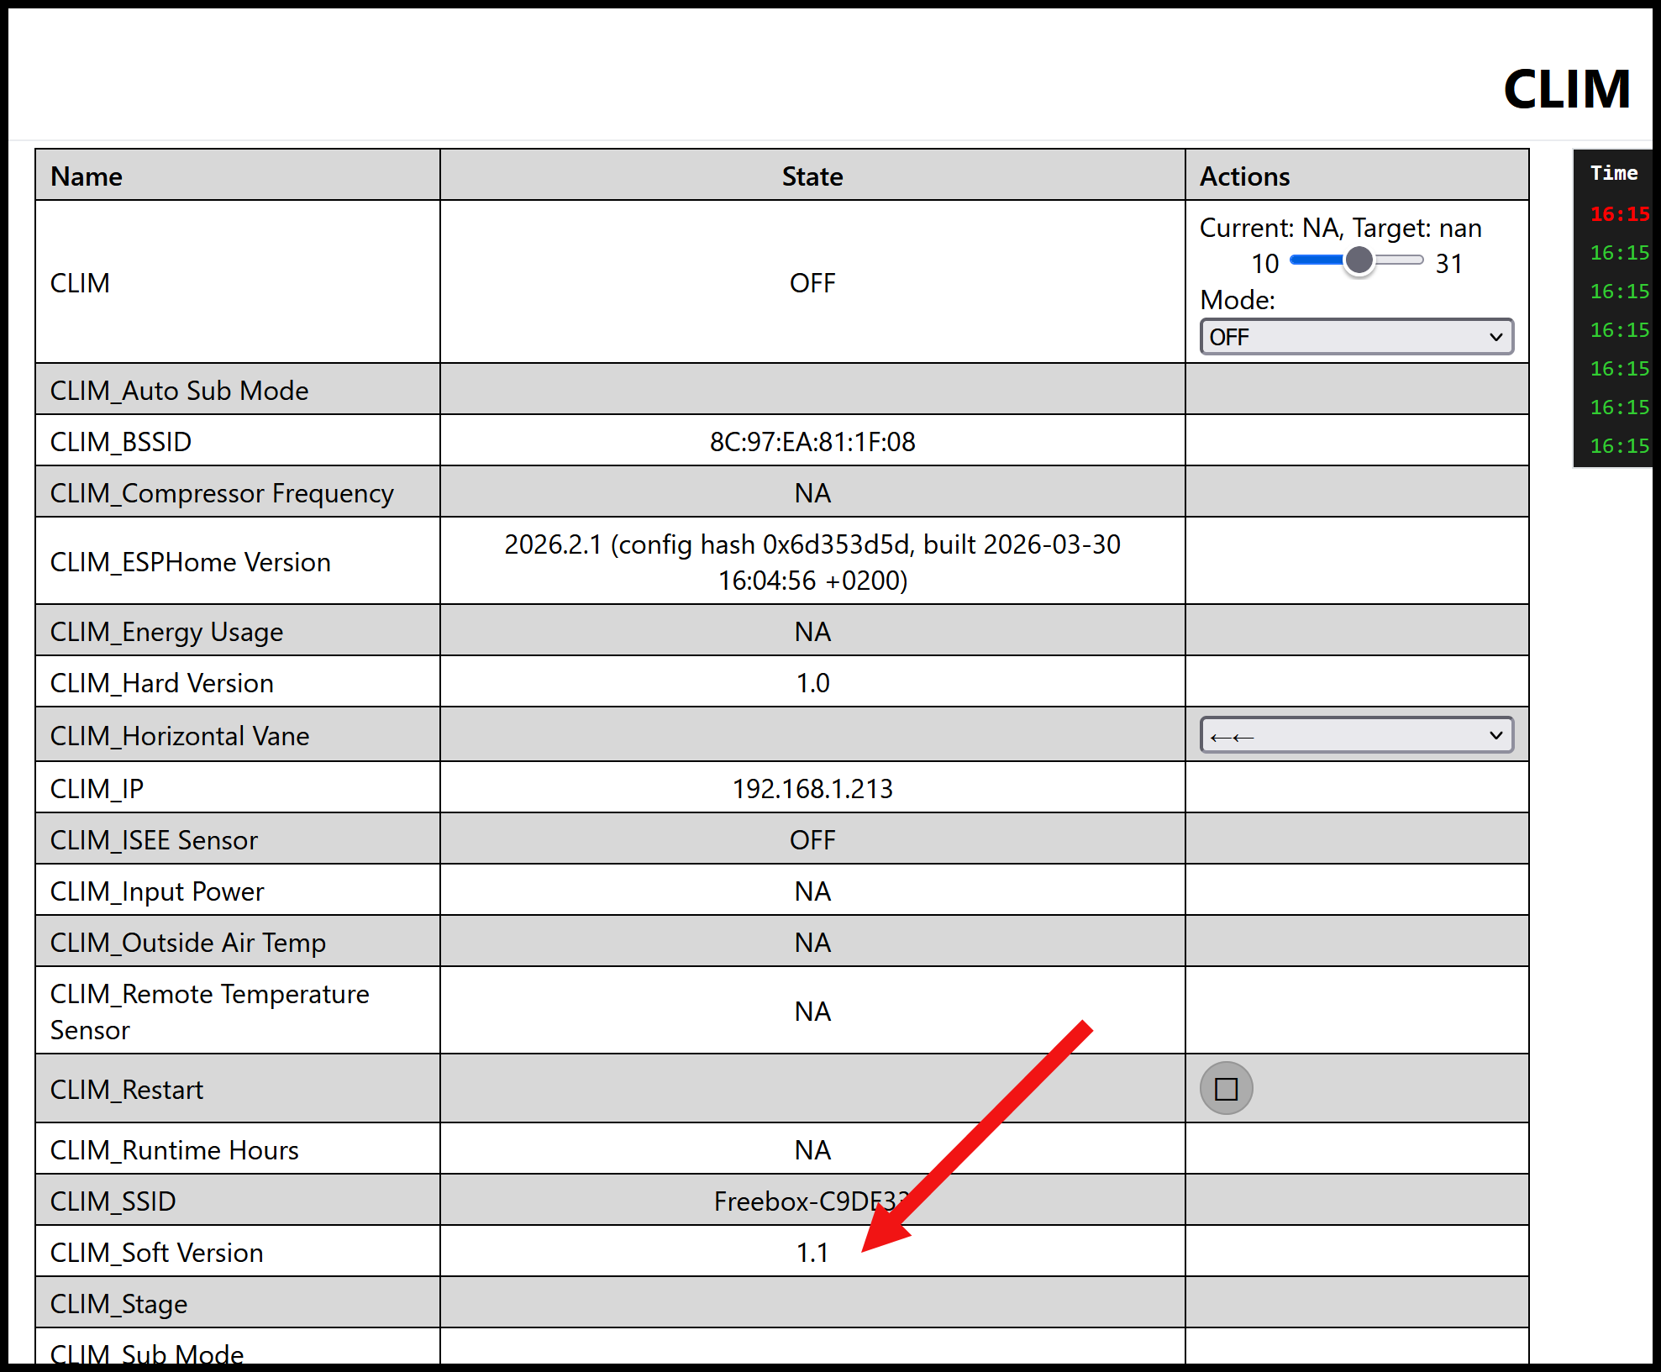

You can now modify the script within ESPHOME Builder via the OTA (WiFi).

