INSTALLATION

This documentation applies to the following devices:

- CN105-2HA
- SCD41-2HA and SCD41M-2HA
- SPS30-2HA
- LD2450-2HA
- LD2410-2HA
- LED10RGB-2HA

Initial Connection of the Module to Your Wi-Fi Network (AP Mode)
To operate in your environment, this module needs to connect to your Wi-Fi network. However, since it doesn't yet know the name (SSID) or the password, it automatically creates a temporary network (known as AP, for Access Point). You will need to connect to this temporary network to provide your Wi-Fi credentials. Once this step is completed, the module will connect to your network and will automatically connect to your network on subsequent startups.

🛠 Steps to Follow
🔌 Plug in the module
Connect it to a USB power supply.
📡 Wait for the temporary network to appear
After some seconds to 3 minutes, a new Wi-Fi network named AP-2HA should appear :
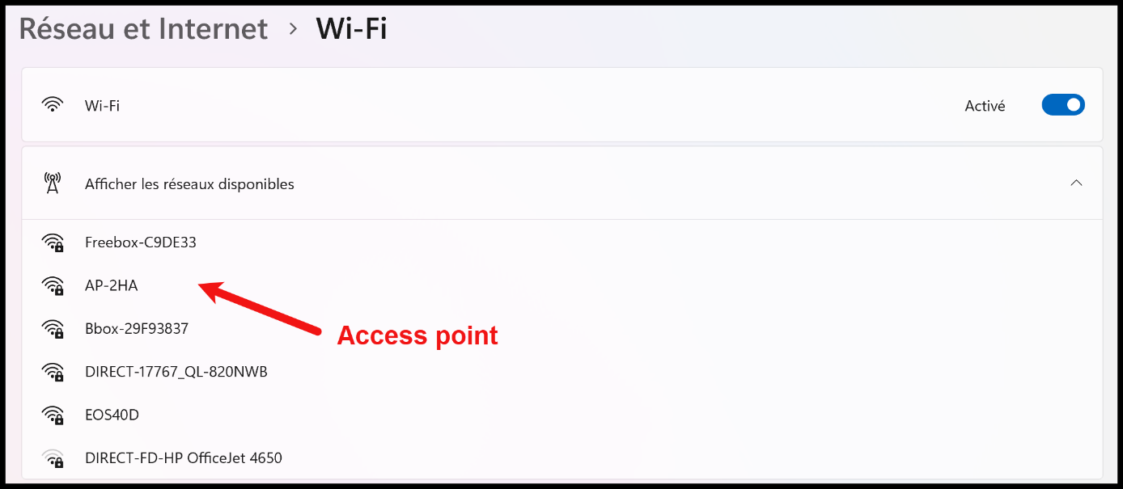

✅ Connect to this network
Select AP-2HA
Press Connect
Enter the following password: abcd1234

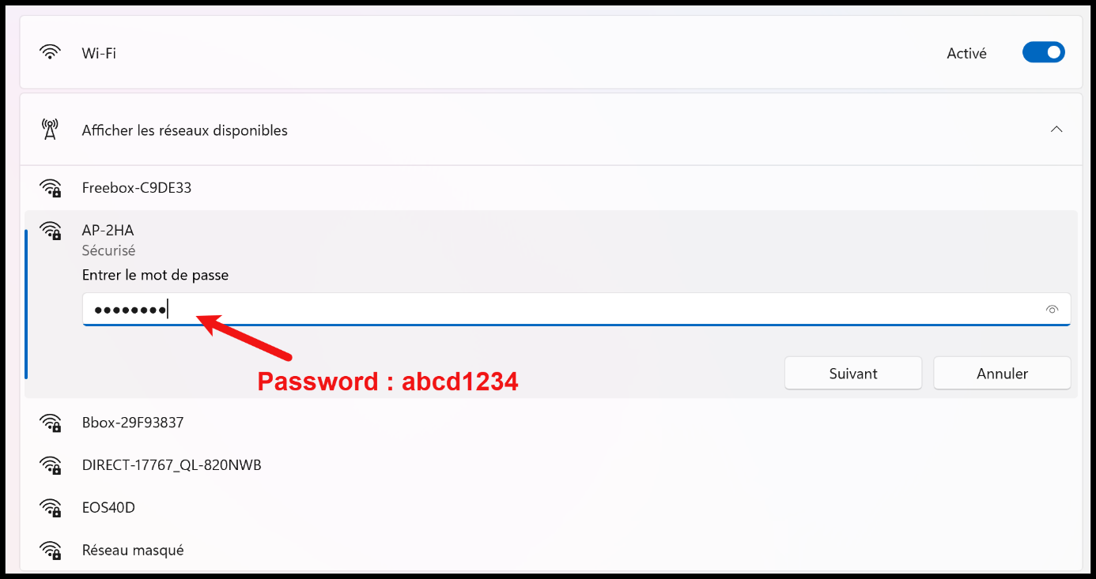

🌐 Access the Configuration Interface
Once connected, a page may automatically appear.
If this is not the case :
Open a browser (Chrome, Safari...)
Type this address in the address bar: http://192.168.4.1 This will be the address in all cases during this initialization phase.

🔒 Enter Your Wi-Fi Credentials
This page or something like that should display :

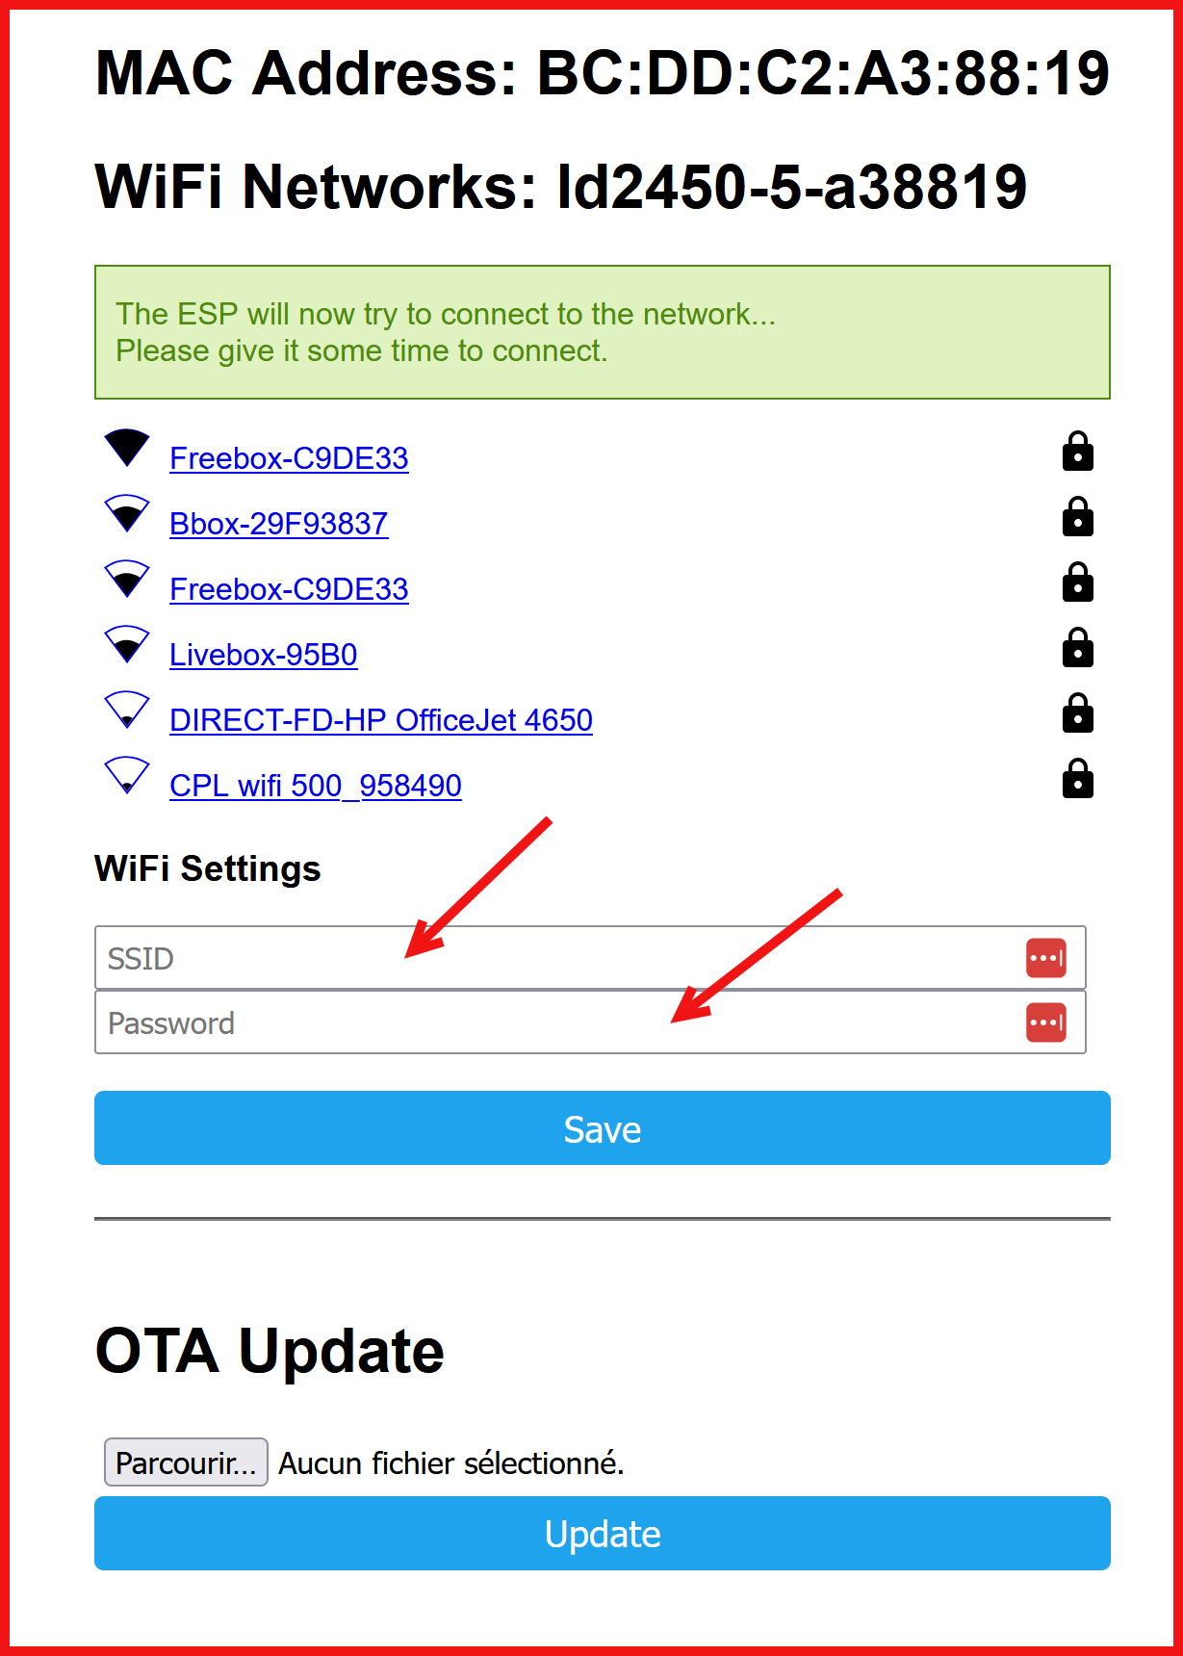
Enter:
Your SSID (Network Name)
Your WiFi Password

Press Save

A message should confirm the successful connection to the Wi-Fi.
⚠️ Important Note : It may happen that this procedure does not succeed on the first attempt (difficult connection, too long delay...). In this case, it is necessary to repeat: unplug/replug the module, reconnect to the AP-2HA network... until you can enter the network credentials from step 5.

Integration of the Module into HA
Prerequisites : have the ESPHome integration installed within Home Assistant. Important : it is the ESPHOME integration and not ESPHOME Builder application !!!

Go to Parameters - Integrations and click as indicated below:

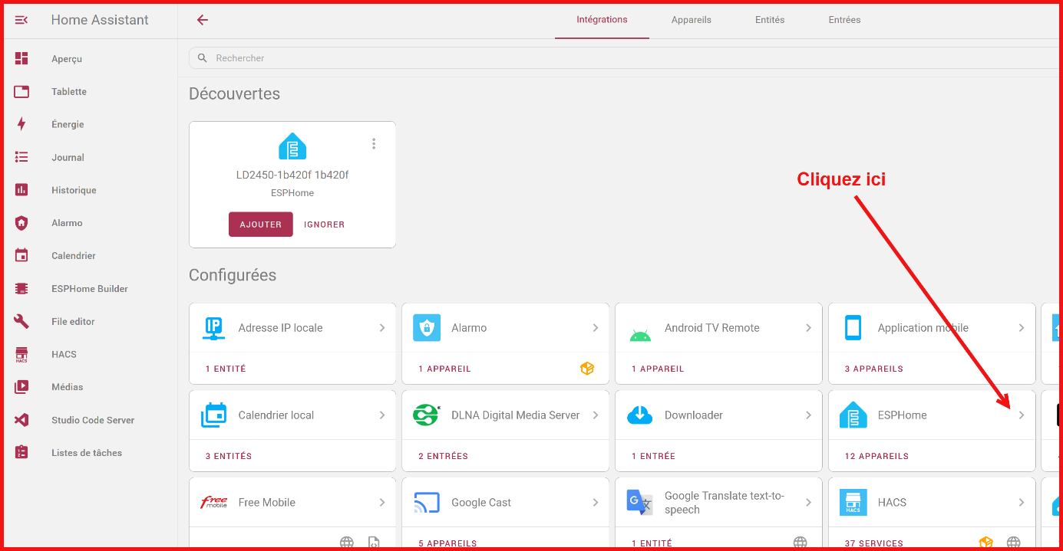

This page should display :
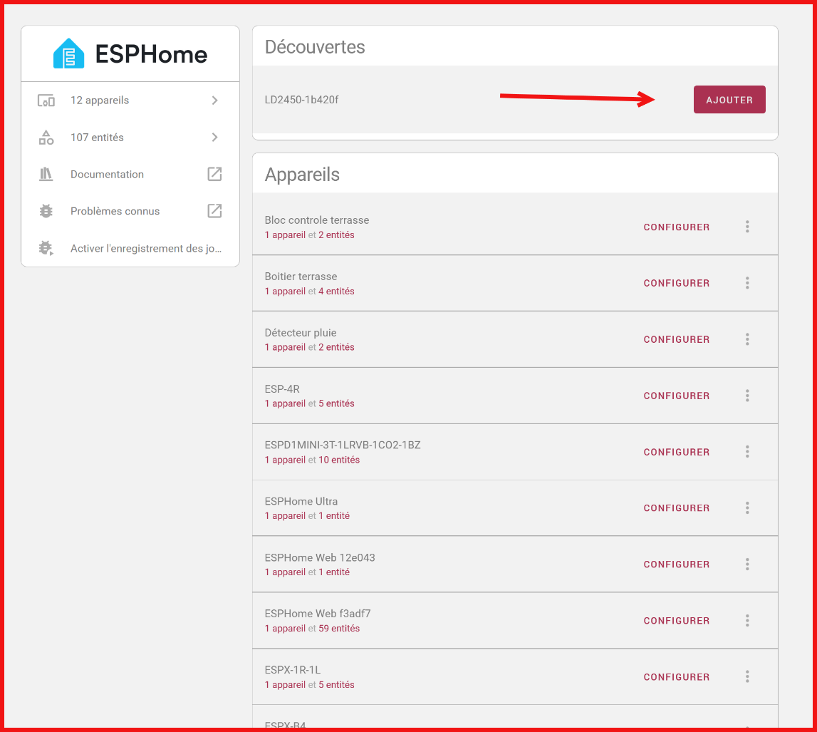

In the Discoveries section, you should see your module; if so, press Add.

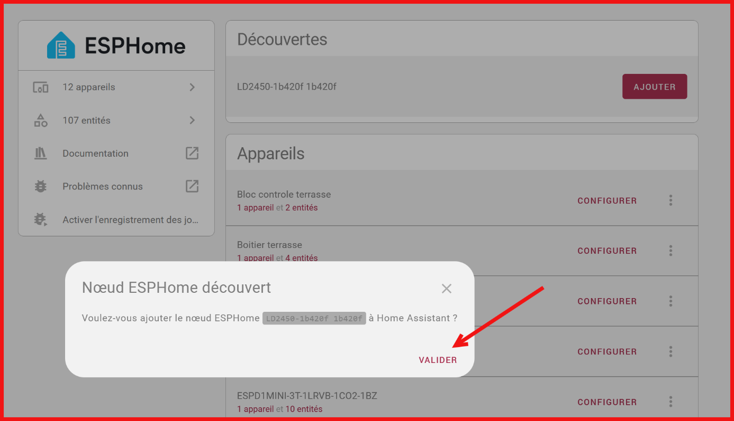

Then click on Validate.

A message will quickly appear, then you can assign a room (living room, bedroom...) to your module.

Then your module should appear in the list of devices :
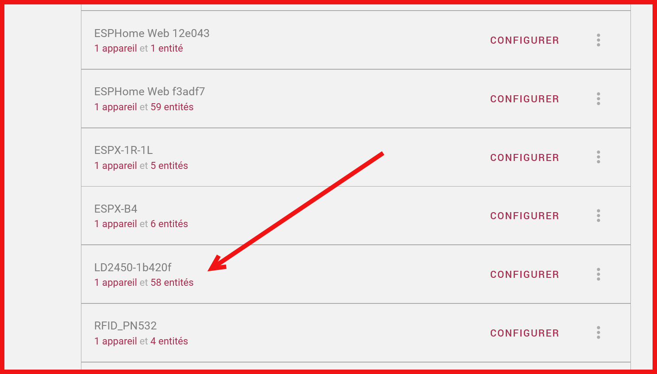

Click on 1 device to see the entities and information of the module:

For the Mitsubishi Air Conditioner Controller, you should see :

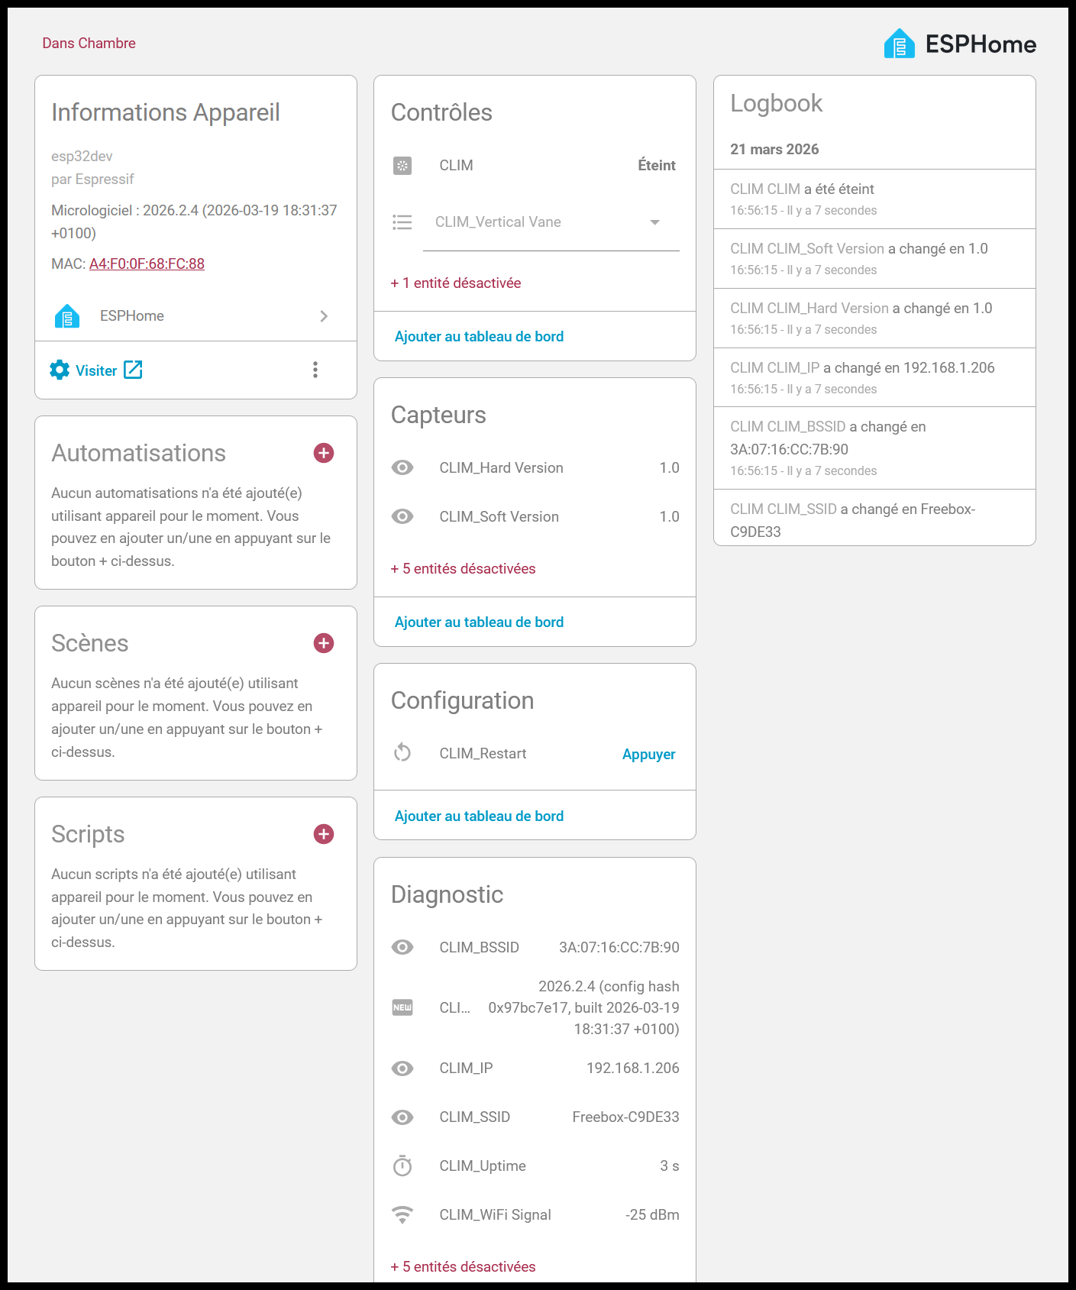

For SPS30-2HA you should see :

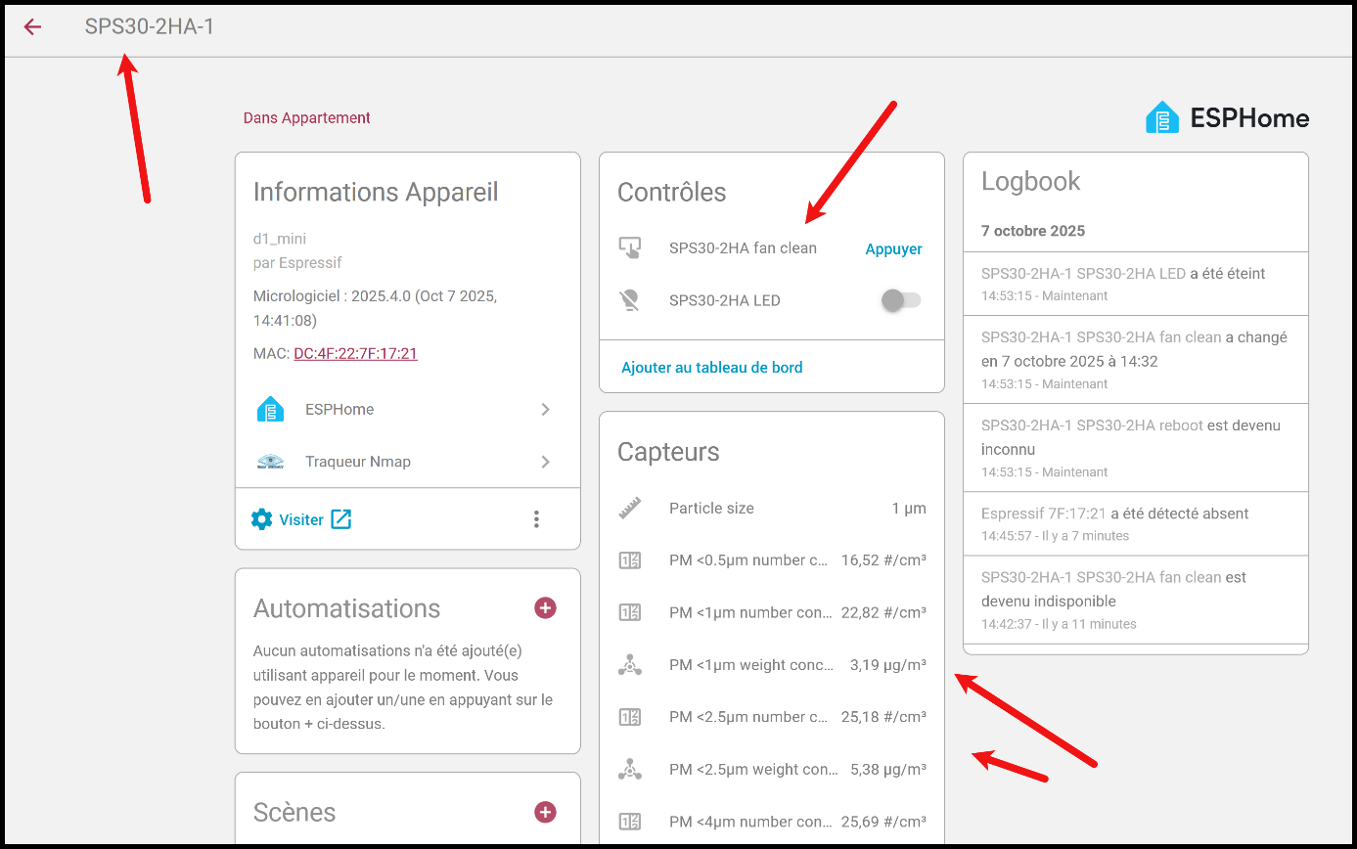

Important note : several users have told me that at the startup, the CN105-2HA module sometimes does not connect properly to the Mitsubishi device. The workaround is to trigger the CN105-2HA module reset procedure using the entity : button.clim_x_restart.

