Tick Tick: Boom!
By Stefan Huneker(1082868) and Philip Tap
Tick Tick: Boom! is an extension to the original Tick Tick game. The game was expanded with, among others, a level editor, larger levels and improved physics. You can find all additions and adjustments in this document.

The level editor
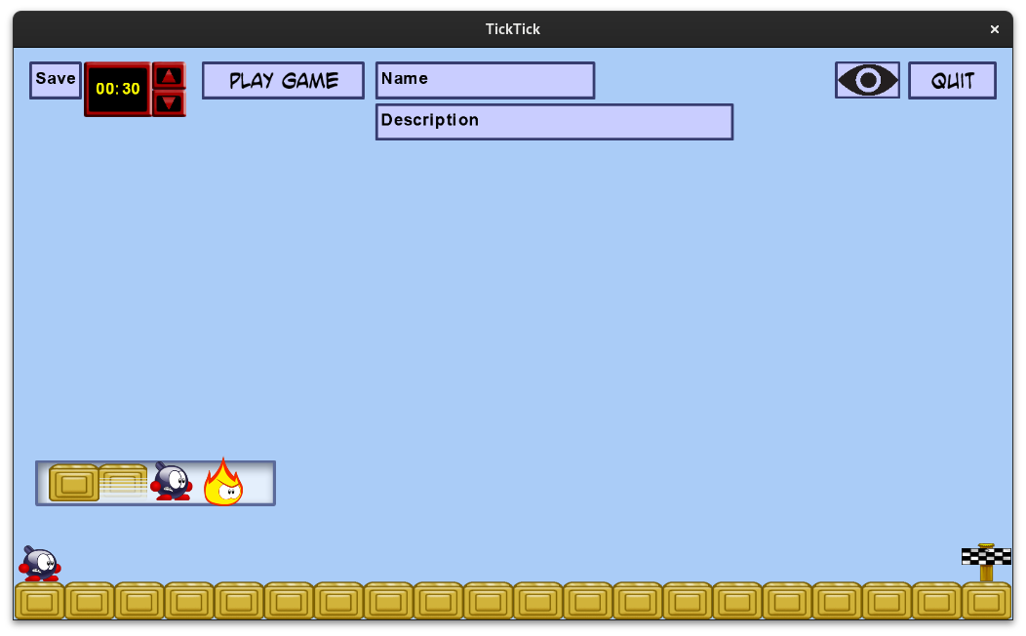
The game includes a level editor. To open it, select Editor from the main menu. In the editor, use the left mouse button to place the selected item and use the right mouse button to delete the selected tile. Use the arrow keys to move around.

Use the save button to save your current level. You will know it has worked if your view moves.

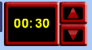
Use the time controls to change the level timer. The timer increases or decreases by 10 each time, with more precise control under 10 seconds. You timer cannot be lower than 1 second.


Use this button to play the current level loaded in the editor. This will not save it, so use the Save button to make the changes permanent.


Use these buttons to select the name and description. Click either one and start typing. Hit enter to confirm.


Use this button to hide certain other buttons. This gives more space to your level. Simply press it again to return to the default view.


This button brings you back to the menu. Be careful, as it will not save your progress.

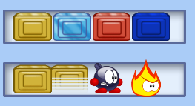
The dock is the most important part of the editor interface. First, click a category: tiles, platforms, level objects or enemies. Then click the desired object. You can now place any number of this objects by clicking or dragging with the left mouse button. Note that you can place only one player and one goal.

Custom level select
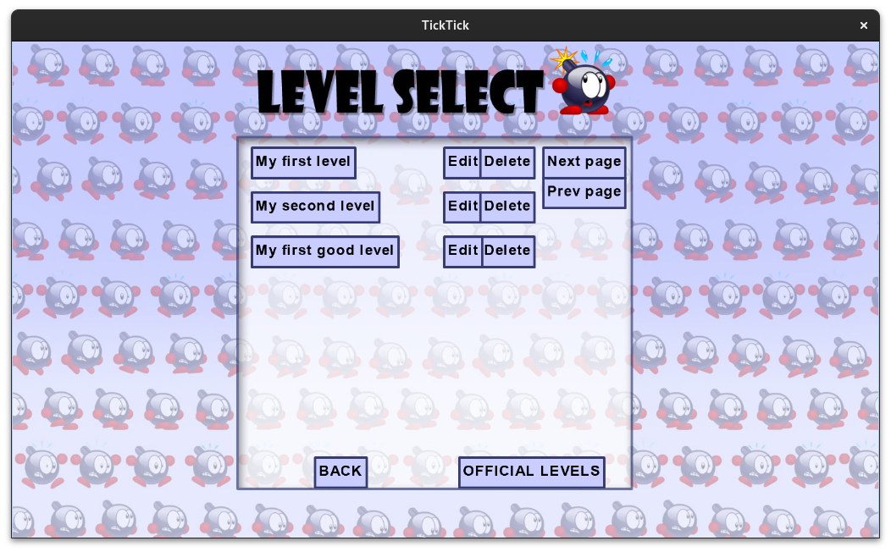
After you saved your custom levels, they will be visible in the custom level select. Simply press PLAY GAME and then CUSTOM LEVELS. You can also find these as txt files in the directory Content/CustomLevels (if you are compiling it yourself, it will likely be /bin/Debug/net6.0/Content instead). You could even share these levels with your friends by making a copy of the file.
To play a level, simply press its name. You can press Edit to open it in the editor. You can delete it by pressing Delete. The file will be marked for deletion. All marked files will be permanently deleted when you return to the title screen. If you change your mind, you can press Keep to remove the mark.
If you love making levels so much that that you get more than 6 of them, they will appear on different pages. Press Next/Prev page to cycle through all your pages.

Physics improvements
The controls of the original Tick Tick may feel a little jarring. This is because it lacks common quality of life improvements to make the game feel more fair.

Coyote time
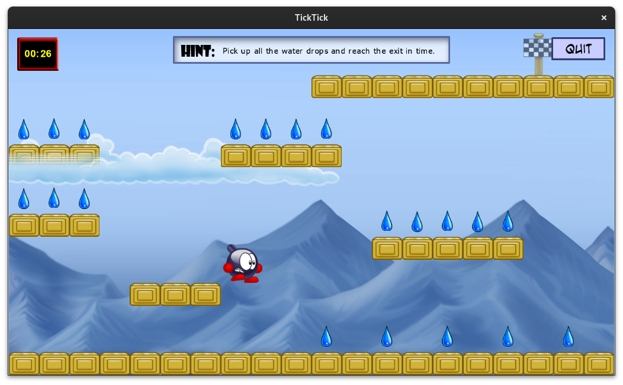
Named after the classic Loony Tunes character, coyote time gives some leeway to nail your jumps. By allowing the player to walk over the air for a brief moment, they will not tragically yet comically run off the platform when preparing a jump.

Jump buffering
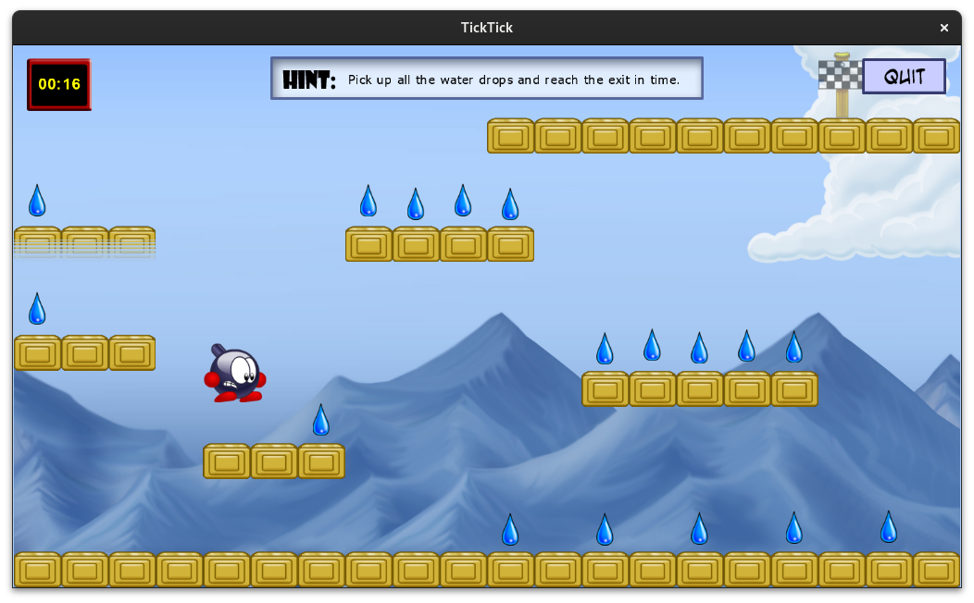
Jump buffering allows the player to press the jump just before falling on a platform, while still registering as a jump. This feels especially great when the player is in a hurry, like when running away from an enemy.

Variable jump strength
One of the most glaring omissions in the game is the variable jump strength. This allows the player to adjust their jump strength by holding and releasing the jump button. Platformers just don’t feel right without it.

Miscellaneous

Jumping on rockets
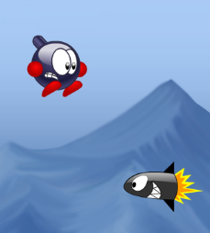
You can now jump on rockets to defeat them! Hold jump to get an even bigger boost!

Scrolling screen
Levels are not limited to just one screen anymore. Especially nice now that you can create your own levels! You might also noticed we added parallax scrolling to the background.

Blue speed tiles
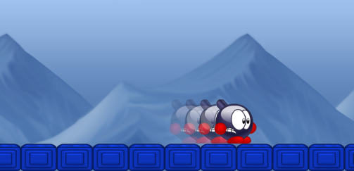
These tiles will give you a temporary speed boost.

Pause screen
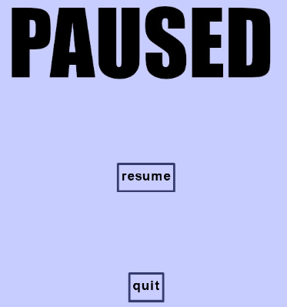
Pressing Quit now brings you to the new pause screen.

New levels
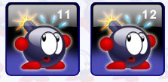
We added two new difficult (that’s code for garbage) levels.

Some smaller changes
- We have changed some of the sound effects and the explosion animation.
- Stepping on a hot tile now gives more feedback.
- The goal is now transparent if you have not collected all droplets yet.
- Enemy collisions are slightly more forgiving.
- The flame enemies now have different colors depending on their behavior.
- The jump animation looks different somehow (NOT A BUG NOT A BUG)

Some more technical changes
You might not see these in gameplay, but they helped us create the other features!
- We fixed a bug where you could win and lose at the same time.
- The amount of clouds is now based on the width of the level.
- The second text line in the level format is now used for the time limit.
- Buttons can now have custom text and will resize dynamically.
- Textboxes can also resize dynamically.

