

Pisa University  
  
  
TASK 1  
LARGE-SCALE AND MULTI-STRUCTURED DATABASES

**feasibility study for a Key-Value traslation of the database model**  
academic year 2019-2020  
  
  
  
  
stefano petrocchi, Andrea Tubak, Francesco Ronchieri, Alessandro Madonna

Summary

Study 3

Application 3

Description 3

Load 3

Key-Value Model 3

Characteristics 3

Disadvantages 4

Suitable Data Types 4

LevelDB 4

Entities Analyses 5

User 5

Film 5

Cinema 6

Comment 6

Projection 6

Conclusion 6

Entities suited to a relational database 6

Key-Value recommended Entities 7

# Study

## Application

### Description

PisaFlix is an application that helps people to find the best place to watch a movie within Pisa. It provides all of the information regarding cinemas, films that are going to be projected and projection schedules. Users can also express their opinion by writing comments and adding favorites both to cinemas and films.

### Load

The following list contains some estimates useful to understand the order of magnitude of the load that will affect our application:

* Pisa is a medium sized Italian city and it has a population of nearly 100˙000 inhabitants (including foreign students).  
  Is estimated that about 50% of people in Italy goes to cinema at least once a year.
* Are estimated 1˙000 daily active users.
* Seven cinemas are located in Pisa, one of them has multi-room.
* About 50 new film are estimated to be projected every month.
* Cinemas are open every day from 3:00 pm to 1:00 am and we estimate 5 projection for each room of a cinema every day.

These are the numbers to consider for the future scalability of the application.

## Key-Value Model

### Characteristics

A ***key****-****value*** store is a database which uses an array of *keys* where each key is associated with only one *value* in a collection. The *key-value* stores usually do not have query languages as in ***relational databases*** to retrieve data. They only provide some simple operations such as get, put and delete.

*Key-value* databases work in a very different way from *[relational databases](https://en.wikipedia.org/wiki/Relational_database" \o "Relational database)*. *RDBs* pre-define the data structure in the database as a series of tables containing fields with well-defined [data types](https://en.wikipedia.org/wiki/Data_type). Exposing the data types to the database program allows it to apply a number of optimizations. In contrast, *key-value* systems treat the data as a single opaque collection, which may have different fields for every record. This offers considerable flexibility and more closely follows modern concepts like [object-oriented programming](https://en.wikipedia.org/wiki/Object-oriented_programming). Because optional values are not represented by placeholders or input parameters, as in most *RDBs*, *key-value* databases often use far less [memory](https://en.wikipedia.org/wiki/Computer_memory) to store the same database, which can lead to large performance gains in certain workloads. Furthermore, in contrast with the *RDBs* that provides an *ACID* transaction model, a *BASE* approach is better suited for *key-value* databases.

### Disadvantages

Disadvantages of *key-value* models:

* The only queries that are efficient are simple, one-row-at-a-time queries.
* Is not really a data model, indeed there is no association between attributes that form an entity.
* Is hard to use most ordinary SQL operations such as JOIN or GROUP BY.
* There isn’t a possibility to choose an appropriate SQL data type for the value.
* There isn’t a possibility to use many SQL constraints such as FOREIGN KEY or NOT NULL.
* A lot more application code is needed to reassemble collections of *key-value* pairs into objects.

### Suitable Data Types

Types of data suitable for storing in a key-value pair:

* **Data of indeterminate form:** For example, each HTML page  is different. Defining a schema for such page is complex. Since relational databases expect a schema, it is not possible  to store the HTML page. *Key-value* data-store does not require a schema and it would be a best fit for such data.
* **Data of huge size and quantity:**  *RDBs* are optimized for small rows that supports table fitting within a single server. In contrary Key-value data-stores support storing large objects with huge quantity, spread across multiple servers.
* **Unrelated Data:** Application might require storing unrelated data which is not suitable to be stored in  *RDBs*. Since Key-value data stores are not based on relations, storing such unrelated data is supported.

### LevelDB

***LevelDB*** is a *key-value* store built by Google. It can support an ordered mapping from string keys to string values. The core storage architecture of LevelDB is a log-structured merge tree (LSM), which is a write-optimized B-tree variant. It is optimized for large sequential writes as opposed to small random writes.

*Key-value* store supports the mapping from the key to the corresponding value. In SSTable the layout of key and value is managed as adjacent string sequence.

## Entities Analyses

In order to evaluate if some of the entities that populate our database are suitable to be stored on a key value database; let us analyse the structure and the scale of the number of transaction related to each entity.

Considering the database entities schema of the application:

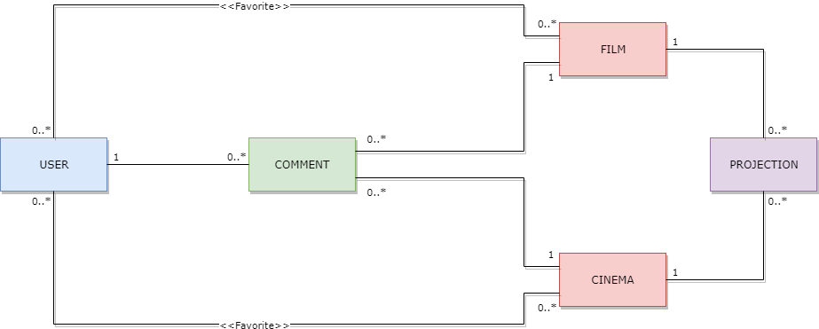

### User

***User***entity represent a client or a not-technical administrator of the application. The information contained in this entity regards app login information, registry information and privilege level information. That information is small size data that can be naturally organized in a tabular form.

*User* is related with *Comment*, *Film* and *Cinema* entities.

An estimate of the typical transactions load for this entity in a day is:

* *Very small* number of ***write*** transactions (profile creation, deletion or modification).
* A number of ***read*** transactions less then active users ( $±$*500* logs in).
* A number of new ***favourite*** cinema and film similar to that of log in.

### Film

***Film*** entity represent a film and its description. The information contained in this entity can be of indeterminate form and dimension (i.e. for the description).

*Film* is related with *User*, *Comment* and *Projection* entities.

An estimate of the typical transactions load for this entity in a day is:

* *Very small* number of ***write*** transactions (small number of new films every month).
* A number of ***read*** transactions slightly greater than the number of active users ( *> 1˙000* ).

### Cinema

***Cinema*** entity represent a cinema and few general information. That data is small sized and can be naturally organized in a tabular form.

*Cinema* is related with *User*, *Comment* and *Projection* entities.

An estimate of the typical transactions load for this entity in a day is:

* *Insignificant* number of ***write*** transactions.
* A number of ***read*** transactions slightly greater than the number of active users ( *> 1˙000* ).

### Comment

***Comment*** entity represent a user comment. The information contained in this entity can be of indeterminate dimension.

Comment can be related to cinemas and films but forms of comment that are nested or related to other entities could also be implemented.

An estimate of the typical transactions load for this entity in a day is:

* A number of ***write*** transactions similar to that of log in ( $±$ *500* ).
* A number of ***read*** transactions largely greater than the number of active users (*>>> 1˙000* ).

### Projection

**Projection** entity represent the information of a single projection of a specific film in a specific cinema. That data is small sized and can be naturally organized in a tabular form.

*Projection* is related to *Film* and *Cinema* entities.

An estimate of the typical transactions load for this entity in a day is:

* $±$*100* ***write*** transactions (five projection for a cinema room daily).
* A number of ***read*** transactions greater than the number of active users ( *> 1˙000* ).

## Conclusion

### Entities suited to a relational database

From the entities analysis it has emerged that both read and write transactions regarding *User*, *Film* and *Cinema* entities will have a limited impact on the overall performance of the application. Even foreseeing a strong expansion of the application, a relational database will be able to handle this load just fine.

Furthermore, those entities are strongly related to each other; e.g. the possibility for a user to have favourite cinemas and films introduces the need to keep this relationship updated whenever a change occurs. In case of a Key value solution, this work would have to be done by application code which takes a considerable amount of time to develop.

*User* and *Cinema* contains small sized data and can be naturally organized in a tabular form.

According to this study *User*, *Film* and *Cinema* entities are preferably mouldable through an ***RDB*** model because of their static structure and the reduced load that they entail in terms of transactions compared to the overall system.

### Key-Value recommended Entities

Given the fact that the vast majority of all read and write operations are related to the *Comment* and *Projection* entities, it is safe to say that the scalability of the application depends largely on the management of these entities. This is basically the end of the suitable traits for the *Projection* entity because old record of projections are almost useless and the operations that will work on them are going to die out over time. Moreover it is preferable to have consistent transactions for *Projection* in order to provide users correct and updated informations.

The *Comment* entity is much better suited for a Key-Value solution. The information contained in *Comment* can be of indeterminate form and dimension, plus, comments can refer both to a movie or to a cinema and therefore need a flexible scheme in order to insert the id of the cinema or that of the film. Another important consideration is that we might want to change the structure of the *Comment* entity in order to support new ways of commenting stuff. For instance we might want to include emojis, gifs, stickers, images of different formats, audio files, etc. An RDB would have to be modified to accommodate each one of this changes, while our key-value store is already capable of handling all of this.

Having said all of that we have to admit that the *Comment* entity is not a perfect match either. The problem is that each comment is related with other entities, those relations can be handled by a key-value database at the cost of writing *ad hoc* code for cascades and joins management. We will have to implement some work around to make this operations fast enough to justify the use of a Key-Value database given the present implementation of comments.

According to this study it is not recommended a *key-value* model also for *Comment* and *Projection* entities unless is expected a strong expansion of the application and an evolution of the *Comment* capabilites. In that case a **key-value** model could guarantee the necessary features to make the application scalable. Given its characteristics, *Comment* is more suited to be stored in a *key-value* database compared to all other entites; and this is why we are going to implement an hybrid solution just to store comments.

Key-Value Implementation

## Introduction

This document is meant to be a guide to understand our implementation of a hybrid solution for **Task 1 *PisaFlix***.

We decided to use ***LevelDB*** to store the information of all the comments made by users on Cinemas and Films.

Much of the software remained untouched, therefore we are going to discuss just the **main differences** with respect to the purely relational solution.

## Database

### Relational Part

The relational part of our database differs from the original design just for the absence of 3 tables:

* ***comment***
* ***cinema_has_comment***
* ***film_has_comment***

The data that was stored in *comment* table will be now entirely stored in the *LevelDB* store and the information contained in the other two tables must be reconstructed with ***ad hoc*** java code when a cinema or a film is retrieved.

E-R DIAGRAM

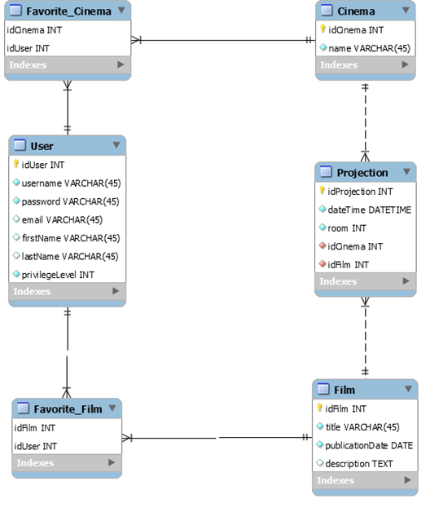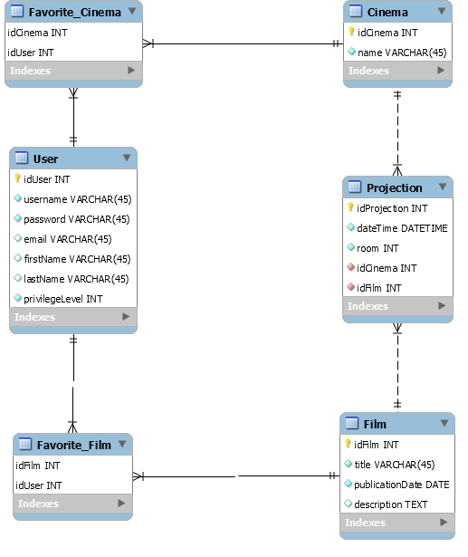

Key-Value Module

This part of our database does not have a defined structure; it is basically just a container where you can store data associated to a string that acts as a *key*. Given this characteristic we have used *LevelDB* to store all the data necessary to replace the relational implementation of the *Comment* entity.

The Data Stored

In the first time on which *LevelDB* is opened, a couple of *key-value* pairs are added as part of an **initialization**. The keys are:

* ***settingsPresent***
* ***setting:lastCommentKey***

The *first* one will contain ***true*** if the initialization is **already been done**, the *second* one will contain the **id of the last comment** being inserted, so that whenever a new comment is created, we can retrieve the right id to insert it. Obviously, this id will be **incremented** at each insert.

The next data we are going to discuss is comment itself. For clarity’s sake let us remind the **structure** of the *Comment* entity.

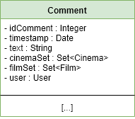

Each comment being stored in LevelDB will be divided in all its components, so there will be a   
*key-value* pair of each field of a comment being stored. The main idea is to use the *key* ***comment:x:field*** for each field of a comment, where **x** is the **id of the comment** to be stored.  
The keys to each field are:

* **comment:x:timestamp**
* **comment:x:text**
* **comment:x:cinema | comment:x:film** (one or the other)
* **comment:x:user**

As an example, let’s say we want to store a new comment that has “*awesome film*” as text. In this case we will get the id of this new comment by retrieving the id of the last comment being inserted (e.g. “*5*”), and then we will save this *key-value* pair: ***comment:6:text***, “*awesome film*”.

The last kind of data stored in LevelDB are hand-made **indexes** that store the list of ids of all the comments associated to a given Film or Cinema. To achieve this, whenever a comment is created, it is also **added to the list of ids linked to that Cinema or Film**.

As an example, the *key* to access the list of ids linked to a cinema or a film with id *8* would be ***cinema:8:comments***, for the former, and ***film:8:comments*** for the latter. What we will find is a string of concatenated ids separated by a colon symbol.

This feature has been implemented to make the retrieve operation of all the comments associated to a Film/Cinema more efficient. The heart of the problem is that we would have to go through all the comments stored in the *LevelDB* store just to see which one match with the Film/Cinema we want to visualize. Given the fact that most of the load on this database will be associated to the visualization of comments, the hassle of implementing these indexes is easily justified.

## Software Implementation

The main differences in this area are:

* Different **annotations** in the entities involved with comments
* A new super class to manage operations on LevelDB called ***KeyValueDBManager***
* CommentManager completely replaced by ***CommentManagerKV***
* A slightly different implementation of all database managers having to deal with *CommentManagerKV*

Entities Annotations differences

Given the fact that the ***Comment*** entity is completely out from our relational database, this entity will not have any kind of directives for *Hibernate*.

1. // file Comment.java
2. **public** **class** Comment **implements** Serializable {
3. **private** **static** **final** **long** serialVersionUID = 1L;
4. **private** Integer idComment;
5. **private** Date timestamp;
6. **private** String text;
7. **private** Set<Cinema> cinemaSet = **new** LinkedHashSet<>();
8. **private** Set<Film> filmSet = **new** LinkedHashSet<>();
9. **private** User user;
11. // Getters and Setters
12. }

Other entities like **Cinema** and **Film** have a Set<Comment> which contains the set of comments associated to them. In this case we just replaced all the directives with @Transient, which tells *Hibernate* to **ignore** that field. We will have to manage those fields in the ***EntityDBManager*** associated to each entity.

1. // file Film.java
2. @Entity
3. @Table(name = "Film")
4. **public** **class** Film **implements** Serializable {
5. **private** **static** **final** **long** serialVersionUID = 1L;
7. @Id
8. @GeneratedValue(strategy = GenerationType.IDENTITY)
9. @Basic(optional = **false**)
10. @Column(name = "idFilm")
11. **private** Integer idFilm;
13. @Basic(optional = **false**)
14. @Column(name = "title")
15. **private** String title;
17. @Basic(optional = **false**)
18. @Column(name = "publicationDate")
19. @Temporal(TemporalType.DATE)
20. **private** Date publicationDate;
22. @Lob
23. @Column(name = "description")
24. **private** String description;
26. @JoinTable(name = "Favorite_Film", joinColumns = {   
     @JoinColumn(name = "idFilm", referencedColumnName = "idFilm")},  
      inverseJoinColumns = {    
     @JoinColumn(name = "idUser", referencedColumnName = "idUser")})
27. @ManyToMany(fetch = FetchType.EAGER)
28. **private** Set<User> userSet = **new** LinkedHashSet<>();
30. @Transient // ⎜====||
31. **private** Set<Comment> commentSet = **new** LinkedHashSet<>();
33. @OneToMany(mappedBy = "idFilm", fetch = FetchType.EAGER, cascade = CascadeType.ALL)
34. **private** Set<Projection> projectionSet = **new** LinkedHashSet<>();
36. // List of methods not shown…
37. }

Key Value DB Manager

***KeyValueDBManager*** is a super class which regulates all the basic operations executed on our LevelDB store.

1. **public** **class** KeyValueDBManager {
3. **protected** **static** DB KeyValueDB;
4. **private** **static** **final** Options options = **new** Options();
6. DateFormat dateFormat = **new** SimpleDateFormat("dd:MM:yyyy HH.mm.ss");
8. **public** **static** DB getKVFactory(){
10. **if**(KeyValueDB == **null**){
11. start();
12. }
13. **return** KeyValueDB;
14. }
16. **public** **static** **void** start() {
17. **try** {
18. KeyValueDB = factory.open(**new** File("KeyValueDB"), options);
19. } **catch** (IOException ex) {
20. System.out.println("Errore non si è aperto il keyValueDB");
21. Logger.getLogger(KeyValueDBManager.**class**.getName()).log(Level.SEVERE, **null**, ex);
22. }
23. }
25. **public** **static** **void** stop() {
26. **try** {
27. KeyValueDB.close();
28. } **catch** (IOException ex) {
29. Logger.getLogger(KeyValueDBManager.**class**.getName()).log(Level.SEVERE, **null**, ex);
30. }
31. }
33. **protected** **void** settings() {
34. String value = get("settingsPresents");
35. **if** (value == **null** || "false".equals(value)) {
36. put("settingsPresent", "true");
37. put("setting:lastCommentKey", "0");
38. }
39. }
41. **protected** **void** put(String key, String value) {
42. getKVFactory().put(bytes(key), bytes(value));
43. }
45. **protected** **void** delete(String key) {
46. getKVFactory().delete(bytes(key));
47. }
49. **protected** String get(String key) {
50. **byte**[] value = getKVFactory().get(bytes(key));
51. **if** (value != **null**) {
52. **return** Iq80DBFactory.asString(value);
53. } **else** {
54. //System.out.println("Key not found");
55. **return** **null**;
56. }
57. }
59. }

Every *EntityDBManager* that wants to use this operations has to extend ***KeyValueDBManager*** and to call **super**.settings() inside its constructor (this is done to ensure that the LevelDB store is properly opened and initialized).

An example of this is shown below:

1. // file FilmManagerKV.java
2. **public** **class** FilmManagerKV **extends** KeyValueDBManager
3. **implements** FilmManagerDatabaseInterface {
5. **private** **final** EntityManagerFactory factory;
6. **private** EntityManager entityManager;
8. **private** **static** FilmManagerKV filmManager;
10. **public** **static** FilmManagerKV getIstance() {
11. **if** (filmManager == **null**) {
12. filmManager = **new** FilmManagerKV();
13. }
14. **return** filmManager;
15. }
17. **private** FilmManagerKV() {
18. factory = DBManager.getEntityManagerFactory();
19. **super**.settings();
20. }
22. // ALL OTHER METHODS NOT REPORTED…
24. }

Final note on the utilization of this class: while the **opening** of the *LevelDB* store is done automatically, the **closing** is not. Always remember to call *KeyValueDBManager.close()* at the end of the main method.

Comment Manager KV

***CommentManagerKV*** contains all the code needed to manage comments in our application using just the *LevelDB* store. It implements all the methods in the ***CommentManagerDatabaseInterface*** in order to have a smooth transition from the relational implementation to this one. It also has some auxiliary methods to manage *indexes*, set of *comments retrieval* and *differentiation of the type* of comment (because given an id we don’t know if that comment is associated to a Film or a Cinema).

For the sake of brevity, the code is not reported, the reader can consult it directly in our java project folder.

Entity DB Manager Differences

Given the fact that we added @Transient on all the fields of the classes that have some kind of relationship with *Comment*, we will not get a complete *Cinema* or *Film* whenever we execute an operation like getById() the set of comments associated with a *Cinema*, for instance, will remain **empty**. Therefore, we had to add a **call for the retrieval** of those comments in all the methods which return entities related to *Comment*.

This is, for example, getById() in ***CinemaManager***:

1. //file CinemaManagerKV.java
2. @Override
3. **public** Cinema getById(**int** cinemaId, **boolean** retreiveComments) {
4. Cinema cinema = **null**;
5. **try** {
6. entityManager = factory.createEntityManager();
7. entityManager.getTransaction().begin();
8. cinema = entityManager.find(Cinema.**class**, cinemaId);

11. **if**(retreiveComments){
12. cinema.setCommentSet(CommentManagerKV.getIstance().getCommentsCinema(cinema.getIdCinema()));
13. }
14. } **catch** (Exception ex) {
15. System.out.println(ex.getMessage());
16. ex.printStackTrace(System.out);
17. System.out.println("A problem occurred in retriving a film!");
18. } **finally** {
19. **if**(entityManager.isOpen())
20. entityManager.close();
21. }
22. **return** cinema;
23. }

The only difference from the original code is that, after the retrieval of the cinema object, we check if the *boolean* ***retrieveComments*** is *true* and if that’s the case we go on and call the method **getCommentsCinema()** and give the result to the comment set of the cinema object. The ***retrieveComments*** *boolean* is needed because, depending on the utilization of the cinema object, *we might not need the comments to be set*; saving us time.

