

Pisa University  
  
  
TASK 2  
LARGE-SCALE AND MULTI-STRUCTURED DATABASES

**“*PisaFlix 2.0” project documentation***  
academic year 2019-2020  
  
  
  
  
stefano petrocchi, Andrea Tubak, Francesco Ronchieri, Alessandro Madonna

Summary

Design Document 3

Description 3

Requirements 3

Main Actors 3

Functional 3

Non-Functional 4

Analytics 4

Use Cases 5

ANALYTICS USE CASES And Mockups 6

View Average Rating 6

View Ranking 7

View Engagement Activity 8

Analysis Classes 9

Data Model 10

Architecture 10

Interface Design Pattern 10

# Design Document

## Description

Have you ever found yourself in a gloomy day? Everyone is at home, no one knows what to do and time seems to slow down. That’s the perfect time for a movie!

PisaFlix is a platform in which users can find quality and updated information regarding movies. It provide a service to help you to choice what film to watch. PisaFlix has a comment section that gives at the users the possibility to create a community around their favourite movies, exchanging opinions and news regarding them. It is also possible to add films to a favourite list in order to find them quicker. The possibility to see other users favourites it is essential to find new friends with the same cinematic tastes. Lastly it is possible to view interesting statistics on films, useful both for normal users and for other people involved in the production of films.

PisaFlix offers services that will change the way users approach the world of the movie, providing them everything they need to enjoy at best their passions.

## Requirements

### Main Actors

The application will interact only with the **users**, distinguished by their privilege level:

* **Normal User**: a normal user of the application with the possibility of basic inaction.
* **Social Moderator**: a trusted user with the possibility to moderate the comments.
* **Moderator**: a verified user with the possibility to add and modify elements in the application, like films, cinemas or projections.
* **Admin:** an administrator of the application, with possibility of a complete interaction.

### Functional

1. *Users* can **view** the list of **Movies** available on the platform.
2. *Users* can **view** the information about a specific *Movie*.
3. *Users* can **view** the *Projections* scheduled for a *Film*.
4. *Users* can **view** the ***statistics*** of a *Cinema* or *Film* page.
5. *Users* can **view** a set of **analytics** on Movie and other user.
6. *Users* can **register** an account on the platform.
7. *Users* can **log in** as *Normal users* on the platform in order to do some specific operations:
   1. If logged a *Normal user* can **add/remove** to **favourite** a *Movie*.
   2. If logged a *Normal user* can **comment** a *Movie*.
   3. If logged a *Normal user* can **modify** his *Movie Comments*.
   4. A *Normal user* can **modify/delete** his account.
8. *Users* that can **log in** as *Social moderator* can do all operation of a *Normal user* plus:
   1. If logged as *Social moderator* can **delete** other users’ comments.
   2. If logged as *Social moderator* can **recruit** others *Social moderator*s.
9. *Users* that can **log in** as M*oderator* can do all operation of a *Social moderator* plus:
   1. If logged a *Moderator* can **add/delete/modify** a *Movie/Projection*.
   2. If logged as *Moderator* can **recruit** other *Moderator*s
10. *Users* that can **log in** as*Admins* can do all operation of a M*oderator* plus:
    1. If logged an *Admin* can **delete** another user’s account.
    2. If logged as *Admin* can **recruit** other *Admin*s.

### Non-Functional

1. The application’s focus is the *quality* of the information provided to users.
2. The application needs to be **consistent**, in order to provide correct information to all the users.
3. The application needs to be **tolerant to partitions**, in order to scale the system if needed, preserving the consistency.
4. The application needs to store **replicas** of the data in case of server fault, all the replicas need to be **consistent**.
5. The transactions must be **monotonic:** every user must see the last version of the data and modifications are done in the same order that are committed.
6. The application needs to be *usable* and *enjoyable* for the user, therefore the system needs **limited response times**.
7. The *password* must be protected and stored *encrypted* for privacy issues.

## Analytics

In PisaFlix there are three main types of analytics/statistics:

1. Chosen a temporal interval, the application shows the mean value of movie rating grouped by genre/Director/Actor.
2. Chosen a temporal interval, the application shows either a table with the most involved user or the most engaged film of the platform.  
   This is done by calculating a weighted sum: .

If we are considering user activities: *c* stands for the number of comments that the user does, *f* for the number of favorites given by the user, and *v* for the number of page requested by the user.

If, insead, we are considering film activities: *c* stands for the number of comments received by the film, *f* for the number of favorites, and *v* for the number of visits on the film page.

The above value il calculated for all films/users and it is used to rank them.

1. Chosen a film (or a user) and two years (one for the beginning and one for the end of a period), the application shows the engagement of the chosen film/user by year, in the interval of time specified before. Moreover, the application will show also the composition of the value of the engagement for a chosen year. The formula use to calculate the engagement changes depending on the subject.  
   This is the formula for the engagement of a film . It is basically a weighted sum where E is the engagement, *f* is the number of favourites received by the film, *c* is the number of comments on that film, and *v* is the number of times that the page of the film has been visited.

The formula for the engagement of a user is . It is basically a weighted sum where E is the engagement, *n* is the number of favourites given by the user, *c* is the number of comments written, and *v* is the number of pages visited.

## Use Cases

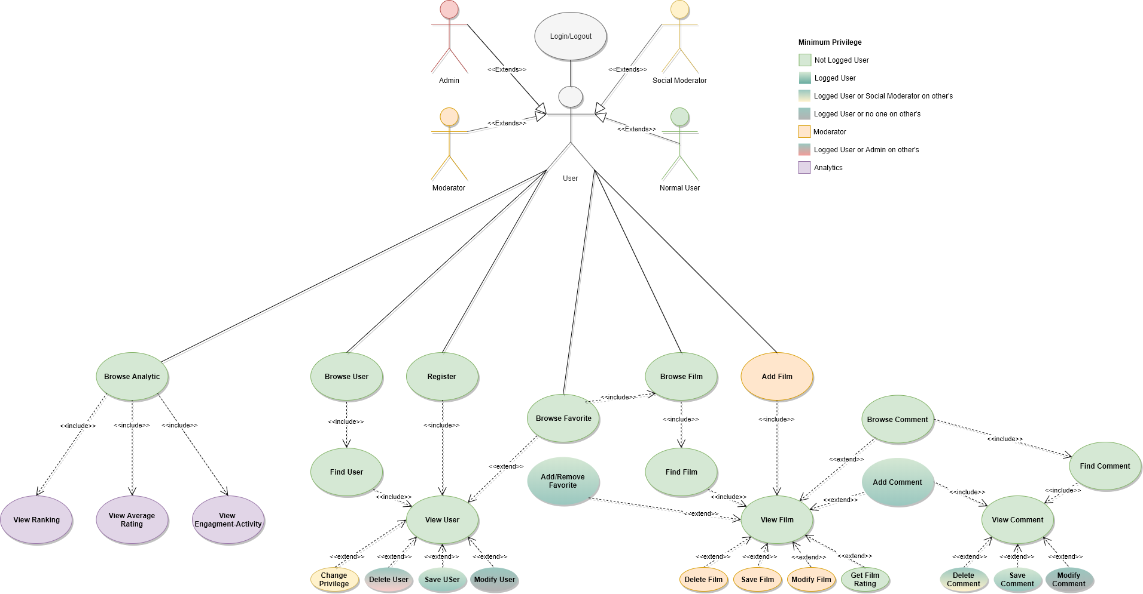

## ANALYTICS USE CASES And Mockups

Let us see the use cases of the analytics reported in the diagram above.

### View Average Rating

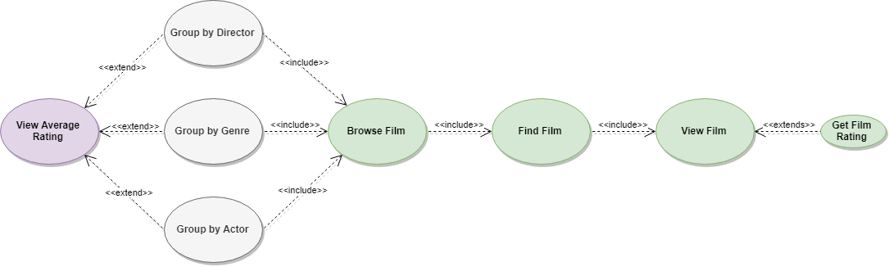

#### Mockup

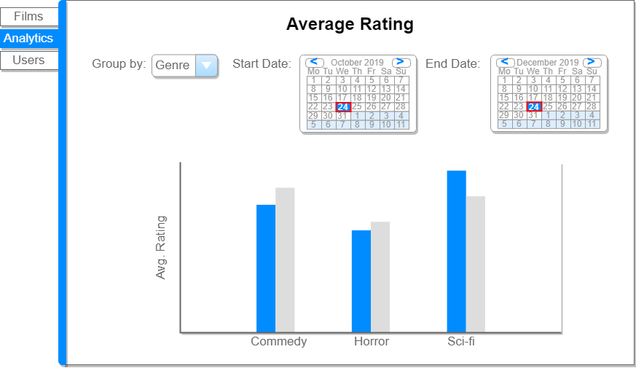

### View Ranking

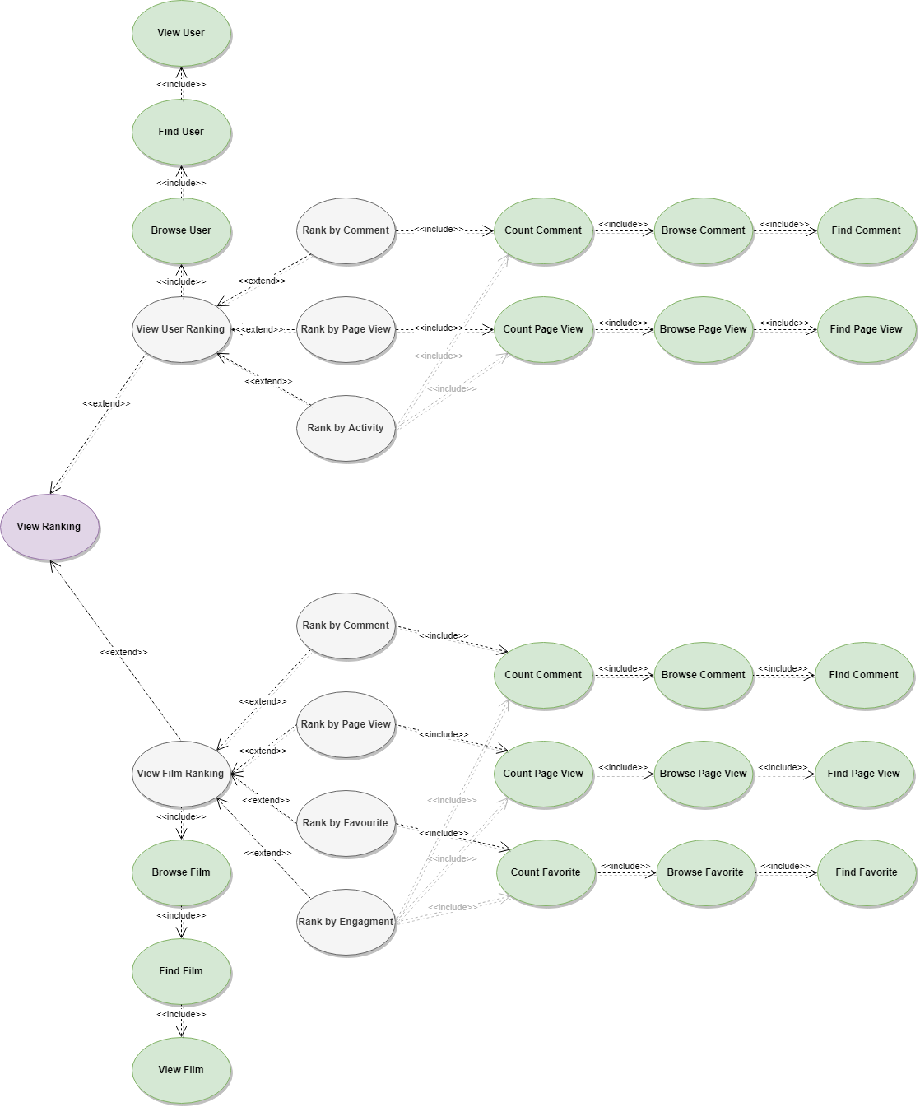

#### Mockup

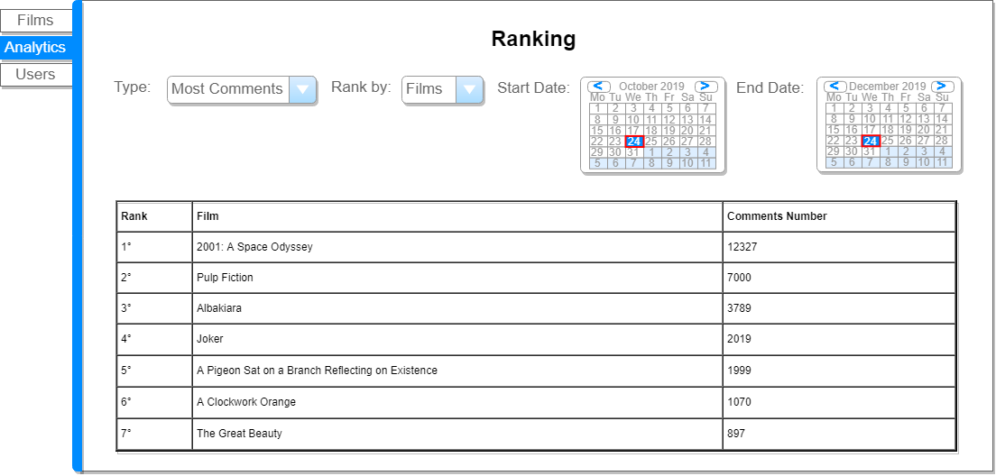

### View Engagement Activity

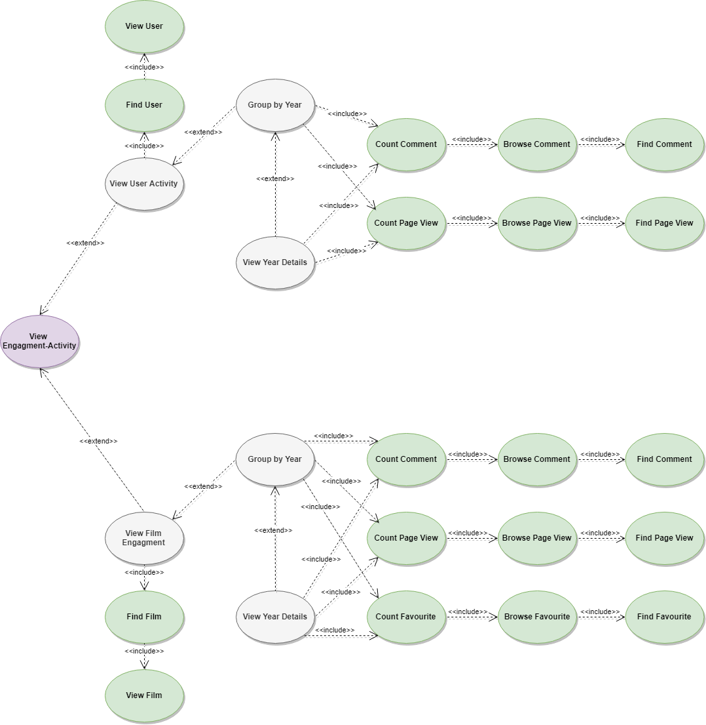

#### Mockup

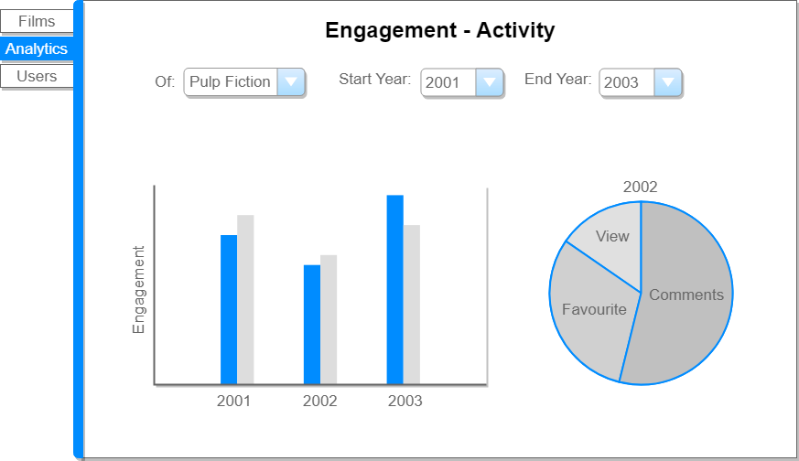

## Analysis Classes

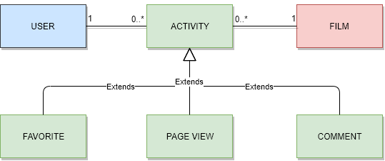

## Data Model

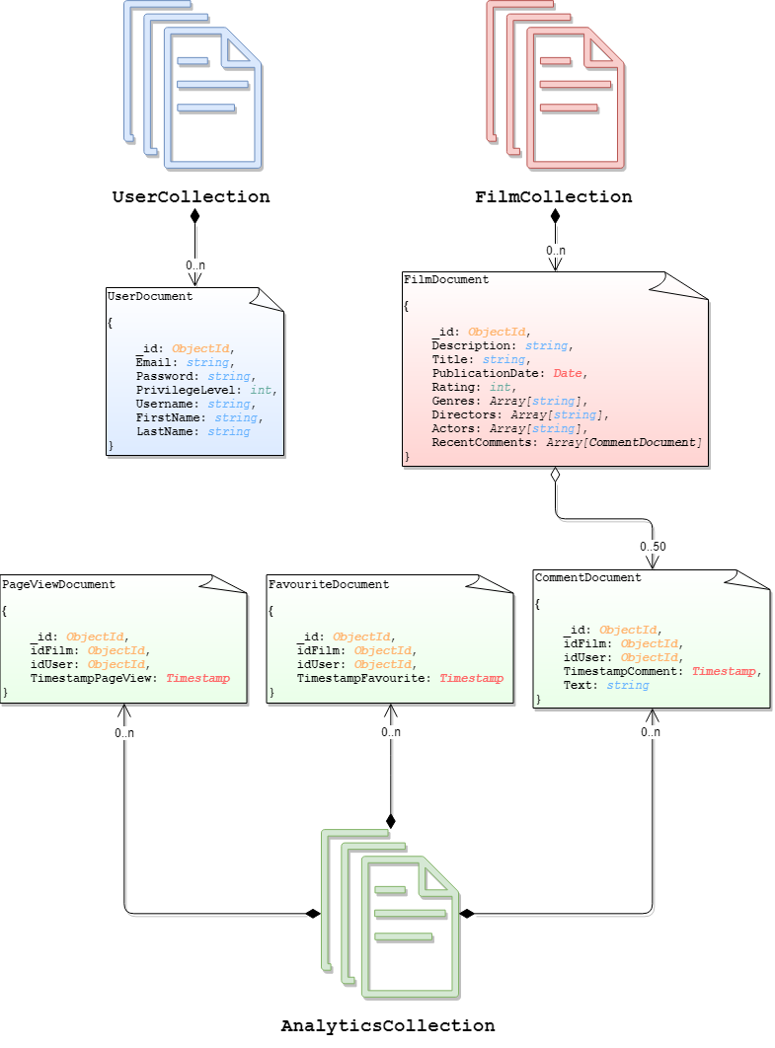

## Architecture

Users can use a java application with a **GUI** to take advantage of all the functionalities of the platform.

The client Application it’s made in *Java* using **JavaFX framework** for the *front-end* and the **MongoDB driver** to manage *back-end* functionalities. **Services** and ***JavaBean* objects** compose the *middleware* infrastructure that connect *front-end* and *back-end.*

### Interface Design Pattern

The graphic user interface was build following the software design pattern of **Model-View-Controller**.

#### **Model**

**Services** module represent the *model* and is the central component of the pattern. It is the application's dynamic data structure, independent of the user interface. It directly manages logic and rules of the application receiving inputs from the controller. The model is also responsible for managing the application’s data in form of JavaBean objects, exchanging them with the controller.

#### **View**

The **fxml files** represents the *view* and are responsible fosr all the components visible in the user’s interface.

#### **Controller**

The **page controllers** are the *controller* of the application. They receive inputs from the *view* and converts them into commands for the *model* or *view* itself. Controllers can also validate inputs and data without the intervention of the *model*. Data is exchanged between *model* and *controller* using JavaBean objects.

## Software classes

### Entities

In the next pages we will describe all classes presents in the application.

Let’s start with the main entities, but since they are self explanatory we will not see them in details.

These classes have all the get and the setter for all private attribute. Moreover, they have a constructor that get the document retrieved from mongodb, and build the object starting from that.

### DB-Manager

All the menagers are implementented following the software design pattern of **singleton pattern** which restricts the instantiation of a manager to one "single" instance, Also the EntityFactoryManager used by Hibernate and managed in the DBManager class it follows this design pattern.

Now it is explained how the structure of the DBManager work.

* **DBManager** is an utility class, it’s a static class that contains all the other manager specific to certain operations, the other managers are accessible trought the public members of the class, it automatically inizialize all the managers on first call and the method DBManager.Stop() must be called at the end of the application in order to close the connection with the mongo Database.
* **UserManagerDatabaseInterface** it’s the interface which defines the basic operation that any user manager should have (independent from the technology)
* **UserManager** implements **UserManagerDatabaseInterface** and is in charge of manage all CRUD operation with the database for the users.

The function get an extra two parameter, that are two integer: limit and skip. These two integer are used to get a pagination, retrieving always “limit” document, and then skipping “skip” document for the next page.

All function are self-explanatory by the name except for:

* + **getFiltered**(String user*nameFilter, int limit, int skip*) which search and returns all users who have “user*nameFilter*” in the username, if user*nameFilter* is not set the filter it’s not taken into consideration and returns all users. Limit and skip are used for the purpose described before.
* **FilmManagerDatabaseInterface** it’s the interface which defines the basic operation that any film manager should have (independent from the technology)
* **FilmManager** implements **FilmManagerDatabaseInterface** and is in charge of manage all CRUD operation with the database for the movies.

Here, too, some functions take two additional parameters, limit and skip, for the same reason of UserManager.

All function are self-explanatory by the name except for:

* + **getFiltered**(String *titleFilter*, Date *startDateFilter*, Date *endDateFilter, int limit, int skip*) which search and returns all movies which have “*titleFilter*” in the title and the pubblicationDate it’s between “*startDateFilter”* and “*endDateFilter*”, if some filter is not set the filter it’s not taken into consideration, if all filter are not set it returns all movies.
* **EngageManagerDatabaseInterface** it’s the interface wich defines the basic operation that any engage manager should have (independent from the techonology)
* **EngageManager** implements **EngageManagerDatabaseInterface** and is in charge of manage all CRUD operation with the database for the engages.

Some function may need an explaination so:

* + **create(**User user, Film film, EngageType type**)** wich create an engage, that can be of type, View or Favourite (Engages can have a third type that is Comment, but that case is managed by the CommentManager)
  + **deleteAllRelated(**Entity entity**)** wich delete all the engages, releted to an entity e.g. delete all the views, favourites and comments, done by an User. In this case the function managed too the comments.
* **CommentManagerDatabaseInterface** it’s the interface wich defines the basic operation that any comment manager should have (independent from the techonology)
* **CommentManager** implements **CommentManagerDatabaseInterface** and extends **EngageManager** and is in charge of manage all CRUD operation with the database for the comment. It extend EngageManager because a comment is a type of engage.
* **AnalyticsManagerDatabaseInterface** it’s the interface wich defines the basic operation that any analytic manager should have (independent from the techonology)
* **AnalyticsManager** implements **AnalyticsManagerDatabaseInterface** and is in charge to perform the analytics described before in the documentation. It is better described in the next section.

The function that perform the three analytics are:

* + **ratingAnalytics(**Date startDate, Date endDate, RatingType typeOfRating**)** which perform the first analytics.
  + **engagementAnalytics(**Date startDate, Date endDate, Entity entity**)** wich perform the seconds.
  + **rankingAnalytics(**Date startDate, Date endDate, RankingType typeOfRanking**)** which perform the third.

All the other funtion are to support these three function.

### Analytics entities

Now are described the entities used in **AnalyticsManager** to support the analytics.

There are three **AnalyticsEntities**, and are associated with the related analytic, so:

* **AverageRatingResul** are associated with the first Analytic.
* **EngageResult** with the second analytic.
* **RankingResult** with the third analytic.

### Pisaflix Services