

Pisa University  
  
  
TASK 3  
LARGE-SCALE AND MULTI-STRUCTURED DATABASES

**“*PisaFlix 3.0” project documentation***  
academic year 2019-2020  
  
  
  
  
stefano petrocchi, Andrea Tubak, Francesco Ronchieri, Alessandro Madonna

Summary5

Design Document 3

Description 3

Requirements 3

Main Actors 3

Functional 3

Non-Functional 3

Use Cases 4

Suggestions 4

Analysis Classes 5

Data Model 5

Example 5

Architecture 6

Interface Design Pattern 6

Software Classes 7

Entities 7

DBManager 7

# Design Document

## Description

PisaFlix 3.0 is a social network, oriented to the discussion of film. An user can follow other users, to see their posts, or a film, to see the post of other user on that film.

## Requirements

Main Actors

The application will interact only with the **users**, distinguished by their privilege level:

* **Normal User**: a normal user of the application with the possibility of *basic inaction*.
* **Social Moderator**: a trusted user with the possibility to *moderate* the comments.
* **Moderator**: a verified user with the possibility to add and *modify* elements in the application, like films and cinemas.
* **Admin:** an *administrator* of the application, with possibility of a *complete interaction*.

Functional

1. *Users* can **view** the list of **Movies** available on the platform.
2. *Users* can **view** the posts about a specific *Movie*.
3. *Users can* ***view*** *the list of* ***Users*** *on the platform.*
4. *Users can* ***view*** *the posts of a specific User.*
   1. *Users* can **register** an account on the platform.
5. *Users* can **log in** as *Normal users* on the platform in order to do some other operations:
   1. If logged a *Normal user* can **follow/unfollow** a *Movie*.
   2. If logged a *Normal user* can **follow/unfollow** a User.
   3. If logged a *Normal user* can **write** a Post on a *Movie*.
   4. If logged a *Normal user* can ***view***Post of his following *Movies* and *Users*.
   5. If logged a *Normal user* can ***view***suggestions on *Movies* to follow.
   6. If logged a *Normal user* can **modify** his ***Posts***.
   7. A *Normal user* can **modify/delete** his account.
6. *Users* that can **log in** as *Social moderator* can do all operation of a *Normal user* plus:
   1. If logged as *Social moderator* can **delete** other users’ comments.
   2. If logged as *Social moderator* can **recruit** others *Social moderator*s.
7. *Users* that can **log in** as M*oderator* can do all operation of a *Social moderator* plus:
   1. If logged a *Moderator* can **add/delete/modify** a *Movie/Projection*.
   2. If logged as *Moderator* can **recruit** other *Moderator*s
8. *Users* that can **log in** as*Admins* can do all operation of a M*oderator* plus:
   1. If logged an *Admin* can **delete** another user’s account.
   2. If logged as *Admin* can **recruit** other *Admin*s.

### Non-Functional

1. The application’s focus is the *quality* of the information provided to users.
2. The application needs to be **consistent**, in order to provide correct information to all the users.
3. The transactions must be **monotonic:** every user must see the last version of the data and modifications are done in the same order that are committed.
4. The application needs to be *usable* and *enjoyable* for the user, therefore the system needs **limited response times**.
5. The *password* must be protected and stored *encrypted* for privacy issues.

## Use Cases

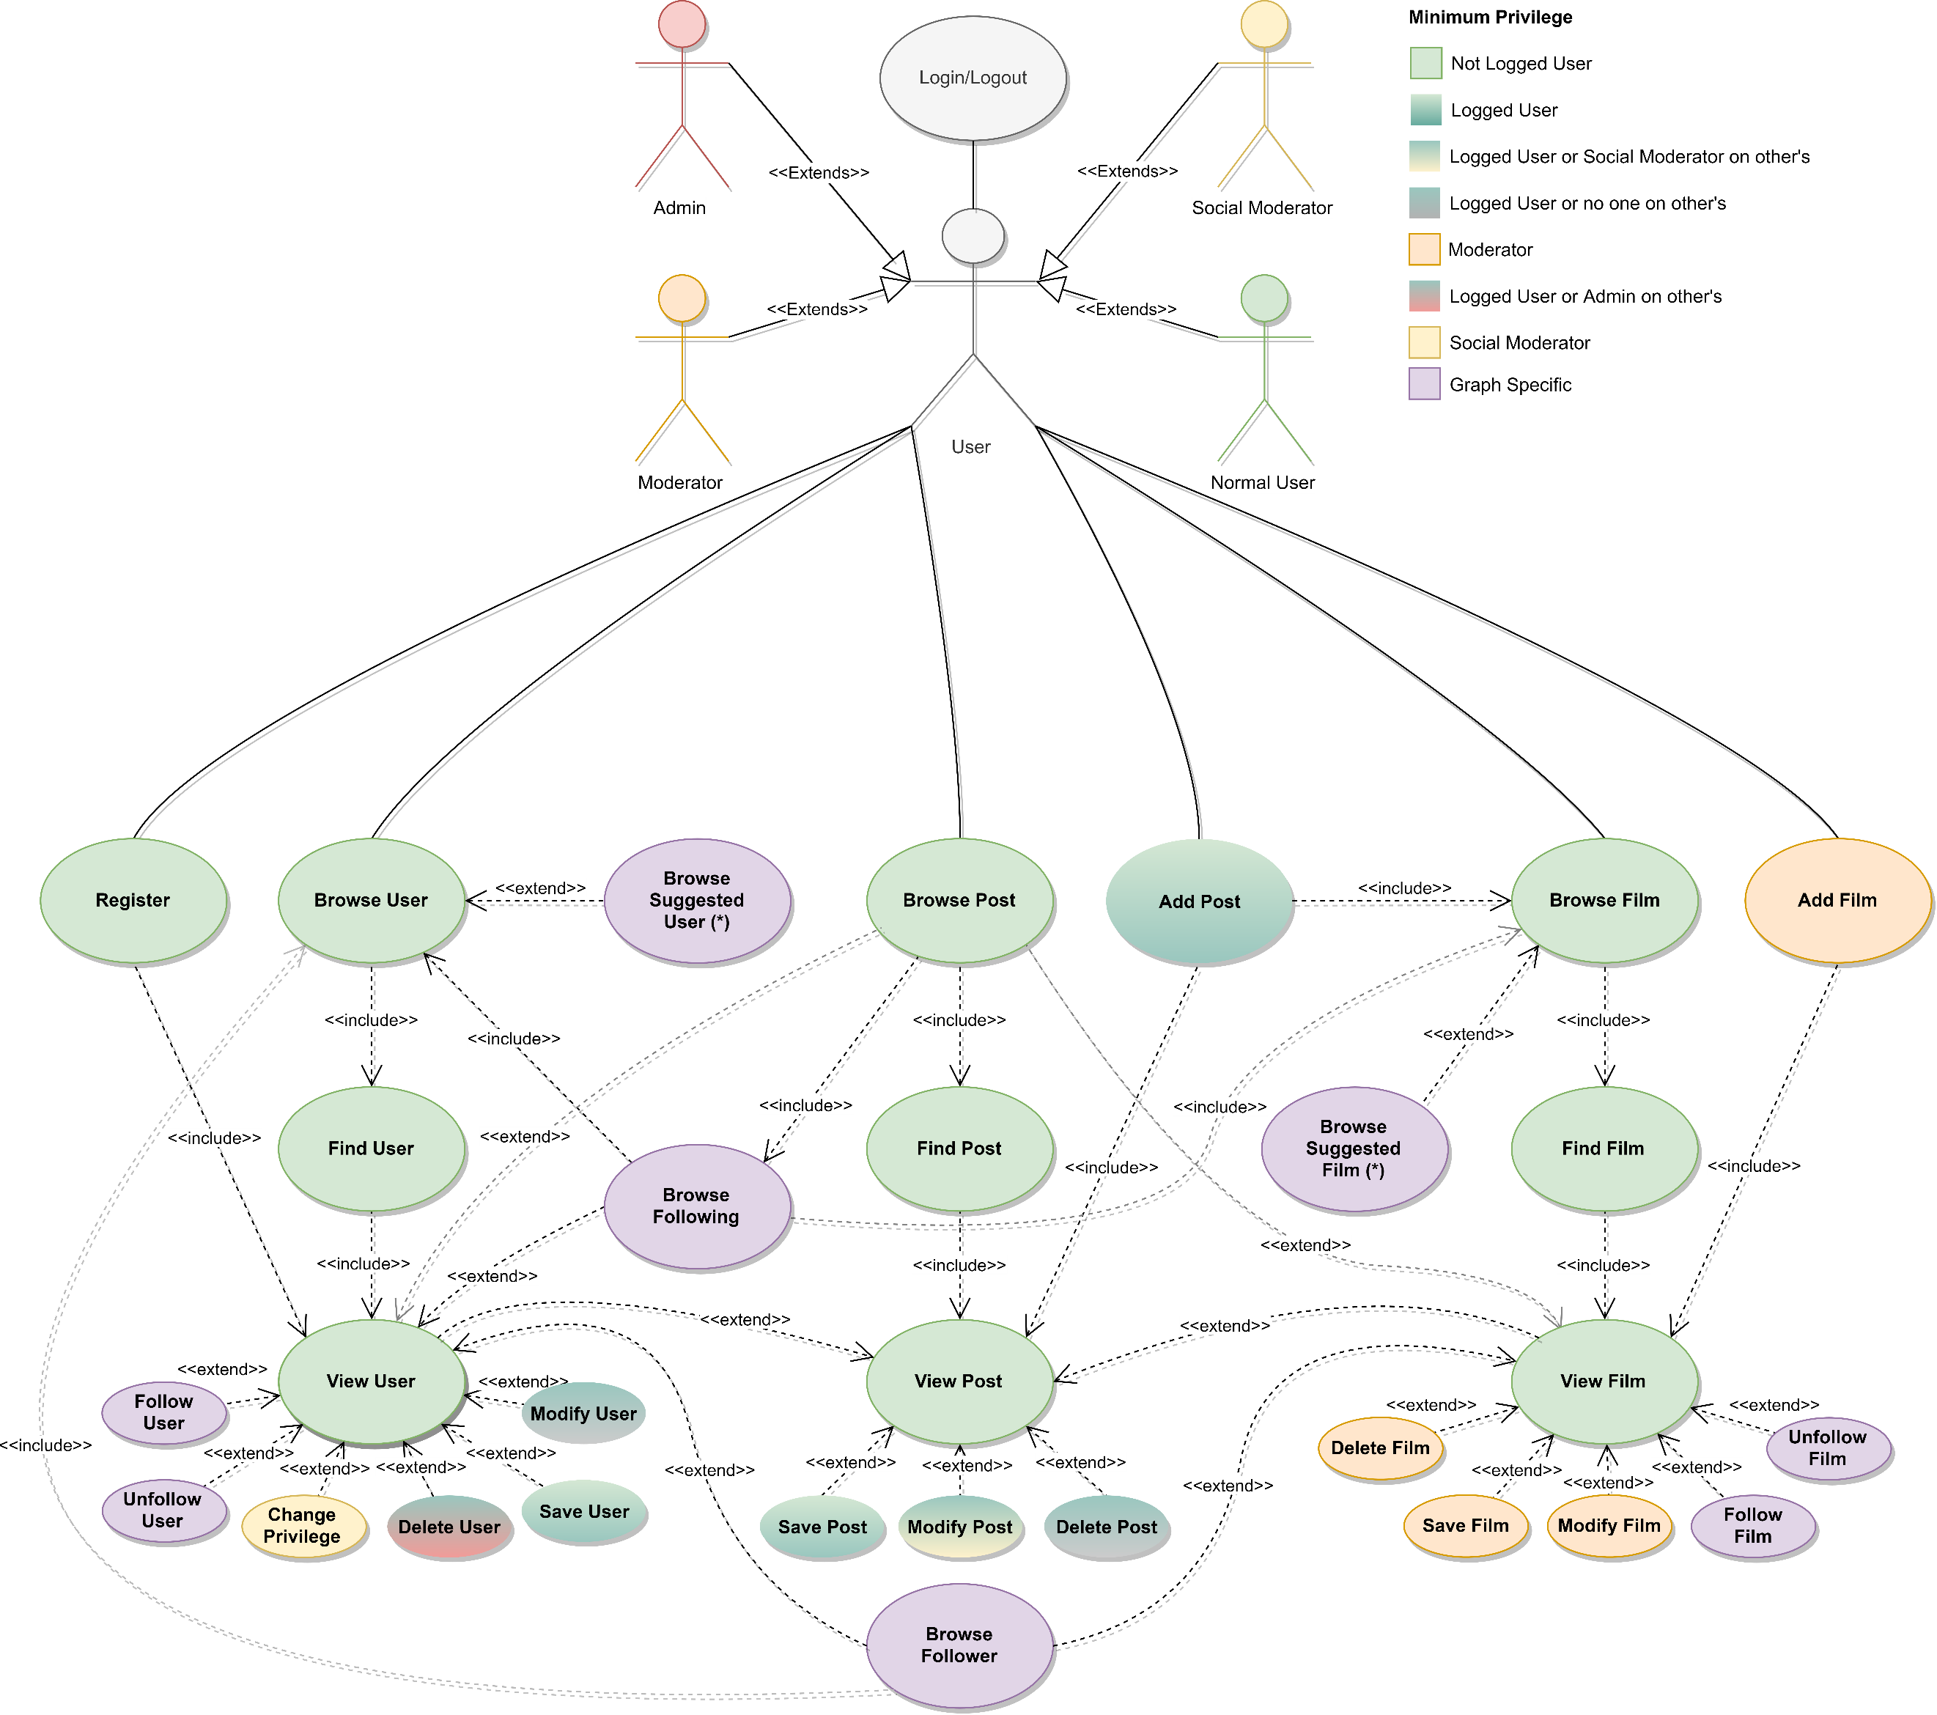

### Suggestions

The suggestions, if the user is logged in, are shown in the initial pages of the *browsers*, the page is filled with the suggestions from the highest priority to the lowest until exhaustion. If the suggestions are not enough to fill the page, the most recent films\users, that have not been suggested, are chosen to complete it.

#### Suggested Films

There are three levels of suggestions with different priorities:

* **Very Suggested:** They have the highest priority, given a user **U1** if **U1** is following user **U2** and **U2** is following a movie **F** and has also posted on **F**, then **F** is *very suggested* to **U1**.
* **Suggested:** They have the second priority level, if a user **U1** is following user **U2** and **U2** is following a film **F**, then **F** is *suggested* to **U1**.
* **Commented by Friend:** They have the lowest priority level, if a user **U1** follows a user **U2** who posted on a movie **F**, then **F** is suggested as "*commented by a friend*" at **U1**.

#### Suggested Users

There are two levels of suggestions with different priorities:u

* **Very Suggested:** They have the highest priority, given a user **U1** if **U1** is following user **U2** and **U2** is following user **U3**, then **U3** is *very suggested* to **U1**.
* **Suggested:** They have the lowest priority level, if a user **U1** is following user **U2** and **U2** is following a user **U3** and **U3** is following a user **U4**, then **U4** is *suggested* to **U1**.

## Analysis Classes

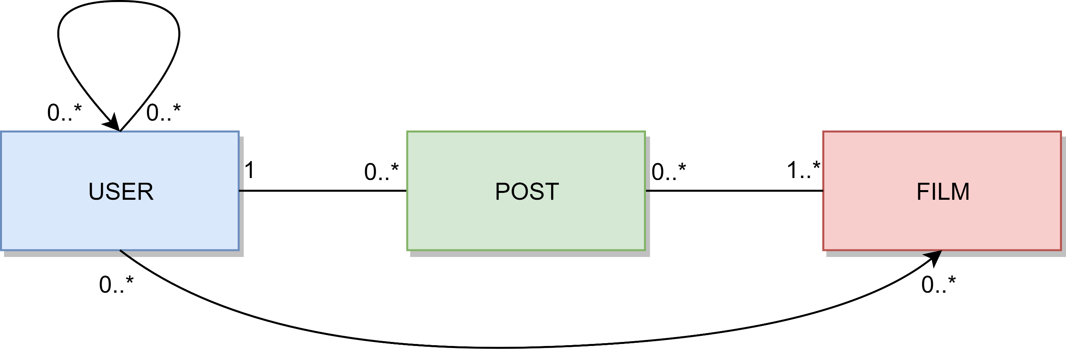

## Data Model

We have basically three entities, User, Film, and Post. The relation between Users is of type “follow”, such as the relation between User and Film. The relation between User and Post is of type “create” and contains a property Timestamp. The relation between Post and Film, is of type “Tags”.

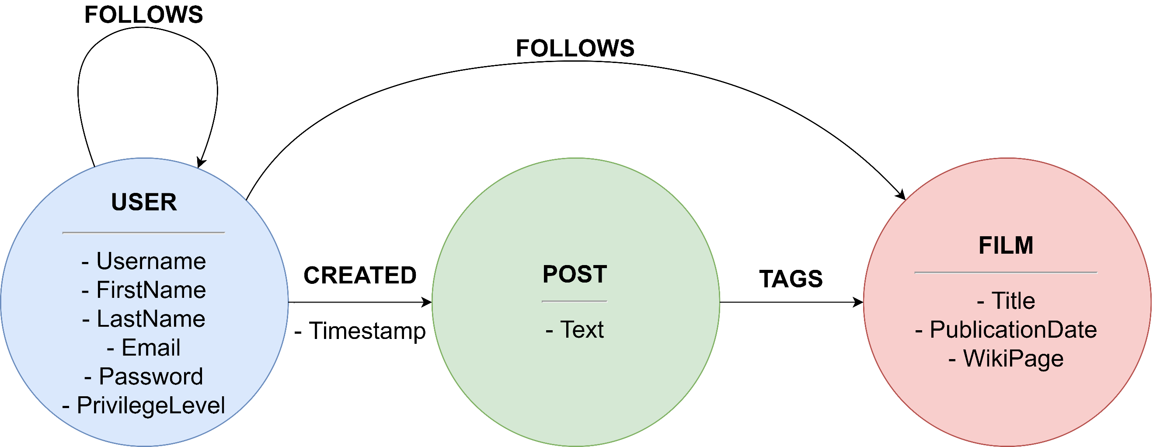

### Example

!!!!!! DA RIFAREEEEEEEEE !!!!!!!!!!!!!!!!!!!!!!!!!!!!!!!!!!!!!!!!!!!!!!!!!!!!!!!!!!!!!!!!!!!!!!!!!!!!!!!

|  |
| --- |
|  |
| {firstName:user, Email:user1@mail.com, LastName:1, Username:user1, PrivilegeLevel:0, Password:pass}  {Title:Parasite, PublicationDate:"2019-11-07T00:00:00Z", WikiPage:url}  {firstName:user, Email:user2@mail.com, LastName:2, Username:user2, PrivilegeLevel:0, Password:pass}  {Text:Non meritava l'Oscar} |

## Architecture

Users can use a java application with a **GUI** to take advantage of all the functionalities of the platform.

The client Application it’s made in *Java* using **JavaFX framework** for the *front-end* and the **MongoDB driver** to manage *back-end* functionalities. **Services** and ***JavaBean* objects** compose the *middleware* infrastructure that connect *front-end* and *back-end.*

### Interface Design Pattern

The graphic user interface was build following the software design pattern of **Model-View-Controller**.

#### **Model**

**Services** module represent the *model* and is the central component of the pattern. It is the application's dynamic data structure, independent of the user interface. It directly manages logic and rules of the application receiving inputs from the controller. The model is also responsible for managing the application’s data in form of JavaBean objects, exchanging them with the controller.

#### **View**

The **fxml files** represents the *view* and are responsible fosr all the components visible in the user’s interface.

#### **Controller**

The **page controllers** are the *controller* of the application. They receive inputs from the *view* and converts them into commands for the *model* or *view* itself. Controllers can also validate inputs and data without the intervention of the *model*. Data is exchanged between *model* and *controller* using JavaBean objects.

## Software Classes

### Entities

Diagram of the **classes**:

### DBManager

