REPUBLIC OF CAMEROON

Peace-Work-Fatherland

MINISTRY OF HIGHER EDUCATION

MINISTERE DE L’EMPLOIET

DE FORMATION

PROFESSIONELE
------------------

REPUBLIQUE DU CAMEROON

Paix-Travail-Patrie

MINISTERE DE L’ENSEIGNEMENT
SUPERIEURE

MINISTRY OF EMPLOYMENT AND

VOCATIONAL TRAINING
------------------

BIAKA UNIVERSITY INSTITUTE OF BUEA (BUIB)



“The Audacity to be different”
SCHOOL OF ENGINEERING AND TECHNOLOGY (SET)
COURSE CEB402 — MOBILE PROGRAMMING

WATIPROP
Network Quality of Experience (QoE) Mobile Monitoring System

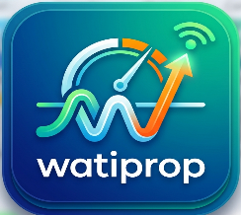
Group 1
PRESENTED BY:
NKENGANYI STEADFAST (SENG23SE003)
MASSANGO PRINCELY (SENG23SE012)
BAKER MOHAMED (SENG23NE002)
NGUEYO FOKENG ISMAEL (SENG23SE013)

LECTURER:
Dr NKEMENI VALERY

2025/2026

Table of Contents
Abstract 3
Chapter 1 — General Introduction 3
1.1 Background and Motivation 3
1.2 Project Objectives 3
1.3 Significance 3
Chapter 2 — Literature Review 3
2.1 Existing Network Monitoring Solutions 3
2.2 Identified Gaps 4
2.3 Technology Evaluation 4
Chapter 3 — System Methodology and Design 4
3.1 Development Methodology 4
3.2 Functional Requirements 4
3.3 Non-Functional Requirements 5
3.4 System Architecture 5
3.5 Key Use Cases 6
3.6 Sequence Flow (Core Telemetry Path) 6
Chapter 4 — Implementation and Testing 7
4.1 Development Environment 7
4.2 Telephony Plugin Fork 7
4.3 Local Database (Drift) 7
4.4 Export Service 8
4.5 Testing Results 8
Chapter 5 — Conclusion and Recommendations 8
5.1 Objectives Assessment 8
5.2 Conclusion 8
5.3 Future Recommendations 9
References 9

Abstract
WATIPROP is a Flutter-based mobile application designed for cellular network Quality of Experience (QoE) monitoring across Cameroon. The system captures signal metrics (RSRP, SINR), network type, GPS location, and device state; persists data locally via a Drift SQLite database; and exports structured reports in CSV and PDF formats for operator analysis. The implementation integrates native Android telephony APIs through a patched local plugin fork, ensuring stability on API 28 devices. This report details the project motivation, system design, component implementation, testing outcomes, and future development roadmap.

Chapter 1 — General Introduction

1.1 Background and Motivation
Mobile network operators in Cameroon — including MTN, Orange, and Camtel — increasingly require granular, field-level performance data to drive infrastructure investment and satisfy ART regulatory benchmarks. Commercial network monitoring tools typically demand enterprise hardware and offer limited export functionality for low-resource field environments. WATIPROP addresses this gap by delivering an offline-capable, export-ready QoE data collector that runs on consumer Android devices.

1.2 Project Objectives
The project pursues the following specific objectives:

- Implement reliable signal and network telemetry collection on Android (API 28+) devices.
- Provide local data persistence and export to CSV and PDF for operator analysis.
- Deliver an intuitive admin interface for surveys, report generation, and alert management.
- Fork and patch the open-source telephony plugin to eliminate runtime crashes and duplicate method-channel replies.
- Ensure cross-platform maintainability through a modular, feature-based Flutter architecture.

1.3 Significance
The application supports faster field-level diagnostics, enables exportable QoE datasets for evidence-based operator decision-making, and provides a stable tool for deployment in low-resource environments where older Android devices are common.

Chapter 2 — Literature Review

2.1 Existing Network Monitoring Solutions
Commercial network quality tools such as NEMO Outdoor and TEMS Investigation provide comprehensive drive-test capabilities but require dedicated hardware and proprietary licensing. Open-source alternatives (e.g., G-NetTrack, Network Cell Info) lack offline export and have inconsistent compatibility with lower-end devices. Research-oriented platforms — including MONROE and Netalyzr — are designed for desktop or constrained laboratory environments rather than continuous field deployment.

2.2 Identified Gaps

Gap in Existing Tools | WATIPROP Response
Enterprise hardware dependency | Mobile-first Flutter architecture
No offline CSV/PDF export | Built-in CSV and PDF export
Poor API 28 compatibility | Patched telephony plugin fork
Closed plugin ecosystems | Open local plugin source
No admin reporting layer | Admin console with alert logs

2.3 Technology Evaluation
The following technology stack was selected after evaluation against project constraints:

Component | Selected Technology
UI Framework | Flutter (Dart ^3.11.5) — cross-platform, single codebase
State Management | Riverpod 3.x — compile-safe, provider-scoped
Local Persistence | Drift (SQLite) — type-safe DAOs, migration support
Telephony Access | Local-forked telephony plugin — patched for API 28 stability
Export | csv + pdf packages with path_provider for storage routing
Build System | Gradle (KTS) with minSdkVersion 28

Chapter 3 — System Methodology and Design

3.1 Development Methodology
An Agile iterative approach was adopted, structuring work into short sprint cycles: requirements scoping → incremental implementation → device testing → rapid issue resolution. This allowed the team to respond quickly to platform constraints discovered during telephony plugin integration and to validate export functionality against a physical Android 9 device throughout development.

3.2 Functional Requirements

- FR-01: Collect RSRP, SINR, network type, and operator identity via native Android telephony APIs.
- FR-02: Capture GPS coordinates and timestamp for each telemetry record.
- FR-03: Persist all records offline in a local Drift SQLite database.
- FR-04: Export telemetry records to CSV with configurable date-range filters.
- FR-05: Generate executive PDF reports with metric summaries and alert highlights.
- FR-06: Surface operational alerts for critical signal degradation events.
- FR-07: Support operator and location filter selection from the admin console.

3.3 Non-Functional Requirements

- NFR-01: Crash-free telemetry collection on Android API 28 devices.
- NFR-02: All I/O operations (DB writes, exports) performed asynchronously to prevent UI blocking.
- NFR-03: Modular feature-based architecture enabling independent module testing and extension.
- NFR-04: Export files stored in an accessible, permission-safe directory.

3.4 System Architecture
The system is organized into seven feature modules:

Module | Responsibility
telemetry | Signal collection via telephony platform channel
storage | Drift database tables, DAOs, and migration management
export | CSV writer and PDF report generator
admin | Admin console screen, alerts, and operator filters
survey | Survey form and submission workflow
location | GPS acquisition and coordinate tagging
core | Shared models, Riverpod providers, theme, and router
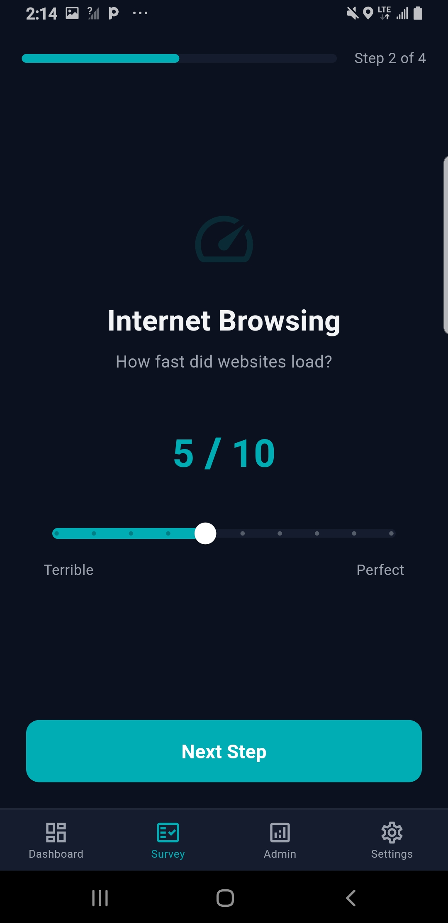
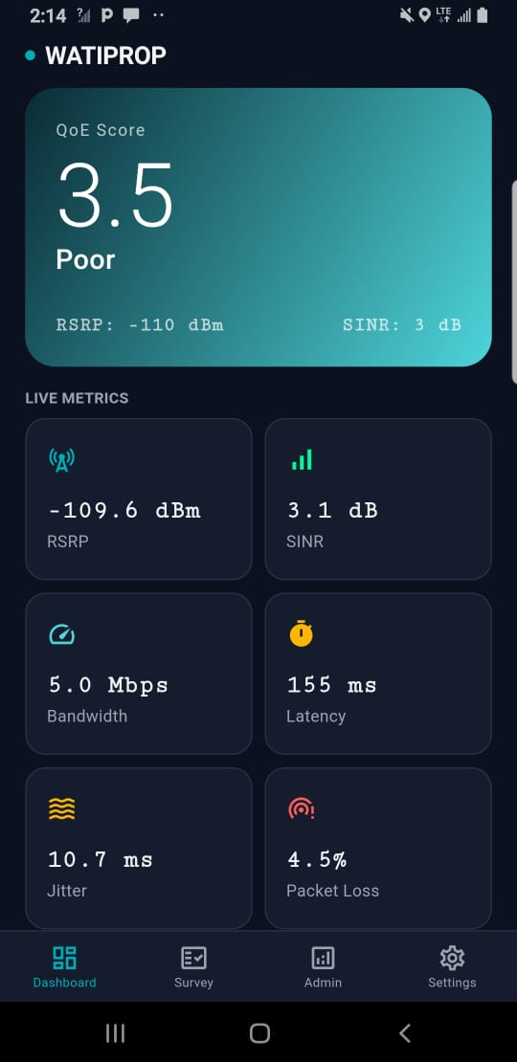
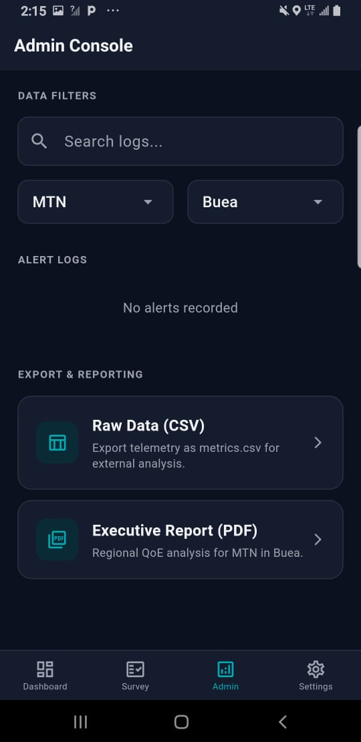

3.5 Key Use Cases

- Field Agent: launches app → grants permissions → begins metric collection → exports CSV report.
- Network Operator: opens admin dashboard → reviews alert log → generates PDF summary → filters by operator/region.
- Survey Respondent: completes QoE survey → submits response → data written to local DB.
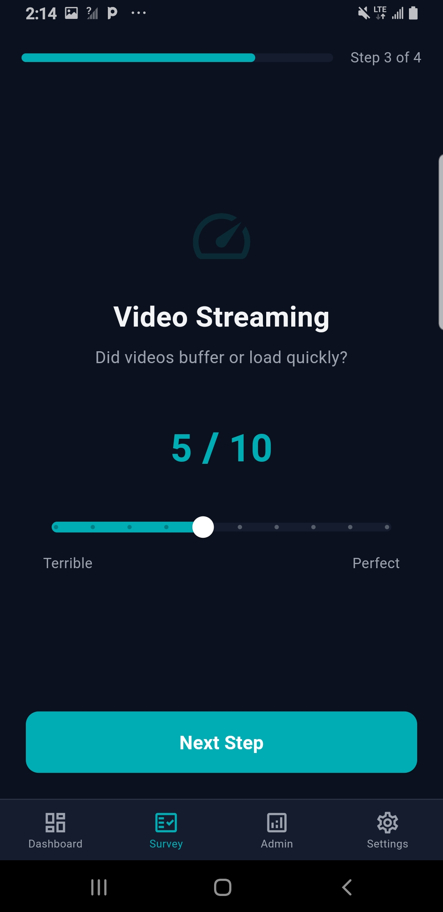

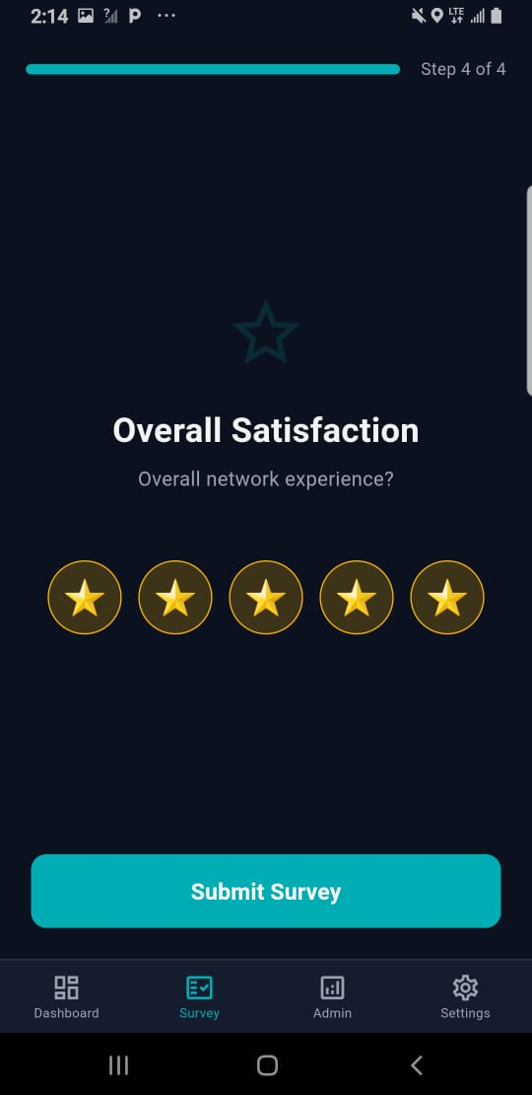


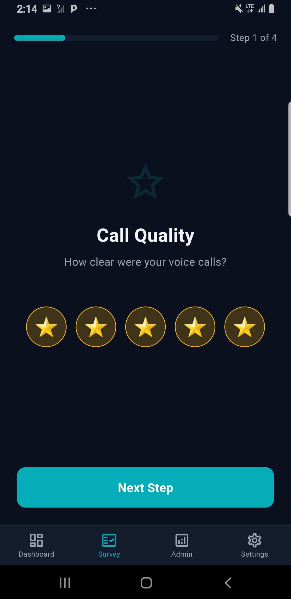

3.6 Sequence Flow (Core Telemetry Path)

Step | Action
1 | User opens app; go_router navigates to Home screen
2 | Riverpod provider requests telephony and location permissions
3 | NetworkMetricsCollector invokes native telephony channel
4 | Returned metrics tagged with GPS coordinates and timestamp
5 | MetricsDao writes record to Drift SQLite database
6 | User triggers export; ExportService writes CSV/PDF to storage
7 | Success snackbar displayed; file path returned to UI

Chapter 4 — Implementation and Testing

4.1 Development Environment

Tooling | Key Packages
Flutter SDK | State Mgmt
Dart ^3.11.5 | Riverpod 3.x
IDE | Database
Visual Studio Code | Drift (SQLite)
VCS | Export
Git | csv + pdf packages
Target Platform | Routing
Android API 28+ | go_router

4.2 Telephony Plugin Fork
The upstream telephony package exhibited two critical defects on API 28: (1) runtime crashes caused by unchecked null returns from CellInfoLte, and (2) duplicate method channel replies triggering PlatformException in Dart. The plugin was forked to a local path dependency, allowing direct modification of the Android Kotlin source. Null guards were added to all CellInfo property accessors, and a reply-sent flag was introduced to prevent duplicate channel callbacks. This eliminated both crash categories observed during physical device testing.

4.3 Local Database (Drift)
The Drift schema defines two primary tables: MetricRecord (signal readings with GPS and timestamp columns) and AlertLog (operator-triggered alert entries). Type-safe DAOs expose insert, query-by-date-range, and delete operations. The database is initialized with a SchemaVersion of 1; a migration path is already wired for future column additions. All DAO operations are await-ed within Riverpod AsyncNotifiers, keeping the UI thread free.

4.4 Export Service
CSV export queries MetricRecord rows within a user-selected date range, maps each row to a comma-delimited string, and writes the file via path_provider's getExternalStorageDirectory. PDF export follows the same query path but renders metric summaries and alert counts into a pw.Document using the pdf package. Both operations run in a Dart Isolate to avoid jank on large datasets.

4.5 Testing Results

Test Area | Outcome
Static Analysis (flutter analyze) | 0 errors in telemetry and export modules; unrelated UI warnings isolated to prototype screens
Telephony Plugin — Null Crash | RESOLVED: null guards prevent crash on cells returning incomplete CellInfoLte
Telephony Plugin — Duplicate Reply | RESOLVED: reply-sent flag prevents PlatformException on rapid polling
CSV Export (Android 9 device) | PASS: file written to Downloads/watiprop/; opened successfully in spreadsheet app
PDF Export (Android 9 device) | PASS: executive report generated with metric summary table and alert count
Drift DB — Offline Persistence | PASS: records retained across app restarts with no data loss
Permission Handling | PASS: telephony and location permissions requested correctly on first launch

Chapter 5 — Conclusion and Recommendations

5.1 Objectives Assessment

Objective | Status
Reliable telemetry collection on Android API 28 | ✓ Achieved
Local persistence via Drift SQLite | ✓ Achieved
CSV and PDF export | ✓ Achieved
Admin interface with alerts and filters | ✓ Achieved
Telephony plugin fork — crash-free operation | ✓ Achieved

5.2 Conclusion
WATIPROP successfully delivers an offline-capable, export-ready QoE monitoring application for the Cameroonian mobile network context. The key technical challenge — unstable native telephony integration on legacy Android devices — was resolved through a targeted plugin fork with surgical null-safety and channel-reply fixes. The feature-based Flutter architecture, Riverpod state management, and Drift persistence layer provide a maintainable foundation for the extensions recommended below.

5.3 Future Recommendations

- Remote Sync: implement a FastAPI backend to receive metric uploads over HTTPS, enabling operator-wide aggregation and trend analysis.
- Authentication: add operator login with role-based access control (field agent vs. admin vs. read-only analyst).
- SQLCipher Encryption: enable at-rest encryption on the Drift database connection for sensitive subscriber location data.
- Real RSRP/SINR Channels: replace stub values with wired Android platform channels returning live LTE/NR signal measurements.
- Automated Test Suite: add widget and integration tests for the ExportService and Admin Console using flutter_test and integration_test.
- iOS Port: audit and adapt the telephony platform channel for CoreTelephony on iOS to achieve true cross-platform parity.

References
- Flutter Documentation — https://docs.flutter.dev
- Riverpod State Management Guide — https://riverpod.dev
- Drift Database Documentation — https://drift.simonbinder.eu
- Android Telephony API Reference — https://developer.android.com/reference/android/telephony
- path_provider, csv, pdf Flutter Package Documentation — https://pub.dev
- ART (Agence de Régulation des Télécommunications) — Cameroon Regulatory Framework, 2024

