# Array

# Hash table

# Linked list

# Math

# Two pointers

011 container with most water

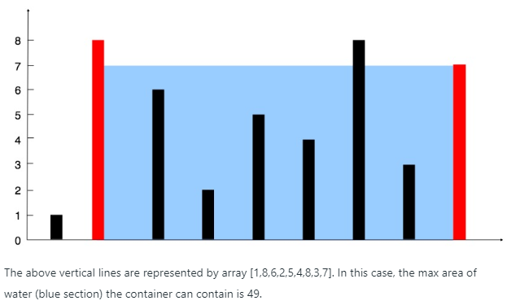

指向头尾，解是min(A[left], A[right]) * (right - left)

指针移动的条件是：对每一次判断，较小的指针向中间移动

因为初始已经是base最长的情况，每一次缩进期望的是min(A[left], A[right])的增大，才可能使目标函数增大；直到左右指针重叠。

# String

# Binary search

# Divide and conquer

# Dynamic programming

# Backtracking

# Stack

# heap

# greedy

# sort

# bit manipulation

# tree

# DFS

# BFS

# Union find

# Graph

# Design

# Topological sort

# Trie

# Binary indexed tree

# Segment tree

# Binary search tree

# Recursion

# Brainteaser

# Memoization

# Queue

# Minimax

# Reservoir sampling

# Map

# Geometry

# Random

# Rejection sampling

# Sliding window