# 

# My Lore of Leh & Beyond

# Hey superwomen,

It’s one life and we all know that while we keep getting carried away by all those pictures and posters of offbeat travel, solo trips of wanderers, and of course the FB wall loaded with friends posting their selfies at exotic landscapes; we all also have to balance out offices, leaves, home chores etc and what not.

Well, these are the few things which we specifically kept in mind before working out this ‘Trip of a Lifetime’

One may not get as many leaves/days for coming back to Ladakh again anytime soon, so it becomes a priority to make you experience the ‘bestest’ and most ‘famous’ of Ladakh.

While we do the above, we also ensure that everyone goes back with a different story, the experiences beyond destinations, so that Ladakh may stay longer in heart.

Walk into what we have aptly termed the “**My Lore of Leh & Beyond**”. This all women expedition encompasses a driving trip of 14 days starting and finishing in Delhi via Amritsar, Srinagar, Leh & Manali to be general. To be specific, discover in details below.

We are going to drive to the what is known to be one the most beautiful roads and passes in the world, sleep under the stars at night, learn some serious photography tips at a pristine setting, teach in a school as volunteer and explore unseen lakes and much more.

The idea is to meet new people, see amazing vistas, and absorb and learn more than what is suggested in the itinerary. And of course, explore one of the most beautiful hamlets in the world, with a mad bunch, under our Chief Experience Officer cum Enthusiast cum Storyteller _XYZ_.

**ROUTE PLAN** - **Delhi -Amritsar-Srinagar-Lamayuru- Dah/ Hanu- Lamayuru- Leh- Nubra via Yarab Tso- Turtuk via Hunder- Pangong Tso- Chushul- Tso Moriri- Tsokar-Pang-Sarchu- Manali- Delhi**

**Duration: 13 Nights 14 days (we may extend a day if required between Amritsar - Srinagar)**

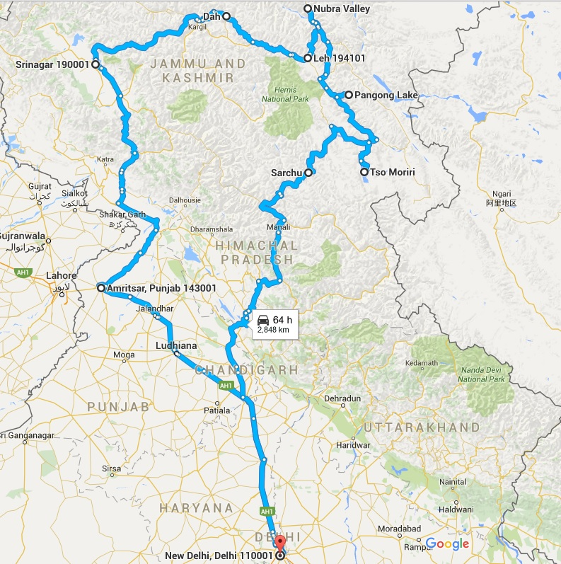

**Day-1: Delhi to Amritsar (Distance - 460, Driving Hours - 10)**

Our first day is easy and out and out foodie drive. We gather at our meeting point for some breakfast, while our crew fit in wireless radios in the vehicles and distribute medi-kits and oxygen cylinders. We start at about 8 am and hit highway soon to join NH-1, which is not only of the longest highways in the country but also a well-laid road to drive on. Traversing three states and approx 450 km, the biggest takeaway of this road is the mouthwatering Dhaba food. Since it’s an easy day, we gotta eat our heart out till we put snooze to our heavy stomach once in Amritsar! Some must-stops shall be at world famous Gulshan dhaba at Sonepat for paratha breakfast, Ambala’s famous Puran Singh Mashoor Dhaba, where the keema and chicken curry literally gives foodgasm, and Lucky Dhaba at Jalandhar, which all shall be satisfying experiences. Once in Amritsar, we end the day with a **quick tour to Golden Temple** to seek the blessings, which shall definitely go throughout our trip. And yeah, we won’t forgot the Patiala glass of lassi or milk before we call it a day..

**Day-2: Amritsar to Srinagar (Distance - 470, Driving Hours - 14)**

We leave Amritsar by 6 am and cover a distance of 700 kms, while stopping at various places for Photo Ops and food breaks, and crossing iconic towns of Pathankot and Jammu on the way. We shall experience the modern India’s engineering marvels as we traverse a four lane highway before hitting the famous J**awaher Tunnel**. It feels proud to see the genius of our own engineers firsthand. As we cross the tunnel, what welcome us are grand vistas of Kashmir Valley with its glowing beauty. After crossing Anantnag, we approach Srinagar to settle in our hand-picked accommodation. We go through rounds of Kahwa before delicious kashmiri dinner before you call it a day! (Accomodation: Hotel/ Homestay with parking facility)

**Day-3: Srinagar – Srinagar (Distance – Local, Driving Hours – Local)**

The Day is at Leisure, one can explore the Grand Mosque, Hazrat Bal Dargah, the various shops opposite Dal selling saffron, embroideries, cinnamon, teas etc. For the early risers (like 4am), there is an option to go the beautiful floating vegetable market in Dal, which is one of its kind as many sellers still barter their way with their produce. For lunch, we will have a full “**Kashmiri Wazwan Meal**”, which is iconic in its own, and should one leave Srinagar without relishing the famous Wazwan, one miss the heart of Srinagar. As the sun sets over the beautiful lakes of this piece of Heaven on Earth, **you enjoy the orange hues with tones of Santoor filling the air at the quieter yet enchanting Nigeen Lake**. (Accomodation: Hotel/ Homestay with parking facility)

**Day-4: Srinagar – Lamayuru (Ladakh) (Distance – 310, Driving Hours – 12)**

Having taken the road from Srinagar, it goes without saying that if one fly to Leh, it misses out on the beauty of Sonamarg, the adventurous rollercoaster ride of Zojila, the winds of Drass (the second coldest inhabited place in the world after Siberia), the patriotic feeling of being in Kargil, the colours of nature through the road to Leh and the extremely swanky BRO signboards. Another advantage of taking the road is that we get acclimatized to the thinness of oxygen and can breathe normally by the time we reach Ladakh.

We start by 06:00 am to make it to the beautiful Sonamarg for some tea and light breakfast before we hit mighty Zozila pass, our first serious driving challenge. This is the pass responsible for closing out of this route for good six months of the year. It’s a smooth drive onwards as we cross Drass and Kargil before moving to Lamayuru. Oh yeah, we couldn’t forget to visit war memorial at Drass on way, just adjacent to famous Tiger hill and Tololing top. One can relive Kargil tales here; **we have requested an army man for a tete a tete with you, going back to pages where the ink still looks fresh**. We actually experience and see it closely to understand that why Kargil victory is celebrated as one of the most special army wins of all times. Our night halt shall be at Lamayuru instead of predictable Leh City, where we also visit famous Lamayuru Gompa before we call it a day, in a comfortable home stay. (Accommodation: Home stay)

**Day-5: Lamayuru – Dah – Lamayuru (Distance – 200, Driving Hours – 5)**

While people rarely know or recommend **Dah and Hanu in Ladakh**, we believe they are crucial to know what Ladakh is all about, as these villages are known for their interesting Ladakhi history. The villages in this small area are the only Dardic settlements in Ladakh, and people of Dah and come from an entirely different ethnic group from other Ladakhis. Stories are afloat about people of Dah and Hanu being the only tribe of purely Aryan people, but the validity of same is questionable. A truth, or something to do with tourism, who know ;-) but definitely a one of its kind selling proposition :-)

Dah is located at an altitude of around 2800 meters perched along the Indus River is a tiny village of apricot groves, grape vines, apple trees, and vegetable gardens. The village of Hanu is quite different from Dah, as they have lost their original language of the Dards and adopted general Ladakhi. It shall be a memorable day for us looking at women dressed in their fineries as they go about doing their chores. And yeah, Dah and Hanu are amazing photo story projects too. We return to Lamayuru for night halt as we also get mesmerized by renowned moonscapes of Lamayuru. (Accommodation: Home stay)

**Day-6: Lamayuru – Leh (Distance – 100, Driving Hours – easy drive)**

Today, we drive to Leh town, just about 3 hours downstream along the River Indus on Leh – Kargil Highway. On way, we have planned **rafting for about 4 kms downside Indus River**. The fast and thrilling rafting has beautiful land scenery. The rafting finishes at Nimoo at the confluence of Zanskar and Indus rivers. Perhaps this stretch is one of the most popular stretches as it is not too harsh and good for beginners.

After lunch, we also get to experience the famed MAGNETIC HILL, which opposes the law of gravity. We all have heard that that when a vehicle is stopped on nonpartisan apparatus on this metallic street the vehicle starts moving uphill. Check for yourself.

Before touching Leh, we again take blessings of the almighty at GURUDWARA PATTHAR SAHIB, which was established by the Lamas of Leh in 1517 to remember the visit of Guru Nanak Dev. Currently; it is being maintained by our respected army.

After visiting Leh war memorial on way, we check-in to comfortable stay in Leh Town (Accommodation: Hotel).

**Day-7: Leh – Leh (Distance – Local, Driving Hours – Local)**

We are going to start our day with a **yoga & meditation camp for one hour** in early morning sun which we have especially set out for you. After a perfect start, we have arranged a bike ride to and fro Hemis monastery. It is going to be an amazing experience to ride stylish bikes to Hemis, which is most renowed monastery in Leh. Alternatively, as per wish, one can drive the cars also, or lie low and rest for start of next leg of journey, while we shall be arranging your pemits.

One can soak up the vibe of this now touristic town which still retains it old world charm in its quaint cafes, ladakhi kitchens. One can shop for trinkets & memoirs and yes, sending a postcard back home from here shall forever remind us of this one of kind sojourn.

Post Lunch, we have arranged a **visit to local School SECMOL**. This place is ideal example of how culture and education go hand in hand. Our group can interact with little kids (oh yes the apple cheeked ones), teachers etc and experience how slowly this 1988 founded education Centre is making a difference. Evening is free again for shopping; or preparing for journey ahead. (Accommodation: Hotel).

**Day-8: Leh – Nubra Valley (Hunder) (Distance - 110, Driving Hours – 6)**

Post breakfast, we drive to Nubra Valley. The street venture from Leh to Nubra Valley crosses famous KHARDUNG LA (the highest motorable road in the world) at 5,602 m or 18390 ft. From the pass, one can see the distant south over the Indus valley to apparently unlimited tops and edges of the Zanskar range, and north to the monsters of the Saser massif.

Once we are descending from Khardungla towards Nubra Valley, we are going to take all to one of our secret places around, **the Yarab Tso. It’s a literal hidden lake**, which is considered holy by local Ladakhis, and often gets overpowered by its bigger cousins like Pangong and Tso Moriri. This one is equally breathtaking with its crystal clear waters against stark barren background.

Nubra Valley is famously known as Ldumra or the valley of flowers. I, upon entry in Nubra, take you to Diskit, which is headquartering town of Nubra valley. Walk around the bazaar watching the shops and individuals going about their everyday errands. Diskit is popular for 515 years of age Buddhist Monastery, lying brilliantly arranged on a peak, confronting the whole Valley.

Unparalleled views of famous Hunder sand dunes await you as we proceed to check in to our tented stay in Hunder for Overnight, where we end our day with a **Bonfire Party** followed by exquisite buffet dinner. (Accommodation: tented stay)

**Day-9: Hunder – Turtuk (Distance – 90, Driving Hours – 2)**

After an early breakfast we drive to sand dunes, where one can have a quiet time, or alternatively get to ride on bacterian camels (double humped camels) in the midst of the sand rises of this desert with snow topped mountains all around. Found in segregation you could well be amongst the sand rises of the Thar Desert in Rajasthan.

Later, we drive to the one of most amazing places of the entire tour "Turtuk" which used be part of POK till 1971, when India captured this strategic point. The same was then opened for tourist in 2010 with prior permissions, and now no permission is required to visit here. Turtuk will welcome us with one of the amazing Balti Tribe with Balti food and beautiful tent stay.

Oh yes we don’t just relish the food, we have also planned a **cooking class here learning the nuances of this Ladhaki Kitchen**. In the evening one can stroll around the small village to perceive how local people live in this a portion of the world. A visit to a Ladakhi home can be masterminded, before we return back to our tented stay. (Accommodation: tented stay)

**Day-10: Turtuk – Pangong Tso (Spangmik) (Distance – 250, Driving Hours – 8**)

Today, we head to place which has brought Ladakh to sudden limelight, the 3 Idiots famed Pangong lake. We have to mention that it is going to be the most challenging driving day of the whole trip. We take a road least travelled by the tourists. So much that we will rarely find a vehicle through all of it. We proceed to Agham and move ahead to traverse Wari-La, one of the most treacherous passes of the area. Not to forget Chang-La, which awaits ahead as the third highest pass in the World.

We shall stop at the ChangLa for a round of Kahawa and noodles. Leaving Tangtse for Pangong you pass through few small villages and finally one have a sudden view of the Pangong lake situated at 14,000 feet (4,267 m). This famous blue brackish Lake of Pangong is 5/6 Kms wide and over 133 Kms long with half of its running the other side of the China border. One rarely feels so close to nature and environment and the scenery is unforgettable.

We have arranged **photography capsule class here for those who get interested**, before we have another bonfire dinner. We end the day in well laid tents along the lake side, which gives an experience to remember.

**Day-11: Pangong – Chushul – Tsomoriri (Distance – 250 km, Driving Hours - 8)**

As we start the journey early to reach in time to enjoy Tso-moriri in full view, the path today is going to traverse the breathtaking Chamthang region, which is least travelled reason of whole of Ladakh. We pass through small villages of Chushul, which is one of the four open posts with China for regular flag meetings. We visit war memorial to know and under famous war story of Rezang-La which changed the course of Indo-China war.

Further passing through Mahe bridge, we finally make to Tso-moriri. The lake is at higher altitude than Pangong. This beautiful blue pallet lake is about 7 KM wide at its broadest point and about 19 KM long. Being part of the wetland reserve under Ramsar site, it is actual known as Tsomoriri Wetland Conservation Reserve, which prohibits the camping on the banks of the lake. While it appears to be most romantic place u have ever seen, one has to be careful as the conditions are much harsher than it seems. Nights here are fantastic for Star Gazing in beautiful clear skies. We stay for such a beautiful night in adjacent Korzok village, which also houses the Korzok gompa. (Accomodation : homestay)

**Day-12: Tsomoriri – Tsokar – Pang – Sarchu (Distance – 230, Driving Hours – 7)**

As we move from Korzok towards Manali, first place we are going to visit this day is Tso-Kar. The Tso-Kar Lake is known as 'White Lake' because the white salt of the water deposits all over the lake shores. The Lake is located at an altitude of 4660m/15280ft. The Tso-Kar lake is very popular with bird watchers, as the area surrounding Tso-kar lake is rich with wildlife and birds. The lake is surrounded by the marshlands that host amazing bird life highlight of which is migratory black-necked cranes. These birds make an amazing site when they takeoff over the green, picturesque plains on the backdrop of snow-clad mountains. Surrounded by hills and mountains on all sides, the lake itself gives a wonderful scenic and amazing view.

Further we join Leh-Manali highway in Debring, before hitting the Morey Plains. Morey plains is a 45 km long plain straight stretch at an average height of approx 4500 m, and is flanked by mountain ranges on both sides. The straights are adorned by beautifully laid down road by BRO, and loved the most by driving enthusiasts. At the end, we hit mighty Tanglang-La which is closed 6 months in a year, and descends via famous Ghata loops to Sarchu for night halt in a basic tenting accommodation.

**Day-13: Sarchu – Manali (Distance – 250, Driving Hours – 8)**

As we move closer to civilization in Manali, we traverse Baralacha-La to reach Keylong which is capital of Lahual Spiti reason. It’s a small quiet town with its own charm, as we start to see stark difference between Ladakh and this area. The cold desert is all but over by now, and hills are full of greenery and tree laden mountains. We move ahead to climb famous touristic destination of Rohtang-La as taxis, crowd, jams suddenly make their way back in our lives.

We reach Manali by evening to check in a comfortable hotel after so many days of tenting and camping, while the feeling of leaving Ladakh still soaks in. We host an exquisite **Gala dinner and drinks in the evening to celebrate the successful completion of the trip of our lifetime.** (Accommodation: Hotel)

**Day-14: Manali – Delhi (Distance – 550, Driving Hours – 12)**We start our long drive back to Delhi, which we are sure be something, which we all wanted to never come. Once in Delhi we deposit our equipments, radios and kits, before dispersing as a clan with memories, experiences, moments we shall savor forever, as we say final goodbyes.