BASIC NETWORK SNIFFER
Using Python and Scapy
Name | Kamar Nisha .S
Internship | CodeAlpha
Project | Basic Network Sniffer
Technology | Python 3, Scapy
Date | 09 July 2026
CodeAlpha Internship Project Report

1. Title
Basic Network Sniffer Using Python and Scapy

2. Objective
The objective of this project is to capture live IP packets travelling through a network interface using Python and the Scapy library, and to display the source address, destination address, and protocol number of each packet. The project provides a hands-on introduction to how network traffic can be observed programmatically and how the IP layer carries routing information for every packet exchanged between two hosts.

3. Tools Used
Tool / Library | Purpose
Python 3 | Core programming language for the project
Scapy | Packet sniffing library used to capture live IP traffic
PyCharm | IDE used to write and run the script
Windows | Operating system used for testing (Npcap driver required)
Run Console / Terminal | Execution environment (requires Administrator privileges)
Scapy is a Python library that can sniff, dissect, and analyze network packets. Its sniff() function is the core building block used in this project to capture a fixed number of live packets.

4. Introduction
Network sniffing refers to capturing packets as they pass through a network interface. It is a foundational technique used in networking, cybersecurity, and troubleshooting, since it allows the contents of network traffic to be observed directly rather than inferred.
Every packet exchanged between two devices carries an IP header containing, among other fields, the source address, the destination address, and a protocol number identifying the transport-layer protocol carried inside (for example, 6 for TCP, 17 for UDP, or 1 for ICMP). By reading these header fields for each packet, it becomes possible to see which machines a computer is communicating with and over which protocol, without needing to decode the encrypted payload itself.
This project implements a minimal sniffer that captures a fixed number of packets from the active network interface and prints the source IP, destination IP, and protocol number for each one, giving a first practical look at how Scapy exposes the IP layer of captured traffic.

5. Methodology
The project was implemented in Python using the Scapy library. The development followed these steps:
- Environment setup — Python 3 and Scapy were installed inside a PyCharm virtual environment. Capturing live packets on Windows requires Npcap to be installed and the script to be run with Administrator privileges.
- Interface access — Scapy's sniff() function was used without specifying an interface, so it defaults to capturing on the active network adapter.
- Callback definition — A callback function, packet_info(), was defined and passed to sniff() via the prn parameter, so that it runs once for every packet captured.
- IP layer check — Each packet is checked for the presence of an IP layer using the IP in packet expression before any fields are read, avoiding errors on non-IP traffic.
- Field extraction — For every IP packet, the source address (packet[IP].src), destination address (packet[IP].dst), and protocol number (packet[IP].proto) are printed to the console.
- Bounded capture — The count parameter of sniff() was set to 10, so the script automatically stops after ten packets have been processed.

6. Working of the Program
The program operates through the following sequence:
- The program prints "Capturing packets..." and calls Scapy's sniff() function with count=10.
- Scapy attaches to the active network interface and begins listening for incoming and outgoing traffic.
- Each time a packet arrives, Scapy invokes the packet_info() callback and passes the captured packet to it.
- The callback checks whether the packet contains an IP layer using the IP in packet test.
- If an IP layer is present, the source IP, destination IP, and protocol number are printed, followed by a separator line of dashes.
- If a packet does not contain an IP layer, it is silently skipped.
- Once ten IP packets have been processed, sniff() returns automatically and the script terminates.

7. Core Code Snippet
The following is the complete code used for packet capture in this project:
from scapy.all import sniff, IP
def packet_info(packet):
if IP in packet:
print("Source IP :", packet[IP].src)
print("Destination IP :", packet[IP].dst)
print("Protocol :", packet[IP].proto)
print("-" * 40)
print("Capturing packets...")
sniff(prn=packet_info, count=10)

8. Screenshot — Running Script
The following screenshot shows the network sniffer running inside the PyCharm run console, capturing ten live IP packets and printing the source IP, destination IP, and protocol number for each one:
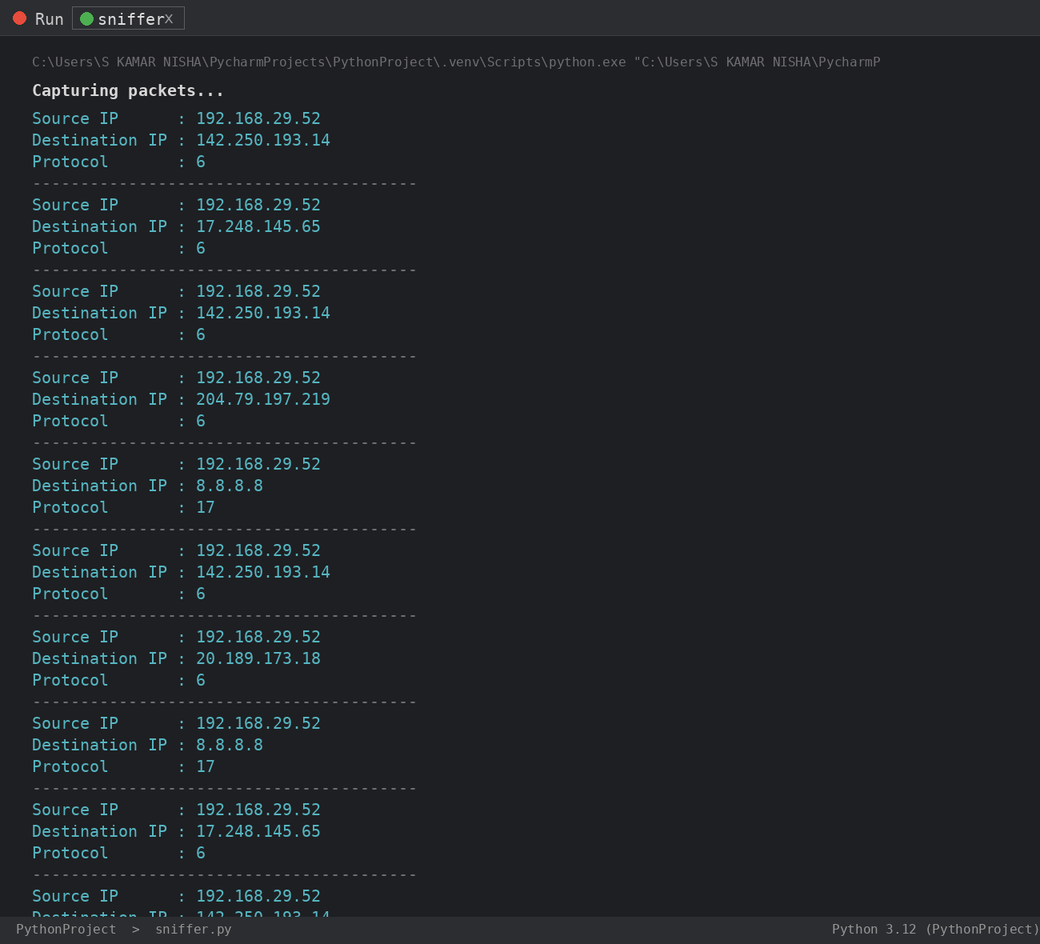
Figure 1: Live packet capture running in the PyCharm console — ten IP packets captured, each showing source IP, destination IP, and protocol number

9. Sample Output
A representative section of the console output produced during a test run is shown below:
Capturing packets...
Source IP : 192.168.29.52
Destination IP : 142.250.193.14
Protocol : 6
----------------------------------------
Source IP : 192.168.29.52
Destination IP : 8.8.8.8
Protocol : 17
----------------------------------------
Source IP : 192.168.29.52
Destination IP : 20.189.173.18
Protocol : 6
----------------------------------------

10. Observations

10.1 Protocol Number Instead of Name
Since the script prints packet[IP].proto directly, protocols appear as raw numbers rather than names — 6 for TCP and 17 for UDP were the two values observed during testing. Mapping these numbers to readable names would require an additional lookup, which this basic version does not perform.

10.2 One Source IP, Many Destinations
Across all ten captured packets, the source IP remained the same local address (192.168.29.52), while the destination IP varied with each outbound connection. This reflects normal client behaviour, where a single machine opens connections to multiple remote servers such as content-delivery and DNS endpoints.

10.3 TCP Dominates Everyday Traffic
The majority of the captured packets carried protocol number 6 (TCP), consistent with background HTTPS connections maintained by browsers and OS services. A smaller share carried protocol number 17 (UDP), typically associated with DNS lookups.

10.4 No Application-Layer Visibility
Because the script only reads the IP header, it cannot show port numbers, TCP flags, or payload content. This confirms that meaningful application-layer detail (such as which website is being contacted) would require inspecting the TCP/UDP layer in addition to the IP layer.

11. Results
The script successfully captured ten live IP packets from the active network interface and printed the source IP address, destination IP address, and protocol number for each one. The capture completed automatically once the count limit was reached, without requiring manual interruption.
During testing, all ten packets originated from the same local address and were addressed to a mix of remote servers, with protocol number 6 (TCP) appearing most frequently and protocol number 17 (UDP) appearing for DNS-related traffic. This matches the expected behaviour of a desktop machine with active background network connections.

12. Conclusion
This project provided a first practical introduction to packet capture using Python and Scapy. Building even this minimal sniffer reinforced core networking concepts, including the structure of the IP header, the meaning of the protocol field, and the relationship between a local source address and multiple remote destination addresses during ordinary network use.
This simple version forms a stepping stone toward a more feature-rich sniffer capable of decoding transport-layer details such as ports and flags, and lays the groundwork for further exploration of protocol analysis and network security monitoring.

13. Future Scope
- Map numeric protocol values to readable names (e.g. 6 → TCP, 17 → UDP, 1 → ICMP) for easier reading.
- Extend the callback to inspect TCP and UDP layers and display source/destination port numbers.
- Remove the fixed count=10 limit and allow continuous capture until manually stopped.
- Write captured packets to a PCAP file using Scapy's wrpcap() for later analysis in Wireshark.
- Add a simple filter (e.g. by protocol or destination IP) using a BPF filter string passed to sniff().
- Log captured packet details to a text or CSV file instead of only printing to the console.

14. References
1. Scapy Project Documentation — https://scapy.readthedocs.io/en/latest/usage.html
2. Python Software Foundation — https://docs.python.org/3/
3. IETF RFC 791 — Internet Protocol (IPv4)
4. Npcap Documentation — https://npcap.com/guide/
5. CodeAlpha Internship Guidelines and Lab Notes

Prepared By | Project
Kamar Nisha .S  Intern — CodeAlpha | Basic Network Sniffer  Python & Scapy | CodeAlpha

