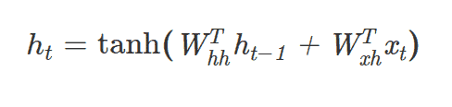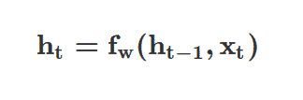**RNN:**

Uses timestamps t. Like in the formula you use previous h and current input

to calculate next ht.

ht is called cell state. F_w is given by weights. Same function and

parameters every timestamp.

The function for RNNs is given by tanh and the weight matrixes aswell as

An offset by the weight matrix WW_hh.

The final output is then given by Wty * ht.

One time through all inputs creates 1 update step where then the weight

matrix is updated.

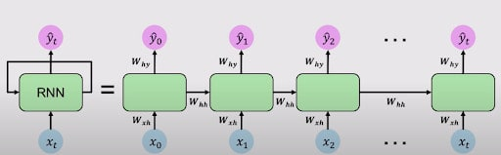

**LSTMs:**

Uses Gates. Information added or removed through Gates. A Gate is a neural net layer. Eg. sigmoid. + a multiplication (pointwise).

First Gate (Forget gate)

Takes prior state ht-1 and new input xt.





