ASG Airlines
Data Engineering Case Study — Project Documentation
A fictional-airline pipeline built end-to-end in local Python/pandas,
modeled into a star schema and visualized in Power BI Desktop.
Repository: github.com/Stebin404/asg-airlines-case-study

Table of Contents
1. Project Overview 3
2. Architecture & Data Flow 4
3. Dataset Description 5
4. Data Quality Audit Findings 6
5. Cleaning & Transformation Logic 7
6. PII Masking Strategy 8
7. Data Model / Star Schema 9
8. KPI Definitions & Key Findings 10
9. Assumptions & Design Decisions 11
10. Privacy & Access Control Notes 12

1. Project Overview
ASG Airlines is a fictional airline used as the subject of this case study. The project builds a complete, small-scale data engineering pipeline end to end: ingesting a raw multi-sheet spreadsheet export, auditing and cleaning it, masking personally identifiable information (PII), modeling the result into a star schema, computing a set of operational KPIs, and publishing the outputs to a Power BI dashboard.
The goal is to demonstrate a realistic, if compact, analytics-engineering workflow rather than to model a real airline: the source data is synthetic and was deliberately seeded with the kinds of quality problems a real intake process encounters — missing values, duplicate keys, invalid codes, and a handful of corrupted timestamps.

Environment
- Processing: local Python 3 with pandas (no cloud/Azure components).
- Visualization: Power BI Desktop, connected to CSV exports.
- Source control: a public GitHub repository (linked below).

Repository
https://github.com/Stebin404/asg-airlines-case-study

2. Architecture & Data Flow
The pipeline runs as six sequential notebooks, each reading the previous stage's output and writing its own artifacts to data/. The diagram below shows the stages, the intermediate artifacts they produce, and the final Power BI deliverable.
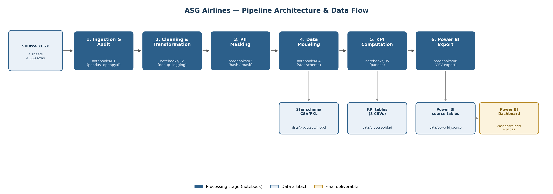
Figure 1 — Pipeline architecture and data flow.

Stage summary
- 01_ingestion_and_audit — loads all four raw sheets and profiles them (missing values, duplicates, dtypes) before any changes are made.
- 02_cleaning_transformation — drops full-row duplicates, resolves duplicate flight_id values, standardizes categorical values, and logs every transformation step.
- 03_pii_masking — hashes or partially masks direct identifiers on the passenger and booking data (detailed in Section 6).
- 04_data_modeling — reshapes the cleaned, masked tables into a star schema (Section 7).
- 05_kpi_computation — computes the eight KPI tables used by the dashboard (Section 8).
- 06_export_for_powerbi — writes the final star-schema and KPI tables to data/powerbi_source/ as the Power BI data source.

3. Dataset Description
The source is a single .xlsx workbook with four sheets. Row and column counts below are taken directly from the ingestion audit (notebook 01), not estimated.
Sheet | Rows | Columns | Column list
flights | 1,020 | 7 | flight_id, airline, source, destination, departure_time, arrival_time, duration
payments | 1,000 | 4 | payment_id, booking_id, amount, payment_method
bookings | 1,000 | 9 | booking_id, passenger_id, flight_id, booking_date, status, passport_number, seat_number, emergency_contact_name, emergency_contact_phone
passengers | 1,039 | 9 | passenger_id, first_name, last_name, age, gender, email, phone, aadhaar_id, date_of_birth

passengers, bookings, and payments carry direct or near-direct identifiers (name, email, phone, national ID, passport number, emergency contact details) which are why PII masking (Section 6) is a required stage before the data is modeled or exported, not an optional add-on.

4. Data Quality Audit Findings
All figures in this section come from the raw audit in notebook 01, run before any cleaning. They describe the source data as delivered, not the cleaned output.

flights
- 41 rows missing airline; 15 full-row duplicates; 16 duplicate flight_id values (a full-row duplicate and a same-ID/different-row duplicate are different things — the counts aren't additive).
- 124 flights flagged overnight (arrival date after departure date) at the raw-audit stage.
- 1 flight with arrival before departure — an impossible, corrupted timestamp: flight_id SJ192, departing 2026-04-19 18:45:42 but arriving 2026-04-18 23:45:42.
- Airline values: IndiGo 249, SpiceJet 240, Air India 236, Vistara 223, 41 missing (NaN), 31 explicit "UNKNOWN".

payments
- 48 rows with missing amount; 30 rows with a non-numeric amount recorded as the literal string "INVALID".
- No full-row duplicates and no duplicate payment_id values.

bookings
- 45 rows missing status; 30 rows with status recorded as "INVALID".
- No duplicate booking_id values and no orphan foreign keys — every flight_id, passenger_id, and booking_id referenced elsewhere resolves cleanly at the raw-audit stage.

passengers
- 10 rows missing last_name.
- 39 duplicate passenger_id values — i.e., the same passenger_id appears on more than one row (see Section 9 for how this was handled).
Numbers that look inconsistent across documents but aren't
Overnight flight count: 124 in the raw audit vs. 122 in the final fact_flights table. Both are correct — they're measured at different stages. Deduplication in notebook 02 removes 15 full-row duplicates and resolves 16 duplicate flight_id values before the overnight flag is recomputed on the cleaned data, so the final count is naturally lower.
Airline distribution: raw audit shows 41 NaN + 31 UNKNOWN = 72 unresolved-airline rows; the final airline_distribution KPI shows 69 UNKNOWN. The gap is explained by the same deduplication step removing a handful of the affected rows before the KPI is computed.
Corrupted-timestamp flight: identified in the raw audit as flight_id SJ192. After cleaning, flight_id values are de-duplicated by appending a numeric suffix (e.g. _1) to the 2nd, 3rd, … occurrence of a repeated ID, so this exact ID may appear suffixed or unsuffixed in fact_flights.csv depending on which occurrence it was.

5. Cleaning & Transformation Logic
notebooks/02_cleaning_transformation.ipynb applies the following steps, in order, to each sheet, logging before/after row counts to data/processed/transform_log.csv:
- Drop full-row duplicates from flights (15 rows removed).
- Resolve remaining duplicate flight_id values by appending a cumulative-count suffix per ID group (e.g. the 2nd occurrence of flight_id ABC123 becomes ABC123_1), so every row keeps a unique key without discarding data.
- Standardize categorical fields (airline names, booking status, payment method) and recode invalid sentinel values ("INVALID", blank) consistently.
- Verify referential integrity — check for orphan bookings/payments against the cleaned flights and passengers tables (0 orphans found, confirming the raw data's foreign keys were already sound).
- Persist the cleaned tables as both CSV and pickle (.pkl) so the PII-masking notebook can load them without re-parsing dates.
Known limitation: fact_bookings fan-out
The payments sheet is not 1:1 with bookings — some booking_id values have as many as 6 associated payment rows (partial payments, refunds, retries, etc.). When fact_bookings is built by joining bookings to payments, this fans a booking out to one row per payment.
As a result, the exported fact_bookings.csv has 1,363 rows even though there are only 1,000 distinct booking_id values. This is by design — dropping the extra payment rows would lose real transaction history — but any KPI built by counting rows of fact_bookings directly (rather than distinct booking_id) will overcount bookings. The KPI notebook accounts for this explicitly; see Section 8.

6. PII Masking Strategy
notebooks/03_pii_masking.ipynb runs after cleaning and before modeling, so no downstream table (star schema, KPIs, or the Power BI export) ever contains a raw identifier. The strategy differs by field, matched to how much of the original value downstream analysis actually needs:
Field | Technique | Rationale
passenger_id, aadhaar_id, passport_number | SHA-256 hash, truncated to 16 hex characters | Preserves joinability (same input → same hash) without retaining the reversible original value.
passenger name | Pseudonymized alias (passenger_alias) | Removes the real name entirely rather than partially masking it.
email | Partial mask — first character and domain kept, remainder replaced with asterisks | Keeps enough structure for spot-checking format validity without exposing the address.
phone | Partial mask, similar pattern to email | Same rationale as email.
date_of_birth | Generalized to birth_year, then bucketed into age_band | Age-band analysis doesn't need a precise birthdate; generalization reduces re-identification risk.
passport_number | Hashed, then dropped from the analytics table entirely | Not needed for any KPI; hashing before dropping preserves an audit trail without keeping the value in the analytics path.
emergency_contact_name, emergency_contact_phone | Dropped entirely | Third-party PII with no analytical use in this project.

Only the resulting passengers_analytics and bookings_analytics tables (and everything derived from them) are written to disk from this point forward; the raw, unmasked frames exist only in memory within this notebook's run.

7. Data Model / Star Schema
notebooks/04_data_modeling.ipynb reshapes the cleaned, masked tables into a conventional star schema: two fact tables (fact_flights, fact_bookings) surrounded by four dimension tables (dim_airline, dim_route, dim_date, dim_passenger). Column names below are taken directly from the exported CSVs in data/powerbi_source/.
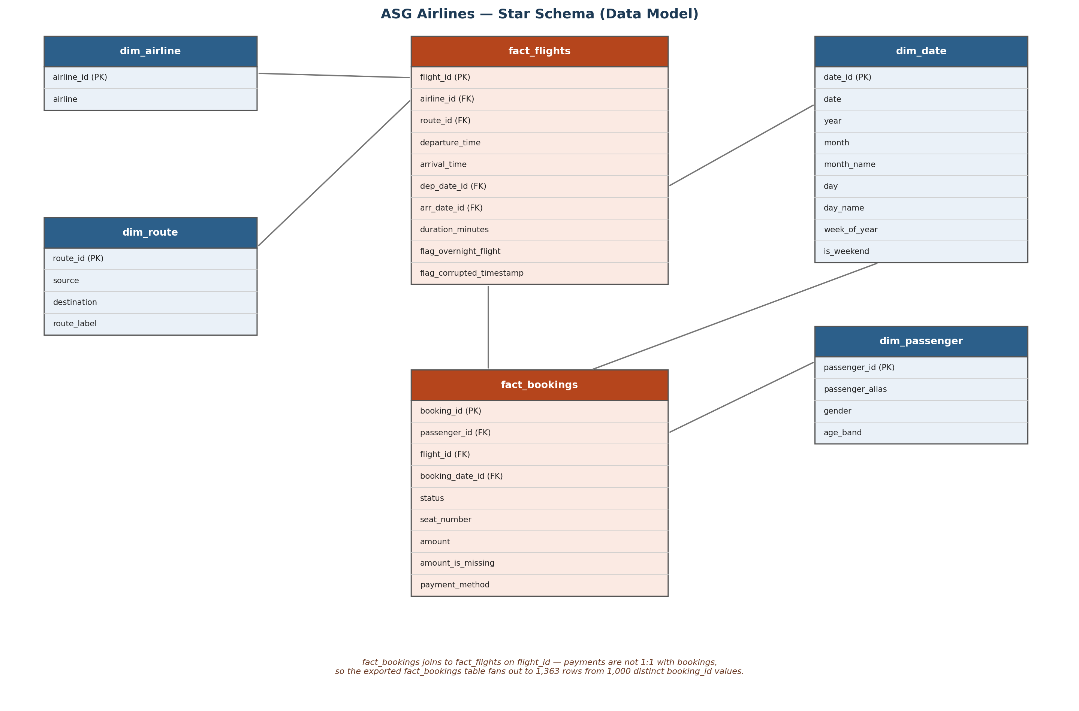
Figure 2 — Star schema, with real exported column names.

Why dim_date has only 5 rows
The flight data in this dataset spans a single five-day window, 2026-04-17 through 2026-04-21 (Friday through Tuesday). dim_date is built from the distinct dates that actually appear in the fact tables, so it has exactly 5 rows — this is a property of the source data's date range, not a bug in the date-dimension logic. It also means Wednesday and Thursday never appear as calendar dates in the model at all, which matters for interpreting the traffic_by_dow KPI in Section 8.

8. KPI Definitions & Key Findings
notebooks/05_kpi_computation.ipynb reads the star schema and writes eight KPI tables to data/processed/kpi/. The headline figures from each are summarized below; full tables are in the CSVs themselves.
KPI | Headline figure
Booking status distribution | CONFIRMED 439 · CANCELLED 418 · PENDING 410 · UNKNOWN 96
Airline distribution (flight count) | Indigo 249 · Spicejet 236 · Air India 233 · Vistara 218 · UNKNOWN 69
Anomaly counts | Overnight flights 122 · Unknown airline 69 · Corrupted timestamp 1
Top route by traffic | BOM → CCU, 90 flights
Top route by revenue | BOM → CCU, ₹700,135
Longest average duration | BLR → MAA, 187.3 minutes
Duration outliers (z-score > 2) | 1 flight: 6F212 (BLR → CCU, 282 min, z ≈ 2.04)

Duplicate-payment handling
Because fact_bookings fans out to 1,363 rows (Section 5), booking_status_dist and any other KPI counted by booking is computed on the distinct booking_id, not on raw row counts of fact_bookings — otherwise bookings with multiple payment rows would be overcounted. Revenue and payment-method KPIs, by contrast, are legitimately computed on the row level, since each payment row is a real transaction.
Known limitation: traffic_by_dow has three NaN rows
traffic_by_dow.csv reports a flight count for Monday, Friday, Saturday, and Sunday, but Tuesday, Wednesday, and Thursday are blank (NaN) rather than zero.
This is expected, not a computation bug. Wednesday and Thursday don't exist at all in this dataset's 5-day date range (Section 7), so they were never going to have a count. Tuesday does exist in dim_date (2026-04-21) but, as it turns out, no flights in the cleaned dataset actually depart on that date — so its true count is 0, but the pivot used to build this KPI leaves days with no matching rows as NaN rather than filling them to 0.
Recommended fix, tracked for a future iteration: reindex the day_name pivot against the full Monday–Sunday list and fill missing values with 0 rather than leaving them as NaN, so the distinction between “no data for this day” and “zero flights on this day” is explicit in the output rather than implicit in a code comment.

9. Assumptions & Design Decisions
- Synthetic data, not a real airline. All names, IDs, routes, and financial figures are fictional; ASG Airlines does not exist.
- Duplicate flight_id values were suffixed rather than dropped, on the assumption that each row represents a real, distinct flight record worth keeping even when the source system reused an ID.
- Duplicate passenger_id values in the raw passengers sheet (39 of them) were left in the passenger dimension as-is rather than deduplicated, on the assumption that this reflects genuine repeat-appearance in the source extract rather than a key-generation error; this is a candidate for follow-up investigation rather than a resolved decision.
- payments were joined to bookings at the row level (not deduplicated to one row per booking), preserving the fan-out described in Section 5, because collapsing it would discard real transaction history.
- "INVALID" and blank/NaN values in categorical fields (status, amount, airline) were treated as distinct data-quality signals and mostly carried through to an explicit UNKNOWN/anomaly bucket in the KPIs, rather than being silently imputed, so the audit trail of "this was actually missing or bad" isn't lost.
- dim_date was built only from dates that appear in the fact tables (5 rows) rather than a generated full calendar range, since a general-purpose calendar dimension wasn't needed for a dataset that only spans 5 days.
- Notebook markdown was kept intentionally minimal (short one-line headers rather than extensive prose) as a style preference for this project; this documentation is where the fuller narrative lives.

10. Privacy & Access Control Notes
This project handled a real (if past) privacy incident, which shaped how the repository is structured today:
Past incident (resolved)
A version of the raw source .xlsx — containing unmasked passenger PII — was accidentally committed to this public GitHub repository before a .gitignore file existed to exclude raw data.
Remediation: the repository was deleted and reinitialized with a clean history, so the exposed file is not recoverable from any commit, branch, or tag. The current repository's first commit is literally titled "Initial commit — clean history, no raw PII file," confirming the clean start.

Current safeguards
- Raw source data is excluded from version control via .gitignore; only cleaned, masked, and modeled outputs are committed.
- PII masking (Section 6) runs before any table is written to data/processed/ or data/powerbi_source/, so no committed CSV — including intermediate ones — contains a raw name, email, phone number, national ID, or passport number.
- The Power BI dashboard is built entirely from the masked, modeled data/powerbi_source/ tables and never connects directly to the raw workbook.

Recommendation for anyone extending this project
Treat the source .xlsx as sensitive from the moment it's downloaded, keep it out of the working tree entirely (or in a path already covered by .gitignore) if possible, and re-run notebook 03 rather than hand-editing any masked output.

