Added a 180 rf pulse in front of the for loop.

The 90 rf is mirrored in the place where the RF train starts in order to start the train.

In clinical sequences the 180 pulses are very short block pulses (no sync) ca 0.3ms. The 90 rf puls is especially in 7T very long. This is done to get a good excitation in the RoI. But now it doesn’t fit into the 180 train sequence -> mirror the echo to the beginning.

For that 3 new delays:

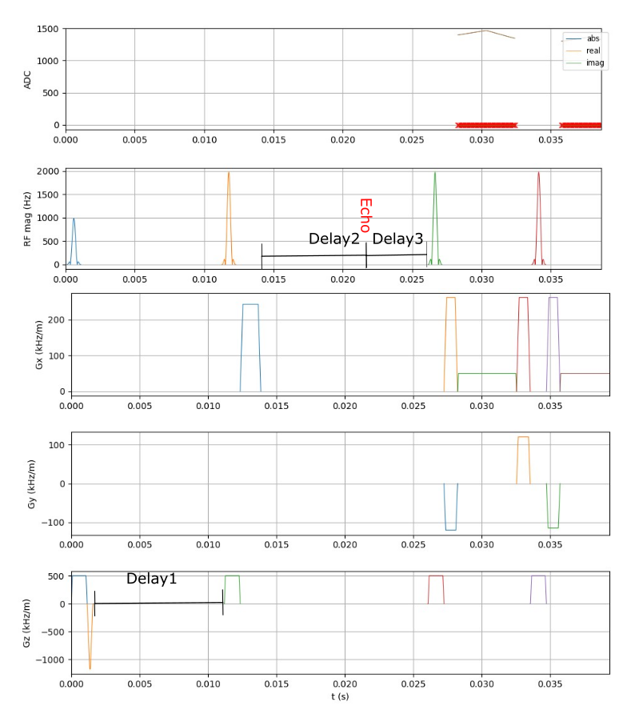

The delays are dependent on delay_length which is in this case 10ms.   
-> QUESTION: Should the TE_long be very short so make delay_length very short or even not use it at all. Or does it not matter?

With these configurations and B0 inhomogeneity = 0 and B1 inhomogeneity = 1: 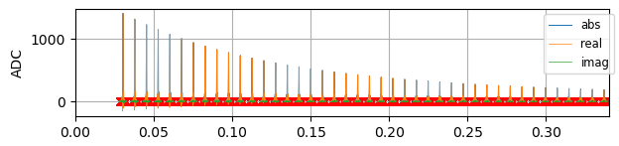  
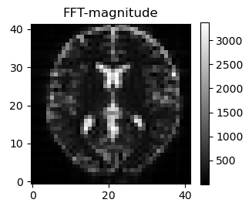  
This is the TARGET. Perfect decay.  
For optimazation one can now use that. E.g. the middle point of ADC -> 44 values to get loss from.   
Or use image and make MSE or sth.

WITH inhomogeneity : B0 = 1,B1=1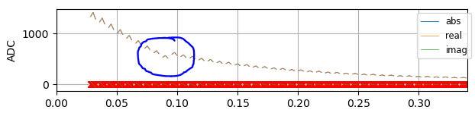

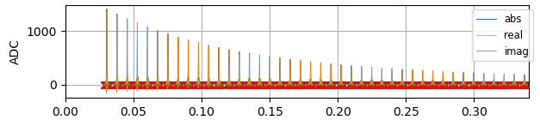

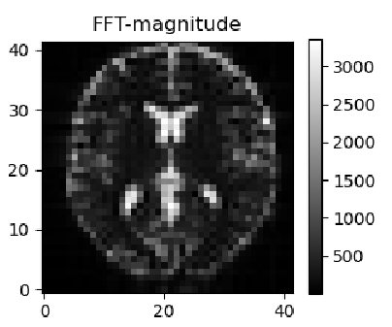

WITH inhomogeneity: B0=0, B1 = *1 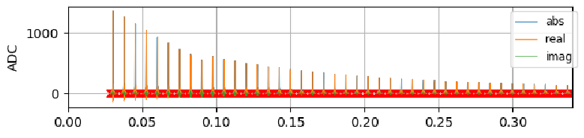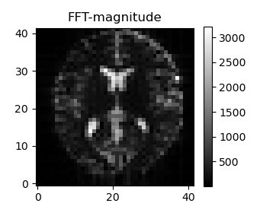

WITH inhomogeneity: B0=*2, B1 = *3 -> decay is faster and echo disappears and reappears  
