A Brief History of SGH

• SGH were all professors at MIT at the same time they did consulting.

# Beginnings: 1956 -1963

## First Practices:

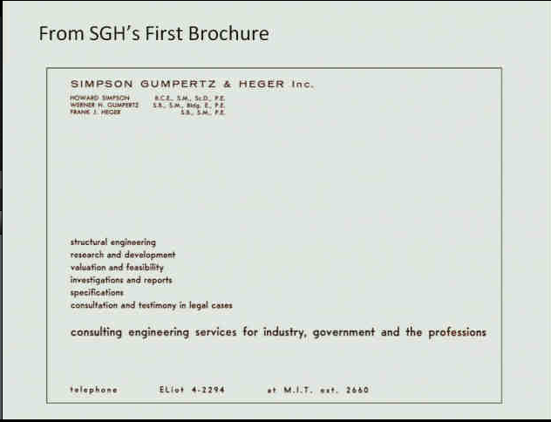

## Founders Work:

##### Werner Gumpertz:

* Left MIT (1956) and rented a room to start the company.
* Specialty: Building Technology
* Worked Preparing Building Material Specifications through research
* Primary Specialty: Roofing Technology

##### Howard Simpson:

* Left MIT later
* Specialty: Precision Structures (Radar, Telescopes, etc.)
* Experts in Finite Element Analysis using STARE? (F111A Fighter Plane)

##### Frank Heger

* Left MIT (1963) after finishing PhD in order to keep network with the University
* Specialty: “Genius in Many Dimensions” Structural Design & Plastics and Buried Infrastructure.
* Worked on the Monsanto House of the Future, Anaheim, CA.

# Greatness takes root: 1964 – 1972

## First Associates:

* Started hiring many MIT graduates
* Joe Antebi and Len Brown (whom later left the company)

## Projects:

##### Kennedy Space Center, Cape Canaveral, FL

Worked on By: Howard Simpsons

Results from STARE (FEA application) seemed odd.

Howard worked on solving the mathematical calculations by hand, later finding that the computer was giving improper results. Further, it was found a bad transistor in the computer.

“Howard wouldn’t give up until he got the correct results” – Glenn Bell.

##### US Pavilion, Expo ‘67

In the words of Glenn Bell “The story says that Frank Heger locked himself in his office on an afternoon for four hours and produced an approximate design for the project, sort of like ‘back of an envelope’ hand calculations. It took Frank’s ‘wiz kids’ at the time a few weeks to prove that Frank’s design was not only safe and correct, but also highly optimized as well”

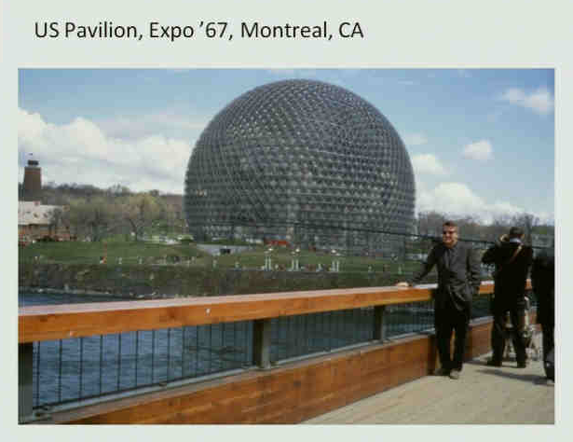

##### Multi-Mirror Telescope

Early collaboration between Engineering Mechanics and Structural Engineering

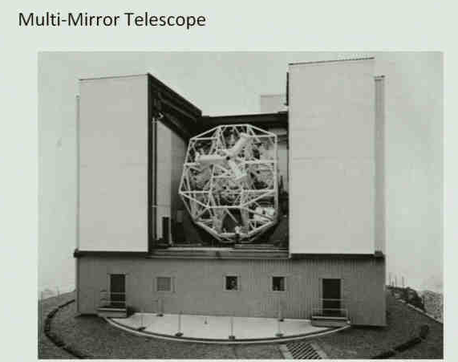

## Expansion of Structural Design:

Although the work on many different structures happened new associates were brought in order to expand Structural Design with more traditional structures as well.

## Investigation work was ongoing: 2000 Commonwealth Ave, Boston Colapse & Others

## Modest Laboratory Beginnings:

# BOLD MOVES IN TWO RECESSIONS: 1973 – 1982

* New Hirings
* Firm Expansion across the country
* Large Projects
* 25th Anniversary (please refer to this letter:

http://sghnet/Corporate/History/Historic%20Documents/SGH%20Column%2025th%20Anniversery.pdf

## Associates hired at the time:

* Tom Schwartz, Paul Kelley, Peter Nelson, Joe Zona, Glenn Bell (1974)

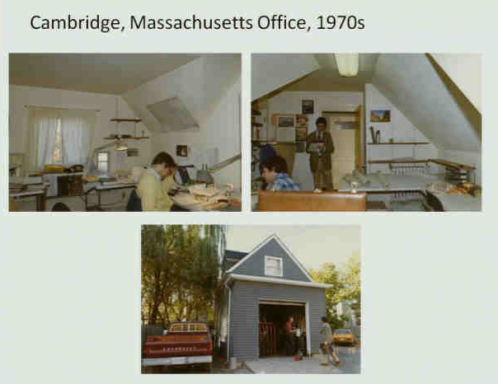

## Projects:

##### SOHIO Operations Center, Prudhoe Bay, AK

Landmark project for SGH. Most of the buildings were designed by SGH.

It went on for 1973-1978

Built in super modules in different areas and then shipped to AK.

The project basically led SGH to expand its office to the West Coast – San Francisco Office Opens, 1975.

##### Aga Khan Hospital, Karachi, Pakistan

It went on for 1975-Early 80’s.

Many starts and stops to ensure international business would workout properly.

##### Spaceship Earth, EPCOT Center, Orlando, FL

Great project in term of collaboration between SGH’s offices and its three divisions.

It went on until 1984.

##### Hyatt Regency, Kansas City, MO

Howard Simpson was called to work on the failure investigation.

# rapid growth (the bold moves pay off): 1983 – 1989

* New location
* Expansion of Laboratory
* Maturation of SGH’s future leaders

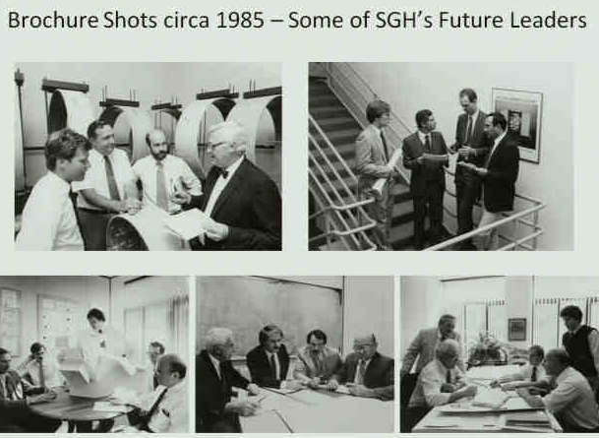

## Changes in Management (1983)

* From Management Committee to Policy Committee.
* Howard Simpson was named first CEO.

## Richard Chambers (One of SGH’s first hires):

* Materials Division was born.

## Projects

##### John Hancock Tower, Boston, MA

Investigation of its breakages and structural problems.

##### Brooklyn Bridge, Brooklyn, NY

Restoration work

# RECESSION – PAUSE – TRANSITION/REFLECTION: 1990 – 1997

## Changes in Management (1983)

* Many new hires but transitions started to be discussed

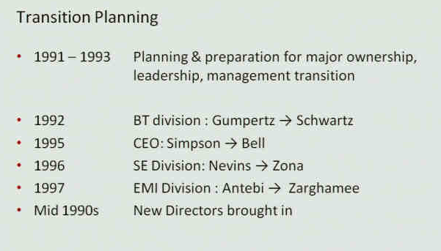

## Changes in Practices:

* Tom Schwartz Re-engineered the Roofing Division

## Projects

##### Metro-Dade Government Center, Miami, FL

Tom’s project. Investigation project.

##### University Hospitals of Cleveland, OH

Collaboration between SGH’s division on the project.

##### Superconducting Supercollider, 1993

## Company changes:

* Expansion of the SFO office.

# WHO ARE THOSE GUYS: 1998 – 2008

* SGH starts being nationally recognized
* 2000 - Washington, DC, Office is open.
* 2002 –
* SGH Tops 200 Employees.
* Hamburger, Harris, McCormick, Goings are hired.
* 2003 –
* Waltham Office is Open
* Laboratory is expanded
* LA Office is also open
* 2005 –
* NYC Office is open
* New Museum of Contemporary Art
* 2006 – 50th Anniversary
* 2007 – Rebranding of Company’s vision and Mission
* 2008 – Orange County Site Opened
* Phil joined the team.
* Nuclear work risen

## Changes in Management (2004)

* Corporate Reorganization:

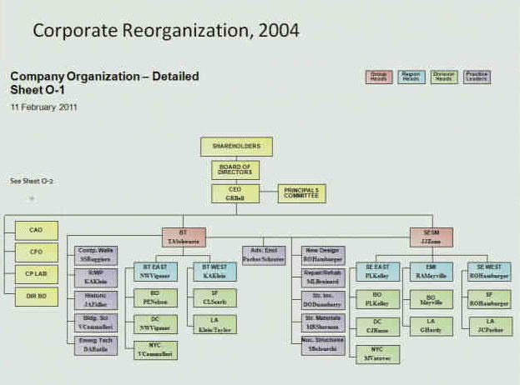

## Company’s Practice are Consolidated:

* Design, Investigate, Rehabilitate: Brings us credibility, people, expertise and diversity.

# 2009 – 2014

## SGH’s Culture:

* Highest pursuit of quality
* Cutting Edge Work
* Continuously learning new skills
* Hire the best and the brightest
* Intellectual honesty
* Honesty and integrity of character
* Make room for people who are making a contribution
* Seller-does model
* Mix of Design, Investigation, Repair and Rehab

## Ideas that have developed over the years

* Deliberately articulated Mission, Vision and Strategy
* Commitment to continuous growth and perpetuation of generational of the firm.
* Recognition of teamwork and interdivisional cooperation
* Fewer number of large offices approach to geographic expansion
* Recognition of the need for dedicated professional managers vs. engineers doing it all part time.