Cracking Nafta’s Reactor Simulation
PowerApp Documentation
31/12/2022



Author: Manuel Portero Leiva

Introduction
This document has the purpose to explain the different parts of the Reactor Designing Function App, its code and functionalities, for understanding and replication purposes. The different parts of the architecture solution are show below.

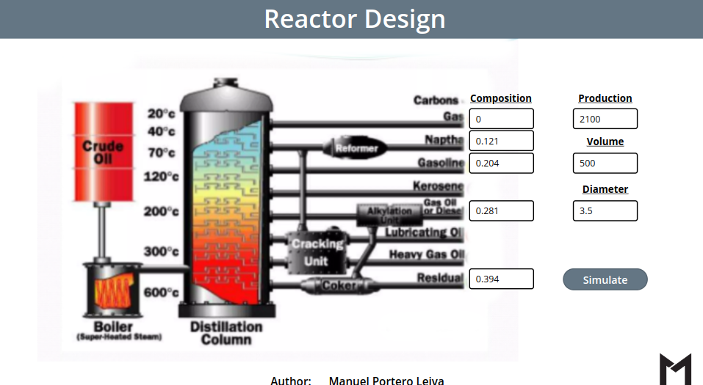

Picture 1: Cracking Nafta Reactor Simulation Layout

Architecture
The composition of the architecture starts in the PowerApp. Once the Reactor design is choosen and the calculate button is pressed, a Function app is triggered via powerAutomate and a Sharepoint list is filled with the reactor’s design data.

A full diagram of the solution is shown below.


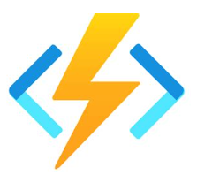


Picture 2: Cracking Nafta Reactor Simulation Architecture

PowerApp
Main Screen
The main screen is composed by the main landscape picture and the navigation buttons to the others screens.

Picture 4: Cracking Nafta Reactor Simulation main Screen

Details Screen
The Details Screen is composed by the different Reactor parameter’s and a reactor design diagram.
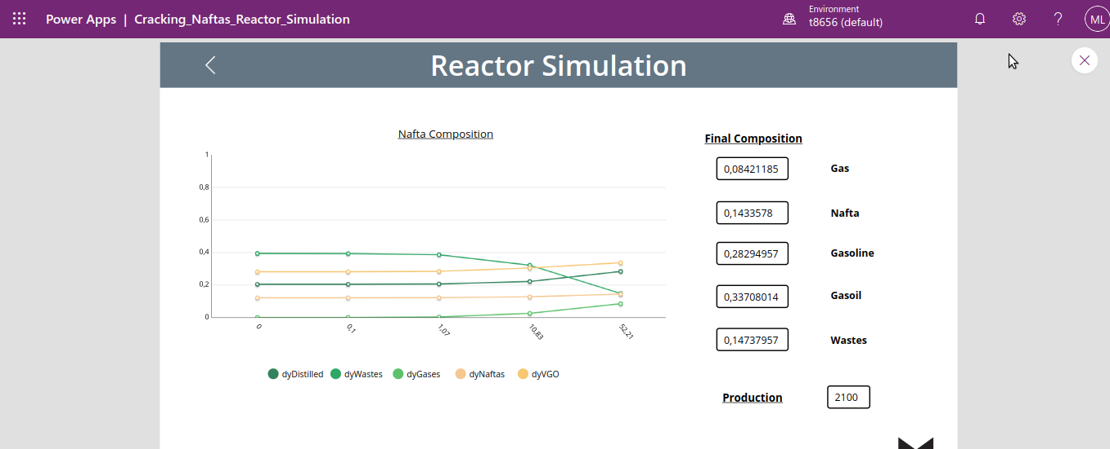

Picture 5: Details Screen

PowerAutomate Flow
The PowerAutomate flow receive the paremeters from the PowerApp clear, the Sharepoint list, call the Azure function with an Http Request action and finally fill the Sharepoint list with the new design parameters.
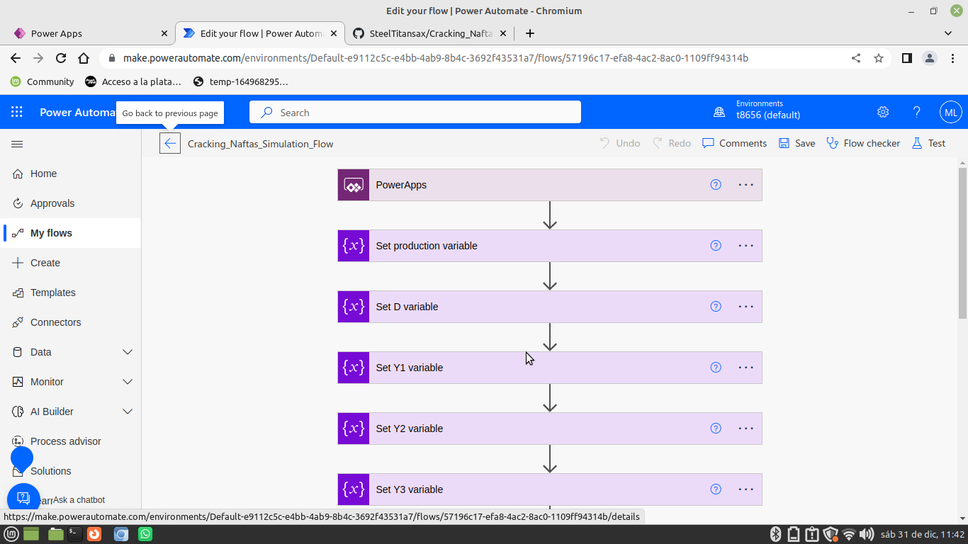
Picture 6: Setting Screen

Azure Function
The Reactor Design azure function will receive the parameters from the PowerAutomate flow and will calculate the Volume and other design parameters of the choosen reactor. The ecuations design code for each reactor type are shown below

Cracking Nafta’s Reactor:

#Libraries
import logging
import azure.functions as func
import json
import numpy as np
from scipy.integrate import solve_ivp

def main(req: func.HttpRequest) -> func.HttpResponse:
logging.info('Reactor designing Begins...')

try:
req_body = req.get_json()
except ValueError:
pass
else:
production = req_body.get('production') # petrol barrels per day
production = float(production)
V0 = production * 0.006624470622 # m3/h
density = 0.715 #g/cm3

massic_flow_0 = V0 * density * 100**3 #g/h
D = req_body.get('D') #m

# res , vgo , des , naf , gas
y1 = req_body.get('y1') # initial non-processed petrol composition
y2 = req_body.get('y2') # initial non-processed petrol composition
y3 = req_body.get('y3') # initial non-processed petrol composition
y4 = req_body.get('y4') # initial non-processed petrol composition
y5 = req_body.get('y5') # initial non-processed petrol composition

# Parsing input data

D = float(D)
y1 = float(y1)
y2 = float(y2)
y3 = float(y3)
y4 = float(y4)
y5 = float(y5)

y0 = [y1,y2,y3,y4,y5] # initial non-processed petrol composition

k1 = 0.147
k2 = 0.022
k3 = 0.020
k4 = 0.098
k5 = 0.057
k6 = 0.007
k7 = 0
k8 = 0.003
k9 = 0
k10 = 0

V_init = 0
V_final = 500

def reactionSystem(V,y):
y1 = y[0]
y2 = y[1]
y3 = y[2]
y4 = y[3]

dyWastes = (-k1*y1-k2*y1-k3*y1-k4*y1)/V0
dyVGO = (k1*y1-k5*y2-k6*y2-k7*y2)/V0
dyDistilled = (k2*y1+k5*y2-k8*y3-k9*y3)/V0
dyNaftas = (k3*y1+k6*y2-k8*y3-k10*y4)/V0
dyGases = (k4*y1+k7*y2+k9*y3+k10*y4)/V0

return np.array([dyWastes, dyVGO,dyDistilled,dyNaftas,dyGases])

sol = solve_ivp(reactionSystem, (V_init,V_final),y0)

# Consolidating outputs:
dyWastes = sol.y[0]
dyVGO = sol.y[1]
dyDistilled = sol.y[2]
dyNaftas = sol.y[3]
dyGases = sol.y[4]
t = sol.t

sol_json = []

for item in range(5):

sol_details = {
"dyWastes": dyWastes[item],
"dyVGO": dyVGO[item],
"dyDistilled": dyDistilled[item],
"dyNaftas": dyNaftas[item],
"dyGases": dyGases[item],
"t": t[item]
}

sol_json.append(sol_details)

logging.info(sol_json)

return json.dumps(sol_json)

return func.HttpResponse("Reactor design succesfully...",status_code=200)

