Materials Management App
PowerApp Documentation
28/08/2022



Author: Manuel Portero Leiva

Introduction
This document has the purpose to explain the different parts of the Material Management App, its code and functionalities, for understanding and replication purposes. The different parts of the architecture solution are show below.

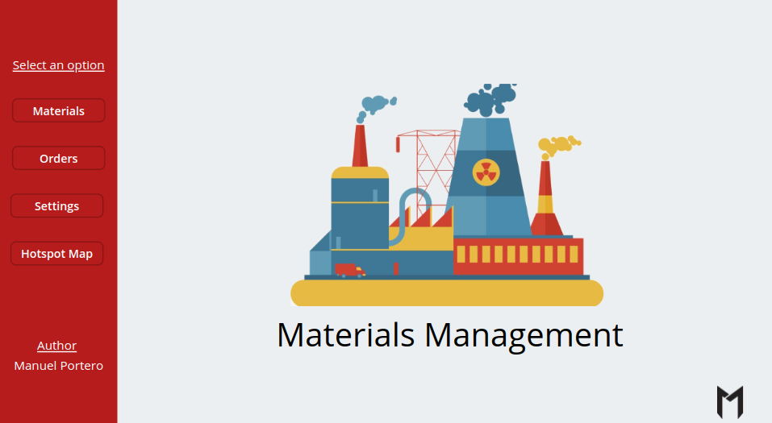

Picture 1: Materials Management Main Layout

Architecture
The composition of the architecture starts in the PowerApp, The travel requests are added to different Dataverse tables and are represented in the differnt screens. After any adding or modification of the Orders Table, a flow is activated and a new location updates the material pointed in the order’s row.

A full diagram of the solution is shown below.

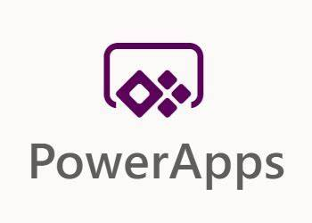



Picture 2: Materials Manager App solution Architecture

Dataverse Database
The Materials Management App solution will have a Dataverse database as a Data storage and manipulation, a sample of the database is shown below.
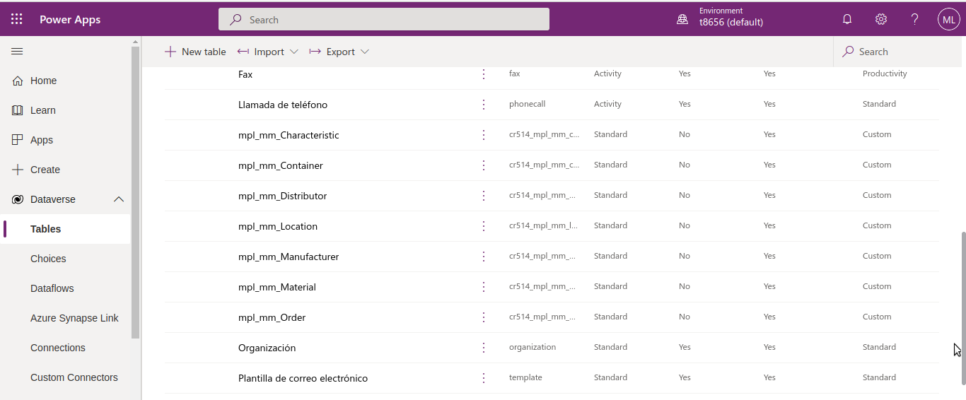
Picture 3: Dataverse database sample

Main Screen
The main screen is composed by the main landscape picture and the navigation buttons to the others screens.

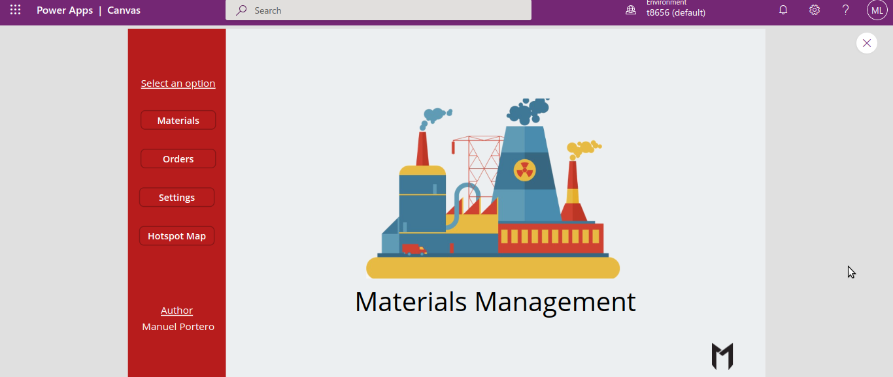
Picture 4: Materials Management App main Screen

Materials Screen
The Materials Screen has a Gallery displaying the Materials of the factory, a name search text input field, two dropdown filters and a reload button and a create button.

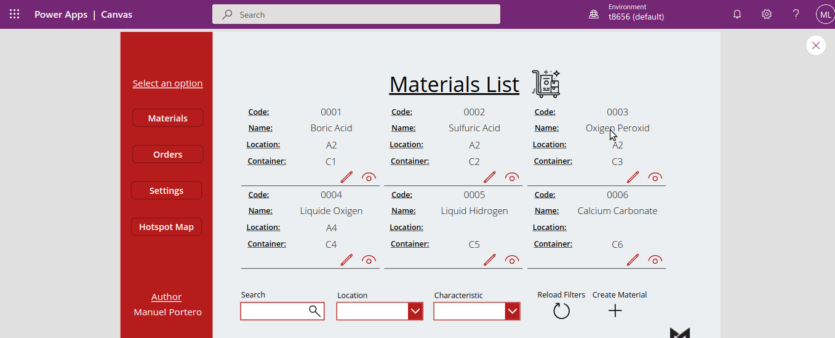
Picture 5: Materials Screen

The code of the materials gallery is the following one :

Filter(
Search(
mpl_mm_Materials;
SearchTextInput8.Text;
"cr514_code";
"cr514_name"
);
If(
LocationDropdown.Selected.Name = Blank();
true;
Location.Name = LocationDropdown.Selected.Name
);
If(
CharacteristicDropdown.Selected.Name = Blank();
true;
Characteristic.Name = CharacteristicDropdown.Selected.Name
)
)

The code of the reload filters button is the following one :

Reset(SearchTextInput8);;
Reset(LocationDropdown);;
Reset(CharacteristicDropdown);;
Notify(
"Filters reseted successfully";
Success
)

Orders Screen
The Orders Screen has a Gallery displaying the Orders of the factory, a name search text input field, two dropdown filters and a reload button and a create button.

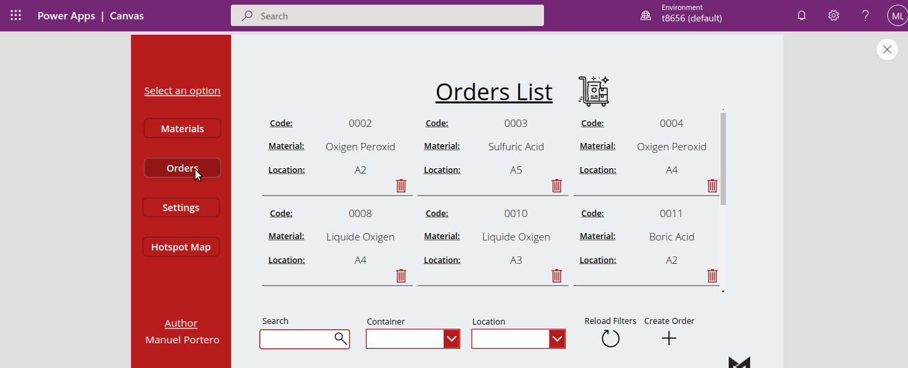
Picture 5: Orders Screen

The Code of the Orders Gallery is the following one :

Filter(
Search(
mpl_mm_Orders;
OrdersTextInput.Text;
"cr514_code"
);
If(
ContainerDropdown2.Selected.Code = Blank();
true;
Code = ContainerDropdown2.Selected.Code
);
If(
LocationDropdown2.Selected.Name = Blank();
true;
Location = LocationDropdown2.Selected.Name
)
)
The reload filters button is the following one :

Reset(OrdersTextInput);;
Reset(ContainerDropdown2);;
Reset(LocationDropdown2);;
Notify(
"Filters reseted successfully";
Success
)

Settings Screens
The settings screens are composed by a gallery, a text search input and a create button (not text search for location and containers).
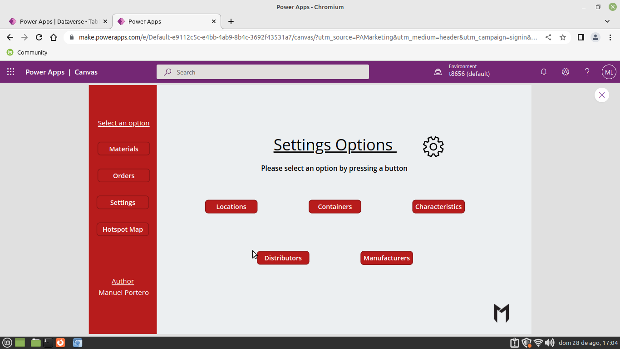
Picture 6: Setting Screen
Dataverse Flow
Every time a row is created in dataverse the materials table will be updated with the new order’s location.
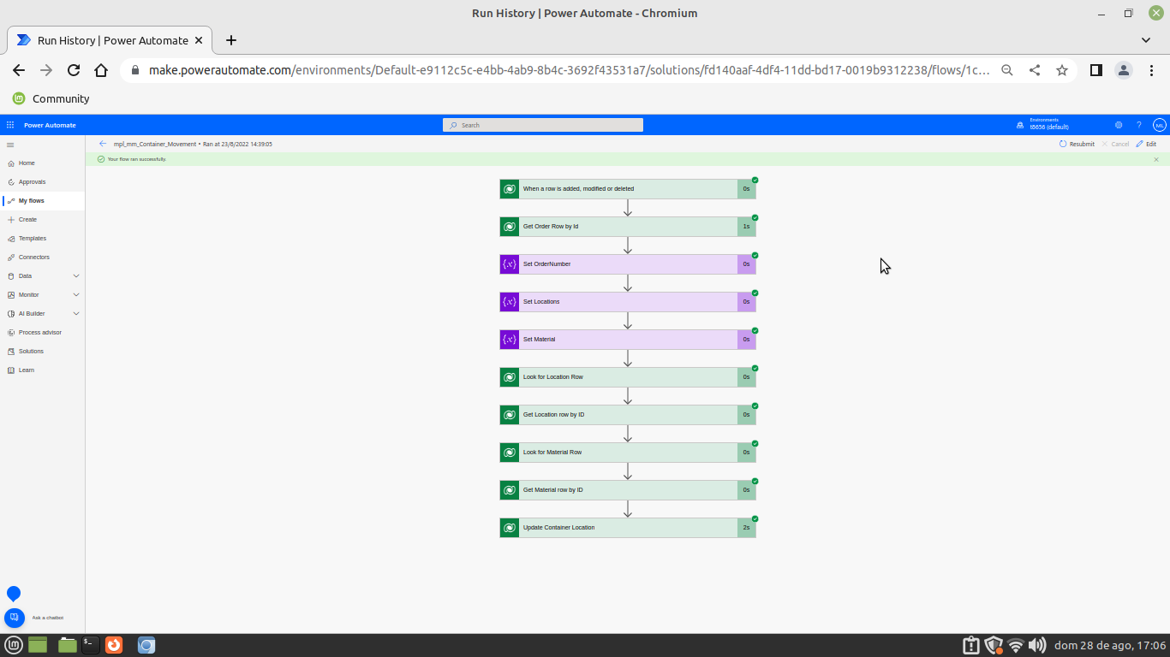
Picture 6: Dataverse flow
The flow will take the order list and search in Get Orders row by id taking al the row elemens, after that the ordernumber, location and material will be setted with the Get Orders row by id outputs. The Look for Location row will list all the elements that match with the locations variable. The Get location row by id will take the first value output of the Look for Location row action.

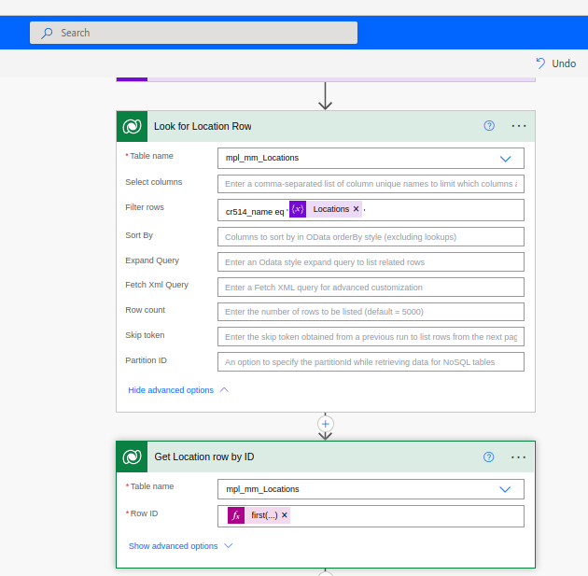
Picture 7: Look for Location action

The Look Material row and the get material row by id will perform the same actions than Look for Location row and get location row by id.

We get the EntityName of the mpl_mm_Materials table calling the dynamics API putting this string in the browser (may be the developer would be to sign in in the powerapp tenant).

https://t8656default.crm4.dynamics.com/api/data/v9.1/EntityDefinitions(LogicalName='cr514_mpl_mm_material')?$select=EntitySetName

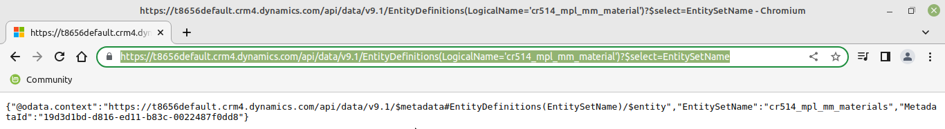
Picture 8: Dynamics API query call

Finally the update actions will update the location setting in the place /EntitySetName(uniqueidentifierOfTheTable)

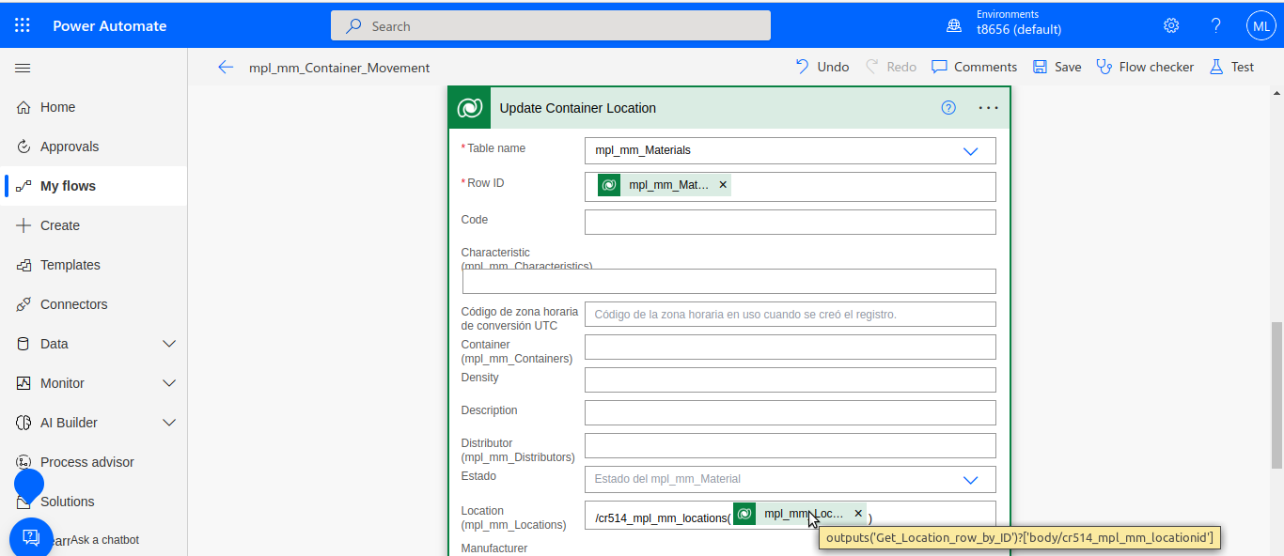
Picture 9: Update MaterialsAction

