Catallogue App
PowerApp Documentation
25/11/2022



Author: Manuel Portero Leiva

Introduction
This document has the purpose to explain the different parts of the Catallogue App, its code and functionalities, for understanding and replication purposes. The different parts of the architecture solution are show below.

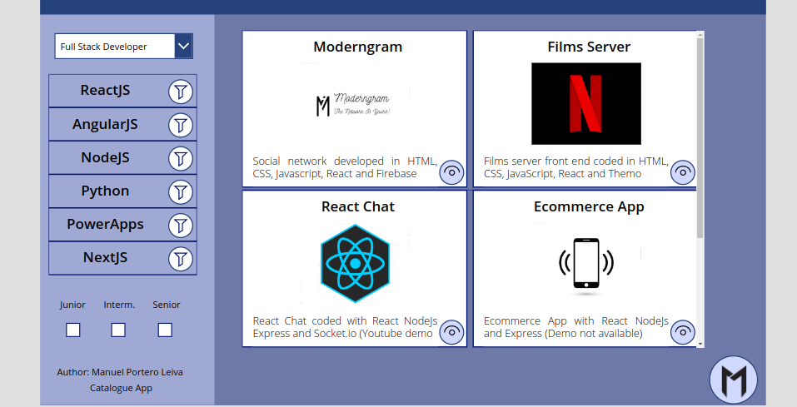

Picture 1: Catallogue App Main Layout

Architecture
The composition of the architecture starts in the PowerApp, the different galleries represented pull data from a unic Sharepoint list. Filters and state interactions are set in order improve the user experience.

A full diagram of the solution is shown below.


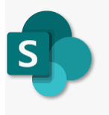

Picture 2: Catallogue App solution Architecture

Main Screen
The main screen is composed by TechnologyGallery, depending of the Porfolio dropdown will display the different porftolios of the Sharepoint list. If we press the filter buttton in any technology. The ProjectsGallery will show the projects related with this tecnology. If we click one of the checkboxes the ProjectsGallery will filter the projects depending of the project’s level.

Picture 3: Phone Catallogue App main Screen
Finally if we click the details button on the ProjectsGallery the Single Projects Gallery will appear, showing the details of the project, it’s repository and a demo.

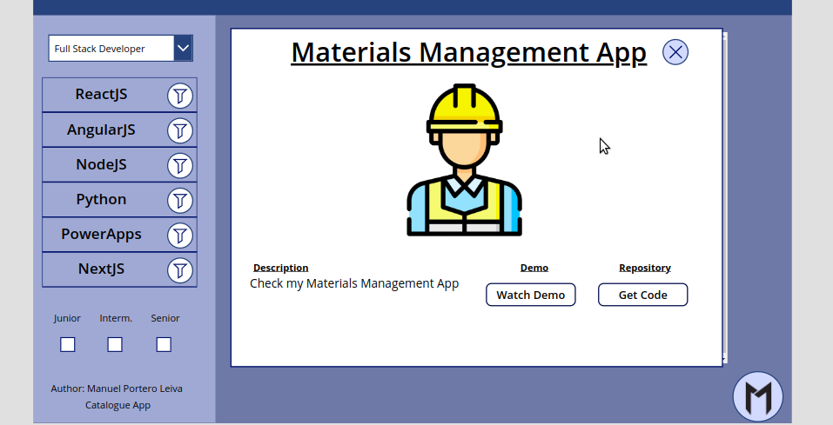

Picture 4: SingleProject Gallery

The Related code associated with the main screen it’s shown below:

TehnologyGallery:
Distinct(
Search(
Catallogue;
PorfolioTypeDropdown.Selected.Result;
"Portfolio"
);
Title
)
ProjectsGallery:
Filter(
Catallogue;
Title = TechnologyGallery.Selected.Result;
If(
juniorVar = "true";
Level = "Junior";
true
);
If(
InterVar = "true";
Level = "Intermediate";
true
);
If(
SeniorVar = "true";
Level = "Senior";
true
)
)

Portfolio Dropdown:

Distinct(Catallogue;Portfolio)

SingleProjectGallery:

ProjectsGallery.Selected

