Clock in / out App
PowerApp Documentation
15/08/2022



Author: Manuel Portero Leiva

Introduction
This document has the purpose to explain the different parts of the app Clock in / out App, its code and functioning, for understanding and replication purposes. The different parts of the architecture are show below.
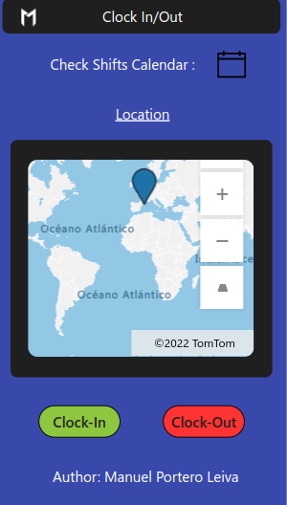

Picture 1: Clock in out Main Layout

Architecture
The composition of the architecture starts in the PowerApp, this one will communicate with a SharePoint list and store the Timestamp, Latitude, Longitude, Action and the name of the worker by pressing Clock-In or Clock-Out button, For each click, a collection with the device Latitude and Longitude will be stored, and a Tom Tom go map will be fed with this coordinates. The Tom Tom go map will show the position of the user for each Clock. Otherwise, in the calendar view, the Clock in/out PowerApp will communicate with the user's Outlook Account and will show the user’s calendars. The user will visualize his shift’s calendar in this view.

A full diagram of the solution is shown below.





Picture 2: Clock In / Out solution architecture

Sharepoint List
The clock in out app will have a SharePoint list for Data storage and manipulation, a sample of the list is shown below.
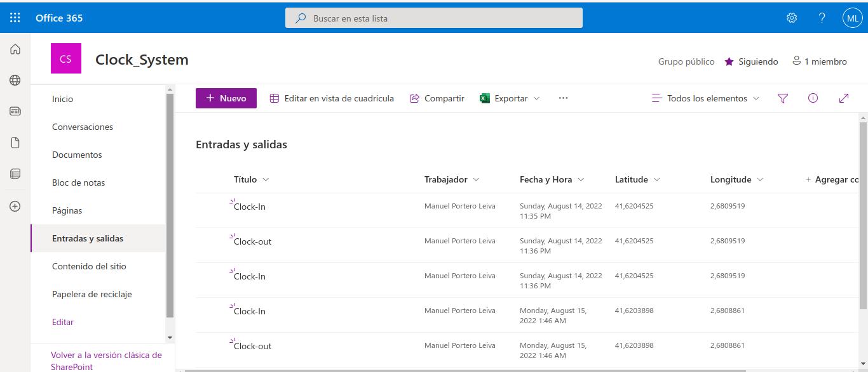
Picture 3: Entradas y Salidas list sample
Main Screen
The main screen is composed of the Calendar navigation button ( on click will navigate to the Calendar Screen ), a Tom Tom Go Map and a Clock In and Clock Out button. The Clock In and Clock out buttons OnSelect attributes will be set with the following codes :

Clock-In Button (OnSelect) :
ClearCollect(
Ubicacion;
{
Latitude: Location.Latitude;
Longitude: Location.Longitude
}
);;
Industry_Clock_System.Run(
User().FullName;
"Clock-In";
Location.Latitude;
Location.Longitude
);;
Notify(
"Clock-in registered successfully";
Success
)
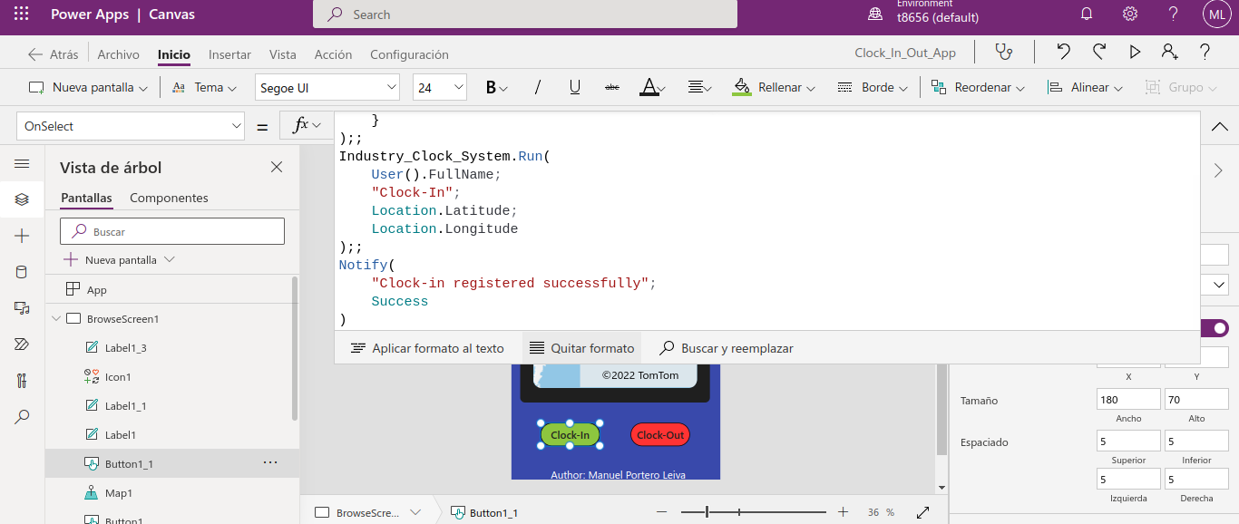
Picture 4: Clock In OnSelect button
Clock-Out Button (OnSelect) :
ClearCollect(
Ubicacion;
{
Latitude: Location.Latitude;
Longitude: Location.Longitude
}
);;
Industry_Clock_System.Run(
User().FullName;
"Clock-out";
Location.Latitude;
Location.Longitude
);;
Notify(
"Clock-out registered successfully";
Success
)
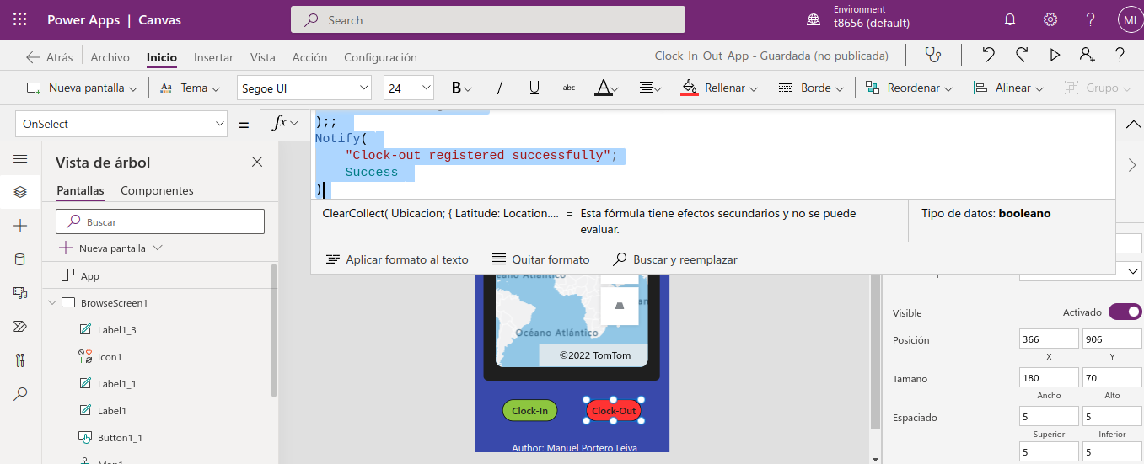
Picture 5: Clock Out OnSelect button

The Tom Tom Map Component Data Origin will be set to ‘Colección 1’ Collection and the ItemsLatitudes and ItemsLogitudes attributes will be set as :

ItemsLatitudes : “Latitude”
ItemsLongitudes : “Longitude”
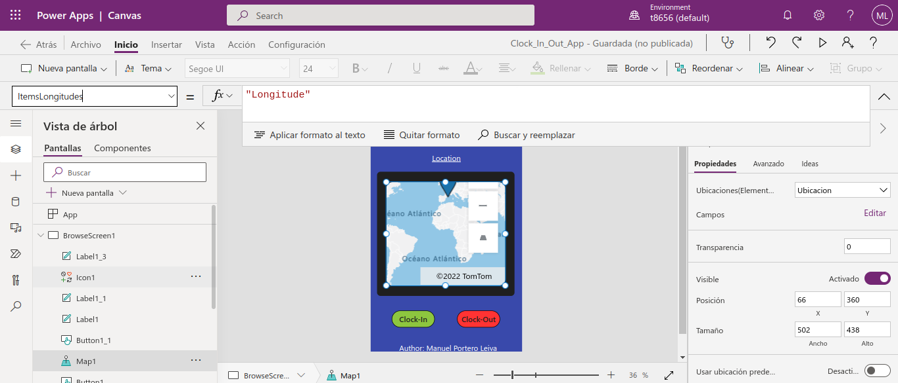
Picture 6: ItemsLongitudes attribute

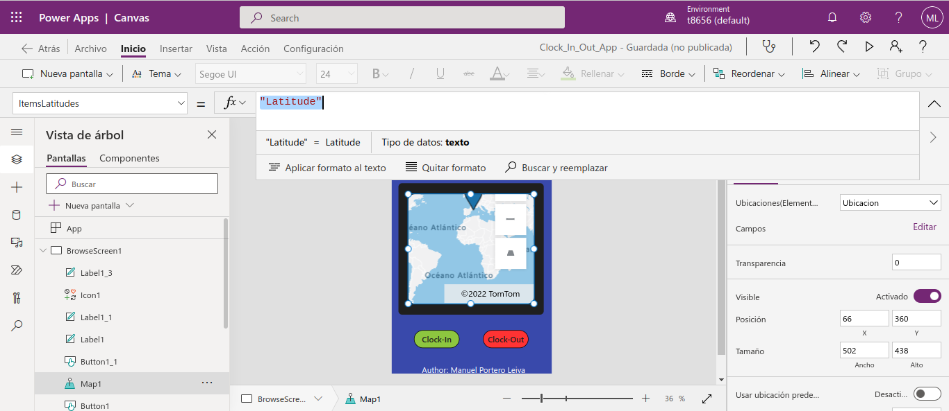
Picture 7: ItemsLatitudes attribute

Every time the Clock-In and Clock-Out buttons will be pressed, a register in “Entradas y Salidas” Sharepoint List will be filled and new Latitude and Longitude coordinates will be introduced in ‘Colección 1’ collection (clearing the last position). Tom Tom map will show the device position in Clock in/out click action.

Calendar Screen
The calendar screen will show the different user’s calendars by clicking the calendar’s dropdown ( this calendar screen is created automatically after pressing add new Screen → Calendar Screen).

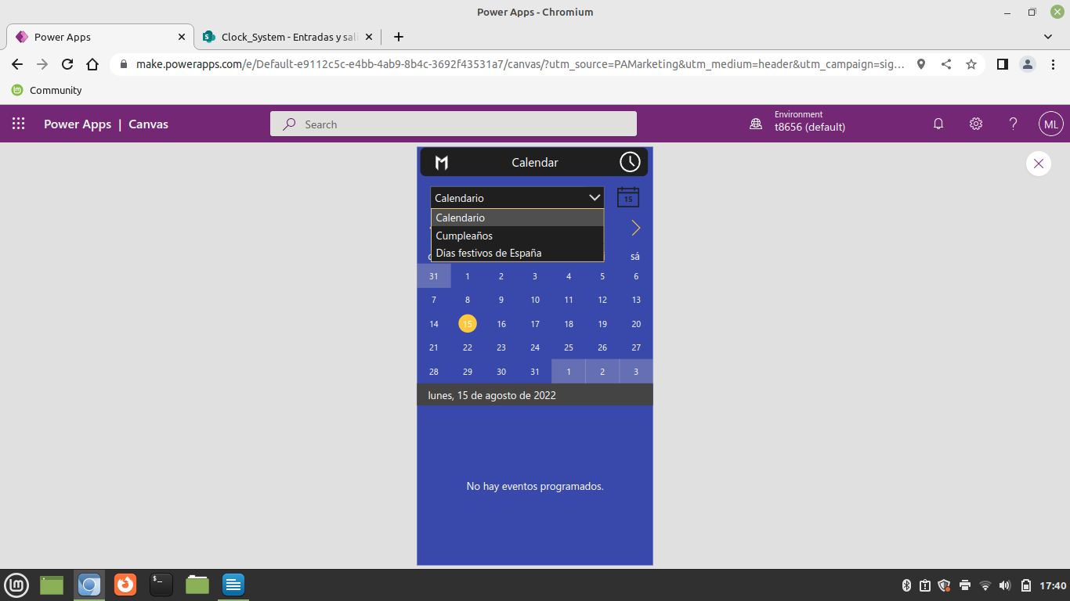

Picture 8: Calendar Screen

