Industry Report App
PowerApp Documentation
15/08/2022



Author: Manuel Portero Leiva

Introduction
This document has the purpose to explain the different parts of the Industry Report App, its code and functionalities, for understanding and replication purposes. The different parts of the architecture solution are show below.
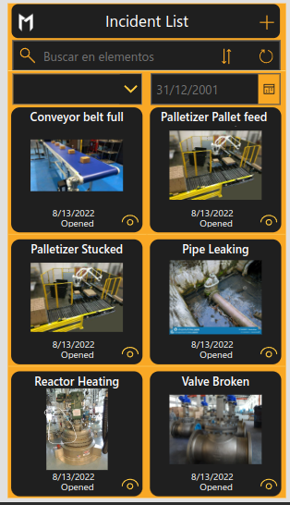

Picture 1: Industry Report Main Layout

Architecture
The composition of the architecture starts in the PowerApp, The incidents with camera and the pen input attachments are added to a sharepoint list and represented again in the main gallery. After adding an incident report a flow is activated for check if the incident is opened after 3 hours, if the incident still opened an email and teams notification is sended as advise for asign another engineer to the incident.

A full diagram of the solution is shown below.







Picture 2: Industrial Report solution architecture

Sharepoint List
The IncidentIndustrialReport app will have a sharepoint list as a Data storage and manipulation, a sample of the list is shown below.
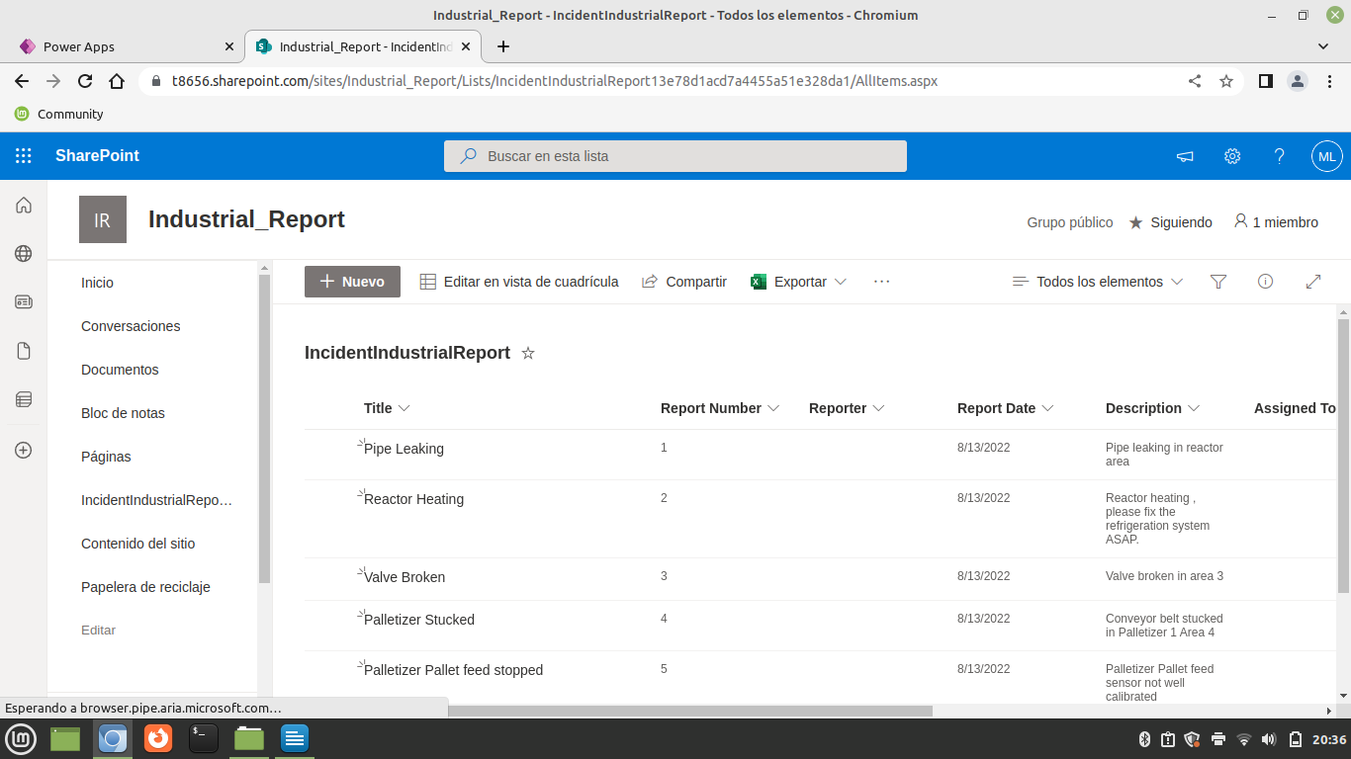
Picture 3: IndidentIndustrialReport list sample
Main Screen
The main screen is composed by a Incidents Gallery, a status dropdown, a date picker and a textInput filters. Finally the main screen has an add new incident button and a view incident details button. In each row of the incidents gallery, the title a complete image of the incident ( camera picture and pen input overlaped) , the date of the incident and the status will be shown.

IncidentsGallery (Items) :
SortByColumns(
Filter(
[@IncidentIndustrialReport];
StartsWith(
Título;
TextSearchBox1.Text
);
If(
Dropdown1.Selected.Result = Blank();
true;
Status = Dropdown1.Selected.Result
);
If(
DatePicker1.SelectedDate = Blank();
true;
'Report Date' = DatePicker1.SelectedDate
)
);
"Title";
If(
SortDescending1;
Descending;
Ascending
)
)
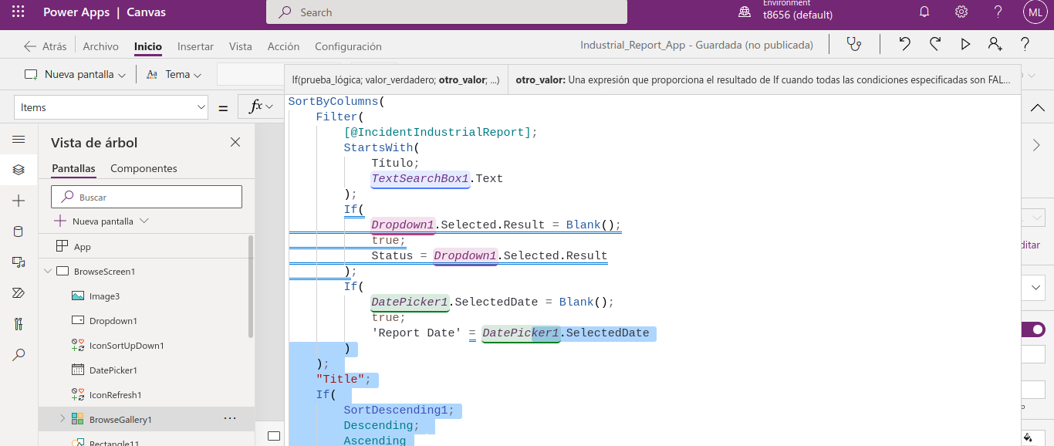
Picture 4: Incident Gallery Items

Status Dropdown (Items) :
Distinct(IncidentIndustrialReport;Status)
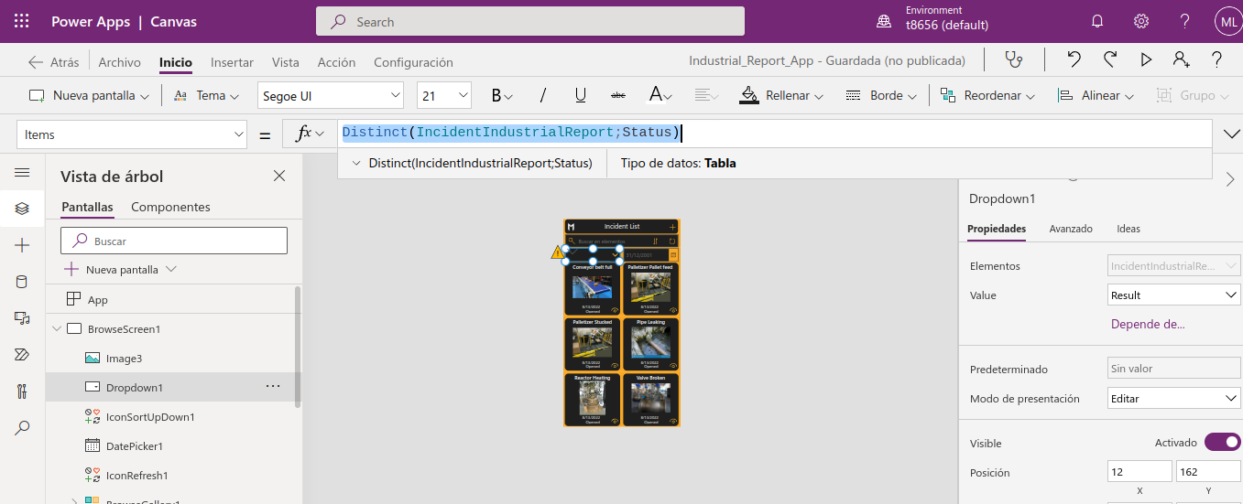
Picture 5: DropdownStatus
Add Button (OnSelect) :
NewForm(EditForm1);;Navigate(EditScreen1; ScreenTransition.None)
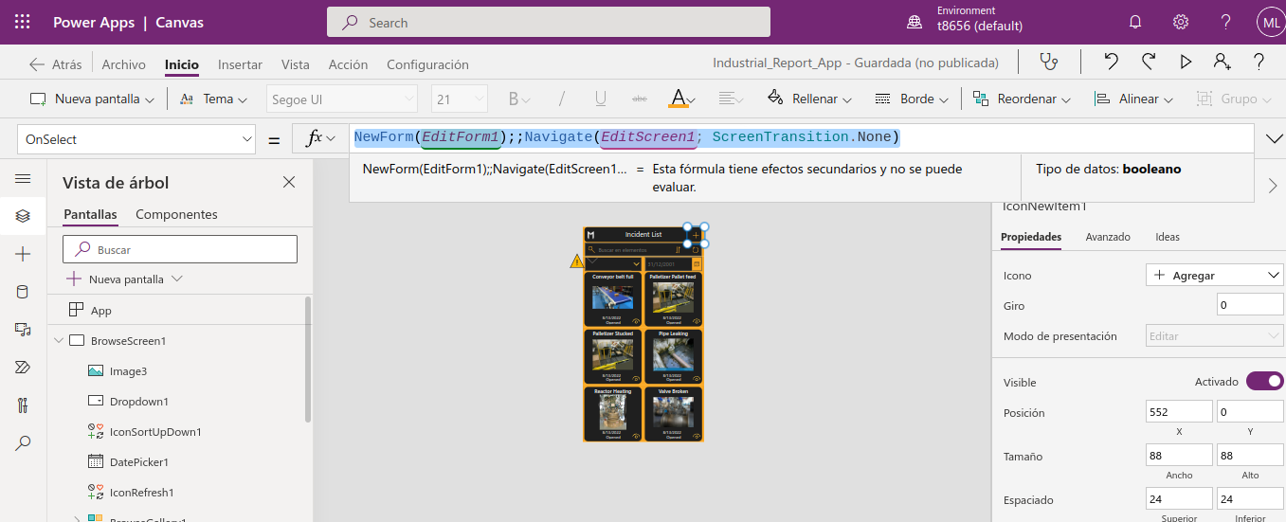
Picture 5: Add button

Reload Button (OnSelect) :
Refresh([@IncidentIndustrialReport]);;Reset(DatePicker1);;Reset(Dropdown1)None)
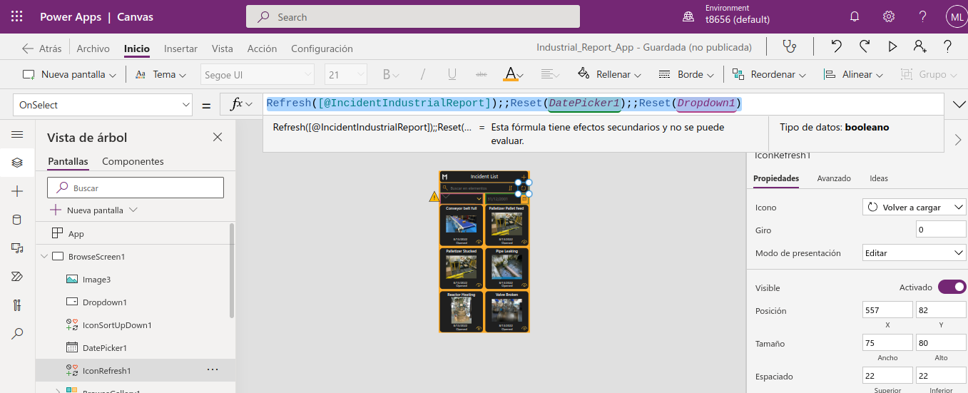
Picture 5: Reload button

Edit Screen
The Edit screen is composed by a EditForm, a create/edit Button (IconAccept), a Reset Form Button (IconCancel) and CameraScreen navigation button. The Attachements Datacard of the form has its default settings changes pointing to the Camera Gallery; doing this change the form will post the jpg files of the camera on each submitform.

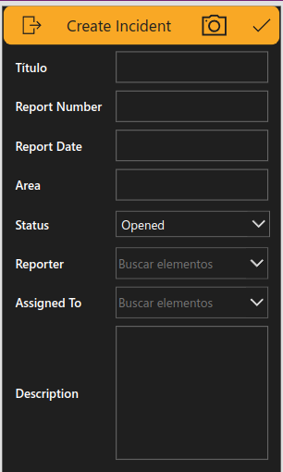

Picture 6: Edit Screen

Details Screen
The Details screen is composed by a DetailsForm and a back navigation Button. The Attachements Datacard of the form has its default settings changed pointing to the PenInput and the Camera file stored in the attachment field of the sharepoint list.
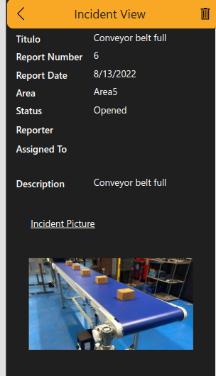

Picture 6: Details Screen
The code for remove the item of the details view is the next one :
Remove([@IncidentIndustrialReport];IncidentsGallery.Selected);;If(IsEmpty(Errors([@IncidentIndustrialReport];IncidentsGallery.Selected));Back());;Notify("Incident report deleted successfully";Success)
Photo Screen
The photo screen has two parts, the initial part where we can see a camera input with its corresponding layout and a second part of the screen, composed by Gallery with the captured image of the camera and a pen input for noting visual issues on the image, clicking the save button on the botton of the screen, the user will be redirected to the edit screen and the picture and pen Input files will be generated. Clicking on the Camera item the second part of the screen will be activated (first part will be hidden).
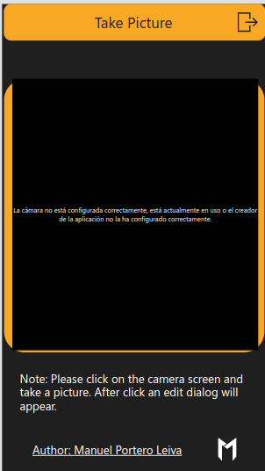

Picture 6: Photo Screen

The OnSelect code for store the image in the second part of the screen is this :
Set(
varName;
GUID()
);;
ClearCollect(
'Colección 1';
{
DisplayName: varName & ".jpg";
Id: varName & ".jpg";
Value: Camera1.Photo
}
);;
Set(
varCameraMode;
false
)

The Code of the Gallery Items is this one :
Items : ‘Colleccion 1’
The default value for the image inside the gallery is this one:
Default : ThisItem.Value
The code of the ‘Save’ Button that allow to storage the pen input and the image in the SharePoint list is this one :
OnSelect :
Set(
penInput;
"ImageEdition"
);;
Collect(
'Colección 1';
{
DisplayName: penInput & ".jpg";
Id: penInput & ".jpg";
Value: PenInput1.Image
}
);;
Set(
varCameraMode;
true
);;
Navigate(EditScreen);;
Notify(
"Picture taken and edited succesfully";
Success
)

Incident_Report_Notifier_Flow
The incident Report Notifier Flow will check the status of the incident after a delay of 3 hours. If in 3 hours the status field of the sharepoint list still being “Opened” a reminder mail to the manager will be sent for reassigning the ticket to another engineer and a message in the engineers team chat group will be posted.
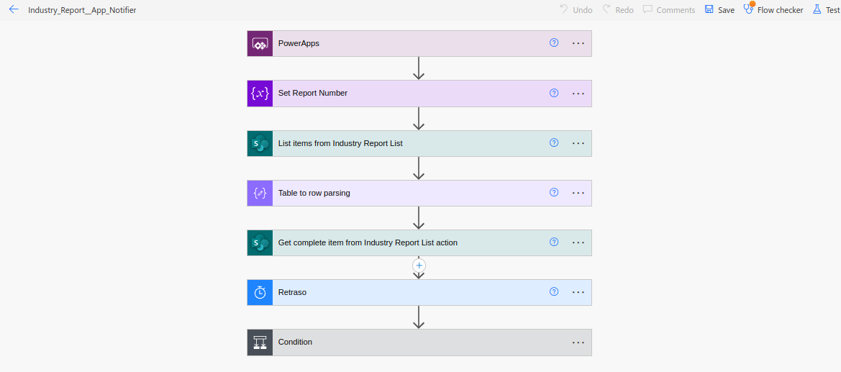

Picture 7: Incident_Report_Notifier_Flow
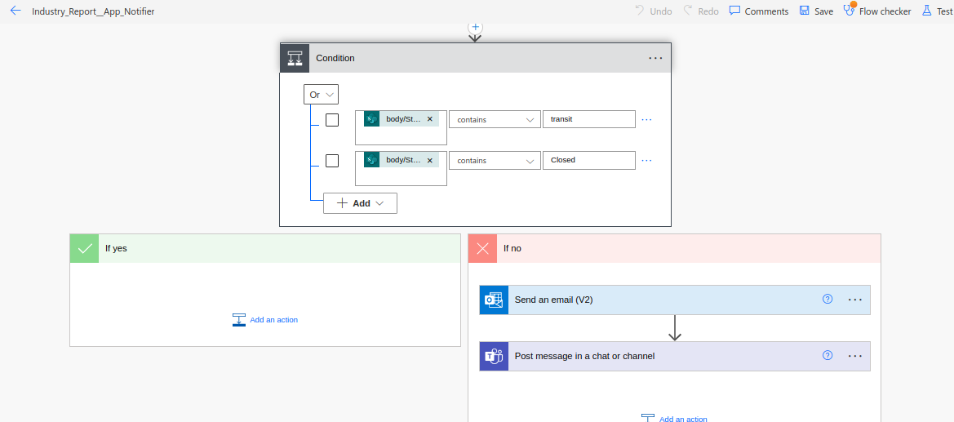

Picture 8: Incident_Report_Notifier_Flow second part

