Travel Report App
PowerApp Documentation
21/08/2022



Author: Manuel Portero Leiva

Introduction
This document has the purpose to explain the different parts of the Travel Report App, its code and functionalities, for understanding and replication purposes. The different parts of the architecture solution are show below.

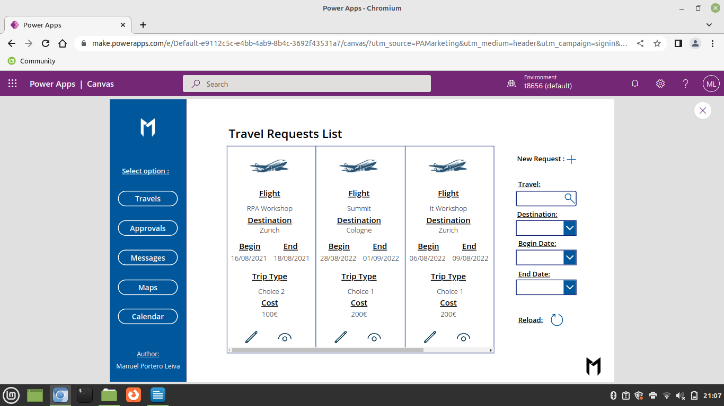

Picture 1: Tavel Report Main Layout

Architecture
The composition of the architecture starts in the PowerApp, The travel requests are added to a SharePoint list and represented in the main gallery. After any adding or modification of the SharePoint list, a flow is activated and an approvals is sent to the company’s manager for accepting or denying the request, after that, the results of the request will be added to the approvals SharePoint list.

A full diagram of the solution is shown below.





Picture 2: Travel request App solution architecture

Sharepoint List
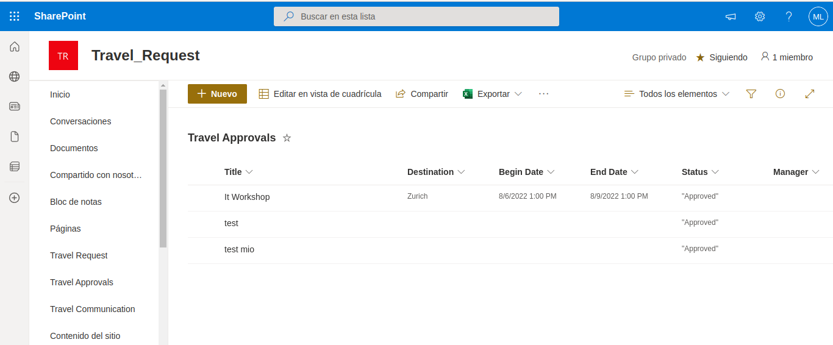
The Travel Request App solution will have a sharepoint list as a Data storage and manipulation, a sample of the list is shown below.

Picture 3: IndidentIndustrialReport list sample

Main Screen
The main screen is composed by a Travels Gallery, a name , begin date finish date and destination filter dropdown and a create request and a reload filters button.

TravelsGallery (Items) :
Filter(
Search(
'Travel Request';
TravelTextInput.Text;
"Title"
);
If(
DestinationDropdown.Selected.Result = Blank();
true;
Destination = DestinationDropdown.Selected.Result
);
If(
BeginDateDropdown.Selected.Result = Blank();
true;
'Trip Begin' = BeginDateDropdown.Selected.Result
);
If(
EndDateDropdown.Selected.Result = Blank();true;
'Trip End' = EndDateDropdown.Selected.Result
)
)
Picture 4: Travels Request App main Screen

Destination Dropdown (Items) :
Distinct('Travel Request';Destination)
Begin Date Dropdown (Items) :
Distinct('Travel Request';’Begin Date’)
End Date Dropdown (Items) :
Distinct('Travel Request';’End Date’)

Approvals Screen
The Approvals Screen has a dataTable displaying the Approvals Sharepoint List and a reload SharePoint list button.

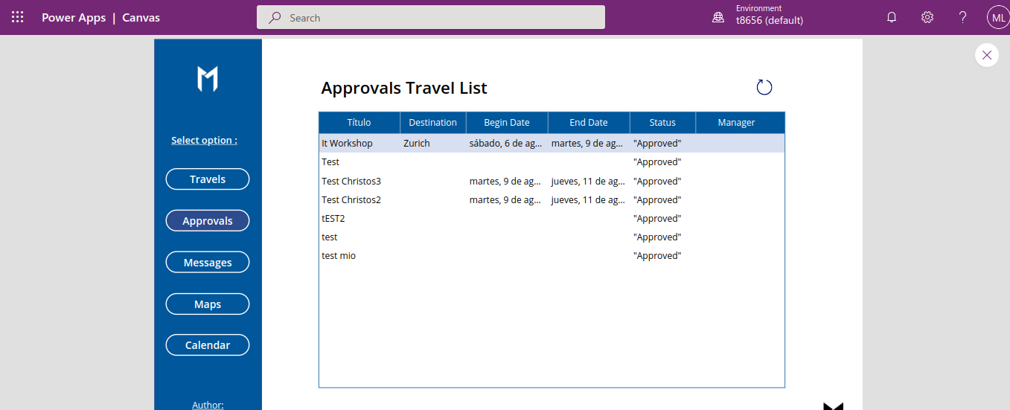
Picture 5: Approvals Screen

Notification Screen
The Notification screen has a form, a mail flow button, an SMS flow button and a Teams message button.

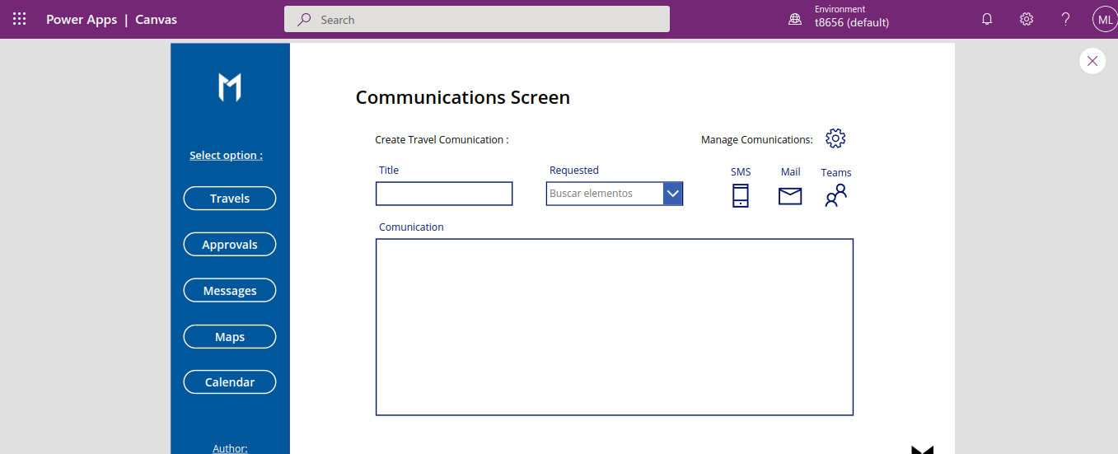
Picture 5: Communication Screen

The Code of the three button flow is :

SMS Flow:

If(
Travel_Request_Comunication_SMS.Run(
Text(DataCardValue23.Text);
Text(DataCardValue25.Selected.FullName);
Text(DataCardValue26.Selected.DisplayName);
DataCardValue24.Text
).result = "OK";
SubmitForm(ComunicationForm);;
NewForm(ComunicationForm);;
Notify(
"Message sent succesfully";
Success
);
Notify(
"Error sending messafge";
Error
)
)

Mail Flow:

If(
Travel_Request_Comunication_Email.Run(
Text(DataCardValue23.Text);
Text(DataCardValue25.Selected.FullName);
Text(DataCardValue26.Selected.Email);
DataCardValue24.Text
).result = "OK";
SubmitForm(ComunicationForm);;
NewForm(ComunicationForm);;
Notify(
"Message sent succesfully";
Success
);
Notify(
"Error sending messafge";
Error
)
)

Teams Flow:

Travel_Request_Comunication_Teams.Run(
Text(DataCardValue23.Text);
Text(DataCardValue25.Selected.FullName);
Text(DataCardValue26.Selected.DisplayName);
DataCardValue24.Text
).result = "OK";
SubmitForm(ComunicationForm);;
NewForm(ComunicationForm);;
Notify(
"Message sent succesfully";
Success
);
Notify(
"Error sending messafge";
Error
)
)
Maps Screen
The Maps Screen is composed by a TomTom Go Map and a Direction input, the Direction location Input is linked to the Latitude and Longitude input of the Tom Tom Map.
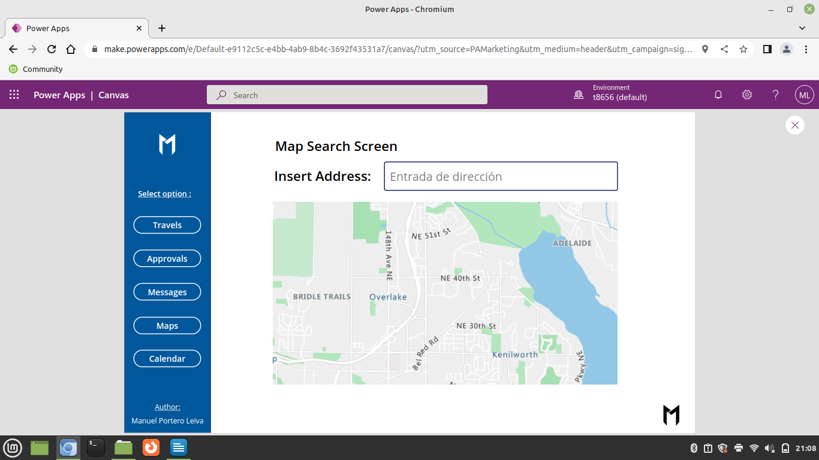
Picture 6: Maps Screen
Calendar Screen
The Calendar screen is composed by a PowerApp calendar screen connected with Outlook.
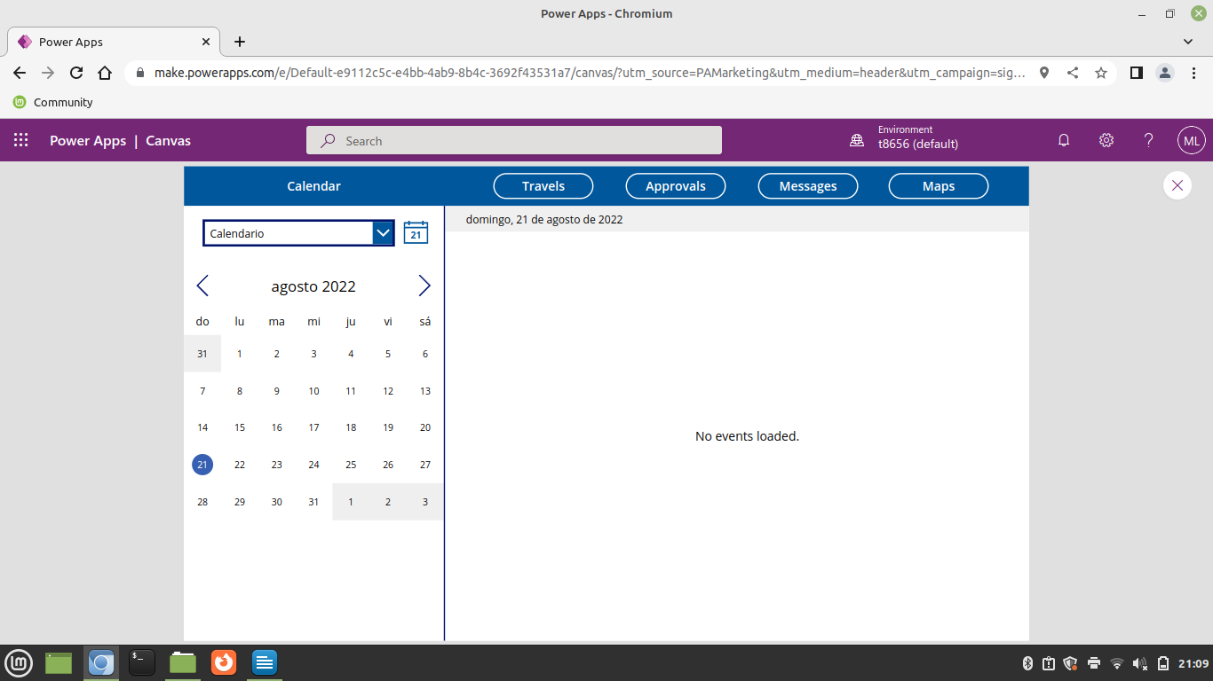
Picture 6: Calendar Screen

