UiPath Graph Interaction User
Robot Documentation
17/09/2022



Author: Manuel Portero Leiva

Introduction
This document has the purpose to explain the different parts of the RPA0001_GraphInteractionUser robot, its code and functionalities, for understanding and replication purposes. The different parts of the architecture solution are show below.
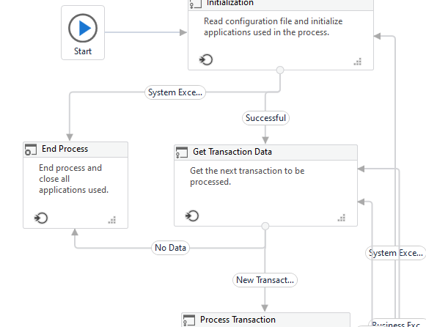

Picture 1: Process diagram

Architecture
The composition of the architecture uses the REF Framework of UiPath, in the dispatcher state an http request to the graph is made and all the users of the Azure tenant are populated to the orchestrator. After that in the process state another http get all the data for each user and save the information in an excel.

Graph Queries
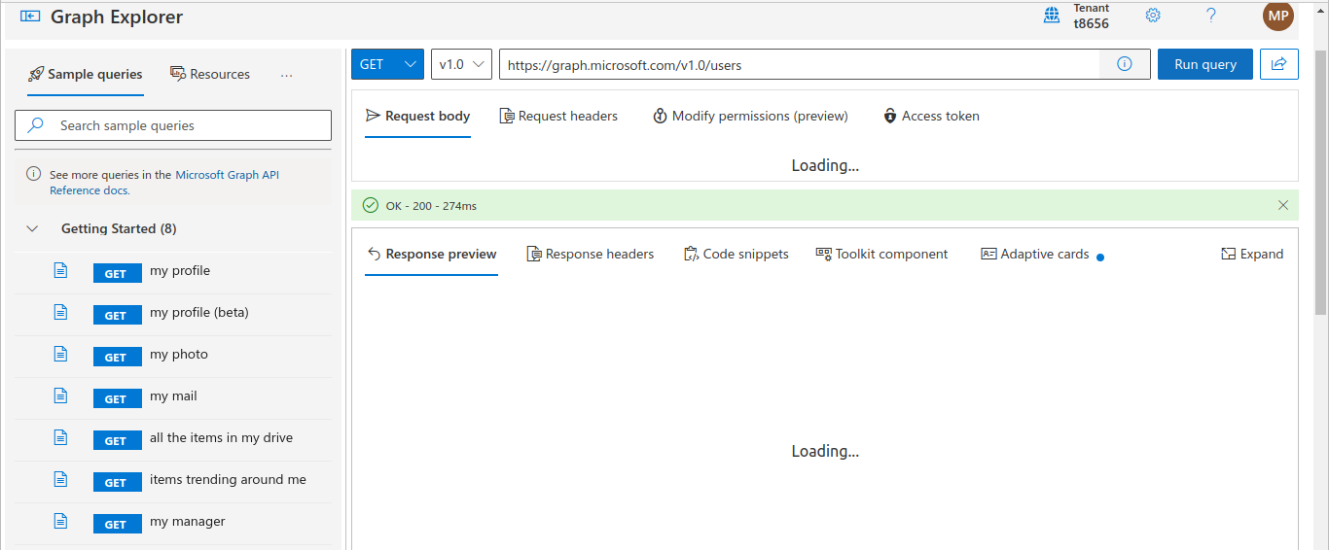
The query graph of the dispatcher is https://graph.microsoft.com/v1.0/users . This query return a list of the different users of an Azure tenant :

Picture 3: List users query Graph
The query https://graph.microsoft.com/v1.0/user/<id> retrieves the detailed data for each users
Init Stage
The init stage load the configuration data from Config.xlsx file and from assets, retrieve credentials from Orchestrator assets or local Windows Credential Manager ,open and login to applications used throughout the process and populate the dispatcher via an http request to the graph.
Process Stage
The process stage get the incoming transaction and use the id of each incoming queue item for generate an http request with the second url to the graph. Retrieve the inormation for each id and saves the object in a dataTable. At the end of this stage a datatable it’s saved.
End Stage
In this stage the robot close or kill all the applications processes.

