Training App
PowerApp Documentation
25/11/2022



Author: Manuel Portero Leiva

Introduction
This document has the purpose to explain the different parts of the Training App, its code and functionalities, for understanding and replication purposes. The different parts of the architecture solution are show below.

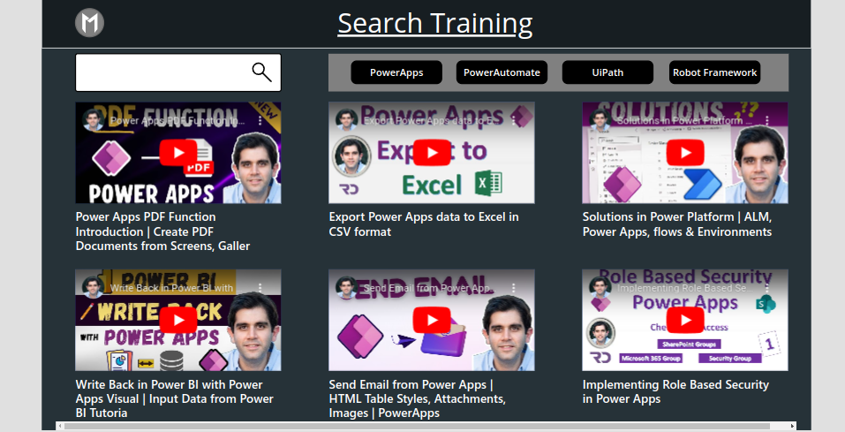

Picture 1: Training App Main Layout

Architecture
The composition of the architecture starts in the PowerApp, the different galleries represented pull data from a unic Sharepoint list. Filters and state interactions are set in order improve the user experience.

A full diagram of the solution is shown below.


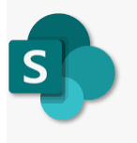

Picture 2: Catallogue App solution Architecture

Main Screen
The main screen is composed by VideoGallery, depending of the different dropdowns will display the video lists. If we introduce text in the TextInputBox the VideoGallery will be filtered too.

Picture 3: Training App main Screen

The Related code associated with the main screen it’s shown below:

VideoGallery:
Filter(
Search(
'Training list';
TextInput.Text;
"Title"
);
Technology = TechnologyStateVar
)

Dropdowns:

Set(TechnologyStateVar;"xxx")

