# FiveOhOne Darts, Championship Matches

## Behaviour

Over 100,000 iterations:

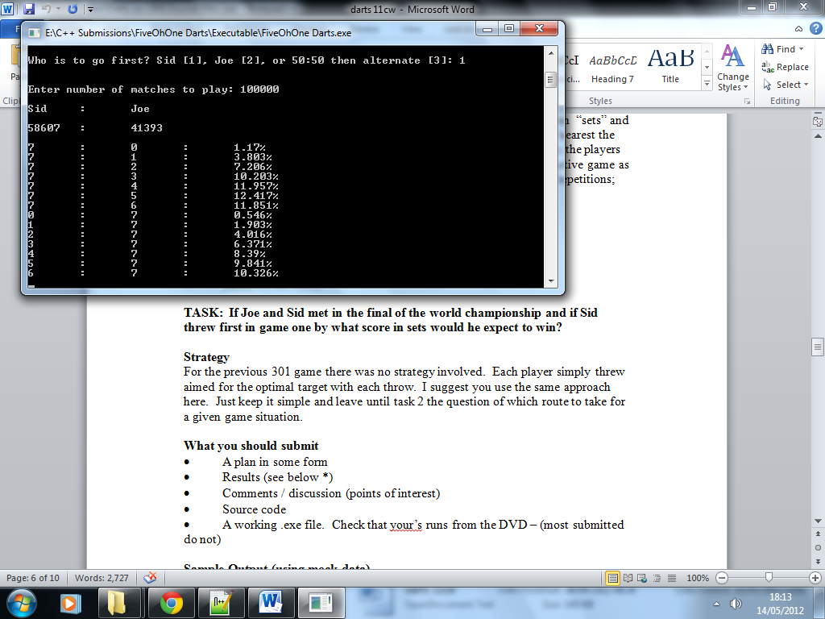

|  |  |  |
| --- | --- | --- |
| *Wins* | Sid | Joe |
| 7 : 0 | 1.17% | 0.55% |
| 7 : 1 | 3.80% | 1.90% |
| 7 : 2 | 7.21% | 4.02% |
| 7 : 3 | 10.20% | 6.37% |
| 7 : 4 | 11.96% | 8.39% |
| 7 : 5 | 12.42% | 9.84% |
| 7 : 6 | 11.85% | 10.33% |