**Codes Unleash: A Skill Sharing Mobile Application for Learning Programming Languages (Kotlin)**

Arvee A. Asilo, Liv M. Basco, Maxene Chanel Baylosis, Charles G. Dela Cruz, and Roy B. Rosima

College of Computing and Information Sciences, Systems Plus College Foundation

October 2023

**Author Note**

Arvee A. Asilo

We have no known conflict of interest to disclose.

Correspondence regarding this research should be addressed to Arvee A. Asilo, College of Computing and Information Sciences, Systems Plus College Foundation, Angeles City Pampanga

[a.asilo@spcf.edu.ph](mailto:a.asilo@spcf.edu.ph)

## **APPROVAL SHEET**

This Capstone project titled “**Codes Unleash: A Skill Sharing Mobile Application for Learning Programming Languages**” prepared and submitted by Arvee A. Asilo, Liv M. Basco, Maxene Chanel Baylosis, Charles G. Dela Cruz, and Roy B. Rosima in partial fulfillment of the requirements for the **Bachelor of Science in Information Technology**, has been examined and found in order and is hereby recommended for acceptance and approval for oral examination.

**LIZA G. MANANQUIL, MIT** Adviser

After having been presented, it is hereby approved by the Committee on Oral Examination with a grade of ____.

**RALPH B. CADALZO, MIT** **RICKY I. OLIVERIA, MIT**  
 Member Member

**GEORGE M. GRANADOS, MM, MIT**Chairman

After having been recommended and approved, it is hereby accepted by the College of Computing and Information Sciences of Systems Plus College Foundation.

**GEORGE M. GRANADOS, MM, MIT ROY D. DAYRIT, DIT**  
 Dean VP for Academic Affairs

## **Acknowledgment**

We are so grateful to Systems Plus College Foundation on their ongoing support for this capstone. If it were not for their unwavering help, we would have met various challenges in life. Special thanks go to our hardworking capstone adviser, Ms. Liza Mananquil, whose expertise contributed to our project’s success. Her insightful criticism, mentorship, and constant support were vital throughout the process, influencing the direction and execution of our work.

In addition, we would like to thank everyone who helped us with advice, support, and encouragement throughout this project. Their efforts, large or small, were much appreciated and played an important role in completing this capstone.

## **Abstract**

The Codes Unleash application is designed to meet the demand for improved educational resources in mobile development, with a specific emphasis on instructing the Kotlin programming language. The purpose of the application is to enhance the educational experience of students at the College of Computing and Information Sciences by offering a user-friendly environment for studying Kotlin. The program provides a comprehensive learning experience by offering multimedia content, including video tutorials, an in-built code compiler for testing, chapter assessments, and an examination system for earning badges. Nevertheless, several constraints have been observed, including the inability to expand videos to occupy the entire screen and difficulties in establishing two-factor authentication for enhanced account security. Given these limitations, the application continues to be functional and effective in accomplishing its main objectives. Future researchers should focus on addressing these restrictions in order to improve user experience and security. Overall, the Codes Unleash application sets a standard for effective implementation of programming language learning software.

**Table of Contents**

**APPROVAL SHEET** ii

**Acknowledgment** iii

**Abstract** iv

**CHAPTER 1 The Problem and Its Settings** 1

**Introduction** 1

**Background of the Study** 5

**Objectives of the Study** 7

**Scope and Limitation of the Study** 9

**Significance of the Study** 10

**Definition of Terms** 10

**CHAPTER 2 Literature Review** 14

**Conceptual Framework** 22

**Synthesis** 24

**Conclusion** 24

**CHAPTER 3 System Development Methodology** 26

**Requirement Specification and Analysis** 26

**System Design Specification** 28

**Logical Specification** 29

**Physical Specification** 30

**Implementation** 30

**Testing and Evaluation** 31

**Methodology** 31

**Research Approach** 32

**Research Design** 32

**Data Collection** 33

**Data Analysis** 34

**Ethical Consideration** 35

**CHAPTER 4 Results and Discussion** 38

**Results** 38

***Data Presentation*** 38

***Data Description*** 38

***Qualitative Findings*** 39

**Discussion** 40

***Interpretation*** 40

***Comparison with the previous Research/System*** 41

***Practical Implications*** 42

***Limitations*** 42

***Future Researchers*** 43

**CHAPTER 5 Conclusion and Recommendation** 44

**Conclusion** 44

**Recommendation** 44

**REFERENCES** 46

**APPENDICES**

**Appendix A Source Code**

**Appendix B Evaluation**

**Appendix C User’s Manual**

**Appendix D Functional Decomposition of Codes Unleash**

**Appendix E Design Criterion for Codes Unleash**

**Appendix F Presentation of Data Collected**

**Appendix G Curriculum Vitae**

**Appendix H Questionnaire**

# **CHAPTER 1 The Problem and Its Settings**

## **Introduction**

Learning gives people the information, skills, and understanding they need to change, grow, and improve in life. In an ever-evolving world, people can learn how to live and thrive through education, experiences, networking and self-reflection. In the past, people mostly learned in classrooms with teachers, libraries, written textbooks and oral communication. Training programs and coaching were popular ways to learn skills by doing them, and oral tradition and group study made learning more fun by letting people share stories and work together.

Education has existed since the beginning, but only sometimes in the same form. Education, which makes learning possible, has always been important (Fastiggi, 2013). There is a way to teach called mobile learning, or m-Learning, that uses phones and tablets to deliver educational material and experiences. It lets students access and interact with learning materials at any time and from anywhere, making learning more accessible and more open.

Mobile learning is not just combining "mobile" and "learning." It has always meant "mobile e-learning," its history and development must be seen as both a continuation of traditional e-learning and a response to what people saw as its flaws and limitations (Traxler & Crompton, 2015). Mobile learning includes many things that can be done on a phone or tablet, such as viewing digital textbooks and interactive quizzes, participating in group discussions, and getting personalized feedback. It helped the teachers add something new to their lessons. Plus, it gives them a break from regular school while still helping them remember what they are learning (Mengorio & Dumlao, 2019).

In a world where technology changes quickly, there has never been a more significant need for valuable and easy-to-use learning tools. Mobile learning has changed how people learn because it lets them do it at their own pace, anywhere and at any time. With mobile gadgets becoming increasingly crucial in our daily lives, it is clear that mobile learning applications could completely change how we learn and pick up new skills. Programming language teaching methods should change to meet the needs and wants of students in the 21st century. The rise of mobile-assisted language learning has opened up many new opportunities in the field (Mengorio & Dumlao, 2019). As Kotlin becomes more well-known as a flexible and powerful language for making mobile applications, it is essential to look into how mobile learning applications can help teach its concepts and complexities to students, giving them the skills, they need to do well in the ever-growing field of developing mobile applications.

In mobile learning, programming language learning becomes very important. To learn this requires that one is able to understand the terms used in programming and be able to reason logically for problem solving. These are the same skills needed when creating mobile applications. Kotlin which is a modern and dynamic language meets all the criteria for building applications on mobile devices. People increasingly realize that mobile learning can be essential to teaching hopeful developers Kotlin skills. A look at the teaching strategies, new technologies, and user-centered design concepts that form a constantly evolving mobile learning application. When we look at Kotlin, we get to the core of a computer language that will significantly impact how mobile applications are made. The researchers look at the problems, chances, and life-changing possibilities of mobile learning through this lens. They aim to show how technology and education can work together to help the next generation of Kotlin developers.

The low uptake of mobile learning as an effective teaching tool is among the greatest challenges that needs to be tackled as students require better avenues to aid their learning processes. Despite the fact that mobile learning is a solution to making learning easy, better and convenient across the globe, its full implementation is yet to be realized. A lot of the unrealized potential of mobile learning comes from people being afraid to use it in school. Some schools and teachers would rather spend less on technology because it could replace old-fashioned ways of teaching and make it harder for students to interact with each other while they are learning. Also, smartphones are everywhere, which can be a distraction. It can be challenging for students to stay focused on schoolwork when numerous applications and alerts are to be looked at. At the same time, it is worrying that students do not know about Kotlin as a computer language for making mobile applications or how well it works. Closing these gaps is crucial as this will increase the efficacy of mobile learning and educate learners on contemporary tools such as Kotlin that may be beneficial to them in mobile application development - a world which changes fast.

There are various barriers to the utilization of mobile learning. While many students mean to study, they end up using their phones to chat, share pictures, use social media, or play video games. People could have done something useful with that time instead of being distracted by these things (Thomes, 2019). Both mobile learning and online education require the use of technology for their operation. Over-reliance on technology results in individuals lacking hands-on skills that are only acquired through practice. Take, for example, artists who cannot develop real-world abilities due to lack of feedback and in-person training (Sullivan, 2022). From the point of view of a learner, what is going on behind the scenes is not being shown. He or she needs to learn about the created functions or fully grasp the tools they use (Jalan, 2022).

Mobile learning is one of the most efficient alternatives for online education since it provides access to much information directly on a student's mobile device. Over the past few years, use of online learning has increased and is now more effective than traditional learning. It’s not really hard to see why. Clearly, online learning options have gained wide popularity due to their simplicity compared with the traditional face to face setting of learning (Dexway Communication, 2017). People widely recognize Kotlin as a language for computing which facilitates writing any program that can be imagined by developers. In view of this, software developers who have discovered Kotlin have come to realize how greatly it simplifies their work. This fact has even quickened the process of writing programs besides making it more enjoyable because there will be no need for constant rewriting of code lines due to irrelevance. The Kotlin programming language is designed in such a way that both beginners and professional programmers alike find it quite simple to understand and use. Not only does it contain all modern features necessary for this type of activity but also has a user-friendly configuration that makes it perfectly adaptable tool to be employed in different projects of software development. In Java, there is a defect that makes it one less advantageous than Kotlin: it is too strict, which means people cannot write the own programs easily. Kotlin provides various ways to help developers write fewer lines of code thus enabling them do much more work with the same amount of time on hand. Moreover, Kotlin supports functional programming – an aspect appreciated by many programmers (Jalan, 2022).

Students use many different ways and plans to learn new things and improve their skills. It can help them understand how students do well in different school settings if they know how they learn. It is known that higher education in China is challenging, and high school kids have to put in much work to get into the best colleges. However, it is a good idea to have group learning happen in the same school setting (Ray, 2021). The way people learn in the Philippines has a long history that is based on tradition. Classrooms have always been the primary place where information is shared. Still, the start of the 21st century has caused a paradigm shift, making educators and institutions realize they need to adapt to the needs of a society that is constantly changing around technology. You can find m-learning applications like Duolingo in Pampanga, Philippines. These applications make it easy for people to learn new languages. It gives a well-organized lesson plan shaped like a skill tree. Both eLearning and m-Learning use high-tech ways to teach and test students. Adding games to the course, such as questions and tests that students can interact with, can motivate them to learn more, remember important information, and progress (Sullivan, 2022).

## **Background of the Study**

Systems Plus Inc. was established in Balibago, Angeles City, on June 27, 1985. Its main goal was to hold seminars for people who wanted to work as computer data processing programmers, encoders, or system analysts. The number of students rose from 600 in 1987 to 1,200 in 1989, mainly because of the addition of new classes. The school's name was changed to Systems Plus Institute Foundation, Inc. The school is a college-level school that teaches computers. It was the first school in Region III to offer a BS in computer science. The school made these changes in reaction to the growing need for computer experts worldwide. The school was renamed Systems Plus College Foundation, Inc. in anticipation of transitioning to a four-level institution of higher learning. Along with its new name, the school changed its vision, purpose, and goals from mainly focusing on the provinces to look at things on a global scale. The Elementary Department was incorporated into the main campus in June 1996, establishing the Basic Education Department (Systems Plus College Foundation, n.d).

There are three main courses that the department of the Computing and Information Sciences offers. Each one is designed to give students specific technology skills and information. In the BS Computer Science study, students learn about all the different aspects of computers, from the most basic ideas to the most recent developments in the field. On the other hand, the BS Information Technology program teaches students how to handle all parts of an IT infrastructure, including hardware and software. The specialized tracks in mobile development and network administration help students to know the ways of designing, erecting and lawfully supporting IT systems that suit an organization. Next, the course of Entertainment and Multimedia Computing under Bachelor of Science makes learners get in depth into media creation and designing. They apply concepts from computer science to make media applications more entertaining and engaging (Systems Plus College Foundation, n.d).

It is common to expect that misunderstandings, missed chances and an isolated learning environment may occur as a result of poor communication among students, teachers and administrators. Moreover, due to busy schedules, learners may require assistance in prioritizing one-on-one appointments as well as getting timely feedback from educators. Another big problem for effective learning in the department is the need for more learning tools. Considering these problems is necessary to create a more united and beneficial learning environment. Only some people know that mobile applications exist and can significantly enhance various aspects of our daily lives.

A mobile learning application for students of the college of computing and information1 sciences is being developed to teach them the Kotlin computer language. That is because there is a clear need for better learning tools in mobile development. The effect of this effort is likely to lead to several good results. First, it claims to improve students' learning experience by giving them an easy-to-use platform to work with the Kotlin language. As a result, students should become comfortable with Kotlin, a valuable skill for people who want to work as mobile application developers. The software enables students to learn more effectively by offering opportunities for them to study at their own time and different places. These alterations could eventually lead to better study performance among student populations preparing for careers in the mobile software industry that is greatly associated with Kotlin.

To solve communication problems one of the ways is using a mobile learning application. A person does not have to worry about clarity since they can study by themselves. Making use of an application that arranges learning materials plus easy accessibility can enhance learners’ experience. This technology-based approach lets students quickly get course information and assessments so they do not have to spend much time planning their schedules. By streamlining these steps, students can make better use of their learning time and concentrate more on their studies, leading to a more effective and successful educational journey. Introducing a mobile learning application that lets students learn independently, whenever and wherever they want, can be a game-changer in education. This application could make studying much more fun by giving students the freedom and flexibility to study independently.

## **Objectives of the Study**

The general objective of the study is to develop the mobile application - Codes Unleash: A Skill Sharing Mobile Application for Learning Programming Languages (Kotlin).

The specific objectives of the study are the following:

1. To design a system with the following features:
   1. To have Multimedia Content – video tutorials of the programming language
   2. To have a compiler - checks for errors and then converts it into a language that the computer's hardware can process
   3. Exam to obtain badge – serving as a formal evaluation to determine the participant's proficiency in the programming language
   4. To have a chapter assessment – a chapter assessment at the end of the chapter of the tutorial to open next chapter of lessons
   5. To have CMS – a content management system allows for ability of creating, editing, organizing, as well as managing the application’s content
2. To create a system using
   1. Software specifications
      1. Operating System - Android Operating System
      2. Development Software - Android Studio
      3. Programming Language - Kotlin as primary programming language
      4. Design Software - Figma
      5. Database – MySQL
   2. Hardware specifications
      1. 64-bit Microsoft® Windows® 8/10/11.
      2. Central Processing Unit - x86_64 CPU architecture; 2nd generation Intel Core or newer, or AMD CPU with support for a Windows Hypervisor.
      3. Memory - 8 GB RAM or more.
      4. Storage - 8 GB of available disk space minimum (IDE + Android SDK + Android Emulator)
      5. Monitor - 1280 x 800 minimum screen resolution.
      6. Mobile Device - Android Pie 9.0
3. To test the system using Alpha Testing
4. To evaluate the system using the ISO 25010

## **Scope and Limitation of the Study**

The scope of the study involves developing the mobile application that aims to build a reliable self-paced learning with several essential features to easily learn Kotlin. Such features include video tutorials and a compiler to test your code. In addition, the application has exam that consists of a series of questions to obtain a badge, chapter assessment at the end of every chapter, and a content management system to manage the content of the application.

The necessary software includes the Android running system, Android Studio for development, Kotlin as the primary programming language, Figma for design, and MySQL for managing databases. Minimum hardware requirements include a 64-bit Windows system, a compatible CPU with enough resources, 8 GB of RAM or more, enough storage, a screen size of at least 1280 x 800, and an Android Pie 9.0 mobile device for testing. This system will be thoroughly tested using the right Alpha Testing to ensure it works and is ready for more changes. Using the ISO 25010 framework, a review will also be done, checking functionality, usability, and data security to ensure the application is high quality and easy to use.

This study is limited to certain constraints that affect the feasibility and execution of the research and application development. Time constraints are a significant problem with this work. It acknowledges that the target audience or intended users, students of the College of Computing and Information Sciences department, may need help finding time to test and use the mobile learning application. The demanding academic requirements and responsibilities of the college students can make their schedules hectic. This restriction makes it even more critical that the application be easy to use, quick, and easy to get to so that users can get the most out of it even when trying to get things done. Moreover, features such as video landscape and full screen mode are not impractical within the project scope.

## **Significance of the Study**

This study will be beneficial to the following stakeholders:

* Students. It will benefit college students who specialize in the Department of College of Computing and Information Sciences the most from this study. It is designed to boost their performance in school and enhance their programming skills. It gives us a lot of insights into effective use of mobile devices for studying and a more efficient way of conducting academic programs.
* IT Companies. IT companies will also benefit because they will have access to a pool of graduates who know how to code in Kotlin, a prevalent skill for making mobile applications. The application makes the job market more competitive and encourages new ideas suitable for IT businesses.
* Educational Institutions. Additionally, this study is helpful for the educational institutions because it leads to more creativity and growth because of the rise of skilled students who know Kotlin.
* Future Researchers. Future Researchers will also benefit from the study and they can use the study as their reference for their own study.

## **Definition of Terms**

This research paper will define key terms that are essential for clear comprehension.

1. Kotlin: Kotlin is a statically typed programming language used mostly for developing Android applications. It is popular for creating mobile applications due to its brevity and ability to interface with Java.
2. M-Learning: Shortened form of mobile-learning or otherwise called mobile-based education refers to the process of learning supported by the mobile devices such as tablets or smartphones.
3. eLearning: Stands for "Electronic Learning." Any computer or internet-based learning is part of eLearning. It contains digital learning tools for teaching such as online classes or virtual schools.
4. Operating System: An Operating System is a program that acts as an interface between the user and hardware of a computer by making it possible for the hardware to communicate with the software. For cell phones, two famous running systems are Android and iOS.
5. Development Software: Development software includes tools and settings developers use to create programs, such as Android Studio and Xcode, which are two popular software pieces for building mobile apps.
6. Programming Language: Programing language is a organized kind of language that describe how to do an action by a computer, therefore, it is used in writing applications for instance Kotlin, java, swift and python.
7. Design Software: It is utilized in creating visual features and user interfaces for software using design software. A lot of people use Adobe XD, Sketch, and Figma as creation software.
8. Database: A database is a structured collection of data that is set up so that it is easy to find and control. SQLite, MySQL, and Firebase are all systems that are often used when making mobile applications.
9. Alpha Testing: It refers to testing in the early stages of making software to find and fix big bugs and problems. It means testing the program internally before making it available to more people.
10. ISO 25010: It is set of worldwide standards that describe quality requirements and ways to measure the quality of software products. There are many ways in which evaluating software quality can be done, such as its effectiveness, ease-of-use and functionality.
11. Android OS: Android is an operating system for mobile devices that is built on a modified version of the Linux kernel and other open-source software. It was mostly made for touchscreen phones and tablets.
12. Android Studio: The standard integrated development environment (IDE) for making Android applications is Android Studio. It is based on IntelliJ IDEA, a Java-based IDE for making software, and uses its editor and developer tools to change code.
13. MySQL: MySQL is an open-source Relational Database Management System (RDBMS) that makes it easy to store, organize, and get organized data. It is used for a lot of things, from small projects to big websites and enterprise-level solutions.
14. Central Processing Unit: The CPU, which is also called the "central" or "main" processor, is a complicated group of physical parts that run the computer's OS and programs. Most of the time, the hardware and software applications running on the device tell the CPU what to do and how to do it.
15. Memory: A disk is a piece of hardware that can temporarily or permanently store data or programs (paths of instructions) for use in a computer. Binary code, which is made up of patterns of 0s and 1s, is how computers store information.
16. Storage: It refers to devices that can connect to a computer directly or through a network and allow data to be sent and received using input/output (I/O) processes. There are many storage devices, such as hard disk drives (HDDs), flash-based solid-state drives (SSDs), optical disc drives, tape systems, and etc.
17. CMS: It is a user-friendly program used by people for creating websites easily. It allows one to do the site's content adding, changing and organizing which may include text and images among others without necessarily being a computer expert.

# **CHAPTER 2** **Literature Review**

This part of the manuscript presents the review of related literature and the studies underlying the theoretical and conceptual framework of the study. It will include the generalization and synthesis made after a thorough review of the related literature and studies.

**Best Practices in the Use of Mobile Learning by University Teachers of Didactics Language-Literature**

The central theme of this part is mobile learning best practices for language-literature didactics university lecturers. Educators who successfully integrate mobile learning into their teaching practices should reveal their beneficial strategies. Teachers must grasp the problems and potential of mobile learning and how they overcome them. Mobile learning offers enhanced engagement and flexibility. Therefore, it is essential to study successful pedagogical methods in this field. The idea is to distill best practices to help teachers improve student learning (Romero-Rodríguez et al., 2021).

**Cooperative Mobile Learning for the Investigation of Natural Science Courses in Elementary Schools**

This part of education dwells on collaborative mobile learning in elementary school natural science. It highlights the collaborative character of mobile learning in this educational context and its potential to improve investigation-based natural science instruction. The section emphasizes the need to integrate cooperative mobile learning practices into elementary schools, analyzing their pros and downsides. The goal is to discover excellent practices in natural science education for elementary school children (Huang et al., 2020).

**Designing a Framework for Training Teachers on Mobile Learning in Sub-Sahara Africa**

Here we discuss the article about mobile learning teacher training in Sub-Saharan Africa. This research is important because mobile learning can enhance education in Sub-Saharan Africa. It stresses on the need for teachers to get trained so as they can include mobile learning in their course. The section highlights the problems and prospects of mobile learning in Sub-Saharan Africa and guides educators who want to use it. The purpose is to improve regional education through strategic mobile learning (Oluwadara et al., 2020).

**Development of Mobile Learning in Learning Media to Improve Digital Literacy and Student Learning Outcomes in Physics Subjects: Systematic Literature Review**

The BIRCI-Journal systematic literature review examines mobile learning in physics education to improve digital literacy and student learning outcomes. This study aims to explore the ways in which mobile learning media—educational applications, multimedia content, and interactive simulations—can enhance immersive and interactive physics learning. The aim of the authors is to sum up numerous pieces of research asserting that the utilization of various mobile learning strategies may grow children’s digital literacy levels and school performance. Teachers and scholars can use the present paper in utilizing mobile learning technologies to improve physics teaching (Wijaya et al., 2021).

**EFL Students’ Attitudes Towards the Ease-of-Use Mobile Technology to Learn English at a University in Vietnam**

This study examines Vietnamese university EFL students' views on mobile technologies for English learning. The study examines students' views on mobile technology as a learning aid to assess mobile-assisted language learning's efficacy and acceptability. The study explores the impact of usability, access, and mobile technology on learners’ attitude towards language learning. The survey data and analysis of the author’s inform about the part that mobile phone technology plays in EFL education of Vietnam indicating areas of prospective studies for the instructors and schools aiming at optimization of mobile learning tools for ELT (Loc et al., 2022).

**Endorsement of Individualized Instruction and Learning Performance through Mobile-Based Learning Management**

This is a chapter that discusses how mobile-based learning management systems enable personalized instruction and improved learning outcomes. Consequently, this article looks into the personalization of learning through technology. Moreover, empirical studies have shown that personalization through technology is possible. This part also provides insight into learning organization because of only target information dispersal for appropriate training and flexible pathways that are enabled by mobile internet gadgets too (Shukla & Pandey, 2020).

**Exploring Factors Influencing Mobile Learning in Higher Education – A Systematic Review**

This evaluation takes an organized look at the manner in which academic mobile learning is offered and the accomplishments that follow from it. The review focuses on the various factors that influence the performance of these programs. It examines a variety of works that have been made public in order to identify and classify the motivational variables. The research highlights the fact that mobile learning is becoming increasingly prevalent in higher education and is particularly important for comprehending the aspects that contribute to its success (Gupta, 2021).

**Greek Secondary School Teachers' Degree of Readiness in Adopting Mobile Learning in the Educational Process**

In this literature, discussing the preparedness of the educators in adopting mobile computing for instruction. It recognizes the place for mobile technology in schooling and knowledge acquisition processes around the globe. On the other hand, the paper is aware that it all depends on the preparedness and readiness of teachers first before they can embrace this new path of teaching creativity. These aforementioned authors studied Greek secondary school teachers’ m-learning readiness using real research materials. The study examines how technical skills, pedagogical beliefs, and institutional support affect instructors' preparation. In this study we would like to explore the teachers in Greece preparedness for using mobile technology at the secondary school level as an input for the current debates on this issue (Troulinaki, 2023).

**Human-computer Interaction in Foreign Language Learning Applications: Applied Linguistics Viewpoint of Mobile Learning**

This study analyses the interaction between humans and computers in foreign language learning applications with an applied linguistics approach in terms of mobile learning. It acknowledges the rise in importance of technology in language teaching as well as the need to understand computer- human interaction (HCI). The authors examine how mobile applications help foreign language acquisition through empirical research. This study helps optimize mobile language learning applications to improve learners’ communication skills (Pikhart, 2021).

**Impact of Mobile Learning on Students’ Achievement Results**

This study examines how mobile learning influences student performance. The study in Education Sciences notes that mobile technology is becoming increasingly popular in classrooms and seeks to know how it affects students' learning in many ways. The authors use empirical research and analysis to examine how cell phones and tablets affect student performance. The study examines many topics and education levels to determine how effectively mobile learning works. The study examines facts and statistics to see if mobile learning improves school performance. This study helps us understand how education is changing by concentrating on how mobile technology can increase student learning (Klimova, 2019).

**Mobile Learning: Visualizing Contents Media of Data Structures Course in Mobile Networks**

This study paper, which was released in the Journal of Telecommunication, Electronic and Computer Engineering (JTEC), is about how to use mobile learning in a course on data structures in mobile networks. The study looks into new ways to use mobile technology to visualize course material. It considers the unique problems and chances that mobile networks offer and wants to improve learning for students in this area. The study looks into how data structures and related ideas can be successfully visualized to help people understand and be more interested in using the features of mobile devices. The piece talks about different methods and tools that can be used to make course materials more straightforward to see. (Budiman, 2018).

**Mobile Learning Applications for Refugees: A Systematic Literature Review**

In the approach of education sciences, this paper systematically examines mobile learning applications developed specifically for learners that are refugees. This paper discusses how mobile learning has promoted the education of refugees who have gone through displacement processes on a global scale. A critical analysis of existing research reveals trends, problems, and emerging practices in creating and deploying mobile learning applications for this vulnerable demographic. This systematic review illuminates mobile learning in refugee education and contributes to the discussion on using digital tools for inclusive and equitable learning (Drolia, 2022).

**Mobile Learning Based on Guided Inquiry: Optimization of Students’ Motivation**

This Jurnal Pendidikan Teknologi Dan Kejuruan essay discusses using guided inquiry to motivate students using mobile learning. Mobile devices are used to engage and motivate students in technology-enhanced education. The study examines how guided inquiry and mobile learning may create a dynamic and engaging learning environment. The study explored the impact that this coherent approach had on student drive, building on a knowledge bank that shows how technology can lead to better academic performance plus higher levels of attachment on the part of students (Wirawan, 2018).

**Mobile Learning Design Using Gamification for Teaching and Learning in Algorithms and Programming Language**

Mobile learning tools and gamified aspects of learning could lead to better results in computer science and programming teachings-this is what the essay purports. The combination of these two aspects is aimed at making learning more dynamic and interesting. This study examines this instructional technique's design, implementation, and efficacy, which may improve student engagement, comprehension, and performance in algorithms and programming languages (Tundjungsari, 2019).

**Mobile Learning in Pre-Service Teacher Education: Perceived Usefulness of AR Technology in Primary Education**

In Education Sciences, the study examines mobile learning and pre-service teacher education, focusing on the perceived utility of Augmented Reality (AR) technology in elementary school. The study examines how mobile and AR technology might improve teacher preparation. Pre-service teachers' views on AR technology as a primary education pedagogical tool are examined. Mobile-based AR experiences are tested on pre-service teachers' knowledge, pedagogical abilities, and readiness to employ such technology in primary schools. This study contributes to the discussion on mobile learning and emerging technologies in teacher education by measuring AR technology's perceived utility (Gómez-García, 2021).

**Mobile Learning New Trends in Emerging Computing Paradigms: An Analytical Approach Seeking Performance Efficiency**

This study, published in Wireless Communications and Mobile Computing, examines mobile learning's changing landscape and how emerging computing paradigms improve performance efficiency. The report analyzes mobile learning trends and emphasizes the need for cutting-edge computing tools. It explores how these paradigms optimize mobile learning platforms, improving student learning. The study examines computational methods, tools, and approaches to increase mobile learning efficiency and efficacy. This study illuminates these developments and their consequences for mobile learning in a digital and networked society (Mohiuddin, 2022).

**The Implementation of Mobile Learning in Asia: Key Trends in Practices and Research**

In the Springer International Handbooks of Education, comprehensive investigation of Asia's educational landscape and mobile learning was conducted. The study includes essential mobile learning integration developments in Asian education institutions such as practices and research. Mobile learning's challenges and opportunities in this region are examined, along with the environmental and cultural variables that drive its adoption. It demonstrates how new pedagogical methods, technology, and strategies have expanded Asian mobile learning. A comprehensive assessment of mobile learning technology in Asia helps educators, policymakers, and academics navigate the ever-changing world of educational technology (Churchill, 2018).

**The Use of Mobile Learning to Enhance Learning Innovation Pasca Pandemic COVID-19**

According to a new study by the Journal of Learning and Technology, innovation in learning is driven by mobile learning post-COVID-19. Since the COVID-19 lockdown, educators and schools have been forced to find creative ways of maintaining access to education and quality of education delivery globally. This study examines the changes in mobile learning brought about by the pandemic, how mobile learning strategies and technologies have enhanced education. The research illuminates the changing education landscape and the role of mobile learning technology in shaping it, making it useful for educators, policymakers, and researchers navigating the post-pandemic educational paradigm (Casmat & Pribadi, 2022).

**The Use of Mobile Learning in Higher Education: A Systematic Review**

Mobile learning in higher education is examined in this research paper, which was published in the study of Computers and education. Mobile technology has facilitated the employment of mobile learning to better instruction as well as learning at colleges and universities. Thoroughly analyze current studies addressing mobile learning in this area with the aim of identifying key themes, results and challenges. The relevance of mobile learning in colleges and universities, how it affects grades, student’s active participation and various teaching methods applied by educators is also looked at (Crompton & Burke, 2018).

**Using Mobile Learning Tools in Higher Education: A UAE Case**

This study, published in the "International Journal of Interactive Mobile Technologies (IJIM)," examines mobile learning technologies in higher education in the UAE. Mobile technologies are used to improve teaching and learning at UAE higher education institutions. This case study aims to illuminate how mobile learning technologies affect pedagogy, student engagement, and learning results. The study uses empirical data and qualitative analysis to provide lessons and practices for the utilization of higher education mobile learning tools (Eppard, 2019).

## **Conceptual Framework**

The central focus of the study is to explore the comprehensive nature of the application, with a particular emphasis on its role in facilitating effective learning of the Kotlin programming language. The research topic is a tutorial for the students of the College of Computing and Information Sciences department at Systems Plus College Foundation, focusing on the Kotlin programming language.

Fundamental IT ideas, like how to make mobile applications learn programming languages, form the basis of the application. These ideas are essential for the application to reach its learning goals. Key technologies, such as Kotlin, the Android operating system, and Android Studio, make development and learning possible and make sure the application works well. To improve the learning experience, things like user involvement, compatibility with mobile learning trends, and ease of access are also carefully added. Most research says that mobile learning, or m-learning, could change how we learn. This framework is the foundation on which the teaching and technological parts of the application are built. The chosen theoretical framework for Codes Unleash application is based on how to teach programming languages and use mobile devices to learn. Concepts like constructivism, active learning, and learner-centered methods are used, but they are all changed to fit the needs of teaching Kotlin to college students. The application's design, content delivery, and interactive parts are all based on this theoretical basis. This ensures that they align with best practices in mobile learning and teaching programming languages. By putting Codes Unleash in this theoretical context, we hope to make learning more effective and fun. Clear and specific IT research goals that align with the main goal led to the development of the mobile application "Codes Unleash." These goals include a video tutorial, adding a compiler, making learning more engaging with hands-on activities, testing knowledge with exams for a badge, chapter assessment, giving help and tips, and a content management system.

These goals work together to make a successful and easy-to-use mobile learning experience for college students in the College of Computing and Information Sciences department. IT ideas like constructivism and learner-centered approaches are also significant for determining the application's user-centered design and collaborative learning features. The research proceeds over more important IT tools, like Android Studio for development, Kotlin as the primary programming language, and Figma for design. It stresses how important they are for making a good mobile learning platform. It also lists important variables, like learning results and user engagement measures, along with how they will be measured and analyzed to determine how the application affects students. Lastly, the IT methods chosen include ISO 25010 for full software quality assessment and alpha testing for quality assurance. This gives a solid base for checking how well the application works and fits with the research goals.

## **Synthesis**

Critical determinants for the effective implementation of mobile learning initiatives include the preparedness and capability of educators. Teacher training should be more general covering all aspects in all regions, as this is vital especially for regions like Sub-Saharan Africa and Greece where mobile technology has unique challenges and opportunities. Further, the literature shows the various benefits associated with mobile learning such as enhanced student engagement, flexible learning and better educational results. Impact of Mobile Learning on Students’ Achievement Results literature presents a comprehensive review of the various methods and technologies used in mobile learning. Through data, it is clear that students can do better when they use their mobile as a learning tool. This shows that mobile technology has the potential to improve learning results in all sorts of education situations hence leading to an inaccessible education that can be customized. The literature acknowledges the evolving role of mobile learning in post-pandemic education, as illustrated in studies such as The Use of Mobile Learning to Enhance Learning Innovation Pasca Pandemic COVID-19 (Casmat & Pribadi, 2022). Mobile technology which has emerged as a tool for educational innovation and adaptation in response to global disruptions offers new avenues of remote learning, digital literacy, and flexible pedagogical approaches. A comprehensive understanding of the transformative potential of mobile technology in shaping the future of education is provided by this synthesis through exploration of diverse perspectives, methodologies as well as impacts.

## **Conclusion**

Codes Unleash: A Skill Sharing Mobile Application for Learning Programming Languages (Kotlin). The program is an in-depth tutorial for the Kotlin programming language, a self-paced mobile learning application designed explicitly for the students of College and Computing and Information Sciences department. Mobile learning (m-Learning) has become a significant educational force in this age of rapidly evolving technology. Due to the widespread use of mobile devices, it gives students the freedom to work on schoolwork at their own pace and from anywhere. This shift in thinking also applies to teaching programming languages. Kotlin, a modern and flexible language, fits perfectly with the needs of making mobile applications. Mobile learning not only meets the needs of teaching programming languages but also shows how accessible and user-centered learning experiences can be in general. Kotlin is becoming more popular, and mobile learning applications are great ways for aspiring programmers to learn these skills. This coming together of technology, education, and programming knowledge shows how mobile learning could change the future of Kotlin development and help raise a generation of skilled and flexible programmers.

# **CHAPTER 3 System Development Methodology**

This section identifies the methods and activities that will be performed to accomplish the project or the specified objectives. It informs the readers how the author proceeded with the study. It typically includes sections on sample of participants and how they were obtained, instrumentation used, step-by-step procedures in gathering and processing data, and design and statistical treatment of data. Activities in system methodology are also discussed which cover problem identification, the development, and the implementation of the project.

## **Requirement Specification and Analysis**

Codes Unleash is designed with specific requirements to enhance user experience, ensuring both enjoyment and learning. Users require an Android smartphone with at least Android Pie 9.0 and internet access for application download. This deliberate choice aims to improve accessibility and usability across a broader audience. Basic coding knowledge is recommended, aligning with the app's core goal of enhancing coding skills. The functional decomposition of Codes Unleash, illustrated in a user-friendly chart, ensures a seamless learning journey. The application's commitment to simplicity, inclusivity, and user involvement, catering to both novice and experienced coders.

1. Specification - Codes Unleash has specific requirements that are meant to make the user experience fun and last a long time. To use the app, you need an Android smartphone with at least Android Pie 9.0 installed. Also, users must have access to the internet or mobile data in order to download and run the application. There was a reason for making this choice: to improve accessibility and usability for a bigger range of people. Additionally, it is suggested that people who use Codes Unleash have a basic knowledge of how-to code. That's because this requirement makes it easier for users to understand and use the application's different features, which is in line with the application's main goal of better coding skills. The above guidelines outline how Codes Unleash can be used in a way that is easy, quick, and open to everyone, regardless of their level of coding knowledge. This includes both new and experienced coders.
2. Functional Decomposition – Appendix D represents the Codes Unleash flowchart outlines a user-friendly experience within the application. Starting from the home page displaying navigational snippets and earned badges, users are prompted to authenticate themselves through sign-up or log-in options. Once logged in, they access lessons featuring chapter tutorials and assessments to unlock subsequent chapters. The evaluation stage includes quizzes and exams for badge attainment. A progress section displays the percentage completion of lessons and quiz scores. Lastly, the profile page is where all of the user's information, feedback, and application settings are put together. This organized flow makes sure that learning goes smoothly, that users can see their progress, and that they are involved with every aspect of the Codes Unleash application.
3. Design Criterion - Appendix E illustrates how a primary design criterion for the Codes Unleash application is performance optimization. This involves optimizing the code's execution to achieve efficient performance, reducing reaction time, enhancing loading speed, and overall improving the user experience for a smooth interaction. Furthermore, the application is designed with minimal resource consumption as its top priority. System resources are carefully managed to avoid excessive battery drain and device delay, ensuring an enjoyable and effective user experience. In terms of scalability, the objective is to maintain stability and responsiveness while carefully planning for the application's expansion to handle a growing user base and changing features without sacrificing functionality. Moreover, the objective is to minimize latency, with a specific focus on reducing the time taken for interactions, so guaranteeing rapid execution of important tasks and delivering users a learning experience that is both real-time and satisfying.

## **System Design Specification**

The development of the "Codes Unleash" program requires careful consideration of the algorithms that determine its functionality. The user authentication algorithm utilizes highly secure encryption techniques to ensure the protection of user data during the processes of registration and login. An efficient content distribution algorithm provides a structured and comprehensible presentation of chapters. The adaptable assessment system customizes chapter assessments by taking into account the user's performance, hence improving the personal learning experience. Furthermore, a scoring system for evaluation is utilized to compute scores for quizzes and exams, establishing the specific requirements for obtaining badges.

The application's important functionalities are supported by carefully implemented major data structures. The user profile system securely and reliably stores personal information, tracks progress, and feedback for the application. A highly structured collection of course information effectively organizes chapters, lessons, and related multimedia materials. The structure of the assessment records system is responsible for the management of user assessment data, including the storage of scores, completion status, and badge achievements.

The key features of the program have been meticulously defined in order to cater to different facets of the user experience. User authentication functions consist of sign-up and login. The lesson part functions encompass the finding of lesson content, the presentation of videos, and the administration of chapter evaluations. The evaluation area serves several tasks, including the management of quizzes and exams, the calculation of scores, and presenting of badges. Progress tracking services are responsible for computing the percentage of course completion and storing quiz scores. On the other hand, profile usage functions facilitate users in accessing and modifying their profiles, offering feedback, and adjusting application settings.

The inter-relationship of these functions is essential in order to establish a coherent user experience. The tasks of user authentication are closely linked to the lesson and assessment sections, hence enabling the provision of specific material. The functionality of lesson modules is based upon the progress of the user, hence exerting an influence on the content and assessments that are offered. The impact of evaluation functions appears in the context of progress tracking, updating completion percentages, and badge awards.

The developmental process of Codes Unleash adheres to an organized approach. The development process starts with a thorough requirement analysis, followed by the next phases of database design, algorithm implementation, and function creation. The integration of inter-relationships guarantees the smooth and uninterrupted transfer of information and data across various areas. Thorough testing and debugging processes are employed to detect and resolve defects, hence ensuring the dependable functionality of the application. In essence, deployment signifies the official launch of the application, granting users access to its functionalities. Subsequently, continuous monitoring and collection of feedback are conducted to inform future improvements. This comprehensive analysis provides a full guideline for developing an effective reliable learning platform.

## **Logical Specification**

The Codes Unleash application performs as an informative platform designed to help the learning of programming languages, with a particular focus on providing users with useful and user-friendly interactions. The application employs a variety of instructional tools, including words, symbols, numbers, and video tutorials, to facilitate a full learning experience. Every significant aspect of the program, such as the badge system acquired upon the completion of language classes, is described by specific requirements that are intended to ensure effectiveness and enhance user involvement. The application offers outputs in the form of a comprehensive and operational structure, which serves as an organized and efficient instrument for users to acquire knowledge in programming languages.

## **Physical Specification**

In the Physical Specification phase of the Codes Unleash application, the primary objective is to develop and express the technological and organizational specifications required for the successful implementation of the project. This involves the development of comprehensive program structures, database systems, along with plans for technology development. The Physical Specification phase encompasses the examination of organizational redesign, with the aim of ensuring that the project is in harmony with the current structures and workflows. The outputs generated during this phase function as a comprehensive plan for the actual execution of the application, as well as providing guidance to the development team in constructing an effective and technologically advanced application for Codes Unleash.

## **Implementation**

The implementation phase of the Codes Unleash application contains several important steps, including programming the system, creating data documents, conducting thorough testing of the newly developed application, installing application. Within the structure of smartphone implementation, individuals will engage with the program by means of an APK file, requiring the process of downloading and eventually installing the file onto their own mobile devices. The researchers will successfully explain the objectives, features, and guidelines for utilizing the application to the users. After engaging with users, collecting feedback will be implemented to allow users to contribute insights and report any concerns they may encounter. The researchers will conduct an analysis of user feedback in order to effectively address concerns related to the application. This analysis will contribute to the ongoing improvement of the application and enhance user satisfaction during the implementation phase.

## **Testing and Evaluation**

The testing process includes the utilization of the Alpha Testing Tool, which is an essential phase in the application development cycle. The developers themselves utilized this technology to detect and resolve significant flaws or difficulties, ensuring that the application was strong and prepared for future improvements. In order to evaluate the system's performance more thoroughly, ISO 25010 standards were utilized, acting as a quality assurance checklist that surpasses mere functionality. This assessment evaluated the performance of the application, its ease of use, and the implemented security protocols for protecting user data.

## **Methodology**

In this chapter, the Investigating methodology, research design, data collection, and data analysis of the study are discussed in depth. Regarding ethical concerns, a commitment to conducting the entire research process with integrity and protecting participants will be highlighted in the methodology.

Moreover, it is necessary to clarify the basic rationale of this whole methodology. In addition to its function of providing guidance in the research process, this approach fulfills a specific role in documentation.

## **Research Approach**

The studies technique followed for this study is qualitative, emphasizing an exploratory and in-depth research of the Codes Unleash a programming language educational utility. This technique offers a complete comprehension of purchaser experience, possibilities, and the general performance of the software in helping IT college students’ studying at Systems Plus College Foundation. To delve deep into how users engage with the software, researchers use surveys and usability assessments in this observe. This gives them a whole lot of data that they find useful with the intention to improve and expand the utility with time.

## **Research Design**

The employed studies layout for this study is described as exploratory, pushed through the want to analyze the unexplored discipline of developing a tutorial studying utility customized for the College of Computing and Information Sciences students at Systems Plus College Foundation, with a specific emphasis on the Kotlin programming language. Employing an exploratory technique is taken into consideration suitable for inspecting surprisingly new and unexplored regions, taking into account an in-depth observe of the subject. The exploratory layout of the studies aligns to gain a complete knowledge of the challenges, opportunities, and necessities related to developing an effective educational utility for studying programming languages. This study is characterized by way of its modern nature, as it focuses on the creation of a utility that helps efficient getting to know. The layout of the studies enables the vital flexibility to efficaciously navigate diverse aspects of software development and person experience, in the long run contributing to the introduction of an effective and user-pleasant getting to know environment.

## **Data Collection**

* This Participants or Sample: The study's participants comprise of College of Computing and Information Sciences students who are currently enrolled at Systems Plus College Foundation as well as have the potential to become users of the tutorial learning application. The selection of the sample population employed a purposive sampling technique, to ensure that participants possess a basic understanding of programming languages.
* Data Sources: Data were gathered through a survey. The survey sought to gather qualitative data regarding specific needs and difficulties encountered by students studying information technology in their goal of learning programming language skills.
* Data Collection Instruments: Survey questionnaires were the primary data collection tools employed in this research. Users can view and fill out those questionnaires via the software's consumer profile. The prepared nature of the surveys turned into carried out on cause in order that beneficial statistics and comments from customers once they used the utility can be gathered.
* Data Collection Procedures:
  1. Participants: Participants were selected from the enrolled students of the College of Computing and Information Sciences through the distribution of information.
  2. Informed Consent: Informed consent was given to each person before they participated in the studies. This would tell them approximately its goals, the truth that they may be voluntarily taking thing, and the guarantee that their privacy was protected.
  3. Conducting the Survey: Individuals inquisitive about collaborating completed an online survey questionnaire, thereby providing valuable insights into their possibilities and expectations regarding the mastering application.
  4. Validation: To enhance the accuracy of the effects, a validation technique called member checking was applied. Following the initial evaluation of the information, the researchers offered the members with a summary of the interpreted results.
  5. Reporting: The final result of the statistics collection tactics was the reporting segment, wherein the very last outcomes were completed and supplied in the studies paper.

## **Data Analysis**

* Qualitative Analysis: Qualitative research, specifically thematic analysis for its implementation, comprises a methodical procedure of identifying, organizing, and interpreting patterns or themes within the collected data. The thematic analysis offers a systematic methodology for identifying and exploring important themes, concepts, or subjects that arise from the data gathered from user engagements with the application. The technique starts off evolved with introducing oneself to the information, thereafter intending to generate preliminary characters or labels for important attributes. Following this, the codes are systematically classified into capacity issues, which are then carefully tested and revised to effectively reflect the fundamental nature of the statistics. This methodology enables an in-intensity analysis of the user's experiences, choices, and issues, therefore supplying beneficial insights to enhance the development and use of the educational application.
* Data Validation and Reliability: The validation procedure included the conducting of usability testing procedures with a sample of users who were representative of the target group. Participants' engagement with the application, as well as their comments, was proven effective and recorded. ﻿The objective was to make sure that the capability of the utility matched the expectations and desires of the customers. To make sure the accuracy of the consequences, the experimental design proved to be standardized, and person remarks was cautiously accrued. The usage of this qualitative facts evaluation technique no longer handiest clarifies the experiences of customers but additionally gives helpful guidelines for the enhancement and development of the capstone application. This process ensures greater compatibility with the expectations and preferences of users.

## **Ethical Consideration**

﻿The advent and implementation of the capstone software was conducted via thorough ethical suggestions, with the main aim of protecting the properly-being and privacy of the participating users. The implementation of this moral framework served a important function inside the development of the development method, as it blanketed the studies’ integrity and positioned the maximum importance on the privacy and nicely-being of the users concerned within the assessment of the capstone utility.

* Informed Consent:
  + Participants in the testing phase were provided with complete and clear details regarding the objective of the application.
  + Participants were provided with informed consent forms and given a chance to review and seek clarification on the contents before voluntarily agreeing to participate.
* User Privacy and Anonymity:
  + Specific procedures were taken to preserve the privacy of users. Throughout the testing phase, no data that may potentially expose the identity of individuals was collected.
  + Participants were informed that the application reviews and interactions would be treated as confidential and would not be associated with their identity in any future studies or publications.
* Data Security:
  + Strict data security protocols were in place to ensure the protection of user data. Encryption, a set of security techniques, was employed to ensure the confidentiality and integrity of data during distribution and storage.
  + The user data was securely stored, with restricted access limited to those with permission.
* Destruction of Data:
  + An established procedure for destroying data was established. Upon the conclusion of the study, all data regarding the users that had been gathered throughout the testing phase were thoroughly eradicated, ensuring the complete elimination of any remaining information.
* Feedback Handling:
  + The feedback provided by users was handled with dedication, with a focus on developing a respectful and beneficial discussion. The view of negative feedback was viewed as a chance for growth and enhancement, rather than ordinary criticism.
* Continuous Monitoring and Adaptation:
  + The ethical considerations were not static; the attempt was subject to ongoing monitoring of ethical issues. Urgent attention was given to any developing ethical concerns, and appropriate modifications were efficiently put into place.

# **CHAPTER 4** **Results and Discussion**

This chapter presents the gathered results and the conducted discussion made by the researchers.

## **Results**

## ***Data Presentation***

Appendix F is a chart created to displays developers' feedback on each functionality of the application. These aspects include things like how easy the application is to use, how quickly it runs, and other features. By visually representing users' ratings for each aspect, the chart provides a clear understanding of which functionalities were most favored by the respondents. This feedback helps us gauge the overall satisfaction levels and identify areas where the application excels or could use improvement.

## ***Data Description***

As part of the data collection process for the study, researchers interviewed developers - who are professionals in the field of developing mobile applications for their input on the Codes Unleash application. The researchers used a qualitative approach, enabling developers to directly interact with the application and test its functionalities, in order to guarantee thorough feedback. Following their use of the application, developers were asked to respond to a questionnaire with specifics about their user experience, perspectives on the functionality and design of the application, and recommendations for enhancements. Through collection of rich, complex data from the target audience, the researchers were able to better understand their perspective and provide feedback for continuous improvements to the Codes Unleash application.

## ***Qualitative Findings***

Using a questionnaire aligned with ISO 25010 standards, the respondents provided feedback that the researchers analyzed qualitatively. Several categories of interest surfaced. These included functionality, performance, compatibility, interaction, reliability, security, maintainability, flexibility, and safety. Developers’ perspectives on various facets of the Codes Unleash application were shared within each category.

Under the Functional category, respondents emphasized the user-friendliness and ease of navigation within the application, stating, "It is user friendly and easy to navigate." Regarding Performance, respondents highlighted the application's speed, particularly for users with fast internet connections. They also noted the application's ability to mod with preloaded quizzes, accessible under specific conditions. The application can be modded with preloaded quizzes on which is only accessible when conditions are met such as doing task." In terms of Compatibility, respondents affirmed that the application is responsive and can be used across different orientations, stating “The application is responsive and can be used with other screens orientation." For Interaction, respondents appreciated the feature that allows them to track their progress during quizzes, enabling self-evaluation of their knowledge. One developer mentioned, "Having to see the progress as the quiz goes it can help the users to evaluate their own knowledge." Regarding Reliability, respondents indicated that the application allows for progress to be accessed across different platforms, ensuring consistency and reliability in user experience. In terms of Security, while respondents acknowledged the application's current security measures, such as unique user logins, they also suggested improvements such as implementing two-factor authentication (2FA) for enhanced security. Under Maintainability, respondents affirmed that the application is maintainable, especially with proper documentation, which would aid future developers in understanding the code easily. Regarding Flexibility, respondents agreed that the application is customizable, being custom-made to suit specific needs. In terms of Safety, respondents recognized the application’s safety measures, such as unique user logins, but suggested further enhancements such as implementing single sign-on (SSO) and 2FA for additional security.

Overall, developers expressed their views across various categories, with approximately 50 percent of responses ranging from neutral to strongly agree, indicating a balanced perspective on the different aspects of the Codes Unleash application.

## **Discussion**

## ***Interpretation***

According to their study objectives, interpreting the research findings reveals important insights into the usability and effectiveness of the Codes Unleash application. Developer feedback identified areas for improvement and areas for strength through the ISO 25010 standards-aligned questionnaire. The application's speed, responsiveness, and ease of use are developers' top concerns, as evidenced by the well-integrated multimedia content and interactive features. Improvement recommendations such as supplying thorough documentation and introducing two-factor authentication for security highlight the necessity of ongoing improvement. In general, these results highlight the importance of mobile learning applications such as Codes Unleash in promoting the study of programming languages. The application's ability to store exam and quiz data also makes performance tracking easier and encourages self-directed learning and skill improvement. This demonstrates how crucial it is to include data tracking features in educational applications in order to efficiently maximize learning outcomes.

Its current state is beneficial for future users, as indicated by the results, which also offer valuable insights for further application enhancement. The application satisfies quality benchmarks, as evidenced by developers' positive feedback, particularly with regard to features that follow to ISO 25010 standards. The application is ideal to fulfill the needs of its users, as evidenced by the expert’s validation. Additionally, the input that has been gathered is utilized to create a course of action for upcoming enhancements, ensuring that the application will keep changing to accommodate user preferences and modern technology. Based on all factors, these results demonstrate that the application has the potential to provide a good learning experience and set a strong basis for further development and user involvement.

## ***Comparison with the previous Research/System***

The features and functionalities provided by the Codes Unleash application are consistent with those usually encountered in tutorial applications, as can be seen when comparing the findings with existing research, literature, or applications. Although there are many tutorial applications available for programming languages, not all of them include a full suite of features such as a content management system, quizzes, exams, multimedia content, progress tracking, and a badge for completion. These features are unique to the Codes Unleash Application and greatly support students in their educational endeavors. Multimedia content increases understanding and engagement, while the inclusion of a compiler guarantees that the concepts learned are applied in real-world situations. Exams and quizzes aid in evaluating retention of information, and progress tracking lets users keep a reliable visual on their learning. The content management system also makes it simple to organize and update educational materials, which keeps the application up-to-date and dynamic. In addition, the badge displays the user's mastery of the programming language and acts as a motivator for them to finish tutorials. All things considered, the Codes Unleash Application stands out thanks to its wide feature set, which is designed to maximize users' learning experiences.

## ***Practical Implications***

The researchers’ research applications can be found in educational settings, where the Codes Unleash application is an innovative instrument for effectively teaching programming languages. The application becomes a useful tool for learners and educators by adding functions like a dynamic content management system (CMS). By using its features, instructors can better organize their classes and improve the way they teach by managing and accessing the specialized content required for teaching programming languages.

In addition, because of its dynamic structure, the program can be easily adjusted to changing educational requirements, keeping it a current and useful tool for teachers. Students' learning is made more dynamic and engaging by the application's multimedia-rich content and user-centered design, which helps them retain and comprehend programming principles. The overall potential for the application to completely transform programming language teaching through its seamless and effective integration into educational settings is immense, as it will provide both teachers and students with an exclusive learning environment.

## ***Limitations***

Identifying the respondents for this study - mobile developers in particular - was one of the challenges. It was difficult to find and interact with knowledgeable developers in the sector because the researchers were students with no prior professional experience in mobile development. Despite this limitation, efforts were made to use questionnaires and feedback sessions to connect with appropriate respondents who could offer insightful input. The research's gathering of a wide range of opinions may have been impacted by the restricted availability of experienced experts. Nevertheless, the researchers engaged and interacted with respondents in a successful manner to collect valuable data for study.

## ***Future Researchers***

Further studies may utilize the research as a basis for creating innovative lesson programs, gaining concepts from the features and capabilities incorporated in the Codes Unleash application. To further innovate in the field of developing mobile learning applications, researchers might look into innovative methods to improve account security, such adding more authentication checks or encryption protocols. Furthermore, our study's conclusions indicate that the design and structure concepts of the Codes Unleash application may be used as a template for creating teaching applications for subjects other than programming languages, expanding the application's scope of use to a larger range of academic fields. Future researchers can support the further development of mobile learning technologies and encourage innovation in the creation of educational applications by expanding on the research.

# **CHAPTER 5 Conclusion and Recommendation**

This chapter presents the conclusion and recommendations made by the researchers.

## **Conclusion**

The development of the Codes Unleash application is considered very successful as all the set objectives have been effectively met by the application. The application is loaded with a number of different features that have been created in order to enrich learning process; they include multimedia content like video tutorials meant for comprehensive understanding, an in-built compiler that makes it easier for testing your code or just playing around with it, and chapter assessments for ensuring understanding is thorough at every stage. To guarantee that lessons are understood well enough before moving on there is also an examination required to get a badge which acts as a closing set of questions in it. Additionally, a content management system has been implemented to improve the modification of the contents in the application, making the application more flexible and sustainable. In conclusion, Codes Unleash is symbolic of how well programming language learning software should ideally be implemented.

## **Recommendation**

The Codes Unleash application has well integrated multimedia content, however it has a restricted capability to enable users to fully maximize or view videos in full-screen mode. In addition, other recommendations from the alpha test, such as the implementation of two-factor authentication to boost account security, were not possible due to limitations encountered by the researchers. In order to enhance user experience and security, future researchers of the program should focus on resolving these issues. Still, it is important to recognize that the application performs well, despite these constraints. Future researchers can use these concepts as helpful references to improve and progress the field of mobile application development, promoting continuous innovation and improvement.

# **REFERENCES**

Budiman, E., Haeruddin, H., Hairah, U., & Alameka, F. (2018). *Mobile Learning: Visualizing Contents Media of Data Structures Course in Mobile Networks.* Journal of Telecommunication, Electronic and Computer Engineering (JTEC), 10(1-9), 81–86. <https://jtec.utem.edu.my/jtec/article/view/3877/2789>

Casmat, M., & Pribadi, B. A. (2022). *THE USE OF MOBILE LEARNING TO ENHANCE LEARNING INNOVATION PASCA PANDEMIC COVID-19*. Journal of Learning and Technology, 1(2), 86–94. <https://doi.org/10.33830/jlt.v1i2.4262>

Churchill, D., Pegrum, M., & Churchill, N. (2018). *The Implementation of Mobile Learning in Asia: Key Trends in Practices and Research.* Springer International Handbooks of Education, 1–41. <https://doi.org/10.1007/978-3-319-53803-7_54-1>

Crompton, H., & Burke, D. (2018). *The use of mobile learning in higher education: A systematic review.* Computers & Education, 123, 53–64. <https://doi.org/10.1016/j.compedu.2018.04.007>

Dexway Communication. (2017, July 17). *5 Reasons Why Online Learning is More Effective - Dexway. Dexway.* <https://www.dexway.com/5-reasons-why-online-learning-is-more-effective/>

Drolia, M., Papadakis, S., Sifaki, E., & Kalogiannakis, M. (2022). *Mobile Learning Applications for Refugees: A Systematic Literature Review.* Education Sciences, 12(2), 96.<https://doi.org/10.3390/educsci12020096>

Eppard, J., Hojeij, Z., Ozdemir-Ayber, P., Rodjan-Helder, M., & Baroudi, S. (2019). *Using Mobile Learning Tools in Higher Education: A UAE Case.* International Journal of Interactive Mobile Technologies (IJIM), 13(11), 51.<https://doi.org/10.3991/ijim.v13i11.10823>

Fastiggi, W. (2013). A Brief History of Education (& Educational Technology) | *Technology for Learners.* Technologyforlearners.com. <https://technologyforlearners.com/a-brief-history-of-education-educational-technology/>

Gómez-García, G., Hinojo-Lucena, F.-J., Alonso-García, S., & Romero-Rodríguez, J.-M. (2021). *Mobile Learning in Pre-Service Teacher Education: Perceived Usefulness of AR Technology in Primary Education.* Education Sciences, 11(6), 275*.* <https://doi.org/10.3390/educsci11060275>

Gupta, Y., Khan, F. M., & Agarwal, S. (2021). *Exploring Factors Influencing Mobile Learning in Higher Education – A Systematic Review.* International Journal of Interactive Mobile Technologies (IJIM), 15(12), 140.<https://doi.org/10.3991/ijim.v15i12.22503>

Huang, P.-S., Chiu, P.-S., Huang, Y.-M., Zhong, H.-X., & Lai, C.-F. (2020). *Cooperative Mobile Learning for the Investigation of Natural Science Courses in Elementary Schools*. Sustainability, 12(16), 6606. <https://doi.org/10.3390/su12166606>

Jalan, N. A. (2022, May 21). *Reasons why should NOT start coding with Kotlin.* CodeX*.* <https://medium.com/codex/reasons-why-should-not-start-coding-with-kotlin-dd89654d8280>

Klimova, B. (2019). *Impact of Mobile Learning on Students’ Achievement Results.* Education Sciences, 9(2), 90*.* <https://doi.org/10.3390/educsci9020090>

Loc, V. V., Vu, N. N., & Linh, V. T. (2022). *EFL Students’ Attitudes Towards the Ease of Use Mobile Technology to Learn English at a University in Vietnam.* Advances in Social Science, Education and Humanities Research. <https://doi.org/10.2991/assehr.k.211224.028>

Mengorio, T. M., & Dumlao, R. (2019). *The Effect of Integrating Mobile Application in Language Learning:* An Experimental Study. JET (Journal of English Teaching), 5(1), 50. <https://doi.org/10.33541/jet.v5i1.959>

Mohiuddin, K., Miladi, M. N., Ali Khan, M., Khaleel, M. A., Ali Khan, S., Shahwar, S., Nasr, O. A., & Aminul Islam, M. (2022). *Mobile Learning New Trends in Emerging Computing Paradigms: An Analytical Approach Seeking Performance Efficiency*. Wireless Communications and Mobile Computing, 2022, 1–17. <https://doi.org/10.1155/2022/6151168>

Oluwadara, A., Kolapo, B. L., & Esobi, I. C. (2020). *Designing a Framework for Training Teachers on Mobile Learning in Sub-Sahara Africa.* Journal of Education and Practice, 11(32), 57. <https://iiste.org/Journals/index.php/JEP/article/view/54762/56575>

Pikhart, M. (2021). *Human-computer interaction in foreign language learning applications: Applied linguistics viewpoint of mobile learning.* Procedia Computer Science, 184, 92–98. <https://doi.org/10.1016/j.procs.2021.03.123>

Ray, E. (2021, December 8). *What we can learn from teaching methods around the world - Scholarcy | The long-form article summariser.* Scholarcy | the Long-Form Article Summariser. <https://www.scholarcy.com/what-we-can-learn-from-teaching-methods-around-the-world/>

Romero-Rodríguez, J.-M., Aznar-Díaz, I., Trujillo-Torres, J.-M., & Moreno Guerrero, A. J. (2021). *Best practices in the use of mobile learning by university teachers of Didactics Language-Literature.* Revista Conhecimento Online, 3, 6–25*.* <https://doi.org/10.25112/rco.v3.2772>

Shukla, A., & Pandey, K. (2020). *Endorsement of Individualized Instruction and Learning Performance through Mobile-Based Learning Management.* In www.intechopen.com. IntechOpen. <https://www.intechopen.com/chapters/71120>

Sullivan, S. (2022, October 12). *Top Advantages and Disadvantages of Mobile Learning.* Thinkific. <https://www.thinkific.com/blog/mobile-learning-advantages-disadvantages/>

Systems Plus College Foundation. (n.d.). *History | Systems Plus College Foundation.* <https://www.spcf.edu.ph/history>

Thomes, J. (2019, July 17). *Mobile Learning: Advantages and Disadvantages.* ELearning Industry; eLearning Industry. <https://elearningindustry.com/mobile-learning-advantages-disadvantages>

Traxler, J. M., & Crompton, H. (2015). *Mobile Learning.* Encyclopedia of Mobile Phone Behavior, 506–518. <https://doi.org/10.4018/978-1-4666-8239-9.ch042>

Troulinaki, E. (2023). *Greek secondary school teachers’ degree of readiness in adopting mobile learning in the educational process.* Advances in Mobile Learning Educational Research, 3(1), 658–670. <https://doi.org/10.25082/amler.2023.01.015>

Tundjungsari, V. (2019*). Mobile Learning Design Using Gamification for Teaching and Learning in Algorithms and Programming Language.* The Challenges of the Digital Transformation in Education, 650–661. <https://doi.org/10.1007/978-3-030-11932-4_61>

Wijaya, R. E., Mustaji, M., & Sugiharto, H. (2021). *Development of Mobile Learning in Learning Media to Improve Digital Literacy and Student Learning Outcomes in Physics Subjects: Systematic Literature Review.* Budapest International Research and Critics Institute-Journal (BIRCI-Journal), 4(2), 3087–3098*.* <https://www.bircu-journal.com/index.php/birci/article/view/2027/pdf>

Wirawan, I. M. A., Sunarya, I. M. G., Jayendra, I. G. N. T., & Yudianto, A. (2018). *Mobile Learning Based on Guided Inquiry: Optimization of Students’ Motivation.* Jurnal Pendidikan Teknologi Dan Kejuruan, 24(2), 256–261. <https://doi.org/10.21831/jptk.v24i2.20651>

## **Appendix A Source Code**

* 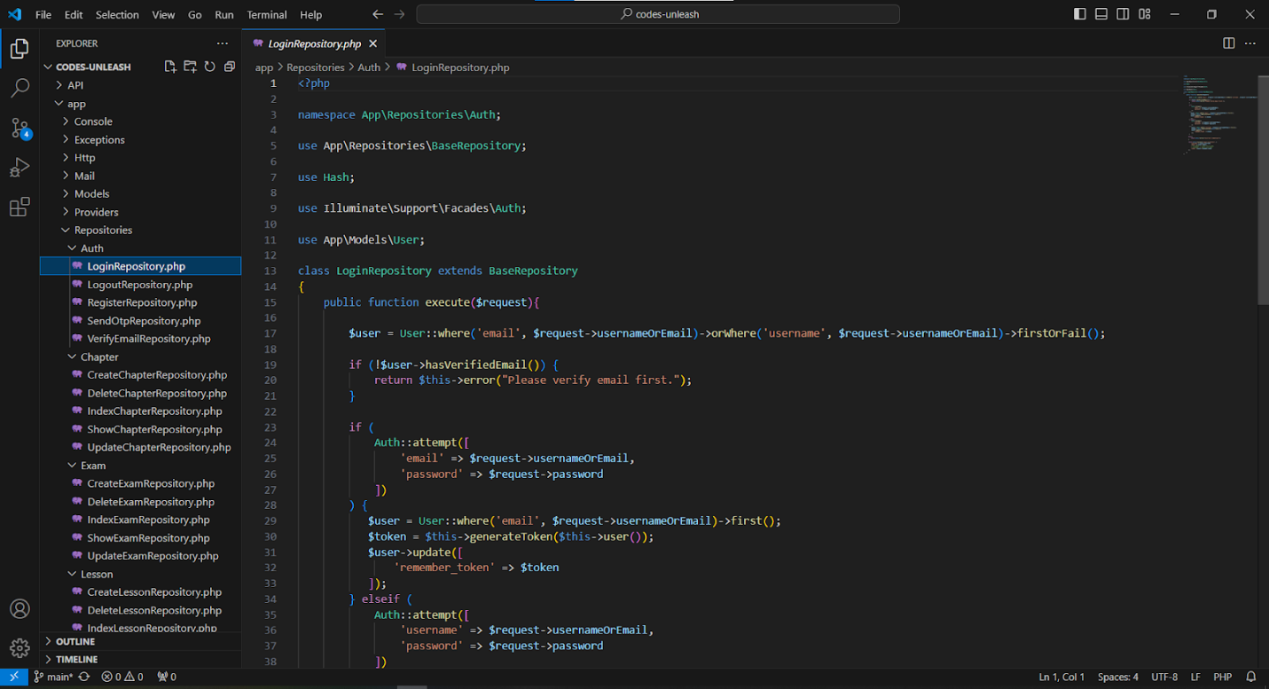Authentication
* 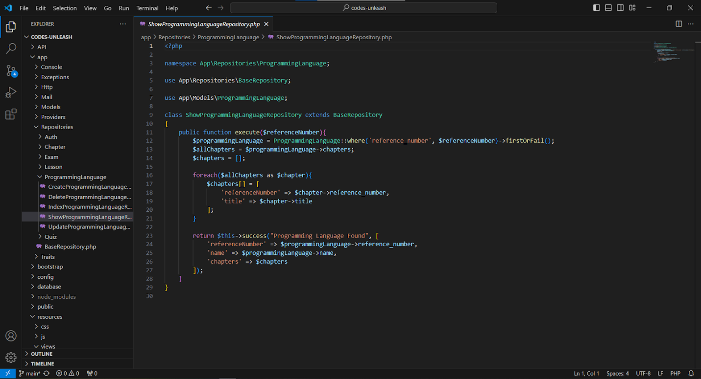Programming Language
* 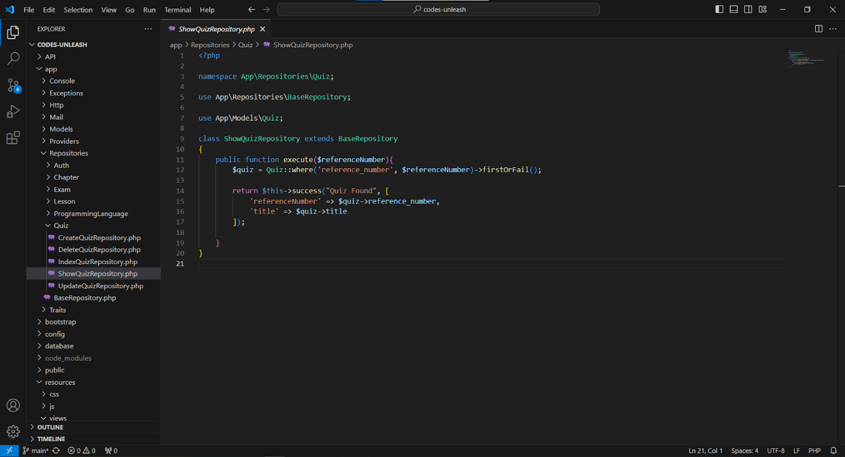Quiz
* 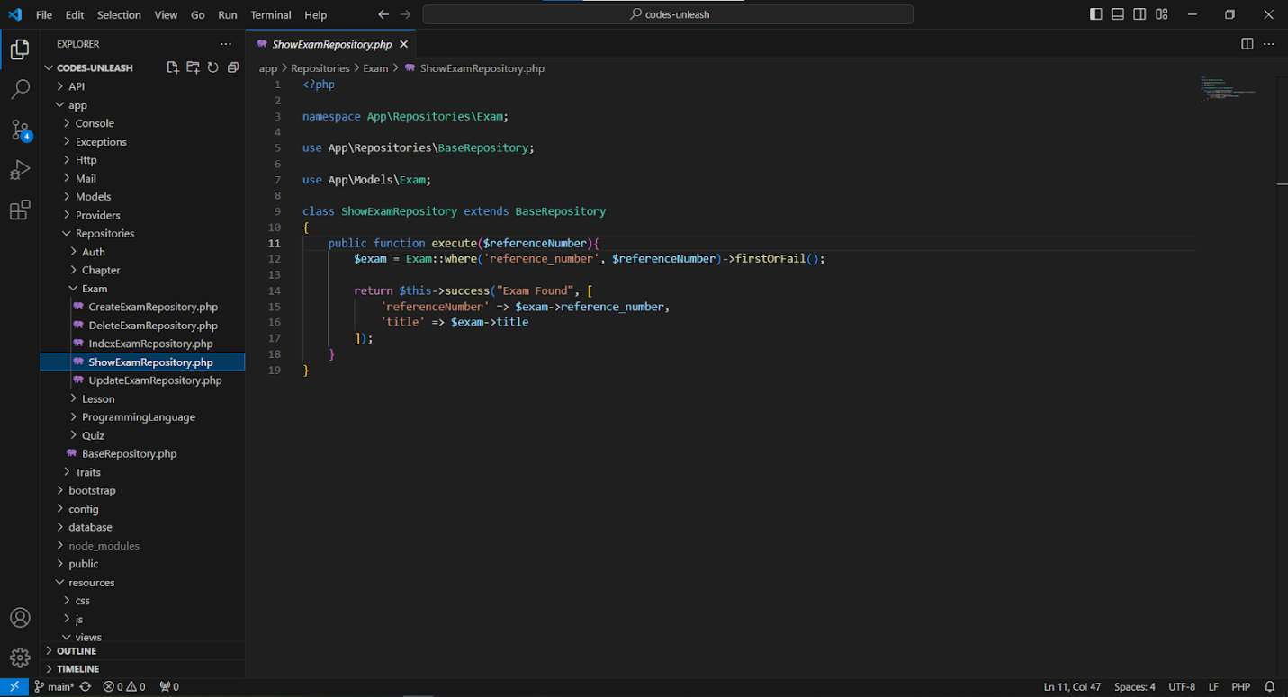Exam

## **Appendix B Evaluation**

* 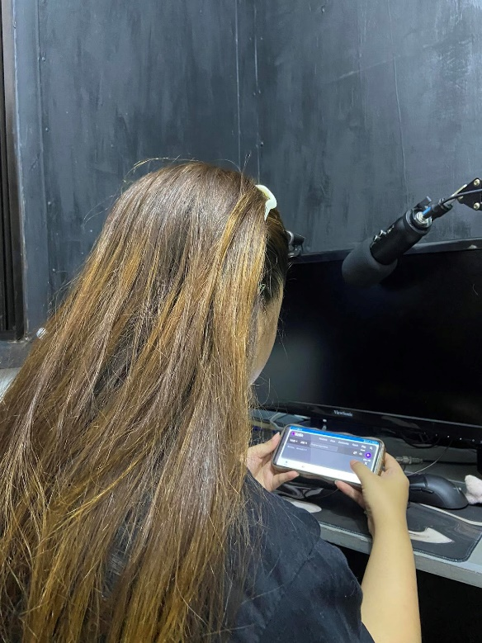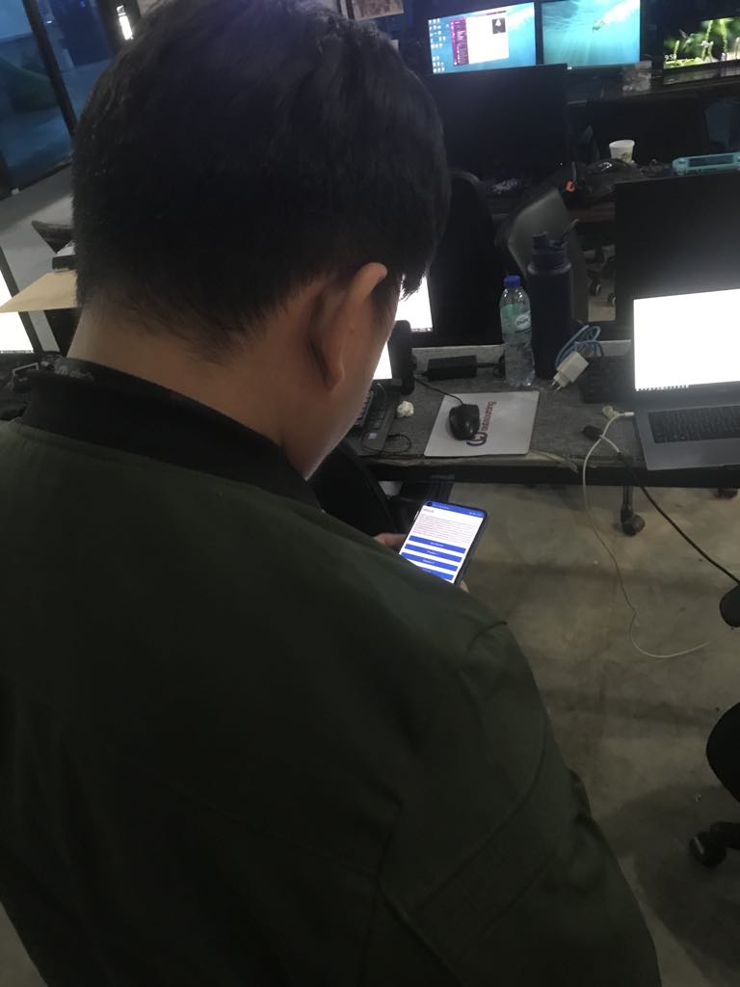Alpha Test



## **Appendix C User’s Manual**

User's Manual for Codes Unleash Application

Welcome to Codes Unleash, your go-to application for learning Kotlin programming language! This manual will guide you through the various features and functionalities of the application to ensure you make the most out of your learning experience. Codes Unleash is designed to provide a comprehensive and interactive learning experience in Kotlin programming. Explore the various features and embark on your journey to mastering Kotlin with Codes Unleash!

1. Getting Started

Upon opening the application, you will land on the main page. Here, you have the option to either log in if you're an existing user or sign up if you're new to the application.

* 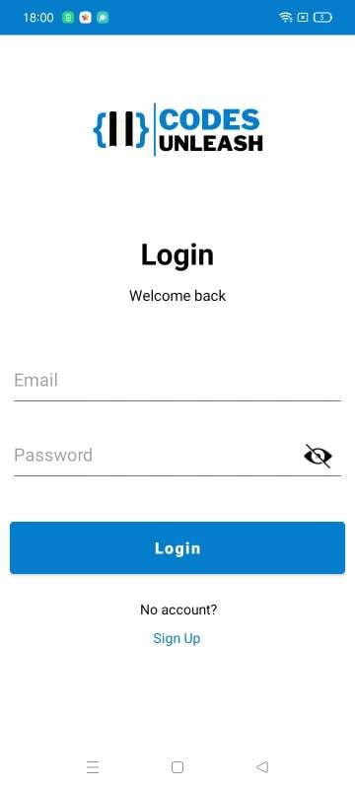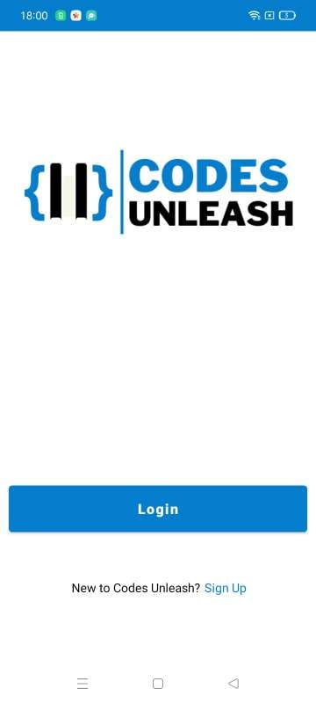Log In: If you're an existing user, enter your registered email and password. You have the option to show or hide your password for privacy. Once done, click the "Log In" button to access the application's homepage.
* 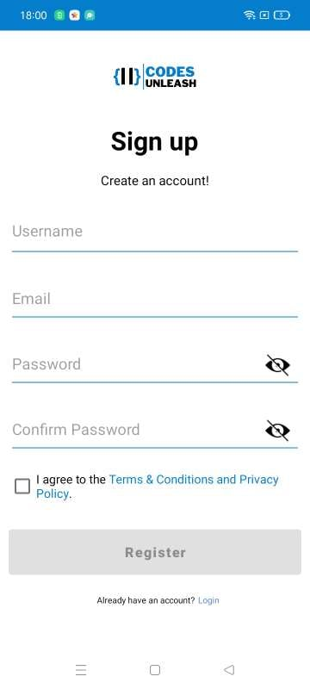Sign Up: New users need to register by providing a username, email, password, and confirming the password. You can choose to hide or show your password. After entering your credentials, read and accept the Terms & Conditions and Privacy Policy by checking the respective checkbox. Click the "Register" button to proceed. An email with a verification code will be sent to your provided email address. Enter the code received to verify your email and access the application's homepage.

1. Application Navigation
   * 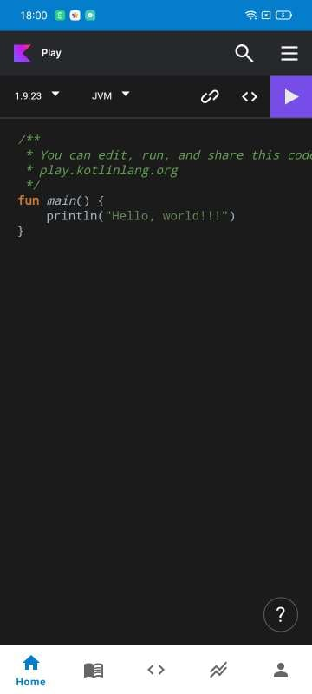Home: Once logged in, you'll arrive at the homepage. Here, you can utilize the application's compiler to practice Kotlin code.
   * Lessons: Go through the introduction and the different chapters composed of Kotlin programming language, following each procedure in order and finishing each lesson before going on to the next. For better understanding and proficiency with Kotlin principles of programming, each lesson includes multimedia content, sample code snippets, and thorough explanations.

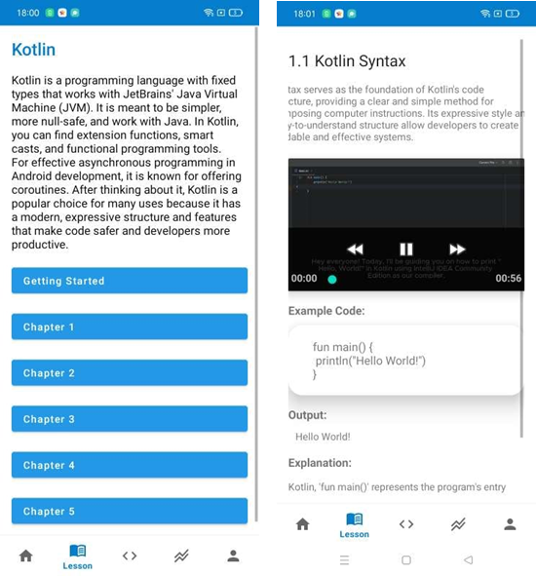

* + 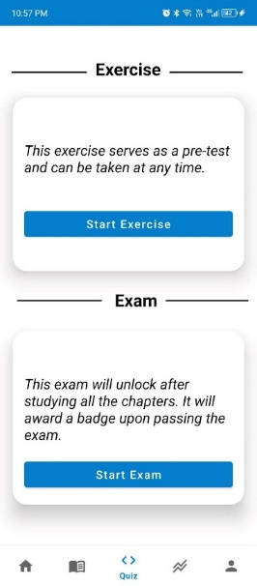Quiz: Access exercises and exams to test your knowledge. Exercises which are the chapter assessments and take exams to earn badge upon completing the tutorial.
  + 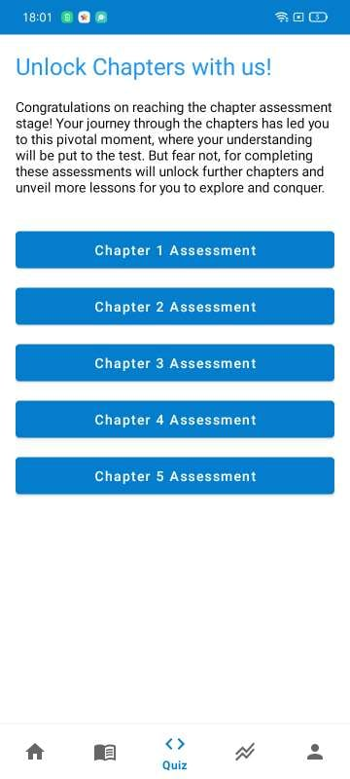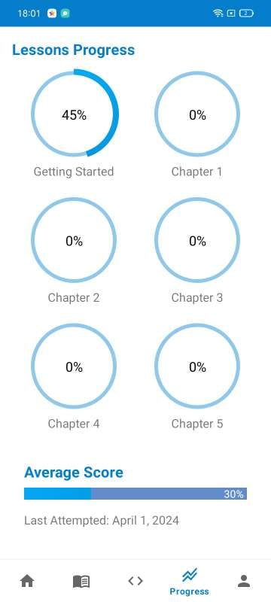Progress: Track your progress throughout the tutorial, view your score, and check when you last accessed the application.
  + 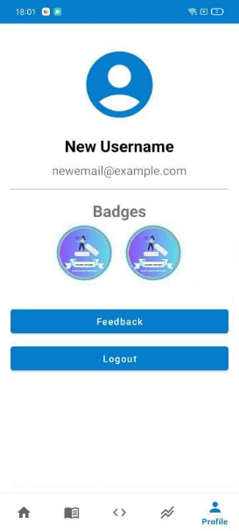Profile: Manage your profile. Change your profile picture, view your username, and see the badges you've earned. Additionally, provide feedback via the feedback button, which directs you to a Google Form created by researchers. Use the log-out button to securely log out of the application.

1. Important Notes
   * Ensure to use a valid email address during registration to receive the verification code.
   * Complete lessons in order to access later chapters.
   * Utilize the compiler to practice Kotlin code.
   * Take quizzes and exam to assess your knowledge and earn badges.

## **Appendix D Functional Decomposition of Codes Unleash**

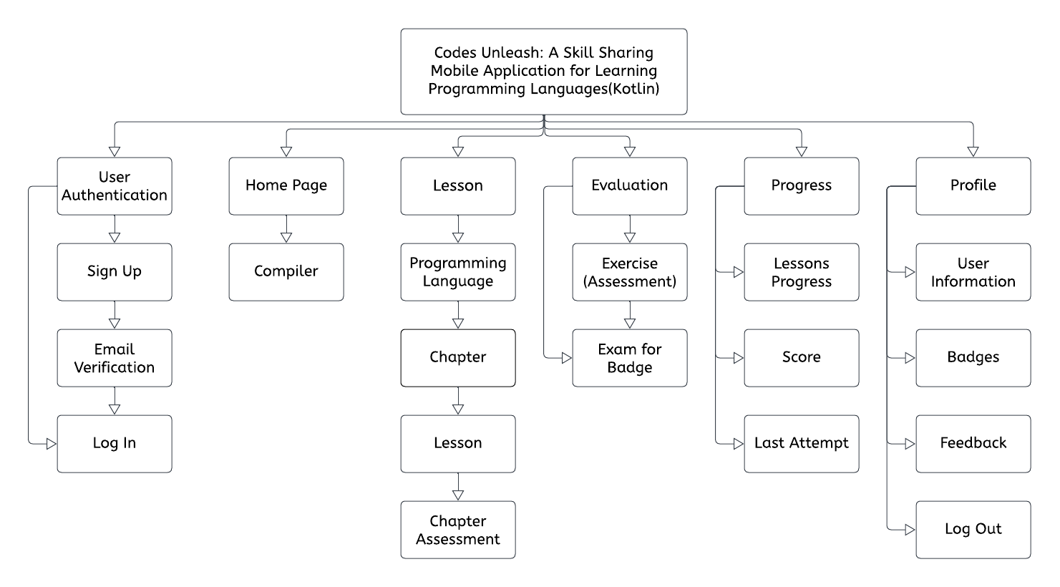

## **Appendix E Design Criterion for Codes Unleash**

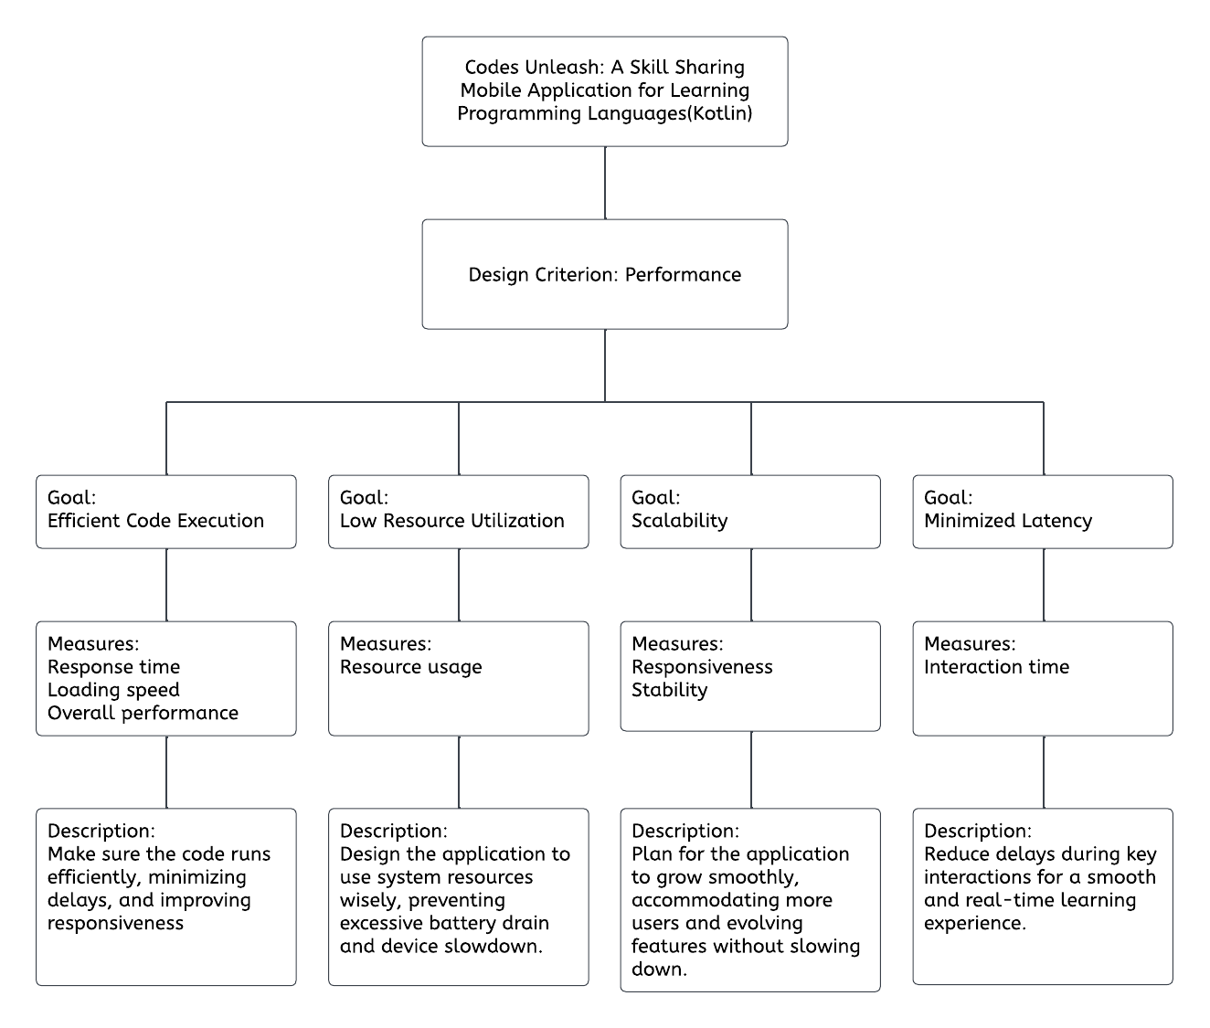

## **Appendix F Presentation of Data Collected**

## **Appendix G Curriculum Vitae**

**Personal Information:**Arvee Andaya Asilo  
12107 Dalandan Street Dau Homesite Mabalacat City Pampanga  
[asiloarvee@gmail.com](mailto:asiloarvee@gmail.com)  
09605607716

Date of Birth:  
Place of Birth:  
Citizenship:  
Sex:  
Age:  
Civil Status:  
Religion:

**Educational Attainment:**2024 Jun  
  
  
2020 Mar  
  
  
  
2018 Apr

January 07, 2002  
Mabalacat City  
Filipino  
Female  
22  
Single  
Roman Catholic  
  
Systems Plus College Foundation (SPCF)  
Information Technology  
Bachelor's/College Degree  
Systems Plus College Foundation (SPCF)  
Technical-Vocation-Livelihood Track:  
Information & Communications Technology  
Senior High School Diploma  
Systems Plus College Foundation (SPCF)  
High School Diploma

**Personal Information:**Liv Basco  
Blk 7 Lot 18 Fiesta Communities Mining Angeles City  
[ccis.liv.basco@gmail.com](mailto:ccis.liv.basco@gmail.com)  
09283567697

Date of Birth:  
Place of Birth:  
Citizenship:  
Sex:  
Age:  
Civil Status:  
Religion:

**Educational Attainment:**

2024 Jun  
  
  
2020 Mar  
  
  
  
2018 Apr

June 26,2002  
Angeles City  
Filipino  
Female  
21  
Single  
MCGI

Systems Plus College Foundation (SPCF)  
Information Technology  
Bachelor's/College Degree  
Systems Plus College Foundation (SPCF)  
Technical-Vocation-Livelihood Track: Information & Communications Technology  
Senior High School Diploma  
Francisco G. Nepomuceno Memorial High School  
High School Diploma

**Personal Information:**Maxene Chanel L. Baylosis  
2040 Oregon St. Villasol Subdivision, Brgy Anunas, Angeles City, Pampanga  
[ccis.maxene.baylosis@gmail.com](mailto:ccis.maxene.baylosis@gmail.com)  
09555820415

Date of Birth:  
Place of Birth:  
Citizenship:  
Sex:  
Age:  
Civil Status:  
Religion:

**Educational Attainment:**

2024 Jun  
  
  
2020 Mar  
  
  
  
2018 Apr

May 07, 2002  
Angeles City  
Filipino  
Female  
21  
Single  
Roman Catholic

Systems Plus College Foundation (SPCF)  
Information Technology  
Bachelor's/College Degree  
Systems Plus College Foundation (SPCF)  
Technical-Vocation-Livelihood Track: Information & Communications Technology  
Senior High School Diploma  
Malabanias Integrated School  
High School Diploma

**Personal Information:**Charles G. Dela Cruz  
93 lanzones street, clarkview subd. brgy Malabanias Angeles City, Pamapanga  
[delacruzcharles071@gmail.com](mailto:delacruzcharles071@gmail.com%20)   
09087733565

Date of Birth:  
Place of Birth:  
Citizenship:  
Sex:  
Age:  
Civil Status:  
Religion:

**Educational Attainment:**

2024 Jun  
  
  
2020 Mar  
  
2018 Apr

July 16 2001  
Angeles City  
Filipino  
Male  
22  
Single  
Roman Catholic

Systems Plus College Foundation (SPCF)  
Information Technology  
Bachelor's/College Degree  
Malabanias Integrated School  
Technical-Vocation-Livelihood Track: Information & Communications Technology  
Senior High School Diploma  
Malabanias Integrated School  
High School Diploma

**Personal Information:**Roy B. Rosima  
Ayson Subdivision, Manibaug Paralaya, Porac, Pampanga  
[rrosima@spcf.edu.ph](mailto:rrosima@spcf.edu.ph)  
09694601841

Date of Birth:  
Place of Birth:  
Citizenship:  
Sex:  
Age:  
Civil Status:  
Religion:

**Educational Attainment:**

2024 Jun  
  
  
2019 Apr  
  
  
2017 Apr

February 11, 2001  
Porac, Pampanga  
Filipino  
Male  
23  
Single  
Roman Catholic

Systems Plus College Foundation (SPCF)  
Computer Science/Information Technology  
Bachelor's/College Degree  
Angeles City National Trade School  
Technical-Vocation-Livelihood Track: Cookery  
Senior High School Diploma  
Angeles City National Trade School  
High School Diploma

## **Appendix H Questionnaire**

