**Stephen Adeniyi SQL Adventures Work Project**

* **Task 1**

The query successfully extracts the first name, last name, and job title of employees.

And the total number of employees is 290.

* **Task 2**

The query returns the ProductID, Product Name, and List Price for each product in the database.

The total product is 504.

* **Task 3**

The query successfully filters orders from 2012. A total order of 3915 was placed in the year 2012.

* **Task 4**

The query successfully retrieves the ProductID, Name, Product Number, and List Price for the 10 highest-priced products.

The top 10 most expensive products are 3000+ in price.

* **Task 5**

The total number of orders placed in the year 2021 is 3915.

* **Task 6**

This query retrieves high-value orders, specifically those with a total due greater than $1500, which are 12,542 in number.

* **Task 7**

This query retrieves products with a list price between $100 and $500, which are 78 in number.

* **Task 8**

This query retrieves customers from a US region, and there are 7,827 in total.

* **Task 9**

This query calculates the total sales amount for each year from 2012 to 2014.

2012 --- 37675700.312

2013 --- 48965887.9632

2014 --- 22419498.3157

* **Task 10**

This query displays the number of orders placed by each customer.

which 28 is the highest, and 1 is the lowest.

* **Task 11**

This query retrieves a list of products that have never been sold, which are 238 in total.

* **Task 12**

This query is to find the total number of employees with the title "Sales Representative," which they are 14 in total.

* **Task 13**

This query is to retrieve the average list price for all products in the "Bikes" category.

which is 1586.737—Bikes

* **Task 14**

This query lists the top 5 customers based on total order amount.   
They are:

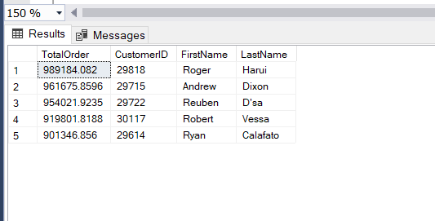

* **Task 15**

The purpose of this query is to show every product that was sold more than fifty times in 2014.

***There are 136 products in total.***