**Peers and children feedbacks analysis**

After the development of the prototype app using Adobe XD, a very complete program for designing and prototyping mobile applications and websites. Our app prototype was not only very realistic, it was also possible to emulate its functioning using the program. Thus, allowing our testers (users) to concretely judge the application content and its functionalities in terms of user interface and user experience.

To this end, two testing sessions were conducted, one with our peers which do not represent concretely the target users and one more representative with the children. The feedbacks were collected using a keyword mapping technique, the users had to choose between 1 and 12 words out of 36 which best represent our application from his/her point of view, placing them on a paper and every time justifying why they chose this word.

Again, the feedbacks collected were qualitative and we decided, firstly, to make an enumeration of the different keywords used and for every one of them, choosing if the word is positive or negative. Secondly, we will go through the feedback and taking out of them the positive and negative aspects of our application with respect to the words list. Finally, with these data, we will analyze how we can improve our applications and which sides specifically by taking in account the feedback and the suggestions.

Below is the compilation of all words used during the 10 peers’ feedbacks on the left column and the 3 children’s feedbacks on the right column. It would have been very useful to have more children’s feedbacks (like 10) as we can really see a sort of tendency in the word used when compiling a certain amount of them. Both columns are sorted by the number of times a word appeared in the different feedbacks. The white lines represent the neutral or positive words whereas the red lines are the clearly negative words. As we can see, the records are rather very positive. Indeed, on both sides (peers and children), our application is described as,

* **Interesting** and **innovative** in the concept.
* **Organized**, **simple**, **clear**, **intuitive** and **easy** in the general usability.
* **Inviting**, **smooth**, **persuasive**, **fresh**, **concise** and **clean** in the design (interface).
* **Useful**, **helpful** and **appropriate** in a general manner for the user.

In the negative aspects, also very useful in term of feedback, our application is described as,

* **Dull** by two feedbacks.
* **Incomprehensible**, **confusing**, **dated**, **overwhelming**, **unattractive** and **unpredictable** by one feedback each respectively.

The negative aspects represent a rather minority with 9 negative words against 145 rather positive (or neutral words), that is to say a 94% of positive denominators against a 6% of negative ones.

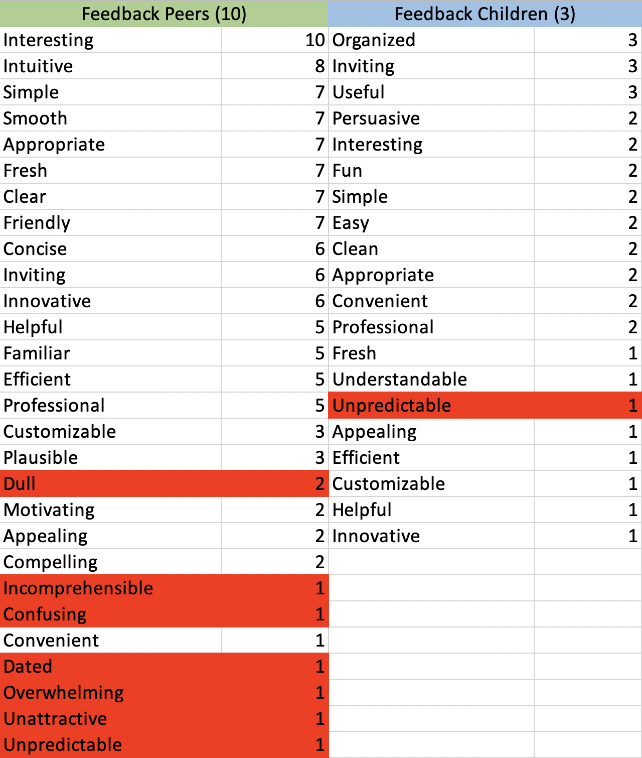

Now comes the associated feedbacks, globally, they have been very positive,

* The graphical interface (the design in general) was much appreciated. It makes the application appealing and push people to try it and play with it.
* The user experience and functionalities were also among the positive aspects. The navigation was described as clear, clean and intuitive. Apart from some functionalities like finding a friend which was more difficult to find and the settings for which the access is described as unpredictable, the other functionalities were very user-friendly.
* A lot of feedbacks pointed out the usefulness of the applications and the educative aspect which can be revealed as very helpful for children. Quite surprisingly, even though our idea seemed unclear at the beginning, it is now accepted as an original and very interesting concept and above all, potentially very useful for the users.
* The negative feedbacks, particularly the fact that the application is described as dull, overwhelming and unattractive, comes from the educative aspect which somehow killed the game aspect and thus lead to a potentially boring application. Concerning, the dated aspect, it was pointed out due to the fact that nowadays, the internet offers hundreds of other possibilities for learning: MOOC, YouTube documentaries… which can be more interesting than reading texts on an app.

Finally, the interesting suggestions given by the users were the following,

* Refactoring the way information are presented about the famous personages. The long texts are described as boring and not inviting, we should rather put some key facts. In the same idea, a user suggested the implementation of quizzes about the personages to reinforce the game and the educative aspects at the same time. Moreover, another user suggested the implementation of videos (small documentary) instead of texts for each famous personage.
* In terms of usability, the possibility of having a tutorial at the beginning of the app would be really useful. A more minor suggestion was about adding the possibility to order our personages by rarity, name, dates…
* Last but not least, a commentary, which was already made during the questionnaire in the last paper prototypes concerns the facial recognition. It seems that users tend to find it unpredictable as they don’t really understand how it could compare their faces with the one of actual famous personages. Even if this functionality is part of the DNA of the app, it is true that maybe some refactoring and improvement should be made on this part as it seems still unclear for the users how the facial recognition really works.