Homework 1

**Stefan Weber**

**Introduction to Signal and Image Processing**

**March 18, 2020**

# Fourier Transform



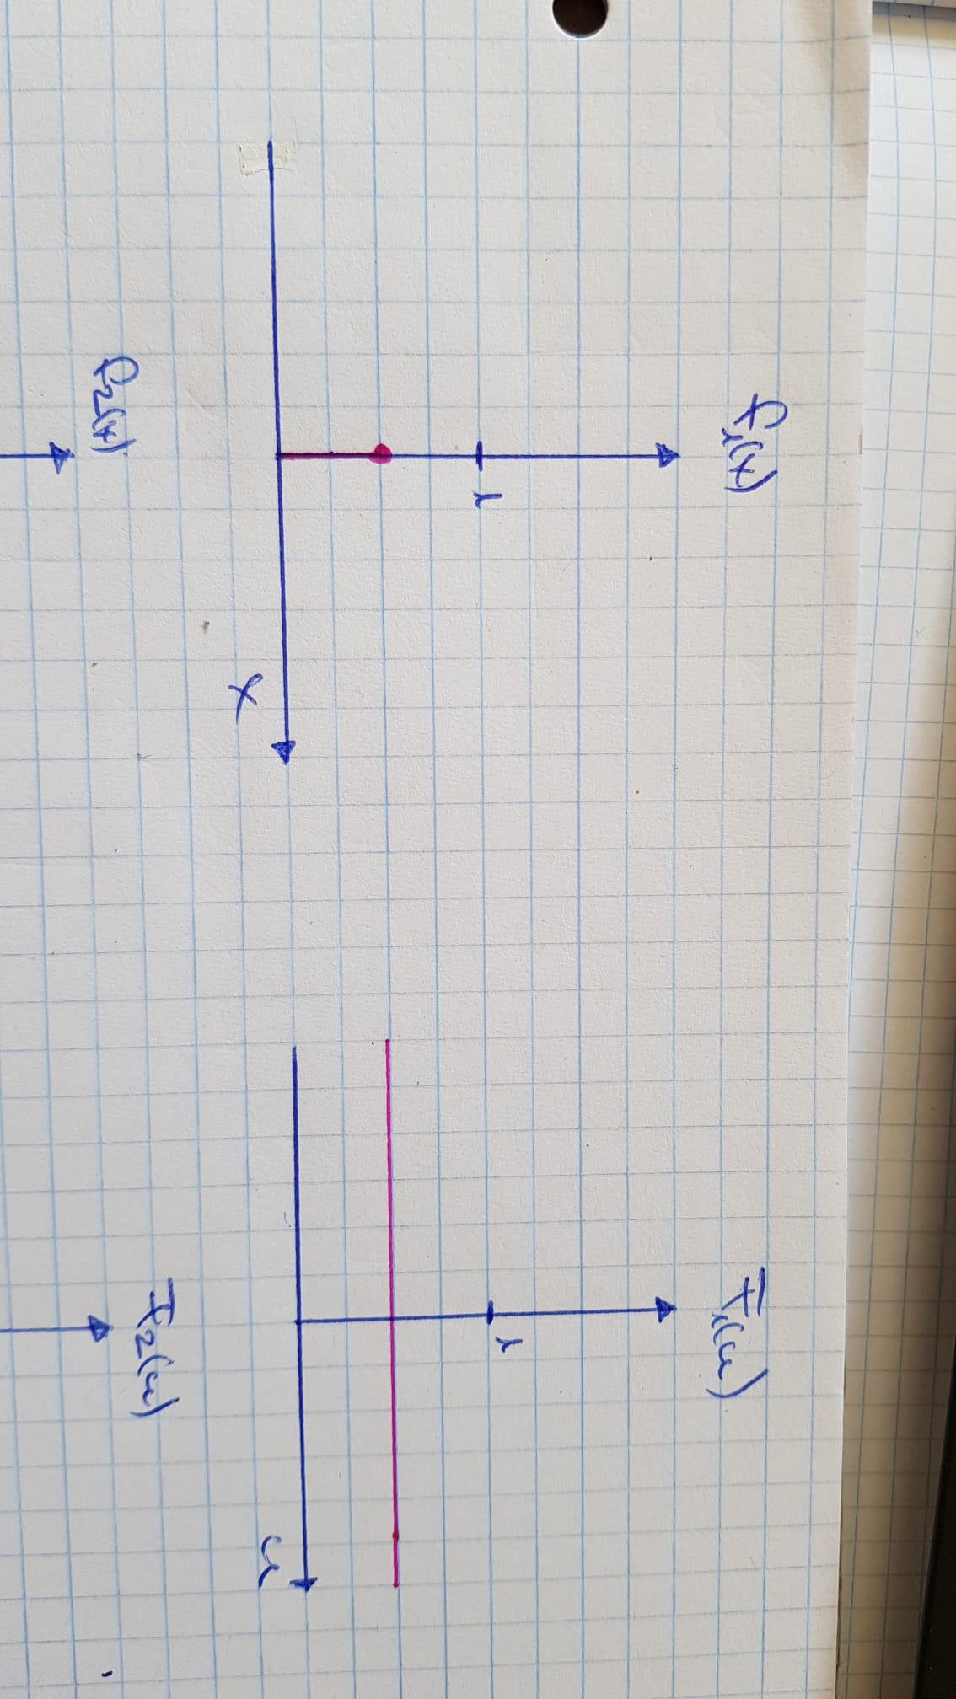

Figure 1: Sketch of the solution with an impulse function in the time and the frequency domain



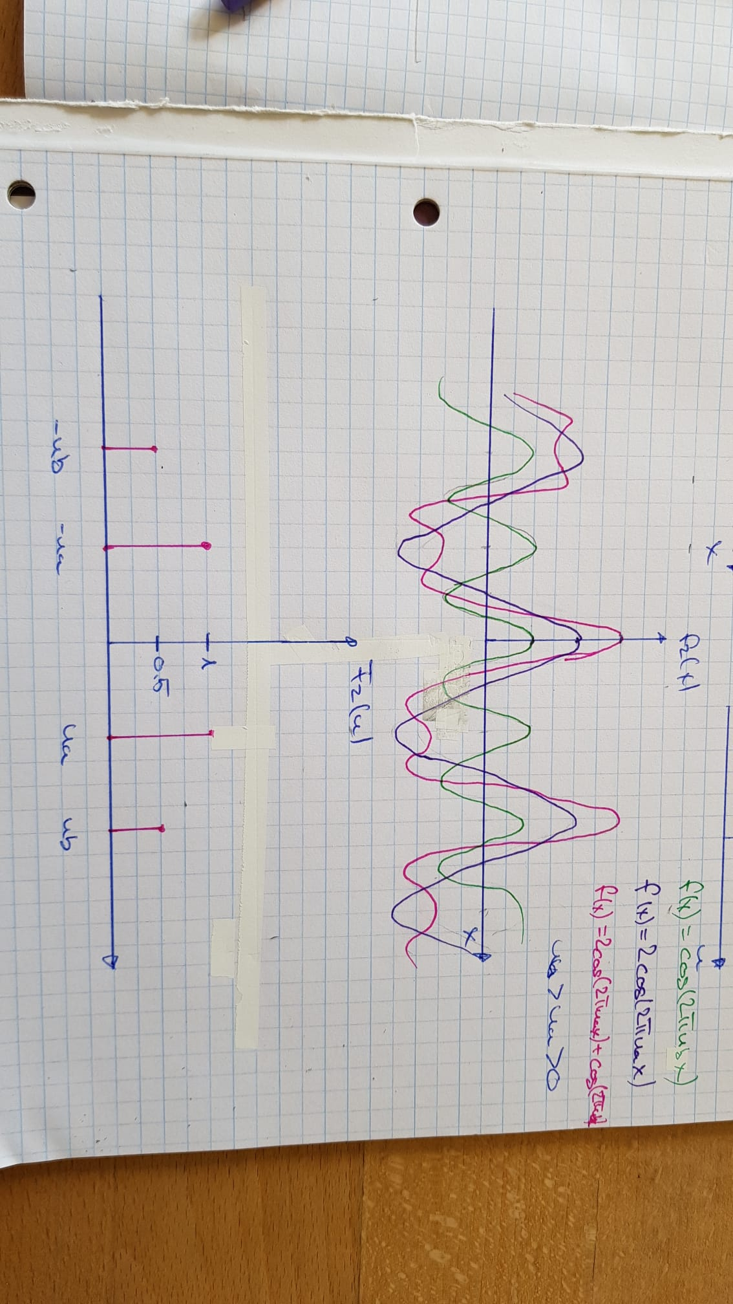

Figure 2: Sketch of the solution with two overlaid cos functions in the time and the frequency domain.

# Lloyd-Max quantization



The only step of the sum with  :



To get the minimum:



















The only step of the sum with  :



To get the minimum:











Random initialisation:



First iteration with random values:





Second iteration with the values from the first iteration:





 will converge to 0.5.  will converge to 0.25 and  will converge to 0.75

# Chamfer distance maps

To generate the chamfer distance maps the neighbouring pixels approach was used. The distance was calculated with the L-norm.

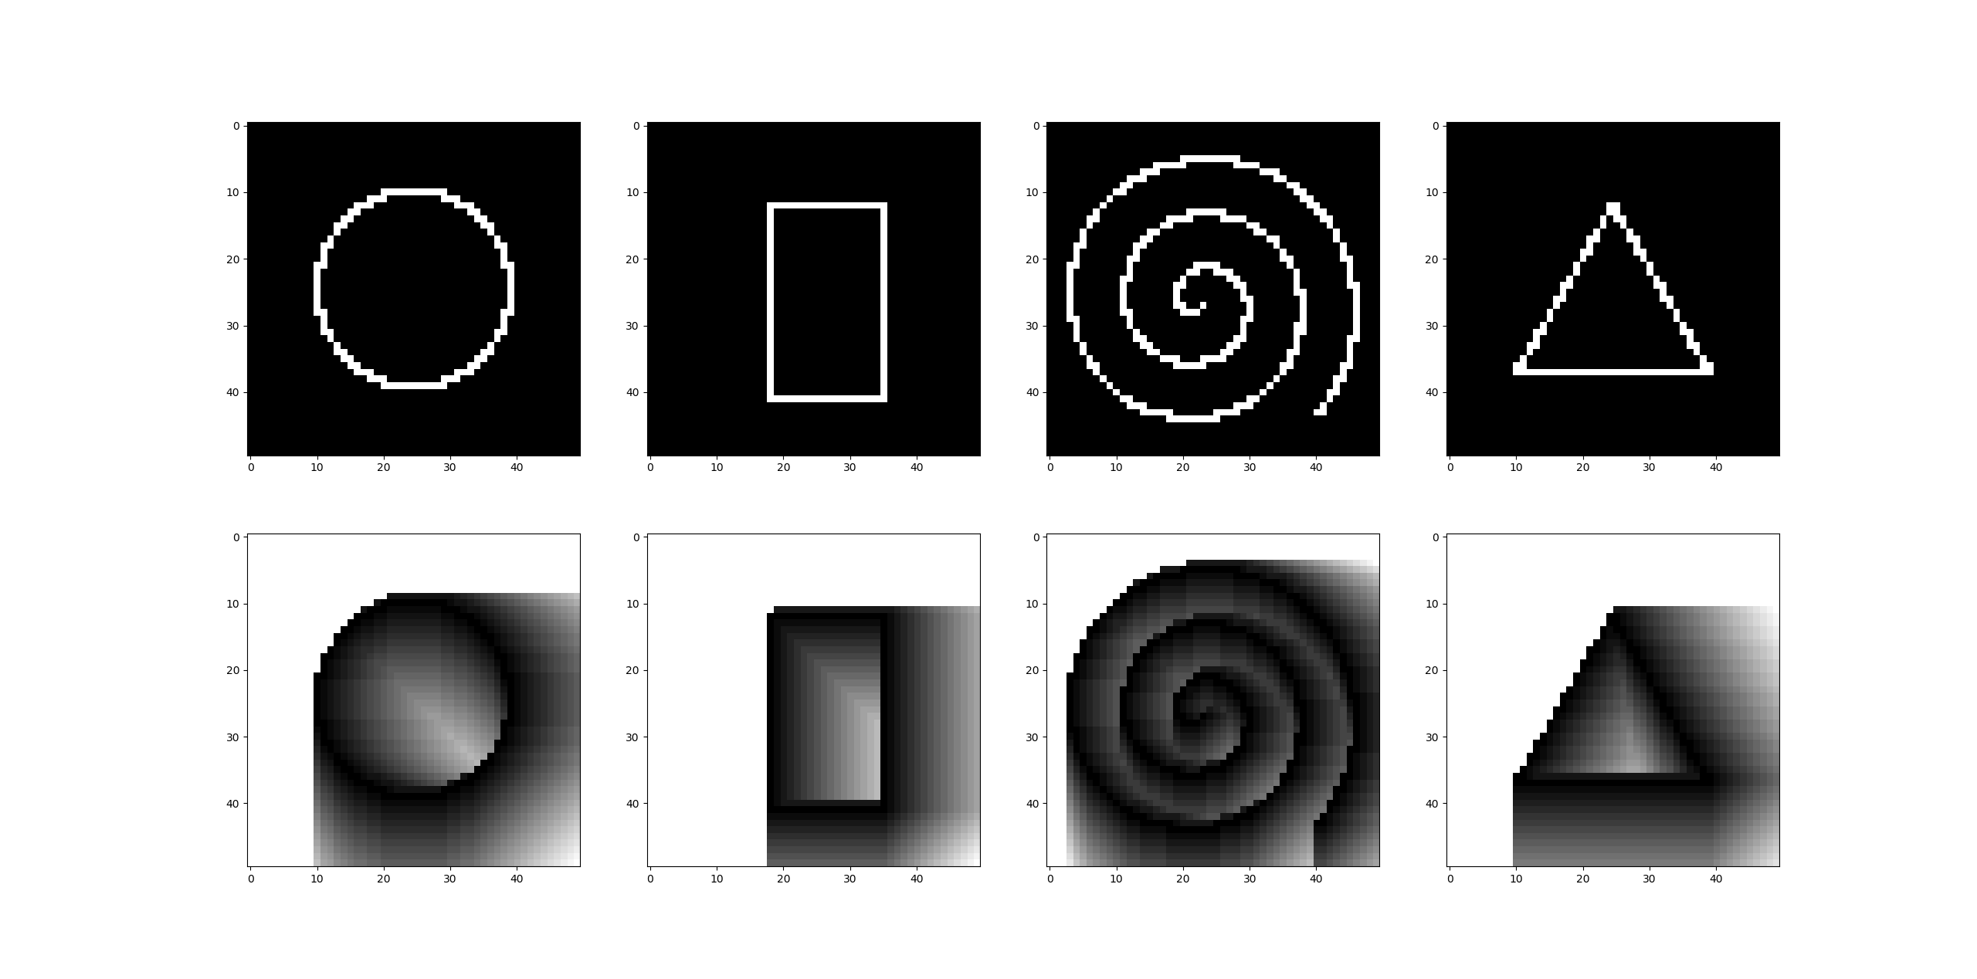

Figure 3: Upper row shows the shapes and the lower row shows the distance map of the respective shape after the first pass.

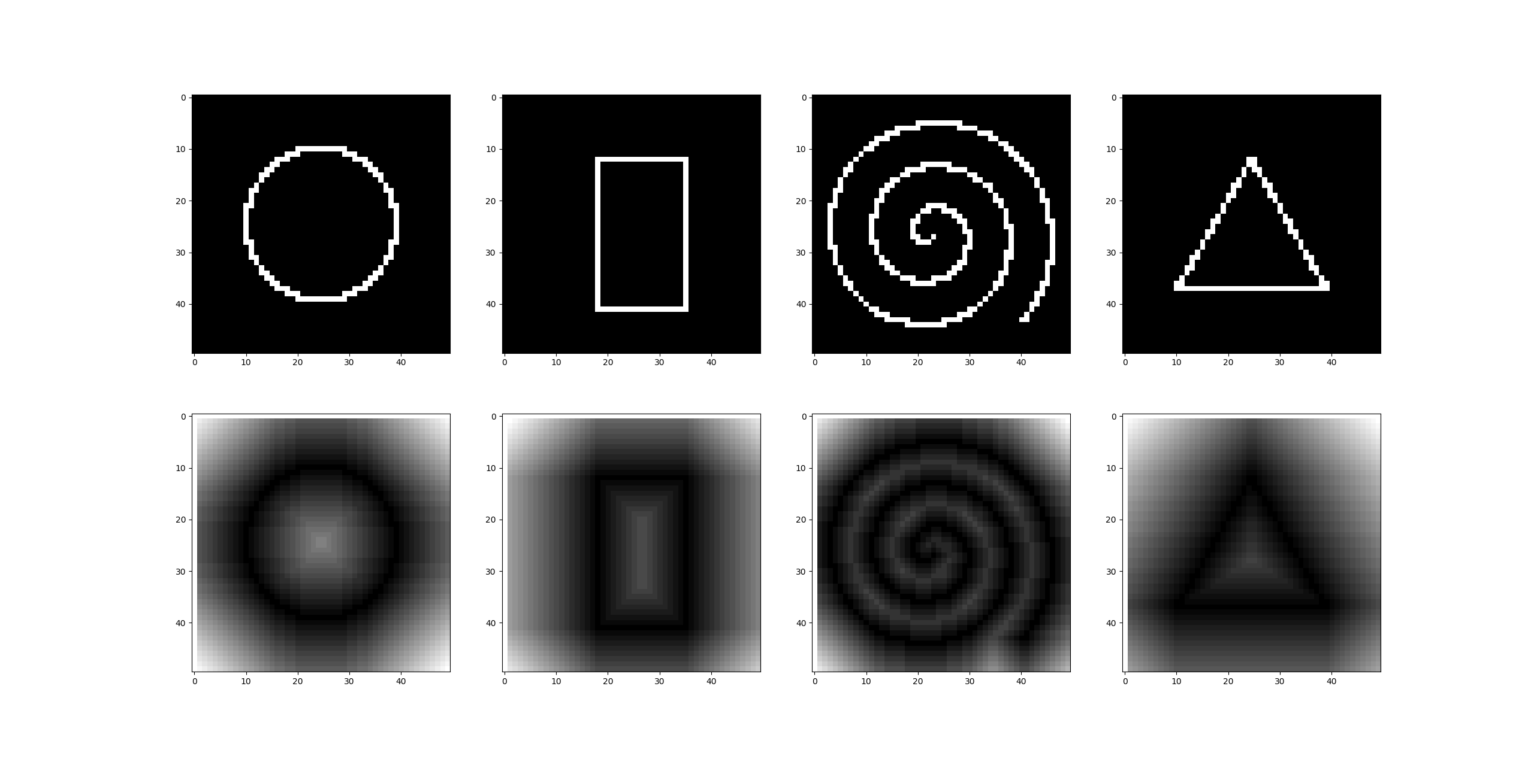

Figure 4: Upper row shows the shapes and the lower row shows the final distance map of the respective shape

# Bilinear interpolation

The graphics in the following section explains what the parts of the code are doing.

## Linear interpolation

The linear interpolation can be used to extract a new data point from a discrete sampled signal and to resample the signal with more or less values as before.

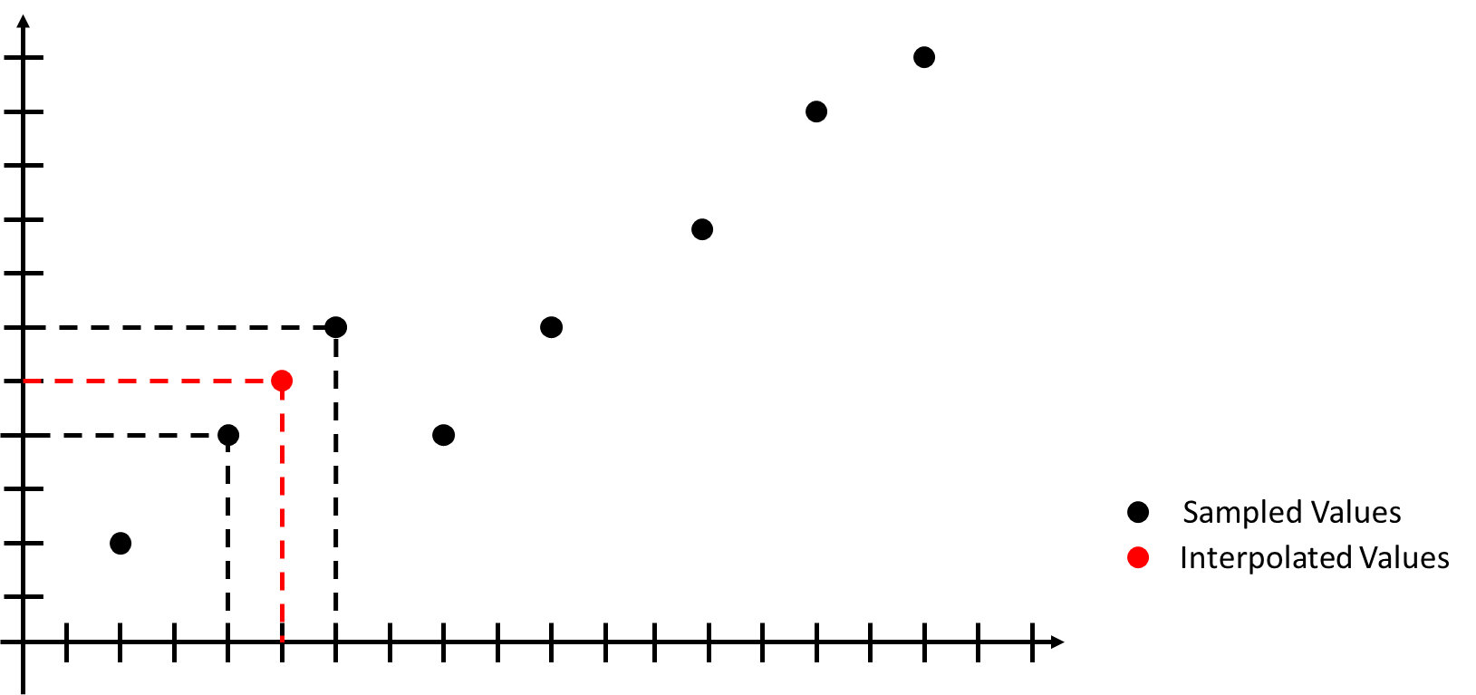

Figure 5: Linear interpolation on a given x-value

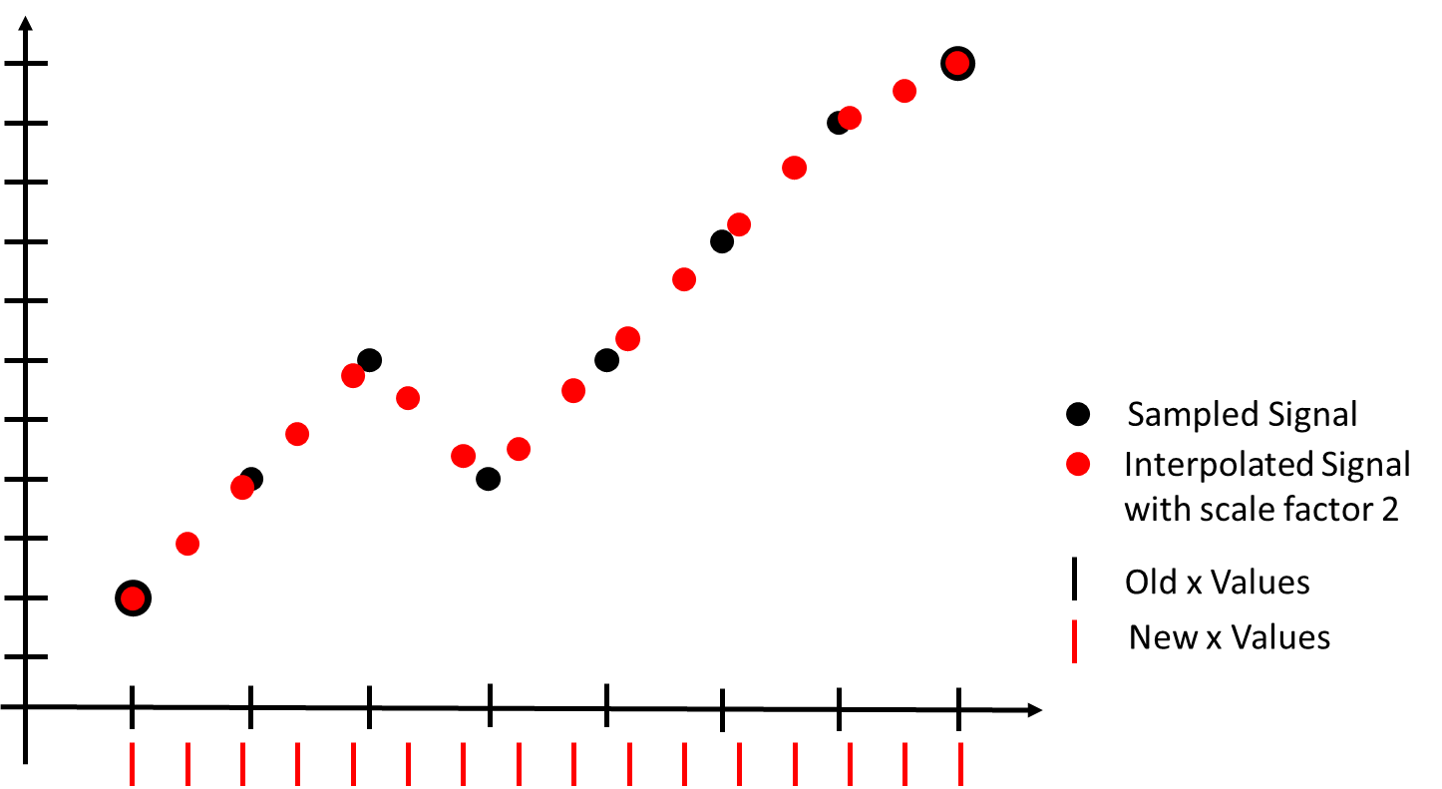

Figure 6: Linear interpolation of a signal with a given scale factor

## Bilinear interpolation

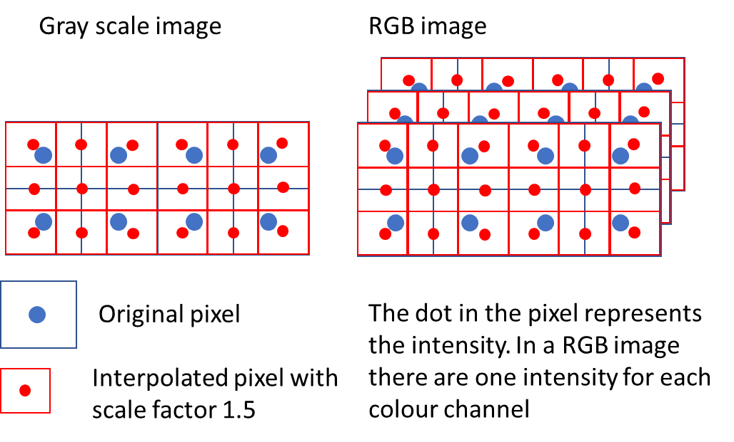

Figure 7: Graphical illustration of a bilinear interpolation in a grayscale image and in a RGB image.

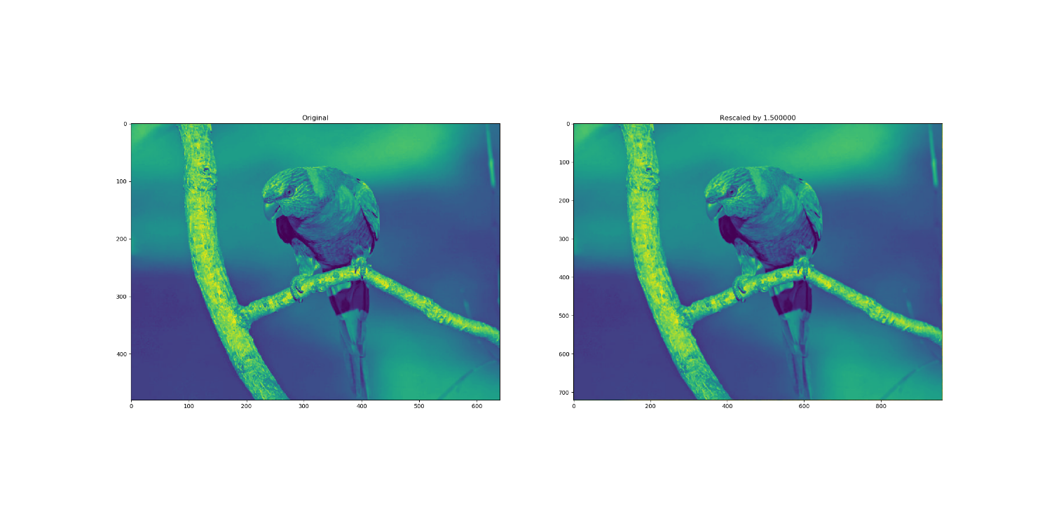

Figure 8: Left shows the initial grayscale image and right shows the rescaled grayscale image by a scale factor of 1.5.

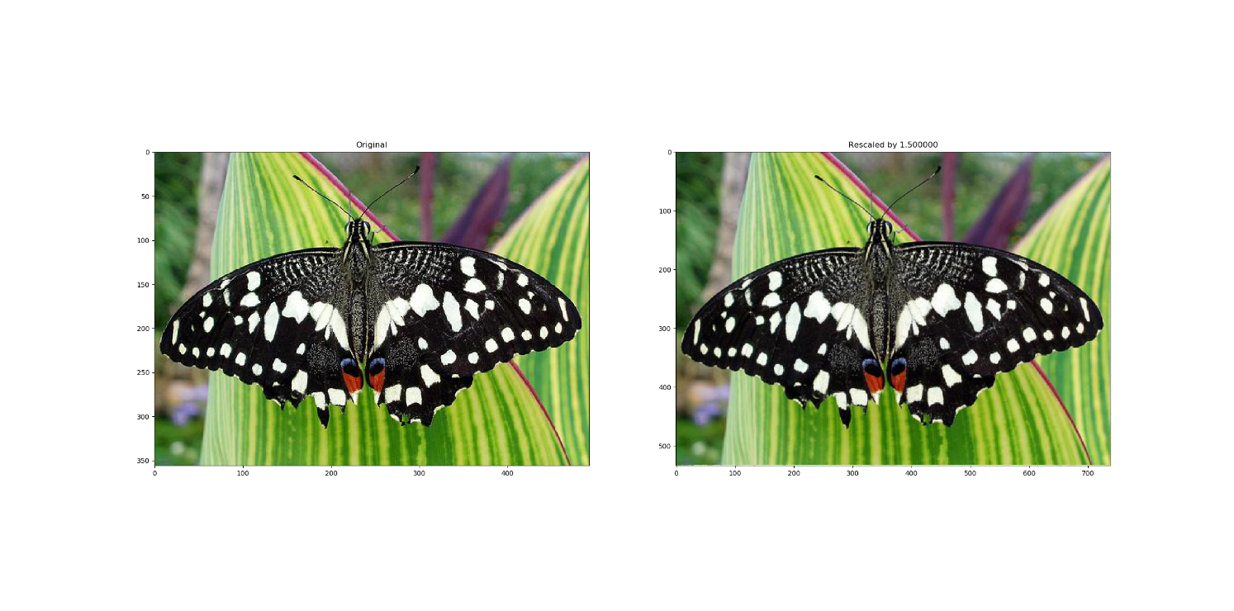

Figure 9: Left shows the initial 3 channel RGB image and right shows the rescaled 3 channel RGB image by a scale factor of 1.5.