Exam Project Description
This exam project provides an overview of various QA testing practices and demonstrates the practical, everyday use of tools, frameworks, and methodologies. It serves as a representation or a shallow dive into common challenges encountered in QA.

1. Mock Frontend (React + Vite)
A simple user interface was created using React and built with Vite. This UI simulates client-side usage of the Unix timestamp conversion API.

2. API Testing with Cypress
Cypress was used to write modular, maintainable API tests, covering:
- For the purpose of this exam positive, negative and edge cases were created
- Also provided re-usability of util functions and cypress commands

3. UI End-to-End Testing with Cypress
Cypress also covers full end-to-end testing through the React UI. Cypress-mochawesome
reporter was utilized to create test reports as a preparation for CI/CD.
- E2E tests were constructed with scalability & maintainability for larger QA operations.

4. Performance Testing with k6
A minimal k6 test script was created to simulate concurrent load on the API. Due to the remote
nature of tested API only minimal performance test was created for validate low to medium load.
Test results help validate API responsiveness and reliability under load.
Configuration:
- Virtual users (VUs) simulate real-world concurrent access
- Measured metrics include:
  - Latency, Throughput, Error Rate

Test Strategy and Recommendations

Scaling Test Automation
- Tests are modular and organized by type (API, UI, performance)
- Reusable utilities and data-driven tests support scalability across services

Avoiding Flaky Tests
- Use of Cypress's built-in retry mechanism
- Network requests intercepted and controlled via cy.intercept

Test Coverage Balance
- Focus on API tests for logic validation and edge coverage
- UI tests cover critical user flows only, to minimize test runtime and flakiness
- Performance tests ensure baseline responsiveness

API Improvement Suggestions
- Include an OpenAPI/Swagger specification for better integration and testing
- Introduce versioning for long-term maintainability

How to Run

1. Install Dependencies
npm install
install k6 depending on used OS (https://grafana.com/docs/k6/latest/set-up/install-k6/)

3. Run React.js
To open Cypress in interactive mode:
npm run build
npm run dev

3. Run Cypress Tests
To open Cypress in interactive mode:
npx cypress open
To run tests headlessly: (reports will be generated during headless run)
npx cypress run

4. Run Performance Tests with k6
k6 run performance/perf-test.js

CI Approach:
The Continuous Integration (CI) approach involves creating a GitHub Actions job that will support both daily QA activities for feature testing and periodic regression testing. This workflow will be defined within the appropriate repository, where all code will undergo peer review through pull requests. Test artifacts, such as reports, will be archived after each run and optionally integrated with project management tools like JIRA or Trello as part of the ticket completion process.

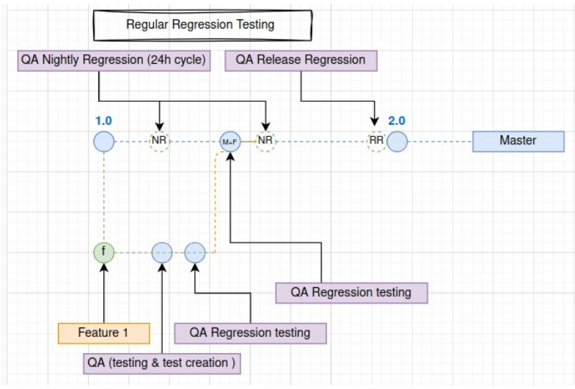

Test Plan:
Used ACC model for short identification of functionality and start of QA process. (ACC) refers to the ability of a software component or module to exhibit specific attributes or functionalities as intended. It involves validating that each component meets defined requirements, behaves correctly under various conditions.

ID | Attribute | Components | Capabilities
AC1 | Valid Date String to Unix | 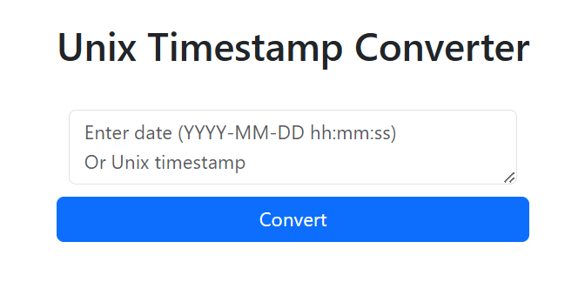 | User can input a valid date string and see the correct Unix timestamp returned
AC2 | Valid Unix to Date String |  | User can input a valid Unix timestamp and see the correct 12-hour datetime string returned.
AC3 | Invalid Input |  | Invalid input (non-date, non-timestamp) results in an appropriate error message.
AC4 | Empty Input | 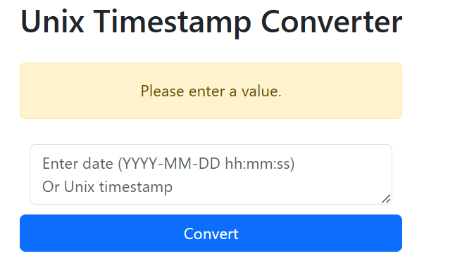 | Empty input triggers alert without making a backend API call.
AC5 | Backend Interception |  | API call to backend is made correctly on valid inputs.
AC6 | Alert Messaging | 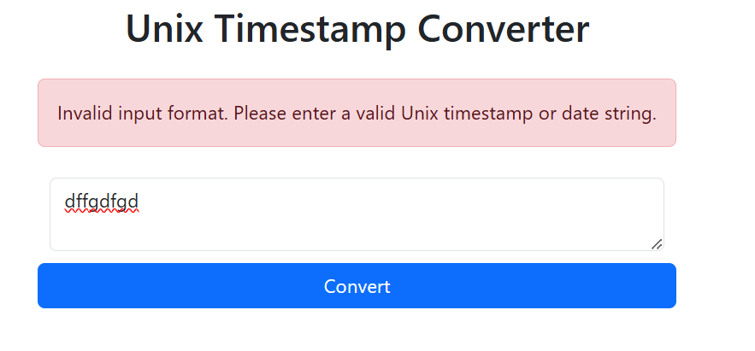 | Alerts correctly show success/failure messaging based on input.

Test Coverage Matrix:
Shows in practice what functionality is covered with witch test.
Test Case ID | Description | Covered ACs | Method
TC1 | Convert valid datetime string to Unix timestamp | AC1, AC5, AC6 | it('converts valid datetime string to Unix timestamp')
TC2 | Convert valid Unix timestamp to 12h datetime string | AC2, AC5, AC6 | it('converts valid Unix timestamp to datetime string')
TC3 | Handle invalid input (non-date, non-timestamp) | AC3, AC5, AC6 | it('shows false for invalid input')
TC4 | Handle empty input, show alert, no API call | AC4 | it('shows alert message for none input')

Risk identification matrix:
Following table and visual representation of identified risk in tested functionality.

ID | Risk Description | Impact | Likelihood | Risk Level | Mitigation / Test Case
R1 | Valid datetime input does not convert to correct Unix timestamp | High | Medium | High | Covered in **TC1** — validates timestamp conversion from datetime
R2 | Valid Unix timestamp does not convert to correct datetime | High | Medium | High | Covered in **TC2** — validates datetime conversion from timestamp
R3 | Invalid inputs do not show proper error messages | Medium | High | High | Covered in **TC3** — verifies alert for invalid format
R4 | Empty input sends API call or breaks app | High | Medium | High | Covered in **TC4** — verifies no API call on empty input
R5 | API call fails silently (no alert shown) | Medium | Medium | Medium | Partially covered in **TC1–TC3**, but no direct simulation of API failure
R6 | API endpoint changes or is unreachable | High | Low | Medium | Not explicitly covered — suggest mocking failure response
R7 | Incorrect success/failure alerts shown | Medium | Medium | Medium | Covered in all test cases — alerts checked after action
R8 | Timezone mismatch in displayed date/time | Medium | Low | Low | Out of scope — not currently tested
R9 | Inconsistent behavior across browsers | Medium | Low | Low | Out of scope — cross-browser testing not included
R10 | Input format changes break conversion | High | Medium | High | Indirectly covered — assumes format compatibility via utility functions

