Access Version checker

This program was created to create an overview of all the access databases on network shares. I did not want to open them 1 by 1 to check them for compatibility.

The program only works with mdb files. Since accdb files are always compatible with access versions 2016+

The program shows:

* The database name
* The person that created the database
* The internal access version of the database
* The file format of the database this is based on the previous access version.
* If the database is compatible with the selected version (currently only access version 2016 is supported)

And then some basic windows properties:

* The date the database was created on
* The Last modification date of the database
* The path where the database is located

The program has 2 ways to add access databases:

1. You can add 1 or more databases manually
2. You can select a text file containing all the access databases

# Add databases manually

1. Press the Add Databases button
2. Select 1 or more mdb databases (use shift for multi select)
3. Press Open

# Read databases from a file

First create a text file by using the dir command:

dir /b /s \\myworkplace.local\*.mdb > c:\temp\files.txt

this will generate the following file:

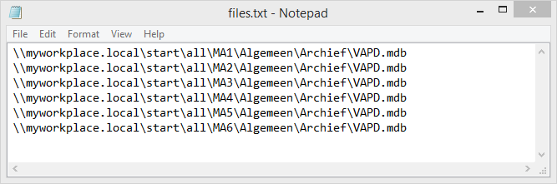

Finally start the program and goto File menu -> Read database paths from file. Select the files.txt file and press open.

The program will start to read the database properties and check the compatibility of each database.

Progress of the task is shown at the lower left corner. The task can be cancelled.

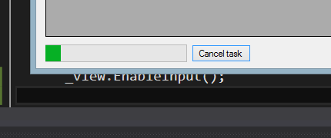

# Errors

# DAO reference not found

This program requires a reference to DAO please install Microsoft Access Database Engine 2010 Redistributable from https://www.microsoft.com/en-us/download/confirmation.aspx?id=13255