Lake Clark
  - Visualizing temperature data
Stef Tasayco
2026-02-27
Table of contents

1. Setup
Using R version 4.5.2 (2025-10-31 ucrt).
Access to download the spreadsheets used for this data can be done in the GitHub repository: https://github.com/StefTasayco/Lake-Trout-AK.git

2. Background
Combinations of different scenarios are being used describe lake trout growth. Each scenario serves as a guide for constructing design profiles with different parameters experienced by the fish being grown in FB4. The goal is to compare the outputs of each of these design profiles to each other and to historical data collected (field observations).
Temperature scenarios:
- Scenario 1: Investigate when 9 C becomes available at each lake (e.g. days 196-215, summer months) and use 9 C for all of those days. For all other days, use surface temperature data. Lake trout assumed to move down in water column in summer to reach 9 C, and stay at surface during winter.
- Scenario 2: By depth bin (e.g. in depth bin 30m, the avg temp = 6.46 C). Must find DOY of when the thermocline is fully set up for that lake. Only summer months modeled for this scenario (not 365 days)
- Scenario 3: Every DOY after ice-on and before ice off set to 4 C. Every other DOY, use surface temperature.
Diet scenarios:
- Scenario a: From literature (Kao et al. 2015) using diet schedule for a full year. Most likely using ages 7-9. Indigestible prey from literature as well.
- Scenario b: 100% benthic (B), 0% prey fish (F) year round. B = 3500 J/g, F = 2256 J/g
- Scenario c: 80% benthic (B), 20% prey fish (F) year round. B = 3500 J/g, F = 2256 J/g
- Scenario d: 60% benthic (B), 40% prey fish (F) year round. B = 3500 J/g, F = 2256 J/g
- Scenario e: 50% benthic (B), 50% prey fish (F) year round. B = 3500 J/g, F = 2256 J/g
- Scenario f: 40% benthic (B), 60% prey fish (F) year round. B = 3500 J/g, F = 2256 J/g
- Scenario g: 20% benthic (B), 80% prey fish (F) year round. B = 3500 J/g, F = 2256 J/g
- Scenario h: 0% benthic (B), 100% prey fish (F) year round. B = 3500 J/g, F = 2256 J/g
Fit to Pmax vs fit to final weight:
- Scenario 𝛂 : Fit to Pmax. Using Fig. 1 from Stewart et al. (1983) .
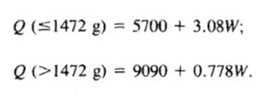
Figure 1: PREDEQ 2 (predator equation 2)- Pmax is set based on fish weight (g). Q = energy density. W = fish weight (g)
- Scenario 𝛃 : Fit to final weight. Final weight = the weight at the next older age from NPS lake trout data.

3. Data

3.1 Plots

3.1.1 Scenario 1
The purpose of scenario 1 is to investigate when 9 C becomes available at each lake (e.g. April 25 - Sept. 5) and use 9 C for all of those days. All other times, (spring, fall, winter) I will use the surface temperature “to approximate surrounding temperature of the modeled fish because larger lakes would be completely homothermous or homothermous to a great depth.”
This approach is used by Kao et al. (2015).
This is consistent with Pazzia et al. (2002), which states that “during the summer, lake trout were assumed to forage in deeper water (closer to 10 C). In winter, they were assumed to forage closer to the surface.
Fig. 2 in Section 3.1 shows only surface temperatures for Lake Clark.
Warning: Removed 271 rows containing missing values or values outside the scale range
(`geom_point()`).
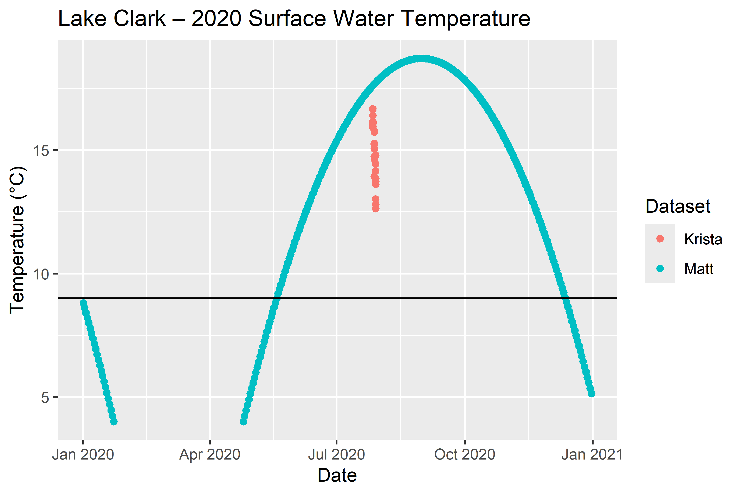
Figure 2: This plot shows all the available surface water temperature data for 2020 in Lake Clark. The year 2020 is used because that is the year that lake trout data was collected. The freeze-up date can be seen at Jan 23rd and the break-up date on April 25th. The black line shows the 9 C cutoff. After mid-May (summer months), it is expected that lake trout will seek to stay around 9 C.
Fig. 3 in Section 3.1 shows temperatures at different depth bins for Lake Clark.
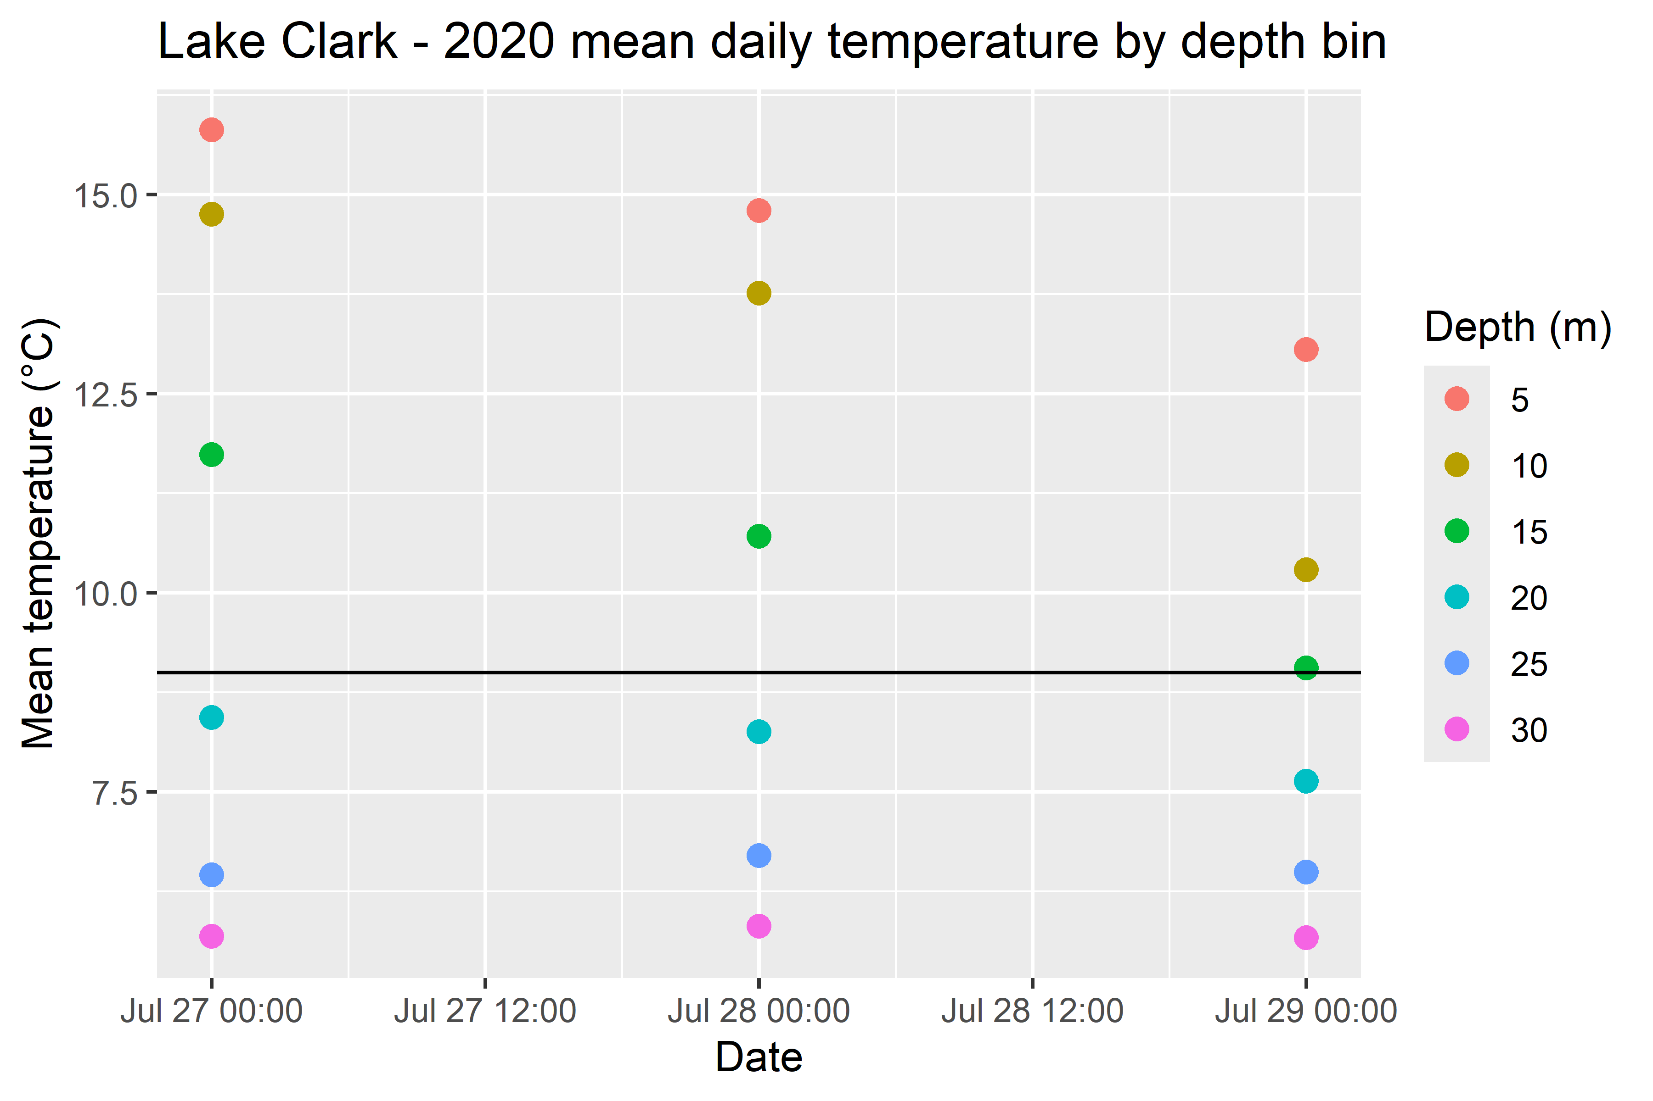
(a) Depth bin 5m is an average of depth bins 1, 2, 3, 4, and 5 m
Figure 3: This plot zooms into Krita’s temp data from the first plot above, and only encapsulates 3 dates in the summer months. Again, the black line shows 9 C and each point is an average daily temperature. The goal was to visualize how far down the sun warms the water to 9 C during the summer. With this information, we can suspect that lake trout will travel down to 20 m below the surface to achieve their preferred temperature.

3.1.2 Conclusion for Scenario 1
I will create a temperature file for Lake Clark using 9 C for days 139 (May 19th) through 346 (December 12th). For all other days, I will use the surface temperature data available for 2020. When ice freezes (Jan 24 - April 24) I will use 4 C.

3.2 Tables
So far, I don’t have any tables to share but if I do, they will be here.

4. FB4 Outputs
Year-long Lake Trout Growth by Age: The following plots show the output of the design profile created using Scenario 1, scenario a, and scenario beta. The fish were fit to a final weight calculated using the weight at the next older age. Finally, the mean of each age of fish was taken, as well as 3 SDs above the mean and 3 SDs below the mean.
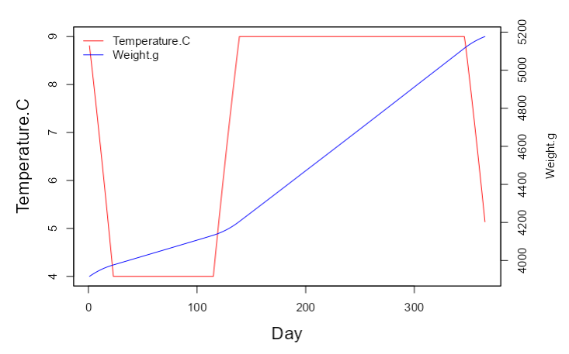
Figure 4: The average yearly growth of the entire cohort plotted with the temperature inputs for 365 days in 2020.
$`Age 12`
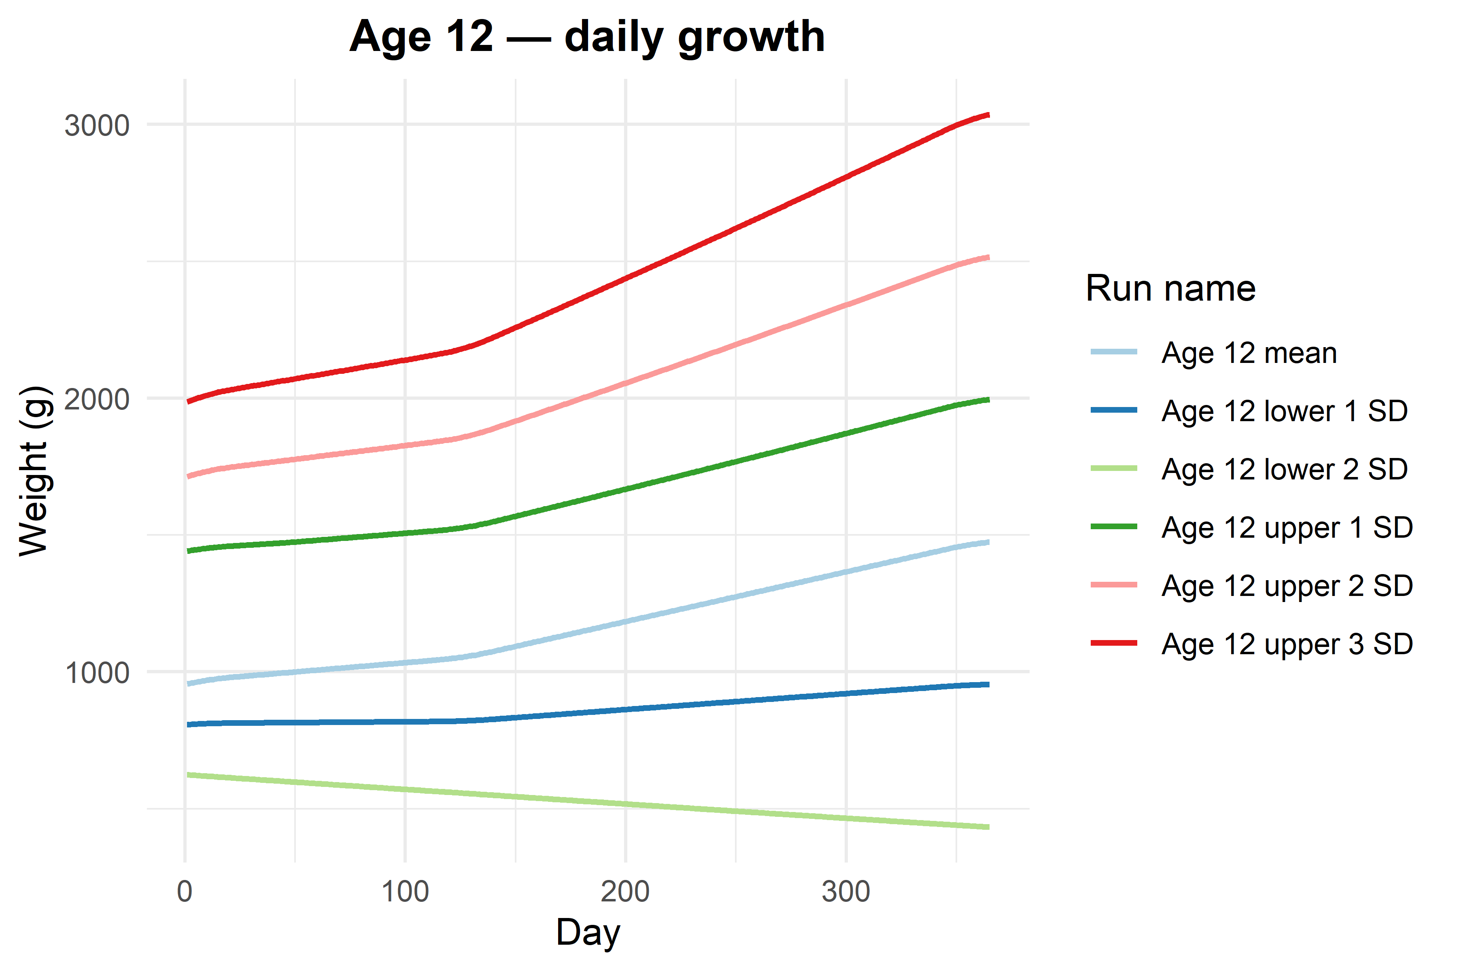
$`Age 13`
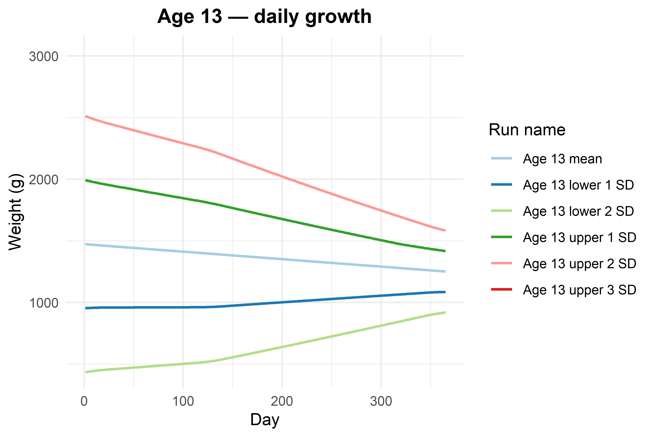
$`Age 14`
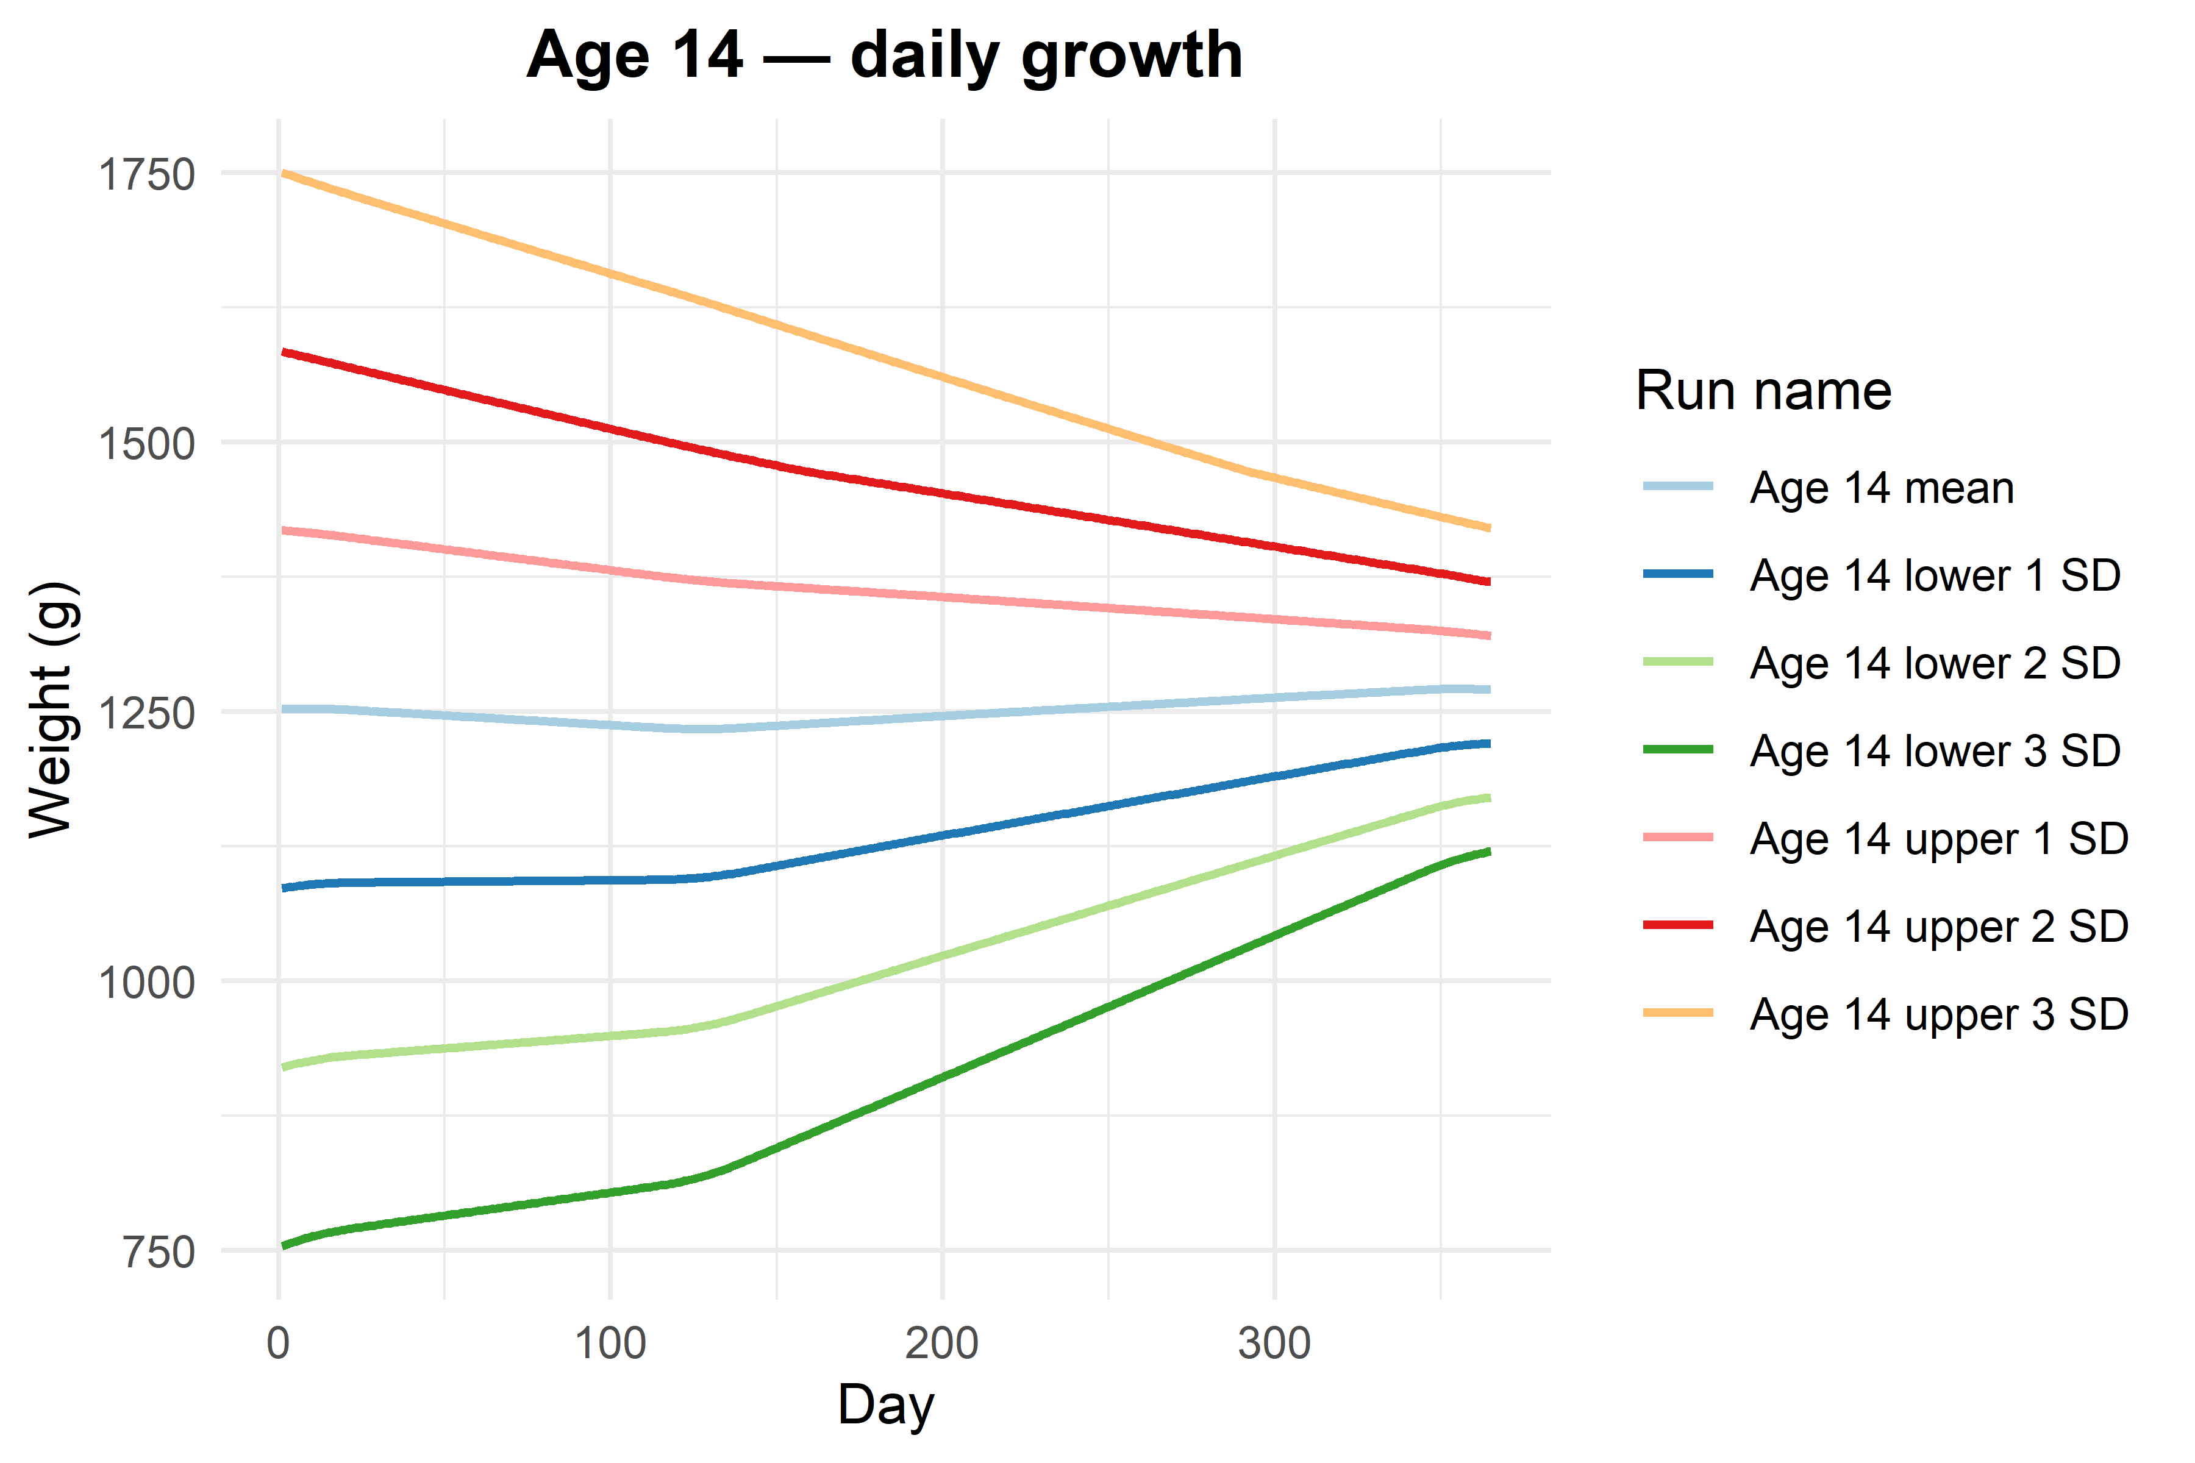
$`Age 18`
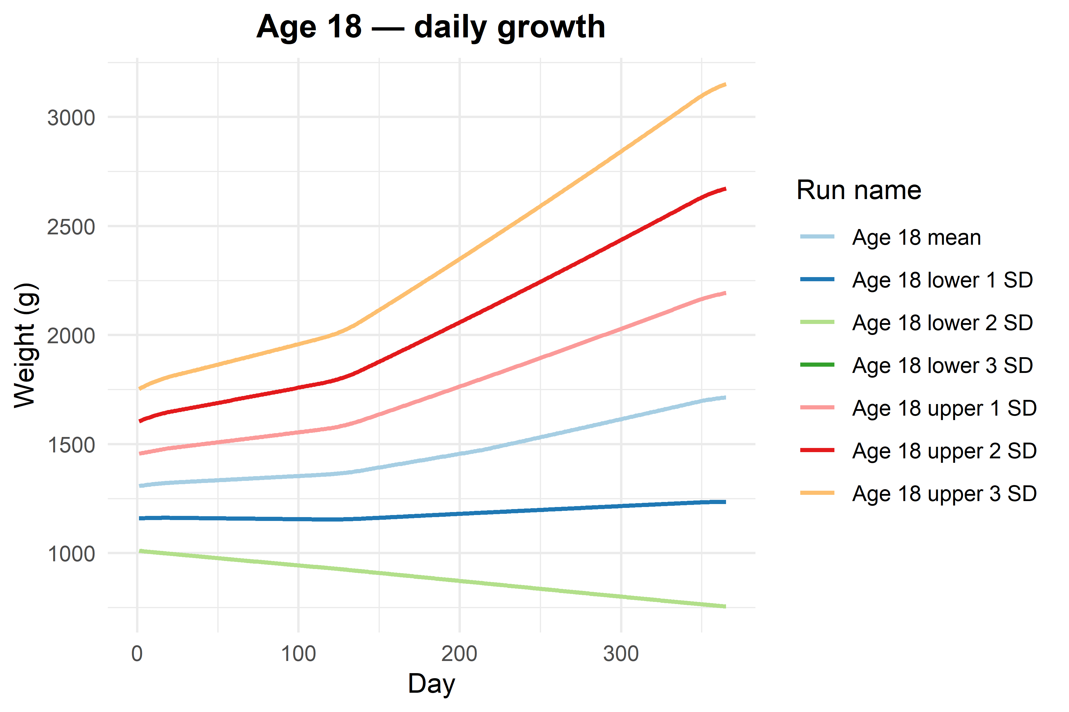
$`Age 23`
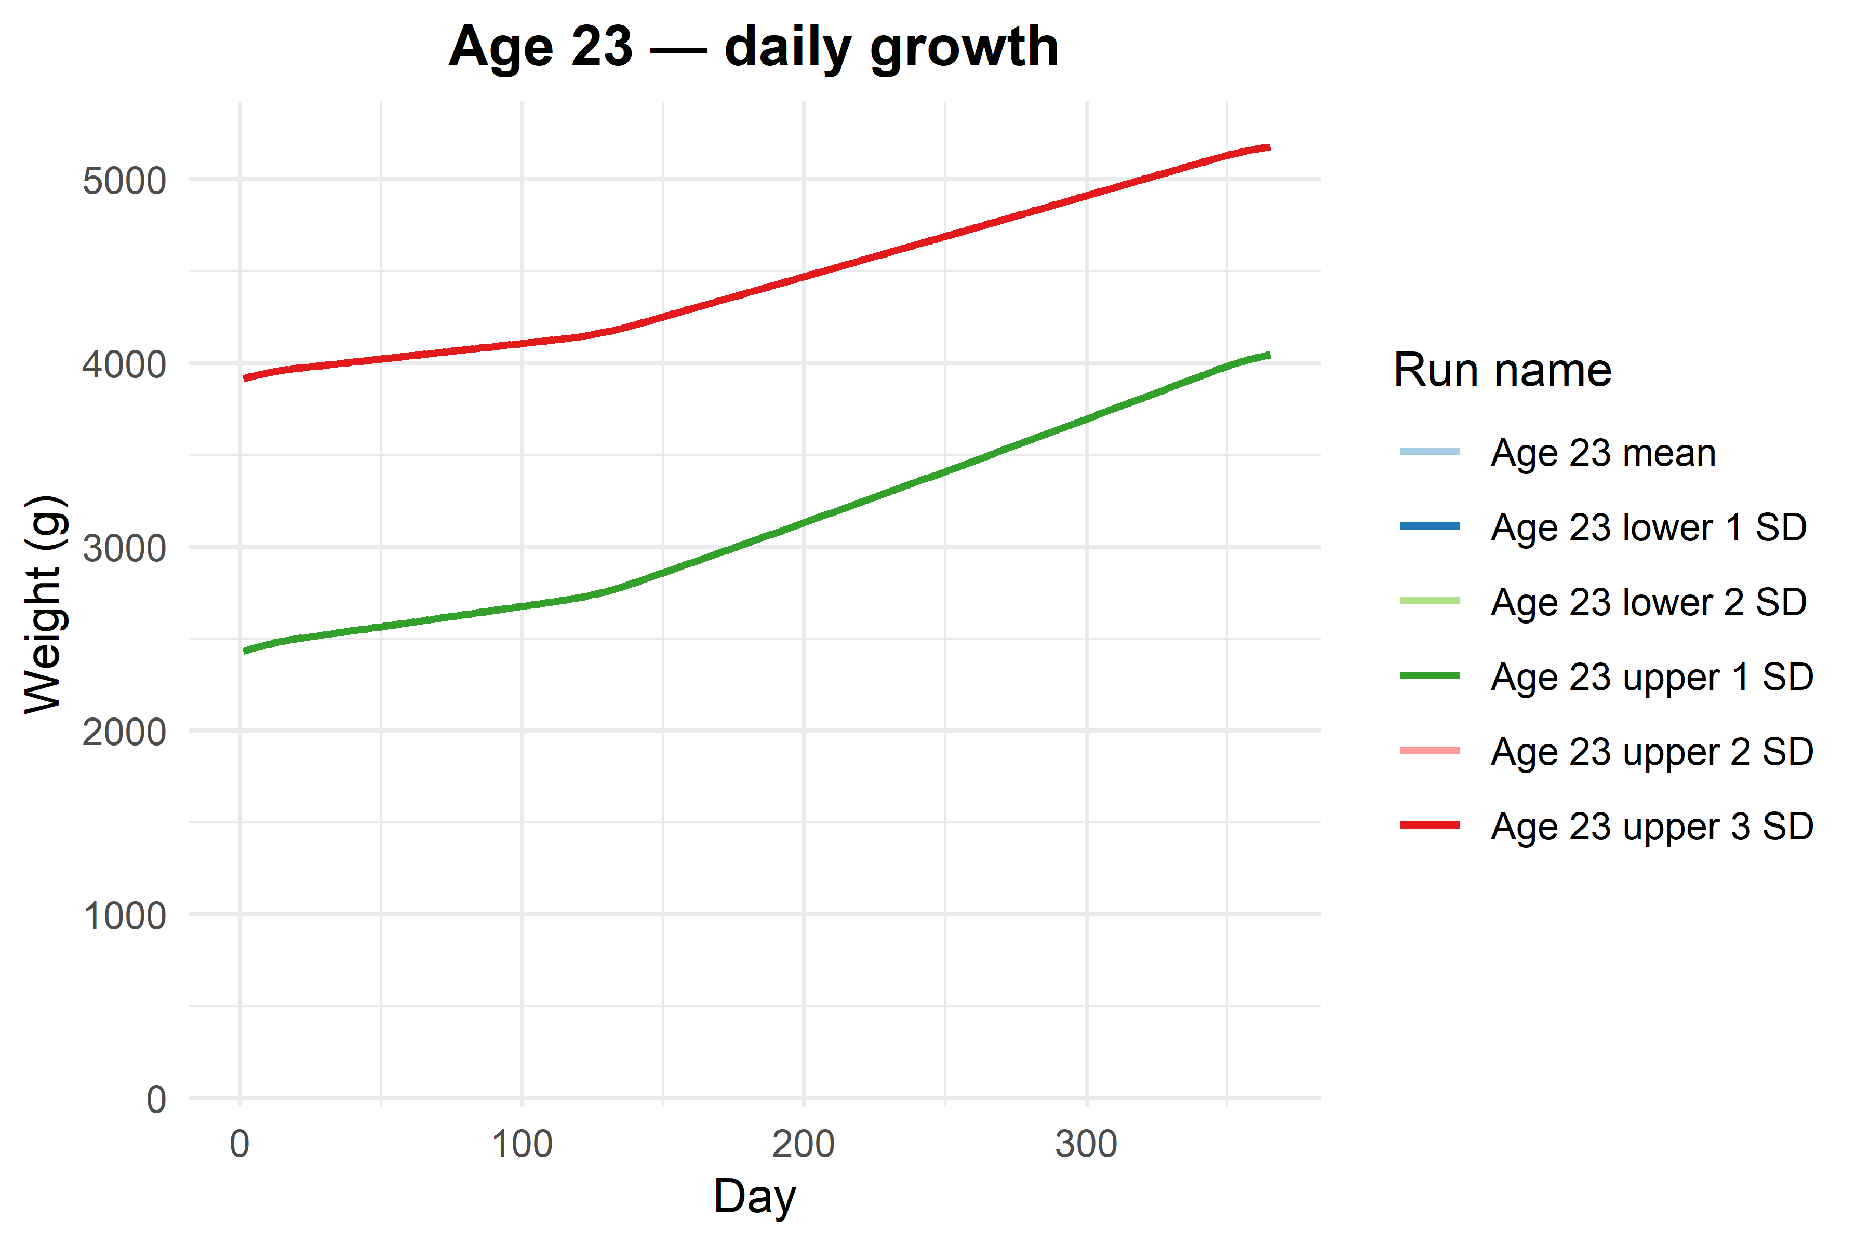
Figure 5: This plot shows the mean growth rate per age for one year in J/g/d. All standard deviations were averaged per day per age.
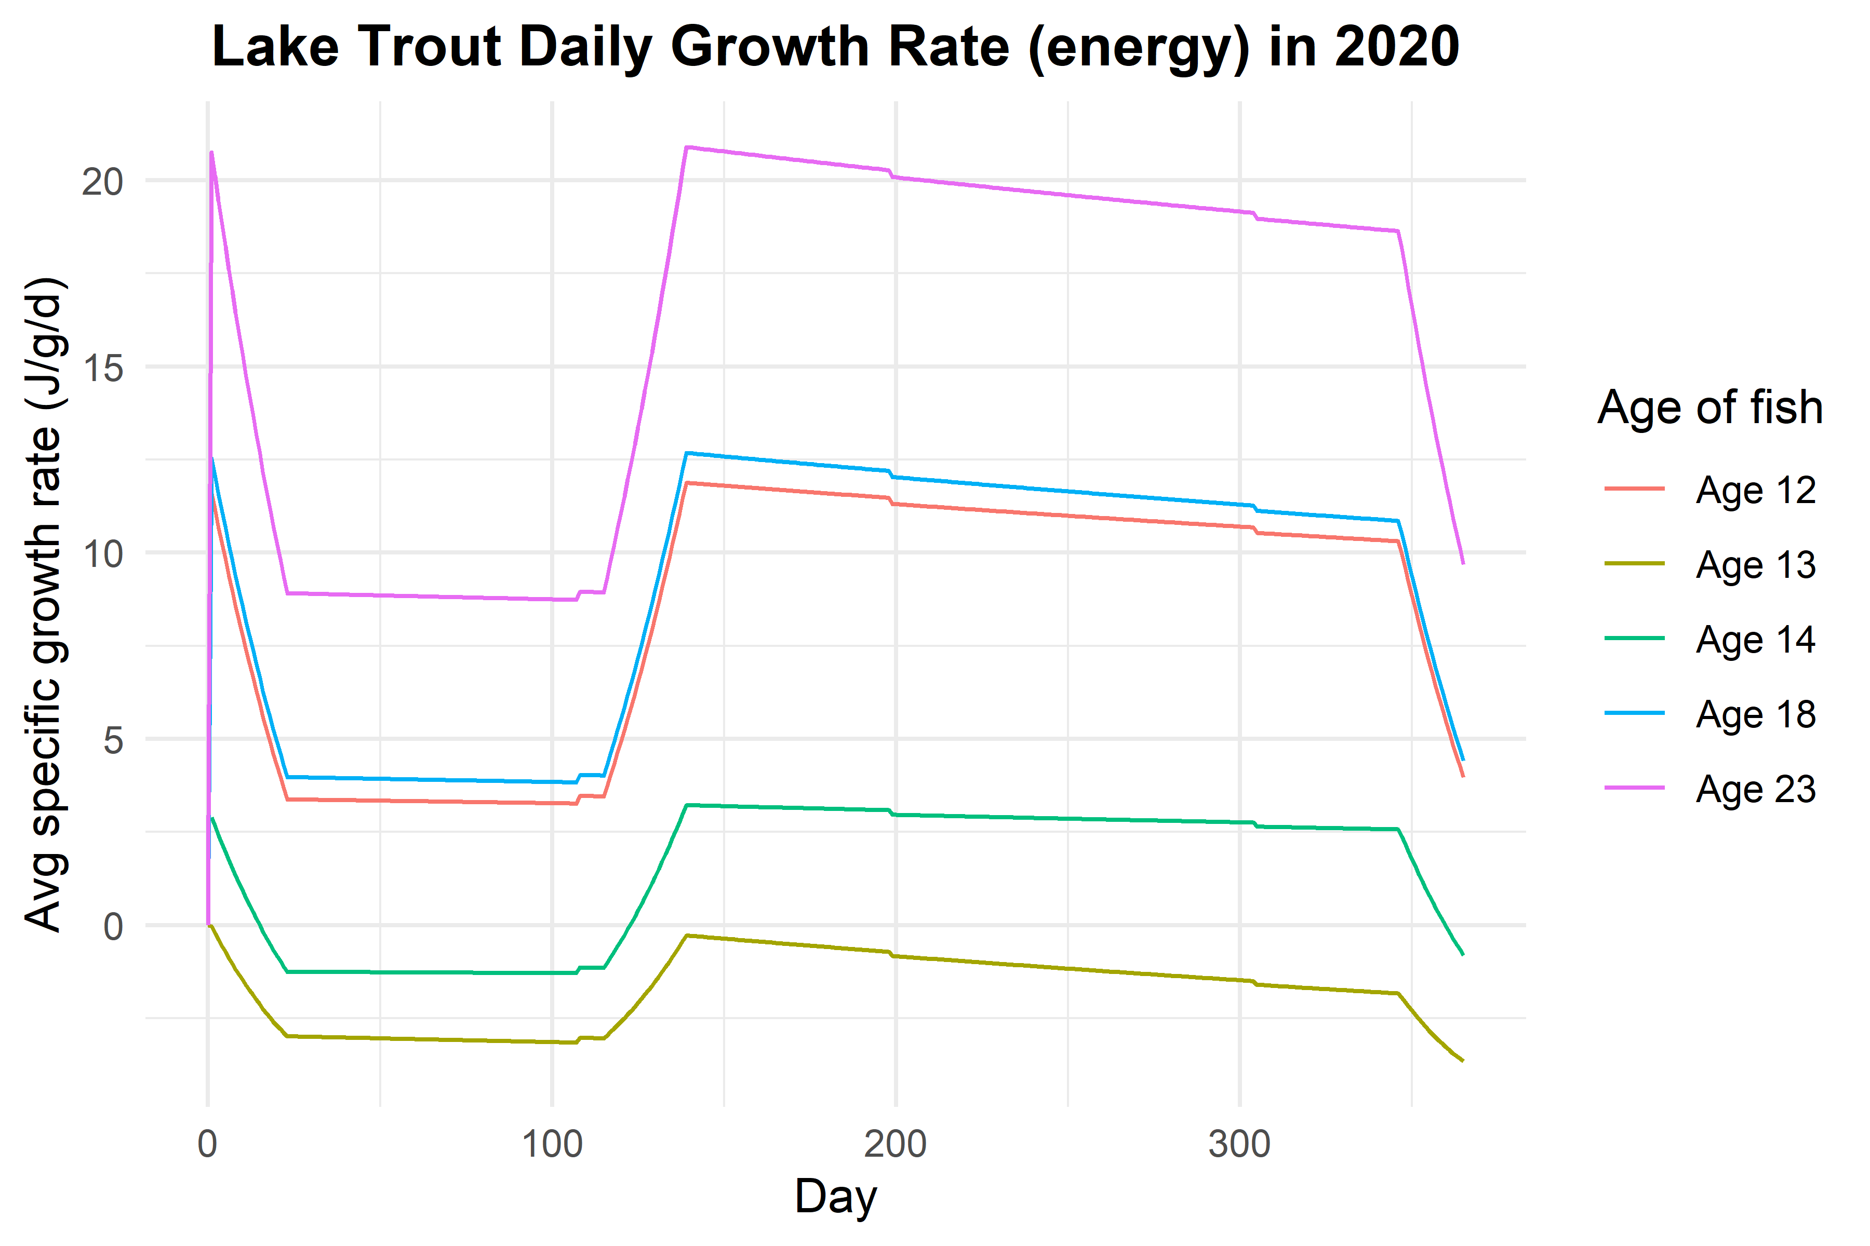
Figure 6: This plot shows the mean growth rate per age for one year in g/g/d. All standard deviations were averaged per day per age.
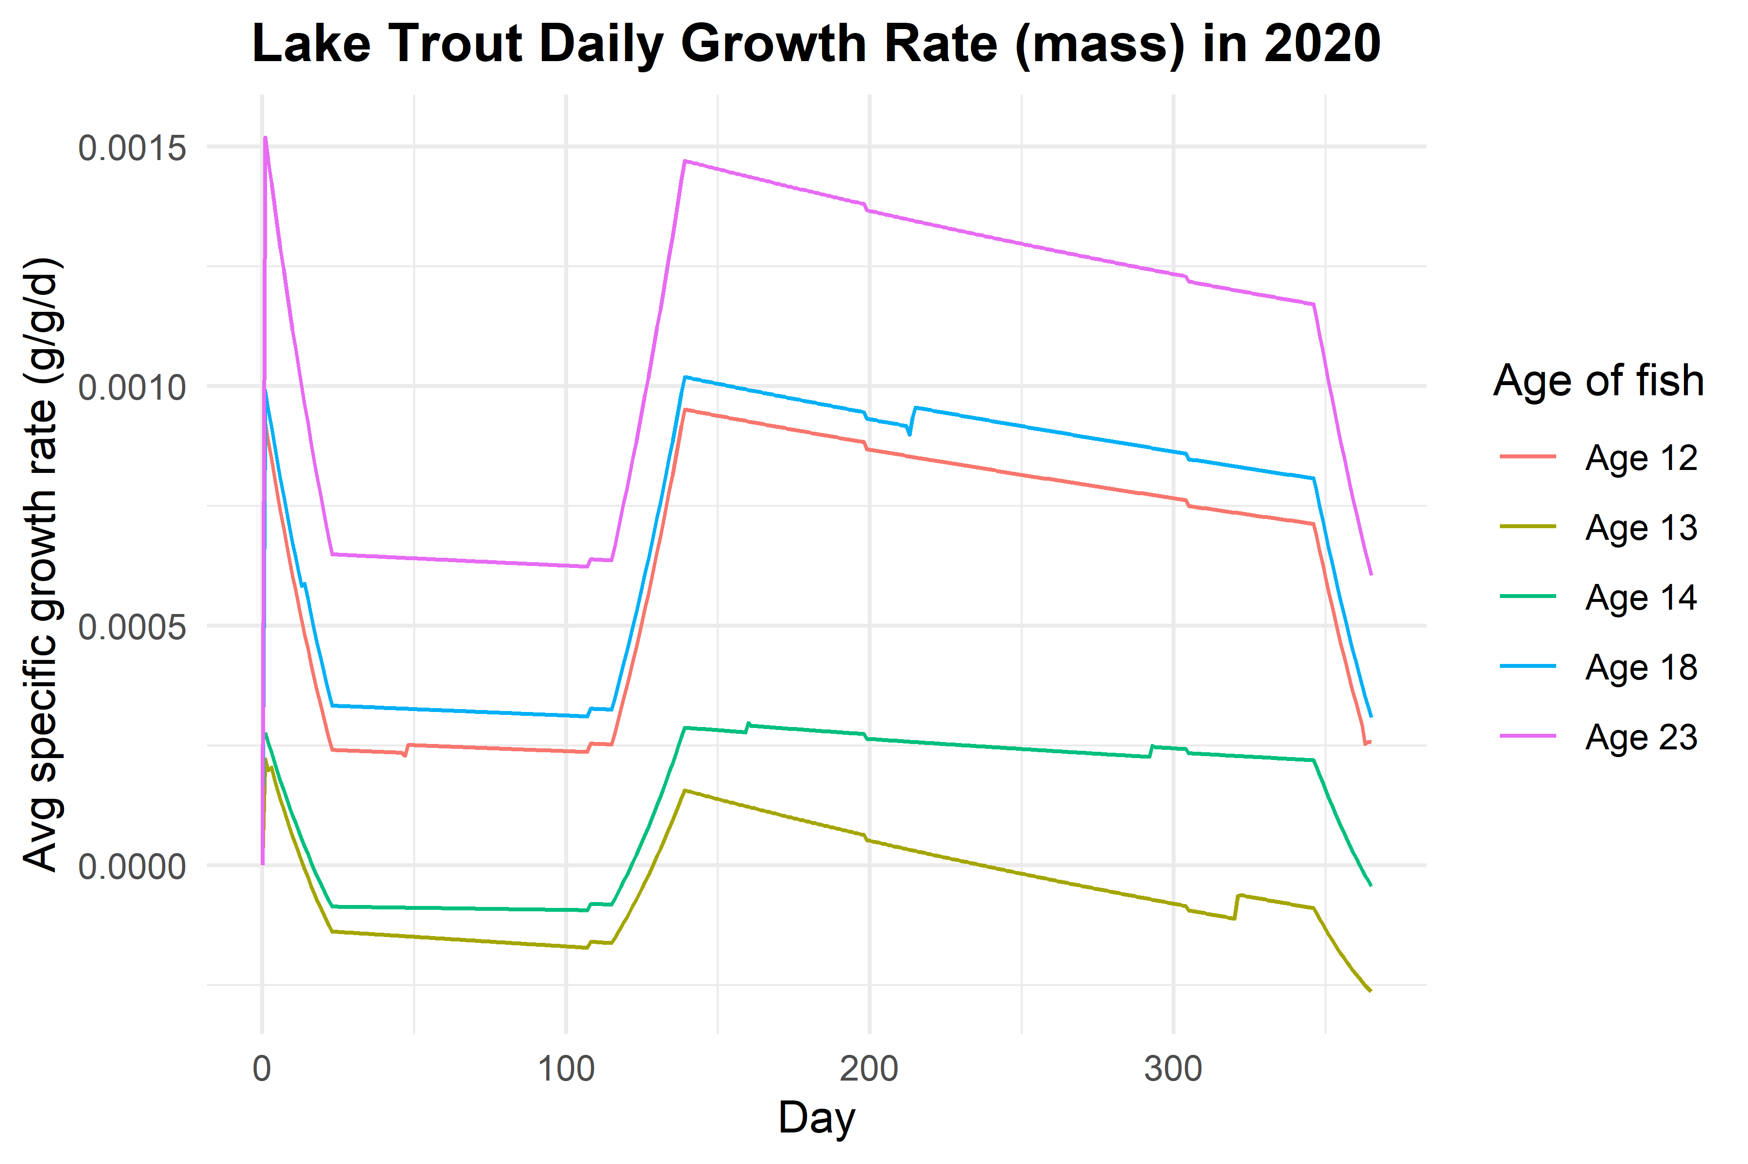

4.1 FB4 Output Conclusions
- Some lower 3 SDs were excluded because they went negative.
- I believe the model could not calculate the growth of some runs because their final weight (the weight at the next older age) was a lot lower than their starting weight. Model might not understand why the fish lost so much weight in one year.
  - Limitations of using observational data!
- The average p-value for the entire cohort is 0.6888.

5. References
Kao, Yu-Chun, Charles P. Madenjian, David B. Bunnell, Brent M. Lofgren, and Marjorie Perroud. 2015. “Temperature Effects Induced by Climate Change on the Growth and Consumption by Salmonines in Lakes Michigan and Huron.” Environmental Biology of Fishes 98 (4): 1089–1104. https://doi.org/10.1007/s10641-014-0352-6.
Pazzia, Ivano, Marc Trudel, Mark Ridgway, and Joseph B Rasmussen. 2002. “Influence of Food Web Structure on the Growth and Bioenergetics of Lake Trout ( Salvelinus Namaycush ).” Canadian Journal of Fisheries and Aquatic Sciences 59 (10): 1593–1605. https://doi.org/10.1139/f02-128.
Stewart, Donald J., David Weininger, Donald V. Rottiers, and Thomas A. Edsall. 1983. “An Energetics Model for Lake Trout, Salvelinus Namaycush : Application to the Lake Michigan Population.” Canadian Journal of Fisheries and Aquatic Sciences 40 (6): 681–98. https://doi.org/10.1139/f83-091.

