**Практическа работа БД**

На Стефан Христов Димитров

Трети Курс, ФИТА

КСТ 1Б

19621416



**Задание:**

Да се проектриа и реализира база от данни за **КОЛИ ПОД НАЕМ**, която да съхранява следната информация:

* Автомобил - вид, марка, модел, година, цвят, изминати километри,цена за ден
* Клиент - име, адрес - град, улица, телефон
* Служител - име, позиция, телефон
* Заемане под наем - клиент, автомобил, служител, дата на заемане, брой дни

Правила:

* Всеки клиент не може да наема повече от една кола в едно и също време
* Всеки автомобил може да бъде само от една марка и един модел

Базата данни трябва да е **нормализирана** и да позволява:

1. Въвеждане и корекция на данни
2. Търсене на автомобил по вид, марка, модел, цена за ден
3. Справки

* Отдадени автомобили под наем от служител, подредени по вид и дата
* Последните 10 заемания, подредени по дни на заемане
* Наети автомобили от клиент, подредени по дата
* Отдаване на автомобили за период, подредени по клиенти, които заемат

**Модели**

Релационен:

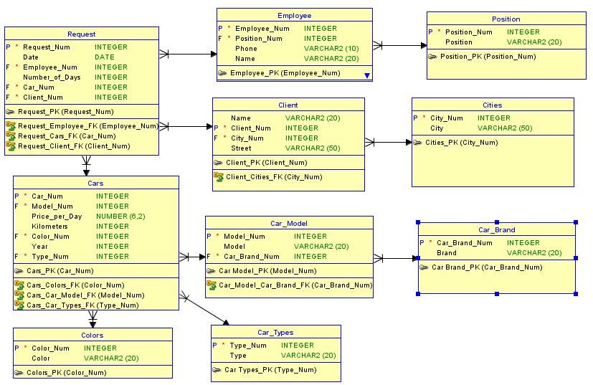

Логически:

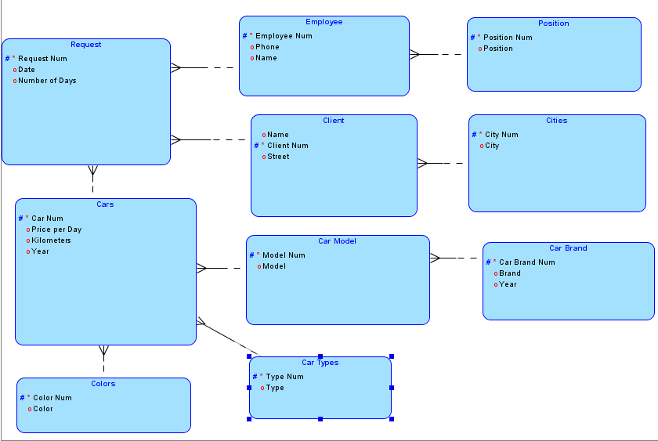

**Примерни данни**

Таблица **Request**

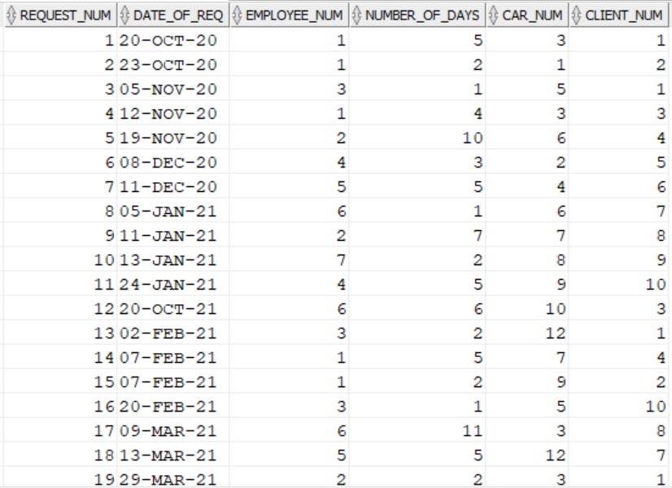

Таблица **Positions**

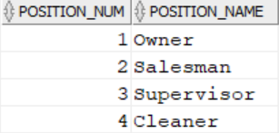

Таблица **Employee**

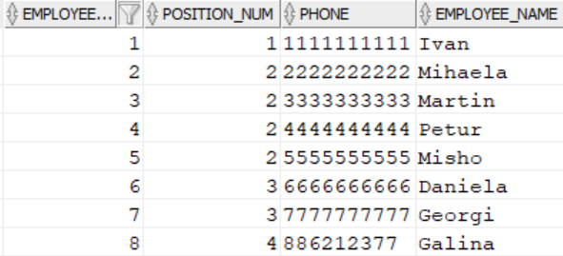

Таблица **Colors**

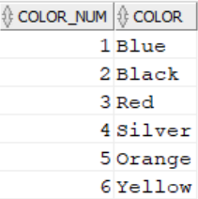

Таблица **Clients**

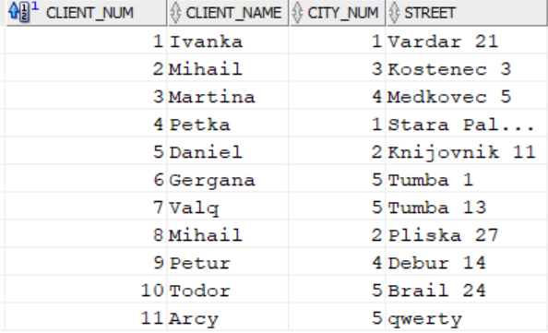

Таблица **Cities**

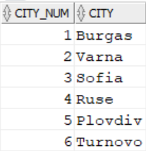

Таблица **Car_Brand**

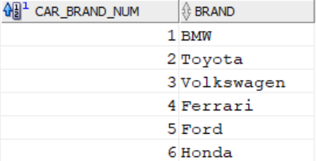

Таблица **Car_Model**

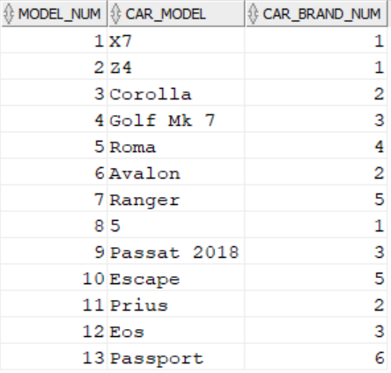

Таблица **Car_Types**

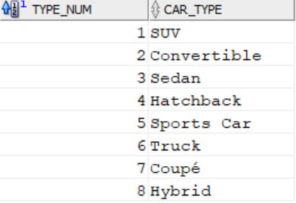

Таблица **Cars**

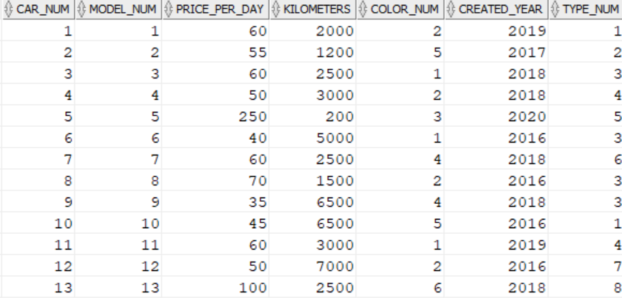

**SQL Команди:**

**DDL**

drop table request;

drop table employee;

drop table positions;

drop table cars;

drop table car_model;

drop table car_brand;

drop table colors;

drop table car_types;

drop table clients;

drop table cities;

truncate table colors;

create table positions

(

Position_Num int,

Position_Name varchar2(20),

constraint Positions_PK primary key(Position_Num)

);

create table employee

(

Employee_Num int,

Position_Num int,

Phone varchar2(10),

Employee_Name varchar2(20),

constraint Employee_PK primary key(Employee_Num),

constraint Positions_Employee_FK foreign key(Position_Num) references positions(Position_Num)

);

create table cities

(

City_Num int,

City varchar2(20),

constraint Cities_PK primary key(City_Num)

);

create table clients

(

Client_Num int,

Client_Name varchar2(20),

City_Num int,

Street varchar2(50),

constraint Clients_PK primary key(Client_Num),

constraint Clients_Cities_FK foreign key(City_Num) references cities(City_Num)

);

create table car_brand

(

Car_Brand_Num int,

Brand varchar2(20) UNIQUE,

constraint Car_Brand_PK primary key(Car_Brand_Num)

);

create table car_model

(

Model_Num int,

Car_Model varchar2(20) UNIQUE,

Car_Brand_Num int UNIQUE,

constraint Model_PK primary key(Model_Num),

constraint Model_Brand_FK foreign key(Car_Brand_Num) references car_brand(Car_Brand_Num)

);

create table car_types

(

Type_Num int,

Car_Type varchar2(20),

constraint Types_PK primary key(Type_Num)

);

create table colors

(

Color_Num int,

Color varchar2(20),

constraint Colors_PK primary key(Color_Num)

);

create table cars

(

Car_Num int,

Model_Num int UNIQUE,

Price_per_Day number(6,2),

Kilometers int,

Color_Num int,

Created_Year int,

Type_Num int,

constraint Cars_PK primary key(Car_Num),

constraint Cars_Colors_FK foreign key(Color_Num) references colors(Color_Num),

constraint Cars_Model_FK foreign key(Model_Num) references car_model(Model_Num),

constraint Cars_Types_FK foreign key(Type_Num) references car_types(Type_Num)

);

-- table for the Rent a car requests

create table request

(

Request_Num int,

Date_of_Req date,

Employee_Num int,

Number_of_Days int,

Car_Num int,

Client_Num int,

constraint Request_PK primary key(Request_Num),

constraint Request_Employee_FK foreign key(Employee_Num) references employee(Employee_Num),

constraint Request_Client_FK foreign key(Client_Num) references clients(Client_Num),

constraint Request_Cars_FK foreign key(Car_Num) references cars(Car_Num)

);

alter table colors

drop column Color;

alter table colors

add (Color varchar2(10));

alter table request

modify Date_of_Req date;

alter table request

rename to Rent_A_Car;

drop table Rent_A_Car

**DML**

insert into positions values (1,'Owner');

insert into positions values (2,'Salesman');

insert into positions values (3,'Supervisor');

insert into employee values (1,1,'1111111111','Ivan');

insert into employee values (2,2,'2222222222','Mihaela');

insert into employee values (3,2,'3333333333','Martin');

insert into employee values (4,2,'4444444444','Petur');

insert into employee values (5,2,'5555555555','Misho');

insert into employee values (6,3,'6666666666','Daniela');

insert into employee values (7,3,'7777777777','Georgi');

insert into cities values(1,'Burgas');

insert into cities values(2,'Varna');

insert into cities values(3,'Sofia');

insert into cities values(4,'Ruse');

insert into cities values(5,'Plovdiv');

insert into clients values(1,'Ivanka',1,'Vardar 21');

insert into clients values(2,'Mihail',3,'Kostenec 3');

insert into clients values(3,'Martina',4,'Medkovec 5');

insert into clients values(4,'Petka',1,'Stara Palnina 19');

insert into clients values(5,'Daniel',2,'Knijovnik 11');

insert into clients values(6,'Gergana',5,'Tumba 1');

insert into clients values(7,'Valq',5,'Tumba 13');

insert into clients values(8,'Mihail',2,'Pliska 27');

insert into clients values(9,'Petur',4,'Debur 14');

insert into clients values(10,'Todor',5,'Brail 24');

insert into car_brand values(1,'BMW');

insert into car_brand values(2,'Toyota');

insert into car_brand values(3,'Volkswagen');

insert into car_brand values(4,'Ferrari');

insert into car_brand values(5,'Ford');

insert into car_model values(1,'X7',1);

insert into car_model values(2,'Z4',1);

insert into car_model values(3,'Corolla',2);

insert into car_model values(4,'Golf Mk 7',3);

insert into car_model values(5,'Roma',4);

insert into car_model values(6,'Avalon',2);

insert into car_model values(7,'Ranger',5);

insert into car_model values(8,'5',1);

insert into car_model values(9,'Passat 2018',3);

insert into car_model values(10,'Escape',5);

insert into car_model values(11,'Prius',2);

insert into car_model values(12,'Eos',3);

insert into car_types values(1,'SUV');

insert into car_types values(2,'Convertible');

insert into car_types values(3,'Sedan');

insert into car_types values(4,'Hatchback');

insert into car_types values(5,'Sports Car');

insert into car_types values(6,'Truck');

insert into car_types values(7,'Coupé');

insert into colors values(1,'Blue');

insert into colors values(2,'Black');

insert into colors values(3,'Red');

insert into colors values(4,'Silver');

insert into colors values(5,'Orange');

insert into cars values(1,1,60,2000,2,2019,1);

insert into cars values(2,2,55,1200,5,2017,2);

insert into cars values(3,3,60,2500,1,2018,3);

insert into cars values(4,4,50,3000,2,2018,4);

insert into cars values(5,5,250,200,3,2020,5);

insert into cars values(6,6,40,5000,1,2016,3);

insert into cars values(7,7,60,2500,4,2018,6);

insert into cars values(8,8,70,1500,2,2016,3);

insert into cars values(9,9,55,3500,4,2018,3);

insert into cars values(10,10,45,6500,5,2016,1);

insert into cars values(11,11,60,3000,1,2019,4);

insert into cars values(12,12,50,7000,2,2016,7);

insert into request values(1,to_date('20/10/2020','DD/MM/YYYY'),1,5,3,1);

insert into request values(2,to_date('23/10/2020','DD/MM/YYYY'),1,2,1,2);

insert into request values(3,to_date('5/11/2020','DD/MM/YYYY'),3,1,5,1);

insert into request values(4,to_date('12/11/2020','DD/MM/YYYY'),1,4,3,3);

insert into request values(5,to_date('19/11/2020','DD/MM/YYYY'),2,10,6,4);

insert into request values(6,to_date('8/12/2020','DD/MM/YYYY'),4,3,2,5);

insert into request values(7,to_date('11/12/2020','DD/MM/YYYY'),5,5,4,6);

insert into request values(8,to_date('5/1/2021','DD/MM/YYYY'),6,1,6,7);

insert into request values(9,to_date('11/01/2021','DD/MM/YYYY'),2,7,7,8);

insert into request values(10,to_date('13/1/2021','DD/MM/YYYY'),7,2,8,9);

insert into request values(11,to_date('24/1/2021','DD/MM/YYYY'),4,5,9,10);

insert into request values(12,to_date('20/10/2021','DD/MM/YYYY'),6,6,10,3);

insert into request values(13,to_date('2/2/2021','DD/MM/YYYY'),3,2,12,1);

insert into request values(14,to_date('7/2/2021','DD/MM/YYYY'),1,5,7,4);

insert into request values(15,to_date('7/2/2021','DD/MM/YYYY'),1,2,9,2);

insert into request values(16,to_date('20/2/2021','DD/MM/YYYY'),3,1,5,10);

insert into request values(17,to_date('9/3/2021','DD/MM/YYYY'),6,11,3,8);

insert into request values(18,to_date('13/3/2021','DD/MM/YYYY'),5,5,12,7);

insert into request values(19,to_date('29/3/2021','DD/MM/YYYY'),2,2,3,1);

insert into request values(20,to_date('1/4/2021','DD/MM/YYYY'),1,5,8,9);

update clients set Client_Name = 'Patrik' where Client_Num = 2;

delete from employee where Employee_Name = 'Galina';

**Резултати от изпълнението на заявките**

**Търсене на автомобил по тип (Sedan)**

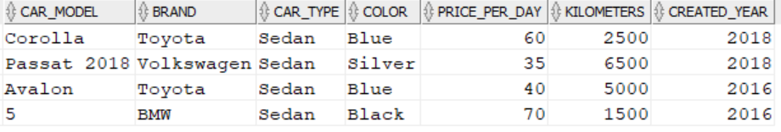

**Търсене на автомобил по марка(BMW)**

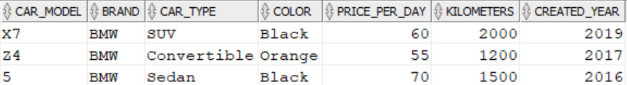

**Търсене на автомобил по модел(Avalon)**



**Tърсене на автомобил по цена за ден(60)**

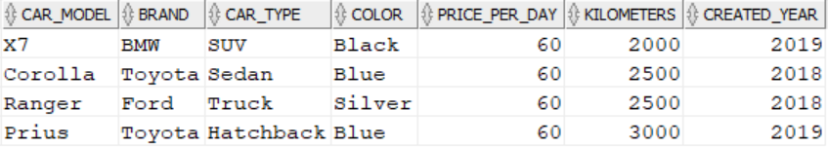

**Справка за отдадени автомобили под наем от служител(1)**

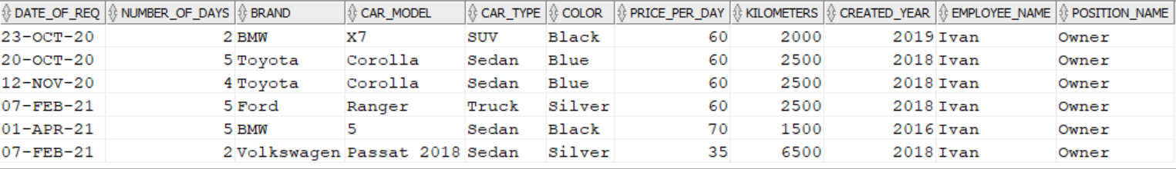

**Справка за последните 10 заемания**

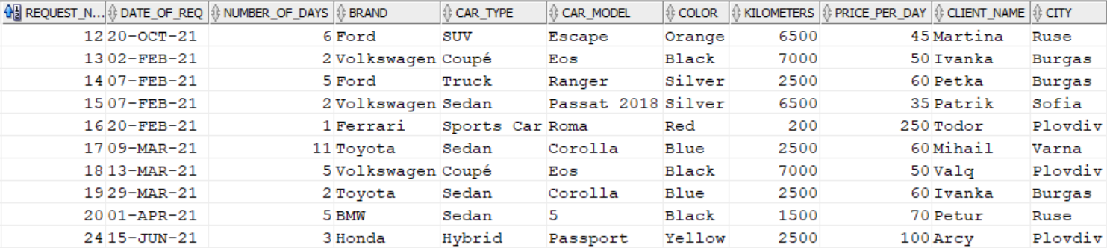

**Справка за наети автомобили от клиент(1)**

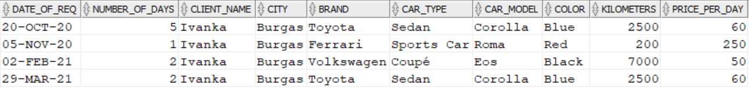

**Спрвака за отдаване на автомобили за период**

**(5-NOV-2020 – 04-MAR-2021)**

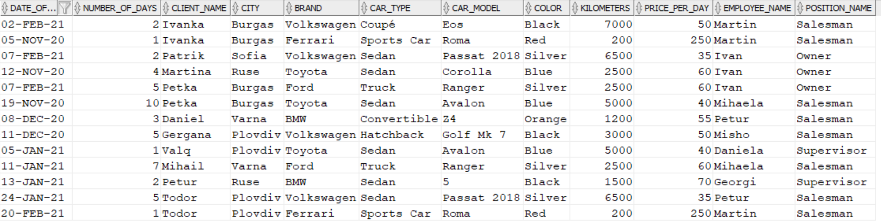

**PL/SQL**

**Процедури**

**brand_inp**

create or replace procedure brand_inp(v_brand Car_Brand.Brand%TYPE)

AS

BEGIN

insert into Car_Brand(Brand)

Values(v_brand);

END;

**brand_upd**

create or replace procedure brand_upd(v_brand_num Car_Brand.Car_Brand_Num%TYPE,v_brand Car_Brand.Brand%TYPE)

AS

Begin

Update Car_Brand set Brand = v_brand

where Car_Brand_Num = v_brand_num;

END;

**brand_del**

create or replace procedure brand_del (v_brand_num Car_Brand.Car_Brand_Num%TYPE)

as

BEGIN

delete from Car_Brand where Car_Brand_Num = v_brand_num;

end;

**car_inp**

create or replace procedure car_inp(v_model_num Cars.Model_Num%TYPE, v_price Cars.Price_per_Day%TYPE,

v_kilometers Cars.Kilometers%TYPE, v_color_num Cars.Color_Num%TYPE, v_year Cars.Created_Year%TYPE,

v_type_num Cars.Type_Num%TYPE)

AS

BEGIN

insert into Cars(Model_Num, Price_per_Day, Kilometers, Color_Num, Created_Year, Type_Num)

Values(v_model_num,v_price,v_kilometers,v_color_num,v_year,v_type_num);

END;

**car_upd**

create or replace procedure car_upd(v_car_num Cars.Car_Num%TYPE,v_model_num Cars.Model_Num%TYPE, v_price Cars.Price_per_Day%TYPE,

v_kilometers Cars.Kilometers%TYPE, v_color_num Cars.Color_Num%TYPE, v_year Cars.Created_Year%TYPE, v_type_num Cars.Type_Num%TYPE)

AS

Begin

Update Cars set Model_Num = v_model_num,Price_per_Day = v_price, Kilometers = v_kilometers, Color_Num = v_color_num,

Created_Year = v_year, Type_Num = v_type_num

where Car_Num = v_car_num;

END;

**car_del**

create or replace procedure car_del (v_car_num Cars.Car_Num%TYPE)

as

BEGIN

delete from Cars where Car_Num = v_car_num;

end;

**city_inp**

create or replace procedure city_inp(v_city_name cities.City%TYPE)

AS

BEGIN

insert into cities(City)

Values(v_city_name);

END;

**city_upd**

create or replace procedure city_upd(v_city_num cities.City_Num%TYPE,v_city_name cities.City%TYPE)

AS

Begin

Update cities set City = v_city_name

where City_Num = v_city_num;

END;

**city_del**

create or replace procedure city_del (v_city_num Cities.City_Num%TYPE)

as

BEGIN

delete from Cities where City_Num = v_city_num;

end;

**client_inp**

create or replace procedure client_inp(v_client_name Clients.Client_Name%TYPE,

v_city_num Clients.City_Num%TYPE, v_street Clients.Street%TYPE)

AS

BEGIN

insert into Clients(Client_Name,City_Num,Street)

Values(v_client_name,v_city_num,v_street);

END;

**client_upd**

create or replace procedure client_upd(v_client_num Clients.Client_Num%TYPE,v_client_name Clients.Client_Name%TYPE,

v_city_num Clients.City_Num%TYPE, v_street Clients.Street%TYPE)

AS

Begin

Update Clients set Client_Name = v_client_name,

City_Num = v_city_num,

Street = v_street

where Client_Num = v_client_num;

END;

**client_del**

create or replace procedure client_del (v_client_num Clients.Client_Num%TYPE)

as

BEGIN

delete from Clients where Client_Num = v_client_num;

end;

**color_inp**

create or replace procedure color_inp(v_color Colors.Color%TYPE)

AS

BEGIN

insert into Colors(Color)

Values(v_color);

END;

**color_upd**

create or replace procedure color_upd(v_color_num Colors.Color_Num%TYPE,v_color Colors.Color%TYPE)

AS

Begin

Update Colors set Color = v_color

where Color_Num = v_color_num;

END;

**color_del**

create or replace procedure color_del (v_color_num Colors.Color_Num%TYPE)

as

BEGIN

delete from Colors where Color_Num = v_color_num;

end;

**employee_inp**

create or replace procedure employee_inp(v_position Employee.Position_Num%TYPE,

v_phone Employee.Phone%TYPE, v_name Employee.Employee_Name%TYPE)

AS

BEGIN

insert into Employee(Position_Num, Phone, Employee_Name)

Values(v_position,v_phone,v_name);

END;

**employee_upd**

create or replace procedure employee_upd(v_emplyoee_num Employee.Employee_Num%TYPE,v_position Employee.Position_Num%TYPE,

v_phone Employee.Phone%TYPE, v_name Employee.Employee_Name%TYPE)

AS

Begin

Update Employee set Position_Num = v_position,

Phone = v_phone, Employee_Name = v_name

where Employee_Num = v_emplyoee_num;

END;

**employee_del**

create or replace procedure employee_del (v_employee_num Employee.Employee_Num%TYPE)

as

BEGIN

delete from Employee where Employee_Num = v_employee_num;

end;

**model_inp**

create or replace procedure model_inp(v_model Car_Model.Car_Model%TYPE,

v_brand Car_Model.Car_Brand_Num%TYPE)

AS

BEGIN

insert into Car_Model(Car_Model, Car_Brand_Num)

Values(v_model,v_brand);

END;

**model_upd**

create or replace procedure model_upd(v_model_num Car_Model.Model_Num%TYPE,v_model Car_Model.Car_Model%TYPE,

v_brand Car_Model.Car_Brand_Num%TYPE)

AS

Begin

Update Car_Model set Car_Model = v_model,

Car_Brand_Num = v_brand

where Model_Num = v_model_num;

END;

**model_del**

create or replace procedure model_del (v_model_num Car_Model.Model_Num%TYPE)

as

BEGIN

delete from Car_Model where Model_Num = v_model_num;

end;

**position_inp**

create or replace procedure position_inp(v_position Positions.Position_Name%TYPE)

AS

BEGIN

insert into Positions(Position_Name)

Values(v_position);

END;

**position_upd**

create or replace procedure position_upd(v_position_num Positions.Position_Num%TYPE,v_position Positions.Position_Name%TYPE)

AS

Begin

Update Positions set Position_Name = v_position

where Position_Num = v_position_num;

END;

**position_del**

create or replace procedure position_del (v_position_num Positions.Position_Num%TYPE)

as

BEGIN

delete from Positions where Position_Num = v_position_num;

end;

**request_inp**

create or replace procedure request_inp(v_date Request.Date_of_Req%TYPE,

v_employee Request.Employee_Num%TYPE,v_days Request.Number_of_Days%TYPE, v_car Request.Car_Num%TYPE,

v_client Request.Client_Num%TYPE)

AS

BEGIN

insert into Request(Date_of_Req, Employee_Num, Number_of_Days, Car_Num, Client_Num)

Values(v_date,v_employee,v_days,v_car,v_client);

END;

**request_upd**

create or replace procedure request_upd(v_request_num Request.Request_Num%TYPE,v_date Request.Date_of_Req%TYPE,

v_employee Request.Employee_Num%TYPE,v_days Request.Number_of_Days%TYPE, v_car Request.Car_Num%TYPE,

v_client Request.Client_Num%TYPE)

AS

Begin

Update Request set Date_of_Req = v_date,Employee_Num = v_employee, Number_of_Days = v_days,

Car_Num = v_car, Client_Num = v_client

where Request_Num = v_request_num;

END;

**request_del**

create or replace procedure request_del (v_request_num Request.Request_Num%TYPE)

as

BEGIN

delete from Request where Request_Num = v_request_num;

end;

**type_inp**

create or replace procedure type_inp(v_type Car_Types.Car_Type%TYPE)

AS

BEGIN

insert into Car_Types(Car_Type)

Values(v_type);

END;

**type_upd**

create or replace procedure type_upd(v_type_num Car_Types.Type_Num%TYPE,v_type Car_Types.Car_Type%TYPE)

AS

Begin

Update Car_Types set Car_Type = v_type

where Type_Num = v_type_num;

END;

**type_del**

create or replace procedure type_del (v_type_num Car_Types.Type_Num%TYPE)

as

BEGIN

delete from Car_Types where Type_Num = v_type_num;

end;

**Тригери**

**brand_tr**

create or replace TRIGGER brand_tr

BEFORE INSERT ON Car_Brand

FOR EACH ROW

WHEN (NEW.Car_Brand_Num IS NULL)

BEGIN

:NEW.Car_Brand_Num := Brand_Seq.NEXTVAL;

END;

**car_tr**

create or replace TRIGGER car_tr

BEFORE INSERT ON Cars

FOR EACH ROW

WHEN (NEW.Car_Num IS NULL)

BEGIN

:NEW.Car_Num := Car_Seq.NEXTVAL;

END;

**city_tr**

create or replace TRIGGER city_tr

BEFORE INSERT ON Cities

FOR EACH ROW

WHEN (NEW.City_Num IS NULL)

BEGIN

:NEW.City_Num := City_Seq.NEXTVAL;

END;

**client_tr**

create or replace TRIGGER client_tr

BEFORE INSERT ON Clients

FOR EACH ROW

WHEN (NEW.Client_Num IS NULL)

BEGIN

:NEW.Client_Num := Client_Seq.NEXTVAL;

END;

**color_tr**

create or replace TRIGGER color_tr

BEFORE INSERT ON Colors

FOR EACH ROW

WHEN (NEW.Color_Num IS NULL)

BEGIN

:NEW.Color_Num := Color_Seq.NEXTVAL;

END;

**employee_tr**

create or replace TRIGGER employee_tr

BEFORE INSERT ON Employee

FOR EACH ROW

WHEN (NEW.Employee_Num IS NULL)

BEGIN

:NEW.Employee_Num := Employee_Seq.NEXTVAL;

END;

**model_tr**

create or replace TRIGGER model_tr

BEFORE INSERT ON Car_Model

FOR EACH ROW

WHEN (NEW.Model_Num IS NULL)

BEGIN

:NEW.Model_Num := Model_Seq.NEXTVAL;

END;

**position_tr**

create or replace TRIGGER position_tr

BEFORE INSERT ON Positions

FOR EACH ROW

WHEN (NEW.Position_Num IS NULL)

BEGIN

:NEW.Position_Num := Position_Seq.NEXTVAL;

END;

**request_tr**

create or replace TRIGGER request_tr

BEFORE INSERT ON Request

FOR EACH ROW

WHEN (NEW.Request_Num IS NULL)

BEGIN

:NEW.Request_Num := Req_Seq.NEXTVAL;

END;

**type_tr**

create or replace TRIGGER type_tr

BEFORE INSERT ON Car_Types

FOR EACH ROW

WHEN (NEW.Type_Num IS NULL)

BEGIN

:NEW.Type_Num := Type_Seq.NEXTVAL;

END;

**Курсори**

**search_car_by_type**

create or replace Procedure search_car_by_type(v_type Car_Types.Car_Type%TYPE)

IS

BEGIN

DBMS_OUTPUT.PUT_LINE('Car Type:');

DECLARE

CURSOR Car_TYP IS

select m.Car_Model,b.Brand,t.Car_Type,color.Color,c.Price_per_Day,c.Kilometers,

c.Created_Year

from Cars c

join Car_Types t

on c.Type_Num = t.Type_Num

join Car_Model m

on c.Model_Num = m.Model_Num

join Car_Brand b

on m.Car_Brand_Num = b.Car_Brand_Num

join Colors color

on c.Color_Num = color.Color_Num

join Car_Types t

on c.Type_Num = t.Type_Num

where t.Car_Type = v_type;

BEGIN

FOR Car_Types in Car_TYP

LOOP

DBMS_OUTPUT.PUT_LINE(Car_Types.Car_Model || ' ' || Car_Types.Brand || ' ' ||Car_Types.Car_Type

|| ' ' ||Car_Types.Color || ' ' || Car_Types.Price_per_Day || ' ' || Car_Types.Kilometers|| ' ' ||

Car_Types.Created_Year);

end loop;

end;

end;

**При въвеждане на SUV**

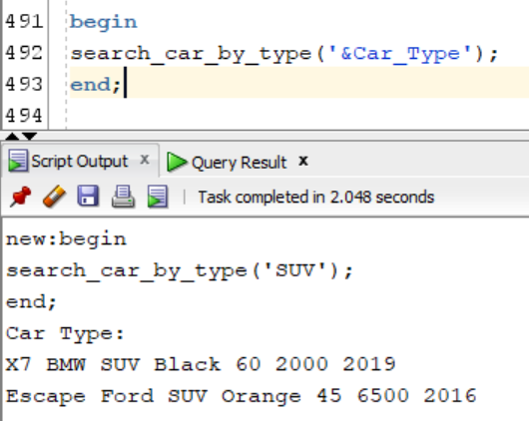

**Search_car_by_brand**

create or replace Procedure search_car_by_brand(v_brand Car_Brand.Brand%TYPE)

IS

BEGIN

DBMS_OUTPUT.PUT_LINE('Car Brand:');

DECLARE

CURSOR Car_BRND IS

select m.Car_Model,b.Brand,t.Car_Type,color.Color,c.Price_per_Day,c.Kilometers,

c.Created_Year

from Cars c

join Car_Types t

on c.Type_Num = t.Type_Num

join Car_Model m

on c.Model_Num = m.Model_Num

join Car_Brand b

on m.Car_Brand_Num = b.Car_Brand_Num

join Colors color

on c.Color_Num = color.Color_Num

join Car_Types t

on c.Type_Num = t.Type_Num

where b.Brand = v_brand;

BEGIN

FOR Car_Brand in Car_BRND

LOOP

DBMS_OUTPUT.PUT_LINE(Car_Brand.Car_Model || ' ' || Car_Brand.Brand || ' ' ||Car_Brand.Car_Type

|| ' ' ||Car_Brand.Color || ' ' || Car_Brand.Price_per_Day || ' ' || Car_Brand.Kilometers|| ' ' ||

Car_Brand.Created_Year);

end loop;

end;

end;

**При въвеждане на Toyota**

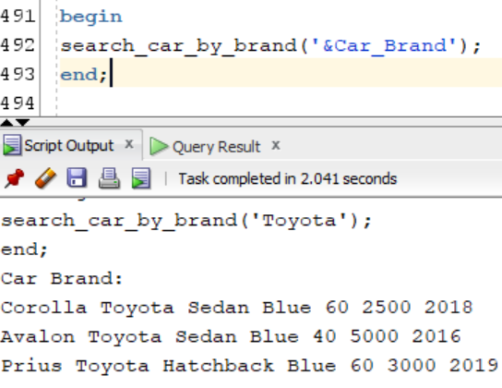

**search_car_by_model**

create or replace Procedure search_car_by_model(v_model Car_Model.Car_Model%TYPE)

IS

BEGIN

DBMS_OUTPUT.PUT_LINE('Car Model:');

DECLARE

CURSOR Car_MDL IS

select m.Car_Model,b.Brand,t.Car_Type,color.Color,c.Price_per_Day,c.Kilometers,

c.Created_Year

from Cars c

join Car_Types t

on c.Type_Num = t.Type_Num

join Car_Model m

on c.Model_Num = m.Model_Num

join Car_Brand b

on m.Car_Brand_Num = b.Car_Brand_Num

join Colors color

on c.Color_Num = color.Color_Num

join Car_Types t

on c.Type_Num = t.Type_Num

where m.Car_Model = v_model;

BEGIN

FOR Car_Model in Car_MDL

LOOP

DBMS_OUTPUT.PUT_LINE(Car_Model.Car_Model || ' ' || Car_Model.Brand || ' ' ||Car_Model.Car_Type

|| ' ' ||Car_Model.Color || ' ' || Car_Model.Price_per_Day || ' ' || Car_Model.Kilometers|| ' ' ||

Car_Model.Created_Year);

end loop;

end;

end;

**При въвеждане на Ranger**

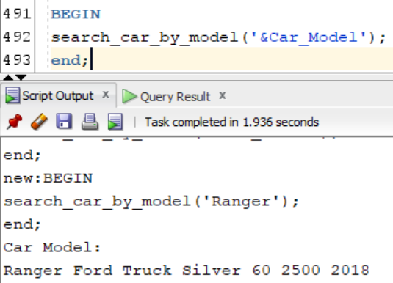

**search_car_by_price**

create or replace Procedure search_car_by_price(v_price Cars.Price_per_Day%TYPE)

IS

BEGIN

DBMS_OUTPUT.PUT_LINE('Car Price:');

DECLARE

CURSOR Car_PRC IS

select m.Car_Model,b.Brand,t.Car_Type,color.Color,c.Price_per_Day,c.Kilometers,

c.Created_Year

from Cars c

join Car_Types t

on c.Type_Num = t.Type_Num

join Car_Model m

on c.Model_Num = m.Model_Num

join Car_Brand b

on m.Car_Brand_Num = b.Car_Brand_Num

join Colors color

on c.Color_Num = color.Color_Num

join Car_Types t

on c.Type_Num = t.Type_Num

where c.Price_per_Day = v_price;

BEGIN

FOR Price_Per_Day in Car_PRC

LOOP

DBMS_OUTPUT.PUT_LINE(Price_Per_Day.Car_Model || ' ' || Price_Per_Day.Brand || ' ' ||

Price_Per_Day.Car_Type|| ' ' ||Price_Per_Day.Color || ' ' || Price_Per_Day.Price_per_Day || ' ' ||

Price_Per_Day.Kilometers|| ' ' || Price_Per_Day.Created_Year);

end loop;

end;

end;

**При въвеждане на 60**

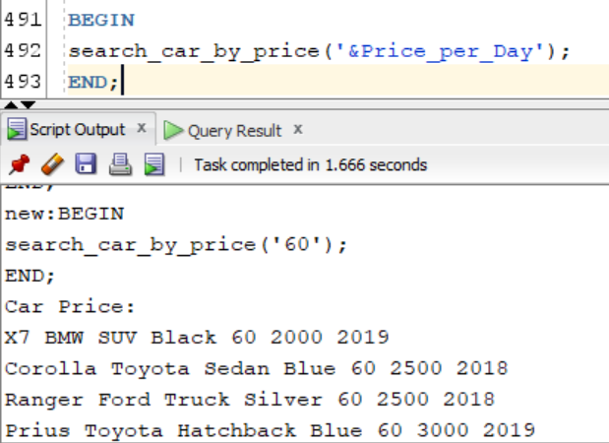

**cars_from_employee**

create or replace PROCEDURE cars_from_employee(Employee_Name varchar2)

IS

Employee_Name_new varchar2(20);

BEGIN

Employee_Name_new :='%'||Employee_Name||'%';

DECLARE

CURSOR Car_Emp IS

select req.Date_of_Req,req.Number_of_Days,b.Brand, m.Car_Model,t.Car_Type,color.Color, c.Price_per_Day,

c.Kilometers,c.Created_Year,e.Employee_Name,p.Position_Name

from request req

join cars c

on req.Car_Num = c.Car_Num

join car_model m

on c.Model_Num = m.Model_Num

join Employee e

on req.Employee_Num = e.Employee_Num

join Positions p

on e.Position_Num = p.Position_Num

join Colors color

on c.Color_Num = color.Color_Num

join Car_Brand b

on m.Car_Brand_Num = b.Car_Brand_Num

join Car_Types t

on c.Type_Num = t.Type_Num

where e.Employee_Name like Employee_Name_new

order by m.Model_Num, req.Date_of_Req;

BEGIN

FOR Cars in Car_Emp

LOOP

DBMS_OUTPUT.PUT_LINE(Cars.Date_of_Req || ' ' || Cars.Number_of_Days || ' ' || Cars.Brand || ' ' ||

Cars.Car_Model || ' ' || Cars.Car_Type || ' ' || Cars.Color || ' ' || Cars.Price_per_Day || ' ' ||

Cars.Kilometers || ' ' || Cars.Created_Year || ' ' || Cars.Employee_Name || ' ' || Cars.Position_Name);

END LOOP;

END;

END;

**При въвеждане на Mihaela**

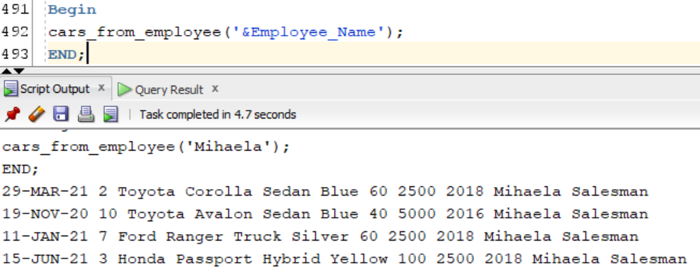

**last_ten_req**

create or replace PROCEDURE last_ten_req

IS

BEGIN

DBMS_OUTPUT.PUT_LINE('Last 10:');

DECLARE

CURSOR Last_Ten IS

select * from(select req.Request_Num,req.Date_of_Req ,req.Number_of_Days,b.Brand,

t.Car_Type,m.Car_Model,color.Color,c.Kilometers,c.Price_Per_Day,cli.Client_Name,cit.City

from request req

join cars c

on req.Car_Num = c.Car_Num

join Car_Model m

on c.Model_Num = m.Model_Num

join Car_Brand b

on m.Car_Brand_Num = b.Car_Brand_Num

join Colors color

on c.Color_Num = color.Color_Num

join Car_Types t

on c.Type_Num = t.Type_Num

join Clients cli

on req.Client_Num = cli.Client_Num

join Cities cit

on cli.City_Num = cit.City_Num

order by Date_of_Req desc)

where rownum <=10;

BEGIN

FOR Request in Last_Ten

LOOP

DBMS_OUTPUT.PUT_LINE(Request.Request_Num || ' ' || Request.Date_of_Req || ' ' || Request.Number_of_Days

|| ' ' || Request.Brand || ' ' || Request.Car_Type || ' ' || Request.Car_Model || ' ' ||Request.Color

|| ' ' || Request.Kilometers || ' ' || Request.Price_per_Day || ' ' || Request.Client_Name || ' ' ||

Request.City);

END LOOP;

END;

END;

**Излиза**

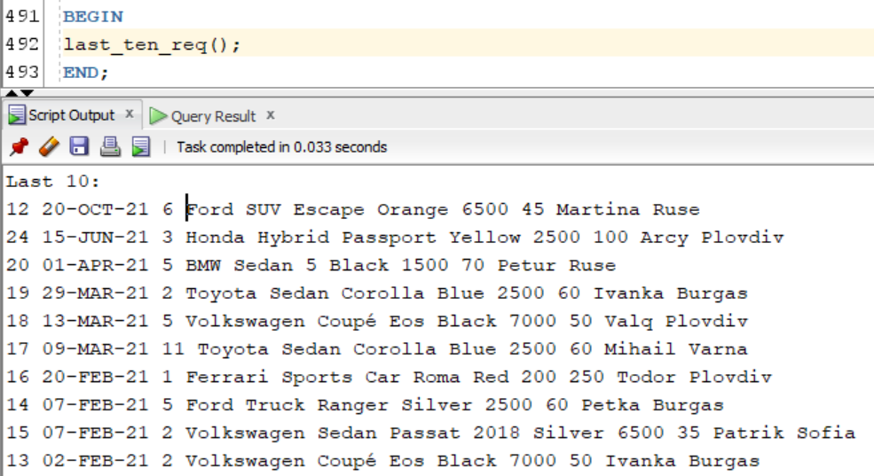

**cars_from_client**

create or replace PROCEDURE cars_from_client(Client_Name varchar2)

IS

Client_Name_new varchar2(20);

BEGIN

Client_Name_new :='%'||Client_Name||'%';

DECLARE

CURSOR Car_Cli IS

select req.Date_of_Req, req.Number_of_Days,cli.Client_Name,cit.City,b.Brand,

t.Car_Type,m.Car_Model,color.Color,c.Price_per_Day,c.Kilometers,c.Created_Year

from Request req

join Clients cli

on req.Client_Num = cli.Client_Num

join Cities cit

on cli.City_Num = cit.City_Num

join cars c

on req.Car_Num = c.Car_Num

join Car_Model m

on c.Model_Num = m.Model_Num

join Car_Brand b

on m.Car_Brand_Num = b.Car_Brand_Num

join Colors color

on c.Color_Num = color.Color_Num

join Car_Types t

on c.Type_Num = t.Type_Num

where cli.Client_Name like Client_Name_new

order by Date_of_Req;

BEGIN

FOR Cars in Car_Cli

LOOP

DBMS_OUTPUT.PUT_LINE(Cars.Date_of_Req || ' ' || Cars.Number_of_Days || ' ' ||Cars.Client_Name || ' ' ||Cars.City || ' ' ||

Cars.Brand || ' ' || Cars.Car_Type || ' ' || Cars.Car_Model || ' ' || Cars.Color || ' ' || Cars.Price_per_Day || ' ' ||

Cars.Kilometers || ' ' || Cars.Created_Year);

END LOOP;

END;

END;

**При въвеждане на Patrik**

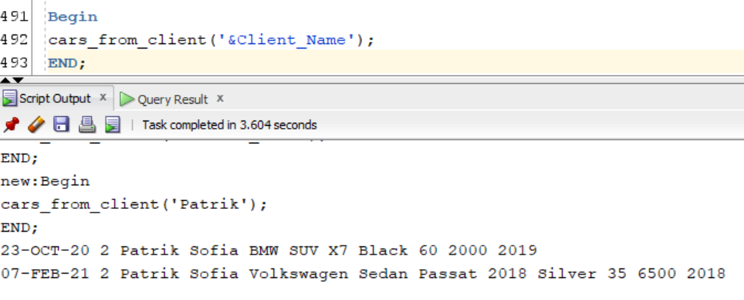

**cars_between_date**

create or replace PROCEDURE cars_between_date(Str_Date Request.Date_of_Req%Type,End_Date Request.Date_of_Req%Type)

IS

BEGIN

DECLARE

CURSOR Car_Date IS

select req.Date_of_Req,req.Number_of_Days,cli.Client_Name,cit.City,b.Brand,

t.Car_Type,m.Car_Model,color.Color,c.Kilometers,c.Price_Per_Day,e.Employee_Name,p.Position_Name

from request req

join Clients cli

on req.Client_Num = cli.Client_Num

join Cities cit

on cli.City_Num = cit.City_Num

join cars c

on req.Car_Num = c.Car_Num

join Car_Model m

on c.Model_Num = m.Model_Num

join Car_Brand b

on m.Car_Brand_Num = b.Car_Brand_Num

join Colors color

on c.Color_Num = color.Color_Num

join Car_Types t

on c.Type_Num = t.Type_Num

join Employee e

on req.Employee_Num = e.Employee_Num

join Positions p

on e.Position_Num = p.Position_Num

where req.Date_of_Req >= Str_Date AND req.Date_of_Req <= End_Date

order by cli.Client_Num;

BEGIN

FOR Cars in Car_Date

LOOP

DBMS_OUTPUT.PUT_LINE(Cars.Date_of_Req || ' ' || Cars.Number_of_Days || ' ' ||Cars.Client_Name || ' ' ||

Cars.City || ' ' ||Cars.Brand || ' ' || Cars.Car_Type || ' ' || Cars.Car_Model || ' ' || Cars.Color

|| ' ' || Cars.Kilometers || ' ' ||Cars.Price_per_Day || ' ' || Cars.Employee_Name || ' ' ||

Cars.Position_Name);

END LOOP;

END;

END;

**При въведени дати ('5-NOV-20','4-MAR-21')**

