SpacePyLibrary

File name: 0000.doc

Contents:

1 Introduction 4
1.1 Purpose 4
1.2 Referenced Documents 4
2 Pre-requisites 5
2.1 Software Packages 5
2.2 Configuration 5
3 Library Layering 9
4 Subsystems 11
4.1 CCSDS 11
4.1.1 CLTU 11
4.1.2 FRAME 11
4.1.3 PACKET 11
4.1.4 SEGMENT 11
4.1.5 SEGMENThelpers 12
4.2 EGSE 12
4.2.1 EDEN 12
4.2.2 EDENPDU 12
4.2.3 IF 13
4.3 GRND 13
4.3.1 CRYOSATDU 13
4.3.2 IF 13
4.3.3 NCTRS 13
4.3.4 NCTRSDU 14
4.3.5 NCTRSDUhelpers 14
4.4 LINK 14
4.4.1 IF 14
4.4.2 TMGEN 15
4.4.3 TMTC 15
4.5 PUS 15
4.5.1 PACKET 15
4.5.2 SERVICES 15
4.6 SCOE 16
4.6.1 EGSEgui 16
4.6.2 EGSEserver 16
4.7 SCOS 16
4.7.1 ENV 16
4.7.2 MIB 17
4.8 SIM 17
4.8.1 AdminServer 17
4.8.2 GRNDgui 17
4.8.3 LINKgui 17
4.8.4 OBQgui 17
4.8.5 SPACEgui 18
4.8.6 TCserver 18
4.8.7 TMserver 18
4.9 SPACE 18
4.9.1 DEF 18
4.9.2 IF 19
4.9.3 OBC 19
4.9.4 OBQ 19
4.9.5 TMGEN 19
4.10 UI 19
4.10.1 TKI 20
4.11 UTIL 20
4.11.1 BCH 21
4.11.2 CRC 21
4.11.3 DU 21
4.11.4 SYS 21
4.11.5 TASK 21
4.11.6 TCP 22
4.11.7 TIME 22
5 SIM 23
5.1 Overview 23
5.2 Architecture of SIM 23
6 SCOE 25
6.1 Overview 25
6.2 Architecture of SCOE 25

Introduction

Purpose
The SpacePyLibrary is a Python library that can be used for building lightweight applications in the Space domain. The implementation of the library is driven by the needs of different project in that domain.
Two applications are bundled together with the library to give examples for the library usage:

- SIM: A simulator that can be connected to ESA’s Mission Control System SCOS-2000. It simulates a groundstation, the space link, and some generic functionality of a spacecraft’s onboard computer.
- SCOE: A simulator that can be connected to a Central Checkout System. It simulates some generic functionality of a Frontend Checkout Equipment.

Referenced Documents
The following documents are referenced or used as standards for the implementation of the SpacePyLibrary:

Ref | Description | ID | Issue | Date
CLTU | Telecommand – channel service | CCSDS 201.0-B-3 | 3 | 2000-06
COP | Communicatons Operation Procedure-1 | CCSDS 232.1-B-1 | 1 | 2003-09
MIB | SCOS-2000 Database Import ICD | EGOS-MCS-S2K-ICD-0001 | 6.9 | 2010-07-06
PUS | Ground systems and operations – Telemetry and telecommand packet utilization | ECSS-E-70-41A |  | 2003-01-30
TC | Telecommand – data routing service | CCSDS 202.0-B-3 | 3 | 2000-11
TIME | Time Code Formats | CCSDS 301.0-B-3 | 3 | 2002-01
TM | Packet Telemetry | CCSDS 102.0-B-5 | 5 | 2000-11

Pre-requisites

Software Packages
The SpycePyLibrary has been developed and tested on SuSE Linux 8.2 and then ported to other operating systems. The following python packages have been used for validating the SpycePyLibrary:

Platform | Python package | Version
SuSE Linux 8.2 | python | 2.2.2
SuSE Linux 8.2 | python-tk | 2.2.2
SLES 10 / SP2 | ActivePython | 2.7.1.4
SLES 11 / SP2 | python | 2.6.0
SLES 11 / SP2 | python-tk | 2.6.0
Windows XP / SP2 | ActivePython | 2.7.1.4
OS-X 10.11.4 | Python | 2.7.10
OS-X 10.11.4 | Tkinter | 8.5.9

Configuration
The SpacePyLibrary is implemented in pure python and does not share any source code with other systems. Even though there are some aspects that make the SpacePyLibrary dependant from ESA’s mission control system SCOS-2000:
- The SIM application – which is based on the SpacePyLibrary – implements communication interfaces that are compatible with the SCOS-2000 TM/TC backend interface (NCTRS / NIS).
- The SpacePyLibrary uses some configuration variables and configuration files in SCOS-2000 format. The reason for this design concept was to simplify the installation of SpacePyLibrary within an existing SCOS-2000 environment.
The following configuration items are used by the SpacePyLibrary:

Environment variable | Description
HOST | Hostname of the SCOS-2000 runtime account
scosii_homedir | Location of the SCOS-2000 runtime directory
NCTRS_ADMIN_SERVER_PORT | NCTRS admin server port of the TC releaser. This variable is set in start script SIM.
NCTRS_TC_SERVER_PORT | NCTRS TC server port of the TC releaser. This variable is set in start script SIM.
DEF_GROUND_STATION_ID | Groundstation ID, used for the NCTRS TC connection to the TC releaser. This variable is set in start script SIM.
GROUND_STATION_NAME | Groundstaton name, used for the NCTRS admin connection to the TC releaser. This variable is set in start script SIM.
TC_TT_PKT_BYTE_OFFSET | If the TC packet is time tagged (execution time > now), then this variable is used to determine the offset of the TC packet within the time tagged uplink packet. This variable is set in start script SIM.
TC_ACK_ACCEPT_SUCC_MNEMO | Mnemonics of the TM packets that are used for TC acknowledgements. This variable is set in the start scripts SIM and SCOE.
TC_ACK_ACCEPT_FAIL_MNEMO
TC_ACK_EXESTA_SUCC_MNEMO
TC_ACK_EXESTA_FAIL_MNEMO
TC_ACK_EXEPRO_SUCC_MNEMO
TC_ACK_EXEPRO_FAIL_MNEMO
TC_ACK_EXECUT_SUCC_MNEMO
TC_ACK_EXECUT_FAIL_MNEMO
TC_ACK_ACCEPT_SUCC_APID_PARAM | Name of the TM parameter that contains the APID for TC acknowledgements. This variable is set in start scripts SIM and SCOE.
TC_ACK_ACCEPT_FAIL_APID_PARAM
TC_ACK_EXESTA_SUCC_APID_PARAM
TC_ACK_EXESTA_FAIL_APID_PARAM
TC_ACK_EXEPRO_SUCC_APID_PARAM
TC_ACK_EXEPRO_FAIL_APID_PARAM
TC_ACK_EXECUT_SUCC_APID_PARAM
TC_ACK_EXECUT_FAIL_APID_PARAM
TC_ACK_ACCEPT_SUCC_SSC_PARAM | Name of the TM parameter that contains the source sequence count for TC acknowledgements. This variable is set in start scripts SIM and SCOE.
TC_ACK_ACCEPT_FAIL_SSC_PARAM
TC_ACK_EXESTA_SUCC_SSC_PARAM
TC_ACK_EXESTA_FAIL_SSC_PARAM
TC_ACK_EXEPRO_SUCC_SSC_PARAM
TC_ACK_EXEPRO_FAIL_SSC_PARAM
TC_ACK_EXECUT_SUCC_SSC_PARAM
TC_ACK_EXECUT_FAIL_SSC_PARAM
TM_CYCLIC_MNEMO | Mnemonics of the TM packet that is used for cyclic telemetry. This variable is set in start scripts SIM and SCOE.
TM_CYCLIC_PERIOD_MS | Period in milliseconds of cyclic telemetry packets. This variable is set in start scripts SIM and SCOE.

Configuration file | Configuration item | Description
pid.dat | whole files | Information about TM packets and TM parameters are read from these MIB tables and used in SIM for the generation of the testdata.txt file.
pic.dat | whole files
tpcf.dat | whole files
pcf.dat | whole files
plf.dat | whole files
testdata.sim | whole file | This file is generated by SIM and SCOE and later on used from SIM and SCOE when sending TM to SCOS-2000 or CCS.
testdata.txt | whole file | This file is deprecated and not needed anymore by SIM and SCOE. It has been replaced by the testdata.sim file. Neverless when the testdata.sim file is generated then testdata.txt is generated, too.  This file can still be used with the test tool gpgen to inject TM packets into SCOS-2000.
TPKTconnTable.dat | TM Packetiser Port | The TM packetiser port is read from the first data line. If there are data lines, then the wrong port might be used. Note: During runtime of SIM it is possible to manually overwrite the port number.
TPKTconfigTable.dat | Spacecraft ID | The spacecraft ID is read from the first data line. If there are different spacecraft IDs in the file, then the wrong spacecraft ID might be used.

There are also hardcoded configuration items in SIM:

Source file | Configuration item | Description
ENV.py | SCOS_PACKET_HEADER_SIZE | Constants used for the generation of telemetry data.
ENV.py | TPKT_PKT_IDLE_APID | Constants used for the generation of telemetry data.
ENV.py | TPKT_PKT_IDLE_SPID | Constants used for the generation of telemetry data.
ENV.py | TPKT_PKT_IDLE_FRAME_SPID | Constants used for the generation of telemetry data.
ENV.py | VPD_DATA_SPACE | Constants used for the generation of telemetry data.
MIB.py | Testdata file name $scosii_homedir/testbin/  testdata.sim | Path defined relative to scosii_homedir.
MIB.py | Testdata file name $scosii_homedir/testbin/  testdata.txt | Path defined relative to scosii_homedir.
MIB.py | MIB directory $scosii_homedir/data/ASCII. | Path defined relative to scosii_homedir.
MIB.py | MIB file names and TM packetiser configuration file names:  $scosii_homedir/data/ASCII/pid.dat  $scosii_homedir/data/ASCII/pic.dat  $scosii_homedir/data/ASCII/tpcf.dat  $scosii_homedir/data/ASCII/pcf.dat  $scosii_homedir/data/ASCII/plf.dat  $scosii_homedir/data/ASCII/TPKTconnTable.dat  $scosii_homedir/data/ASCII/TPKTconfigTable.dat | Path defined relative to scosii_homedir.

Library Layering
The SpacePyLibrary has the following structure:

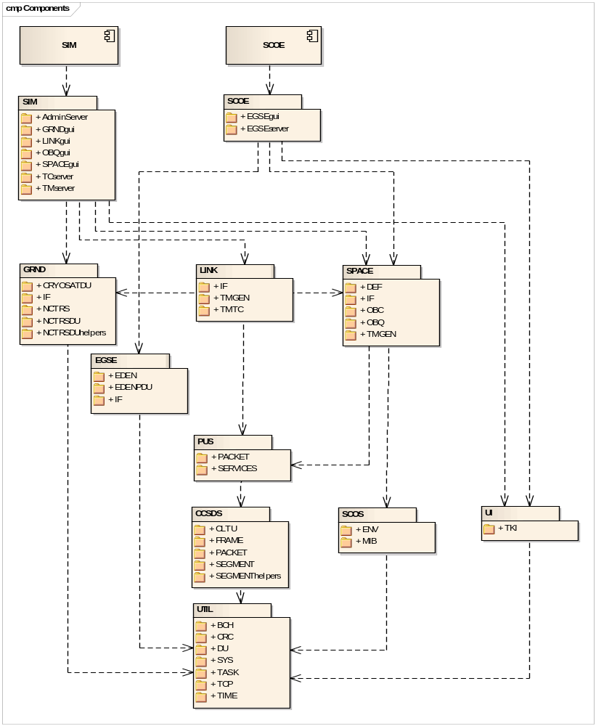

The library structure is based on a layering schema:

- SIM and SCOE
  - are application components that rely on packages
  - are implemented as python files SIM.py and SCOE.py
- Level 0 packages
  - are the big boxes in the figure
  - are bundling level 1 packages
  - are implemented as folders
  - the arrows in the figure show the dependencies between level 0 packages
- Level 1 packages
  - are the small boxes in the figure - inside the big boxes
  - are bundling python classes, functions and type definitions
  - are implemented as python files

Subsystems
This chapter describes the different subsystems in alphabetical order.

CCSDS
This level 0 package consists of the following level 1 packages:

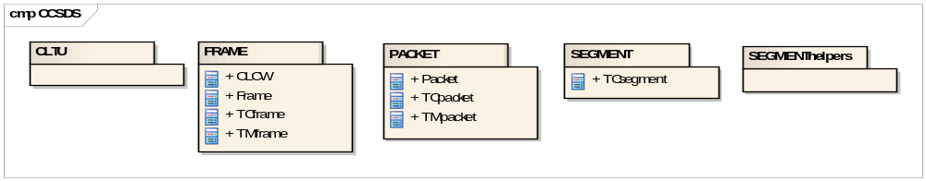

CLTU
Description: CLTU Handling Module

Classes: none

FRAME
Description: Transfer Frame Module

Classes:
- CLCW: Command link control word
- Frame: telemetry or telecommand transfer frame
- TCframe: telecommand transfer frame
- TMframe: telemetry transfer frame

PACKET
Description: CCSDS Packet Module

Classes:
- Packet: telemetry or telecommand packet
- TCpacket: telecommand packet
- TMpacket: telemetry packet

SEGMENT
Description: Telecommand Segmentation Module

Classes:
- TCsegment: Telecommand segment

SEGMENThelpers
Description: Telecommand Segmentation Module helpers

Classes: none

EGSE
This level 0 package consists of the following level 1 packages:

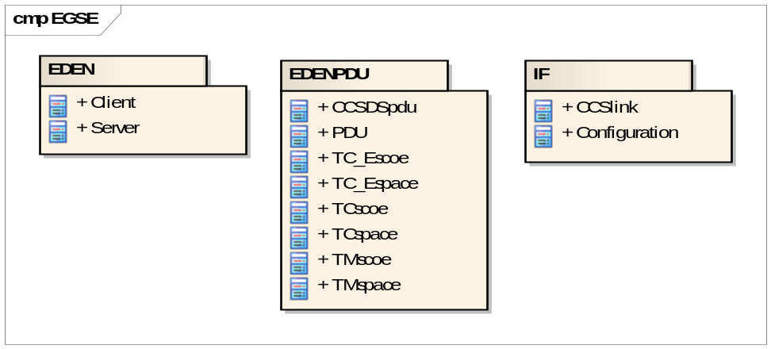

EDEN
Description: EDEN protocol

Classes:
- Client: EDEN PDU interface - CCS side
- Server: EDEN PDU interface - SCOE side

EDENPDU
Description: EDEN protocol Data Units Module

Classes:
- CCSDSpdu: Superclass for different CCSDS PDUs
- PDU: Generic EDEN protocol data unit
- TC_Escoe: (TC_E,SCOE) PDU
- TC_Espace: (TC_E,SPACE) PDU
- TCscoe: (TC,SCOE) PDU
- TCspace: (TC,SPACE) PDU
- TMscoe: (TM,SCOE) PDU
- TMspace: (TM,SPACE) PDU

IF
Description: EGSE Interface

Classes:
- CCSlink: Interface to the central checkout system
- Configuration: Configuration

GRND
This level 0 package consists of the following level 1 packages:

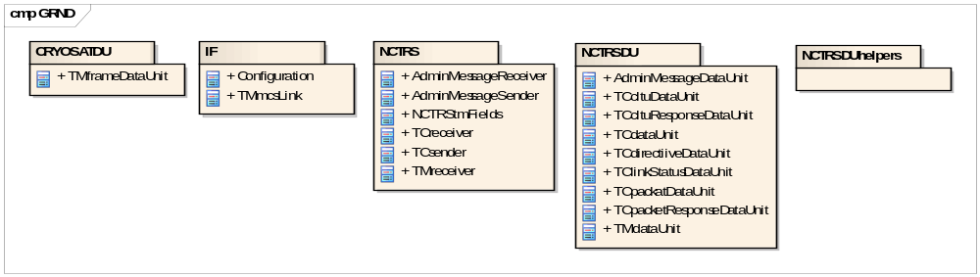

CRYOSATDU
Description: CRYOSAT Data Units Module

Classes:
- TMframeDataUnit: CRYOSAT telemetry frame data unit

IF
Description: Ground Interface

Classes:
- Configuration: Configuration
- TMmcsLink: Telemetry interface to the mission control system

NCTRS
Description: NCTRS Module

Classes:
- AdminMessageReceiver: NCTRS admin message receiver interface - SCOS side
- AdminMessageSender: NCTRS admin message sender interface - NCTRS side
- NCTRStmFields: Helper class that contains static initialization attributes
- TCreceiver: NCTRS telecommand receiver interface - NCTRS side
- TCsender: NCTRS telecommand sender interface - SCOS side
- TMreceiver: NCTRS telemetry receiver interface - SCOS side
- TMsender: NCTRS telemetry sender interface - NCTRS side

NCTRSDU
Description: NCTRS Data Units Module

Classes:
- AdminMessageDataUnit: NCTRS admin message data unit
- TCcltuDataUnit: NCTRS telecommand CLTU data unit
- TCcltuResponseDataUnit: NCTRS telecommand CLTU response data unit
- TCdataUnit: NCTRS telecommand data unit
- TCdirectivesDataUnit: NCTRS telecommand directives data unit
- TClinkStatusDataUnit: NCTRS link status data unit
- TCpacketDataUnit: NCTRS telecommand packet data unit
- TCpacketResponseDataUnit: NCTRS telecommand packet response data unit
- TMdataUnit: NCTRS telemetry data unit

NCTRSDUhelpers
Description: NCTRS Data Units Module helpers

Classes: none

LINK
This level 0 package consists of the following level 1 packages:

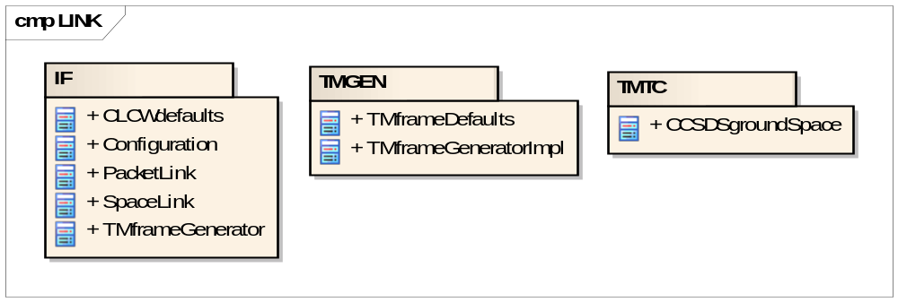

IF
Description: Ground to Space Interface

Classes:
- CLCWdefaults: Default values for CLCW
- Configuration: Configuration
- PacketLink: Interface to the packet link
- SpaceLink: Interface to the spacecraft
- TMframeGenerator: Interface of the generator for telemetry packets

TMGEN
Description: Telemetry Frame Generator

Classes:
- TMframeDefaults: Default values for TM transfer frame creation
- TMframeGeneratorImpl: Generator for telemetry frames

TMTC
Description: Telemetry and Telecommand Channels

Classes:
- CCSDSgroundSpace: Implementation of the space and packet link, connects the ground segment with the space segment

PUS
This level 0 package consists of the following level 1 packages:

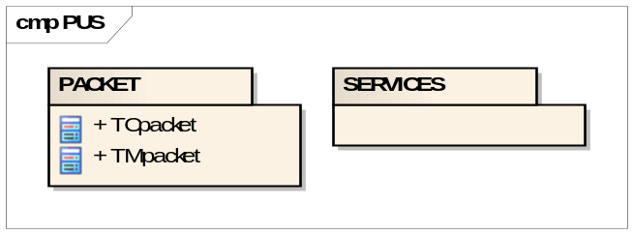

PACKET
Description: Packet Module

Classes:
- TCpacket: telecommand PUS packet (with datafield header)
- TMpacket: telemetry PUS packet (with datafield header)

SERVICES
Description: Service Definition

Classes: none

SCOE
This level 0 package consists of the following level 1 packages:

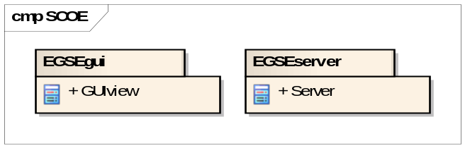

EGSEgui
Description: EGSE server GUI

Classes:
- GUIview: Implementation of the SCOE EGSE GUI layer

EGSEserver
Description: EGSE server for connection to CCS

Classes:
- Server: Server interface class to the CCS

SCOS
This level 0 package consists of the following level 1 packages:

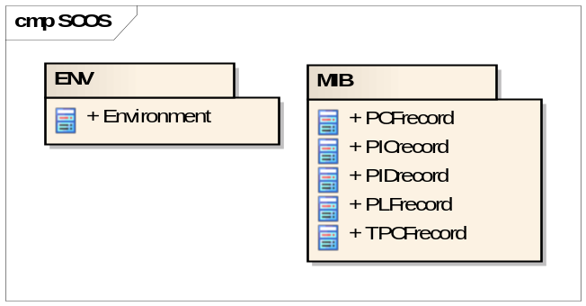

ENV
Description: Environment

Classes:
- Environment: Manager for environment data

MIB
Description: Mission Database (MIB) handling

Classes:
- PCFrecord: MIB record from pcf.dat
- PICrecord: MIB record from pic.dat
- PIDrecord: MIB record from pid.dat
- PLFrecord: MIB record from plf.dat
- TPCFrecord: MIB record from pid.dat

SIM
This level 0 package consists of the following level 1 packages:

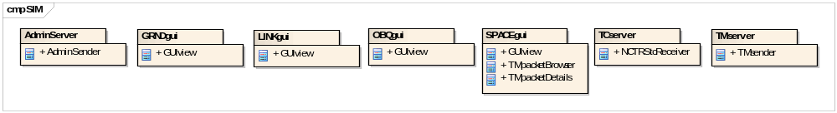

AdminServer
Description: NCTRS admin message server

Classes:
- AdminSender: Subclass of GRND.NCTRS.AdminMessageSender

GRNDgui
Description: Ground Segment Simulation GUI

Classes:
- GUIview: Implementation of the SIM Ground GUI layer

LINKgui
Description: Space Link Simulation GUI

Classes:
- GUIview: Implementation of the SIM Link GUI layer

OBQgui
Description: Onboard Queue Simulation GUI

Classes:
- GUIview: Implementation of the SIM Onboard Queue GUI layer

SPACEgui
Description: Space Segment Simulation GUI

Classes:
- GUIview: Implementation of the SIM Space GUI layer
- TMpacketBrowser: Browser for TM packets
- TMpacketDetails: Displays the packet details, implemented as Tkinter.Frame

TCserver
Description: NCTRS TC server

Classes:
- NCTRStcReceiver: Subclass of GRND.NCTRS.TCreceiver

TMserver
Description: NCTRS TM server

Classes:
- TMsender: Subclass of GRND.NCTRS.TMsender and SPACE.OBC.TMsender

SPACE
This level 0 package consists of the following level 1 packages:

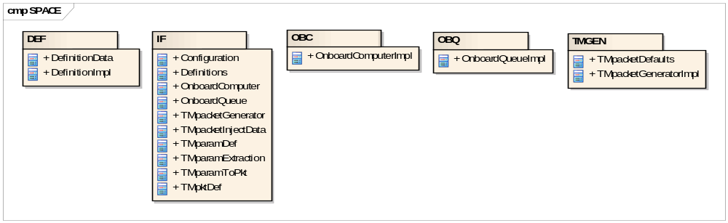

DEF
Description: Space Data Definitions

Classes:
- DefinitionData: Data part of the Definitions that can be saved and loaded
- DefinitionsImpl: Manager for definition data

IF
Description: Space Interface

Classes:
- Configuration: Configuration
- Definitions: Interface for definition data
- OnboardComputer: Interface of the onboard computer
- OnboardQueue: Interface of the onboard queue
- TMpacketGenerator: Interface of the generator for telemetry packets
- TMpacketInjectData: Data of a TM packet that can be injected
- TMparamDef: Contains the most important definition data of a TM parameter
- TMparamExtraction: Defines a dedicated parameter extraction in a packet
- TMparamToPkt: Contains the data for a single raw value extraction
- TMpktDef: Contains the most important definition data of a TM packet

OBC
Description: Onboard Computer

Classes:
- OnboardComputerImpl: Interface of the onboard computer

OBQ
Description: Onboard Queue

Classes:
- OnboardQueueImpl: Implementation of the onboard computer

TMGEN
Description: Telemetry Packet Generator

Classes:
- TMpacketDefaults: Default values for TM packet creation
- TMpacketGeneratorImpl: Implementation of the generator for telemetry packets

UI
This level 0 package consists of the following level 1 packages:

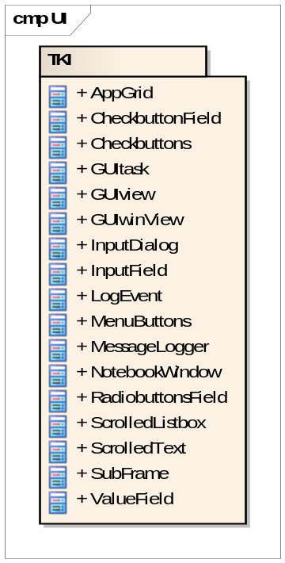

TKI
Description: Tkinter support classes

Classes:
- AppGrid: Helper class for grid layout
- CheckbuttonField: Combines a fixed label field and an checkbutton field
- Checkbuttons: Maintains a set of check buttons
- GUItask:Tkinter based task, is the parent task (in the main thread)
- GUIview: Frame with grid layout that consumes status updates
- GUIwinView: GUI window contents
- InputDialog: Input dialog with text field and checkbox entries
- InputField: Combines a fixed label field and an entry field
- LogEvent: event that forces a logging in the gui task
- MenuButtons: Maintains application buttons
- MessageLogger: Scrolled text which implements a GUI based UTIL.SYS.Logger
- NotebookWindow: Application window with a notebook for embedded views.
- RadiobuttonsField: Combines fixed label fields and an radiobutton fields
- ScrolledListbox: Tkinter.Listbox with scroll bars, implemented as Tkinter.Frame
- ScrolledText: Tkinter.Text with scroll bars, implemented as Tkinter.Frame
- SubFrame: Maintains a frame with grid layout
- ValueField: Combines a fixed label field and a dynamic value field managed by a StringVar

UTIL
This level 0 package consists of the following level 1 packages:

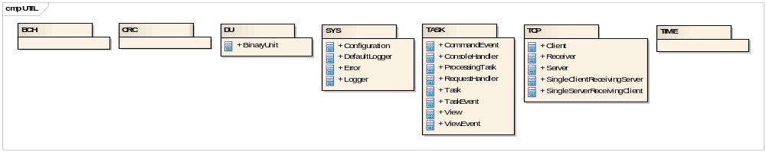

BCH
Description: BCH Encoding

Classes: none

CRC
Description: CRC Checksum Calculation

Classes: none

DU
Description: Data Unit

Classes:
- BinaryUnit: immutable binary data unit

SYS
Description: System Module

Classes:
- Configuration: configuration manager
- DefaultLogger: simple logger that logs via print
- Error: module specific exception to support selective catching
- Logger: interface for logger implementation

TASK
Description: Task Module

Classes:
- CommandEvent: command event that forces an execution in the task
- ConsoleHandler: generic keyboard handler that can be registers in the ModelTask
- ProcessingTask: A task that performs the processing of the application.
- RequestHandler: Handles the requests invoked by the ART framework
- Task: A task is an execution unit attached to a thread.
- TaskEvent: events that are executed from a task
- View: consumer of status updates
- ViewEvent: status event that automatically notifies all views

TCP
Description: TCP/IP Module

Classes:
- Client: TCP/IP client
- Receiver: TCP/IP receiver
- Server: TCP/IP server
- SingleClientReceivingServer: TCP/IP server that receives data from a single client
- SingleServerReceivingClient: TCP/IP client that receives data from a single server

TIME
Description: Time Conversions

Classes: none

SIM

Overview
SIM is a Ground/Space Simulator implemented with the SpacePyLibrary. It has been developed to support system testing of ESA’s spacecraft control system SCOS-2000. The major advantages of SIM are:
- simplicity
- support for non-nominal tests
- the generic design, which allows testing of telemetry and telecommand components of various SCOS-2000 configurations in a semi-automatic way:

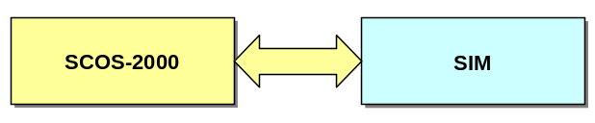

Three TCP/IP connections are used between SCOS-2000 and SIM:

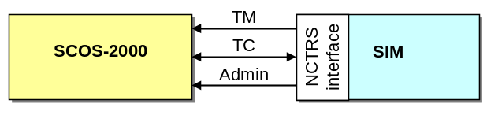

- TM: This connection is used to send telemetry frames from SIM to SCOS-2000.
- TC: This connection is used to send telecommand CLTUs from SCOS-2000 to SIM and to send groundstation replies from SIM back to SCOS-2000.
- Admin: This connection is used to send groundstation administration messages from SIM to SCOS-2000.

Architecture of SIM
SIM has a layered architecture according to the model/view separation pattern:

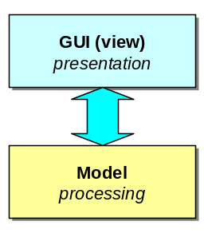

Depending on the python platform that is used for the execution of SIM, GUI and Model are running in a common thread (single-threaded python) or in separate threads (multi-threaded python). The model and view layers consist of the following major components:

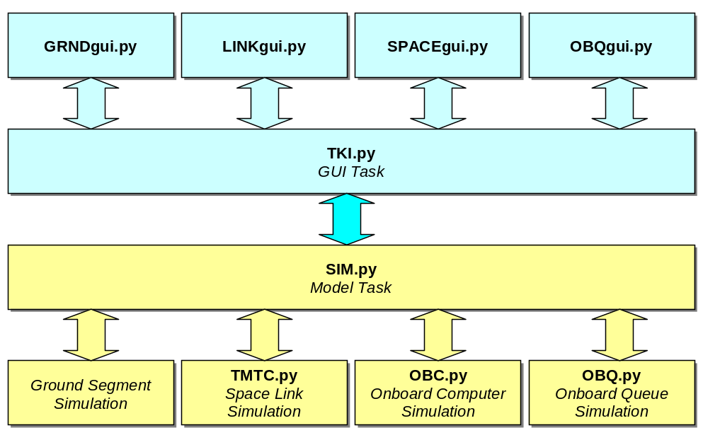

The model objects are:
- Ground Segment Simulation: Simulates the ground components, especially the NCTRS interface to SCOS.2000. In addition the ground station TC responses are generated here.
- TMTC.py This component simulates the CCSDS telemetry and telecommand link from the ground station to the spacecraft.
- OBC.py This component simulates the spacecraft’s onboard computer: Spacecraft TC acknowledgements are generated here for received telecommands.
- OBQ.py This component simulates the spacecraft’s onboard queue. Telecommands are delayed according to the related execution time.
The view objects are implemented with the python GUI packets Tkinter and Ttk:
- GRNDgui.py This component visualizes the state of the ground simulation and handles the ground simulation user input commands.
- LINKgui.py This component visualizes the telemetry and telecommand link from the ground station to the spacecraft and handles the link user input commands.
- SPACEgui.py This component visualizes the spacecraft state and handles the user input of spacecraft user input commands.
- OBQgui.py This component visualizes the spacecraft’s onboard queue simulation and handles the onboard queue user input commands.

SCOE

Overview
SCOE is a Frontend Checkout Equipment Simulator implemented with the SpacePyLibrary. It has been developed to support system testing of Central Checkout Systems (CCS) like ESA’s EGSE SCOS system or TERMA’s Test Sequence Controller. The major advantages of SCOE are:
- simplicity
- support for non-nominal tests
- the generic design, which allows testing of telemetry and telecommand components of various CCS configurations in a semi-automatic way:

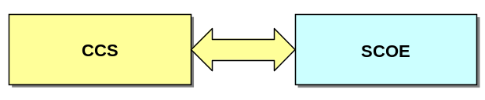

One TCP/IP connection is used between CCS and SCOE:

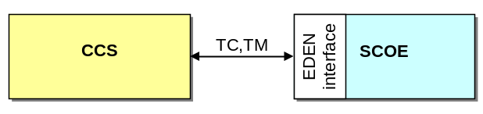

- TC,TM: This connection is used to send telecommand packets from the CCS to SCOE and to send telemetry packets from SCOE to the CCS.

Architecture of SCOE
SCOE has a layered architecture according to the model/view separation pattern:

Depending on the python platform that is used for the execution of SCOE, GUI and Model are running in a common thread (single-threaded python) or in separate threads (multi-threaded python). The model and view layers consist of the following major components:

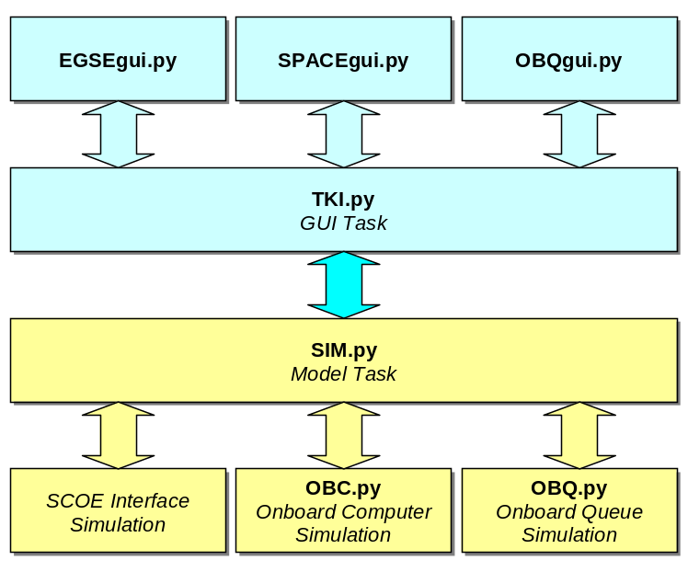

The model objects are:
- SCOE Interface Simulation: simulates the SCOE EDEN interface for TC and TM.
- OBC.py This object simulates the spacecraft’s onboard computer: Spacecraft TC acknowledgements are generated here for received telecommands.
- OBQ.py This object simulates the spacecraft’s onboard queue. Telecommands are delayed according to the related execution time.
The view objects are implemented with the python GUI packets Tkinter and Ttk:
- EGSEgui.py This object visualizes the state of the SCOE EDEN interface and handles the related user input commands.
- SPACEgui.py This object visualizes the spacecraft state and handles the user input of spacecraft user input commands.
- OBQgui.py This object visualizes the spacecraft’s onboard queue simulation and handles the onboard queue user input commands.

<<end of document>>

