Scrum Planner

Vision

Version 1.1

Revision History

|  |  |  |  |
| --- | --- | --- | --- |
| **Date** | **Version** | **Description** | **Author** |
| 12/03/2016 | 1.0. | Initial draft | Stefan Pamparau |
| 20/03/2016 | 1.1 | Second draft | Stefan Pamparau |
|  |  |  |  |
|  |  |  |  |

**Table of Contents**

1.Introduction 3

1.1Purpose 3

1.2Scope 3

1.3Definitions, Acronyms, and Abbreviations 4

1.4References 4

1.5Overview 4

2.Positioning 4

2.1Problem Statement 4

2.2Product Position Statement 5

3.Stakeholder and User Descriptions 5

3.1Stakeholder Summary 5

3.2User Summary 6

3.3User Environment 6

4.Product Requirements 7

# Introduction

The current Vision document provides a high-level overview of the first phase of the System Development Life Cycle for the Scrum Planner application. It focuses on the capabilities needed by the stakeholders and the target users, and why these needs exist. The details of how the Scrum Planner application fulfills these needs are detailed in the use-case and supplementary specifications.

The introduction of the Vision document highlights the main sections of the entire document. It includes the purpose, scope, definitions, acronyms, abbreviations, references and an overview of this Vision document.

## Purpose

The purpose of this vision document is to communicate business needs in common terms to all project and technical team members to ensure the end product meets the established business objectives afferent to phase 1. It collects, analyzes and defines high-level needs and features of the Scrum Planner application.

## Scope

The current Vision document is associated with the Scrum Planner application. The main features in scope for phase 1 are:

* The development of a central server which will retain information about the clients and associated projects
* The development of a desktop client application to be able to communicate with the central server
* The establishment of a REST API to facilitate the communication between the clients and server
* Creation of class hierarchies afferent to users, server, user stories, company, projects, etc.
* Registration and Login and afferent account CRUD operations
* Creation of Scrum projects and their associated actions (e.g.: CRUD operations)
* Ability of a user to join/leave a project
* Creation of user stories and their associated actions (e.g.: CRUD operations)
* User ability to join multiple projects and change between them
* Permission requirements to perform CRUD operations on projects, clients, etc.
* Ability of an user to be Scrum Master
* Live edit of user stories

## Definitions, Acronyms, and Abbreviations

|  |  |
| --- | --- |
| Scrum | an iterative and incremental agile software development framework for managing product development |
| CRUD | create, retrieve, update and delete operations |
| Scrum Master | the facilitator for a product development team that uses Scrum. He is responsible for making sure a Scrum team lives by the values and practices of Scrum. |

For a more complete list of abbreviations and terms used please refer to the Glossary document.

## References

The following list of documents / sources are referenced in this document:

|  |  |  |
| --- | --- | --- |
| Document source | Date | Version |
| Use Case Model | 20.03.2016 | 1.1 |
| Supplementary Specification | 20.03.2016 | 1.1 |
| Glossary document | 20.03.2016 | 1.1 |

## Overview

The next sections of the current Vision document are Positioning, Stakeholder and User Descriptions followed by Product Requirements. The Positioning section states the project's area of interest providing a problem statement and a product position statement. The Stakeholder and User Descriptions section detail information about the project's stakeholders and targeted users as well as the user's environment. The Product Requirements section specifies the project's specifications (e.g.: hardware or platform requirements, performance requirements).

# Positioning

## Problem Statement

|  |  |
| --- | --- |
| The problem of | Poor team performance in software development |
| affects | Software companies, business companies, software developers, software quality |
| the impact of which is | Low quality code and low software performance |
| a successful solution would be | Improving team communication, establishing of clear team member roles, better task distribution between software developers |

## Product Position Statement

|  |  |
| --- | --- |
| For | Software companies, developer teams, developers |
| Who | Develop software products / follow agile practices |
| The (product name) | Scrum Planner |
| That | Manages collocated or distributed agile teams from vision to working products |
| Unlike | Other agile tools |
| Our product | Offers flexible team management with live edit |

# Stakeholder and User Descriptions

This section section aims to identify and provide a description of the stakeholders and target users of the Scrum Planner application. It does not describe their specific requests or requirements, instead it supplies a background and justification for why the requirements are needed.

## Stakeholder Summary

|  |  |  |
| --- | --- | --- |
| **Name** | **Description** | **Responsibilities** |
| Board of directors | Body of elected or appointed members who jointly oversee the activities of a company or organization. | * Approve funding in a company * Ensure the availability of adequate financial resources for company projects |
| Project manager | Appointed employee of the company which is in charge of the Software's Development Life Cycle. | * Responsible for the success of the project * Appoints task to team developers * Handles communication with the clients * Ensures written code quality * Ensure application meets established requirements |
| Project team | Team of employees who design, implement and test the final product. | * Responsible for designing and implementing the end product * Ensure application meets established requirements |
| Stockholders | An individual or institution that legally owns a share of the company's stock. | * ensure that everyone is working towards the same goal |
| Sponsors | Sponsors allocate and supply resources and finances to fund the project. | * responsible for the overall success and vision of the project. * provide feedback and make decisions regarding project implementation and assure that the project manager remains on the task. |

## User Summary

|  |  |  |
| --- | --- | --- |
| **Name** | **Description** | **Responsibilities** |
| Business customers | End company which will utilize the end product. | * Provide feedback * Reports bugs * Request additional features |
| Client customers | End client which will utilize the end product. | * Provide feedback * Reports bugs * Request additional features |

## User Environment

The working environment for the end users will most likely consist of their work place. Since Scrum Planner targets end users are involved in software development, the work place can vary according to the end users preferences.

Scrum Planner is a management application for software development teams that use agile practices. More specifically, Scrum Planner is intended for the Scrum agile practice which is framework within which people can address complex adaptive problems, while productively and creatively delivering products of the highest possible value.

The Scrum framework consists of Scrum Teams and their associated roles, events, artifacts, and rules. Each component within the framework serves a specific purpose and is essential to Scrum’s success and usage.

The Scrum process framework can be depicted in the following picture:

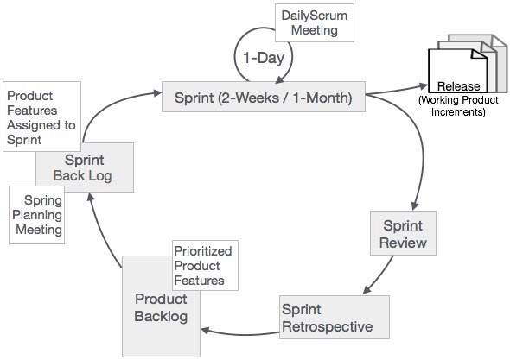

The Scrum Planner application will not be expected to integrate with other end points in the phase 1 of the development life cycle, although this can change as more and more parts of the central server (e.g. user registration and login, etc.) can be separated into multiple end points.

# Product Requirements

As Scrum Planner will be implemented in an object oriented language, the application will be expected to meet the requirements set by the object oriented paradigm. Apart from the software requirements of the application, the hardware requirements will not be very high as the involved application is a small to medium sized project.

Software requirements:

SOLID principles:

* Single responsibility principle – every class needs to have a single responsibility. This principle can further be extended to include class methods
* Open closed principle – an application needs to be opened for extension and closed for modification. In other words, based on th existing code, new features must be easily implemented
* Liskov substitution principle – a subclass can be substituted with it's superclass
* Interface segregation principle – interfaces which declare methods that do not have similarities must be separated
* Dependency inversion principle – classes must depend on abstractions

Hardware requirements:

* OS independence
* minimal hardware resource consumption
* maximum stability and reliability
* fault tolerant