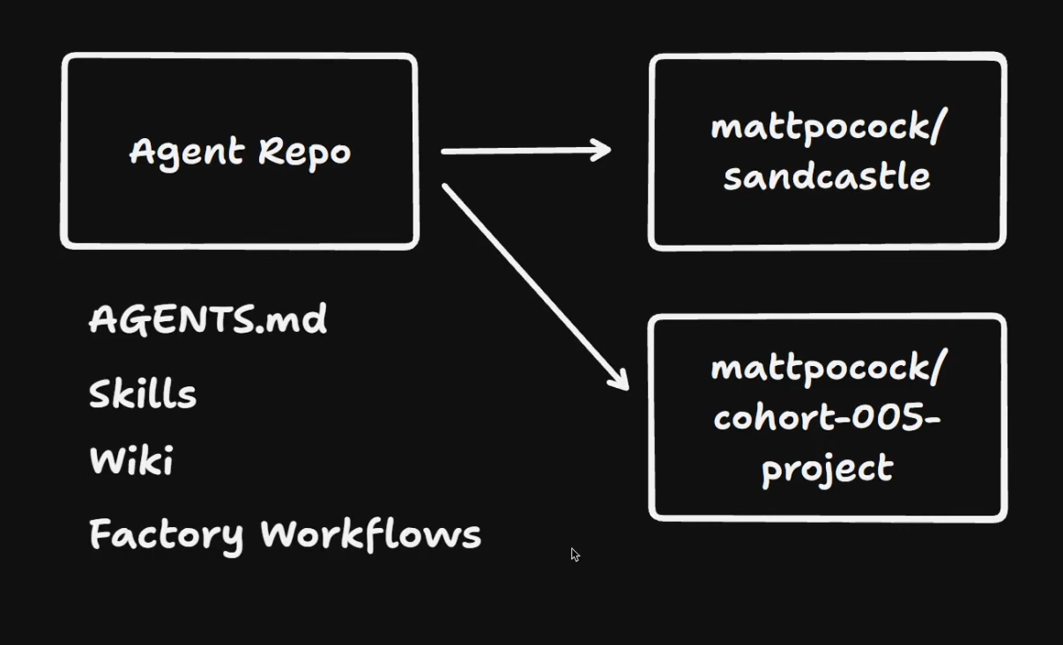
Agent repo
Links to other repos, you can clone if you want/need

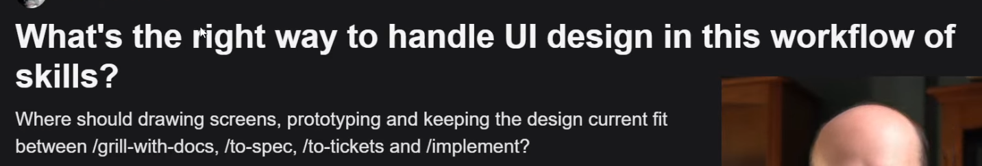
Design/UI: wayfinder, prototyping
Skills: impeccable etc. (prototyping)

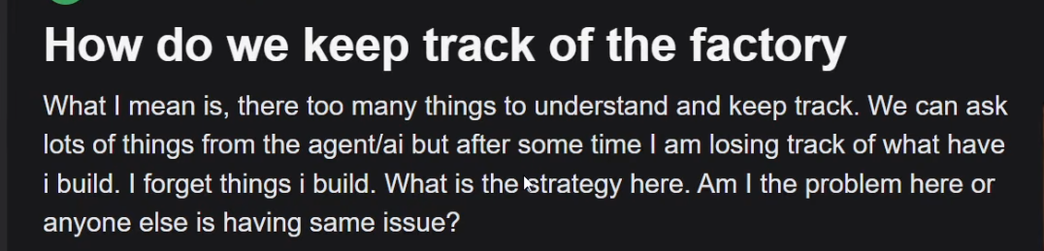
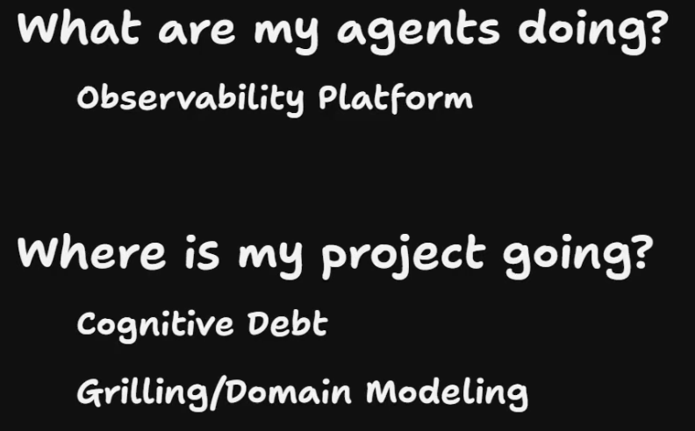
- Agent: cost
- Project: code base

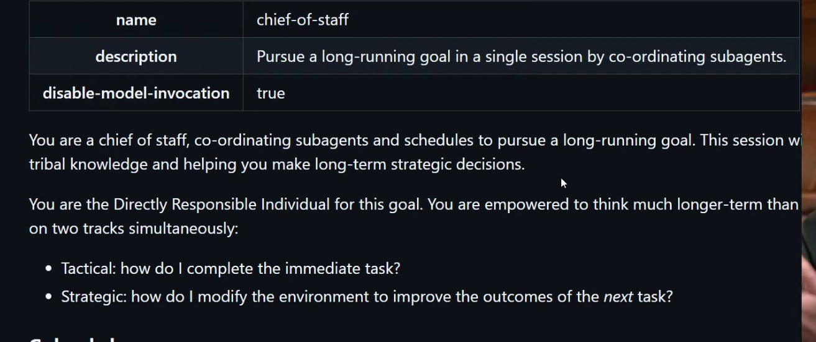
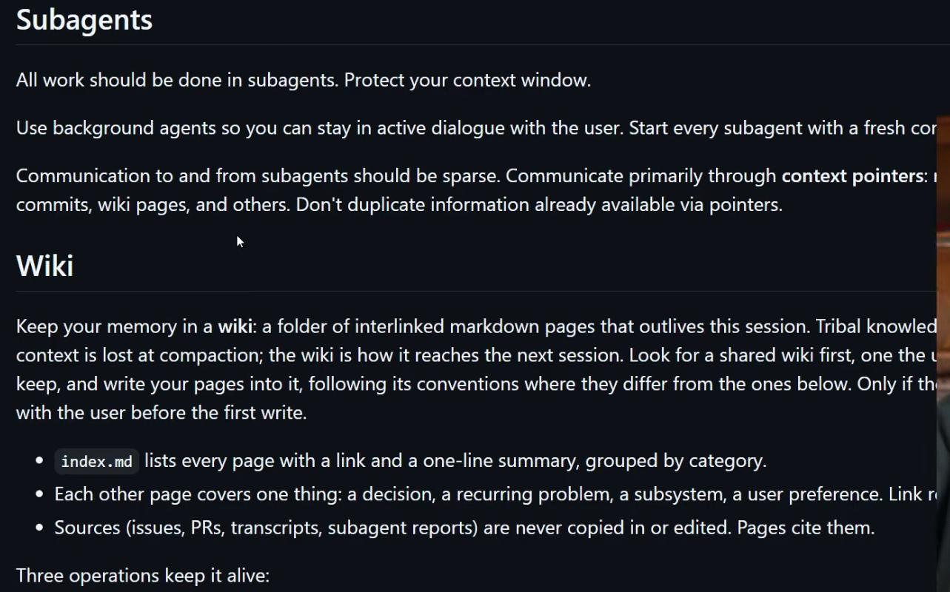
Runs in agent repo

Team Works
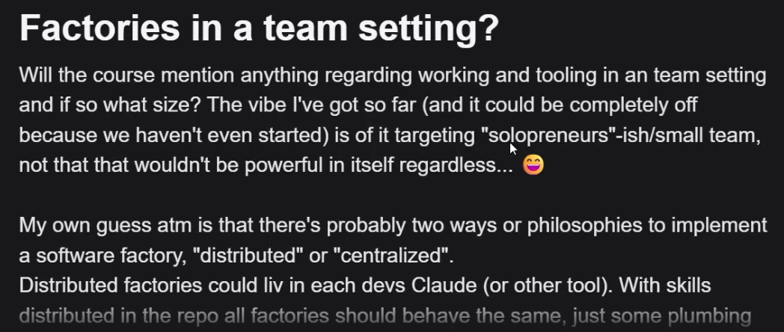

Google Chat? Slack Channel, Pair Programming

