Deployment plan and rollout strategy

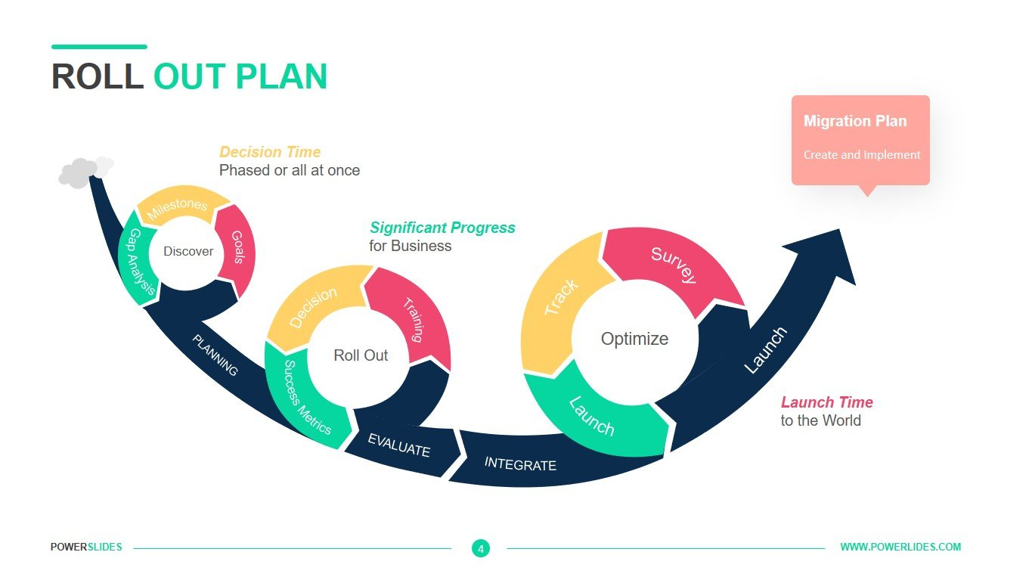

Table of Contents

1. Overview 3

Project Name: 3

Objective: 3

2. Deployment Environment 3

Cloud Provider: 3

Infrastructure: 3

3. Timeline 3

Start Date: 3

End Date: 3

4. Key Stakeholders 3

5. Infrastructure Setup 3

6. Deployment Strategy 3

Rolling Updates: 3

Process: 3

Advantages: 4

Considerations: 4

7. Monitoring and Observability 4

8. Backup and Recovery 4

9. Contingency Planning 4

10. Scaling 4

11. Security 4

12. Testing 5

13. Training and Documentation 5

14. Closure 5

# 1. Overview

## Project Name:

K8 cluster deployment

## Objective:

Deploy a K8 cluster in Development Environment(It was decided that there was no point in deploying it in a production environment at this point of time as the process of deploying is the same and the project is finalized, the only thing needed to do is connect the kubectl command to the AKS and run the deployment and service files.)

# 2. Deployment Environment

# Cloud Provider:

Azure.

# Infrastructure:

Kubernetes Cluster (AKS)(Production) and Minikube(Development).

# 3. Timeline

# Start Date:

28/11/2023

# End Date:

15/01/2024

# 4. Key Stakeholders

Teachers, clients and developer.

# 5. Infrastructure Setup

Refer to the cluster design document and the project management plan.

# 6. Deployment Strategy

## Rolling Updates:

Definition: In a rolling update, new versions of your application are gradually deployed to a subset of instances while the rest continue running the old version.

## Process:

Deploy the new version to a small number of instances.

Verify that the new version is functioning correctly.

If successful, continue deploying to the next set of instances.

Repeat until the new version is deployed to all instances.

## Advantages:

Minimal downtime.

Gradual and controlled rollout.

## Considerations:

Ensure that your application can handle mixed versions during the rollout.

# 7. Monitoring and Observability

For monitoring we are going to be using the built in Azure tool (Azure monitor) to watch our deployment, logs and important information about the deployment, pods and nodes.

# 8. Backup and Recovery

Refer to Backup solution documentation.

# 9. Contingency Planning

Refer to Business continuity plan.

# 10. Scaling

Kubernetes has a built in scaling system that distributes the load between its load balancers.

# 11. Security

We have first a network policy:

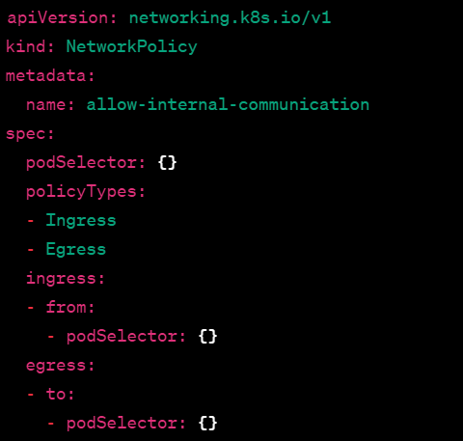

Which allows the pods to communicate with each other both for ingress and egress traffic and we fill in the frontend in the ingress traffic and egress traffic for the rest of the pods.

We have also setup Azure AD Pod Identity configuration:



And a Pod Identity Binder:

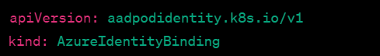

(You can check the rest of the files in the files for the deployment, this is just to show them and not leak information)

# 12. Testing

Refer to testing documentation.

# 13. Training and Documentation

Refer to handover guide(user manual)

# 14. Closure

Good luck to the ones using this project in the future.