# Exercises: Object and Classes

Problems for exercise for the ["PHP Fundamentals" course @ SoftUni](https://softuni.bg/trainings/2344/php-fundamentals-may-2019).

You can check your solutions in [Judge](https://judge.softuni.bg/Contests/1222/).

## Order by Age

You will receive an **unknown** number of lines. On each line, you will receive array with **3** elements. **The first** element will be а **string** and represents the name of the person. **The second** element will be a **string** and will represent the **ID** of the person. **The last** element will be an **integer** and represents the **age** of the person.

When you receive the command "**End**", stop receiving input and print **all the** **people**, **ordered** by **age**.

### Examples

|  |  |
| --- | --- |
| **Input** | **Output** |
| Georgi 123456 20  Pesho 78911 15  Stefan 524244 10  End | Stefan with ID: 524244 is 10 years old.  Pesho with ID: 78911 is 15 years old.  Georgi with ID: 123456 is 20 years old. |

## Average Grades

Define a class Student, which holds the following information about students: **name**, **list of grades** and **average grade** (calculated property, read-only). A single grade will be in range [2…6], e.g. 3.25 or 5.50.

Read an **array of students** and print the students that have **average grade ≥ 5.00** ordered **by name** (**ascending**), then by **average** **grade** (**descending**). Print the student name and the calculated average grade.

**Examples**

|  |  |
| --- | --- |
| **Input** | **Output** |
| 3  Ivan 3  Todor 5 5 6  Diana 6 5.50 | Diana -> 5.75  Todor -> 5.33 |
| 6  Petar 3 5 4 3 2 5 6 2 6  Mitko 6 6 5 6 5 6  Gosho 6 6 6 6 6 6  Ani 6 5 6 5 6 5 6 5  Iva 4 5 4 3 4 5 2 2 4  Ani 5.50 5.25 6.00 | Ani -> 5.58  Ani -> 5.50  Gosho -> 6.00  Mitko -> 5.67 |

## Book Library

To model a **book library**, define classes to hold a **book** and a **library**.

The library must have a **name** and a **list of books**. The books must contain the **title**, **author**, **publisher**, **release date** (in dd.MM.yyyy format), **ISBN-number** and **price.**

Read a number **n**, followed by **n** lines of **lists of books**, add them to the library and print the **total sum of prices by author**,ordered **descending by price** and **then by author’s name lexicographically**.

Books in the input will be in format **{title} {author} {publisher} {release date} {ISBN} {price}**.

The total prices must be printed **formatted to the second decimal place**.

### Examples

|  |  |
| --- | --- |
| **Input** | **Output** |
| 5  LOTR Tolkien GeorgeAllen 29.07.1954 0395082999 30.00  Hobbit Tolkien GeorgeAll 21.09.1937 0395082888 10.25  HP1 JKRowling Bloomsbury 26.06.1997 0395082777 15.50  HP7 JKRowling Bloomsbury 21.07.2007 0395082666 20.00  AC OBowden PenguinBooks 20.11.2009 0395082555 14.00 | Tolkien -> 40.25  JKRowling -> 35.50  OBowden -> 14.00 |

### Hints

* Create classes Book and Library with all the mentioned above properties:
* 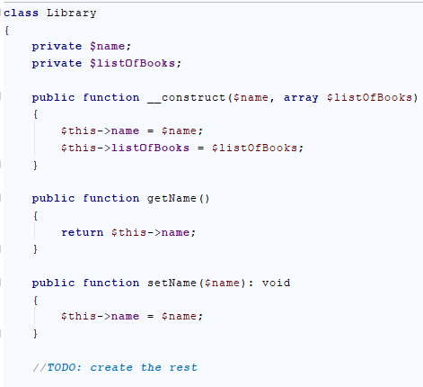
* 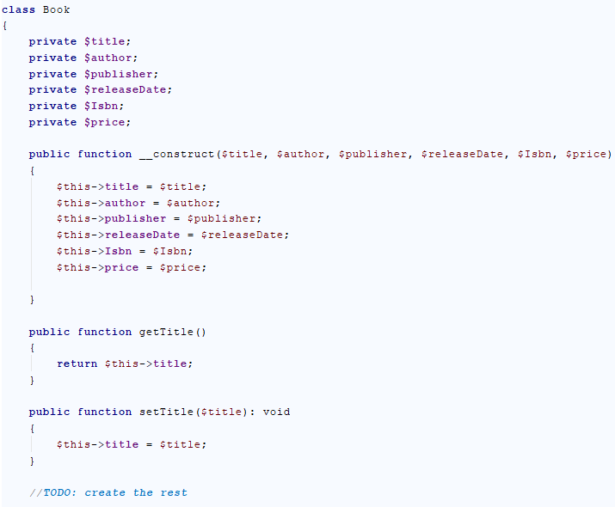
* **Create** an object of type Library.
* **Read the input** and create a Bookobject for each book in the input.

## Articles

Create an article class with the following properties:

* **title** – a string
* **content** – a string
* **author** – a string

The class should have a constructor and the following methods:

* **edit (new content**) – change the old content with the new one
* **changeAuthor (new author)** – change the author
* **rename (new title)** – change the title of the article
* override __toString() – print the article in the following format: **"{title} - {content}: {author}"  
  Hint: you can check** [here](http://php.net/manual/en/language.oop5.magic.php#object.tostring) **for more details**

Write a program that reads an article in the following format **"{title}, {content}, {author}"**. On the next line, you will get a number **n**. On the next **n lines,** you will get one of the following commands:

"Edit: {new content}"

"ChangeAuthor: {new author}"

"Rename: {new title}"

At the end, print the final article.

### Example

|  |  |
| --- | --- |
| **Input** | **Output** |
| some title, some content, some author  3  Edit: better content  ChangeAuthor: better author  Rename: better title | better title - better content: better author |

## Articles 2.0

Change the program, so you can store a **list of articles**. You will not need the methods any more (**except the** __toString() **method**). On the **first line**, you will get a number **n**. On the **next n lines**, you will get some **articles in the same format** as the previous task (**"{title}, {content}, {author}"**). Finally, you will get one of the **three inputs**:

**"title"**

**"content"**

**"author"**

You need to **order the articles** alphabetically based on the command and **print them sorted by the given criteria**.

### Example

|  |  |
| --- | --- |
| **Input** | **Output** |
| 2  Science, planets, Bill  Article, content, Johnny  title | Article - content: Johnny  Science - planets: Bill |
| 3  title1, C, author1  title2, B, author2  title3, A, author3  content | title3 - A: author3  title2 - B: author2  title1 - C: author1 |

## Mentor Group

You are mentor of a group. You have done your job well and now you have to generate a report about your group's activity. You will be given usernames and dates ("***dd/MM/yyyy***"), dates (**if any**) are separated with comma, until you receive command "**end of dates**". After that you will receive user and some comment (separated with dash). You can add comment for every user who is **in** your group(if **not** ignore the line). Adding comment/date to same user more than once should **append** to that user the comment/date. Upon receiving command "**end of comments**" you should generate report in format:

|  |
| --- |
| {user}  Comments:  - {firstComment} …  Dates attended:  -- {firstDate}  -- {secondDate} |

Users should be printed ordered by name (ascending). For every user, their dates should be sorted again in ascending order. Input will be valid and in the format described - you should **not check** it explicitly!

### Examples

|  |  |
| --- | --- |
| **Input** | **Output** |
| nakov 22/08/2016,20/08/2016  simeon10 22/08/2016  end of dates  nakov-Excellent algorithmic thinking.  Gesh4o-Total noob.  end of comments | nakov  Comments:  - Excellent algorithmic thinking.  Dates attended:  -- 20/08/2016  -- 22/08/2016  simeon10  Comments:  Dates attended:  -- 22/08/2016 |
| **Comments** | | |
| Not that simeon10 has no comments but we still leave the comments section. User Gesh4o does not have attendancy date so he is not registered in your group therefore he is not a part from the report. | | |

|  |  |
| --- | --- |
| **Input** | **Output** |
| student1  student2 13/11/2011  end of dates  student1-Bad.  student1-Good.  student1-Definetely good.  end of comments | student1  Comments:  - Bad.  - Good.  - Definitely good.  Dates attended:  student2  Comments:  Dates attended:  -- 13/11/2011 |

## Teamwork Projects

It's time for teamwork projects and you are responsible for making the teams. First you will receive an integer - the **count** of the teams you will have to **register**. You will be given a **user** and a **team** (separated with "-"). The user is the **creator** of that team. For every newly created team you should **print** a message:

"Team {team Name} has been created by {user}!"

Next you will receive user with team (separated with "->") which means that the user wants to **join** that **team**. Upon receiving the command: "end of assignment", you should print **every team**, **ordered** by the **count** of its **members** (**descending**) and then by **name** (**ascending**). For each team, you have to print its members **sorted** by name (**ascending**). However, there are several **rules**:

* If user tries to **create** a team more than once a message should be displayed:
  + "Team {teamName} was already created!*"*
* Creator of a team cannot **create** another team - message should be thrown:
  + "{user} cannot create another team!"
* If user tries to **join** currently non-existing team a message should be displayed:
  + "Team {teamName} does not exist!*"*
* Member of a team cannot **join** another team - message should be thrown:
  + "Member {user} cannot join team {team Name}!"
* In the **end** (*after teams' report*) teams with **zero** members (with **only a creator**) should **disband**. Every **valid** team should be printed ordered by **name** (ascending) in this format:

|  |
| --- |
| "{teamName}:  - {creator}  -- {member}…" |

### Examples

|  |  |  |
| --- | --- | --- |
| **Input** | **Output** | **Comments** |
| 2  Didi-PowerPuffsCoders  Toni-Toni is the best  Petq->PowerPuffsCoders  Toni->Toni is the best  end of assignment | Team PowerPuffsCoders has been created by Didi!  Team Toni is the best has been created by Toni!  Member Toni cannot join team Toni is the best!  PowerPuffsCoders  - Didi  -- Petq  Teams to disband:  Toni is the best | Toni created a team in which he tried later to join. So message was shown. Since there is no one other who is trying to join his team the team have to **disband**. |
| 3  Tatyana-CloneClub  Helena-CloneClub  Trifon-AiNaBira  Pesho->aiNaBira  Pesho->AiNaBira  Tatyana->Leda  PeshO->AiNaBira  Cossima->CloneClub  end of assignment | Team CloneClub has been created by Tatyana!  Team CloneClub was already created!  Team AiNaBira has been created by Trifon!  Team aiNaBira does not exist!  Team Leda does not exist!  AiNaBira  - Trifon  -- Pesho  -- PeshO  CloneClub  - Tatyana  -- Cossima  Teams to disband: | Note that when you join a team you should check **first** if it exists, **then** check if the user is already in a team:  Tatyana has created CloneClub, then she tries to join a non-existing team – so message for non-existing team is shown. |