# PHP Basic Web: Set up Symfony Project

**Symfony framework** comes with various ways of creating a project, all of them involving the [presence of Symfony project](https://symfony.com/download). The most convenient way is to **create a project via your IDE**. Luckily there are several **plugins** for **PHPStorm** (and the other **IDEA**-based IDE’s) which help developing application with Symfony.

## Install Plugins

Before we start working on our project, we can make our life easier by **installing** a couple of related **plugins**. After that we need to restart **PHPStorm**:

* Go to **[File]** 🡺 **[Settings]**

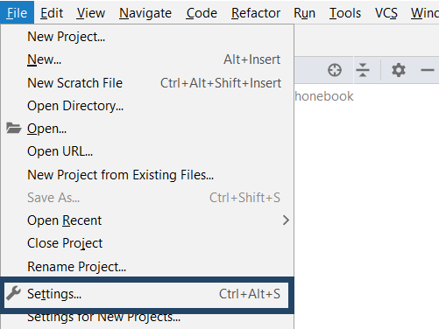

* **[Plugins]** 🡺 **[Browse Repositories]**

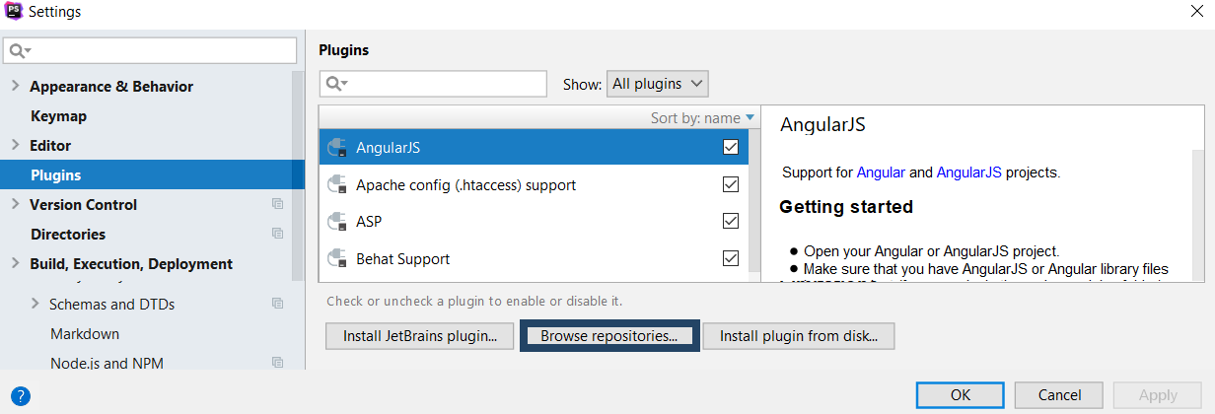

First install **Symfony Plugin**:

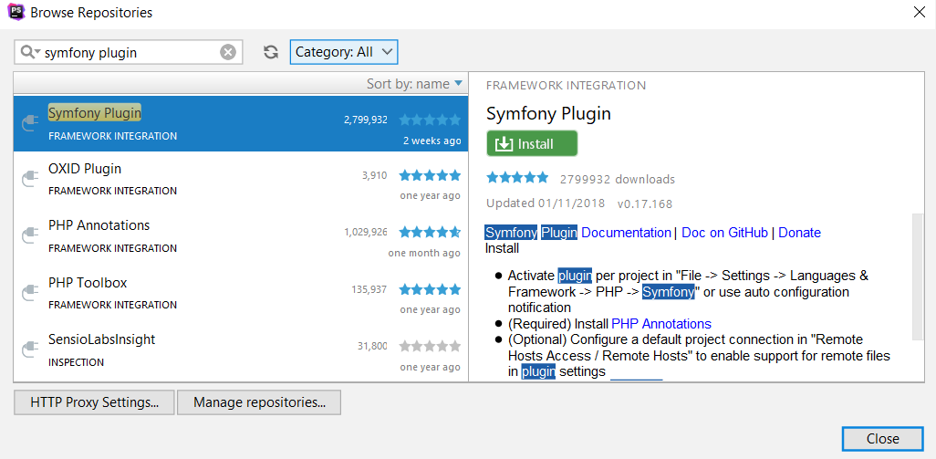

Then **PHP Annotations**:

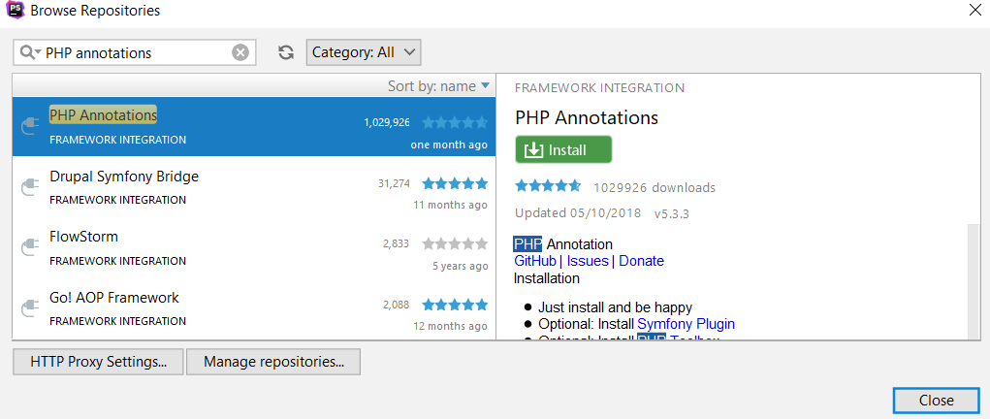

## Enabling the Symfony Plugin

* Go to **[PHP]** 🡺 **[Symfony]**

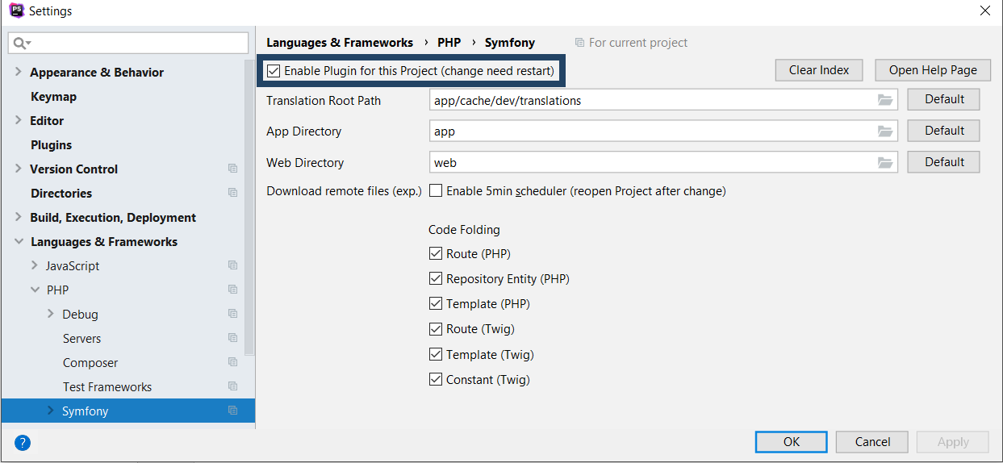

## Install Project Dependencies

Next we need to install theproject **dependencies** from the **composer.json** file:

* + Open the terminal

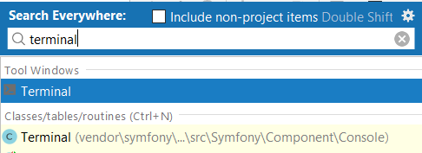

* + Write the following command: **composer install**

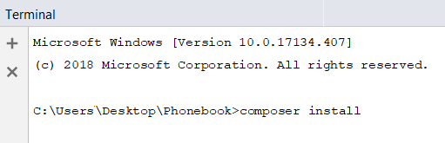

## Add Configuration

It's time to run the project. We need to create the **run configuration.** Open the **edit configurations** screen from the **top right** corner of PhpStorm:



You will be greeted by this screen:

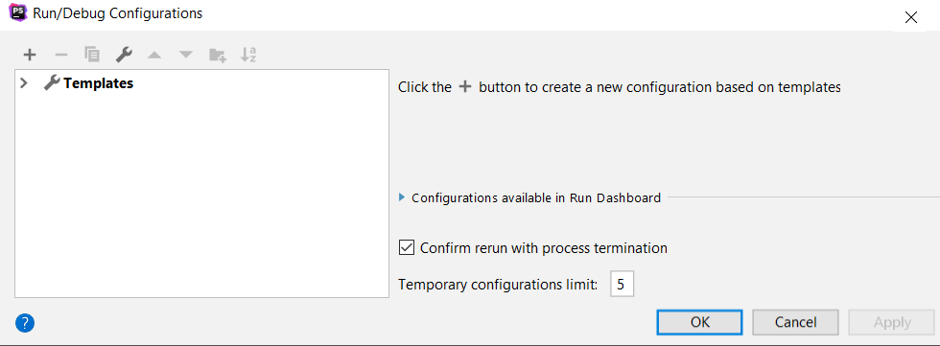

Open the add menu (**+**) and add a **PHP Script** run configuration:

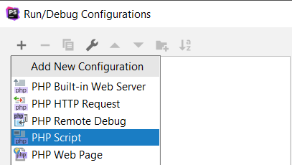

Check the "**Single instance only**" checkbox. After that, point the **File** textbox to the **bin/console** file, which is inside your project directory:

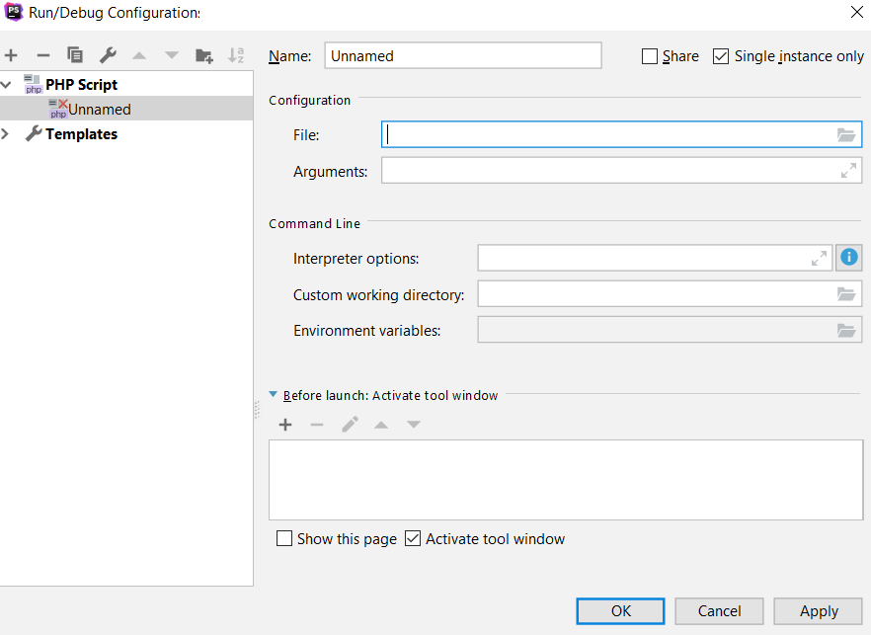

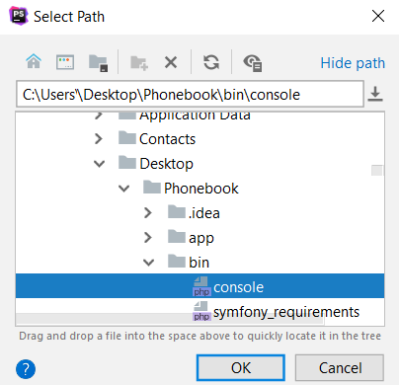

After that, add the "server:run" argument to the **arguments**. In the end, make sure your run configuration looks something like this:

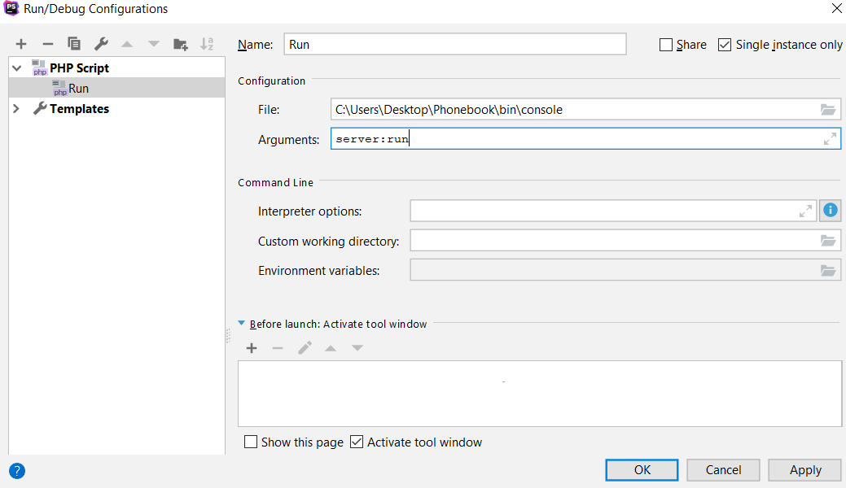

Now, if you attempt to **run** it by using the play button on the top right, if everything works correctly, you should be greeted by this screen on the bottom:

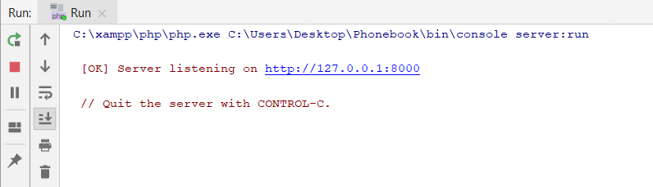

All the run configuration does is simply run the command line colored in blue, so you don’t have to type it into a command prompt every time. :)