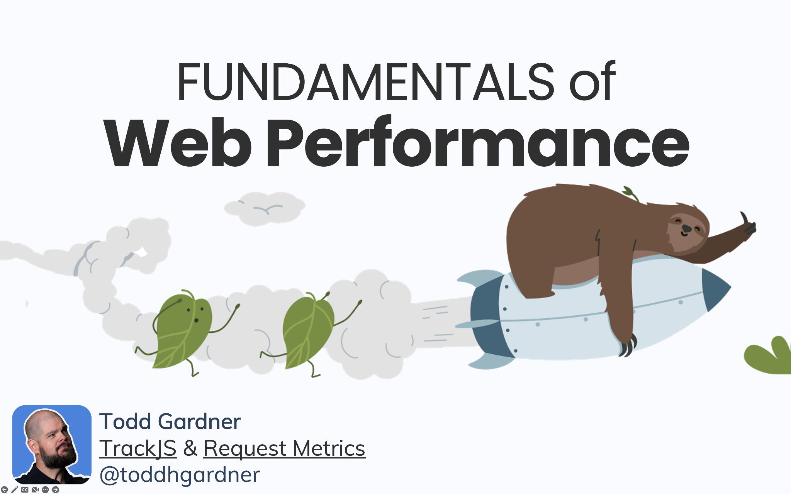

This folder is shared publicly readonly as materials for “Fundamentals of Web Performance”, a workshop given by Todd Gardner.

**Other Materials:**

<https://github.com/toddhgardner/perf-training-website>

<https://stackblitz.com/edit/node-em618c>