OLDR
Chimu Stefan-Catalin
Ciocoiu Alexandra
Murarasu Ionela

Project’s short description – project’s goal (max 150 words):
Application based on Linear Support Vector Machine (SVM) implemented by scikit-learn that detects offensive words from Romanian language. The model learns which words are bad and how bad they are because the words appear more often in offensive texts. We obtained our data by scraping web pages.

Architecture (schema):
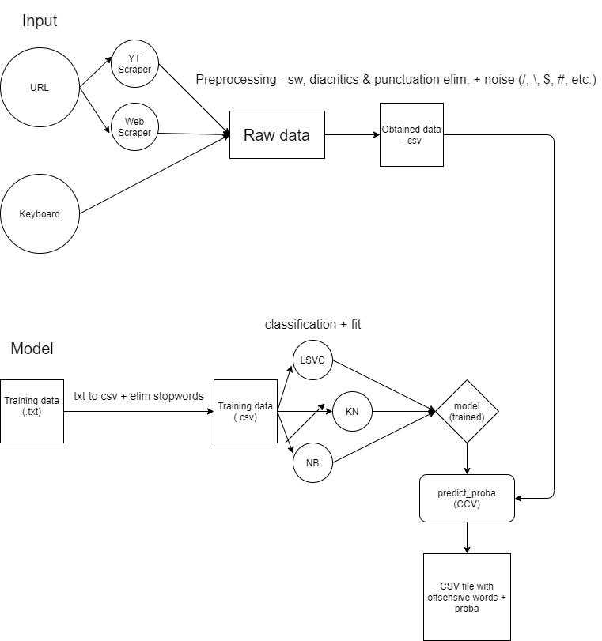

Project’s details (max 6 pages), including:
- Motivation:
Why did you choose this project? SWOT analysis of each team member (what were each team member’s main strengths/weaknesses/opportunities/threats)
This concept is the most used in social media and other text-based websites (services). We wanted to put our own mark by trying to implement a tool like that.
Stefan’s main strengths are logical thinking and determination which made him a great leader for our team but also a good colleague because of his contribution to the project development.
Alexandra’s team spirit and creativity had an impact on solving problems more openly.
Ionela’s adaptability and attention to details helped preventing mistakes and overcoming difficult sittuations.
- Challenges:
What was difficult/different that you expected/easier/…
The development of neural network and the classification of the words was more difficult because it required a lot of research and we had to try different methods till we found the right one for our project. On the other hand, making the charts was easier because we already had the results that just needed to be interpreted.
What was really enjoyable to work at?
All parts were enjoyable because we had the chance to apply our knowledge and learn more about the algorithms we implemented. For example, we began with scraping different web pages in order to make our corpus, then little by little we built our network, classifiers and interface.
- State of the art:
Discuss similar approaches (min. 2 articles per team member) in the same domain. Give a short paragraph for each articles you analysed, stating which was the method the authors used, the resources involved, the main findings. Provide also the full citation at the end, in the Reference section.
At the end of this section, discuss how the approach of your team is different then the one analysed before.
“In this paper, we describe an automatic flame detection method which extracts features at different conceptual levels and applies multi-level classification for flame detection. While the system is taking advantage of a variety of statistical models and rule-based patterns, there is an auxiliary weighted pattern repository which improves accuracy by matching the text to its graded entries.”
The authors of the article used multi-level classification for their software.
Our implementation is based on Linear Support Vector Machine provided by scikit-learn.
- Objectives:

Mainly the major steps towards the full architecture. Each objective can have different activities (sub-tasks) associated.

- Short description of each module in the architecture, including methods used, programming language, additional resources (if any), input/output formats, etc.
Python is used for the entire project.
- Web scraper:
Our function takes the text content from a web page like Wikipedia (with static text content). We used beautiful soup to offload the html page (only <p> </p>) and formatted the content so it can be ready to be used as a corpus.
- YouTube scraper:
Takes comments from YouTube with the help of selenium and chrome-driver. We changed our implementation compared to the web scraper because YouTube loads the comments dynamically. We needed to open a page with the help of chrome-driver which is scrolled automatically by the script to make a snapshot of the comments.
- Removing the stopwords:
The script replaces the letters with diacritics with the correspondent letter and also removes characters which appears in the html format.
- Preparing the data set:
We format the data from a txt file by removing the stopwords and creates a tuple array that contains the offensive labels and the formatted text. This array is written in a new csv file which will be used for training.

- Training:
For all classifiers the reading, splinting and vectorizing are the same: we read data from a csv file, then the data is splited in two parts (y is an array that contains the labels and X is an array that contains the text part). After that X is passed to the TF-IDF vectorizer and we call fit_transform(X) to obtain an array which can be passed to the classifier (classifier.fit(X, y)).
We have three classifiers: LinearSVC, KNeighbors and GaussianNB.
- Testing the accuracy:
The first function takes the results from the csv file (data obtained from scrapers/keyboard) and processes them according to the selected classifier. Words with predict_proba >= 0.85 will be considered offensive (we found out that those words are more relevant).
The second function compares offensive labels from the file used in the training proces with the labels obtained after training the model. Labels with proba >= 0.85 will be considered as offensive and the other ones as non-offensive. We used score functions from scikit-learn to obtain accuracy, precision, f1 and recall.
- Making the charts:
In this file we take the results we obtained after each call of test_acc_on_trained_dataset() which uses the training model to generate scores. Those scores will go into the chart showing the differences between classifiers.

- Description of the integration of different modules: problems foreseen, if any (incompatibility of programming languages, input/output format changes, etc.).

Project management (no imposed max. words no.): - please insert also link to project management board
- Assignment of team members for each different module (one team member per module)
Ionela: https://bit.ly/2P1jtny
Alexandra: https://bit.ly/3tPKU2t
Stefan: https://bit.ly/3siTTJc
- Did the project had a team leader? If yes, who is it? What were its main duties?
Stefan is the team leader. His main duties were to assign the tasks for each of us.

- Qualitative measures for the evaluation of the project (e.g. no. of annotations, no. of sentences processed, parsing accuracy/recall/precision, etc.).
- THIS WILL BE USED TO EVALUATE YOUR PROJECT!

References
https://link.springer.com/chapter/10.1007/978-3-642-13059-5_5
https://www.geeksforgeeks.org/plotting-multiple-bar-charts-using-matplotlib-in-python
https://scikit-learn.org/stable

