Design Report ROBOTICS II

Jerry-Rig

# Table of contents

Table of contents 2

Project Description 3

Hardware 4

Project Schedule 5

Flowchart and Pseudocode 6

Testing 7

Final words 7

Appendix 8

Sources 9

# Project Description

Jerry – Rig, is a robotic tricycle made from VEX robotics, arduino and rasberry pi component‘s and is remotely controlled through a web interface on a browser with any device i.e. laptop, desktop, tablet or phone.

When coming up with the idea for the project we wanted to focus on minimalism and simplicity so when the idea for a small rc car came up we wanted to go even simpler and decided on a tricycle.

In the making of the project we did not have a special design to follow rather what we did was to take the parts we saw laying around and made the robot out of what we had which in our opinion makes the project that much better because that enables almost anyone to make this project themselves.

# Hardware

Component's used:

-Rasberry Pi 3 Model B: <http://bit.ly/1WTq1N4>  
 -16GB micro sd card: http://amzn.to/2wZKjyc   
-2.5A micro usb charger: <http://amzn.to/2xIRIBo>  
-Generic circuit board cut to dimensions: <http://amzn.to/2gJBQc8>  
-Generic 6 pack AA battery holder, 7.2V: <http://amzn.to/2yprZzX>  
-Generic 165mm Breadboard: <http://amzn.to/2yspejs>

-Arduino Component's

-9v Battery snap connector: <http://bit.ly/2kTAMqH>  
-2x 10 jumper wire 150mm pack: <http://bit.ly/2zs8XJq>  
-L293D Motor Driver: http://bit.ly/2zspcpG

-Vex Robotics Component's

-Classroom & Competition Programming Kit (276-2900)  
 -2x 269 2-wire motor: <http://bit.ly/2eBeW9e>  
 -1x 2,75" omni wheel, 2x 2,75" wheel: <http://bit.ly/2exmwOz>  
 -Shaft cut to size: <http://bit.ly/2ewHUDB>  
 -Metal structure components cut to size (see pictures): http://bit.ly/2AkPVV9

-Additional Hardware for project:

-Monitor, HDMI cable and or converter for another output connector  
-Keyboard and Mouse  
-Ethernet Cable Cat5e  
-Common tools i.e. pliers, wire cutter etc.  
-Soldering Iron + Tin  
-Powerbank with 2.4A usb output for rasberry pi

Software used in development process

GIT – for version control.

GitHub – for version conrol repostiry hosting.

ssh – used to connect to the robot remotly.

Python – main programming language used for robot.

HTML, CSS, Javascript – used as to control the robot remotely without remote controller on any device that has access to a web-browser.

Flask – micro framework for python.

Lighttpd – super light weight web server .

# Flowchart and Pseudocode

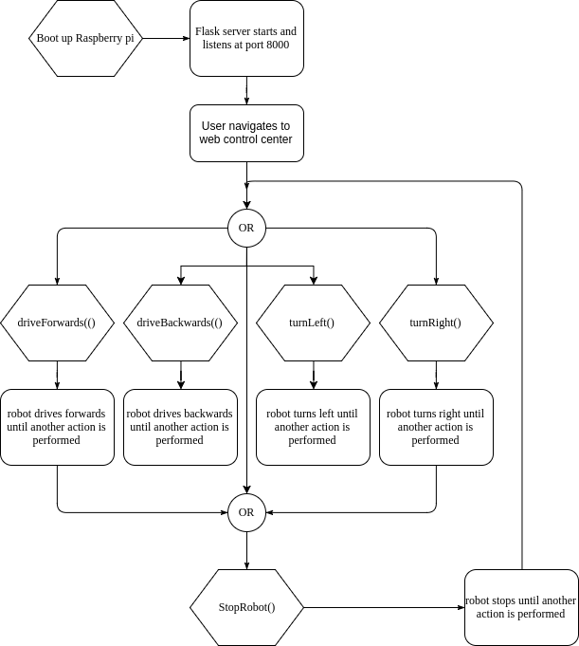

# Testing

Here‘s a link to our youtube video where we do our testing with continous input from a user with a smart phone used as the controller and the robot responding to inputs from user moving in all directions.

# <https://www.youtube.com/watch?v=jtw6Vwh3kg0>

# Final words

We learned a lot from this build especially since we were doing everything from scratch. The main purpose was to make something so simple as to anyone could make it out of spare parts laying around which was exactly what we did. We gained a lot of debugging expirience because we were working with the parts we had not making the parts working with our design and as well how to create a open remote connection where whoever with the domain could have control over the robot. All in all the project was very fun and we were happy with the outcome.

# Appendix

<https://github.com/StefanFreyr/rob2b3u>

<https://www.youtube.com/watch?v=jtw6Vwh3kg0>

# Sources

<http://www.instructables.com/id/IoT-Controlling-a-Raspberry-Pi-Robot-Over-Internet/>