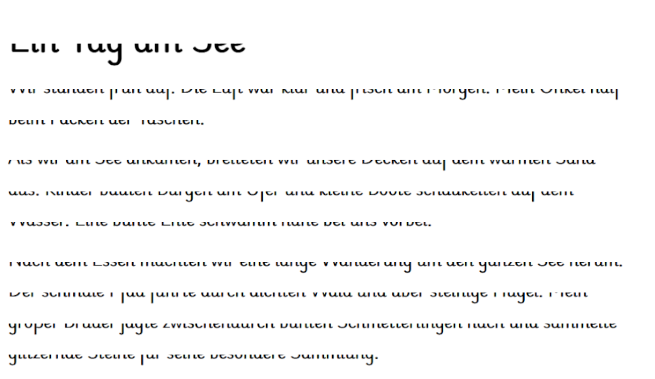
[© Stefan Giesberg Lerncoaching – stefangiesberg.de]

