# 

## Multilingual web application with administration.

Technologies used:

Front end: HTML,CSS,JS, JQuery, Bootstrap 4 framework, Owl carousel, dropzone, open street maps, etc.

Back end: Laravel 8 framework, PHP, MySQL.

Purpose of website is advertisement of places and events in Dubrovnik (Croatia) and making reservations for same. Website is divided in two parts one is front for regular visitors that doesn’t require login and other is for administrators. There are ulrs that can be visited only by administrators, else visitor is redirected back or on home page.

Admins can do all CRUD options on places, events and landmarks and they can review new reservations.

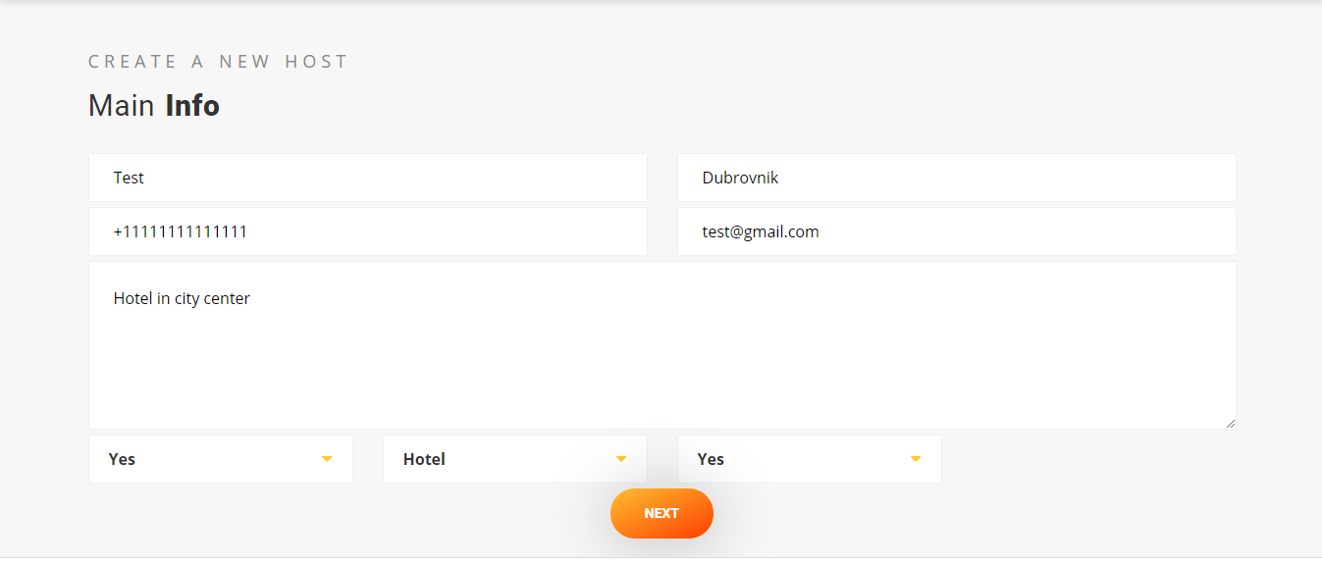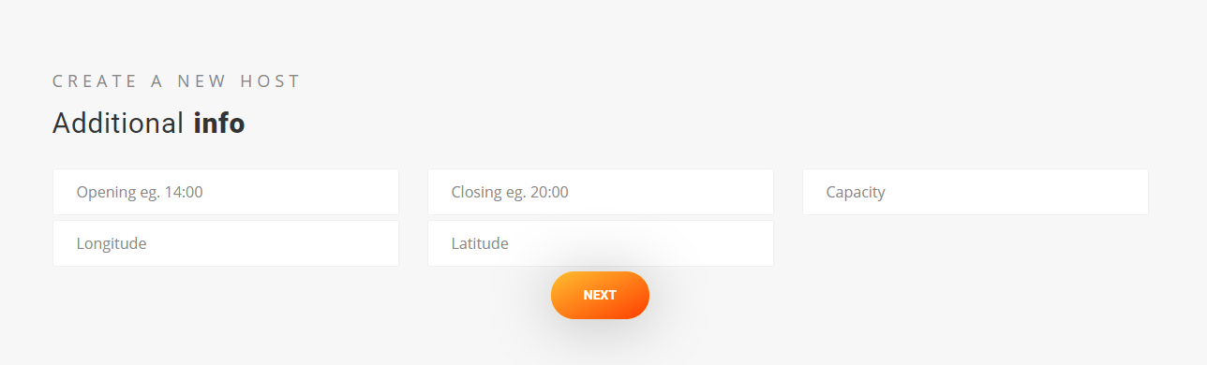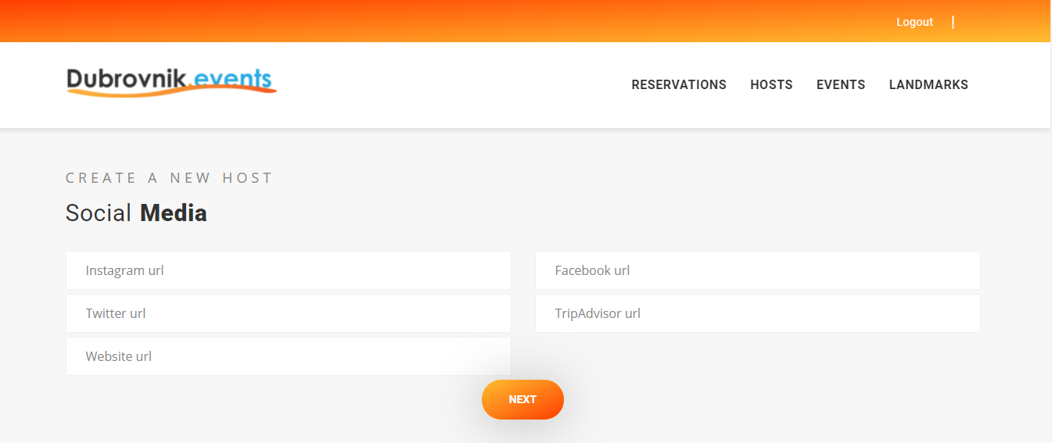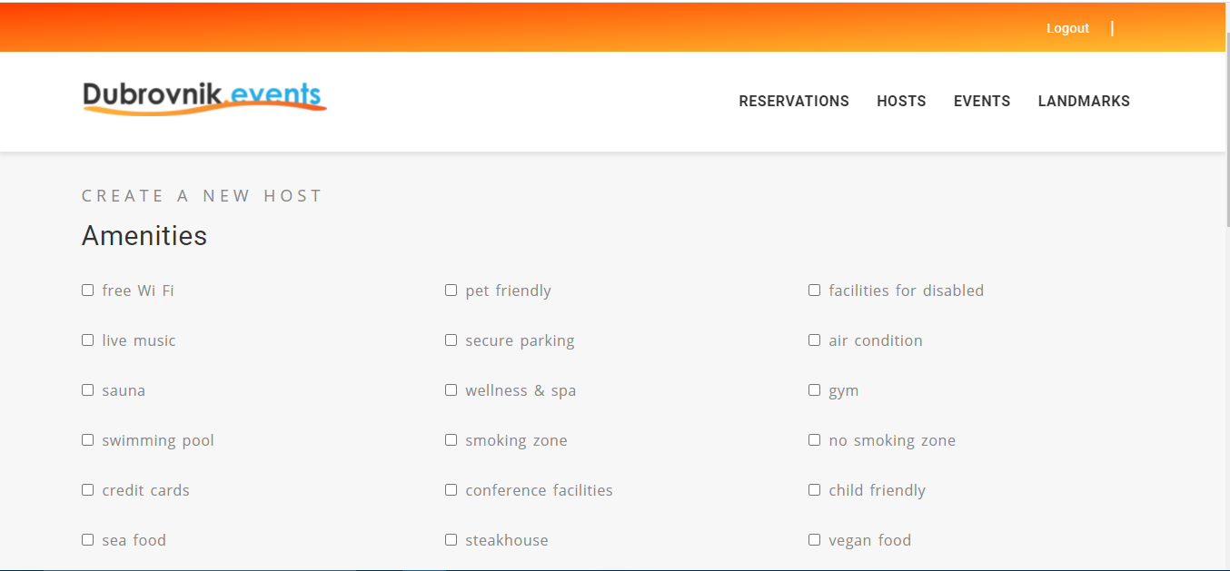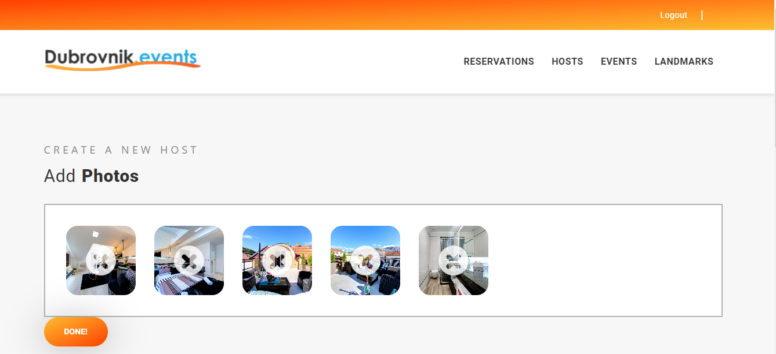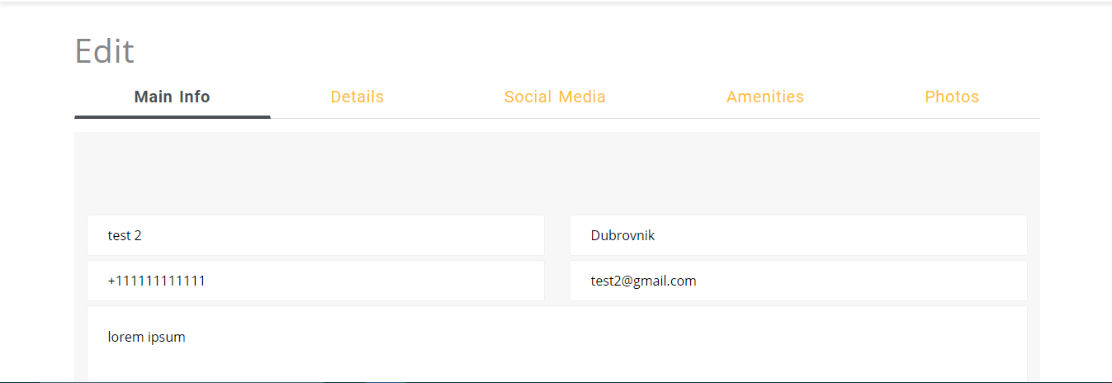

On photos above is shown simplicity of adding and editing places in database through administration.

Website can be easily translated on as many languages as required because all logic is already done with middlewares and routes.

Route::*group*([  
 'prefix'=>'{locale}',  
 'where'=>['locale'=>'[a-zA-Z]{2}'],  
 'middleware'=>'setlocale',  
],**function**(){

All routes are grouped with prefix that consist of two characters that are representation for language. Middleware ‘setlocale’ is appended to route group.

**public function** handle($request, Closure $next)  
{  
 app()->setLocale($request->segment(1));  
 **return** $next($request);  
}

All this middleware does is getting first segment or that prefix for language