Codebook accompanying MainData.csv

The following variables are included in MainData.csv

# Anonymous identifiers

Subj – Identifying variable

Subjnr – Double identifier, only created to efficiently merge between the two separate data sets

# Tailored preference data

**Prec**

Data about precommitment decisions taking a value of 1 for no and 2 for yes, as below

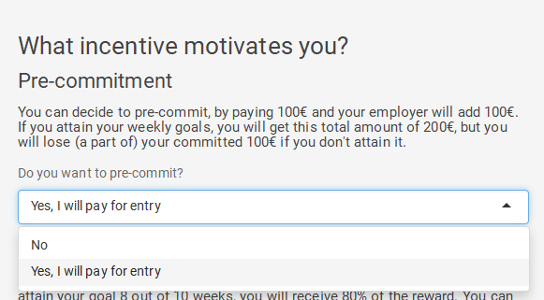

**Weekly**

Data about frequency taking a value of 1 for one pay-out and 2 for weekly pay-outs

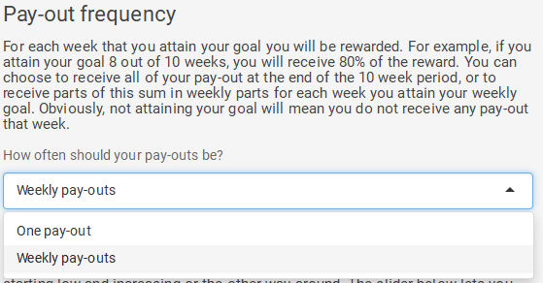

**Mode**

Weekly pay-outs could be changed in terms of structure, where the values represent the following:

1 = strongly ascending, 2= weakly descending, 3=constant, 4=weakly descending, 5= strongly descending

Note that if respondents have selected one pay-out they will have a 3 here

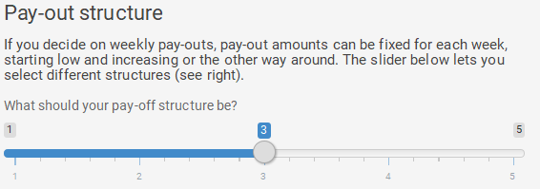

**P**

Probability of reward, takes a value between 1 and 100.

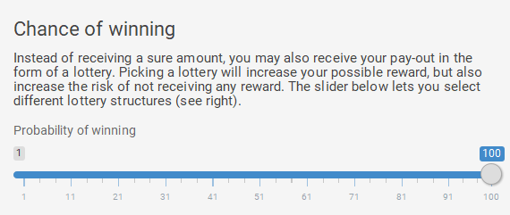

**W1 to W10**

Rewards paid out at each week. This data is not reported anywhere in the manuscript.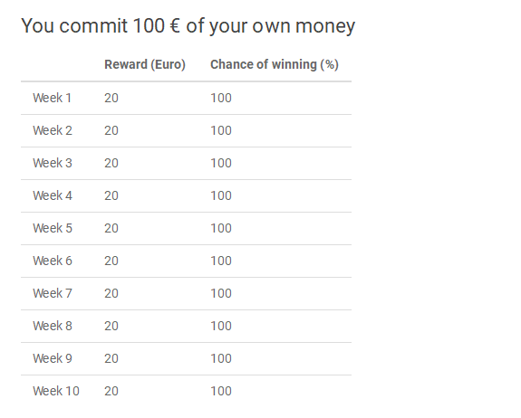

## Parameters summarizing risk preferences

**Note: Throughout the data-set, G and L refer to Gains and losses.**

LAKW – Loss aversion as defined by Köbberling & Wakker, see Online Supplements for details

**AUC.G–** Nonparametric summary of utility curvature for gains, not reported in manuscript

**AUC.L –** Nonparametric summary of utility curvature for losses, not reported in manuscript

**Alpha.G-** Power utility coefficient (see Online supplements for details)

**Alpha.L**

**Gamma.G –** Probability weighting parameter for gains (see Online Supplements)

**Gamma.L–** Probability weighting parameter for losses (see Online Supplements)

## Indifference points extracted from non-parametric method

As outlined in the Online supplements, probability weighting was approximated by eliciting certainty equivalents. These certainty equivalents are reported and stored by their respective probability of getting the high outcome and, such that **PBSG10 to PBSG90** are the elicited certainty equivalents for probabilities of 10% to 90% in the gain domain, and **PBSL10 to PBSL90** report the same certainty equivalents for losses. The normalized decision weights are reported as **DWG10 to** **DWG90** and **DWL10 to DWL90** for gains and losses respectively.

The non-parametric method elicited a standard sequence of equidistant utility points, which is reported as

**SSL4 SSL3 SSL2 SSL1 RP SSG1 SSG2 SSG3 SSG4**

Where the RP is set to 0, SSL indicates equidistant points in the loss domain and SSG equidistant points in the gain domain. For details see the Online Supplements.

**Time preference data**

Time preferences were approximated by eliciting 2 indifferences per domain (i.e. 2 for gains and 2 for losses). These indifferences are reported such that their domain and the durations involved are clear. That is BDG05 indicate a choice in the gain domain between receiving a smaller rewards now (0 weeks) or a larger reward in 5 weeks, and BDL510 indicates a choice in the loss domain between a smaller reward in 5 weeks or a larger reward in 5 weeks. The reported numbers reflect the elicited later value, the value received earlier (at 0 or 5 weeks) as indicated in the Online Supplements, was SSL4 or SSG4 (depending on the domain). These indifferences are used to calculate the 5 week discount factor (**D5G and D5L),** per week discount rate (**RG and RL**) and present bias (**BetaG and BetaL**) for gains and losses.

## Demographics

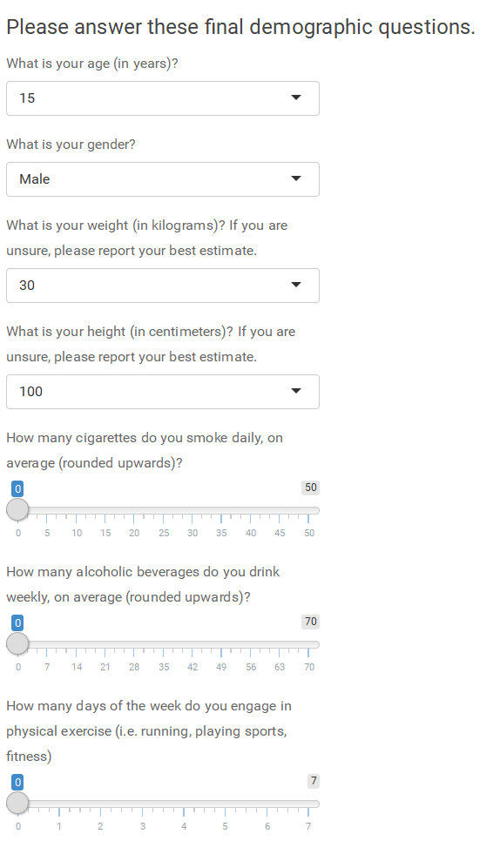

**Age =** Stored as integer current age

**Gender =** Male, Female, or Other (not reported in this study)

**Weight =** weight in kg

**Height=** height in cm

**Cigarettes =** Cigarettes per day (discrete numbers from 0 to 50)

**Alcohol =** Weekly alcoholic beverages (discrete numbers from 0 to 70)

**Exercise =** Amount of days per week exercise is performed (discrete from 0 to 7)

**BMI =** Calculated as usual (see script)

## Psychological measures

The questionnaire was adapted from Tangney et al. (2018), and measures self-control as a trait, i.e. the degree to which individuals in general are able to self-regulate. Items marked with * require reverse coding, and it is reported as a mean in the main text.

**TSCs –** Scale score on Tangney’s trait self-control measure. For calculation see Analysis script.

|  |  |  |  |  |  |  |  |
| --- | --- | --- | --- | --- | --- | --- | --- |
| *The following statements may reflect how you perceive yourself. Please indicate below to what extent these statements reflect how you typically are, by circling the answer that applies.* | | | | | | | |
|  | ***Not at all Very much***  ***↓ ↓*** | | | | | | | |
| *1* | *I am good at resisting temptation* | *1* | *2* | *3* | *4* | *5* |  | |
| *2\** | *I have a hard time breaking bad habits.* | *1* | *2* | *3* | *4* | *5* |  | |
| *3\** | *I am lazy* | *1* | *2* | *3* | *4* | *5* |  | |
| *4\** | *I say inappropriate things.* | *1* | *2* | *3* | *4* | *5* |  | |
| *5\** | *I do certain things that are bad for me, if they are fun.* | *1* | *2* | *3* | *4* | *5* |  | |
| *6* | *I refuse things that are bad for me.* | *1* | *2* | *3* | *4* | *5* |  | |
| *7\** | *I wish I had more self-discipline.* | *1* | *2* | *3* | *4* | *5* |  | |
| *8* | *People would say that I have iron self- discipline.* | *1* | *2* | *3* | *4* | *5* |  | |
| *9\** | *Pleasure and fun sometimes keep me from getting work done.* | *1* | *2* | *3* | *4* | *5* |  | |
| *10\** | *I have trouble concentrating.* | *1* | *2* | *3* | *4* | *5* |  | |
| *11\** | *I am able to work effectively toward long-term goals.* | *1* | *2* | *3* | *4* | *5* |  | |
| *12\** | *Sometimes I can’t stop myself from doing something, even if I know it is wrong.* | *1* | *2* | *3* | *4* | *5* |  | |
| *13\** | *I often act without thinking through all the alternatives.* | *1* | *2* | *3* | *4* | *5* |  | |

**CRTs –** Scale score (amount of correct items on cognitive reflection task)

This three item task developed by Toplak et al. (2011) aims to quantify the degree to which individuals rely on their automatic system by asking questions which seems to have an immediate, simple and right answer, which only after reflecting on it for some time appears to be in fact *wrong.* The CRT is scored as the amount of correct answers. The questions were answered by with a pen by writing down the answer on the open space.

1. *A bat and a ball cost €1.10 in total. The bat costs €1.00 more than the ball. How much does the ball cost? ________ cents*
2. *If it takes 5 machines 5 minutes to make 5 widgets, how long would it take 100 machines to make 100 widgets? _______ minutes*
3. *In a lake, there is a patch of lily pads. Every day, the patch doubles in size. If it takes 48 days for the patch to cover the entire lake, how long would it take*

**PQNs, PQEs, PQPs, PQLs:** Scale scores for personality domains Neutoricism, Extraversion, Psychoticism and Social Desirability. For calculation see Analysis script.

The last questionnaire used is a revised short-form version of the Revised Eysenck Personality Questionnaire, which captures personality on 4 domains. Items 1, 10, 12, 15, 19 and 22 capture Neuroticism. Items 2, 4, 14, 16, 21 and 24 capture Extraversion. Items 3, 6, 9, 13, 17 and 23 capture Psychoticism, and finally, items 5, 7, 8, 11, 18, and 20 capture Social desirability. Items marked with * are recoded, meaning that code 1 means has characteristic related to personality dimension and code 0 means does not relate to that dimension. Means are reported in main text.

*Please answer the following questions by answering “Yes” or “No” (circle which applies). There are no right or wrong answers. It is not necessary to think very long about these questions.*

|  |  |  |  |
| --- | --- | --- | --- |
| *1* | *Does your mood often go up and down?* | *Yes* | *No* |
| *2* | *Are you a talkative person?* | *Yes* | *No* |
| *3\** | *Would being in debt worry you?* | *Yes* | *No* |
| *4* | *Are you rather lively?* | *Yes* | *No* |
| *5\** | *Were you ever greedy by helping yourself to more than your share of anything?* | *Yes* | *No* |
| *6* | *Would you take drugs which may have strange or dangerous effects?* | *Yes* | *No* |
| *7\** | *Have you ever blamed someone for doing something you knew was really your fault?* | *Yes* | *No* |
| *8* | *Do you always practice what you preach?* | *Yes* | *No* |
| *9* | *Do you prefer to go your own way rather than act by the rules?* | *Yes* | *No* |
| *10* | *Do you often feel ‘fed-up’?* | *Yes* | *No* |
| *11\** | *Have you ever taken anything (even a pin or button) that belonged to someone else?* | *Yes* | *No* |
| *12* | *Would you call yourself a nervous person?* | *Yes* | *No* |
| *13* | *Do you think marriage is old-fashioned and should be done away with?* | *Yes* | *No* |
| *14* | *Can you easily get some life into a rather dull party?* | *Yes* | *No* |
| *15* | *Are you a worrier?* | *Yes* | *No* |
| *16\** | *Do you tend to keep in the background on social occasions?* | *Yes* | *No* |
| *17\** | *Does it worry you if you know there are mistakes in your work?* | *Yes* | *No* |
| *18\** | *Have you ever cheated at a game?* | *Yes* | *No* |
| *19* | *Do you suffer from ‘nerves’?* | *Yes* | *No* |
| *20\** | *Have you ever taken advantage of someone?* | *Yes* | *No* |
| *21\** | *Are you mostly quiet when you are with other people?* | *Yes* | *No* |
| *22* | *Do you often feel lonely?* | *Yes* | *No* |
| *23\** | *Is it better to follow society’s rules than go your own way?* | *Yes* | *No* |
| *24* | *Do other people think of you as being very lively* | *Yes* | *No* |