Software Engineering Assignment

CPS2002
Software Engineering

Stefan Mallia
stefan.mallia.09@um.edu.mt

Timothy Muscat
timothy.muscat.13@um.edu.mt

Bachelor of Science (Honours)
Computing Science
and
Statistics and Operations Research



University of Malta
Department of Computer Science

Table of Contents
Theory 3
Experimental Procedure 4
Implementation 4
Impulse response of the system 4
Type of System 6
Plotting Theory with Experiment 7
Changing input to a sine wave 8
Changing sampling frequency of system 9
General comments 9

Table of Figures
Figure 1: Simulink set up 4
Figure 2: Impulse response 5
Figure 3: Frequency response 6
Figure 4: Frequency response Theoretical and Experimental 7
Figure 5: Sine wave with frequency set to system’s null frequency 8
Figure 6: Frequency response with increased sampling frequency 9

Part 1: Initial Setup

To create software using continuous integration and a test driven approach, some initial setup is required. The main components of this setup are:
- A github repository
- A Jenkins server
- A Maven project (to manage code in Java)

Github repository
An empty Github repository was created and given the name ‘CPS2002: Software Engineering’. Contributors for this repository were added manually from Settings→Collaborators.

On the local environment, the following commands (in the appropriate directory) were run to associate the remote repository with a local repository:
git init .
git remote add origin <REPOSITORY URL>
git pull origin master

Jenkins Server
A Maven project was created on the Jenkins server with the following configurations:
- GitHub project= <REPOSITORY URL>
- JDK= Java 8
- Source Code Management=
Git
Repository URL= <REPOSITORY URL>
- Poll SCM= *****
- Root POM= pom.xml
- Goals and Options= clean emma:emma install
- Post-build Actions= Record Emma coverage report

Maven Project
A new Maven project was created with two dependencies inserted into the POM.xml, ‘junit’ version 4.12 and ‘org.apache.commons’ version 1.3.2. The name of the project was given as ‘um.edu.mt.cps2002’. This name influences the structure of the project in that each period in the name symbolises a new ‘sub-package’ inside the previous package. So the path to the source files for the given name is ‘./src/main/java/um/edu/mt/cps2002’. In Maven, this path must be mirrored in a separate directory branch for testing purposes under ‘test’ rather than ‘src’, that is, ‘./test/main/java/um/edu/mt/cps2002’. This is where test source files are stored, each test file must have the same name as the corresponding source file it is testing but with ‘Test’ appended to the name.

As a final step, the setup was tested by the creation of some test files (without corresponding source implementations) which were then commited and pushed to the remote repository through git. The Jenkins server was observed to ensure failure. Then an implementation for the test files was provided but one which gives incorrect values. This was done to ensure that Jenkin’s reports a test failure rather than a build failure. Finally, a proper implementation was provided to ensure that Jenkins reports a build and test success. It was also ensured that proper test result and code coverage graphs were displayed on the main Jenkins project page.

After this setup other collaborators executed the following command in their terminals to download an updated copy of the remote repository to their local environments:
git clone <REPOSITORY URL>

Part 2: Initial System

The initial system was implemented using a test driven approach, that is, coding implementations after tests have been put in place such that the implementation succeeds at those tests.

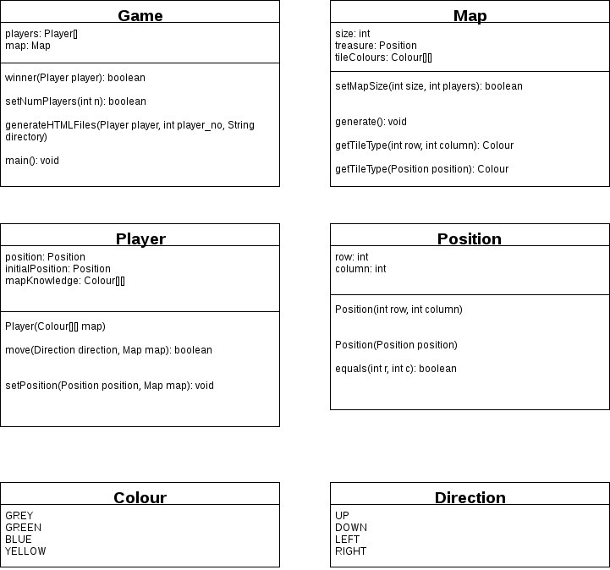

Figure 1: Program design

The system design, shown in Figure 1, is similar to the one specified in the task specification. The main differences are the following:
- Two enumeration classes for Colour, representing the tile type, and Direction, representing a neighboring tile for some given tile.
- Map holds the information on the treasure location and contains an attribute that contains information on the tile type of each tile.
- Position contains a method to check for equality
- Player object holds information on the object’s knowledge of the map. The initial position is also stored in a separate attribute so that the Game class knows where to reset the player.

Tests
Before implementation was begun, tests were created for the Game, Map, and Player classes. These were named the same as their respective class but with Test appended.

GameTest
The first set of tests is for the setting of the number of players. These tests are written inside the function testSetNumPlayers(). The tests check that true is returned only if the number of players being set is between 2 and 8 inclusive. The tests also check that the value of the players attribute is set to the correct value.

The next function, testWinner(), checks that if the Player inputted as an argument is on a yellow tile then a true is returned.

The final function in the Game class is testGenerateHTMLFiles(). This test first initializes 2 Player classes and then calls the Game.generateHTMLFiles() function. The two generated HTML files are then loaded into memory and the contents of these files are string compared with their expected content. The test fails if the contents of the HTML file is not equal to the string literal within the test.

MapTest
The first test in MapTest checks that setMapSize() returns true when an acceptable map size is passed into the function. The map size is dependent on the number of players, which is also passed as an argument, and will return false if the map is too large or too small for a given number of players

The next test, testGenerate(), first generates a map of size 50 and then checks for two things. The first is that there is only one treasure tile. The second is that water tiles are only neighbored by green tiles. This second check is to ensure that a path from the start position to the treasure tile is always present.

The next function, testGetTileType(), first initializes a 6x6 map with hard coded values for the tiles and then tests that getTileType() returns the correct Colour value.

The rest of the test functions test for IndexOutOfBoundsException error when calling getTileType() with out of bound argument values.

PlayerTest
There are two test functions for the Player class. The first tests that the Player.move() function works as intended. The second test function tests that the setPosition() function works as intended.

Rules and assumptions
One assumption that the design of this program makes is that water tiles are not allowed to neighbor each other. This choice was made to ensure that a path from each player’s initial position to the treasure tile exists.

Another assumption made for the program is that players cannot see each other at any point of the game. This includes when competing players step on tiles that have been discovered by the player.

Also related to player vision; falling in to a water tile resets the players position to their initial position but will preserve their knowledge of the map.

The HTML files are generated to the directory where the program is run. If the program is run using Maven, then the HTML files are generated to the root directory of the project.

Experimental Procedure

Implementation

The FIR system given by was implemented in Simulink with simulation stop time set to . A step function block was used as an input signal to represent the impulse signal. The system is shown in Figure 1.

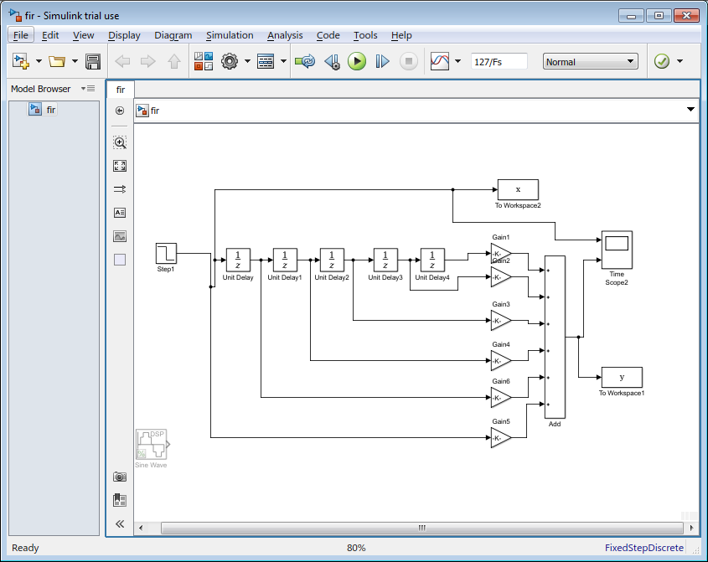
Figure 1: Simulink set up

The coefficients for the gain blocks correspond to the coefficients given in .

Impulse response of the system
The code provided was inputted into Matlab and executed to run the system. As expected, the output of the filter conformed to the values given by the impulse response . Figure 2 shows the outputted values.

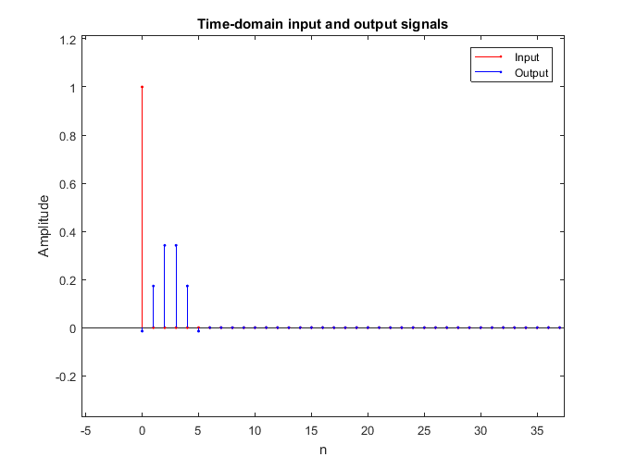
Figure 2: Impulse response

Type of System

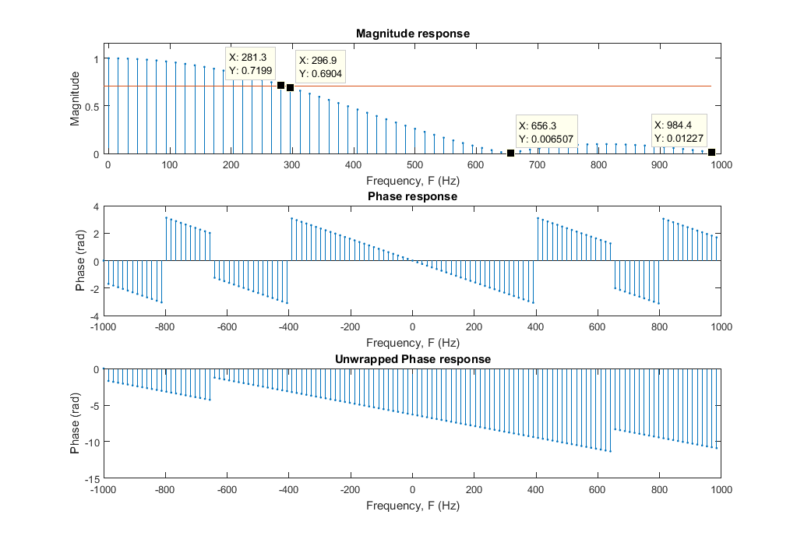
Figure 3: Frequency response

By looking at Figure 3, it can be seen that this system is a lowpass filter due to the magnitude response’s peak being situated close to 0.

The cutoff point is at around 287Hz. This can be seen in Figure 3 as the horizontal red line which was set to equal due to this corresponding to the cutoff point.

The frequencies where null points can be found are at around 656 and 1000.

The phase response in Figure 3 is displayed in an unwrapped state as well as its wrapped state. This is done to remove jumps and make analysis of the phase response easier. Since a cycle is represented by , any multiple of the values between and will not be distinct from its factor. In the unwrapped state it can be seen that phase response is linear until the null point at which point we have a change in polarity.

Plotting Theory with Experiment

The theoretical part was plotted using the following code:
w = f * 2* pi /Fs;
%frequencies = rad_per_sample.*(44100/(2*pi));
theor_H = (-0.0294*cos(5*w/2) + 0.346*cos(3*w/2) + 0.684*cos(w/2) ).*exp(-1i*5*w/2);

subplot(3,1,1)
hold on
plot(f,abs(theor_Y),'r')
subplot(3,1,2)
hold on
plot(f, angle(theor_Y), 'r')
subplot(3,1,3)
hold on
plot(f, unwrap(angle(theor_Y)), 'r')

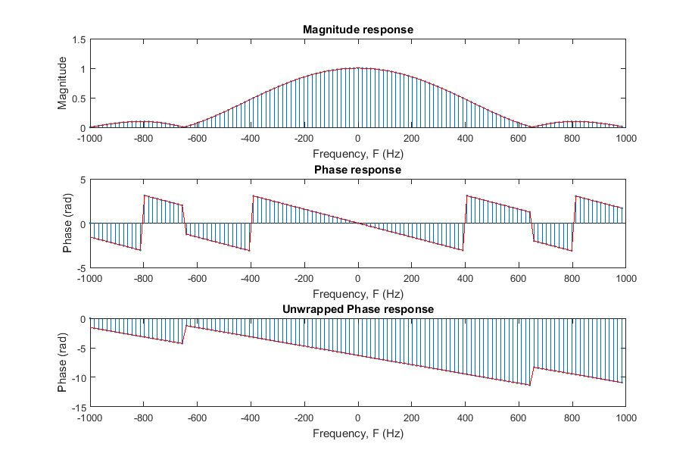
Figure 4: Frequency response Theoretical and Experimental

There do not seem to be any differences thus confirming the simulation results.

Changing input to a sine wave

The input was changed from an impulse to a sine wave with its frequency set to what was found to be the approximate value for the null-frequency (656Hz). Alternatively, the exact value was found by using the theoretically derived value for

Matlab code:
theor_H = (-0.0294*cos(5*w/2) + 0.346*cos(3*w/2) + 0.684*cos(w/2) ).*exp(-1i*5*w/2);
solve(theor_H==0, w)/(2*pi)*2000

Where the second line uses the formula . One of the results from this computation is 650.9609

The resulting simulation is shown in Figure 5.

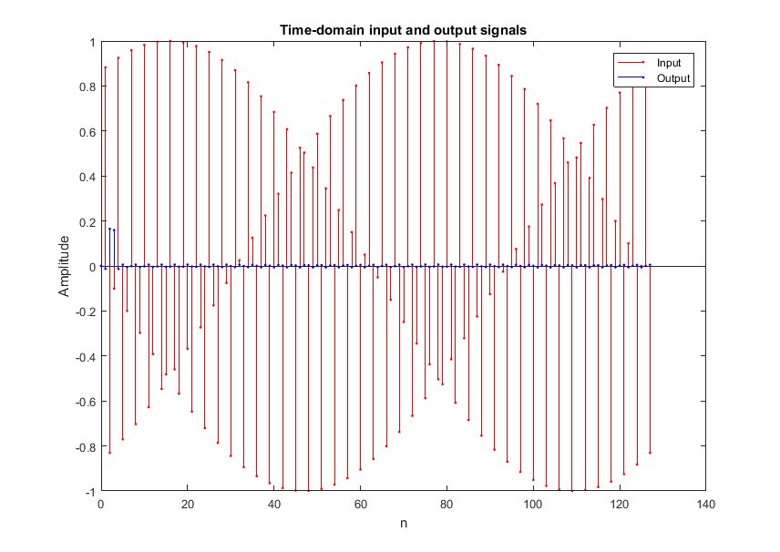
Figure 5: Sine wave with frequency set to system’s null frequency

Due to the sine way having the system’s null frequency, the output is almost negligible.

Changing sampling frequency of system

An increase in the sampling frequency means that now each term in

represents the impule response at time for . So now the impulse response of the system takes place in a shorter time frame.

This is shown in Figure 6 where the sampling frequency is increased to 20kHz. As can be seen, the frequency response’s scale increased horizontally to cover larger frequencies. The null points can now be found at 6563Hz and 9844Hz.

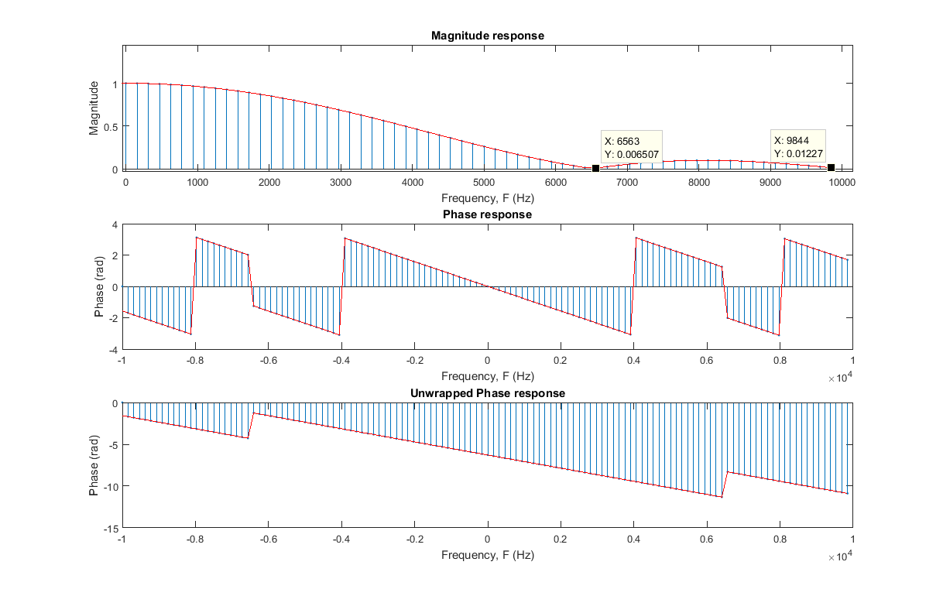
Figure 6: Frequency response with increased sampling frequency

General comments

The system specified was found to be a low-pass filter and it was found to have two null points due to a rebound in magnitude after the first null point.

The system’s null points and cutoff frequencies were found to depend on the sampling frequency of the system due to the sampling frequency being one of the parameters that define a system. However, although the frequencies of the system change with the sampling frequency, the radians/sample values remain the same.

